Education Service
Processing Enrollments with Vacation Days
September 2022
Version 1.0

Lesson Overview
Topic | Description
Time Estimate: | 60 minutes including assessment
Purpose of the Lesson: | Provides training on processing of enrollments for non-standard terms at IHL facilities which include vacation days. Includes guidance on how to review to determine whether vacation days may impact education benefit processing. Also, provides guidance on when to develop for vacation days.
Prerequisite Training Requirements: | N/A
Target Audience: | Education Veterans Claims Processors (VCEs), Senior VCEs, Lead VCEs, and Education Quality & Training Specialist (EQTS).
Lesson References: | M22-4, Part 4 Chapter 6, subchapter 2
Lesson Objectives: | - Identify when to consider vacation days  - Determine when to develop for vacation days  - Understand how to process enrollments containing vacation days
Post Training Requirements: | Upon completion of the classroom portion of the lesson, participants are required to complete an online lesson assessment and survey in Talent Management System (TMS).  To demonstrate successful completion of the lesson, participants must pass the assessment with a score of at least 80%.  Participants must also complete the online survey to earn credit for completion of the lesson.

Slides | Instructor Script
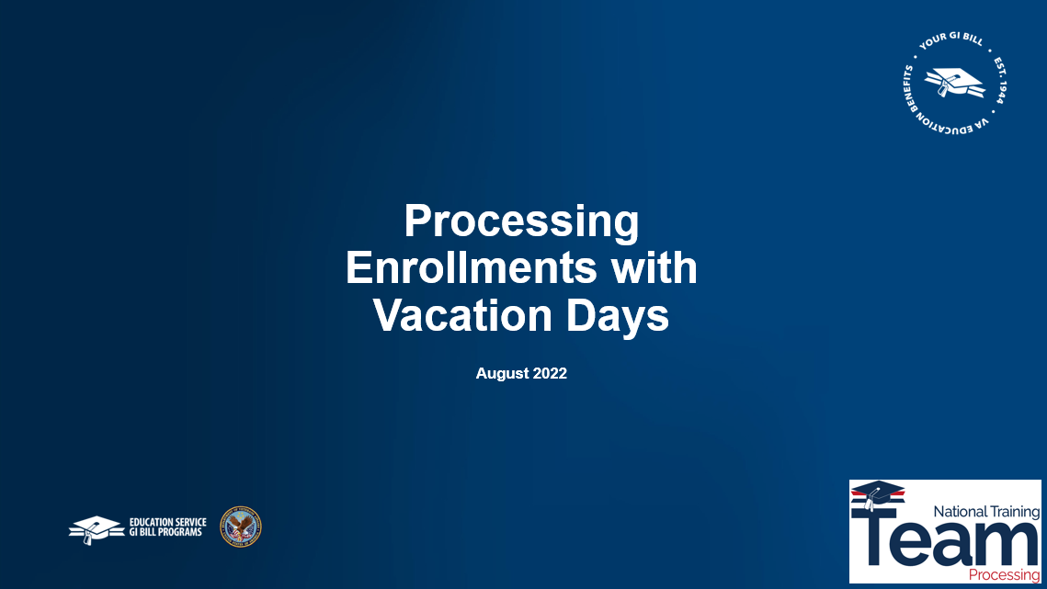 | Slide  Welcome to the training module on processing enrollments with vacation days. Today’s training will focus on vacation days certified for undergraduate, non-standard terms reported as credit hours at IHL (Institution of Higher Learning) facilities. Vacation days at NCD (Non-College Degree) facilities will be covered in another training module.
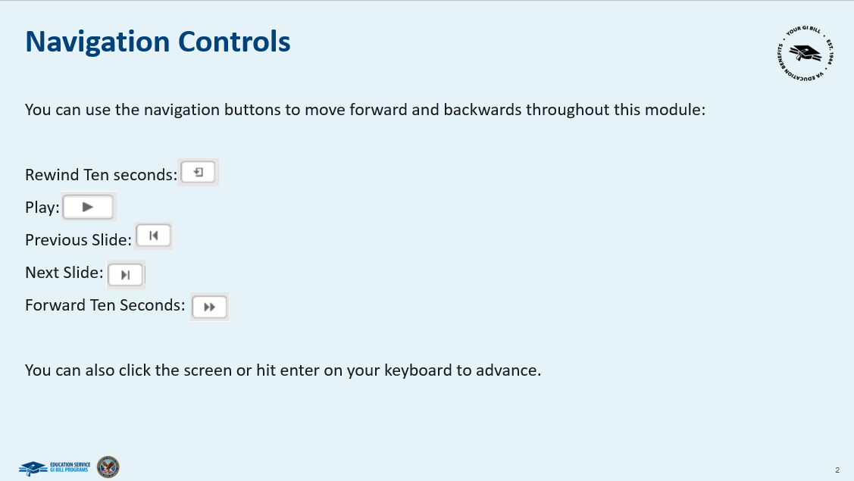 | Slide  You can use the navigation buttons shown here to move forward and backward throughout this module.  You can also click the screen or hit enter to advance to the next screen.
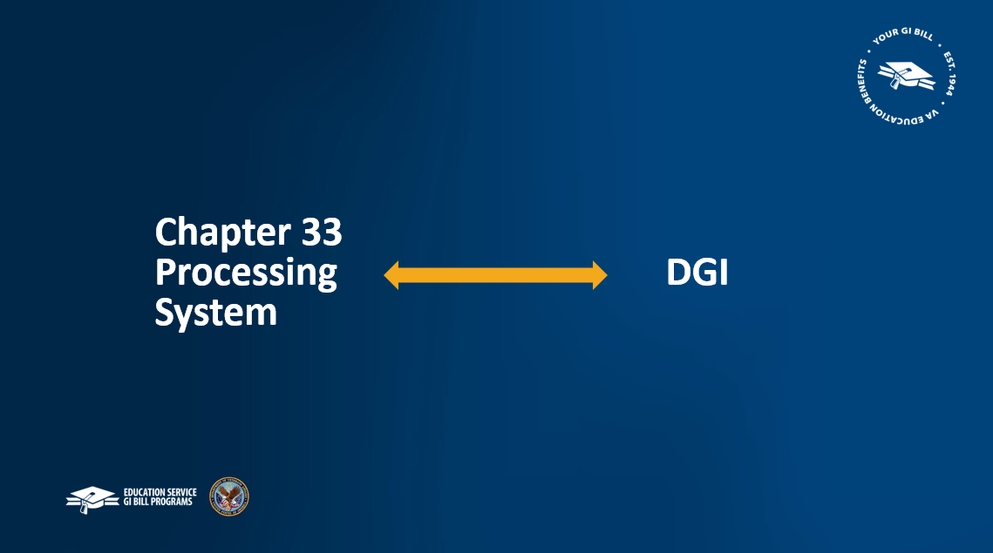 | Slide 3.  Note throughout this training the terms Chapter 33 Processing System and DGI will be used interchangeably.
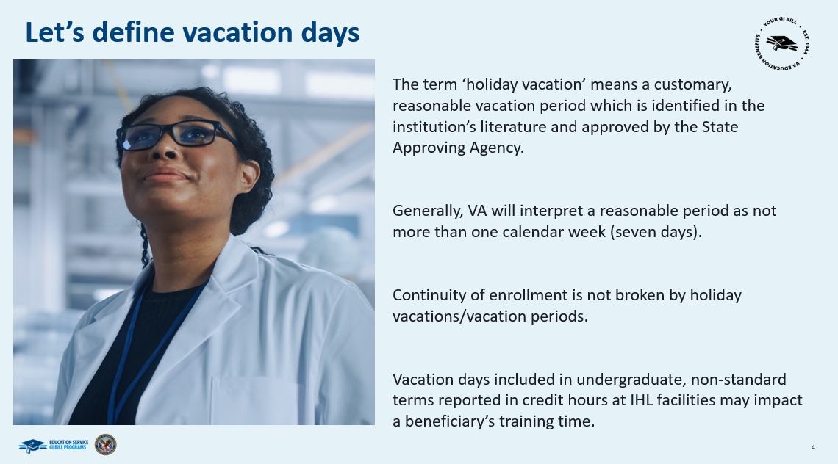 | Slide 4.  Let’s start with defining vacation days.The term ‘holiday vacation’ means a customary, reasonable vacation period which is identified as a holiday vacation in the educational institution's literature, approved by the State Approving Agency of jurisdiction.  Generally, VA will interpret a reasonable period as not more than one calendar week (seven days). Christmas and New Year’s holidays can be considered as separate vacation periods and may exceed seven consecutive days when combined.  Continuity of enrollment is not broken by holiday vacations or vacation periods. Vacation days included in undergraduate, non-standard terms reported in credit hours at IHL facilities may impact a beneficiary’s training time.  Remember, rate of pursuit for chapter 33 and training time for non-chapter 33 during STANDARD TERMS are not impacted by vacation days.
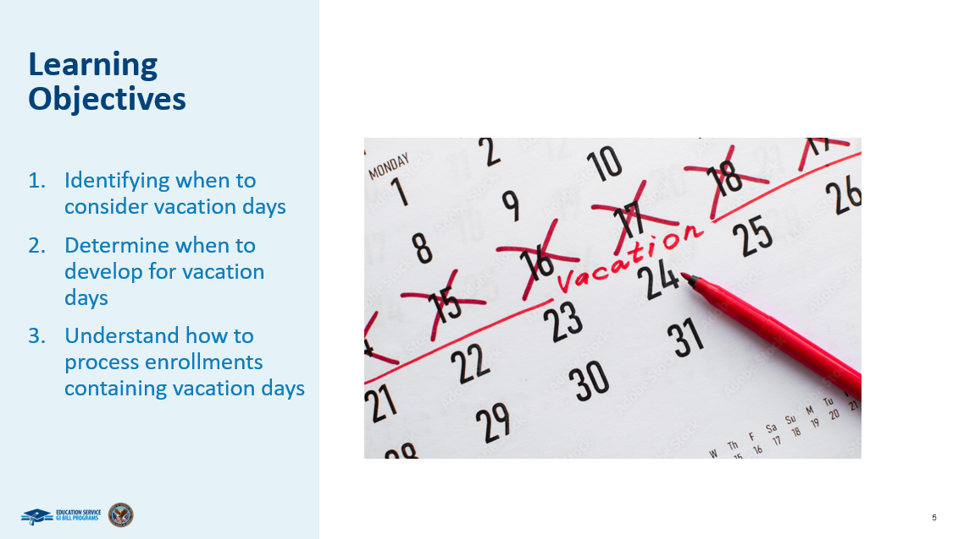 | Slide 5.  At the end of today’s lesson, you will be able to identify when vacation days should be considered during award processing; determine when to develop for vacation days; and how to process enrollments containing vacation days
 | Slide 6.  Identifying when to consider vacation days
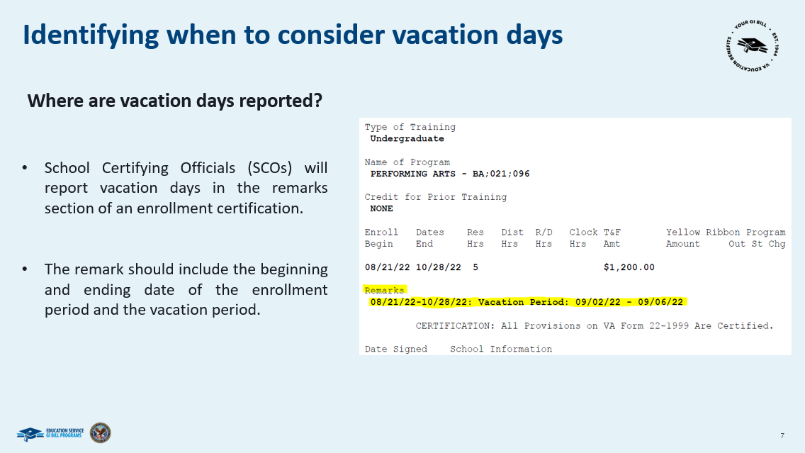 | Slide 7.  As previously mentioned, this training will cover vacation days certified for undergraduate, non-standard terms reported in credit hours at IHL facilities. Remember, standard semester terms are 15 to 19 weeks and standard quarter terms are 10 to 13 weeks. Non- standard terms are longer or shorter than a standard semester or quarter term.  School Certifying Officials (SCOs) have been advised not to report vacation days for graduate training. VCEs should not take any action on vacation days reported for graduate training.  SCOs will report vacation days in the remarks section of the enrollment certification. The remark should include the beginning and ending date of the vacation period. VCEs should ensure the vacation period reported falls within the certified enrollment period.
 | Slide 8.  Determine when to develop for vacation days
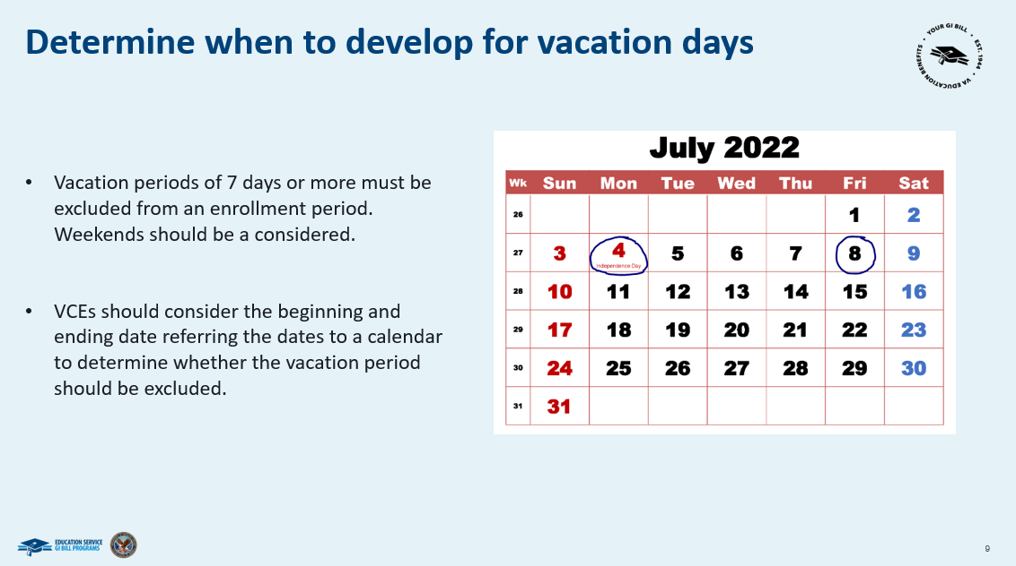 | Slide 9.  Vacation periods of 7 days or more must be excluded from an enrollment period. Weekends should be considered when determining the length of a vacation period.  To determine whether to exclude a vacation period, VCEs should consider the beginning and ending date and the length of the reported vacation period. This may require the VCE to refer to a calendar to account for weekend days.
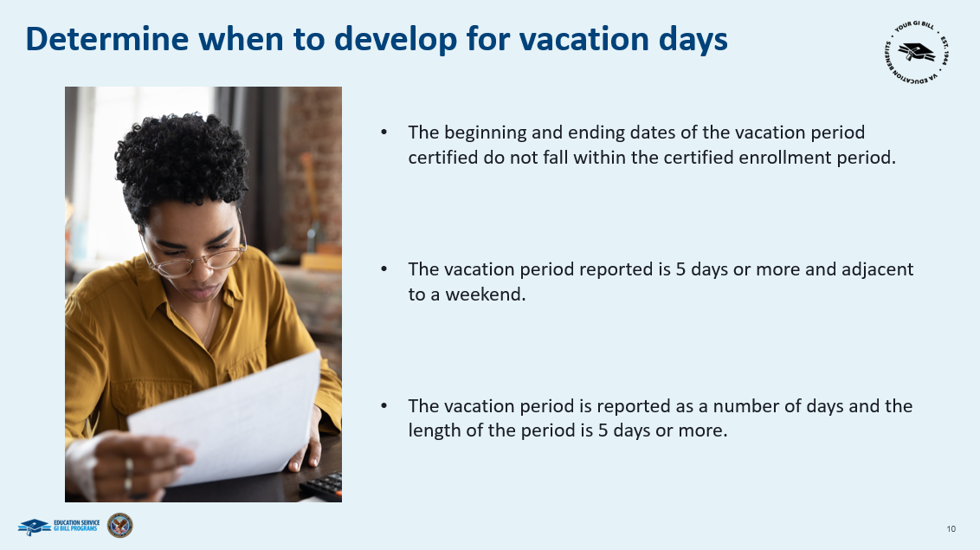 | Slide 10.  VCEs must use existing development procedures and capture all responses from the development actions into TIMS if:  The beginning and ending dates of the vacation period certified do not fall within certified enrollment period.  The vacation period reported is 5 days or more and is adjacent to a weekend.  The vacation period is reported as a number of days without specific dates and the length of the period is 5 days or more.  Let’s go over some specific scenarios to illustrate when to develop for vacation days.
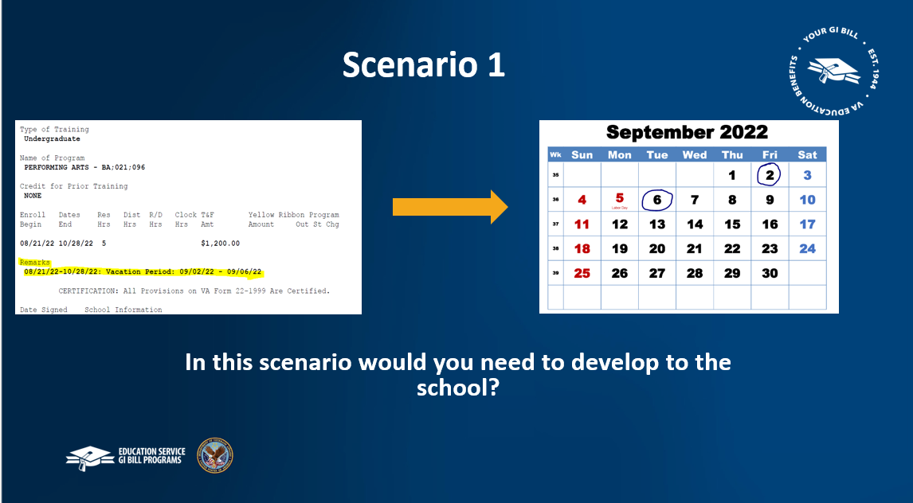 | Slide 11.  In this scenario, the school reports vacation days from Sept 2nd to Sept 6th. A review of the calendar shows the dates are Friday through Tuesday. Would it be necessary to develop to the school?  No, it is not necessary to develop. The beginning and ending dates of the vacation period were reported. A review of the calendar indicates the vacation period already accounts for weekend days. Since the vacation period is less than 7 days, it does not have to be excluded from the enrollment period.
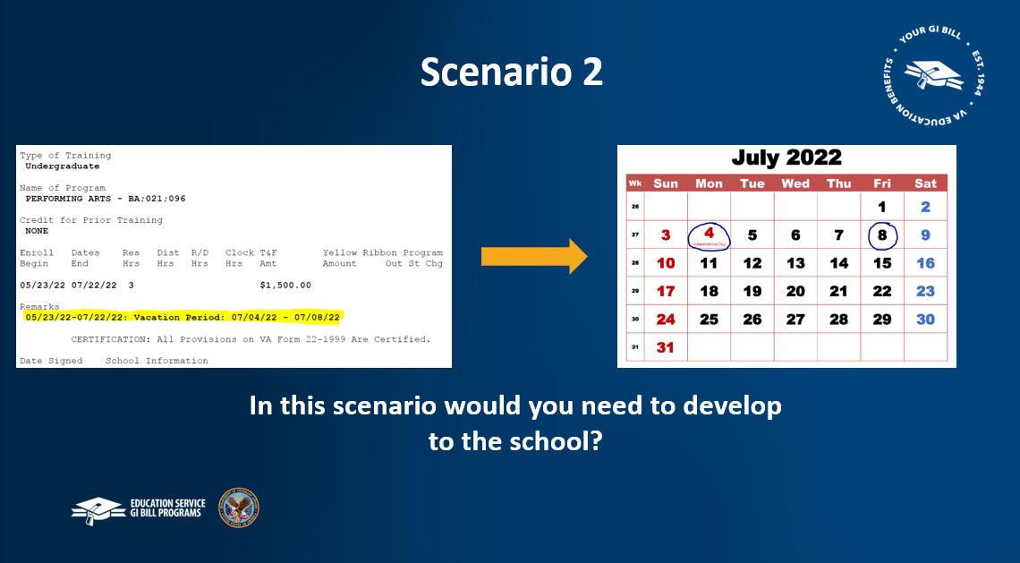 | Slide 12.  In this scenario, the school reports vacation days from July 4th to July 8th. A review of the calendar shows the dates are Monday through Friday. Would it be necessary to develop to the school?  Yes, it is necessary to develop. The length is 5 days and is adjacent to two weekends. The VCE must develop to the school to determine whether classes were held on the weekend days. The VCE should then account for any weekend days on which no classes were held and include in the vacation period. If the resulting period is 7 days or more, it should be excluded from the enrollment period.
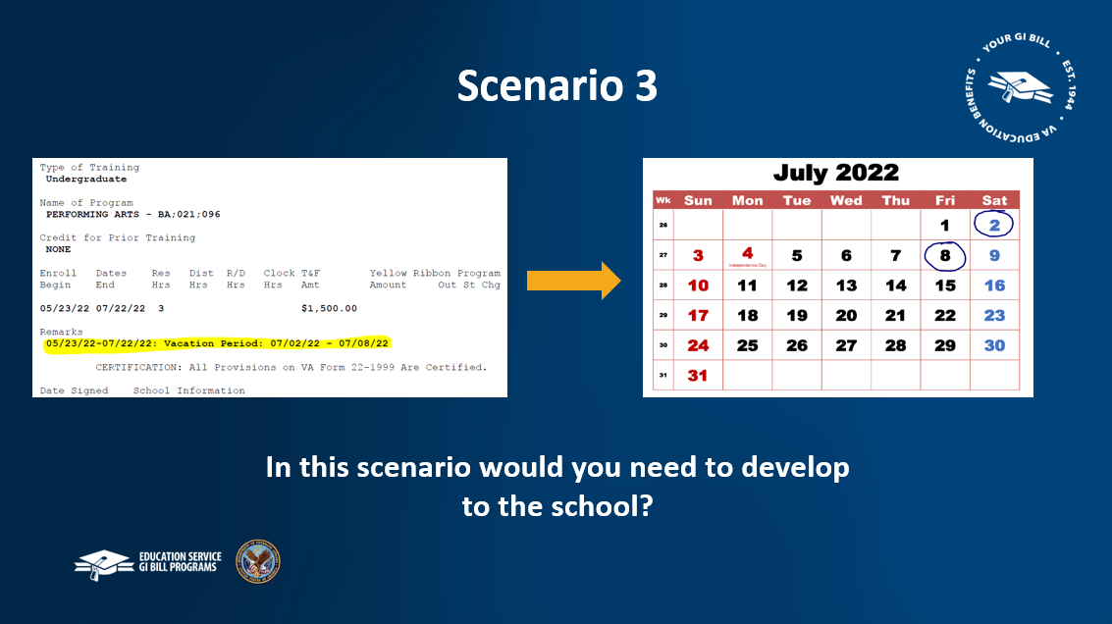 | Slide 13:  In this scenario, the school reports vacation days from July 2nd to July 8th. A review of the calendar shows the dates are Saturday through Friday. Would it be necessary to develop to the school?  Yes, it is necessary to develop. The length is 5 days or more, and is adjacent to a weekend. The VCE must develop to the school to determine whether classes were held on the weekend after the vacation period end date. The VCE should then account for any weekend days on which no classes were held and include in the vacation period. The resulting days should be excluded from the enrollment period.
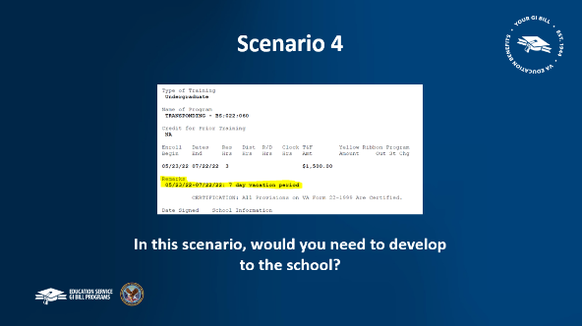 | Slide 14.  In this scenario, the school reported vacation days as 7 vacation days and did NOT provide a date range for this vacation period. Would it be necessary to develop to the school?  Yes, in this scenario it is necessary to develop. A vacation period of 7 days must be excluded, however, the VCE must develop to determine if additional weekend days should be accounted for in the vacation period. The VCE should develop to the school for the exact dates of the vacation period, including weekends. The resulting period should be excluded from the enrollment period.
 | Slide 15.  Understand how to process enrollments containing vacation days
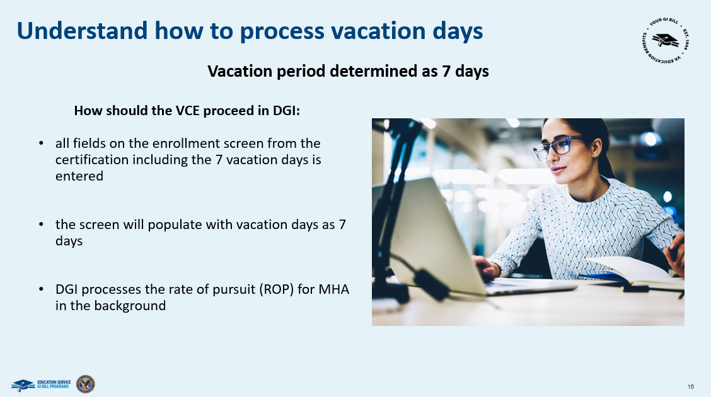 | Slide 16.  As stated previously, only vacation periods of 7 days or more need to be excluded from an enrollment period. If the vacation period is determined to be less than 7 days, no additional action is needed to account for the vacation period.  For chapter 33 claims, vacation periods of 7 days or more should be entered in DGI. On the enrollment screen, VCEs must populate all fields, entering the beginning and ending dates of the certified enrollment period. VCEs must also enter number of vacation days in the vacation days field.  DGI will populate the enrollment and account for the vacation days when calculating the rate of pursuit for MHA.
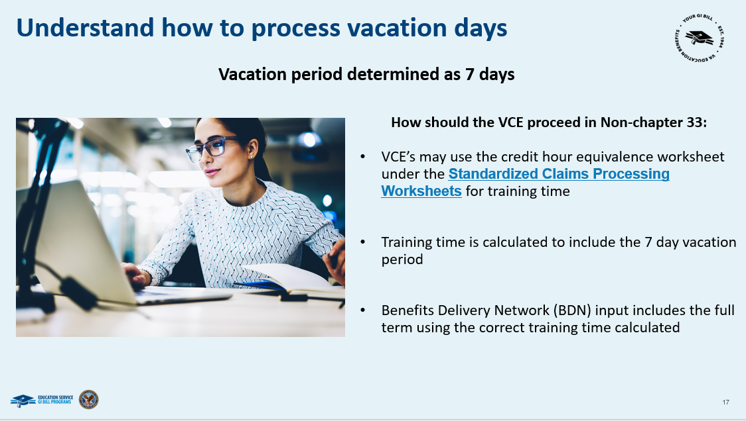 | Slide 17.  For Non-33 claimants, VCEs may use the credit hour equivalency worksheet under the Standardized Claims Processing Worksheets as one method to determine training time.  For non-chapter 33 claims, vacation periods of 7 days or more must be excluded prior to calculating equivalent credit hours. After determining ECH, the corresponding training time should be entered in BDN when processing an award.  Let’s check out some more in-depth processing scenarios with vacation days!
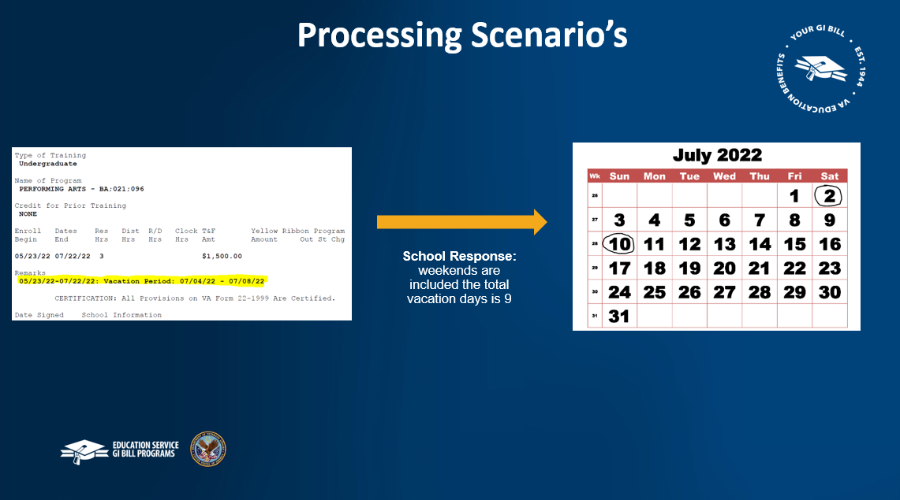 | Slide 18.  Processing Scenarios: In this scenario, you can see the school reported 5 vacation days. After development, the actual vacation period is 9 days. Press the next arrow to see this scenario processed in DGI and BDN.
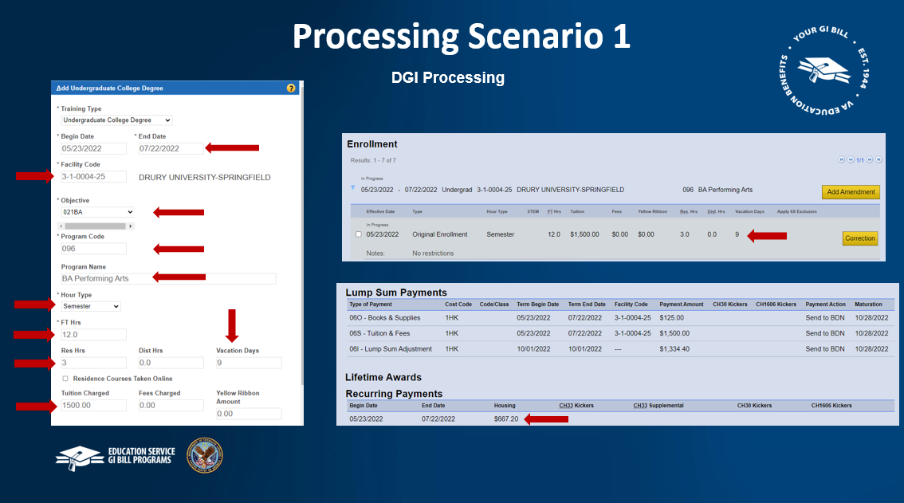 | Slide 19.  Processing Scenario 1: DGI Processing for a chapter 33 claim, the VCE will enter the undergraduate term on the enrollment screen in DGI. The VCE will enter the term dates, facility code, objective, program code and program name, the hour type, amount of full-time hours, residence or distance hours, tuition amount, as well as entering the 9 day vacation period in the vacation days field. After completing all fields, the VCE will click Save and DGI will calculate the rate of pursuit.
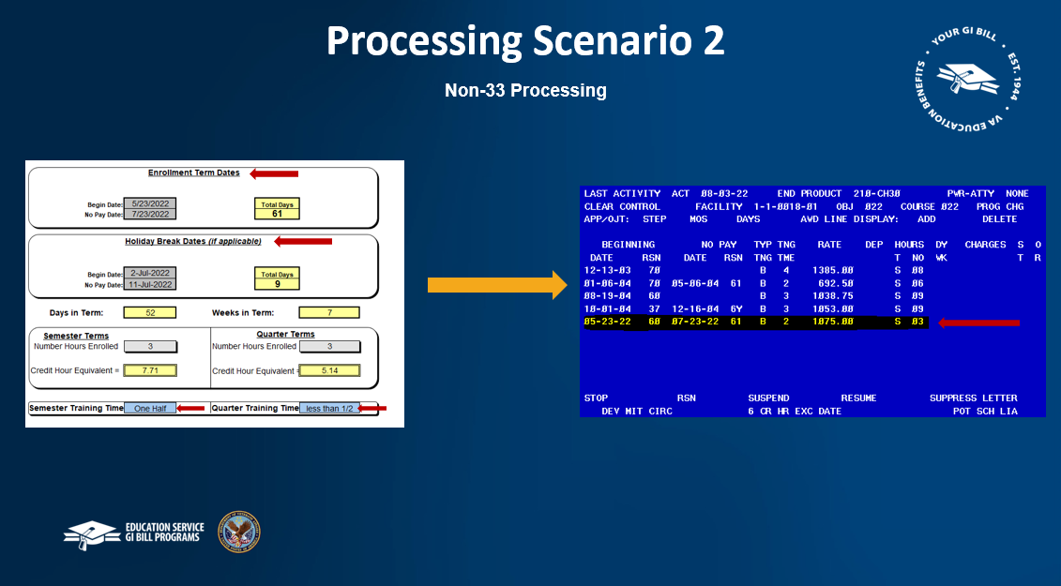 | Slide 20.  Processing Scenario 2: This is the same scenario, except it is a non-chapter 33 claim.  First, you can use the Equivalency Credit Hour worksheet to determine training time. You will add the enrollment dates and the vacation period dates under the enrollment term dates section and the holiday break dates section. The number of hours enrolled will be entered in the semester or quarter area. This will factor the training time used for the term at the bottom of the sheet.  Once the equivalency credit hour worksheet and training time have been calculated, process the award in BDN. Enter the actual beginning date and no pay date and use the training time associated with the Equivalency Credit Hour worksheet.  Now let's check your knowledge of information we covered today.
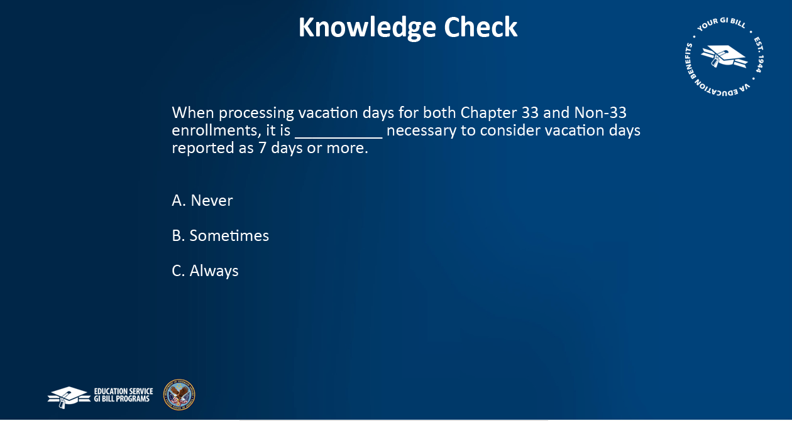 | Slide 21.  Knowledge Check Number 1- Fill in the Blank: When processing vacation days for non-standard terms at IHL facilities for both Chapter 33 and Non-33 enrollments, it is ________ necessary to consider vacation days reported as 7 days or more.  - Never  - Sometimes  - Always
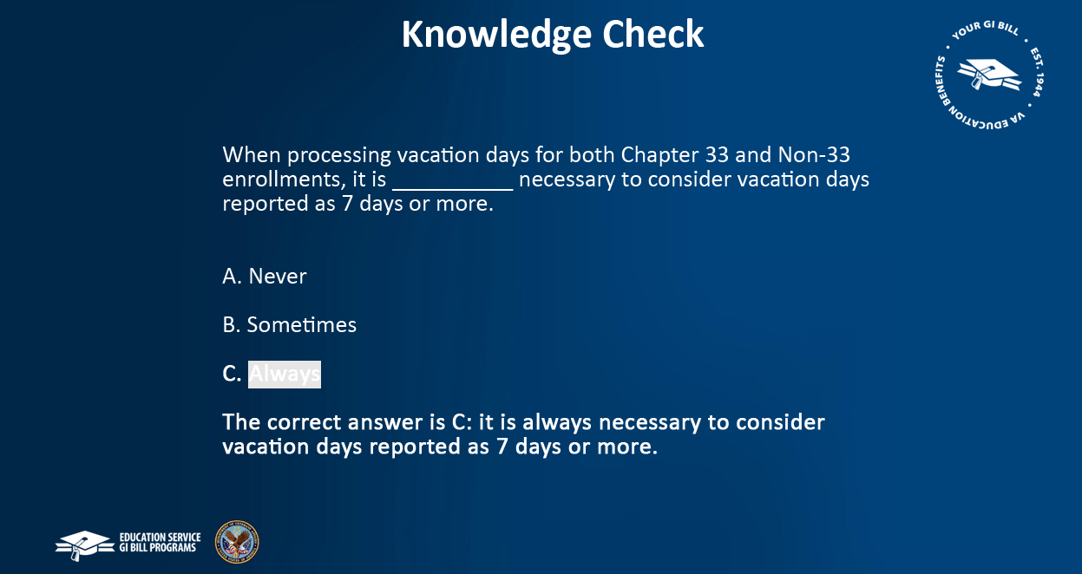 | Slide 22.  The correct answer is C, it is ALWAYS necessary to consider vacation days reported as 7 days or more.
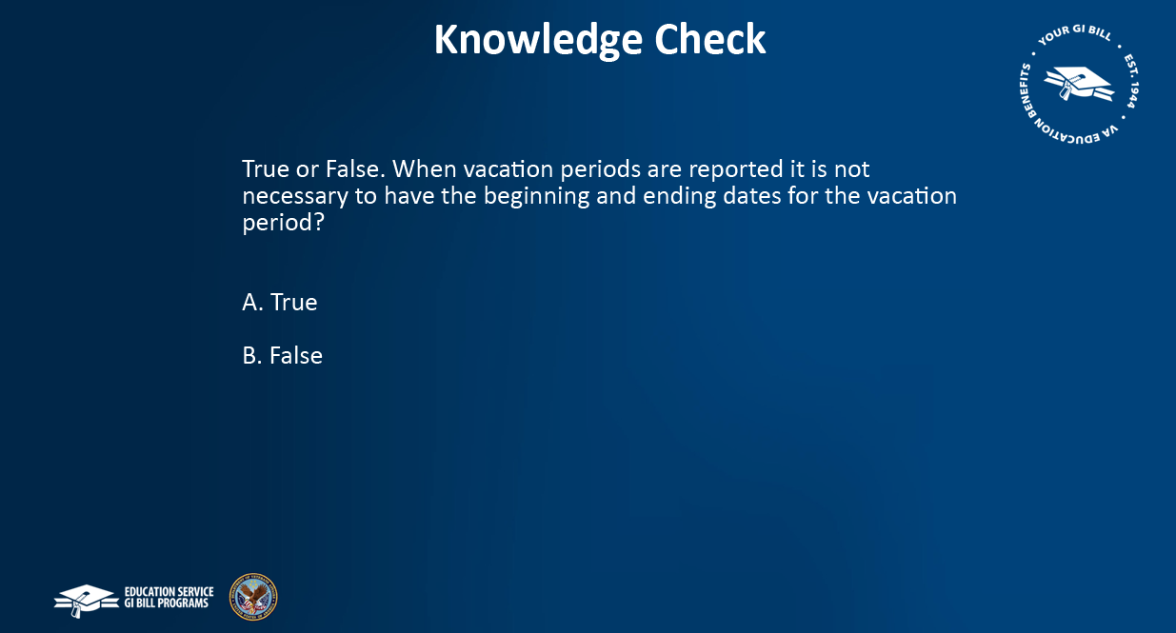 | Slide 23.  Knowledge Check Number 2- True or False. When vacation periods are reported it is NOT NECESSARY to have the beginning and ending dates for the vacation period?  - True  - False
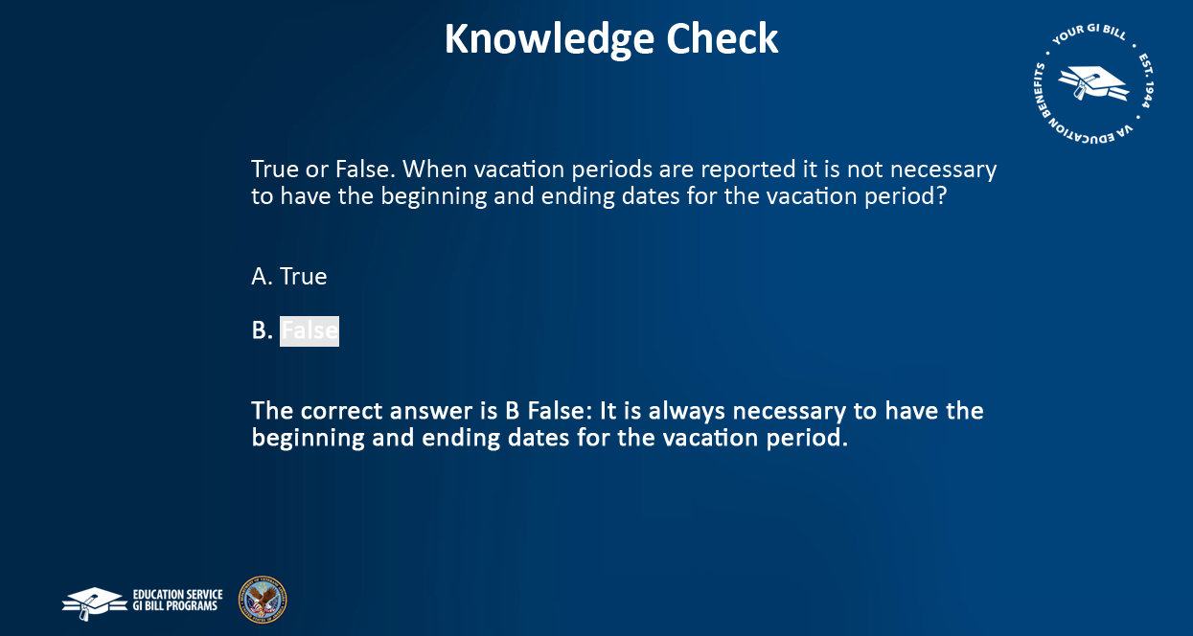 | Slide 24.  The correct answer is B False: It is always necessary to have the beginning and ending dates for the vacation period
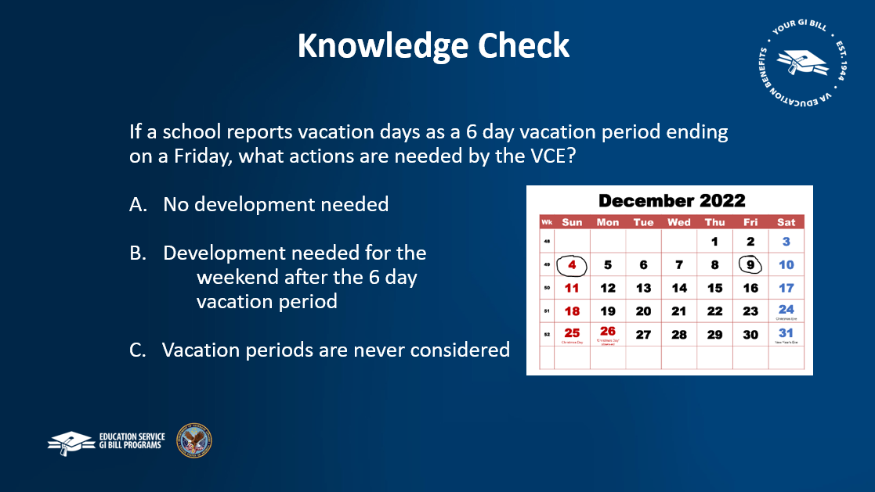 | Slide 25.  Knowledge Check Number 3- Multiple Choice: If the school reports vacation days as a 6-day vacation period ending on a Friday, what actions are needed by the VCE?  - No development needed  - Development needed for the weekend after the 6-day vacation period  - Vacation periods are never considered
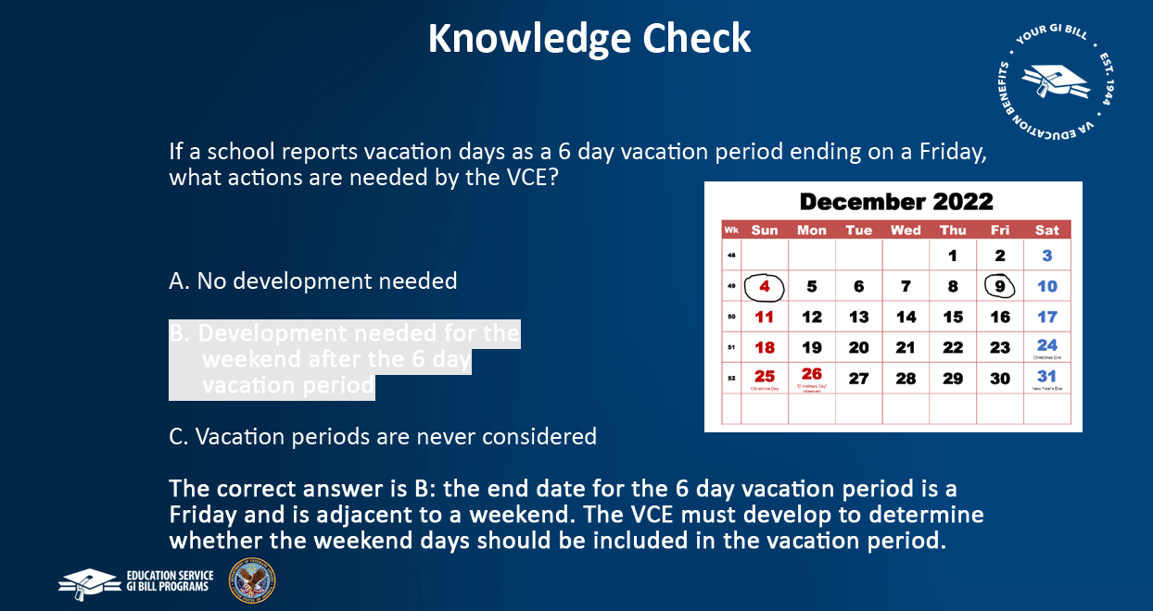 | Slide 26.  The correct answer is B: the ending date for the 6-day vacation period is a Friday and is adjacent to a weekend. The VCE must develop to determine whether the weekend days should be included in the vacation period.
 | Slide 27.  This concludes today’s training module on vacation days. The reference for today’s training is linked here on the page under M22-4- Part 4 Chapter 6-
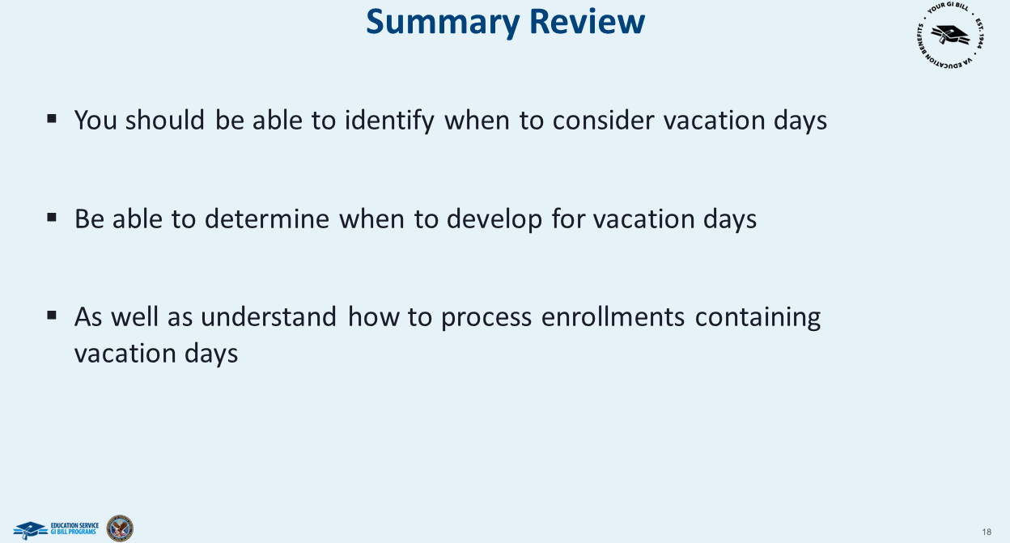 | Slide 28.  You should now be able to identify when to consider vacation days, determine development if it is needed for vacation days, and understand your role in the processing of vacation days!
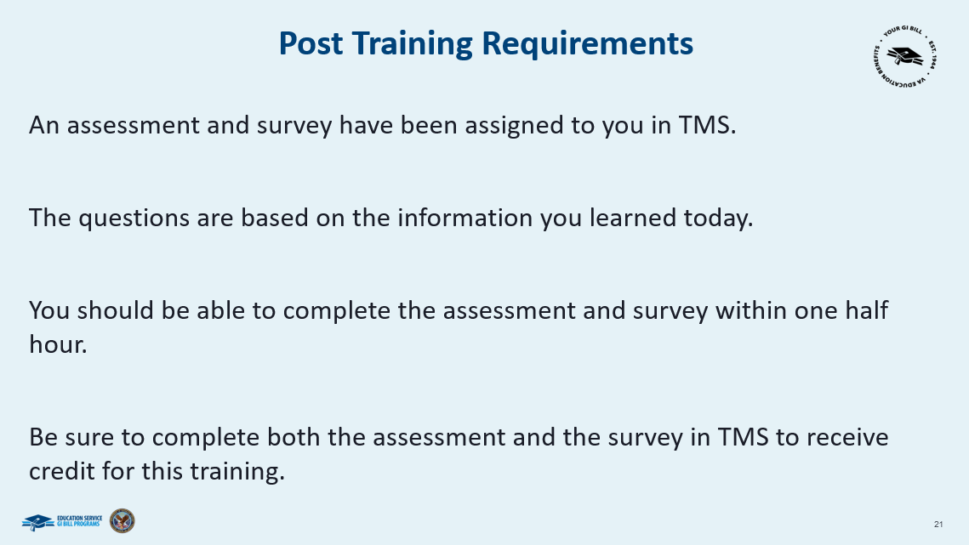 | Slide 29.  In order to receive credit for completion of today’s training you will need to complete the TMS assessment and Survey. The assessment will be assigned to you in TMS and consists of both multiple choice and true/false questions. It should take approximately one hour for you to complete the assessment and survey.
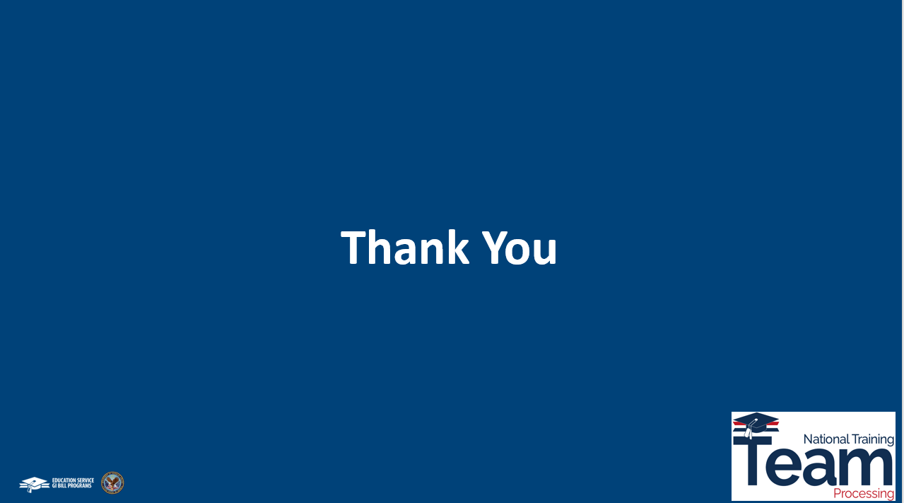 | Slide 30.  Thank You for taking the time today to complete training on vacation days! Until next time!

