Education Service
DGI Claims Processing Vol.2
Training Series
July 2022
Version 1.0

Lesson Overview
Topic | Description
Time Estimate: | 60 minutes including assessment
Purpose of the Lesson: | Digital GI Bill (DGI) Claims Processing System Volume 2 training on upcoming DGI release including chapter 33 processing changes for original claims.
Prerequisite Training Requirements: | N/A
Target Audience: | Education Veterans Claims Processors (VCEs), Senior VCEs, Lead VCEs, and Education Quality & Training Specialist (EQTS).
Lesson References: | N/A
Lesson Objectives: | - An Introduction to the automation of original claims  - A new application process for beneficiaries  - New 1990 TIMS documents
Post Training Requirements: | Upon completion of the classroom portion of the lesson, participants are required to complete an online lesson assessment and survey in Talent Management System (TMS).  To demonstrate successful completion of the lesson, participants must pass the assessment with a score of at least 70%.  Participants must also complete the online survey to earn credit for completion of the lesson.

 | Instructor Script
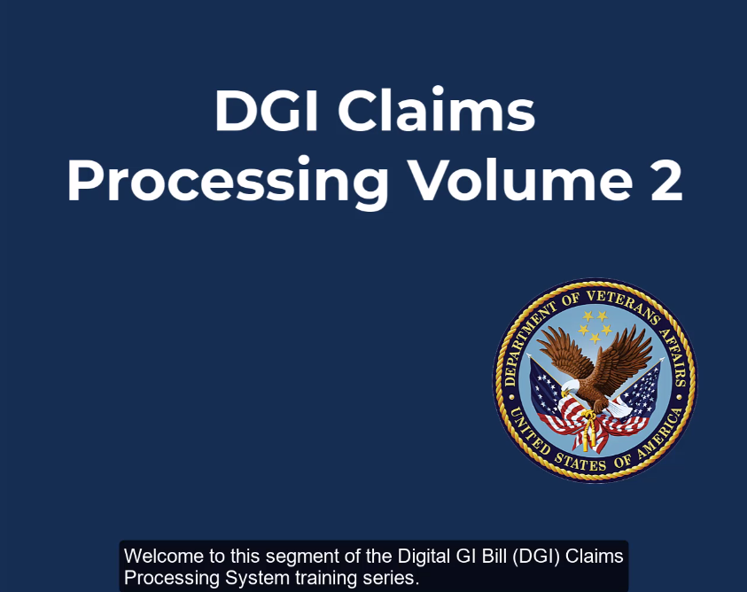 | Welcome to this segment of the Digital GI Bill (DGI) Claims Processing System training series.
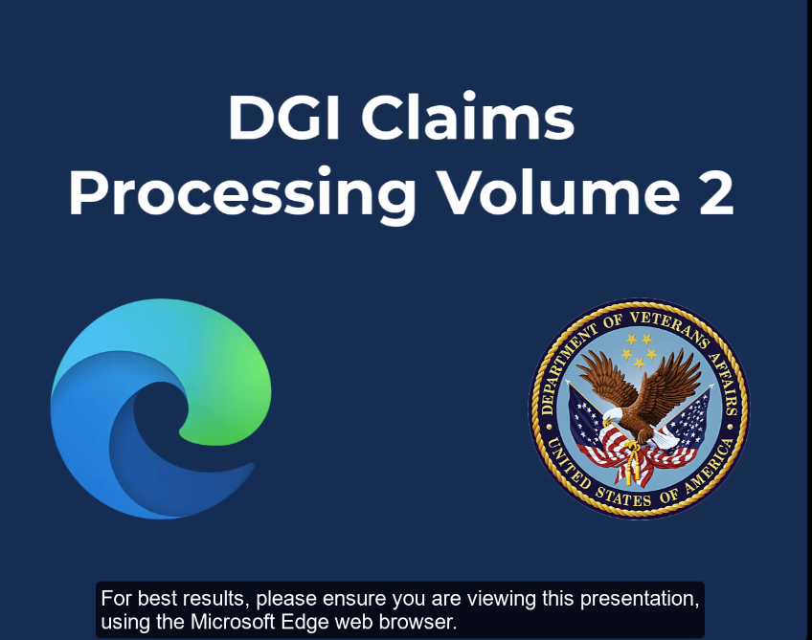 | For best results, please ensure you are viewing this presentation, using Microsoft Edge web browser.
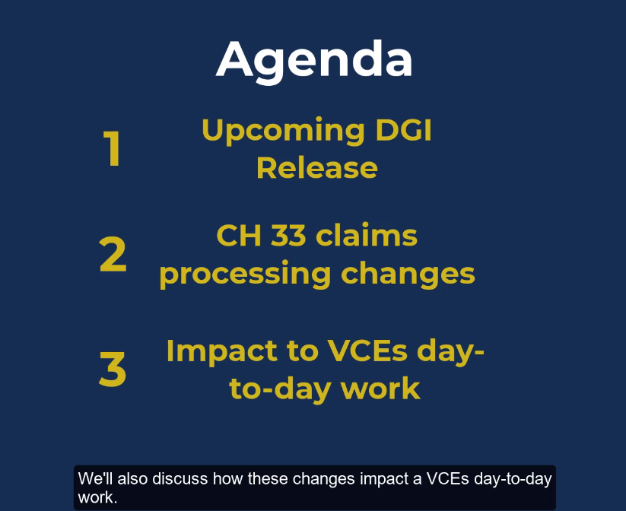 | Today’s training will discuss the upcoming DGI release, and some of the chapter 33 claims processing changes for original claims included within, we’ll also discuss the way these claims processes impact a VCE’s day to day work.
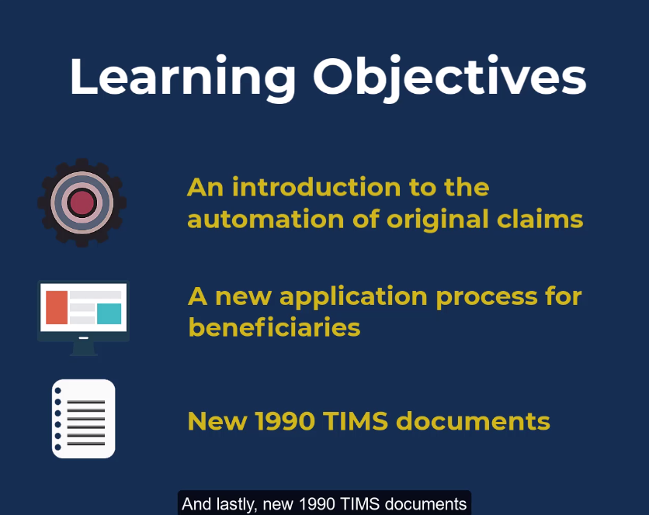 | For learning objectives, the topics covered in today’s training will be:  An introduction to the automation of original claims  A new application process for beneficiaries  And lastly,  New 1990 TIMS documents
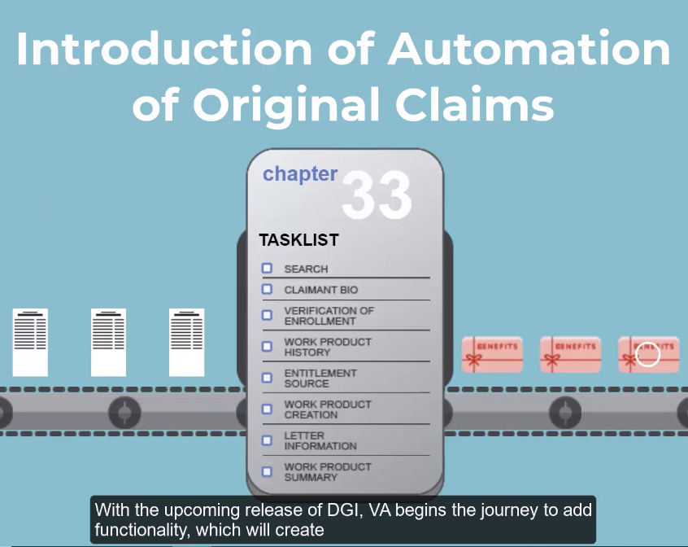 | With the upcoming release of DGI. VA begins the journey to add functionality which will create a more streamlined process of submission, adjudication, and letter generation for chapter 33 Original Claims.
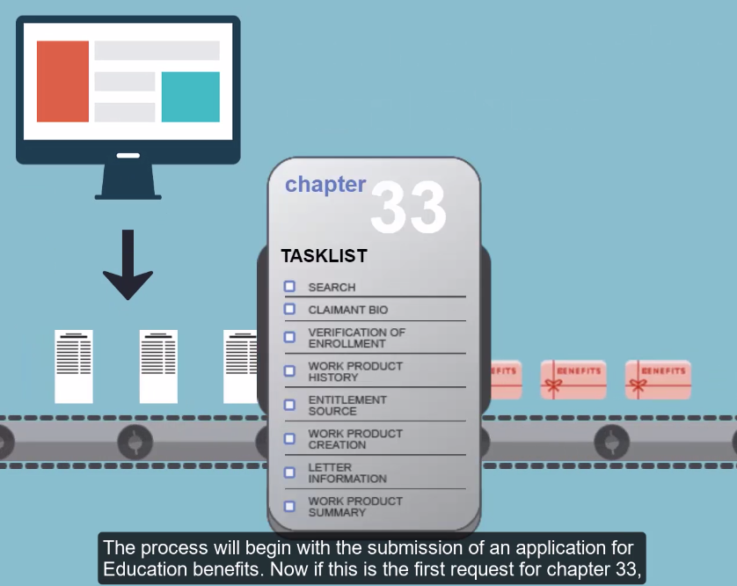 | The process will begin with the submission of an application for education benefits.
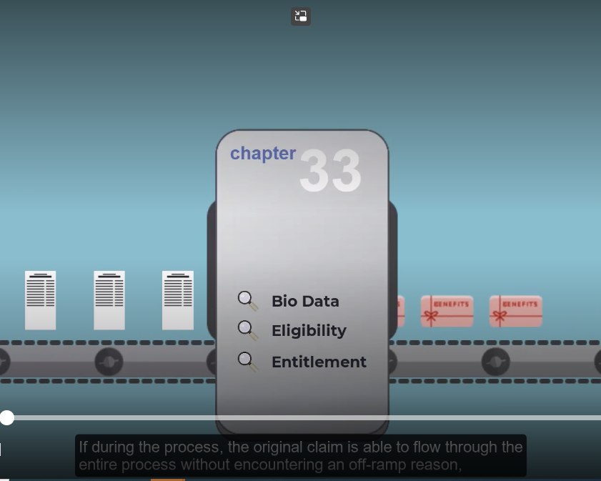 | Now if this is the first request for chapter 33, the application will go through an automated workflow and check for biographical data, eligibility, and entitlement.
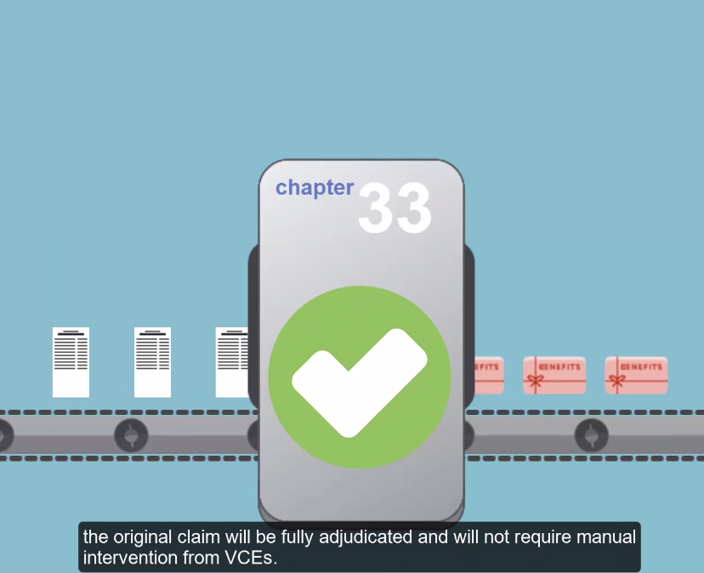 | If during the process the original claim is able to flow through the entire process without encountering an off-ramp reason, the original claim will be fully adjudicated and will not require manual intervention from VCE’s.
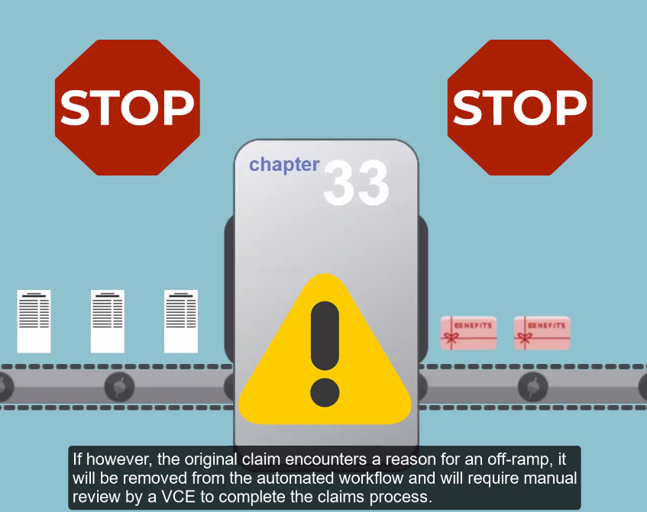 | If however, the original claim encounters a reason for an off-ramp, it will be removed from the automated workflow and will require manual review by a VCE to complete the claims process.
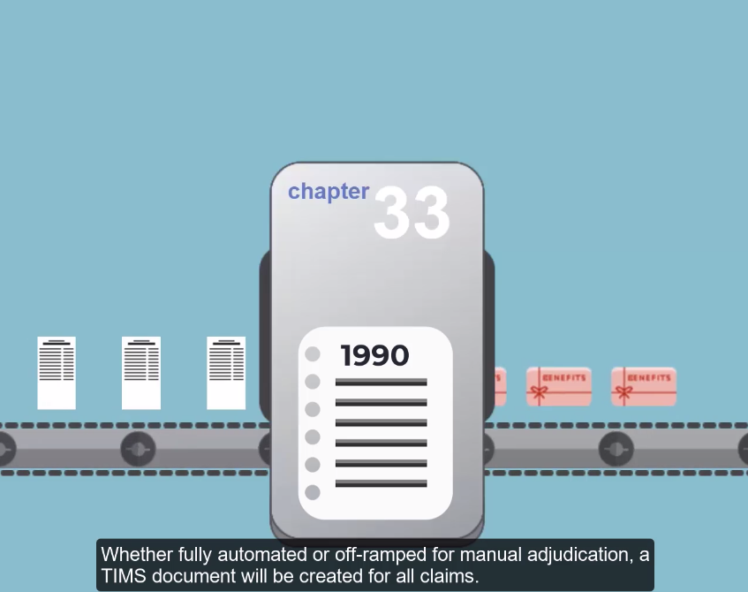 | Whether fully automated or off-ramped for manual adjudication, a TIMS document will be created for all claims.
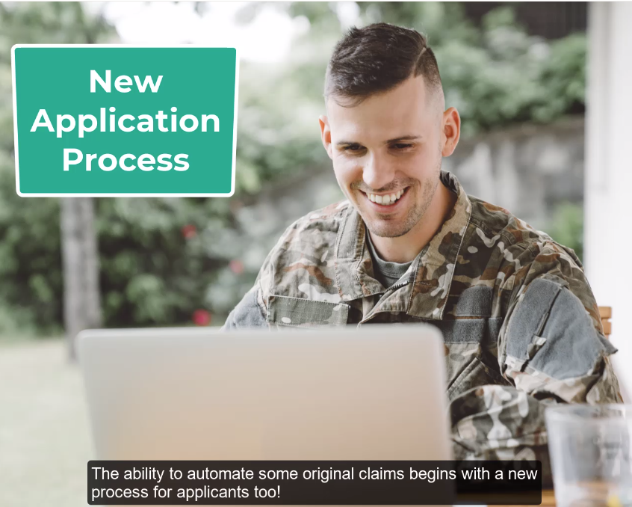 | The ability to automate some original claims begins with a new process for applicants too!
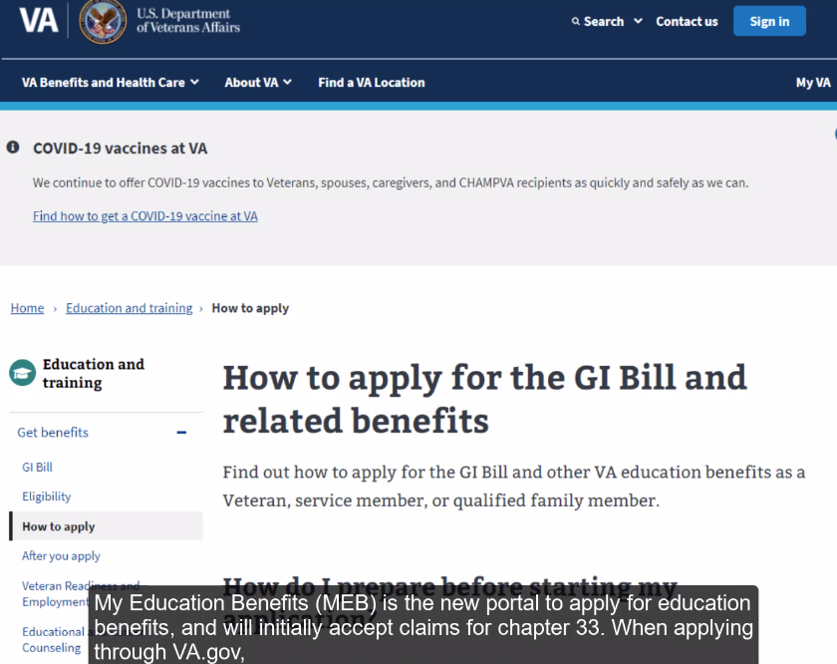 | My Education Benefits (MEB) is the new portal to apply for education benefits, and will initially accept claims for chapter 33. When applying though VA.gov, a username and password is requested to continue with an application. MEB introduces a more secure way to interact with VA by using ID.me, as a means for authentication.
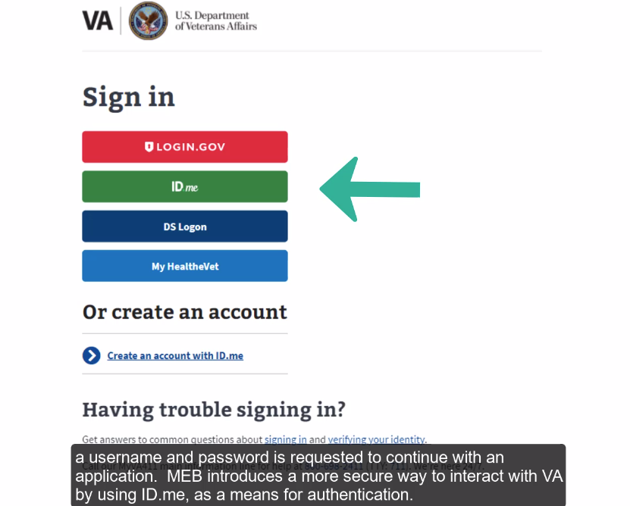 | When applying though VA.gov, a username and password is requested to continue with an application. MEB introduces a more secure way to interact with VA by using ID.me, as a means for authentication.
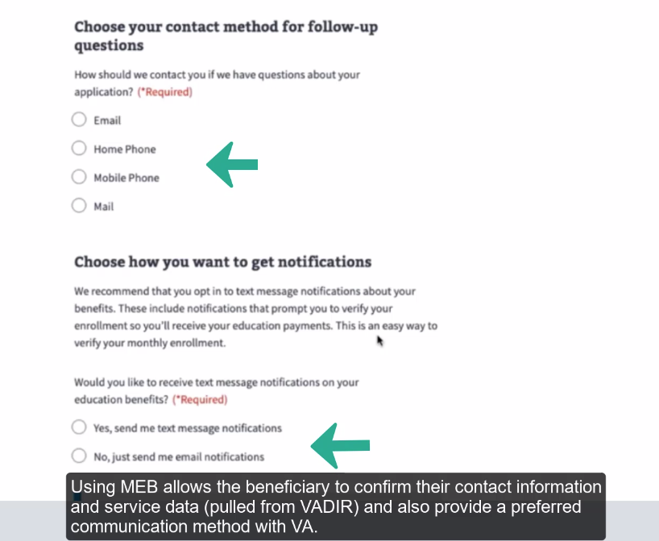 | Using MEB allows the beneficiary to confirm their contact information and service data (pulled from VADIR) and also provide a preferred communication method with VA.
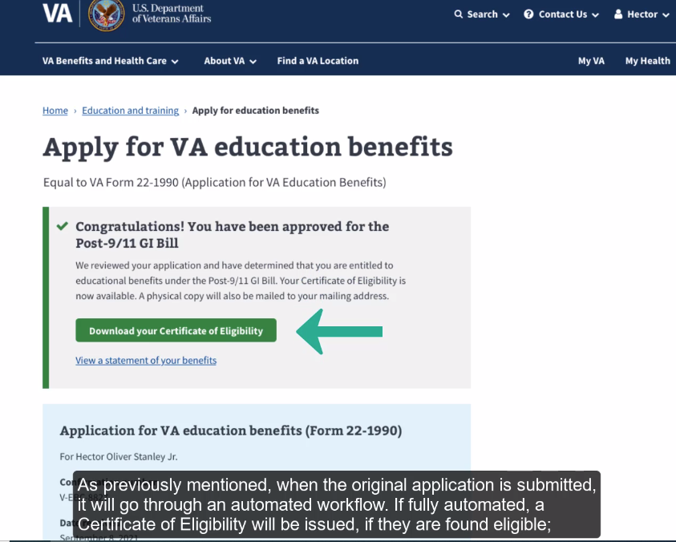 | As previously mentioned, when the original application is submitted, it will go through an automated workflow. If fully automated, a Certificate of Eligibility will be issued, if they are found eligible;
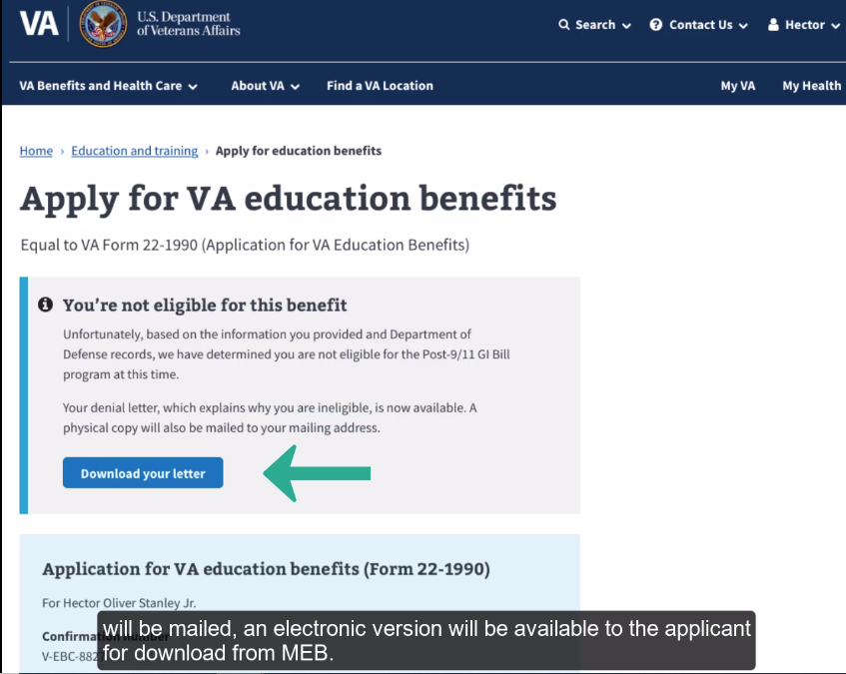 | Or a DIS-17 will be issued if they’re found ineligible. A hard copy of the decision letter will be mailed, an electronic version will be available to the applicant for download from MEB.
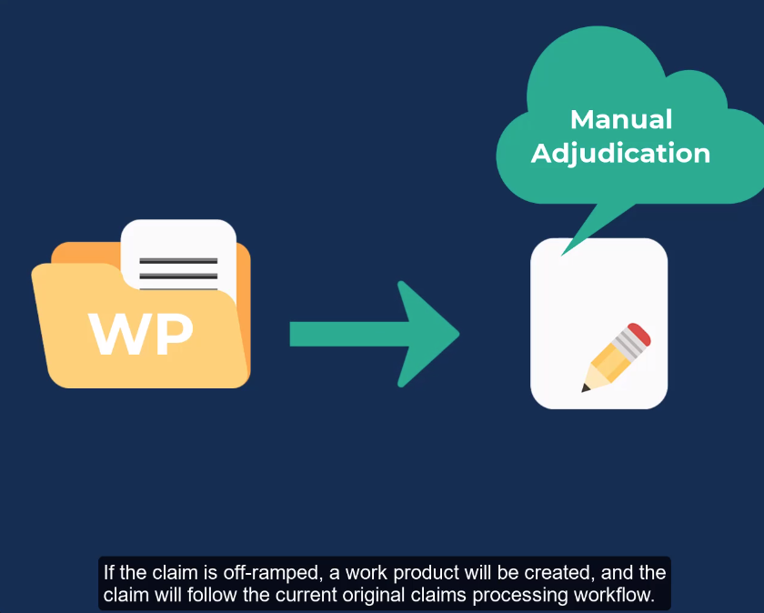 | If the claim is off-ramped, a work product will be created, and the claim will follow the current original claims processing workflow.
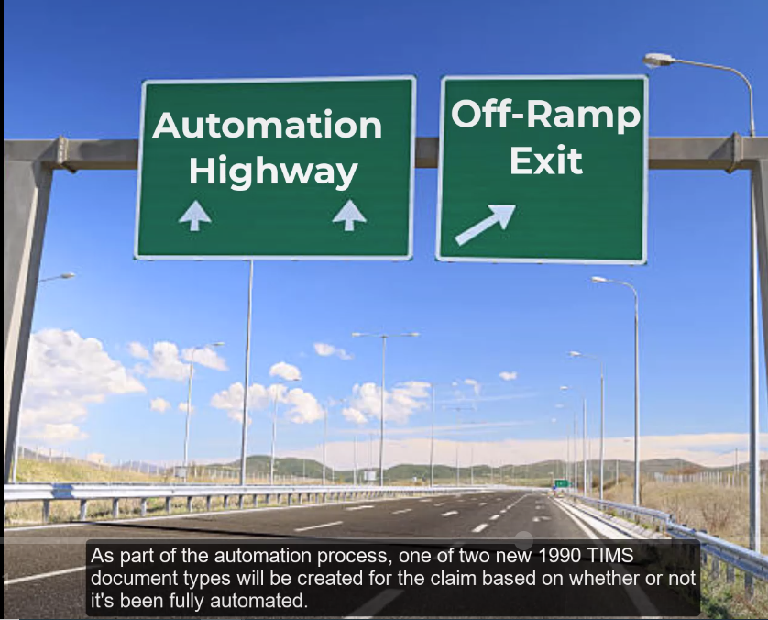 | As part of the automation process, one of the two new 1990 TIMS document types will be created for the claim based on whether or not its been fully automated.
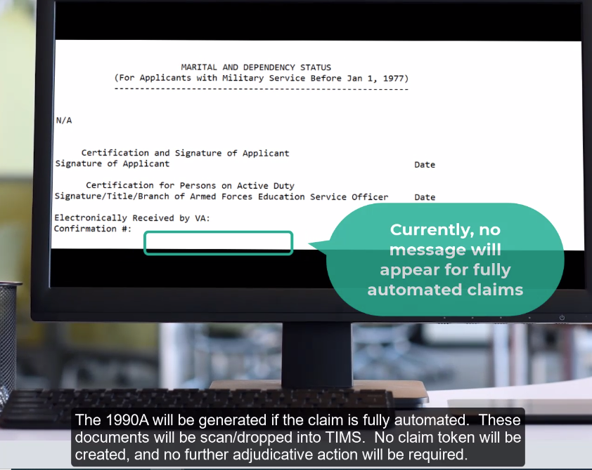 | The 1990A will be generated if the claim is fully automated. These documents will be scan/dropped into TIMS. No claim token will be created, and no further adjudicative action will be required.
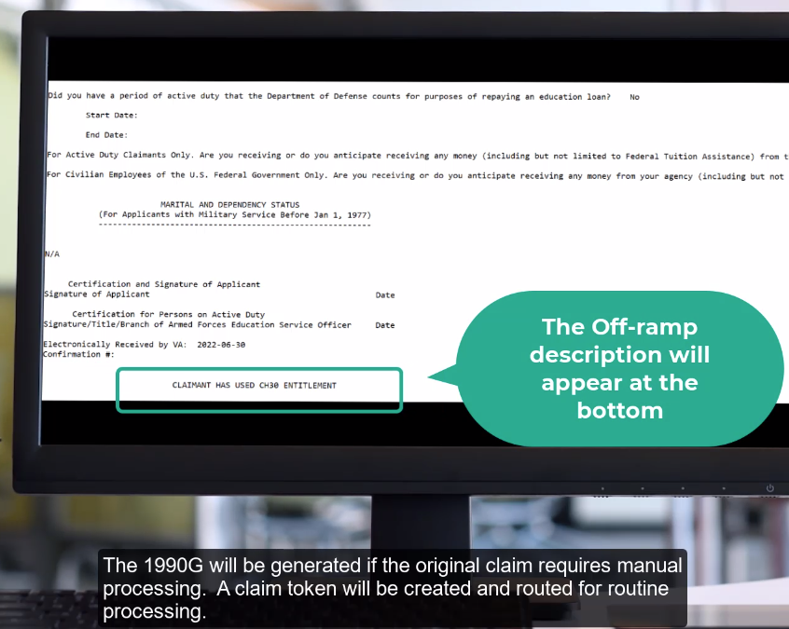 | The 1990G will be generated if the original claim requires manual processing. A claim token will be created and routed for routine processing.
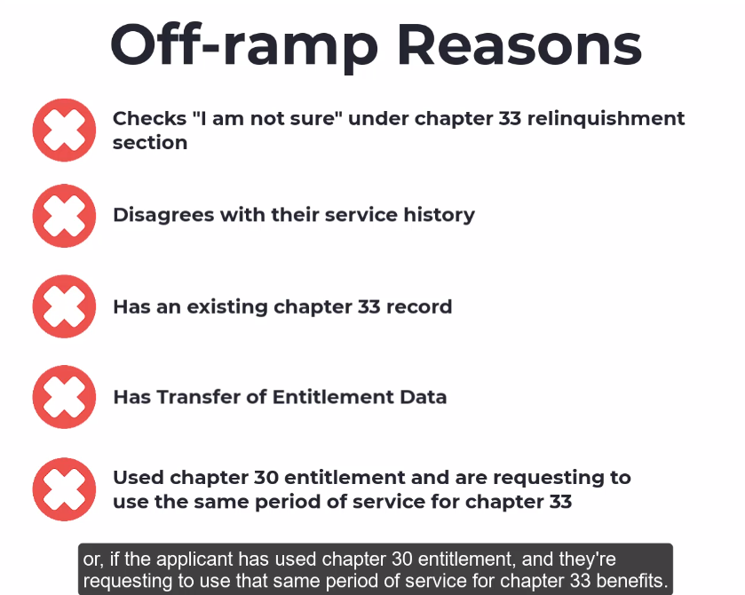 | Some of the off-ramp reasons which will create a 1990G include,  - if the applicant checks: “I’m not sure” under chapter 33 relinquishment section  - if the applicant disagrees with their service history, has an existing chapter 33 record  - has transfer of entitlement data  - if the applicant has used chapter 30 entitlement, and they’re requesting to use that same period of service for chapter 33 benefits.
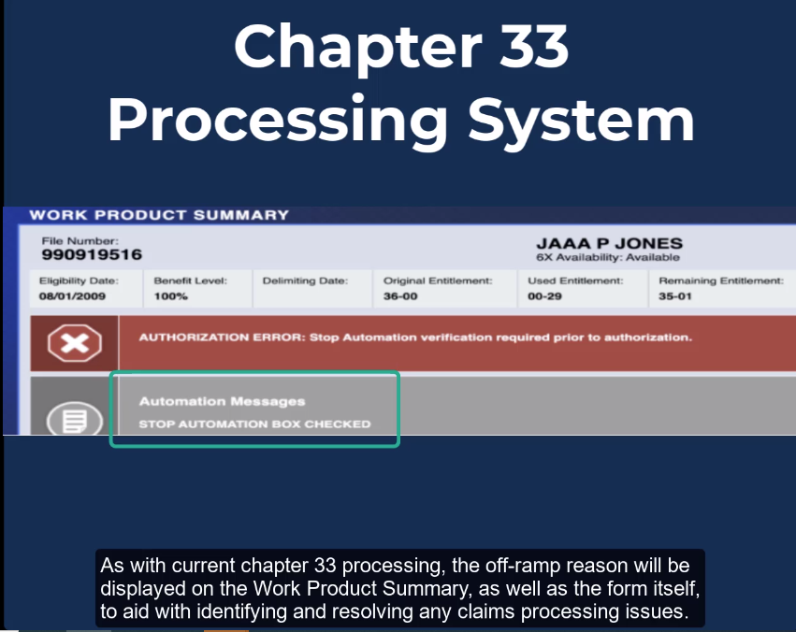 | As with current chapter 33 processing, the off-ramp reason will be displayed on the Work Product Summary, as well as the form itself, to aid with identifying and resolving any claims processing issues.
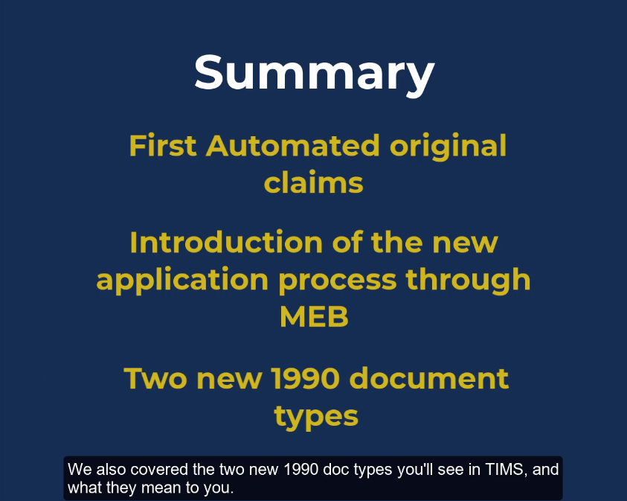 | This concludes today’s training. Thank you for joining, as we walked through expectations for the first automated originals for DGI, and the introduction of the application process through My Education Benefits (MEB), we also covered the two new 1990 doc types you’ll see in TIMS, and what they mean to you.
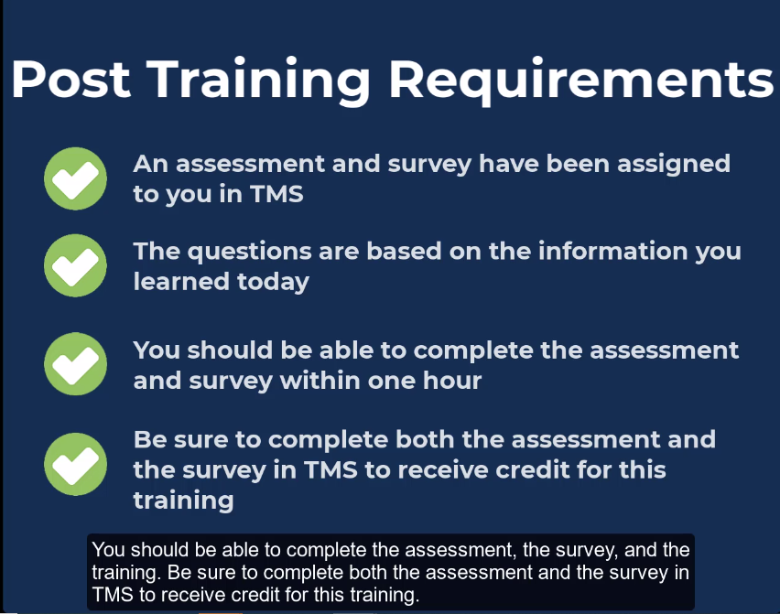 | The assessment and survey have been assigned to you in TMS. The assessment is comprised of scenario based questions based on the information that you learned today. You should be able to complete the assessment, the survey, and the training. Be sure to complete both the assessment and the survey in TMS to receive credit for this training.
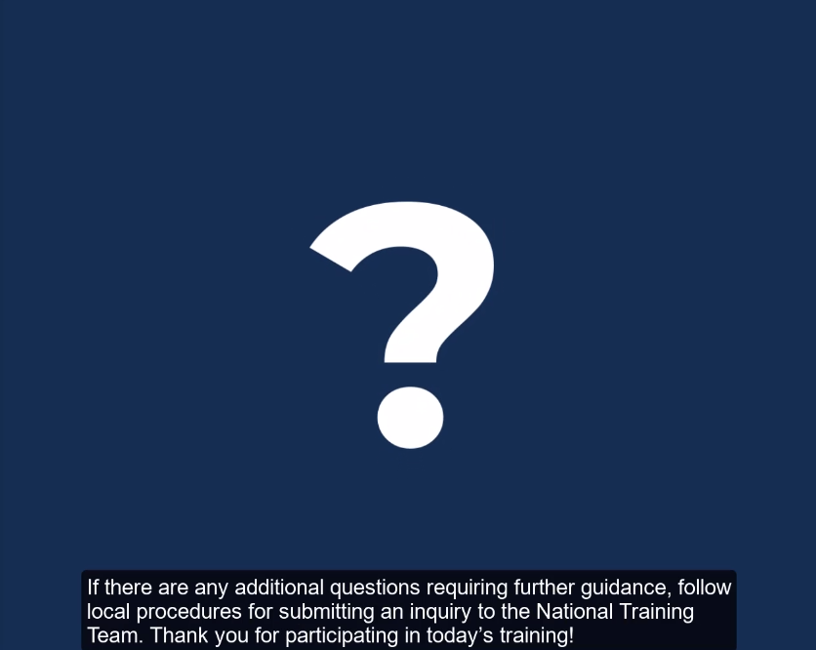 | If there are any additional questions requiring further guidance, follow local procedures for submitting an inquiry to the National Training Team.
 | Thank you for participating in today’s training!

