Education Service
The Tuition Fairness and REMOTE Act
Overview Training
February 2022
Version 1.0

Lesson Overview
Topic | Description
Time Estimate: | 30 minutes
Purpose of the Lesson: | Provides an overview of provisions of the Tuition Fairness Act Public Law 117-68 and the REMOTE Act Public Law 117-76. Recognizes the impact of these Public Laws on education benefits.
Prerequisite Training Requirements: | N/A
Target Audience: | Education Veterans Claims Processors (VCEs), Senior VCEs, Lead VCEs, and Education Quality & Training Specialist (EQTS).
Lesson References: | PL 117-68 (Col. John M. McHugh Tuition Fairness for Survivors Act of 2021)  PL 117-76 (Responsible Education Mitigating Options and Technical Extensions Act of 2021)
Lesson Objectives: | - Understand the provisions of Public Law 117-68, Colonel John M. McHugh Tuition Fairness for Survivors Act of 2021(the Tuition Fairness Act).  - Understand the provisions of Public Law 117-76, Responsible Education Mitigating Options and Technical Extension Act (the REMOTE Act).  - Recognize the impact of Public Laws 117-68 and 117-76 on education benefits.
Post Training Requirements: | Upon completion of the classroom portion of the lesson, participants are required to complete an online lesson assessment and survey in Talent Management System (TMS).  To demonstrate successful completion of the lesson, participants must pass the assessment with a score of at least 80%.  Participants must also complete the online survey to earn credit for completion of the lesson.

Slides | Instructor Script
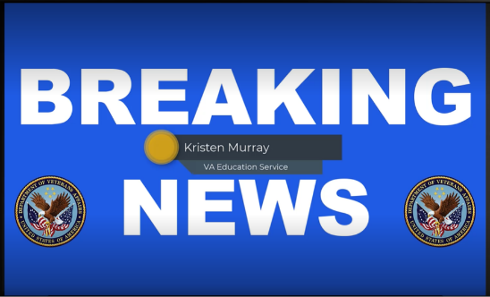  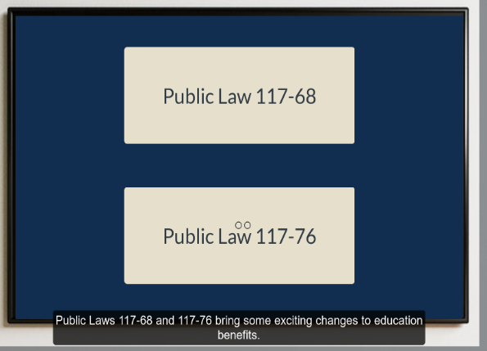 | Segment  Breaking News: (VA Reporter with “breaking news” banner or background and use bullets on the screen to highlight the two main points: “Public Law 117-68 the Colonel John M McHugh Tuition Fairness for Survivors Act of 2021” & “Public Law 117-76 the Responsible Education Mitigating Options and Technical Extension” newsroom)  Hello, we interrupt your regularly scheduled programming to bring you a special, breaking news report, from Education Service. Public Laws 117-68 and 117-76 bring about some exciting changes to education benefits.
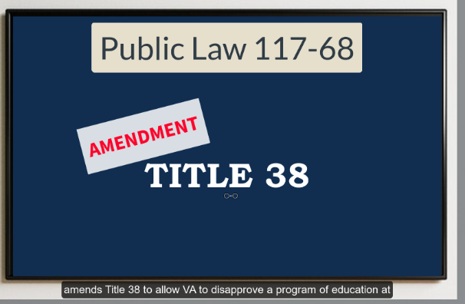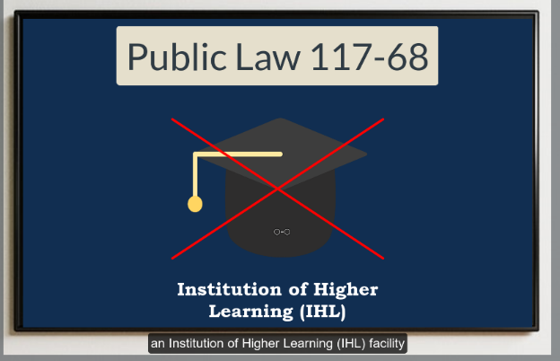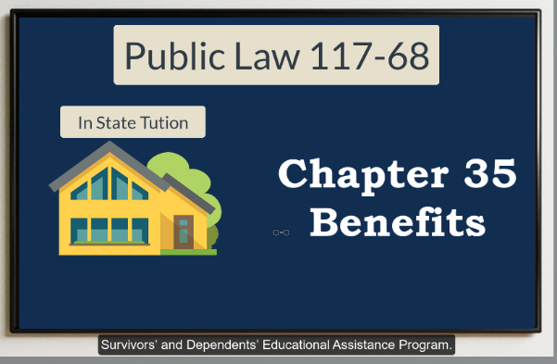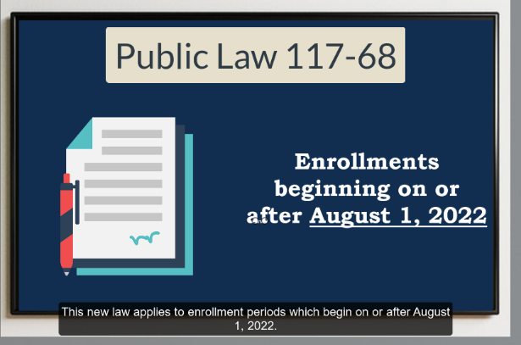 | Segment  Breaking News: (VA Reporter with “breaking news” could we move the screen as if the Anchor was changing to a different “camera view” for this next segment. Banner or background and use bullets on the screen to highlight the main point: “Public Law 117-68 the Colonel John M McHugh Tuition Fairness for Survivors Act of 2021” & “bullet points” newsroom)  Public Law 117-68, the Colonel John M. McHugh Tuition Fairness for Survivors Act of 2021, amends Title 38 to allow VA to disapprove a program of education at an Institute of Higher Learning (IHL) facility if the IHL facility does not charge in-state tuition rates for those using chapter 35, Survivors’ and Dependents’ Educational Assistance Program.  This new law applies to enrollment periods which begin on or after August 1, 2022.
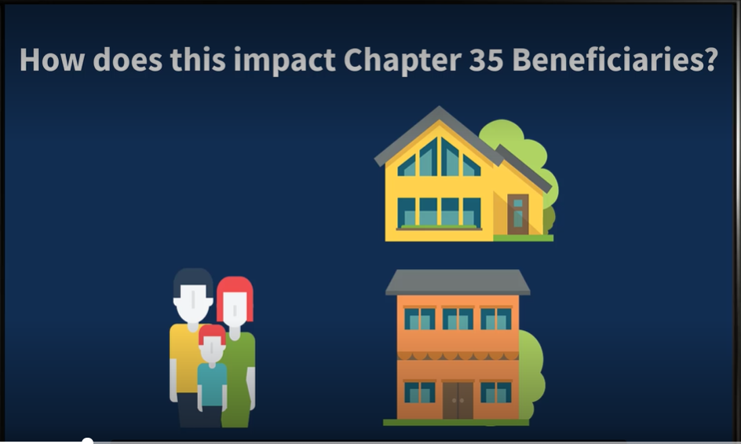  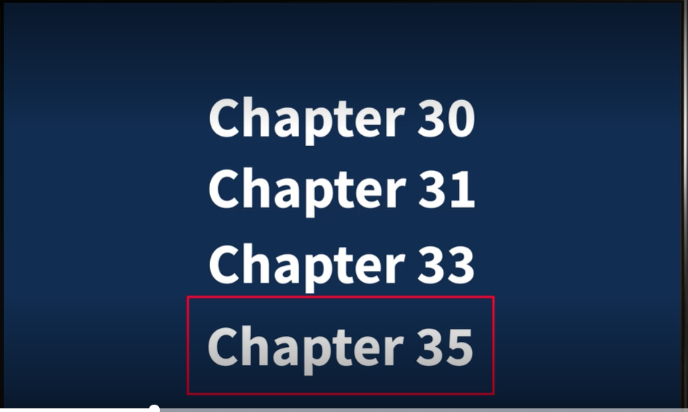 | Segment  Breaking News: (VA Reporter with “breaking news”. Banner or background and use bullets on the screen to highlight: “the Tuition Fairness Act of 2021” “Images Examples In-State Tuition on the screen”)  I’m sure you are asking, how does this impact chapter 35 beneficiaries? As we know, military families move frequently, which may impact their ability to meet in-state tuition residency requirements. Previously passed legislation removed residency requirements for beneficiaries in receipt of chapter 30, 31, and 33 benefits. The Tuition Fairness Act extends the same protections under the law to beneficiaries in receipt of chapter 35 benefits
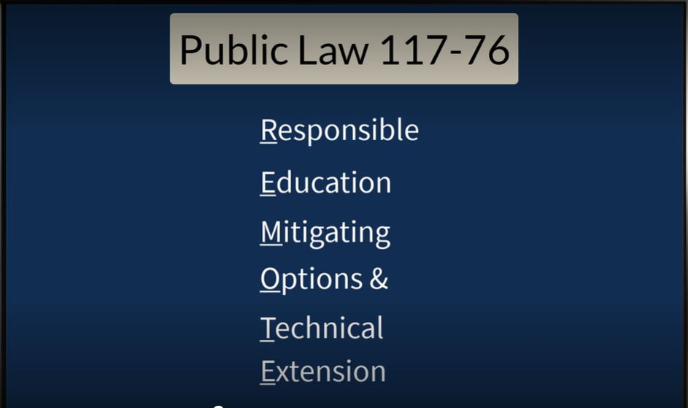 | Segment  Breaking News: (VA Reporter with “breaking news” could we move the screen if the Anchor was changing to a different “camera view” for this next segment. Banner or background and use bullets on the screen to highlight the main points: “Public Law 117-76 the responsible education mitigating options and technical extension Act (REMOTE Act)” & “bullet points” any image examples that would help explain)  Public Law 117-76, the Responsible Education Mitigating Options and Technical Extension or the REMOTE Act also provides expanded protections under the law. There are four specific provisions or sections in the REMOTE Act which impact education beneficiaries. Let’s take a closer look at each of these four sections.
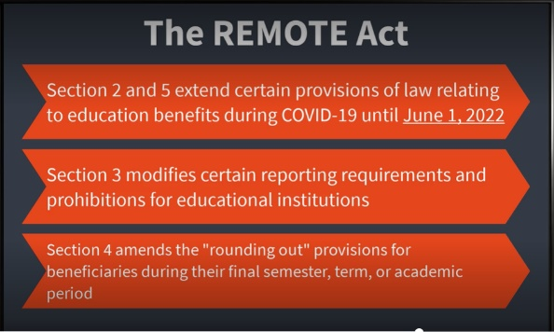  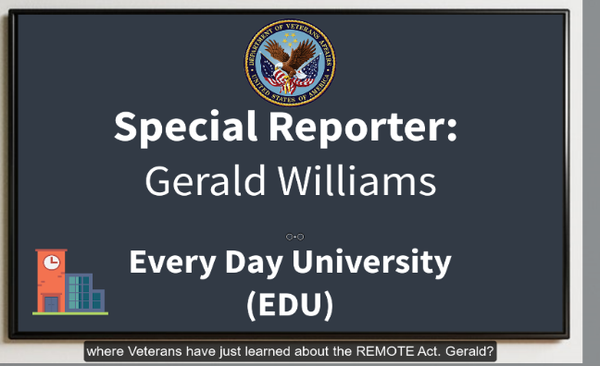 | Segment 5.  Breaking News: (VA Reporter with “breaking news”. Banner or background and use bullets on the screen to highlight the main point: “the Remote Act” & bullets of the sections” & transition background while speaking to a different screen giving smaller tidbits of section 2-5 as they are spoken about for the purposed of (June 1, 2022))  Section 2 and 5 extend certain provisions of the law aimed at providing relief to beneficiaries impacted by the COVID-19 pandemic until June 1, 2022. These include payment at the in-resident housing rate for online training, delimiting date extensions and no charge to entitlement for certain beneficiaries who were unable to continue training due to the pandemic.  Section 3 modifies certain requirements for educational institutions relating to enrollment verification and exempts foreign schools from certain prohibitions.  Lastly, section 4 allows beneficiaries to “round out” to enroll in, and VA pay for, additional courses not required for graduation during their final semester, term or academic period.  Now to our special reporter, Mr. Gerald Williams, who is live on the campus of Every Day University (EDU) where Veterans have just learned about the REMOTE Act. Gerald….
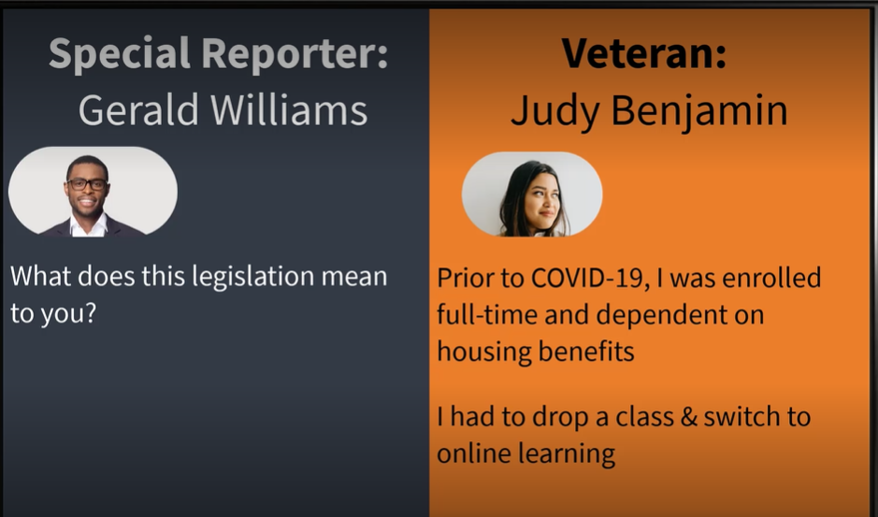  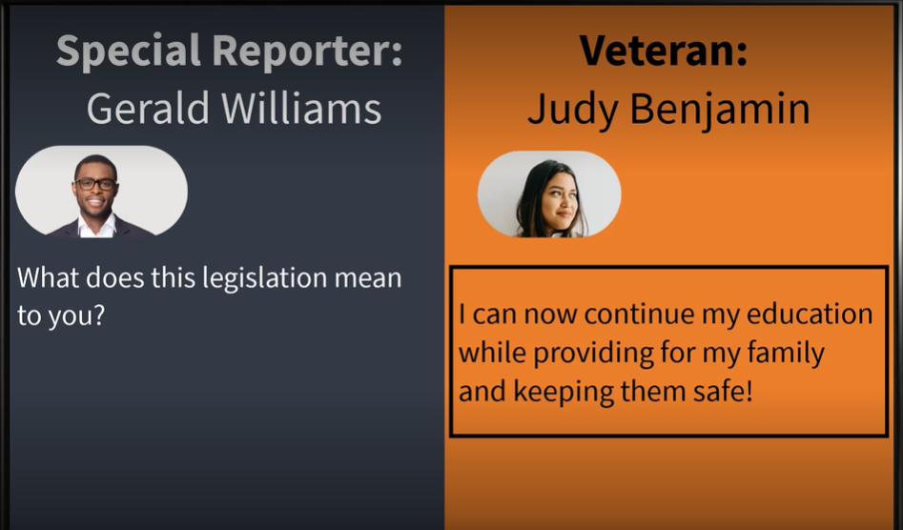 | Segment 6.  Field Reporter: (VA Field Reporter out interviewing a directly impacted veteran. Screen moves between interviewer and interviewee)  Newscaster Gerald Williams: Thank You and hello. I am here with Judy Benjamin, a Veteran who is receiving education benefits for her enrollment at Every Day University. Judy, can you tell us what this recently passed legislation means to you?  Judy Benjamin: I’m just so glad to hear the REMOTE Act passed. Prior to the pandemic, I was enrolled full-time and depended on my housing benefits. As a result of the pandemic, I had to drop a class and switch to online learning. I was worried this would impact my housing. This law allows me to continue my education through virtual learning while also providing for my family and keeping them safe.  Newscaster Gerald Williams: Thank you Ms. Benjamin, you heard it here first folks. We are directly impacting and helping protect those who have protected us. Back to you in the newsroom, Kristen!
   | Segment 7.  Breaking News: (VA Reporter back to the newsroom and the Original Slide showing 117-68 and 117-76)  Thank You Gerald, it’s great to hear how new laws are making a difference in the lives of deserving Veterans.  This has been your breaking news report from Education Service. Stay tuned for additional information on the Tuition Fairness and REMOTE Acts. I’m Kristen Murray. Now back to your regularly scheduled programming.

