Education Service
Two Certification Processing
Lesson Plan
February 2022
Version 1.0

Lesson Overview
Topic | Description
Time Estimate: | 30 minutes
Purpose of the Lesson: | Provides on overview of the two certifications required by Public Law 116-315, section 1010, the various methods used by the school to meet the two certification requirement and how to process the unchanged amendments.
Prerequisite Training Requirements: | N/A
Target Audience: | Education Veterans Claims Processors (VCEs), Senior VCEs, Lead VCEs, and Education Quality & Training Specialist (EQTS).
Lesson References: | - M22-4, Part 12, Chapter 11, Subchapter 1
Lesson Objectives: | - Understand school certification requirements set forth by section 1010 of PL 116-315  - Understand the methods used by the school to meet the two certification requirement  - Recognize how to correctly identify and process unchanged amendments
Post Training Requirements: | Upon completion of the classroom portion of the lesson, participants are required to complete an online lesson assessment and survey in Talent Management System (TMS).  To demonstrate successful completion of the lesson, participants must pass the assessment with a score of at least 80%.  Participants must also complete the online survey to earn credit for completion of the lesson.

Slides | Instructor Script
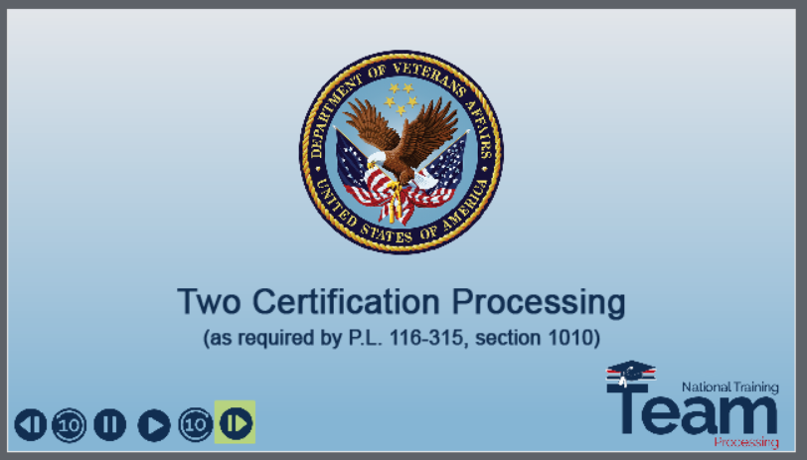 | DISPLAY slide  Today’s training offers an overview of chapter 33 processing guidance for the two certification process, which is required by section 1010 of public law 116-315.
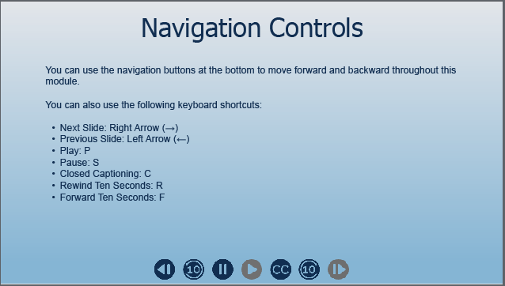 | DISPLAY slide  You may use the navigation buttons at the bottom of the screen or the keyboard shortcuts listed on the screen to move forward and backward throughout the module.
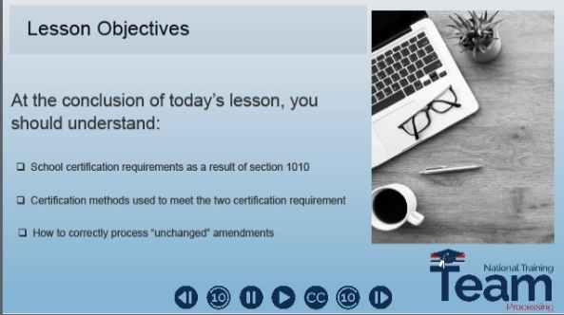 | DISPLAY slide  At the end of this lesson, you should understand the school certification requirement established under section 1010, the various methods the school can use to meet this two-certification requirement and how to correctly process an “unchanged” amendment.
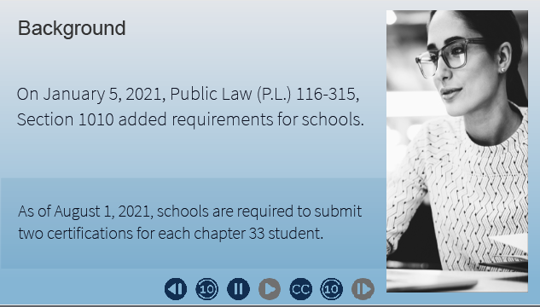 | DISPLAY slide  Section 1010 of Public Law (P.L.) 116-315, added a new enrollment verification requirement for both schools and beneficiaries using the Post-9/11 GI Bill or chapter 33.  Schools are required to submit two certifications for each chapter 33 NCD or IHL enrollment period. The second certification must be submitted after the school’s drop-add period.  This training will provide guidance for processing these certifications.
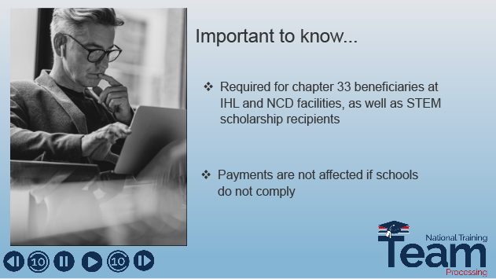 | DISPLAY slide  Some important things to note:  - Section 1010 only affects chapter 33 beneficiaries at NCD or IHL facilities and those using the STEM scholarship  - Payments are not affected if the schools do not send the second certifications
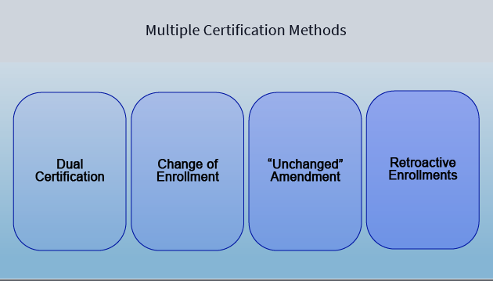 | DISPLAY slide  There are several ways the school can meet the two certification requirement. Click on each to see a description of the method and how each method may be reported.
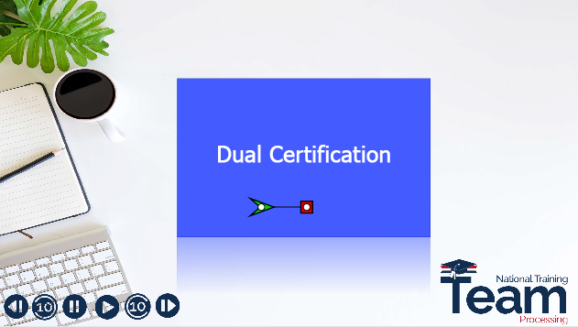 | DISPLAY slide  Dual certification is the practice used by the school to submit the initial enrollment certification without tuition and fees. Then, after the drop-add period, amends the certification to add the tuition and fees.  Following this common process satisfies the two certification requirement.
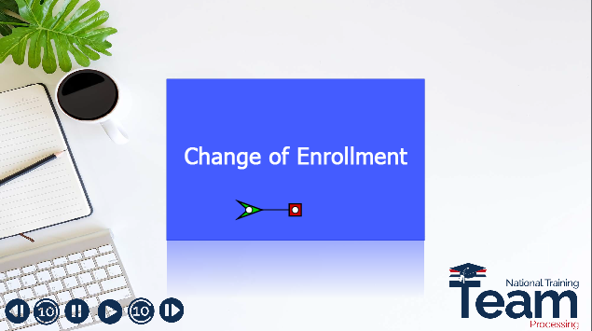 | DISPLAY slide  When a beneficiary makes changes to their enrollment, the process of certifying the adjustment has not changed under the two certification requirement.  Length of enrollment is not a factor. A second certification is still required when an enrollment is less than 30 days in length.  Any change submitted after the drop-add period will satisfy the two certification requirement. This includes the school’s report of “Graduation” or "End of Term or Course".
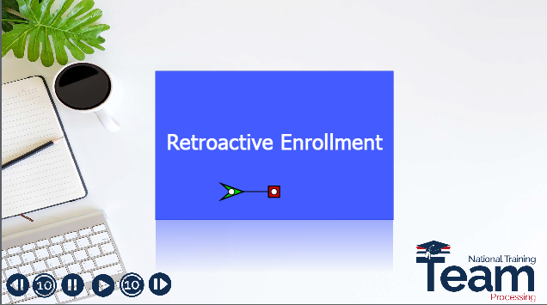 | DISPLAY slide  It’s important to understand the second certification is still required even when a completed term is reported. A retroactive enrollment will be followed by an amended certification reflecting no change.  Current procedures remain for processing amended certifications.
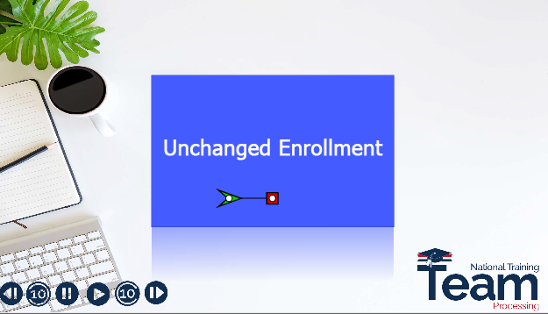 | DISPLAY slide  Similarly the second certification is still required when there are no changes to be reported. An enrollment will be followed by an amended certification reflecting no changes. Current procedures remain for processing amended certifications.  The second certification requirement applies whether schools submit using paper or VA-ONCE.  Now let’s take a look at processing.
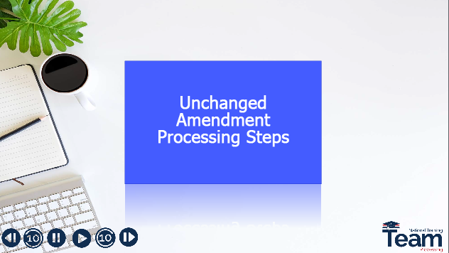 | DISPLAY slide  When an “unchanged” amendment is received, it should not be deemed as no action necessary, or NAN. Open a work product in the Chapter 33 Processing system. Verify no changes were made. Authorize the work product with automatic payments and allow the system generated letter or letters to be released. Clear and capture the appropriate supplemental end product to the electronic claims folder.
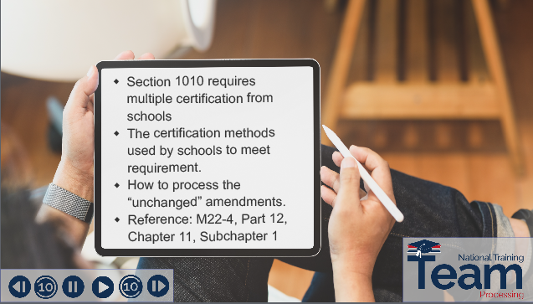 | DISPLAY slide  Today, we covered the two certification requirement under section 1010, the methods used by schools to meet this requirement, and how to process the unchanged amendments. The references used for today’s presentation can be found in the M22-4, Part 12, Chapter 11, Subchapter 1.
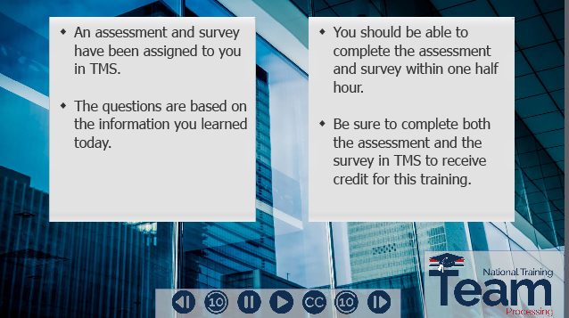 | DISPLAY slide  The assessment and survey have been assigned to you in TMS. The assessment is comprised of scenario-based questions and is based on the information you learned today.  You should be able to complete the training, assessment and survey within 30 minutes. Be sure to complete both the assessment and the survey to receive credit in TMS for this training.
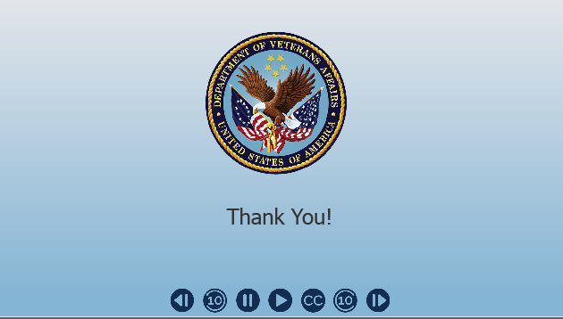 | DISPLAY slide  Thank you for your time and attention today.

