Detailed Issue Form
Video Script | 11.17.2021
Target Audience:
Channel:
Script timer: (length) (date)

VOICE OVER & MUSIC | IMAGERY, TITLES, etc.
Hello and welcome to today’s training on the Detailed Issue Form, (or DIF). | Training Video Title: Detailed Issue Form  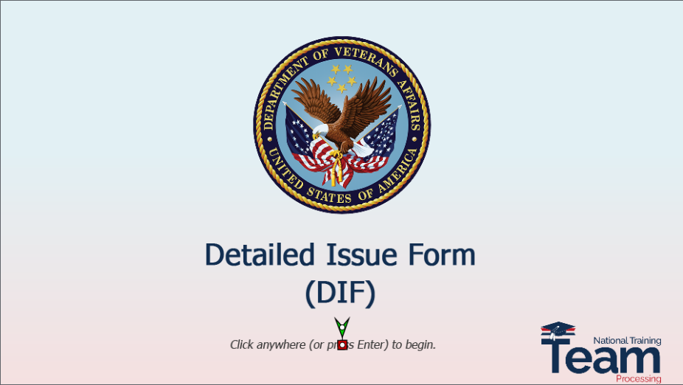
You can use the navigation buttons at the bottom of the screen to move forward and backward throughout this module. Also, you may use the keyboard shortcuts that are shown on the screen. | Header: Navigation Controls  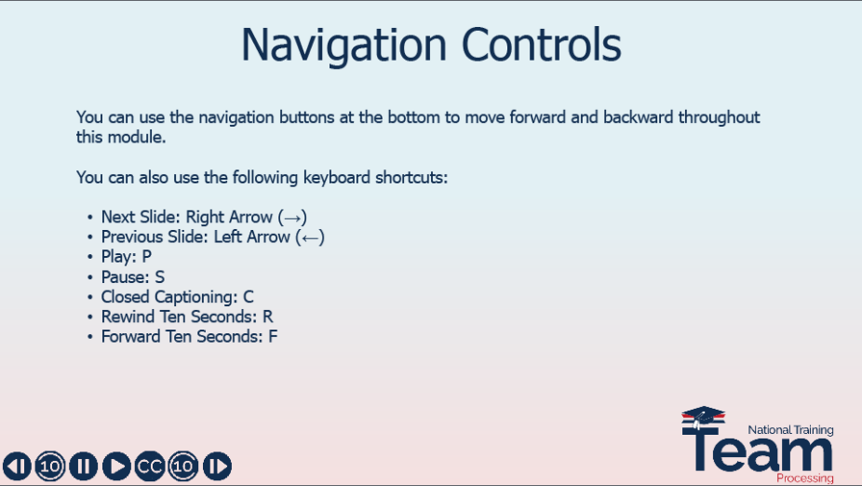
This training is expected to answer the questions you may have about a DIF, such as, What is it? When is it necessary? And how do I complete it? We will start by discussing our objectives, then provide a brief background of the DIF and its purpose. Then, we’ll discuss when it’s necessary to complete the form before providing a short demo including capturing an image. Let’s get started. | Header: Overview  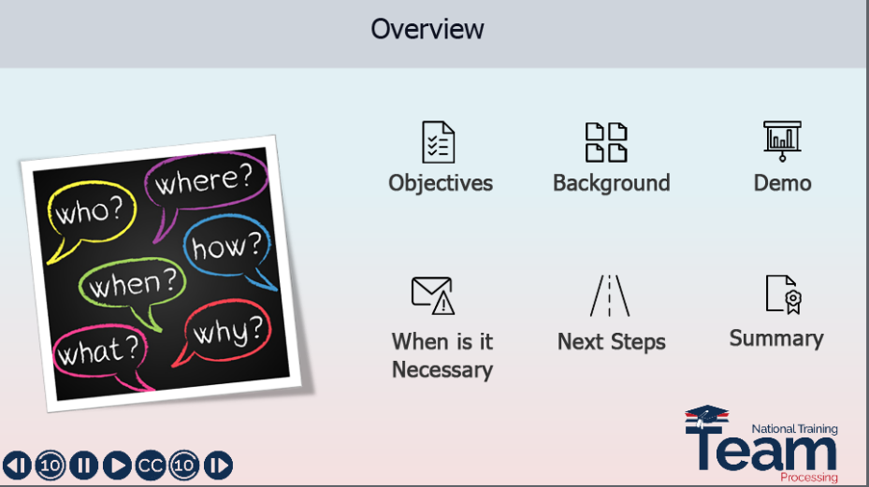
An abbreviations and acronyms slide has been provided for your reference. Also, the link provided on the slide is a direct link to the VA Acronym Lookup tool for some of the most common VA acronyms. What a great tool! | Header: Abbreviations & Acronyms  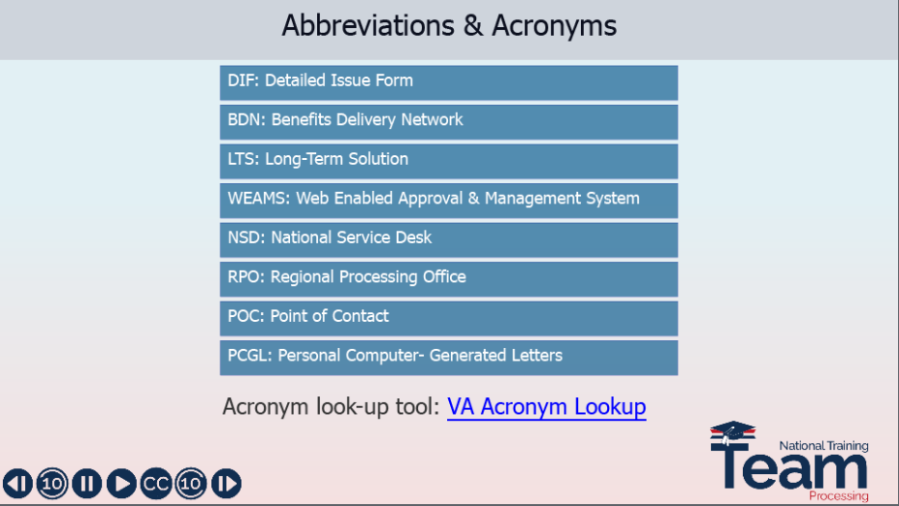
At the conclusion of today’s lesson, you should understand:  - The purpose of the DIF  - When a DIF is necessary  - How to properly complete and submit the DIF | Header: Objectives  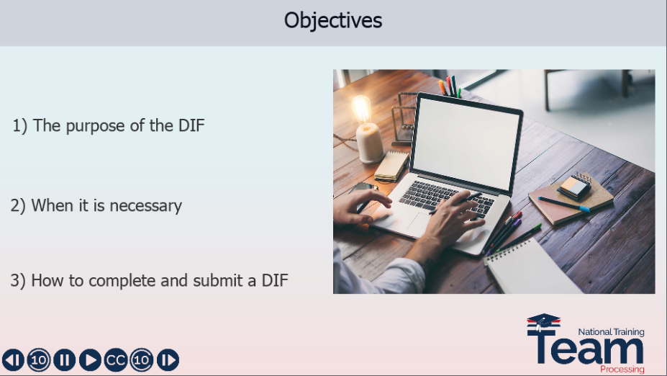
Have you ever had one of these moments when you encounter a problem while processing a claim and wonder, what am I supposed to do next? In many instances, you would contact the National Service Desk, although in this situation he might need to call the fire department!  Computer problems and errors may be encountered with any one of the many applications we use for claims processing. It is important to report system errors as soon as possible. This training is designed to familiarize you with the process of submitting a DIF when you encounter system issues. | Header: System Errors  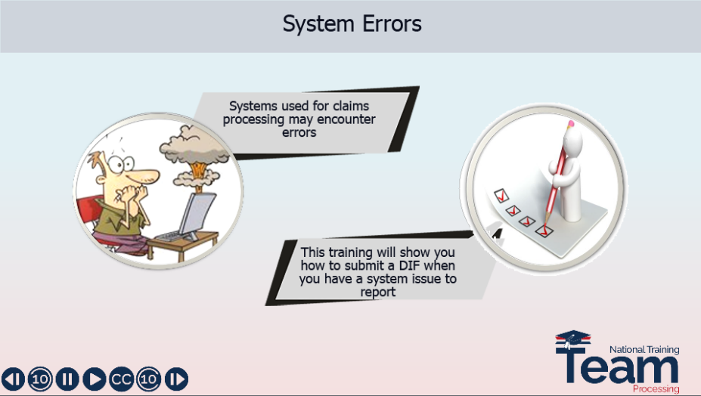
Immediately reporting issues will allow troubleshooting to begin to determine the extent of the issue. Some issues may be limited to a small number of claims and maybe resolved quickly. Other issues may have a more widespread impact and could potentially result in errors or a miscalculation of payments. The key is to immediately report issues in order to minimize the potential negative impact on beneficiaries and allow you to resume normal processing activities. | Header: Reporting Issues Quickly  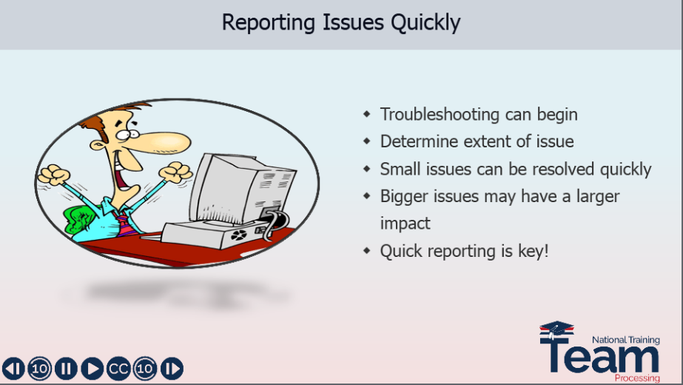
Let me provide a little background for you, the DIF was introduced when the Long-Term Solution, or LTS, was deployed for chapter 33 benefits. It’s the mechanism used to provide a report of any system related problems to the program developers and designers to assist them in identifying and correcting the problem as quickly and as efficiently as possible. There are instances when a DIF may be required for other system errors and issues, but most DIF issues involve errors within the LTS, which transitioned into a managed service. | Header: DIF Purpose  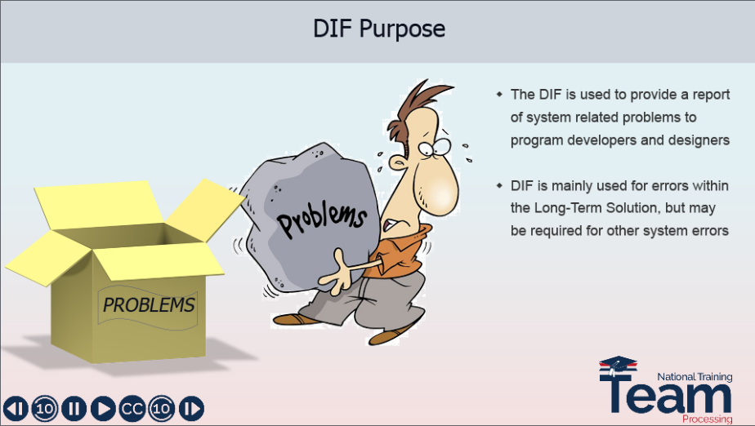
Let’s review some specific situations when the DIF is necessary and when it is not necessary.  If you have a system issue involving LTS (other than a nationwide outage or a social security number change), you will need to complete the DIF. As mentioned before and as you see here, there may be other instances when a DIF is requested or necessary. Later, we will discuss the process you should follow to complete the DIF when you have determined it is necessary. If you are unsure whether your issue requires a DIF, seek guidance from your senior or supervisor. | Header: When is it Necessary?  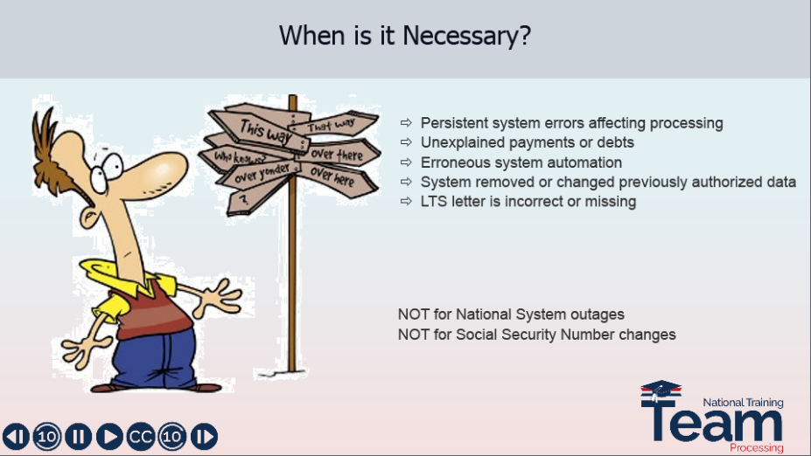
Next up is our demonstration. Remember, all names, identification numbers and claim numbers you see here are fictitious and do not belong to actual beneficiaries. No personally identifiable information, or PII, is contained in this training. | Header: Next up…  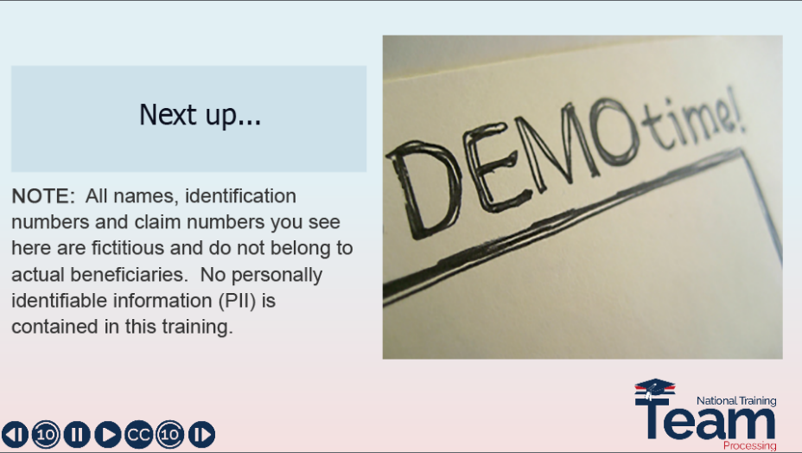
In our demo today, we will show how to properly complete the DIF. Typically, the DIF is completed by the RPO education employee who identifies the error in the system and is then submitted to the designated Regional Procession Office’s point of contact.  If you identified the error and are completing the form, you are the Originator and will enter your name in that section. You’ll notice the blue box for the originator name, then you’ll enter your RPO’s point of contact name and email address. Now this is the person who will submit the form for review. To finish completing the form, you will enter the date the issue was first identified. My issue has not been resolved, so I’ll leave this section blank.  Next, select the systems affected by the error. Select all systems which are impacted. For my issue, I’ve identified a problem which involved LTS and the text messaging system, so you can see I’ve selected “Other”, and entered the description of the other system involved as well as selected the LTS system. The Detailed Description of Incident section is a request for you to include the details of the issue. You should explain the summarized version of what the issue is and how you discovered it. For our demo today, I’ve included a detailed description. His term ended in September, but he received a text message asking if he was still enrolled in October. I have included an image of the text message document, after we explain the issue, we are asked to identify the claim. The first entry requests the Person Key Number. If you have never been asked to provide this before you may be unfamiliar with the term or where to find this information. Each person in LTS is assigned a person key number, this is a nine-digit number found at the end of the URL address within the work product history screen within the record of the beneficiary. If you are unfamiliar with what the URL address is, it is the address of the website and can be located at the top of the browser window. Now, at the end of this address within the beneficiary’s work product history screen you can locate the nine-digit person key. You will go ahead and enter that on your Detailed Issue Form and you will see I’ve entered 555123789. Our next field asks for the work product key. The work product key is also a nine-digit number located at the end of the URL address. However, this nine-digit number identifies the work product in which the error was found or created. This work product key can be found while in the affected work product in which the error was found. Now, you’ll notice I’ve entered the work product key here and it is 123456789. Next, you’ll notice it asks for the file number or social security number and you will enter that here. When describing the steps to reproduce, it’s important you be very detailed in your description and enter the exact steps you took which created the scenario where the error was found. Enter each detailed step and include any changes in information or screen data. This information is needed to recreate the issue in a test environment in order to troubleshoot the error so that a resolution may be tested. Now remember, when completing this section, be as specific and detailed as possible. You will notice I’ve entered a description here of how I came about this error. In the next section, you will answer yes or no questions. Does the error affect payment or entitlement? Mine did not, so I said No. Does it affect all claims? My scenario does not, so I said No. If no, which type of claims are affected? In my scenario, it’s unknown if this error is going to include all so I put “unknown”. If there are specific issues within your example, for instance, if it were a Fry child claim, you would want to include that information here. For the final section of the DIF, you are asked to provide screenshots if available. Here, you can use your snipping tool, or the latest version, the “Snip & Sketch” app to capture visual evidence into your Detailed Issue Form. | Header: Screenshot Demo  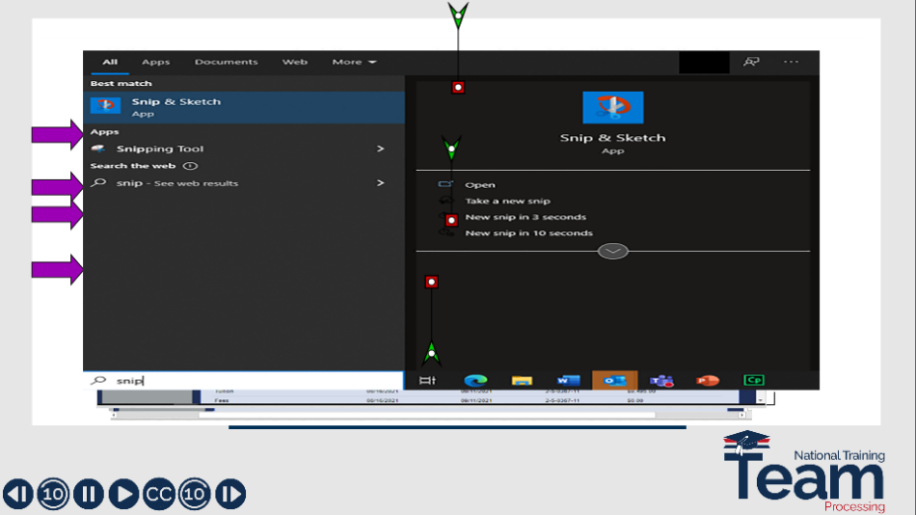
Once you have completed the DIF form, email it to the designated point of contact in your office. Suspend the claim in awaiting mail for 2 weeks pending a response. Remember, do not attempt any manual workarounds or other remediation without procedural guidance. | Header: Next Steps  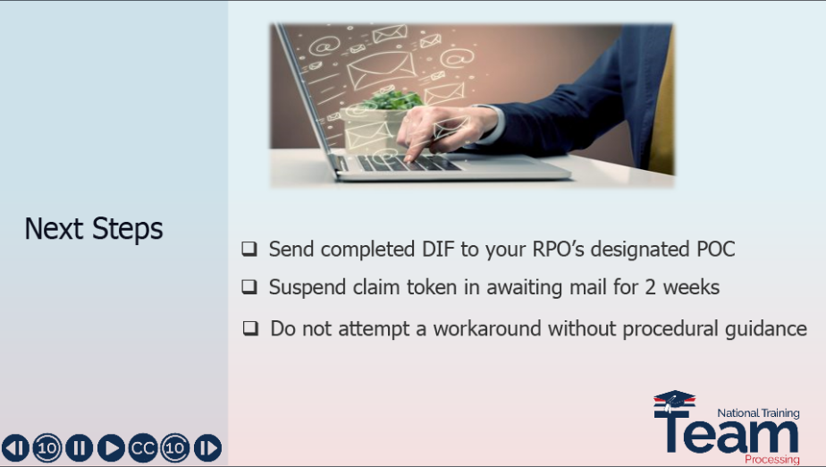
It’s that time again, it’s time for a knowledge check, let’s see what you’ve learned.  Which of the following would NOT require a DIF?  - BDN is generating incorrect payments  - LTS displays a persistent error  - National LTS outage  - LTS social security number change  The correct answer is D. The RPOs should not submit DIFs for requests to change the SSN in LTS. Please follow your current procedural guidance for these necessary updates. | Header: Knowledge Check  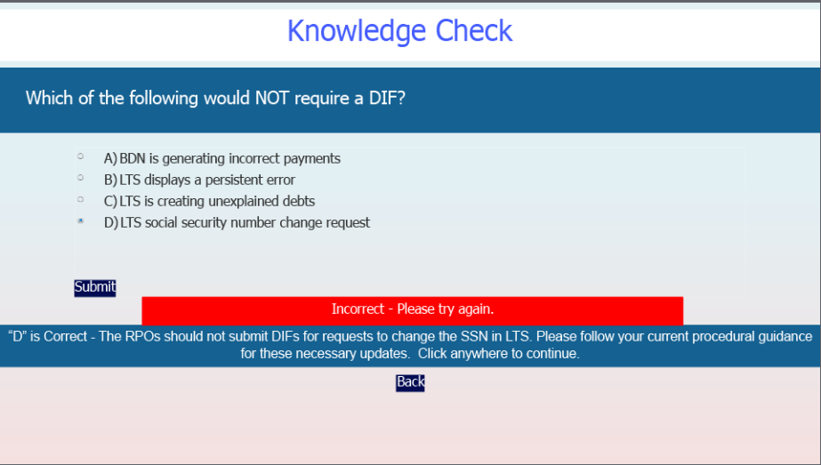
Okay, let’s try another knowledge check question.  The claim you are working has unexplained payments and debts showing up on the Work Product Summary. You were advised to complete a DIF. While completing the form, you are asked for the Work Product Key. Where can you find the Work Product Key?  - On the LTS BIO screen  - In the URL address of the Work Product with error  - It is the same as the file number  - On the Work Product History screen  The correct answer is B. You can find this nine-digit number at the end of the URL address on any screen within the Work Product in which the error was found. | Header: Knowledge Check  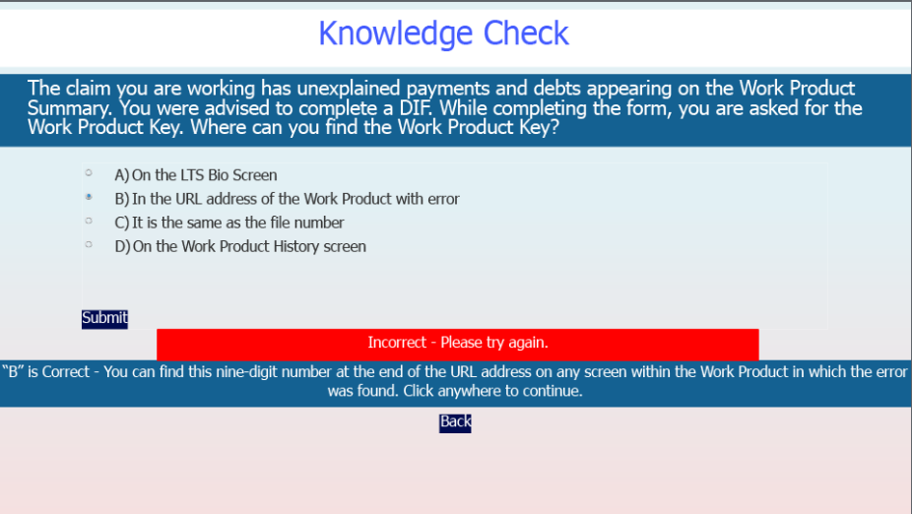
Okay, it is time for the final knowledge check. Are you ready?  The same claim needing the DIF will require you to capture an image of the error you have found. What is the name of the application you can use to capture this image?  - Snip & Sketch  - Snatch & Grab  - Snip & Clip  - Snippet & Forget It  The correct answer is A. Snip & Sketch is the latest version of the snipping tool we can use to capture images from programs, websites, and documents. | Header: Knowledge Check  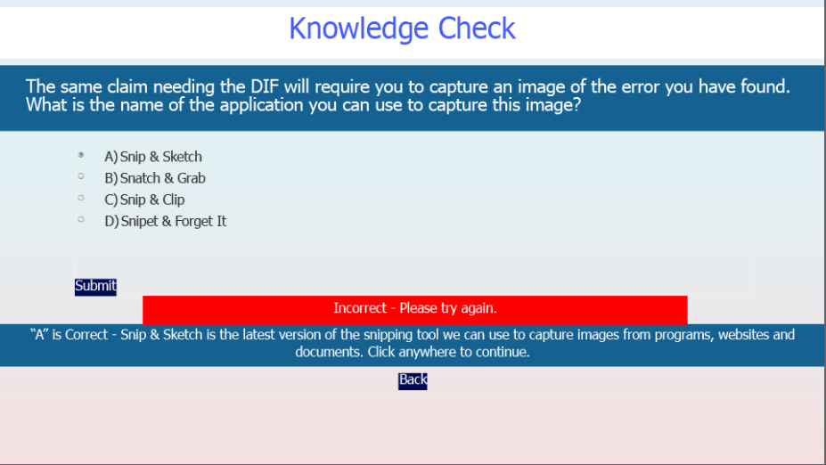
This concludes our presentation on the Detailed Issue Form. With the information you were provided today, you now should better understand:  - The purpose of the DIF  - When it is necessary  You should also be more confident in how to properly report issues using the DIF, the steps to submit a DIF, and what to expect next.  The reference used for this presentation is linked here, as well. | Header: Summary  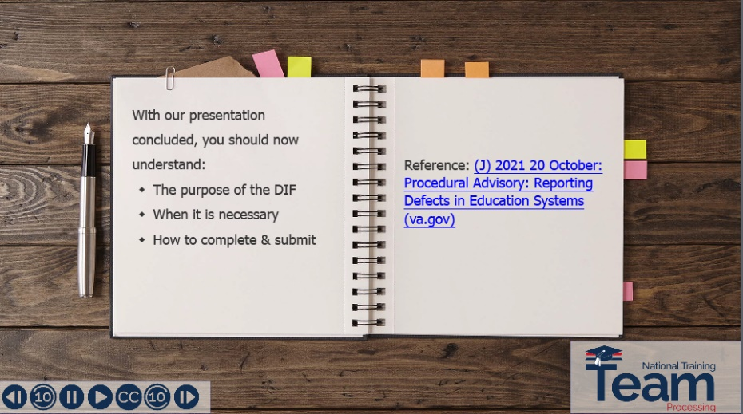
- The assessment and survey have been assigned to you in TMS.  - The assessment is comprised of scenario-based questions.  - The questions are based on the information you learned today.  - You should be able to complete the assessment and survey within 30 minutes.  - Be sure to complete both the assessment and the survey in TMS to receive credit for this training | Header: TMS Assessment and Survey  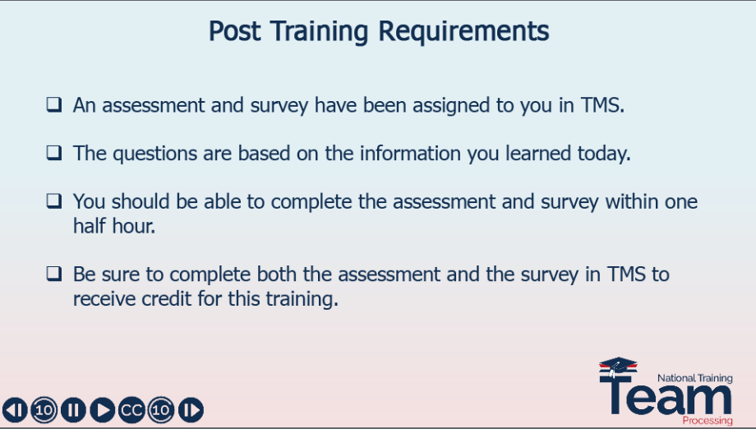
Thank you for your time and attention. This concludes the presentation. Enjoy the rest of your day! | Header: Thank You!  

