Education Service
Public Law (PL) 116-315, Section 1008
Lesson Plan
June 2021
Version 1.0

Lesson Overview
Topic | Description
Time Estimate: | 30 minutes
Purpose of the Lesson: | The intent of this training is to inform the audience of the changes resulting from the law, how to implement the legislation and how these implementations will impact education processing.
Prerequisite Training Requirements: | None
Target Audience: | Education claims processors, to include VCEs, Sr. VCEs, Lead, EQTS and ECMs
Lesson References: | - PL 116-315, Section 1008  - M22-4 Part 4, Ch 1.14
Lesson Objectives: | The information being shared with you will cover section 1008 of Public Law (PL) 116-315, including how to implement the legislation. At the end of the lesson, the learner should understand how to process impacted claims.
What You Need: | N/A
Post Training Requirements: | Upon completion of the classroom portion of the lesson, participants are required to complete an online lesson assessment and survey in Talent Management System (TMS).  To demonstrate successful completion of the lesson participants must pass the assessment with a score of at least 100%.  Participants must also complete the online survey to earn credit for completion of the lesson.

Instructor Notes

PowerPoint Slides | Instructor Activities
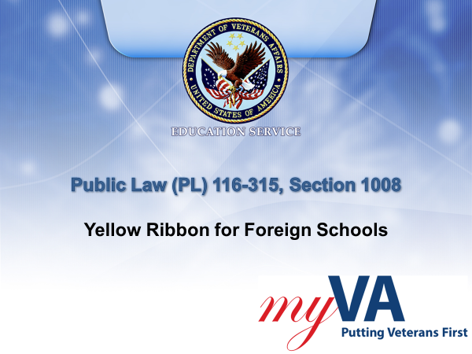 | DISPLAY slide  Welcome to today’s training covering section 1008 of Public Law 116-315, the Johnny Isakson and David P. Roe, M.D. Veterans Health Care and Benefits Improvement Act of 2020.  Section 1008 allows VA to pay Yellow Ribbon Program benefits at foreign schools.
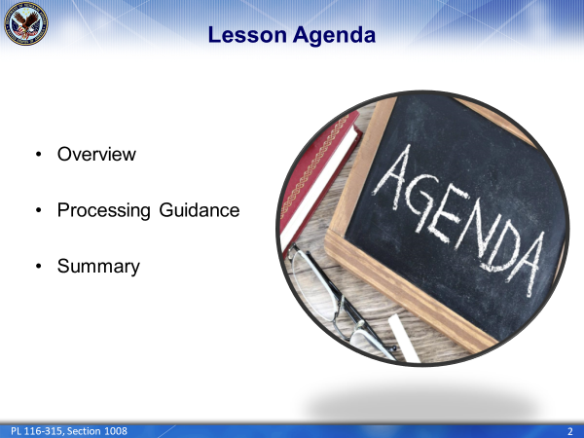 | DISPLAY slide  In today’s lesson, we will provide an overview of this section of the legislation. We will then discuss the associated processing guidance to include verification procedures. Finally, we will conclude with a summary of today’s lesson. Let’s get started.
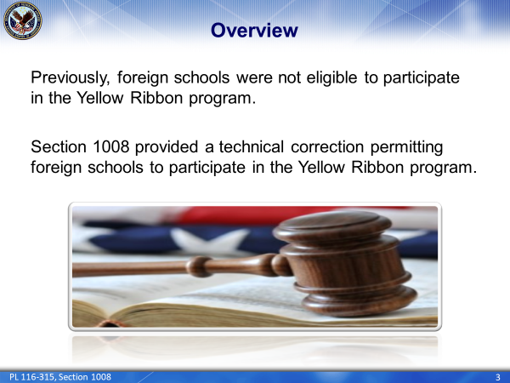 | DISPLAY slide  Prior to PL 116-315, section 1008, foreign schools were not eligible to participate in the Yellow Ribbon program.  Section 1008 was enacted on January 5, 2021, clarifying eligibility which allows foreign schools and training establishments to participate in the Yellow Ribbon program. By replacing the simple phrase “established charges” with the phrase “tuition and fees”, this section allows foreign schools to participate in the Yellow Ribbon program.
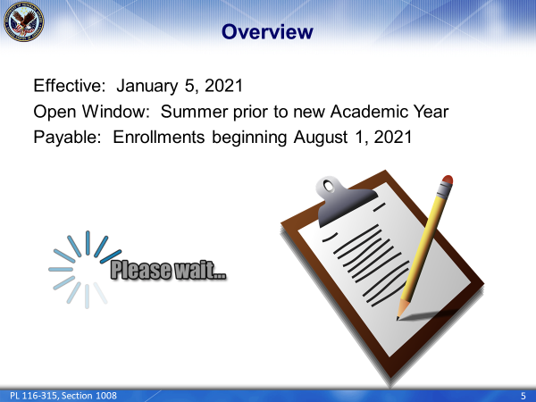 | DISPLAY slide  Keep in mind, a school must first apply and be approved to participate in the Yellow Ribbon program.  During the summer of 2021, foreign schools will be allowed a special open window to apply for Yellow Ribbon participation.  If approved, beneficiaries at foreign schools will be eligible to receive Yellow Ribbon Program payments for certified enrollments beginning on or after August 1, 2021.
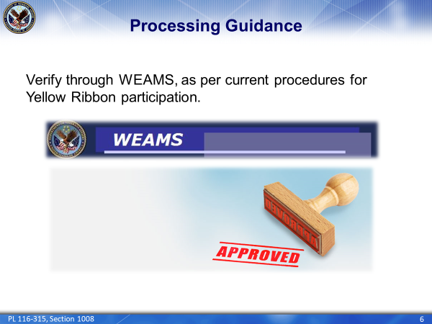 | DISPLAY slide  VCE’s should follow current guidelines for verifying participation. A review and capture of WEAMS showing the approval information should be performed. There is no additional development needed and there is no change to the current procedures.
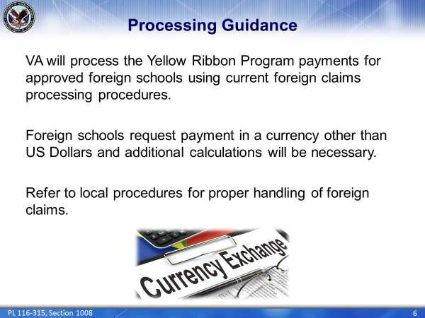 | DISPLAY slide  When a qualifying enrollment is received from a foreign school and WEAMS confirms them as a participating facility, VA will process the Yellow Ribbon Program payments using current procedures.  Remember, foreign schools request payment in a currency other than US Dollars. Therefore, additional calculations will be necessary.  Refer to your local procedures for handling foreign claims and currency exchange rate information. The Yellow Ribbon Program payments will be handled in the same manner tuition and fee payments are currently handled.
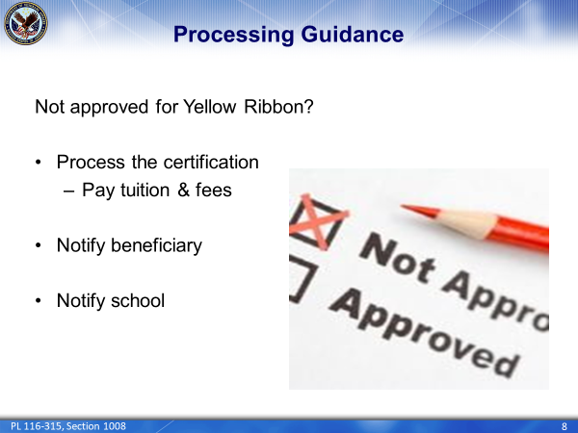 | DISPLAY slide  If a foreign school has requested a Yellow Ribbon Program amount on an enrollment certification but is not listed as approved in WEAMS, VCEs should follow development procedures in Part 4, Ch 1.14 of the M22-4. No payment should be authorized while development is pending.  If information is received confirming the school is not an approved Yellow Ribbon Program participating school, the VCE should process the award issuing tuition and fees only. The VCE should also send a letter notifying the beneficiary and the school Yellow Ribbon Program payments cannot be paid since the school is not approved to participate in the program. A template for the denial letter for Yellow Ribbon can also be found in Part 4, Ch 1.14 of the manual.  Remember to capture all edited letters into the electronic file.
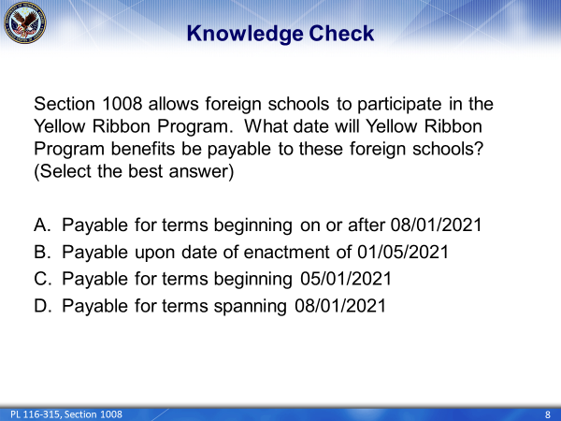 | DISPLAY slide  Let’s do a Knowledge Check:  Section 1008 allows foreign schools to participate in the Yellow Ribbon Program. What date will Yellow Ribbon be payable to these foreign schools? (Select all that apply)  - Payable for terms beginning on or after 08/01/2021  - Payable upon date of enactment of 01/05/2021  - Payable for terms beginning 05/01/2021  - Payable for terms spanning 08/01/2021
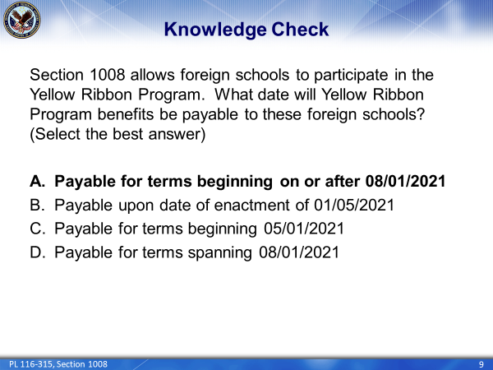 | DISPLAY slide  The correct answer is “A”. Section 1008 was enacted on January 5, 2021, and foreign schools were allowed to sign-up during the open window. Yellow Ribbon Program payments can be paid for enrollments beginning on or after August 1, 2021.
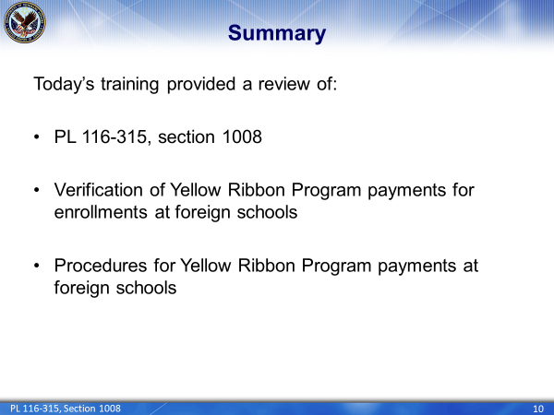 | DISPLAY slide  Today’s training provided a review of PL 116-315, Section 1008 including the verification and processing procedures for issuing Yellow Ribbon Program payments for enrollments at foreign schools.
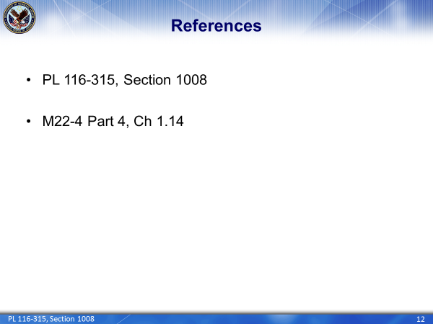 | DISPLAY slide  Here are the references used in today’s presentation.
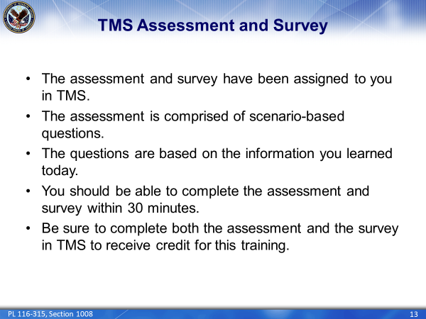 | DISPLAY slide  This concludes our review of PL 116-315, Section 1008. This training will be followed by an assessment and survey in TMS.  The assessment will be a mix of scenario-based questions based on the information you were provided today.  You should be able to complete this training, the assessment and the survey within 30 minutes.  Be sure to complete the assessment and survey in TMS to receive credit for this training.
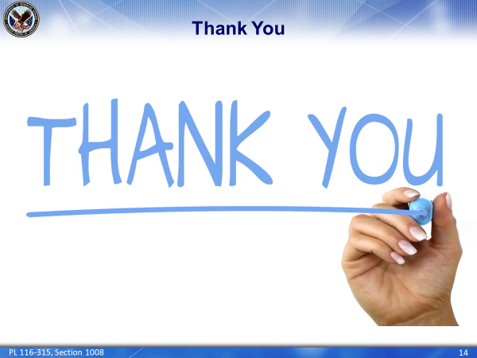 | DISPLAY slide  As always, thank you for your time and attention.

