

EDUCATION SERVICE

PL 116-315 SECTION 1021 RESTORATION OF ENTITLEMENT LTS UPDATE TRAINING MODULE
Lesson Plan

June 2021 Version 1.0

Lesson Overview
Time Estimate: |  | 1 hour
Purpose of the Lesson: |  | The purpose of this lesson is to present a general overview of PL 116-315 related to section 1021 and to provide key impacts of PL 116-315 provision effective after the date of enactment.
Prerequisite Training Requirements: |  | Section 109 Restoration of Entitlement Training (TMS ID -VA 4561564)
Target Audience: |  | Veteran Claims Examiners  Muskogee Restoration of Entitlement Team
Lesson References: |  | The following references support the lesson content:  - PL 116-315 - Johnny Isakson and David P. Roe, M.D. Veterans Health Care and Benefits Improvement Act of 2020
Lesson Objectives: |  | At the end of today’s lesson, you will understand:  - General facts about PL 116-315  - Related LTS (Long-Term Solution) Updates  - School Closure Letter Updates  - VA Form 22-0989 Updates  - Section 1021 Processing
What You Need:
Post Training Requirements:

Instructor Notes
The purpose of this training is to provide an Overview of Public Law 116-315 related to section 1021, review the school closure letter, VA Form 22-0989 Updates and the restoration of entitlement process.
PowerPoint Slides | Instructor Activities
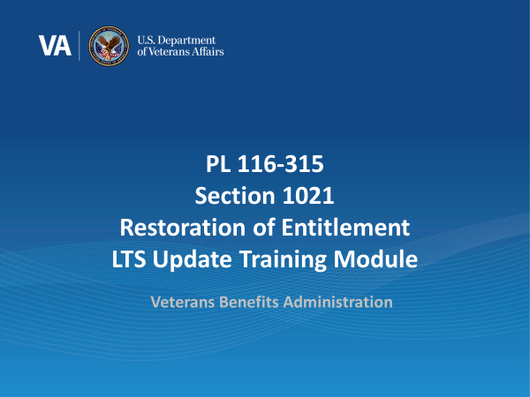 | DISPLAY slide 1  Welcome to the training module for section 1021 of Public Law 116-315, the Johnny Isakson & David P. Roe, M.D. Veterans Health Care and Benefits Improvement Act of 2020. In today’s training, you will learn about the updates made to the Long Term Solution (LTS) which enable the VA to accurately process restoration of entitlement claims for certain beneficiaries.  Please note the examples you will see during this training were processed in a test system. All names and claim numbers you see are fictitious and do not belong to actual beneficiaries. No personally identifiable information (PII) is contained in this training.  Please click ‘Next’ in the bottom right-hand corner when you are ready to move on to the next page.  NEXT SLIDE
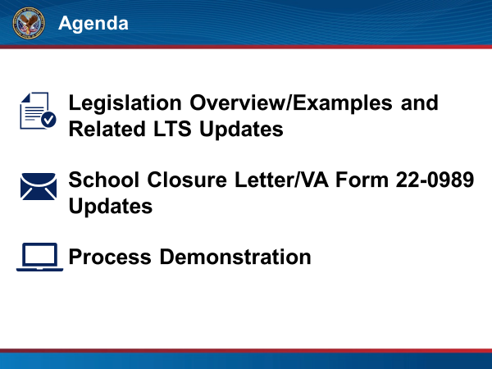 | DISPLAY slide 2  In this training, we will begin by providing an overview of the new legislation, sample Restoration of Entitlement (RoE) scenarios, and updates made in the LTS. Then, we will go over updates to the School Closure letter and its attachment, VA Form 22-0989: Education Benefit Entitlement Restoration Request due to School Closure, Program Suspension or Withdrawal. Finally, we will then provide an end-to-end demonstration on how to process restoration of entitlement within the LTS for a school closure or disapproval when the beneficiary has not been able to transfer at least 12 credit hours to a new school.  Please click “Next” to continue.  NEXT SLIDE
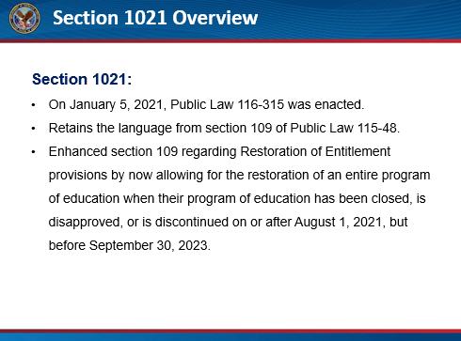 | DISPLAY slide 3  As stated earlier, on January 5, 2021, Public Law 116-315 was enacted.  Section 1021, of this Public Law, retains the language from section 109 of The Harry W. Colmery Veterans Educational Assistance Act of 2017 (Public Law 115-48). Section 1021 has enhanced section 109 regarding Restoration of Entitlement provisions by now allowing for the restoration of an entire program of education when their program of education has been closed, is disapproved, or is discontinued on or after August 1, 2021, but before September 30, 2023.  Please click “Next” to continue.  NEXT SLIDE
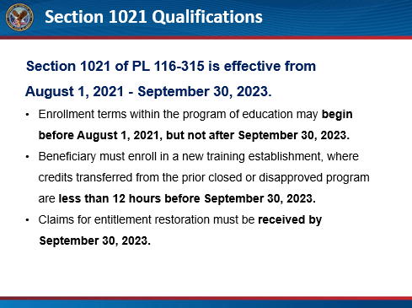 | DISPLAY slide 4  Section 1021 of PL 116-315 is effective from August 1, 2021, through September 30, 2023, but there are nuances as to when the school closure/disapproval, the reenrollment and the request for entitlement restoration occur - in order for the provision to be effective.  To qualify for entitlement restoration under section 1021, the effective date of the program of education closure, disapproval or discontinuance must be between August 1, 2021, and September 30, 2023.  The terms, potentially for RoE under section 1021, may begin prior to August 1, 2021, however the last eligible begin date is September 30, 2023.  The beneficiary must have been unable to complete a program of education as a result of a school closure, program disapproval or program discontinuance which occurred either during the beneficiary’s period of enrollment or within 120 days of the beneficiary’s last period of enrollment AND, was only able to transfer fewer than 12 credit hours after enrolling in a new training establishment to complete the interrupted program of education. This loss of credits or training time does not need to be COVID-related.  However, the request must be received within 120 days of the program termination.  The responsibility to provide the transfer credit information lies with the new training establishment. It is the beneficiary's responsibility to obtain the necessary certifications from their new training establishment and VA should assist in any way possible.  Further, the legal authority of section 1021 of Public Law 116-315 ends on September 30, 2023. Therefore, claims for entitlement restoration must be received by September 30, 2023.  Please click “Next” to continue.  NEXT SLIDE
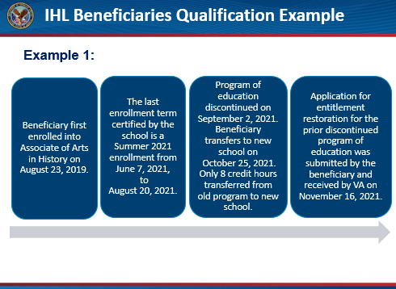 | DISPLAY slide 5  Now, we will discuss an example of when this section would apply. A beneficiary first enrolled in the Associate of Arts in History on August 23, 2019. The last enrollment term certified by the school is a Summer 2021 enrollment from June 7, 2021, to August 20, 2021. The program of education is discontinued on September 2, 2021. The beneficiary transfers to a new school on October 25, 2021, and only 8 credit hours have been transferred from the old program to the new school. The application for restoration of entitlement for the prior discontinued program of education was received by VA on November 16, 2021.  Please click “Next” to continue.  NEXT SLIDE
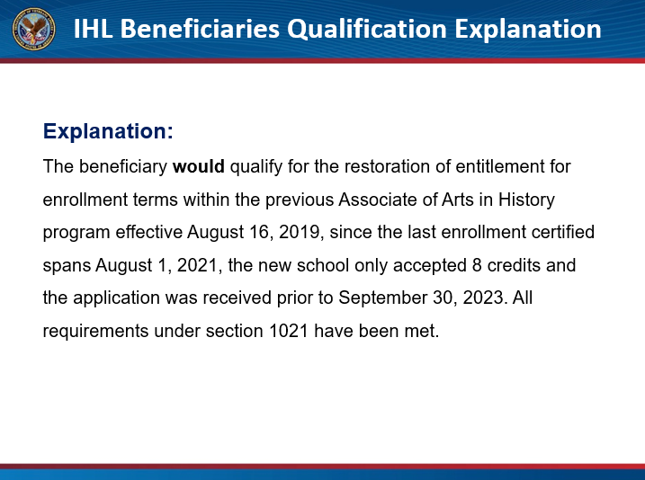 | DISPLAY slide 6  In this example, the beneficiary would qualify for RoE for enrollment terms within the previous Associate of Arts in History program effective August 16, 2019 since the last enrollment certified spans August 1, 2021, the new school only accepted 8 credits and the application was received prior to September 30, 2023. All requirements under section 1021 have been met.  Please click “Next” to continue.  NEXT SLIDE
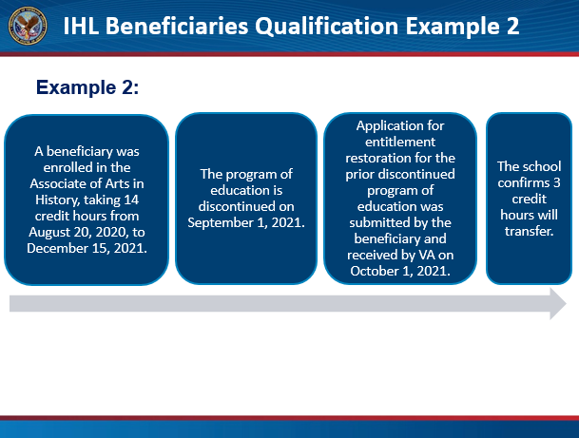 | DISPLAY slide 7  For a second example: A beneficiary was enrolled in the Associate of Arts in History, taking 14 credit hours from August 20, 2020, to December 15, 2021. The program of education is discontinued on September 1, 2021, and the beneficiary applies for restoration of entitlement which is received on October 1, 2021.  The school confirms 3 credit hours will transfer.  Please click “Next” to continue.  NEXT SLIDE
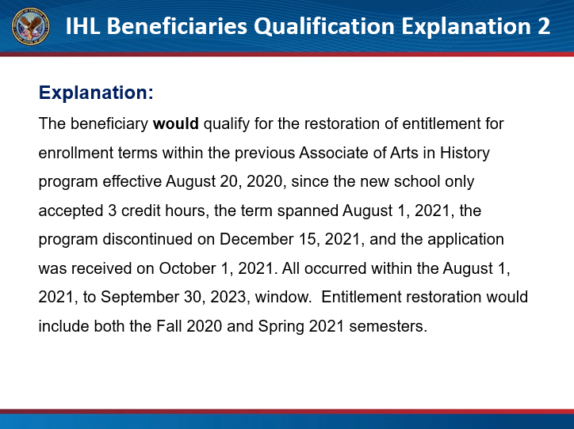 | DISPLAY slide 8  In this example, the beneficiary would qualify for RoE for enrollment terms within the previous Associate of Arts in History program effective August 20, 2020, since the new school only accepted 3 credit hours, the term spanned August 1, 2021, the program discontinued on December 15, 2021, and the application was received on October 1, 2021. All occurred within the August 1, 2021, to September 30, 2023, window. Entitlement restoration would include both the Fall 2020 and Spring 2021 semesters.  Please click “Next” to continue.  NEXT SLIDE
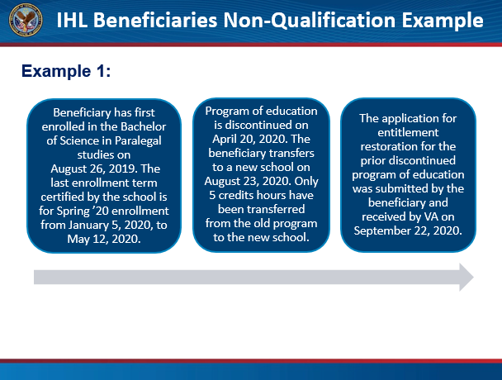 | DISPLAY slide 9  Now, we will discuss examples of when this section would NOT apply. A beneficiary has first enrolled in the Bachelor of Science in Paralegal Studies on August 26, 2019. The last enrollment term certified by the school is for Spring 2020 enrollment from January 5, 2020, to May 12, 2020. The program of education is discontinued on April 20, 2020. The beneficiary transfers to a new school on August 23, 2020, and only 5 credit hours have been transferred from the old program to the new school. The application for restoration of entitlement was received on September 22, 2020.  Please click “Next” to continue.  NEXT SLIDE
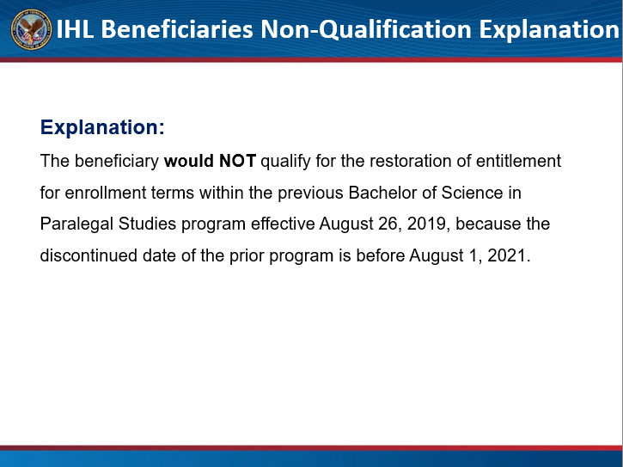 | DISPLAY slide 10  The beneficiary would NOT qualify for RoE for enrollment terms within the previous Bachelor of Science in Paralegal Studies program effective August 26, 2019, because the discontinued date of the prior program is before August 1, 2021.  Please click “Next” to continue.  NEXT SLIDE
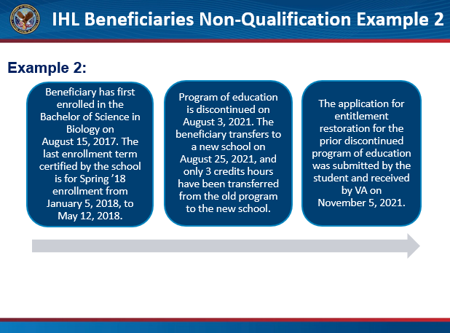 | DISPLAY slide 11  A beneficiary has first enrolled in the Bachelor of Science in Biology on August 15, 2017. The last enrollment term certified by the school is for Spring 2018, enrollment from January 5, 2018, to May 12, 2018. The program of education is discontinued on August 3, 2021. The beneficiary transfers to a new school on August 25, 2021, and only 3 credit hours have been transferred from the old program to the new school. The application for entitlement restoration for the prior discontinued program of education was submitted by the beneficiary and received by VA on November 5, 2021.  Please click “Next” to continue.  NEXT SLIDE
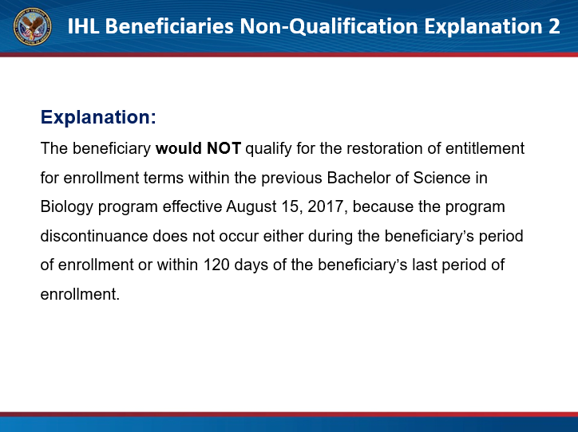 | DISPLAY slide 12  The beneficiary would NOT qualify for RoE for enrollment terms within the previous Bachelor of Science in Biology program effective August 15, 2017, because the program discontinuance does not occur either during the beneficiary’s period of enrollment or within 120 days of the beneficiary’s last period of enrollment.  Please click “Next” to continue.  NEXT SLIDE
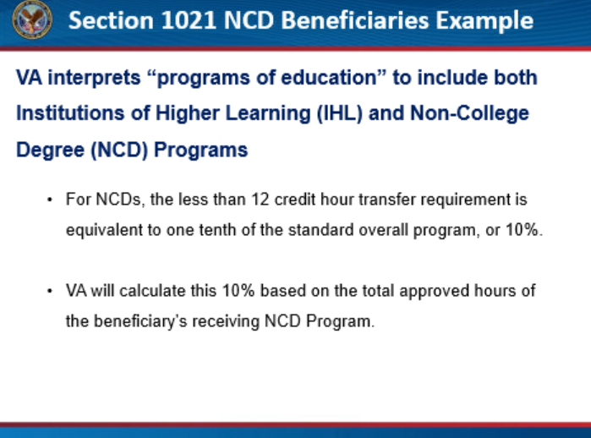 | DISPLAY slide 13  Section 1021 refers to “programs of education” which VA has interpreted to include not only Institutions of Higher Learning (IHL), but also Non-College Degree (NCD) Programs. Because NCD Programs are often not measured in credit hours and the section does not mention any equivalent for programs measured in clock hours, VA has defined how this rule will be applied to NCD Programs.  Most IHL Bachelor’s degree programs require between 120 and 130 credit hours for graduation. Rather than a clock hour equivalent, the 12-credit hour transfer requirement would be equivalent to 10% of the standard overall program or one-tenth of 120 credit hours. Therefore, VA will use 10% of NCD program completion as its transfer requirement for section 1021.  If a beneficiary’s program of education is closed, disapproved, or discontinued after August 1, 2021; the beneficiary attends an equivalent NCD Program before September 30, 2023; and the receiving NCD accepts transfer credit which is less than 10% of their new program, the beneficiary may be entitled to RoE for the entitlement used at the previously closed, disapproved, or discontinued program.  Please click “Next” to continue.  NEXT SLIDE
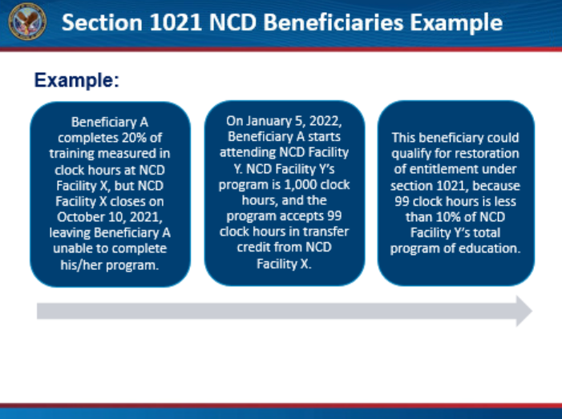 | DISPLAY slide 14  Now we will look an example NCD beneficiary. Beneficiary A completes 20% of training measured in clock hours at NCD Facility X, but NCD Facility X closes on October 10, 2021, leaving Beneficiary A unable to complete his/her program. On January 5, 2022, Beneficiary A starts attending NCD Facility Y. NCD Facility Y’s program is 1,000 clock hours, and the program accepts 99 clock hours in transfer credit from NCD Facility X. This beneficiary could qualify for restoration of entitlement under section 1021, because 99 clock hours is less than 10% of NCD Facility Y’s total program of education. If the new school accepted 100 clock hours or more in transfer credit, the beneficiary should be denied section 1021 relief. When a beneficiary may be denied due to section 1021, section 109 may still apply.  Please click “Next” to continue.  NEXT SLIDE
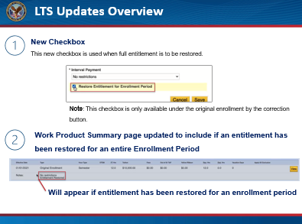 | DISPLAY slide 15  Now we will review updates made to LTS.  LTS has been updated to include a new checkbox to be selected by designated Veterans Claims Examiners (VCEs) when a beneficiary’s entitlement is eligible to be restored based on current guidance. This checkbox is only available under the original enrollment by the correction button. As a reminder, only designated VCEs from the Muskogee Restoration of Entitlement team should be utilizing the checkbox.  As we will cover later in the training, VCEs should note, once the checkbox is selected and they click “Save”, the beneficiary will have their entitlement restored. There is no validation message which will appear before entitlement is restored.  Once entitlement is restored a note is added to the enrollment which can be viewed on the Work Product Summary page stating, “Entitlement Restored.”  Please click “Next” to continue.  NEXT SLIDE
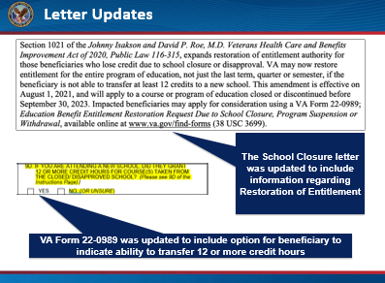 | DISPLAY slide 16  The School Closure letter was updated to include information regarding the RoE.  Beneficiaries will be informed if they are not able to transfer at least 12 credit hours to a new school, they may be eligible to have their entitlement restored for the entire program of education.  VA Form 22-0989 was updated in Box 9D which requests the beneficiary to indicate whether they were able to transfer 12 or more credit hours to a new school or program.  Please click “Next” to continue.  NEXT SLIDE
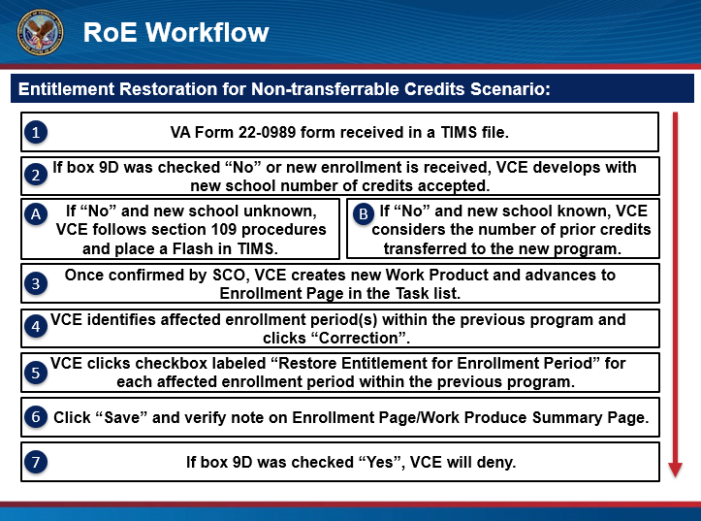 | DISPLAY slide 17  This is the general process followed to restore entitlement. You will be presented with a video demonstration, then the lesson will expand on the process in detail.  Please click ‘Next’ to continue.  NEXT SLIDE
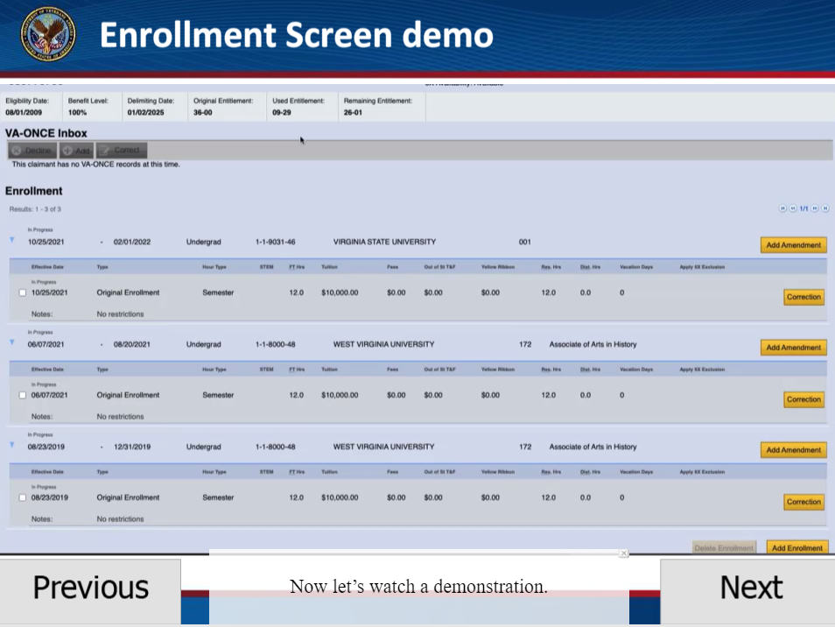 | DISPLAY slide 18 (demo)  Now let’s watch a demonstration. Before we do so, let’s revisit a qualified restoration of entitlement example. The beneficiary first enrolled in the Associate of Arts in History on August 23, 2019. The last enrollment term certified by the school is a Summer 2021 enrollment from June 7, 2021, to August 20, 2021. The program of education is discontinued on September 2, 2021. The beneficiary then transfers to a new school on October 25, 2021, and only 8 credit hours have been transferred from the old program to the new school. The application for restoration of entitlement for the prior discontinued program of education was received by VA on November 16, 2021. Now let’s watch a demonstration on how to process this restoration of entitlement in LTS.  Once VCEs, on the RoE Team in Muskogee, determine a beneficiary is eligible for RoE, they will navigate to the Enrollment Page in LTS.  Designated VCEs will then select the desired enrollment period eligible for entitlement restoration and click the ‘Correction’ button which appears to the right of the enrollment period details. This will bring up a pop-up window. At the bottom of the window is the ‘Restore Entitlement for Enrollment Period’ checkbox. Click the box and then click the ‘Save’ button to restore entitlement for the selected enrollment period.  Of note, there is no confirmation pop-up window and entitlement for the selected period will be automatically restored when the ‘Save’ button is clicked. This box should ONLY be checked by the RoE Team and only after thorough review.  Since we restored entitlement for the summer term, the Enrollment Page will now display only the corrected amount for used entitlement and a note is added to enrollment stating: “Entitlement Restored.”  Finally, VCEs can navigate to the Work Product Summary page and observe the same “Entitlement Restored” note has been added to the enrollment period.  It is important to note, the only two “call-outs” of entitlement being restored is under the original enrollment on the enrollment screen and on the Work Product Summary page. Be sure to verify the affected term is indeed warranted entitlement restoration prior to authorizing.  Please click “Next ” to continue.  NEXT SLIDE
DISPLAY slide 19
Once a new VA Form 22-0989 has been received, VCEs will need to verify the selection for the box- 9D.

If box 9D is checked “No” or left blank, VCEs will do the following:

If the new school is unknown (i.e. an enrollment certification has not been received for the new school), the VCE will follow section 109 procedures and restore the last term attended. In addition, the VCE should place a Flash in TIMS which states,
“If a new enrollment is received, please route to the Restoration queue for review of section 1021 eligibility”.
The VCE should also update remarks in BDN and LTS as section 109 procedures advise.
If new school is known, (i.e. an enrollment certification has been received for the new school), the VCE must consider the number of prior credits transferred to the new program.
If the new school confirms less than 12 credit hours were transferred, the VCE should select the “Restore Entitlement for Enrollment Period” checkbox for every term of the previous program in LTS.

Please remember this checkbox is only available under the original enrollment by the correction button.

It is also important to note, no validation message will appear once a user selects “Save.” Once the “Save” button is selected, the beneficiary will have their entitlement restored.
If the new school confirms 12 credit hours or more were transferred, the beneficiary will not be eligible for section 1021, and the VCE must review for section 109 and should modify the denial letter accordingly.

If prior credit is not provided from the new school, then development is necessary to verify the number of credits accepted. The VCE must capture all communication to the school as validation. The VCE should ensure the new term is processed in LTS. However, VCEs cannot review for section 1021 until the prior credit decision has been received.
If box 9D is checked “Yes”, the beneficiary is not eligible for section 1021 and the VCE will deny the claim as previously instructed under section 109 per Procedural Advisory: Colmery Section 109 Restoration of Entitlement, LTS update.

Please click “Next” to continue.

NEXT SLIDE
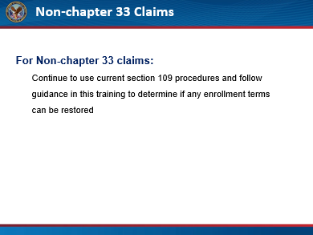 | DISPLAY slide 20  Finally, for non-chapter 33 claims, VCEs should continue to use current section 109 procedures and follow the guidance in this training to determine if any enrollment terms can be restored.  Please click “Next” to continue.  NEXT SLIDE
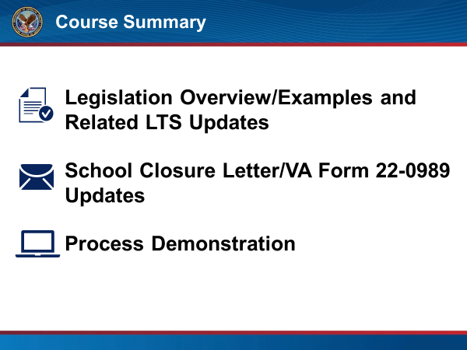 | DISPLAY slide 21  Let’s review what we discussed in this training.  First, we provided an overview of the new legislation, related updates made in the LTS, including the new Restore Entitlement checkbox, updates to the School Closure letter and the attached VA Form 22-0989.  We then walked through an end-to-end demonstration on how to process school closures within LTS when the school has closed, and a beneficiary was not able to transfer at least 12 credit hours.  Please click “Next” to continue.  NEXT SLIDE
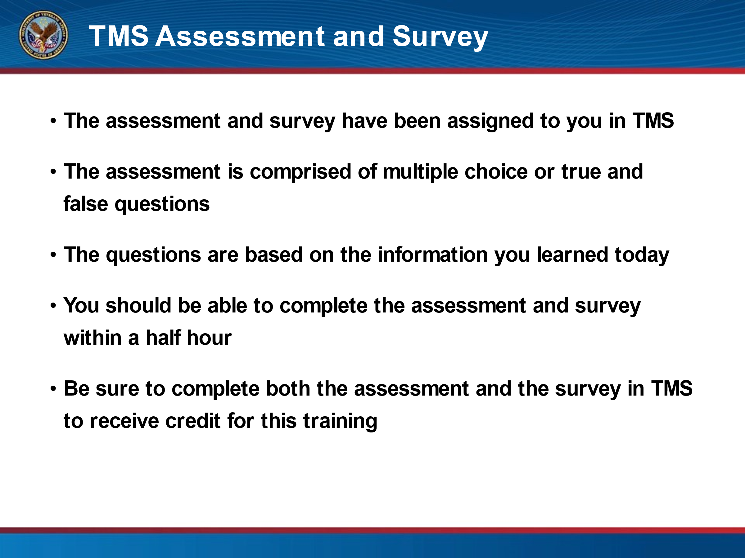 | DISPLAY slide 22  The assessment and survey have been assigned to you in TMS.  The assessment is comprised of multiple choice or true and false questions.  The questions are based on the information you learned today.  You should be able to complete the assessment and survey within a half hour.  Be sure to complete both the assessment and the survey in TMS to receive credit for this training.  Thank you for your participation in today’s training.  Please click the ‘Exit’ button when you are finished.  END PRESENTATION

