Education Service
Veterans Information Solution
Identifying Qualifying Service
Lesson Plan
[FY21]
Version [1.0]

Lesson Overview
Topic | Description
Time Estimate: | 1 hour
Purpose of the Lesson: | The purpose of this training is to provide a review on where to find and how to identify qualifying service in the Veterans Information Solution (VIS) program using the coded data provided on the Education tab for the Veterans Claim Examiner (VCE).  Additionally, the various codes on the Education tab used to determine eligibility will be discussed during this session as well.
Prerequisite Training Requirements: | N/A
Target Audience: | The lesson is designed for entry-level, intermediate, or journey-level VCEs, Senior VCEs, Lead VCE and EQTS.
Lesson References: | - September 1, 2020: System Advisory: VIS – Changes  - Procedural Advisory: VADIR as Authoritative Source for all active service periods after January 1, 2015. dated April 12, 2018  - M22-4, Part 3, Chapter 3.11 – 3.17  - M22-4 Part 5, 3.06a  - System Advisory: VIS – New Codes Displayed Under “Eligibility Code” dated April 20, 2018  - RPO Letter 22-05-11, National Call to Service (NCS)  - System Advisory: VA-Reservist Educational Assistance Program (REAP) & National Call to Service (NCS) Data Move to VIS dated July 16, 2014  - System Advisory: VIS – New login, REAP Status Code and Eligibility Codes dated March 10, 2020  - System Advisory: VIS Updates dated December 3, 2020
Lesson Objectives: | - Review some important VIS basics  - Discuss where to find and how to identify qualifying service in VIS  - Discuss and define codes used on VIS Education tab
What You Need: | Attachment: VIS codes sheet
Post Training Requirements: | Upon completion of the classroom portion of the lesson, participants are required to complete an online lesson assessment and survey in Talent Management System (TMS).  To demonstrate successful completion of the lesson participants must pass the assessment with a score of at least 80%.  Participants must also complete the online survey to earn credit for completion of the lesson.

Instructor Notes
The purpose of today’s training is to provide VCE’s with a brief overview of basic information pertaining to VIS. It is a refresher training focused on describing where to find and how to identify qualifying service in the Veterans Information Solution (VIS) using the data provided on the Education tab. We will discuss the various codes used on the Education tab to determine eligibility. An attachment listing the various codes discussed in today’s training is being provided. This document will serve as a personal reference tool.
PowerPoint Slides | Instructor Activities
 | DISPLAY slide  Introduce the lesson and presenter. Explain the presentation will take approximately 30 minutes with an assessment and survey in TMS to follow which should take no more than 30 minutes for a total of 1 hour of training.
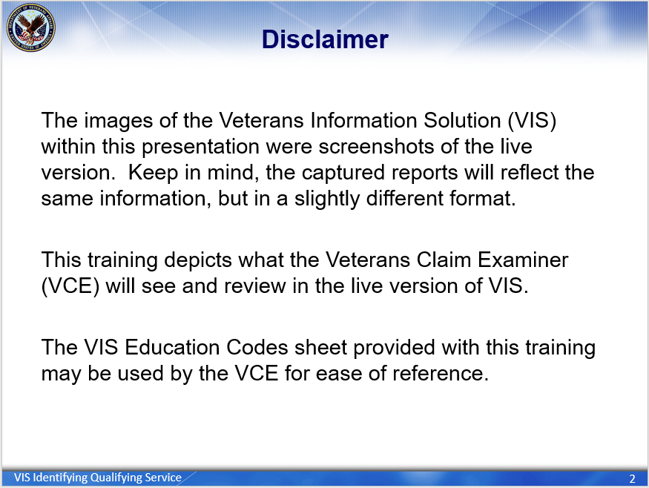 | DISPLAY slide  The images of the Veterans Information Solution (VIS) within this presentation were screenshots of the live version. Keep in mind, the captured reports will reflect the same information, but in a slightly different format.  With the VCE in mind, this training depicts what the VCE will be seeing and reviewing while in the live version of VIS.  The VIS Education Codes sheet provided as an attachment with this training may be used by the VCE for ease of reference.
 | DISPLAY slide  The purpose of today’s training is to provide a review on where to find and how to identify qualifying service in the VIS application using the data provided on the Education tab.  Additionally, we will discuss the various codes on the Education tab used to determine eligibility.
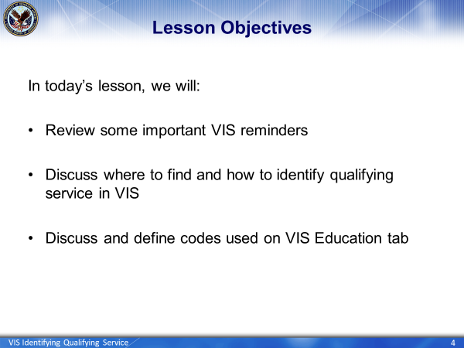 | DISPLAY slide  Today’s lesson we will review a few important VIS reminders, some tips and tricks of how to identify qualifying service in VIS as well as discuss VIS data reported in code.
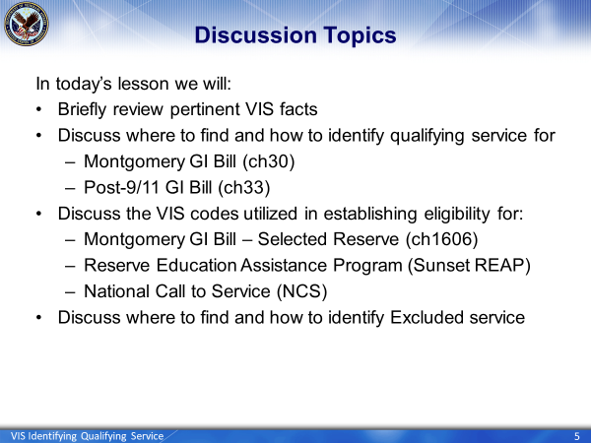 | DISPLAY slide  After a brief review of some VIS reminders, today’s training will be discussing how best to identify qualifying service data for the Post-9/11 GI Bill, the Montgomery GI Bill.  We will also be briefly discussing the various codes used for the Montgomery GI Bill – Selected Reserve (ch1606), the sunset REAP benefit and the NCS benefit. Finally, we will discuss the excluded service section of the Education Tab.
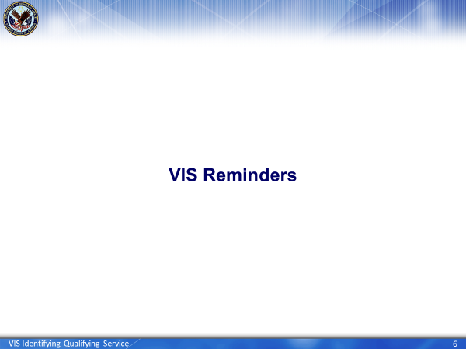 | DISPLAY slide  Let’s begin with a quick review of some VIS reminders.
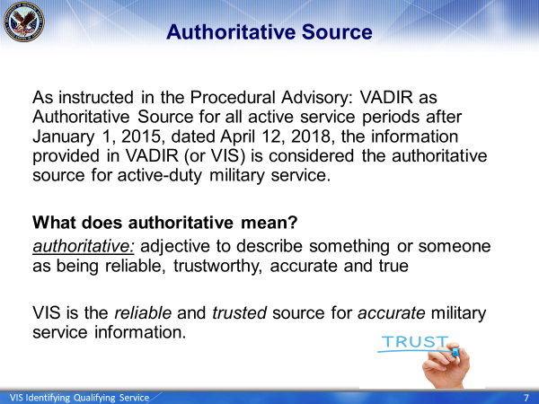 | DISPLAY slide  VIS became the authoritative source with a procedural advisory dated April 12, 2018. The information provided in VADIR (or VIS) must be considered the authoritative source for active-duty military service.  What does authoritative mean?  The definition of authoritative: (adjective) can be trusted as being accurate or true; reliable.  So, based on these facts, VIS is our reliable and trusted source for accurate military service information.
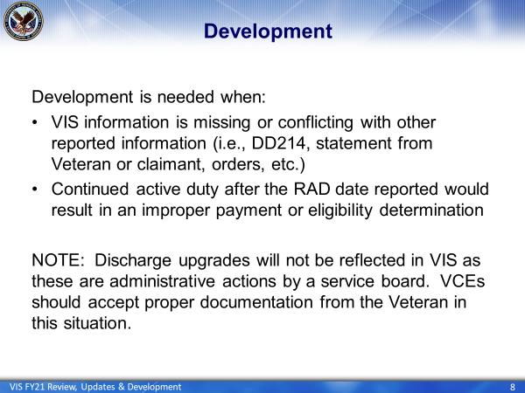 | DISPLAY slide  Basics of when development needed:  - When information is missing or conflicting – for example, the Veteran states he was on active duty from Dec 2019 to April 2020, but there is no evidence in VIS of this service.  - When paying as active duty after the reported RAD date would result in an improper payment or eligibility determination  Be aware upgrades made to a discharge may not reflect in VIS because these changes are made at the service board level. Accepting documentation from the Veteran is approved for this scenario.
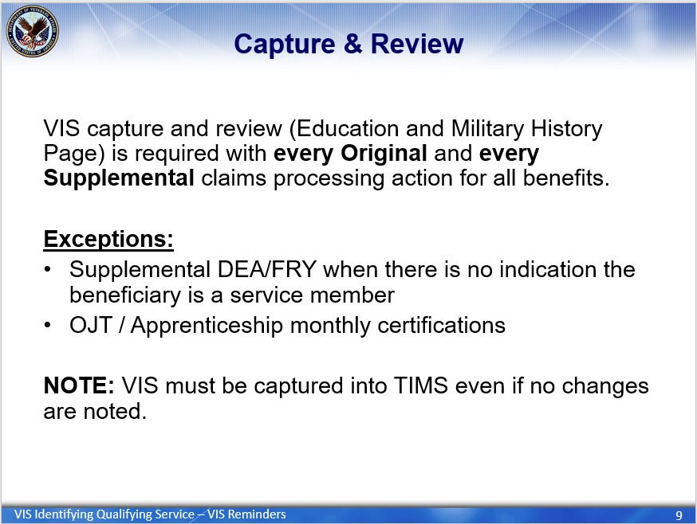 | DISPLAY slide  Remember to capture and review the Education and Military History reports from VIS with all Original and all Supplemental claims processing actions. This requirement is for all benefits except supplemental Dependents Educational Assistance or Fry beneficiaries when there is no indication the beneficiary is a service member, themselves. Also, monthly certifications for OJT or Apprenticeship programs do not require VIS capture. Remember…VIS must be captured into TIMS even if no changes are noted.
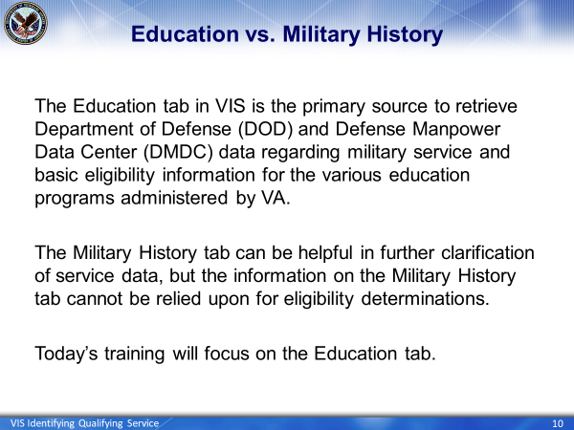 | DISPLAY slide  The Education Tab in VIS is the VA’s primary source to retrieve Department of Defense (DOD) and Defense Manpower Data Center (DMDC) data which provides military service and basic eligibility information for the various Education programs administered by VA.  The Military History tab can be helpful when further clarification of service data is needed, but the information on the Military History tab cannot and should not be relied upon for determining eligibility.  Today’s training will focus on the Education tab.
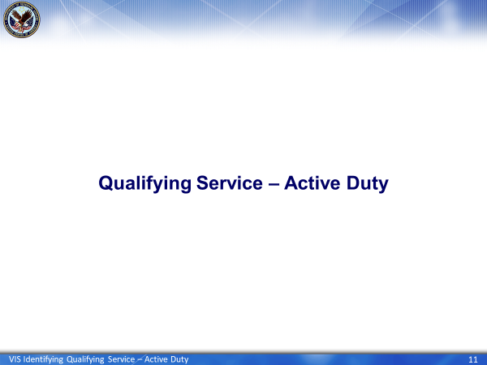 | DISPLAY slide  Let’s begin with a discussion of how to identify qualifying service for chapter 30 and chapter 33 using the Education tab in VIS.
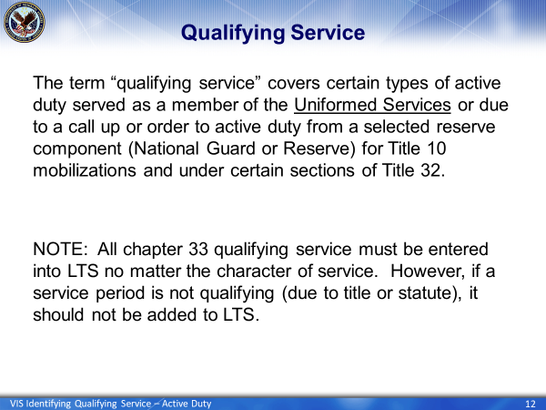 | DISPLAY slide  The term “Qualifying Service” covers certain TYPES of active duty served as a member of the Uniformed Services or as a result of a call to active duty from the Reserve or Guard component for title 10 mobilizations, and under certain sections of Title 32.  Remember - All chapter 33 qualifying service periods must be added to LTS no matter the character of service. This determines the eligibility level, sets the delimiting date (if there is one) and ensures housing is paid correctly. If a service period is NOT considered to be qualifying – it should NOT be added to LTS.
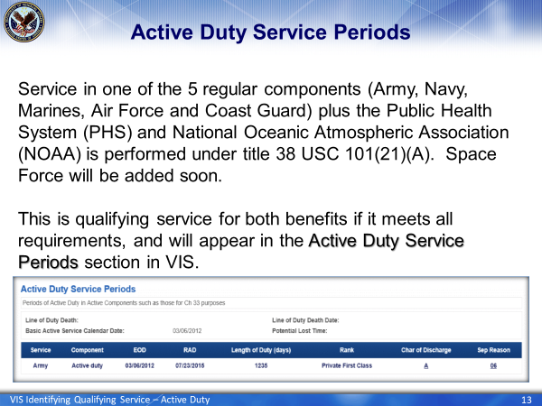 | DISPLAY slide  The Active Duty Service Periods section in VIS lists all active duty performed in one of the 5 regular Armed Forces components, which include the Army, Navy, Marines, Air Force and Coast Guard. Service performed in the Public Health System or National Oceanic Atmospheric Association is also included in this section. Space Force will be added to this section soon.  All service performed in one of these main components is performed under 38 US Code 101 (21) (A) and is qualifying service for both chapter 33 and chapter 30 if it meets all other requirements.
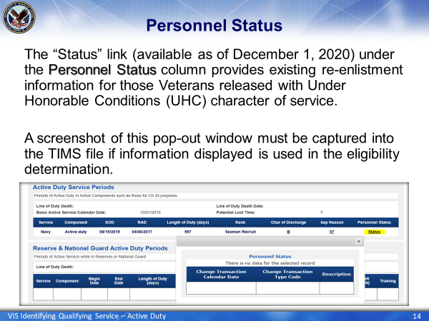 | DISPLAY slide  The new “Status” link available under the Personnel Status column provides existing re-enlistment information for those Veterans released with Under Honorable Conditions (UHC) character of service. This will reduce the need for development for potentially honorable service periods. This feature became available December 1, 2020.  Be sure to capture a screen shot of this pop-out window into the TIMS file if information is displayed and is used in the eligibility determination. This information does not reflect on the reports generated by VIS at this time.
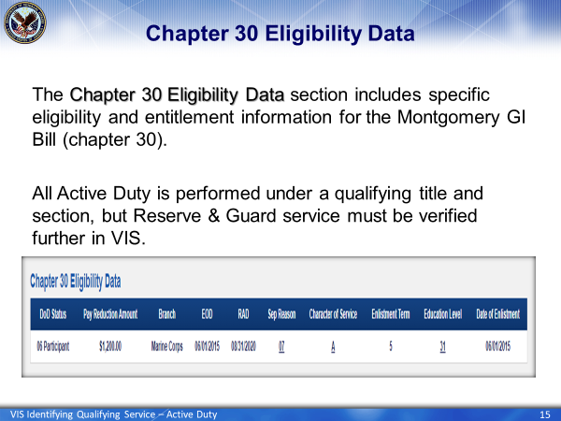 | DISPLAY slide  On June 18, 2019, Chapter 30 eligibility data was moved to VIS from BDN removing the requirement to capture the BDN 30D screen. The information found under the “Chapter 30 Eligibility Data” section provides the DOD status, the pay reduction amount as well as the branch and service dates. The information found here will assist you with your eligibility and entitlement determinations for chapter 30.  All regular branch active duty is qualifying service for chapter30 if it meets all other requirements. However, Reserve and Guard service need further review to verify whether it is qualifying. The Qualifying Statute Codes included on the attached Education VIS codes handout can be helpful in your determination. We will discuss these codes and others in more detail in future slides.  As stated previously, if there is missing or conflicting evidence present, development may be necessary to confirm the correct information.
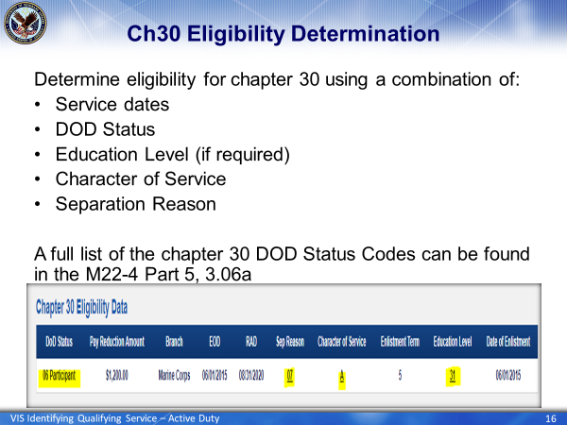 | DISPLAY slide  Chapter 30 eligibility is determined based on the service dates, the DOD status, the education level (at times) as well as the character of service and separation reason. A full list of the chapter 30 DOD status codes can be found in the manual, part 5, but a copy of this list has also been provided on the attached Education VIS codes sheet.  You will also notice the separation reason, character of service and education levels are reflected in codes on the VIS Education tab. Each of these codes have been listed and defined on the attached Education VIS codes sheet for ease of reference.
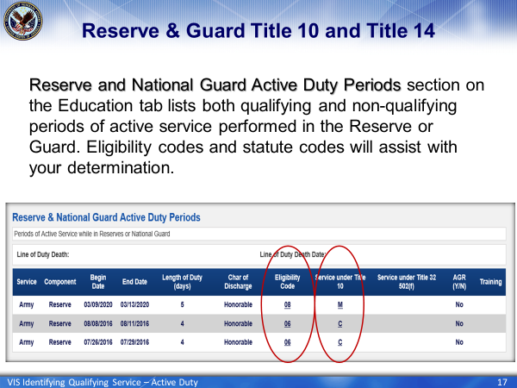 | DISPLAY slide  When reviewing for qualifying service performed in the Reserve and National Guard, we review the section called “Reserve & National Guard Active Duty Periods”. The service listed here may include both qualifying and non-qualifying periods of service.  The eligibility codes as well as the statute codes listed under the column labeled “Service under Title 10” will assist you with eligibility determinations. The next few slides will discuss these codes in more detail.
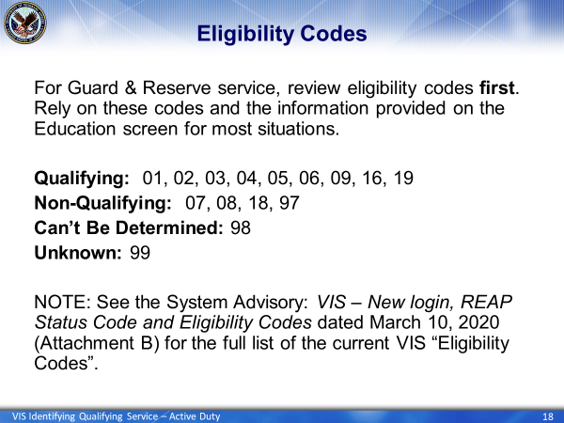 | DISPLAY slide  For Guard & Reserve service, review eligibility codes first. Rely on these codes and the information provided on the Education screen for most situations.  This slide provides a breakdown of the “Eligibility Codes” used to determine Reserve and Guard qualifying service. These codes should be your first indicator of qualifying or non-qualifying service.
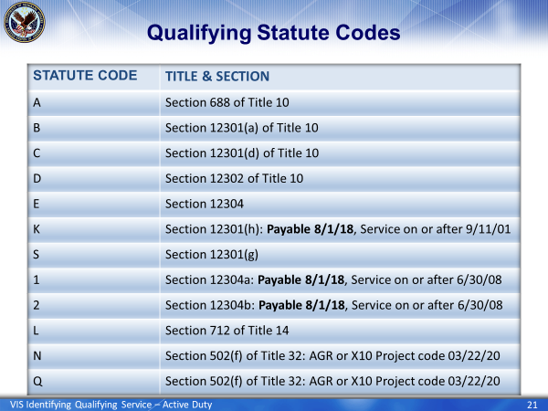 | DISPLAY slide  After you determine a service period is qualifying using the eligibility codes, review the statute codes to determine the correct title and section the service was performed under. Why does this matter? Some service, as you can see, may have special rules regarding when it became qualifying and when it became payable.  This is a complete list of the current qualifying statute codes.  Remember, there are still some C codes that require development before entering in LTS. The attached “Education VIS Codes sheet” will provide the reminder of which codes still require development.
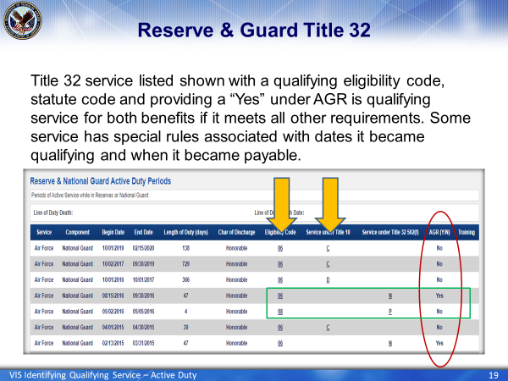 | DISPLAY slide  Again, when a Reservist or Guard Member served under Title 32, we FIRST review the eligibility code, THEN we review the statute codes and we ALSO review the AGR status. If there is a “yes” indicating service is AGR, it should be considered qualifying if it meets all other requirements. Some service has additional rules associated with dates it became qualifying and payable.
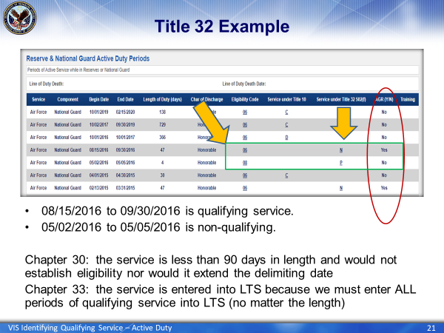 | DISPLAY slide  Let’s take a closer look at the two periods of Title 32 service inside the green box.  - The service from 08/15/2016 to 09/30/2016 is listed with a qualifying eligibility code and statute code and there is a “Y” indicating AGR. This is qualifying service.  - The service from 05/02/2016 to 05/05/2016 shows a period of non-qualifying service under Title 32 - note the eligibility code and AGR status indicates “N” for non-qualifying.  Remember, all AGR service is qualifying if it meets all other requirements. For chapter 30, the length of service is a factor. If service is less than 90 days, it would not establish eligibility nor would it extend the delimiting date.  For chapter 33 , the service must be entered into LTS because we know we must enter ALL periods of qualifying service into LTS no matter the length or character of service.
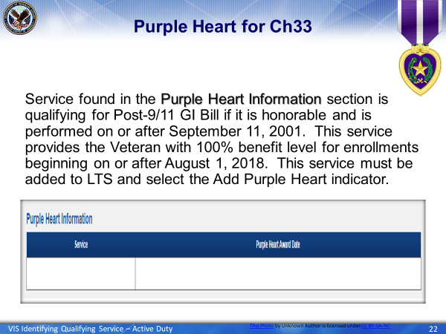 | DISPLAY slide  Purple Heart is one of those special service periods that became payable for chapter 33 enrollments beginning on or after August 1, 2018.  Any service listed as Purple Heart service must be entered into LTS using the “Add Purple Heart” indicator available in order to provide the correct eligibility percentage and payments. Previous workarounds should be corrected when discovered.
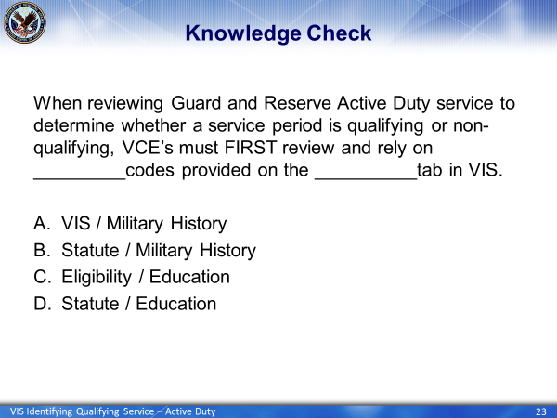 | DISPLAY slide  Let’s review our first knowledge check: Fill in the blanks.  When reviewing Guard and Reserve Active Duty service to determine whether a service period is qualifying or non-qualifying, VCE’s must FIRST review and rely on _________codes provided on the __________tab in VIS.  - VIS / Military History  - Statute / Military History  - Eligibility / Education  - Statute / Education
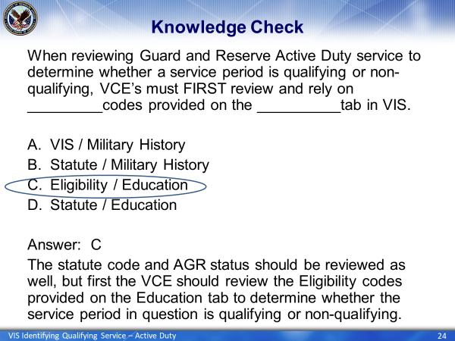 | DISPLAY slide  The Answer is C. The statute code and AGR status should be reviewed as well, but first the VCE should review the Eligibility codes provided on the Education tab to determine whether the service period in question is qualifying or non-qualifying.
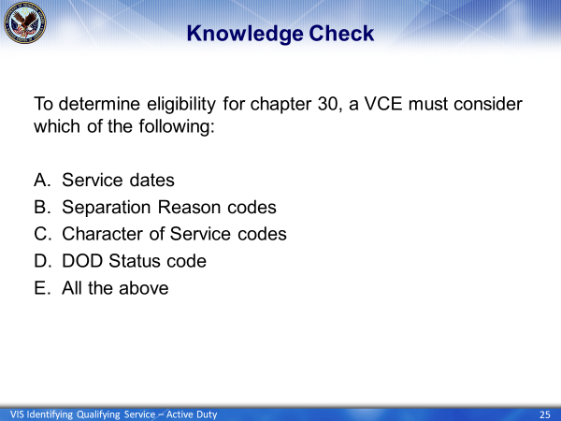 | DISPLAY slide  Let’s do another…  To determine eligibility for chapter 30, a VCE must consider which of the following:  - Service dates  - Separation Reason codes  - Character of Service codes  - DOD Status code  - All the above
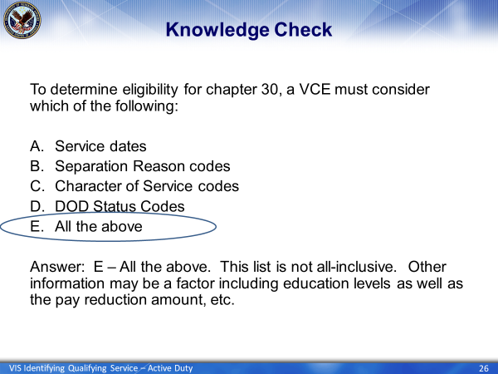 | DISPLAY slide  The answer is E – All of the above. This list is not all-inclusive. We use all of this information and more to determine eligibility for chapter 30, such as education levels as well as the pay reduction amount, etc.
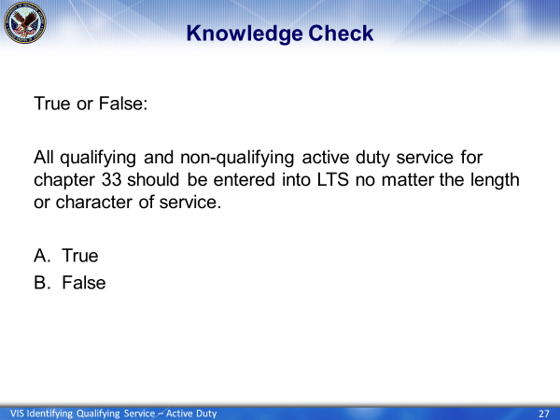 | DISPLAY slide  One more knowledge check – this one is True or False:  All qualifying and non-qualifying active duty service for chapter 33 should be entered into LTS no matter the length or character of service. Is this:  - True, or  - False
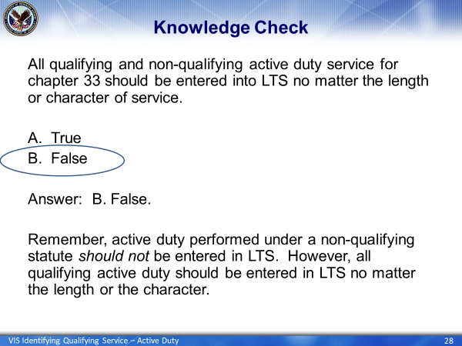 | DISPLAY slide  The answer is B, False.  Remember, active duty performed under a non-qualifying statute should not be entered in LTS. However, all qualifying active duty should be entered in LTS no matter the length or the character.
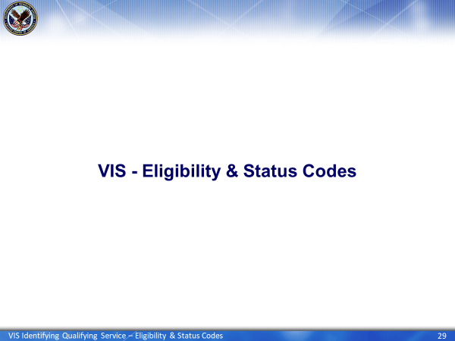 | DISPLAY slide  Next, we will discuss additional eligibility & status codes used to establish eligibility under other Education benefits.
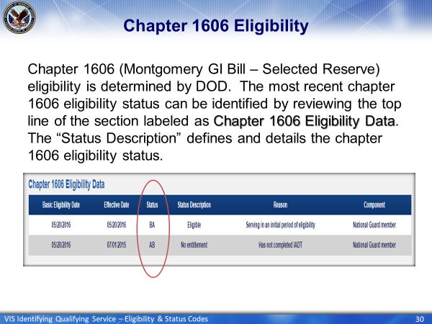 | DISPLAY slide  When reviewing for chapter 1606 eligibility, DOD reports the eligibility status under the “Chapter 1606 Eligibility Data” section. Notice the most current status is the top line. The full list of Chapter 1606 Eligibility Status Codes is included on the “VIS Codes Sheet” attached to this lesson.
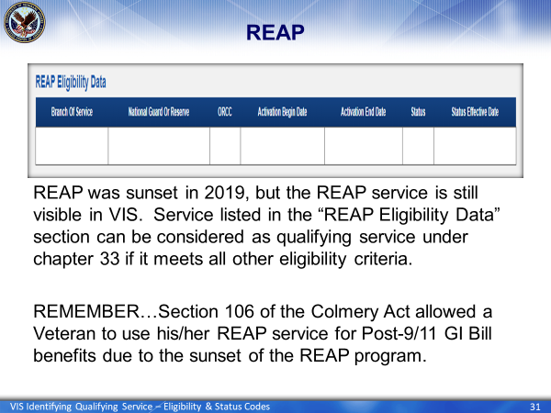 | DISPLAY slide  REAP was sunset in 2019, but the REAP service is still visible in the REAP section of VIS. Service listed in the REAP section can be considered as qualifying service under chapter 33 if meets all other eligibility criteria.  Here are the most recent codes added since the sunset of the benefit. A full list of all REAP codes can be found on the attached “VIS Codes Sheet” provided with the lesson today.  Remember, Section 106 of the Colmery Act allowed a Veteran to use his or her REAP service to qualify for Post-9/11 GI Bill benefits due to the sunset of the program in 2019.
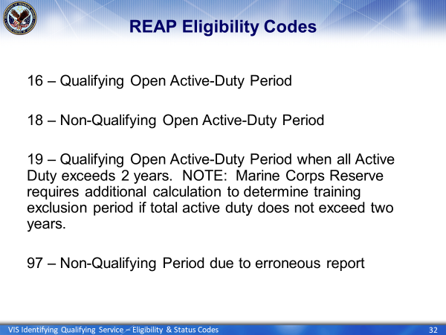 | DISPLAY slide  The REAP eligibility codes were added with the recent System advisory dated March 10, 2020.
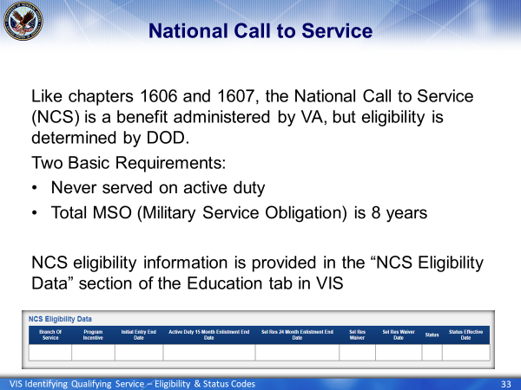 | DISPLAY slide  Like chapters 1606 and 1607, the National Call to Service (NCS) is a benefit administered by VA, but eligibility is determined by DOD.  NCS has two Basic Requirements:  1. Never served on active duty  2. Total MSO (Military Service Obligation) is 8 years  NCS eligibility information is provided in VIS. The Program Incentive codes have been included on the attached “Education VIS codes” list provided with this lesson.
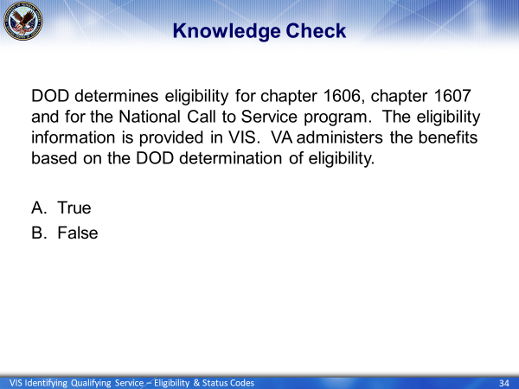 | DISPLAY slide  Time for another knowledge check:  DOD determines eligibility for chapter 1606, chapter 1607 and for the National Call to Service program. The eligibility information is provided in VIS. VA administers the benefits based on the DOD determination of eligibility.  Is this statement A – True, or B – False?
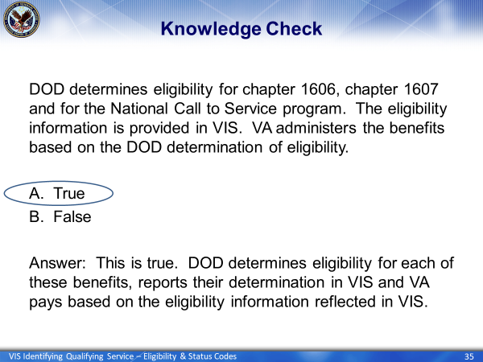 | DISPLAY slide  The answer is A – True. DOD determines eligibility for each of these three benefits, reports their determination in VIS and then VA pays the benefits based on the eligibility information reflected in VIS.
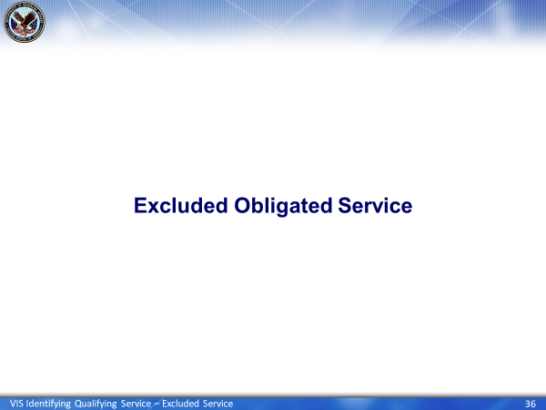 | DISPLAY slide  Finally, we will discuss identifying excluded obligated service as it is an important piece of identifying what is qualifying service and what is not qualifying.
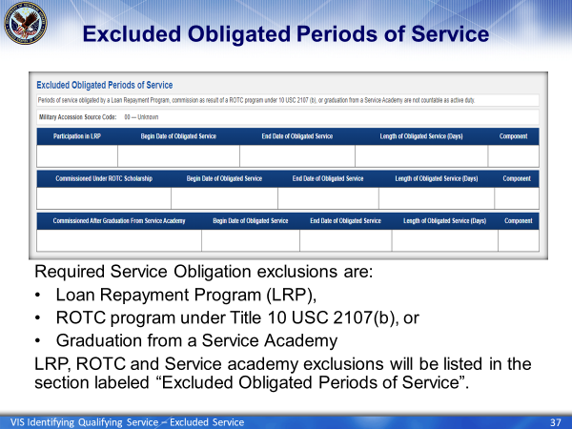 | DISPLAY slide  Service Obligations required to be excluded are:  - Loan Repayment Program (LRP),  - ROTC program under Title 10 USC 2107(b), or  - Graduation from a Service Academy  LRP, ROTC and Service academy exclusions will be listed in the VIS section labeled “Excluded Obligated Periods of Service”.
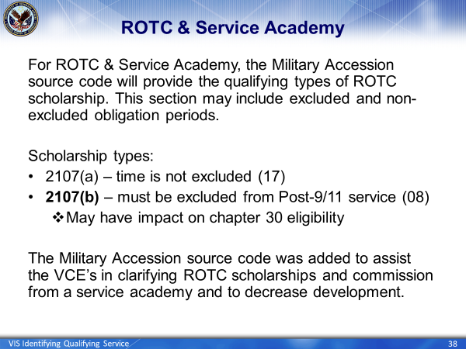 | DISPLAY slide  For ROTC & Service Academy, the Military Accession source code will provide processors with the type of ROTC scholarship. This section may include excluded and non-excluded obligation periods.  Scholarship types:  - For scholarship under 2107(a), the time is NOT required to be excluded. The Military Accession codes is listed as (17)  - For scholarships under 2107(b), time must be excluded from Post-9/11 service (08) and may have an impact on chapter 30 eligibility, as well.  This new Military Accession source code will also assist in clarifying Commission from a service academy. As with any other information, if there is conflicting data or unclear data which cannot be confirmed, development may still be necessary to determine the correct information. The full list of Military Accession source codes has been added to the Education VIS codes attachment provided with this lesson.  This new Military Accession source code will also assist in clarifying Commission from a service academy.  As with any other information, if there is conflicting data or unclear data which cannot be confirmed, development may still be necessary to determine the correct information.  The full list of Military Accession Source Codes has been added to the Education VIS codes attachment provided with this lesson.
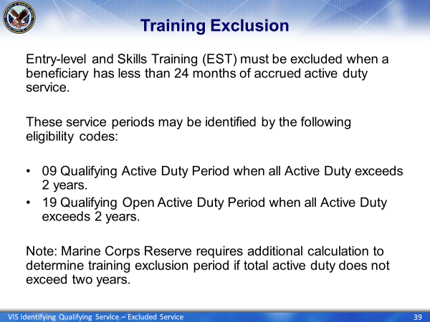 | DISPLAY slide  Entry-level and Skills Training (EST) must be excluded when a beneficiary has less than 24 months of accrued active duty service.  These service periods may be identified by the following eligibility codes: 09 and 19. NOTE: Marine Corps Reserves require additional calculation to determine the correct training exclusion period if the total active duty is less than 2 years.  In addition to this information, we also know “A20” project codes, on the Military History tab in VIS, can be helpful to identify entry level and skills training to be excluded as training.
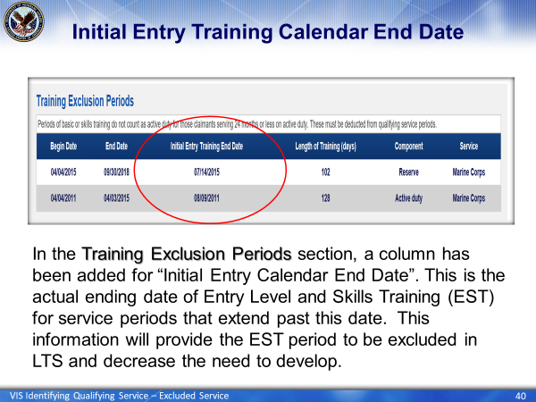 | DISPLAY slide  In the Training Exclusion Periods section, a column has been added for “Initial Entry Calendar End Date”. This is the actual ending date of EST for service periods that extend past this date.  This will provide the actual period of training to be excluded in LTS and should decrease the need to develop for this information.
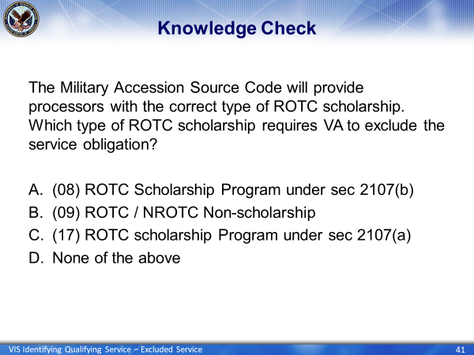 | DISPLAY slide  Let’s do one final knowledge check:  The Military Accession Source Code will provide processors with the correct type of ROTC scholarship. Which type of ROTC scholarship requires VA to exclude the service obligation?  - (08) ROTC Scholarship Program under sec 2107(b)  - (09) ROTC / NROTC Non-scholarship  - (17) ROTC scholarship Program under sec 2107(a)  - None of the above
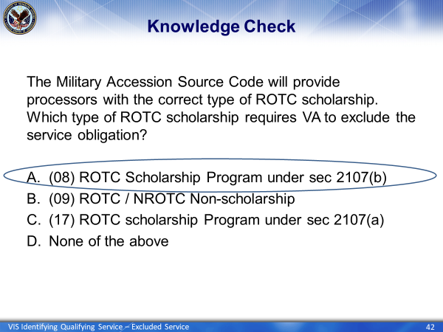 | DISPLAY slide  The answer is A – (08) is the military accession code for ROTC scholarship program under section 2107(b). Any obligated period must be excluded from chapter 33 service and may affect chapter 30 eligibility, as well.
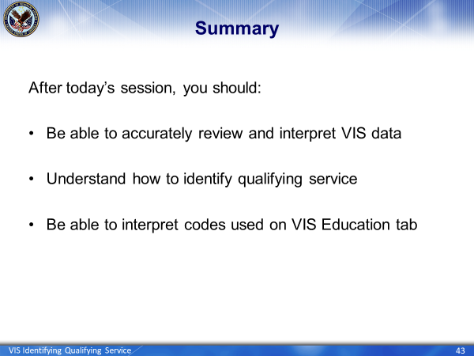 | DISPLAY slide  This concludes today’s lesson. You should now be able to accurately review and interpret VIS data, understand how to identify qualifying service and be able to interpret the codes used on the VIS Education tab.
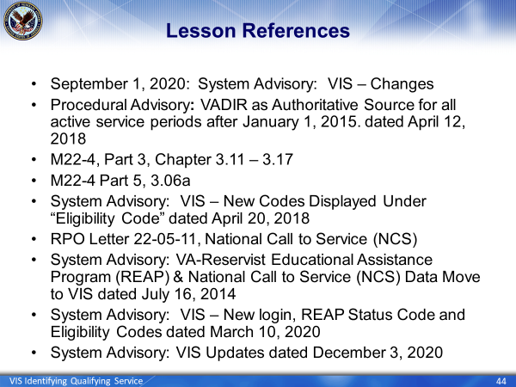 | DISPLAY slide  The references used for today’s lesson are listed here.
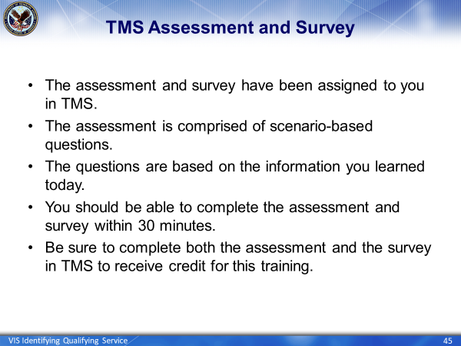 | DISPLAY slide  An assessment and survey have been assigned to you in TMS. The assessment is made up of scenario-based questions using the information from today’s lesson. You should be able to complete the assessment and the survey with 30 minutes. Once you complete both the assessment and the survey, you will receive one hour of credit for today’s training.  Thank you for your time and attention today.

