Education Service
Date of Claim for Processing
Education Benefits -
Lesson Plan

June 2022
Version 2.0

Lesson Overview
Topic | Description
Time Estimate: | 1 hour
Purpose of the Lesson: | The purpose of this training is to provide a review of the Date of Claim to be used when processing Education Benefits.
Prerequisite Training Requirements: | None
Target Audience: | Education Service Claims Examiners
Lesson References: | - M22-4, Part 3, Chapter 1  - M22-4, Part 3, Chapter 3  - CFR §21.1032
Lesson Objectives: | - Locate and determine the correct Date of Claim when processing education benefits.
What You Need:
Post Training Requirements: | Upon completion of the classroom portion of the lesson, participants are required to complete an online lesson assessment and survey in Talent Management System (TMS).  To demonstrate successful completion of the lesson participants must pass the assessment with a score of at least 80%.  Participants must also complete the online survey to earn credit for completion of the lesson.

Instructor Notes
The purpose of this refresher training is to provide a review of the Date of Claim to be used when processing Education Benefits.
PowerPoint Slides | Instructor Activities
 | DISPLAY slide  Introduce yourself as the instructor.  Good morning/afternoon, thank you for joining today’s refresher training session on Date of Claim for processing education benefits.
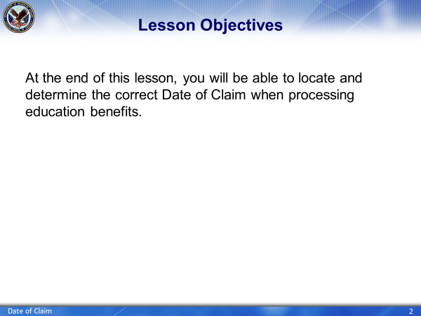 | DISPLAY slide  At the end of todays training, you will be able to locate and determine the correct date of claim to be used for each claim processed.
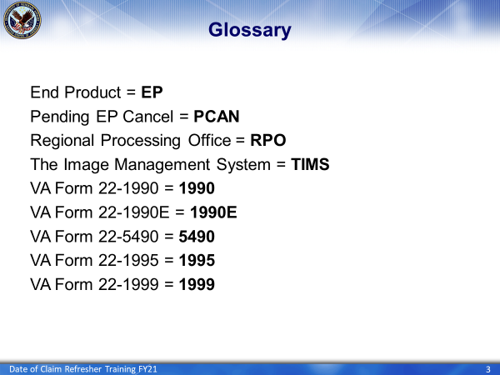 | Display slide 3.  The abbreviations in this slide will be used throughout the presentation.
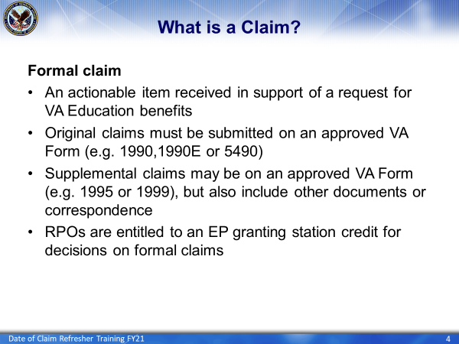 | Display slide 4  Let’s start by defining a claim. A claim can be either formal or informal. A formal claim is an actionable item which must be reviewed and processed at an RPO. Formal claims can be originals submitted on forms such as a VA Form 22-1990, or other original applications for education benefits; or supplemental claims such as a VA Form 22-1999 or any correspondence requiring adjudicative action.
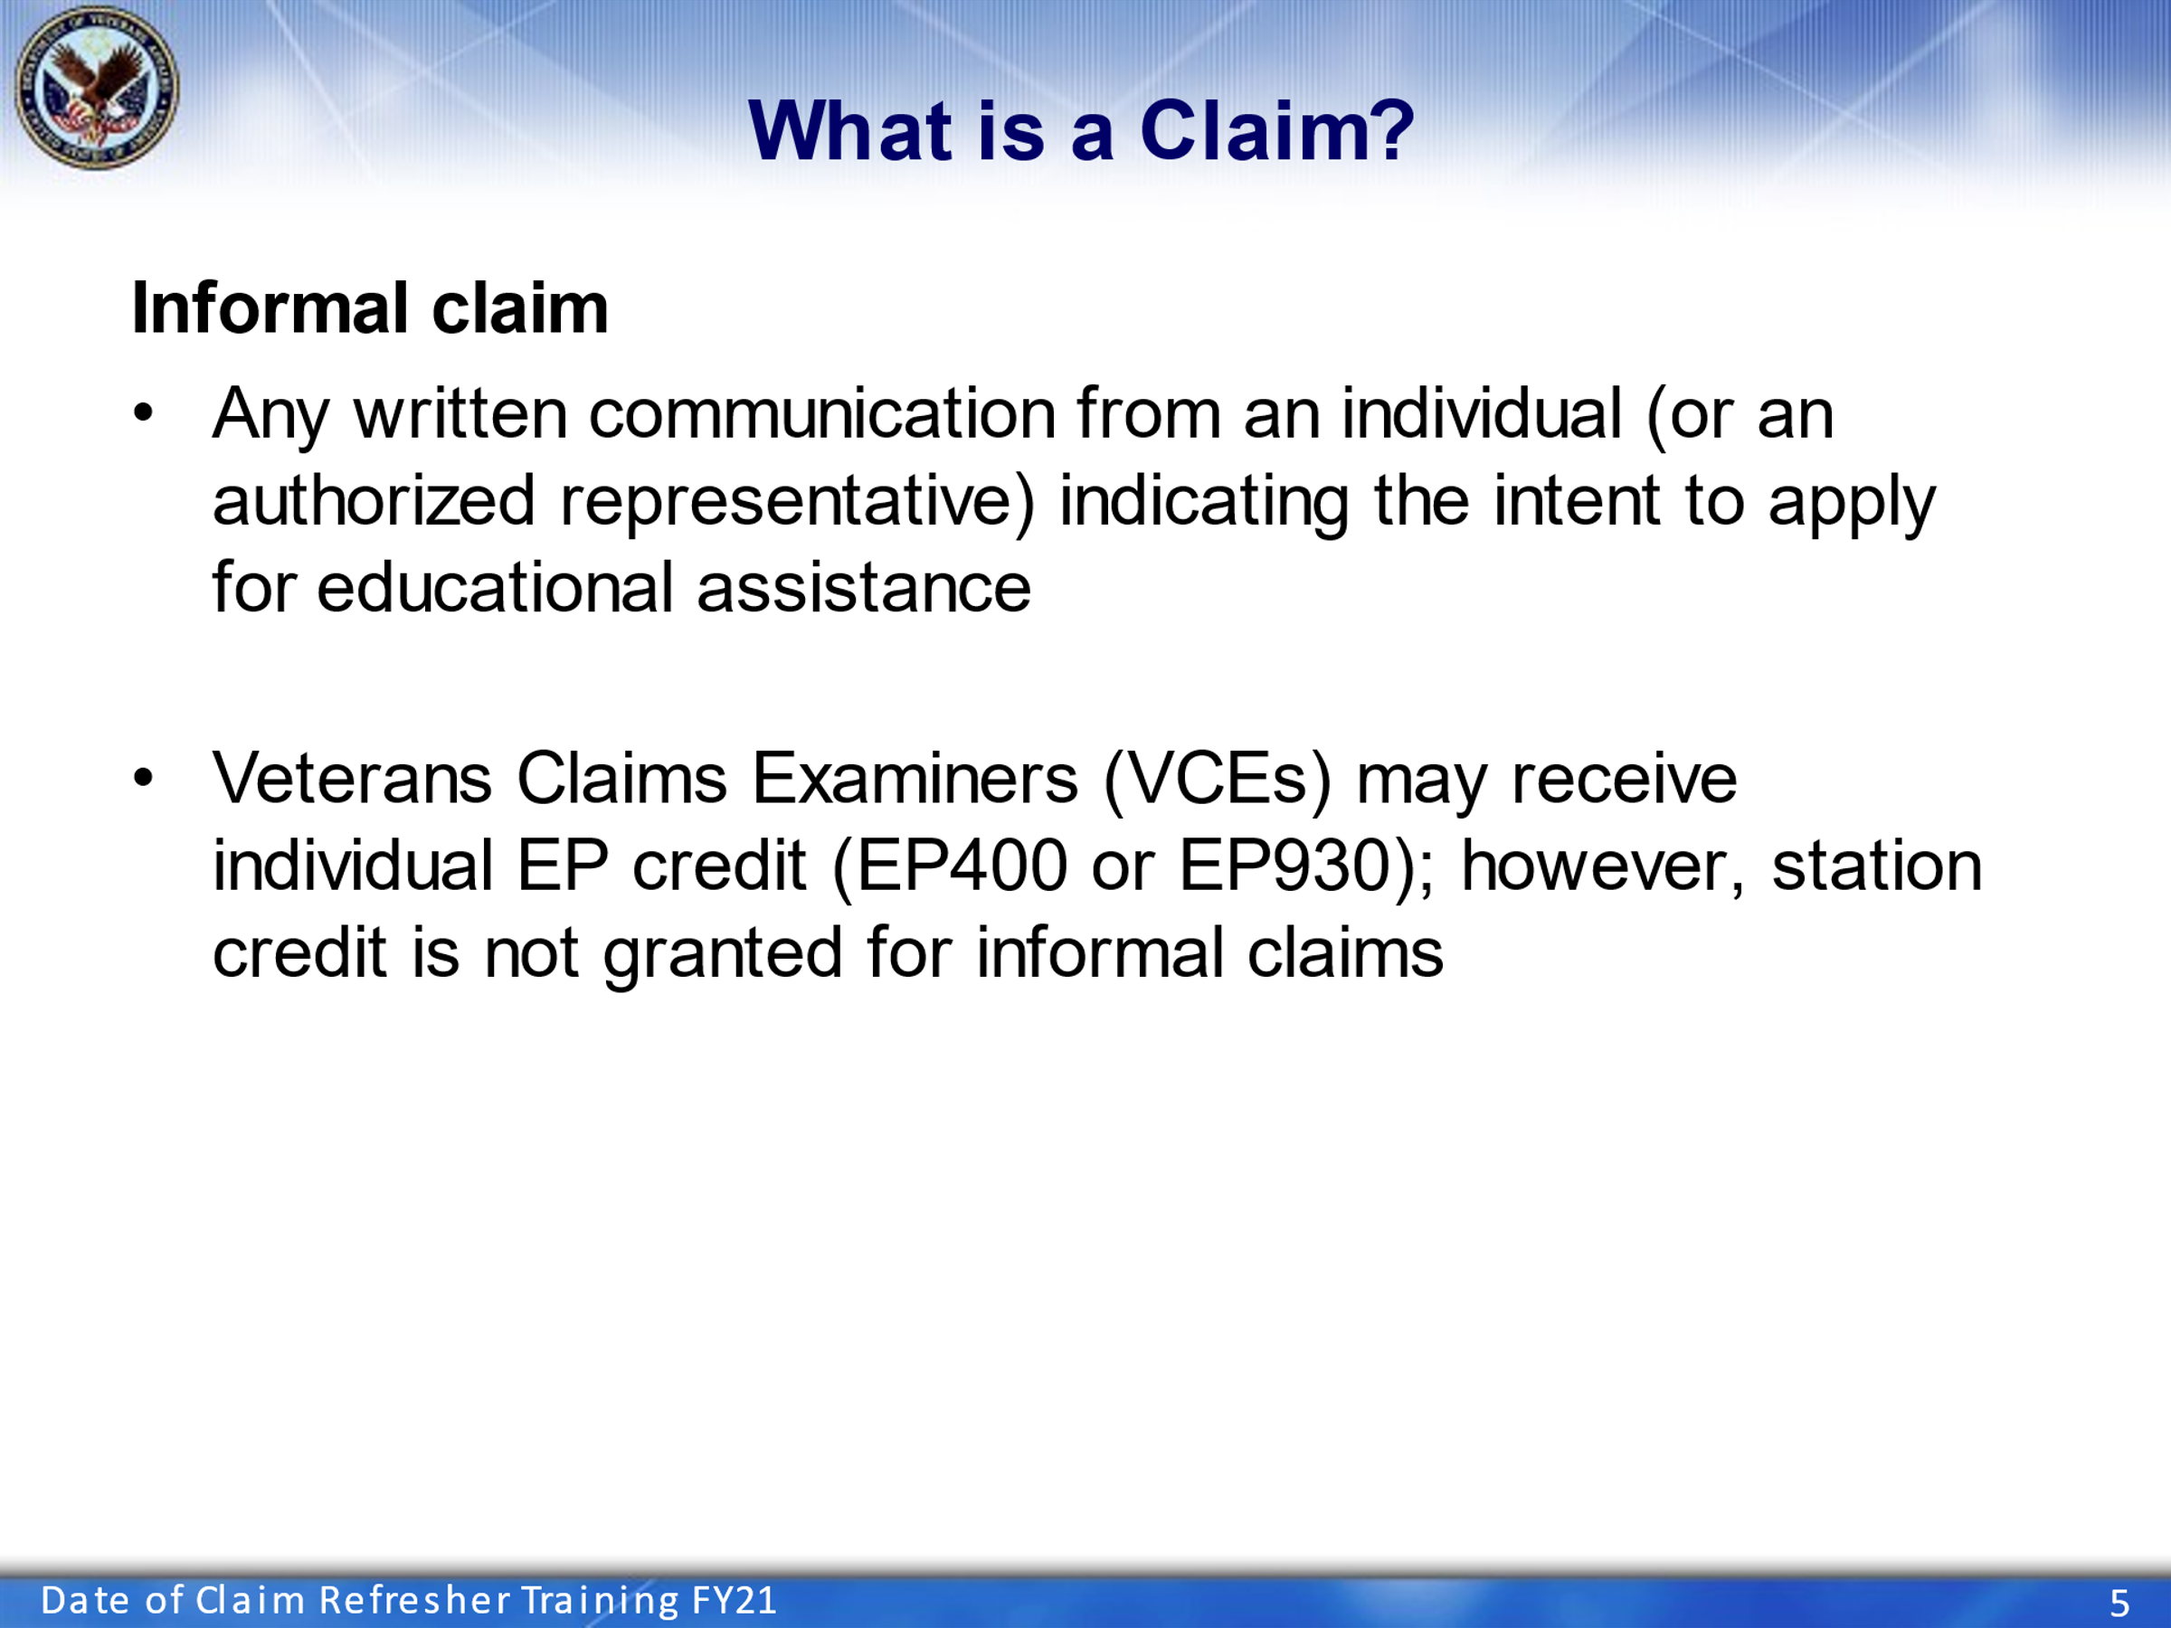 | Display slide 5  An informal claim is any written communication from an individual (or an authorized representative) indicating intent to apply for educational assistance. Although an informal claim may give the VCE local EP credit, such as an EP400. It will not provide an EP with a “date of claim” giving the station EP credit.
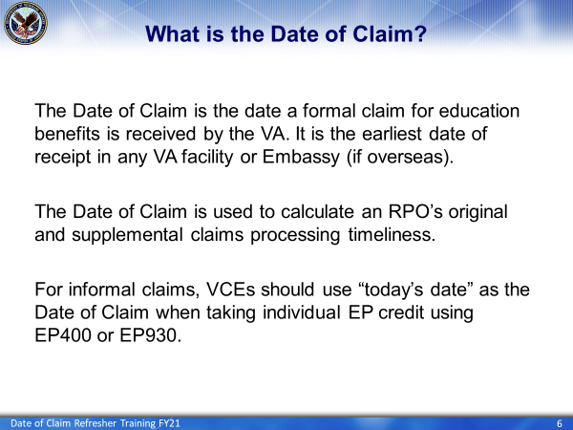 | DISPLAY slide 6.  Now let’s discuss what the Date of Claim is. It is the date a valid request or actionable document for education benefits is received by VA. It is also the earliest date of receipt in any VA Facility or Embassy, if overseas. Claims may be submitted electronically, including through va.gov, or by mail. All paper mail will be processed at the scanning vendor sites.  For informal claims, VCEs should enter “today’s date” as the date of claim when taking EP credit.
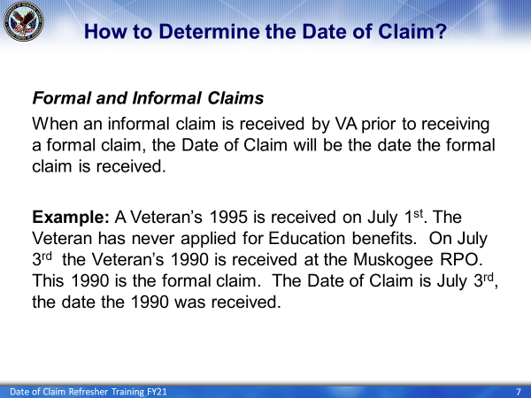 | DISPLAY slide 7.  When an informal claim is received by VA prior to receiving a formal claim, the date of claim will be based on the formal claim.  For example, a 1995 is received on July 1st, there is no file for the Veteran (in any regional office), the Veteran has never applied for Education Benefits. On July 3rd, the Veteran submits a 1990, this is now a formal claim. The date of claim will be based on the 1990, July 3rd.
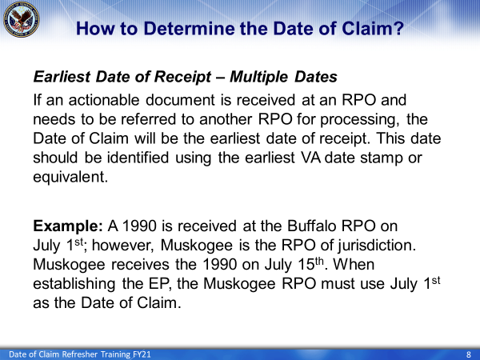 | DISPLAY slide 8.  The date of claim will be the earliest date of receipt in ANY VA facility. If an actionable document is received in one RPO and needs to be processed in the other RPO, the date of claim will still be the earliest date received at a VA office.  Example: A 1990 is received in the Buffalo RPO on July 1st. The jurisdiction for this claim is the Muskogee RPO. The TIMS file is created in the Buffalo RPO and then the file is sent to Muskogee RPO for processing. The TIMS file is not received in the Muskogee RPO until July 15th , when establishing the pending issue control (EP), the Muskogee office must use July 1st as the date of claim.
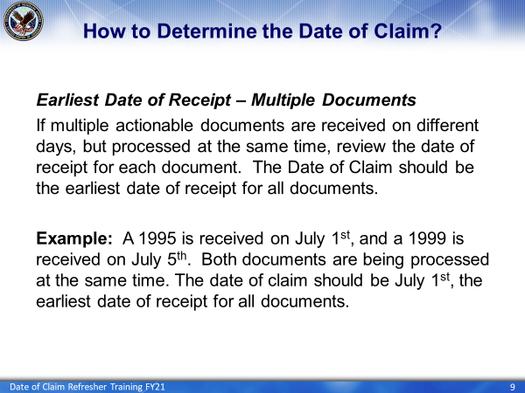 | DISPLAY slide 9.  If multiple actionable documents are received on one claim, use the document with the earliest date of receipt as the date of claim.  Example: A 1995 is received on July 1st, and a 1999 is received on July 5th. Both documents are being worked at the same time, therefor the date of claim will be July 1st.
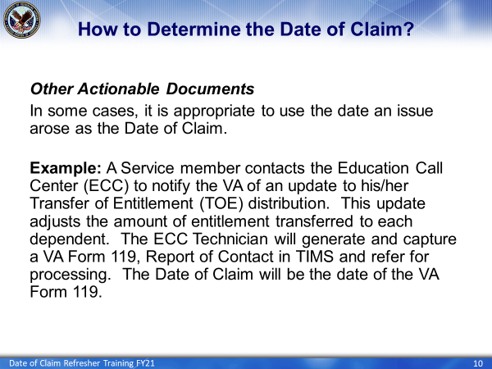 | DISPLAY slide 10.  In some cases the date of claim will not come from a submitted document but will be a date an issue arose.  For example, a service member calls the Education Call Center and informs the phone tech that he/she have updated their TOE distribution. The ECC tech fills out and captures to the dependents TIMS file a report of contact/119. The claim is then routed to the proper que to be processed. The date of claim the VCE will use is the date of the report of contact/119, this is the date the issue arose.
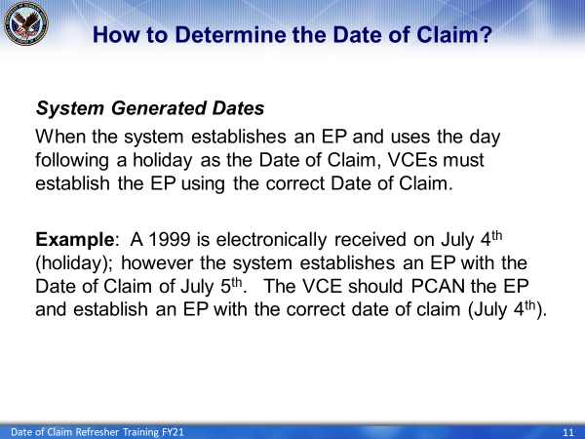 | Display slide 11.  All documents need to be reviewed to determine the date received. If the system sets up the EP, verify that the date of claim on the EP matches the date on the document.  There are times when the system alters the date of claim. One example is if a document is received on a holiday, the system establishes the EP on the day following the holiday. In these cases the EP will need to be PCAN’d (or cancelled) and a new EP established with the correct date of claim.  This may require the VCE to defer processing for one day to re-establish the EP.
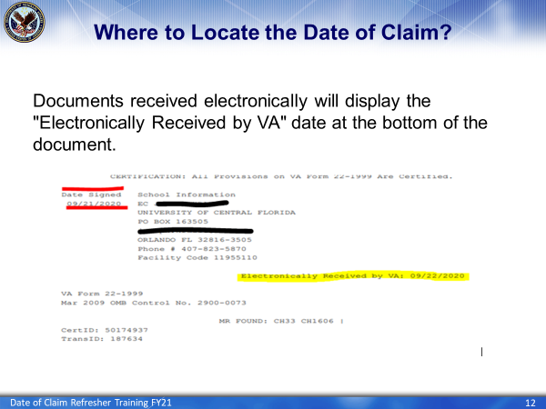 | DISPLAY slide 12.  There are two dates visible at the bottom of electronically received documents; the “Date Signed” highlighted in red and the “Electronically Received by VA” date highlighted in yellow. If the earliest received document was received electronically, the date of claim will be the “Electronically Received by VA” date.
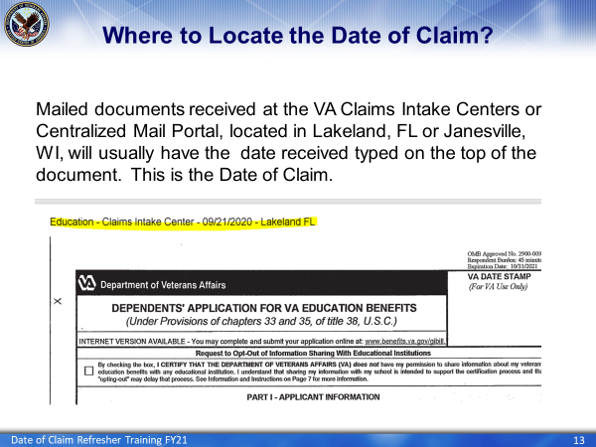 | DISPLAY slide 13.  As previously mentioned, there are two Centralized Mail locations, which are often referred to as CMP. One is Lakeland Florida and the other in Janesville Wisconsin.  When a document is received through CMP, the date received will usually be typed on the top of the document as shown in the slide highlighted in yellow. This will be the date of claim.
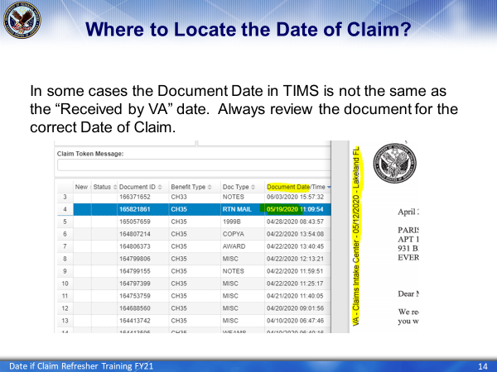 | Display slide 14.  Again, reviewing the document for the correct date of receipt is important. In some cases the “Received by VA” date for documents uploaded from the CMP may not be the same as the Document Date in TIMS.  Do not rely on the Document Date reflected in TIMS for the correct “Received by VA” date. Always review the document for the correct date of claim.
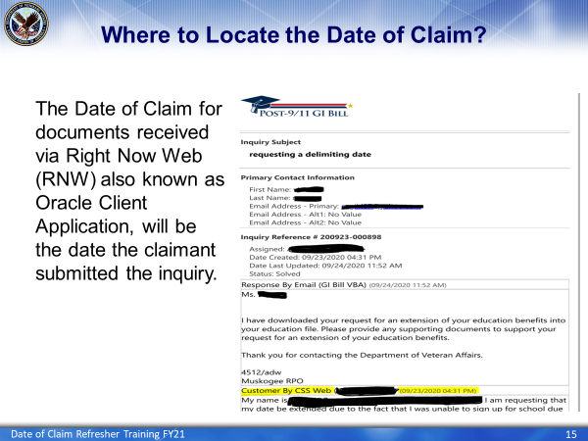 | DISPLAY slide 15.  Documents are also received through Right Now Web or RNW and also known as Oracle Client Application. For these type of receipts of documents the date of claim will be the date the beneficiary submitted the RNW, shown on slide 11 highlighted in yellow.
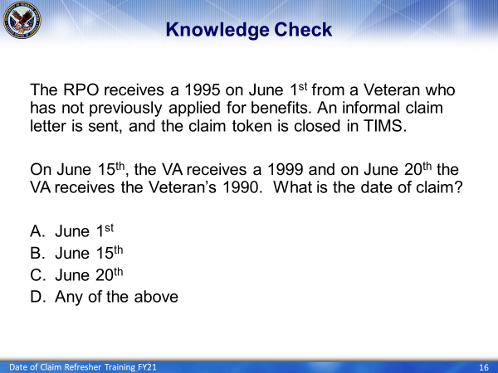 | DISPLAY slide 16.  Question #1: The RPO receives a form v1995 on June 1st from a beneficiary. An informal claim letter is sent, and the file is closed. On June 15th, the school submits a 1999 and on June 20 the beneficiary submits a v1990. What is the date of claim? A. June 1st, B. June 15th, C. June 20th or D. Any of the above?
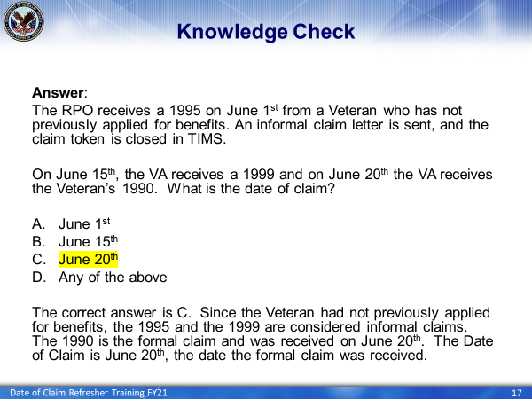 | DISPLAY slide 17.  The correct answer is C, the date the claim became formal with receipt of the v1990 on June 20th.
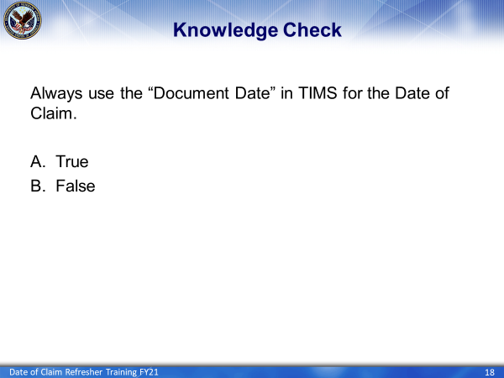 | DISPLAY slide 18.  Question #2: Always use the “Document Date” in TIMS for the Date of Claim. Is this True or False?
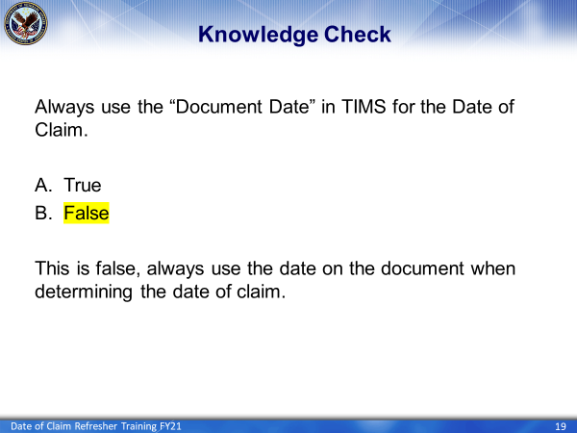 | DISPLAY slide 19.  The correct answer is False.  Always review the document and use the date on the document when determining the date of claim.
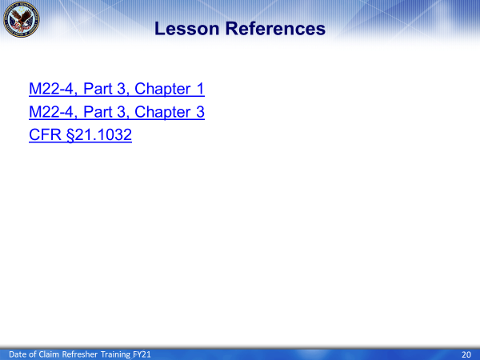 | DISPLAY slide 20.  We have reached the end of todays Date of Claim training. The following references were utilized to develop today’s training.
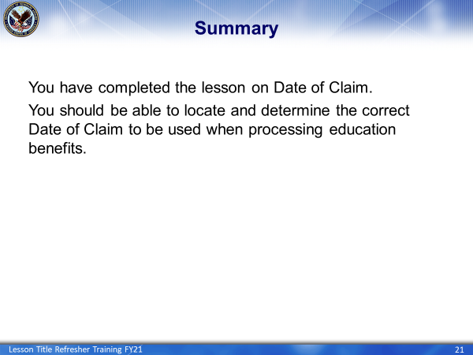 | DISPLAY slide 21.  In summary, today you learned how to locate and determine the correct Date of Claim to be used when processing education benefits.
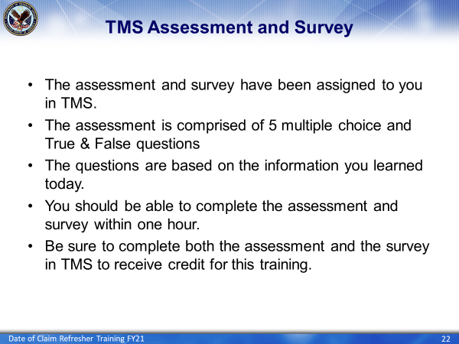 | DISPLAY slide 22.  Finally, in order to receive credit for completion of today’s training you will need to complete the TMS assessment and Survey. The assessment will be assigned to you in TMS and consists of both multiple choice and true/false questions. It should take approximately 30 minutes for you to complete the assessment. Upon completion of the assessment, be sure to complete the survey to receive credit for this training.

