

EDUCATION SERVICE

Conducting a Search in the Knowledge Management Portal (KMP)

Lesson Plan

October 2020 Version 2.0

Lesson Overview
Time Estimate: |  | 1 hour
Purpose of the Lesson: |  | The purpose of this training is to provide refresher training on Conducting a Search in the KMP
Prerequisite Training Requirements: |  | None
Target Audience: |  | Education Service Claims Examiners
Lesson References: |  | The following references support the lesson content:  - KMP Tips and Tricks Handout  - KMP Education Portal
Lesson Objectives: |  | - Refresh your understanding of the KMP functionalities which aid in returning search results  - Refresh your understanding of the various methods you can use to locate resources in KMP
What You Need: | Access to the VBA Intranet and the Education Service Knowledge Management Portal (KMP)
Post Training Requirements:

Instructor Notes
The purpose of this training is to provide a refresher on Conducting a Search in the KMP
PowerPoint Slides | Instructor Activities
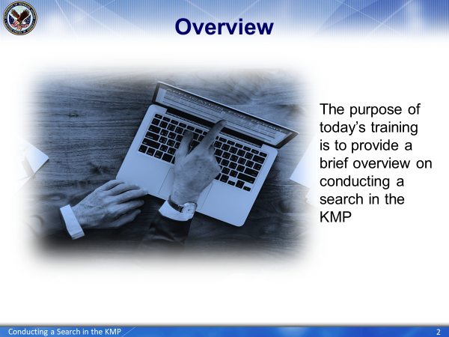 | DISPLAY slide 1  Hello and thank you for joining today’s refresher training session on Conducting a Search in the Knowledge Management Portal (KMP). Today’s training is presented by the National Training Team (Processing).  DISPLAY slide 2  The purpose of today’s training is to provide a brief overview on conducting a search in the KMP
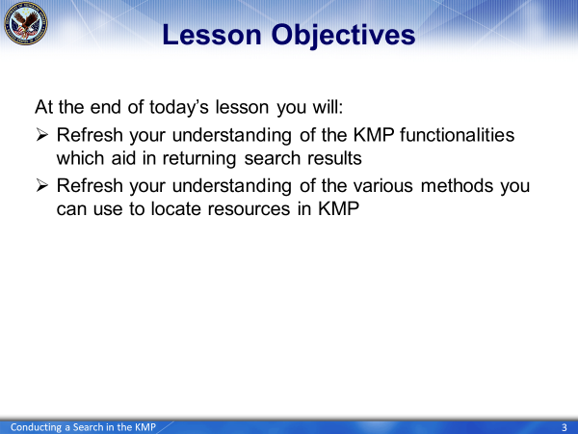 | DISPLAY slide 3  At the end of today’s lesson, you will have an understanding of the KMP and its functionalities.
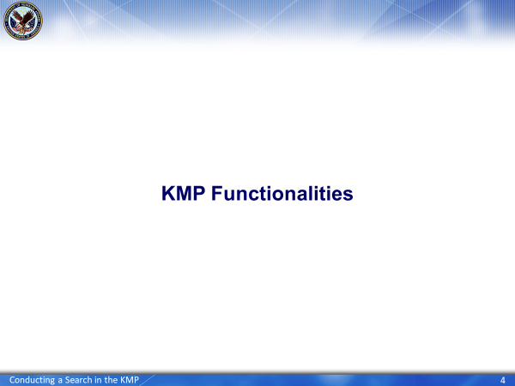 | DISPLAY slide 4
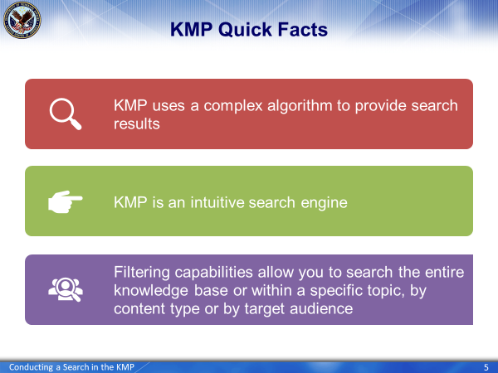 | DISPLAY slide 5  The three key functionalities of the KMP are:  - A two-part complex algorithm  - An intuitive search engine and  - Filtering capabilities  Let’s take a look at each in more detail
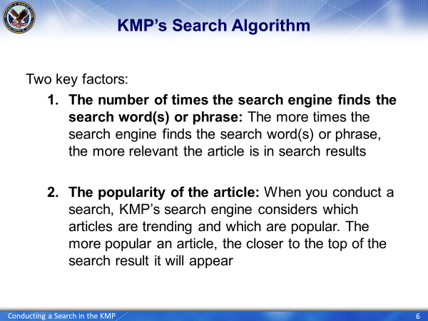 | DISPLAY slide 6  The method in which search results are returned in the KMP is driven by a complex algorithm containing two key factors, the number of times a key word is found and the popularity of the article.:  Essentially, the more times a word or phrase is searched and found in an article, the more relevant that article becomes. Additionally, the more an article is selected and viewed the more popular the article becomes; thus the article will appear at the top or closer to the top of a related search.
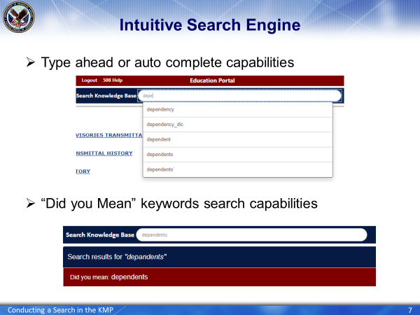 | DISPLAY slide 7  The KMP is an intuitive search engine with type ahead or auto complete capabilities. As you begin typing a keyword or phrase, the algorithm performs a prediction of possible search queries and shows a drop-down list of related words and phrases.  If you misspell a word, the “did you mean” functionality will appear and will provide the correct spelling of the term you are seeking. You simply click on the recommend spelling and are taken to the results page for that search
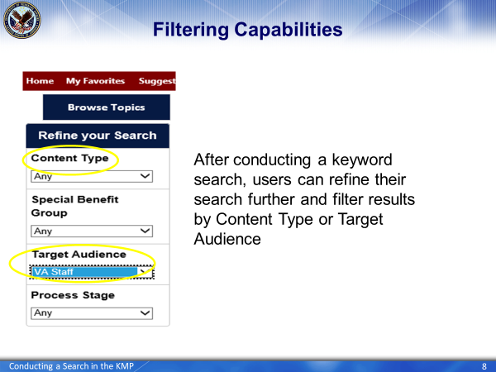 | DISPLAY slide 8  The KMP contains filtering capabilities which allow you to refine your search through a variety of filters. We recommend filtering by Content Type (for example System Advisories or User Guide) or Target Audience, specifically VA Staff or Education. Refining your search in this manner will only return articles tagged or labeled with these particular filters.
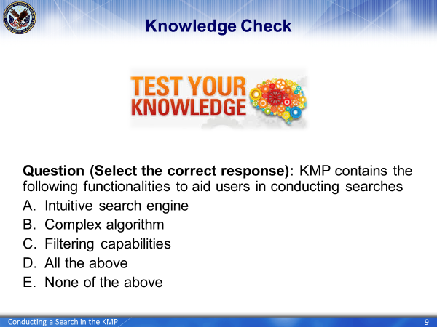 | DISPLAY slide 9  Before we move on, let’s test your knowledge of the KMP functionalities.  KMP contains the following functionalities to aid users in conducting searches  - Intuitive search engine  - Complex algorithm  - Filtering capabilities  - All of the above  - None of the above
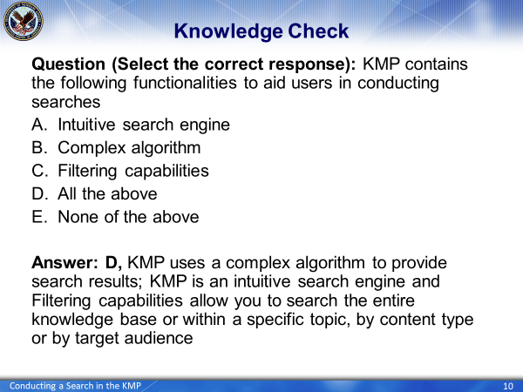 | DISPLAY slide 10  The correct answer is D, All the above. KMP uses a complex algorithm to provide search results; KMP is an intuitive search engine with filtering capabilities that allow you to search the entire knowledge base or within a specific topic, by content type or by target audience
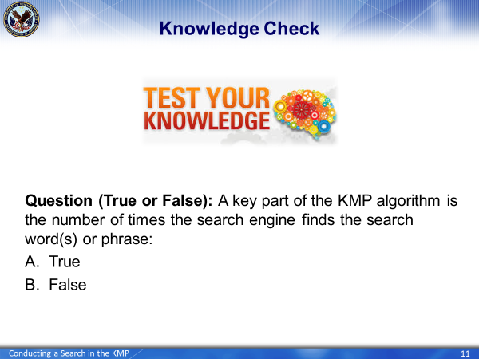 | DISPLAY slide 11  A key part of the KMP algorithm is the number of times the search engine finds the search word(s) or phrase:  - True  - False
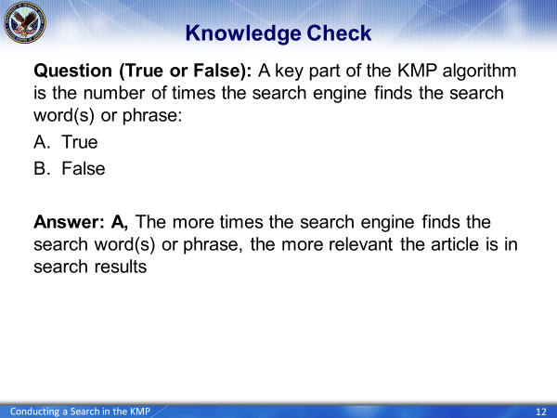 | DISPLAY slide 12  The correct answer is A, True. The more times the search engine finds the search word(s) or phrase, the more relevant the article is in search results.
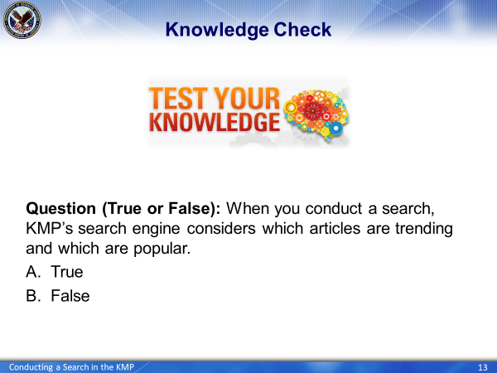 | DISPLAY slide 13  When you conduct a search, KMP’s search engine considers which articles are trending and which are popular.  - True  - False
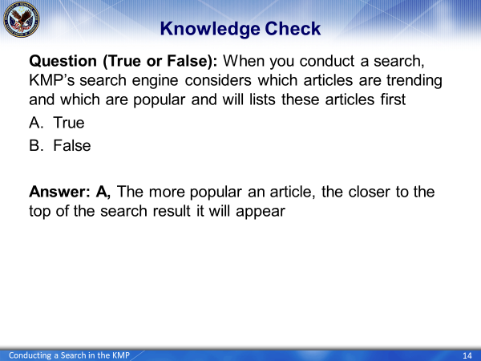 | DISPLAY slide 14  The correct answer is A, True. The more popular an article, the closer to the top of the search result it will appear
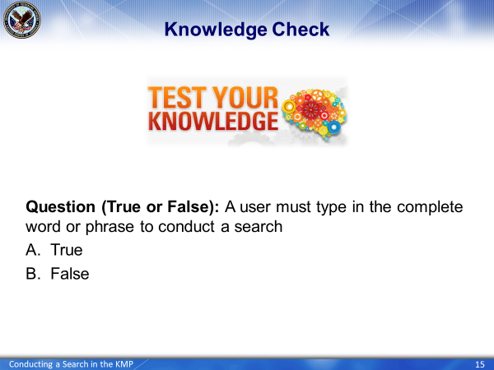 | DISPLAY slide 15  A user must type in the complete word or phrase to conduct a search  - True  - False
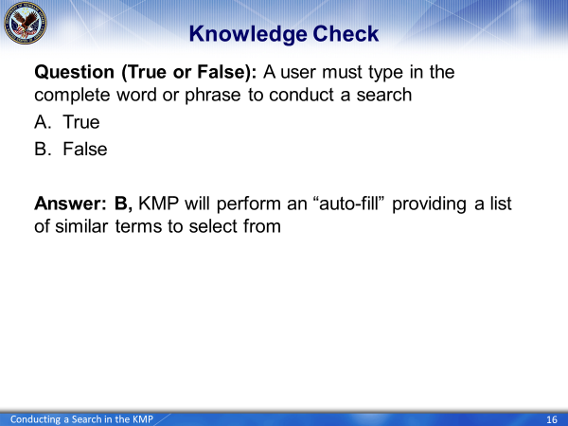 | DISPLAY slide 16  The correct answer is B, False. The KMP will perform an “auto-fill” providing a list of similar terms to select from
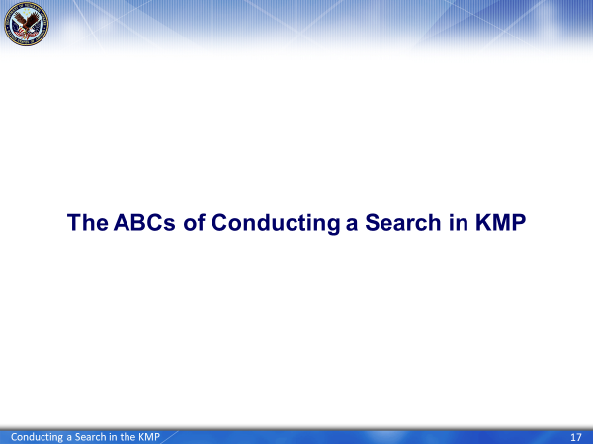 | DISPLAY slide 17  As we have learned more about KMP, we have been able to develop a few tips and tricks on remembering the various methods of conducting a search in the KMP. Let’s explore a few of those now.
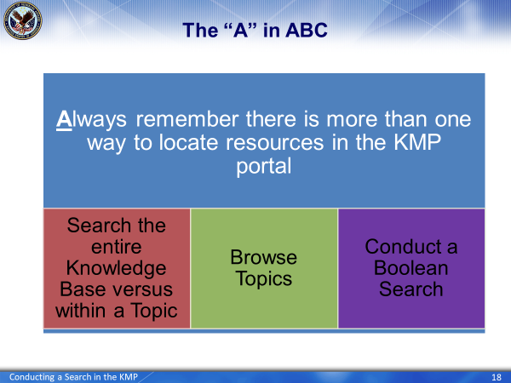 | DISPLAY slide 18  First and foremost, always remember – there is more than one way to locate resources in the KMP portal. You can  - Search the entire knowledge base or you can narrow your results by searching within a specific topic  - Browse Topics: This allows you to save time browsing for specific topics and allows you to navigate much quicker to the content you want to gain access to  And finally, you can  - Conduct a Boolean search  Let’s look at each search method in greater detail
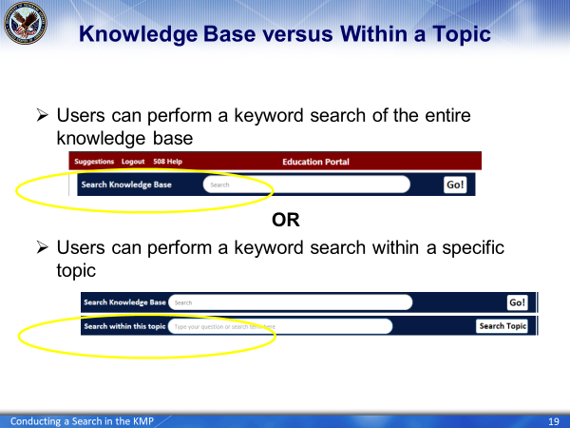 | DISPLAY slide 19  By entering your search word(s) or phrase into the field labeled Search within this topic, KM’s search engine will limit its search to the selected topic instead of searching all of the content in the Education KM portal.
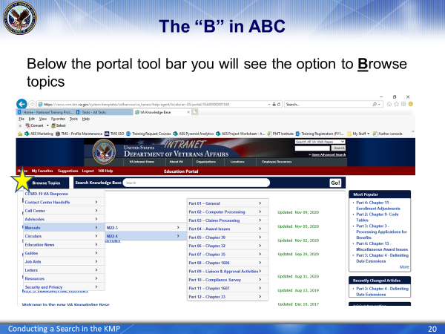 | DISPLAY slide 20  To Browse to a topic, simply hover over Browse and a fly-out menu will appear. Select a Topic from the menu to narrow the search to your specific Topic. For example, if you are looking for information in only the M22-4 Manual, start by narrowing your search using Browse Topics, to select Manuals and then drill down to the M22-4.
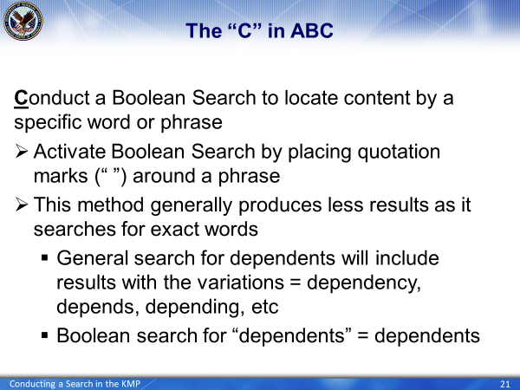 | DISPLAY slide 21  A Boolean search produces more accurate and relevant results, allowing you to navigate through appropriate results while disregarding unrelated results.  To activate a Boolean Search, place quotation marks (“ “) around the phrase. Quotations essentially define a number of words as one exact term, allowing you to narrow your results. pinpoint more accurately.
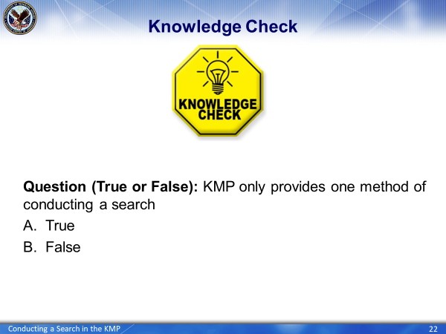 | DISPLAY slide 22  Now that we have reviewed the ABCs of searching in the KMP, let’s test what you have learned.  KMP only provides one method of conducting a search  - True  - False
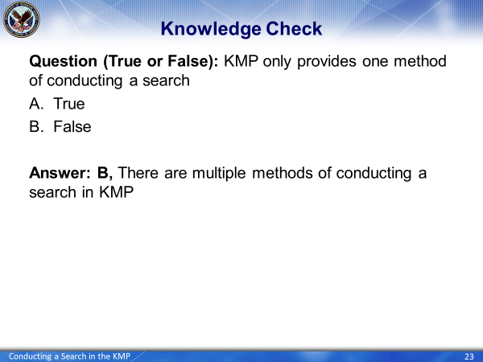 | DISPLAY slide 23  The correct answer is, B, False. There are multiple methods of conducting a search in KMP
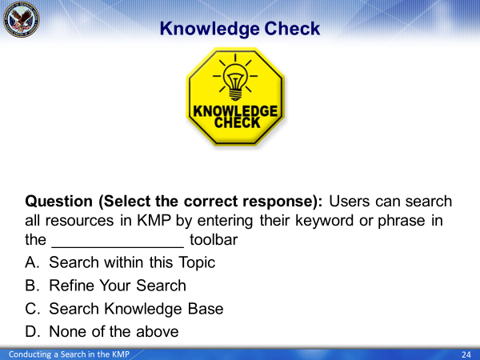 | DISPLAY slide 24  Users can search all resources in KMP by entering their keyword or phrase in the _______________ toolbar  - Search within this Topic  - Refine Your Search  - Search Knowledge Base  - None of the above
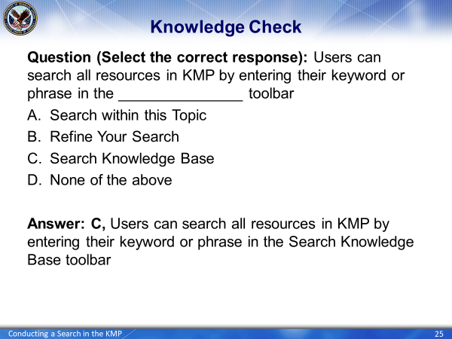 | DISPLAY slide 25  The correct answer is C, Users can search all resources in KMP by entering their keyword or phrase in the Search Knowledge Base toolbar
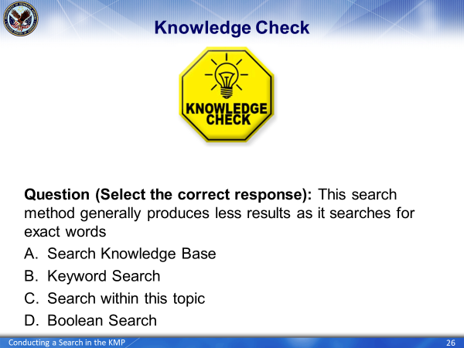 | DISPLAY slide 26  This search method generally produces less results as it searches for exact words  - Search Knowledge Base  - Keyword Search  - Search within this topic  - Boolean Search
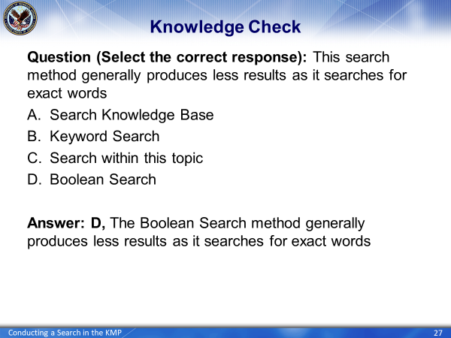 | DISPLAY slide 27  The correct answer is D, the Boolean search method generally produces less results as it searches for exact words
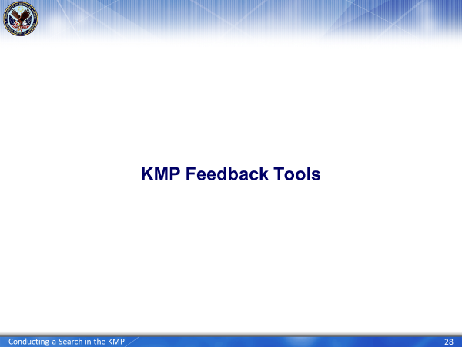 | DISPLAY slide 28  Another feature of the KMP we want to highlight is the ability for you to provide feedback to the KMP team. There are two ways to accomplish this
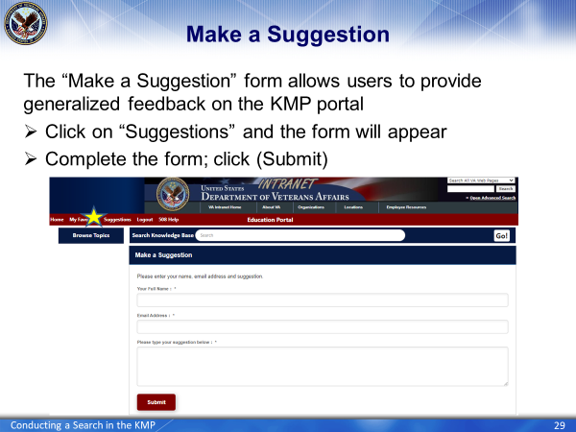 | DISPLAY slide 29  You have the ability to make recommendations on features or the layout of the KMP via the “Make a Suggestion” form. Simply click on the word “Suggestions” on the KMP toolbar and a popup window will appear, opening the form. Simply complete the form and submit it.
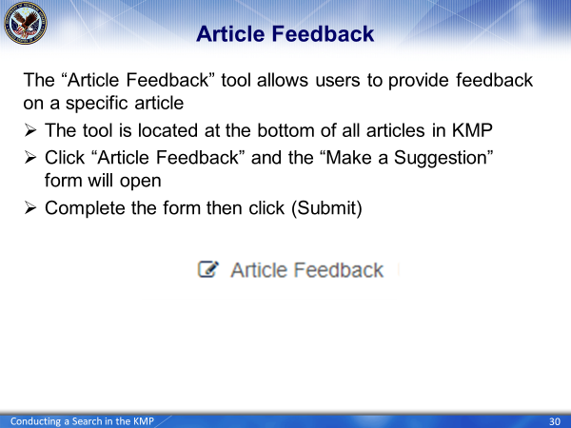 | DISPLAY slide 30  The Article Feedback tool allows you to provide feedback on a specific article. You can report any issues or errors you may have found within the article, such as broken links or incorrect or outdated information.  Simply scroll to the bottom of the article and you will see the “Article Feedback” button. Click on it and a popup window will appear, opening the “Make a Suggestion” form. While this is the same form as previously described, the key difference is your feedback submitted via this method is again, linked directly to the article you are viewing. Complete the form and submit.
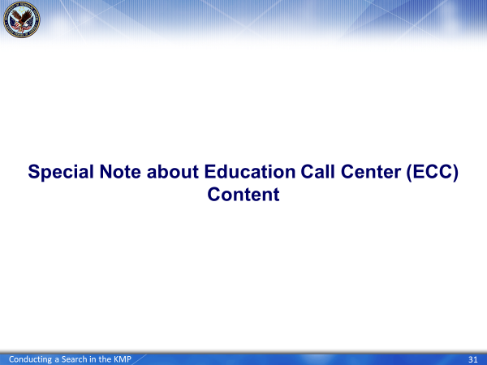 | DISPLAY slide 31  As you are aware, the KMP is a tool for VA lines of business (LOB) to consolidate their different silos of information into one authoritative version located in a centralized location. What does this mean to you?  In addition to housing advisories, manuals, user guides, letters, etc, the KMP also houses content specific to the Education Call Center (ECC).
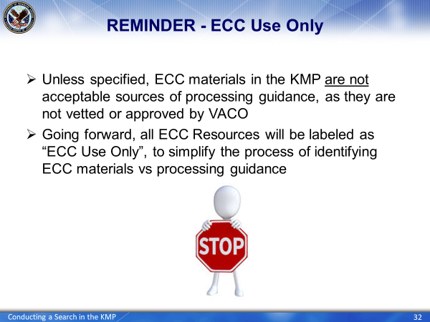 | DISPLAY slide 32  When you are searching for resources in the KMP remember ECC content is not acceptable for use as processing guidance and is solely for use by Call Center agents.  To further alert you to ECC content, the we’ve taken the following actions:  - Labeling all ECC Content with “ECC Use Only” and  - Tagging all ECC Content with a Target Audience of “Education Call Center”.
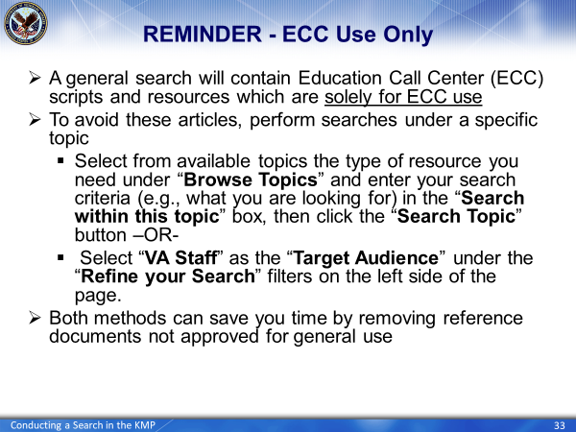 | DISPLAY slide 33  Tagging all ECC Content with a Target Audience of “Education Call Center” will force all ECC content to be filtered from Education Resources when using the Refine Your Search feature.  Simply select “VA Staff” or “Education” as the Target Audience
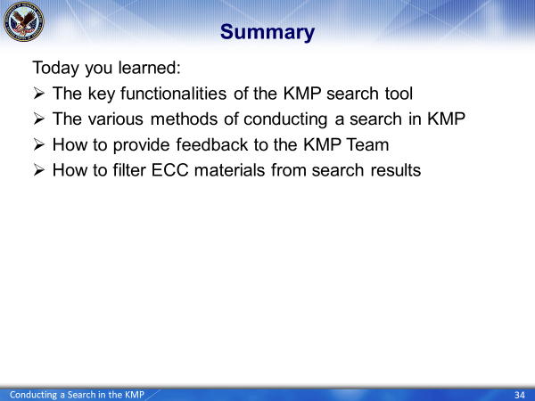 | DISPLAY slide 34  This concludes our refresher training on conducting a search in the KMP. Today, we reviewed  - The key functionalities of the KMP search tool  - The various methods of conducting a search in KMP  - How to provide feedback to the Procedures Team and  - How to filter ECC materials from search results
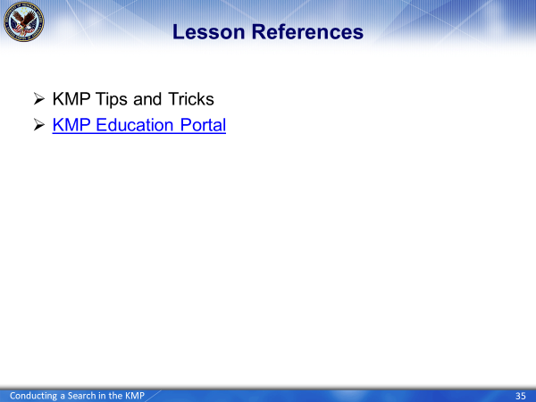 | DISPLAY slide 35  The following resources were used to create today’s training:  KMP Tips and Tricks Handout and the KMP Education Portal
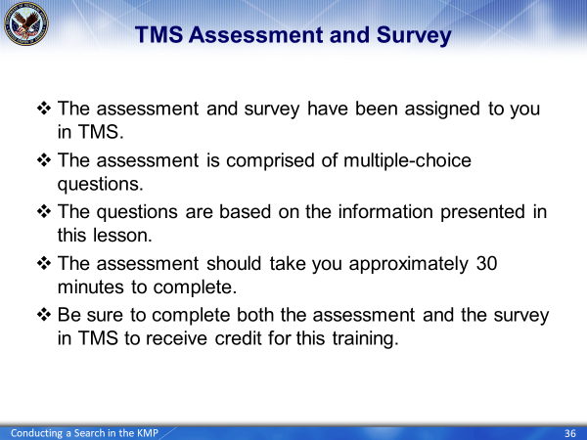 | DISPLAY slide 36  Thank you for your time and attention and be on the lookout for a system-generated email from TMS regarding the course assessment and course survey which must be completed for you to receive credit for the training.

