Education Service
School Closure Processing Procedures (COVID-19 Update) Presentation
Lesson Plan

May 2020
Version 1.0

Lesson Overview
Topic | Description
Time Estimate: | 1 hour
Purpose of the Lesson: | The purpose of this training is to provide the Regional Processing Offices (RPOs) with procedural guidance and instructions for handling temporary school closings under Section 4 and how to handle entitlement charge under Section 5 of PL 116-140.
Prerequisite Training Requirements: | None
Target Audience: | This lesson is designed for the following audiences:  - Veterans Claims Examiners
Lesson References: | - Procedural Advisory: Student Veteran Coronavirus Response Act of 2020: Section 4, Payments of Allowances to Eligible Persons Enrolled in Educational Institutions Closed for Emergency Situations  - Procedural Advisory: Student Veteran Coronavirus Response Act of 2020: Section 5, Prohibition of Charge to Entitlement of Students Unable to Pursue a Program of Education due to an Emergency Situation.
Lesson Objectives: | After you have completed the School Closure Procedures Presentation due to COVID-19 presentation, you will be able to:  - Process temporary school closings under Section 4 of PL 116-140  - Identify what action is needed when reviewing and charging entitlement under Section 5 of PL 116-140
What You Need: | School Closure Processing Procedures (COVID-19 Update) Presentation
Post Training Requirements: | Upon completion of the classroom portion of the lesson, participants are required to complete an online lesson assessment and survey in Talent Management System (TMS).  To demonstrate successful completion of the lesson participants must pass the assessment with a score of at least 80%.  Participants must also complete the online survey to earn credit for completion of the lesson.

PowerPoint Slides | Instructor Activities
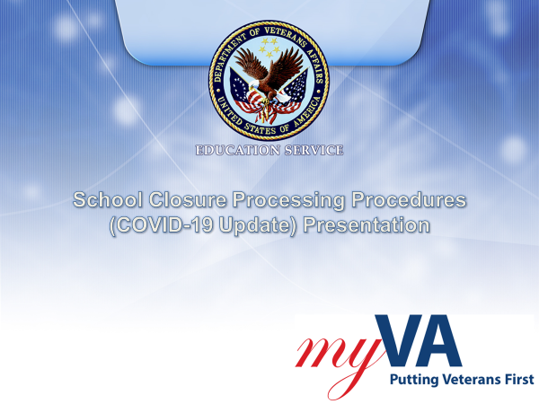 | DISPLAY slide 1. “Processing Housing Relief Requests for Colmery Cases”  INTRODUCE yourself as the instructor and fellow instructors (if any).  INTRODUCE the lesson.
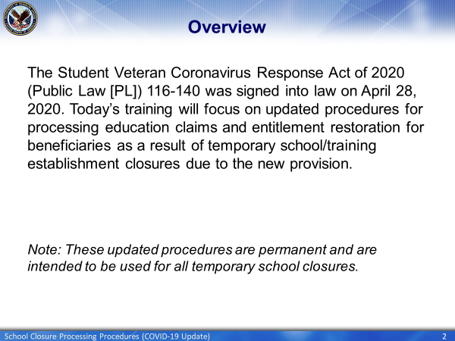 | DISPLAY slide 2. “Overview”  EXPLAIN That the Student Veteran Coronavirus Response Act of 2020 (Public Law [PL]) 116-140 was signed into law on April 28, 2020 and that today’s training will focus on updated procedures for processing education claims and entitlement restoration for beneficiaries as a result of temporary school/training establishment closures due to this provision.
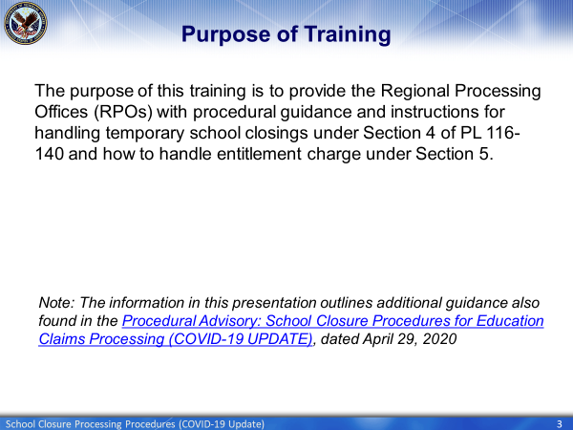 | DISPLAY slide 3. “Purpose of Training”  EXPLAIN The purpose of this training is to provide the Regional Processing Offices (RPOs) with procedural guidance and instructions for handling temporary school closings under Section 4 of PL 116-140 and how to handle entitlement charge under Section 5.  INFORM the class that The information in this presentation outlines additional guidance also found in the Procedural Advisory: School Closure Procedures for Education Claims Processing (COVID-19 UPDATE), dated April 29, 2020
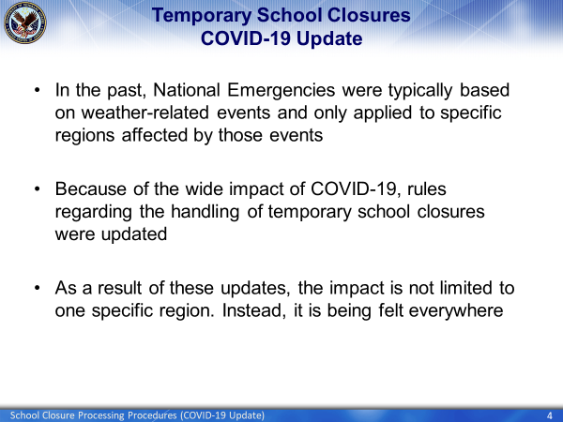 | DISPLAY slide 4. ”Temporary School Closures - COVID-19 Update”  EXPLAIN that however because of the wide impact of COVID-19, rules regarding the handling of temporary school closures were updated  EXPLAIN that as a result of these updates, the impact is not limited to one specific region. Instead, is being felt everywhere
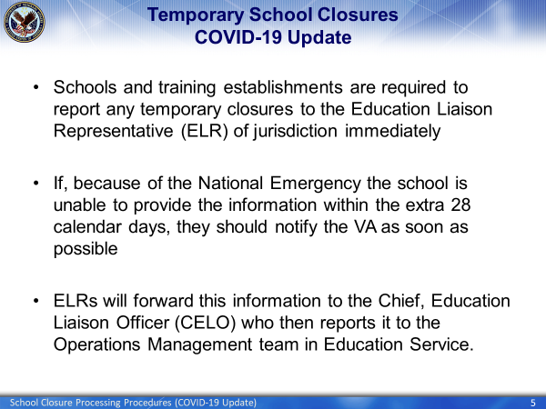 | DISPLAY slide 5 ”Temporary School Closures - COVID-19 Update”  EXPLAIN that Schools and training establishments are required to report any temporary closures to the Education Liaison Representative (ELR) of jurisdiction immediately  EXPLAIN that if, because of the National Emergency the school is unable to provide the information within the extra 28 calendar days, they should notify the VA as soon as possible  EXPLAIN that ELRs will forward this information to the Chief, Education Liaison Officer (CELO) who then reports it to the Operations Management team in Education Service.
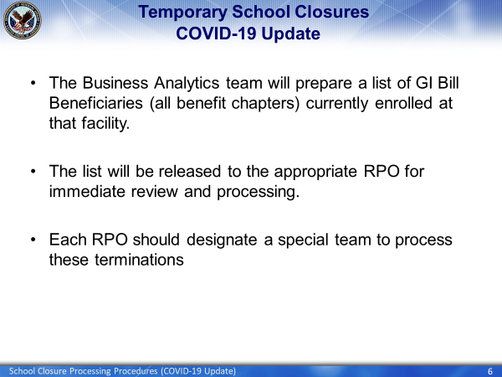 | DISPLAY slide 6 “Claim Process”  EXPLAIN The Business Analytics team will prepare a list of GI Bill Beneficiaries (all benefit chapters) currently enrolled at that facility.  EXPLAIN that the list will be released to the appropriate RPO for immediate review and processing.  EXPLAIN that each RPO should designate a special team to process these terminations
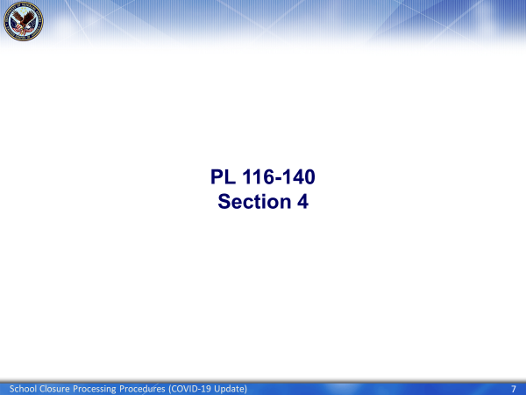 | Display slide 7 “PL 116-140 Section 4”  EXPLAIN that that you will first discuss Section 4 of PL 116-140 which deals with the processing of benefits due to the temporary school closure.  INFORM the this is just a high-level explanation of what Section 4 covers.
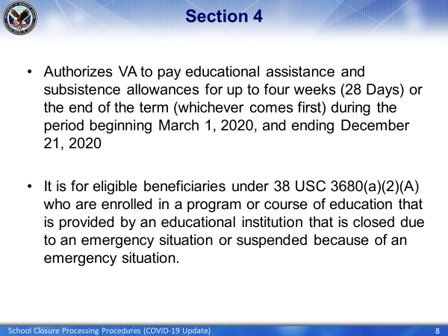 | DISPLAY slide 8 “Section 4”  EXPLAIN that this section authorizes VA to pay educational assistance and subsistence allowances for up to four weeks (28 Days) or the end of the term (whichever comes first) during the period beginning March 1, 2020, and ending December 21, 2020  EXPLAIN that is is for eligibile beneficiaries under 38 USC 3680(a)(2)(A) who are enrolled in a program or course of edduction that is provided by an educational institution that is closed due to an emergency situation or suspended because of an emergency situation
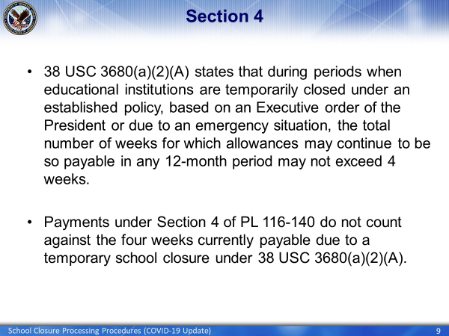 | DISPLAY slide 9 “Section 4”  EXPLAIN that 38 USC 3680(a)(2)(A) states that during periods when educational institutions are temporarily closed under an established policy, based on an Executive order of the President or due to an emergency situation, the total number of weeks for which allowances may continue to be so payable in any 12-month period may not exceed 4 weeks  EXPLAIN that payments under Section 4 of PL 116-140 do not count against the four weeks currently payable due to a temporary school closure under 38 USC 3680(a)(2)(A)
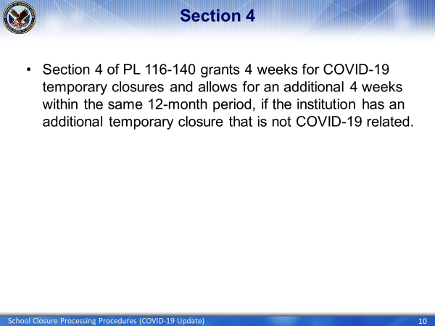 | DISPLAY slide 10 “Section 4”  EXPLAIN that Section 4 of PL 116-140 grants 4 weeks for COVID-19 temporary closures and allows for an additional 4 weeks within the same 12-month period, if the institution has an additional temporary closure that is not COVID-19 related.
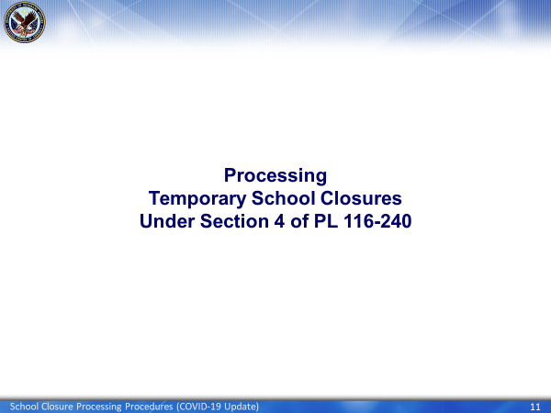 | DISPLAY slide 11 “Processing Temporary School Closures Under Section 4 of PL 116-240”  EXPLAIN that these next few slides will go over what action VCEs must take when they receive a School Closure case.
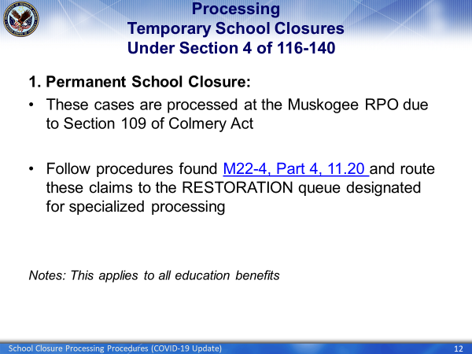 | DISPLAY slide 12 “Processing Temporary School Closures Under Section 4 of PL 116-240”  EXPLAIN that these cases are processed at the Muskogee RPO due to Section 109 of the Colmery Act  INFORM the class to follow the procedures found in M22-4, Part 4, 11.20 and route these claims to the RESTORATION queue designated for specialized processing.
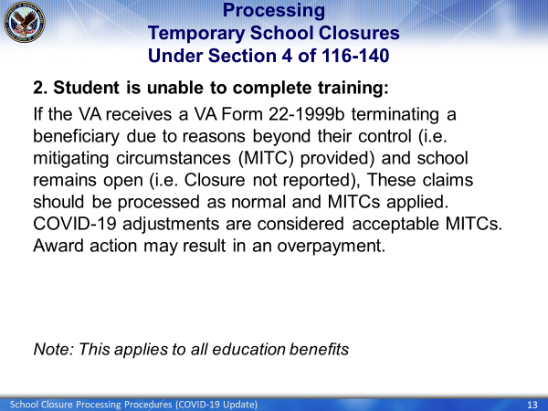 | DISPLAY slide 13 “Processing Temporary School Closures Under Section 4 of PL 116-240”  EXPLAIN that when the student is unable to complete training:  - VA receives VA Form 22-1999b terminating beneficiary due to reasons beyond their control (i.e. mitigating circumstances (MITC) provided) and school remains open (i.e. Closure not reported)  - Process these claims normally and apply MITCs. COVID-19 adjustments are considered acceptable MITCs and award action may result in an overpayment.  EXPLAIN that normal award processing should be taken, and that the action may result in an overpayment.
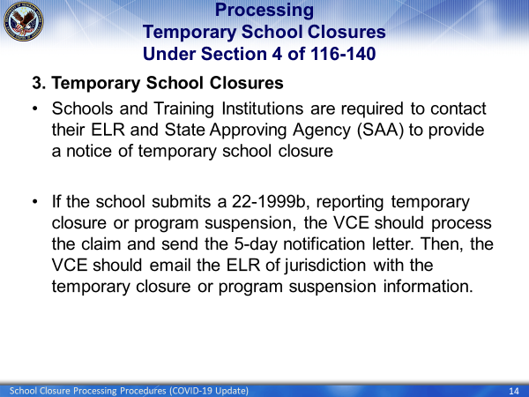 | DISPLAY slide 14 “Processing Temporary School Closures Under Section 4 of 116-140”  EXPLAIN that under temporary school closures:  - Schools and Training Institutions are required to contact their ELR and State Approving Agency (SAA) to provide a notice of temporary school closure  - If the school submits a 22-1999b, reporting temporary closure or program suspension, the VCE should process the claim and send the 5-day notification letter. Then, the VCE should email the ELR of jurisdiction with the temporary closure or program suspension information
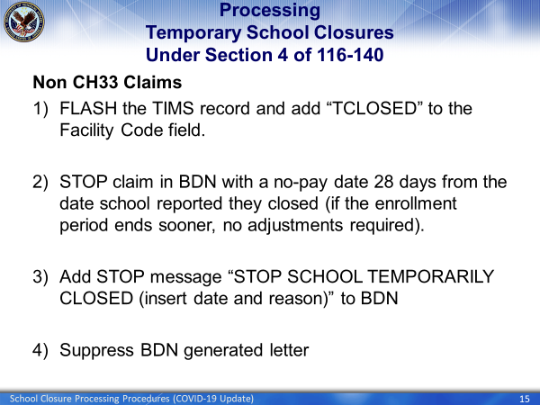 | DISPLAY slide 15 “Processing Temporary School Closures Under Section 4 of 116-140”  EXPLAIN that the steps listed on this slide go over how to handle processing a Section 4 temporary closure claim for beneficiaries receiving Non-Chapter 33 benefits
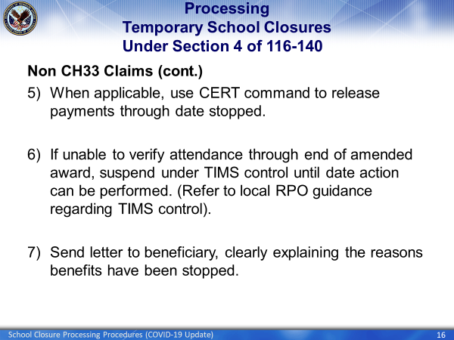 | DISPLAY slide 16 “Processing Temporary School Closures Under Section 4 of 116-140”  EXPLAIN that the steps listed on this slide is a continuation of over how to handle processing a Section 4 temporary closure claim for beneficiaries receiving Non-Chapter 33 benefits
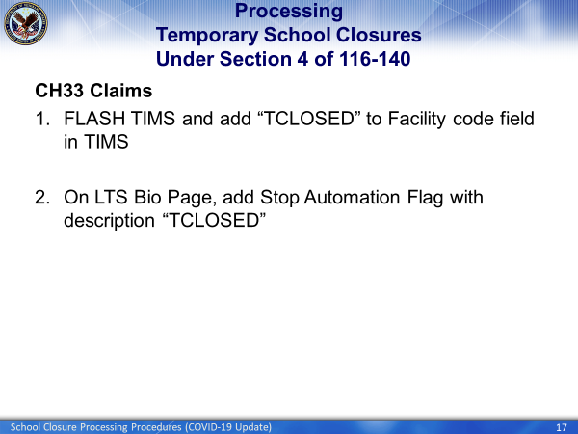 | DISPLAY slide 17 “Processing Temporary School Closures Under Section 4 of 116-140”  EXPLAIN That these next several slides will go over the steps for processing a Section 4 temporary closure claim for beneficiaries receiving Chapter 33 benefits
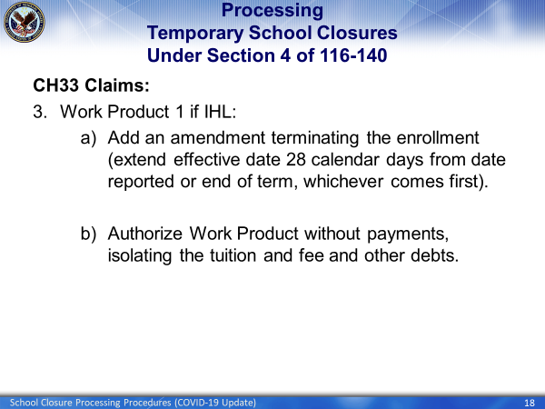 | DISPLAY slide 18 “Processing Temporary School Closures Under Section 4 of 116-140”  EXPLAIN that processing a temp school closure for Chapter 33 claims requires 2 work products.  EXPLAIN that this slide goes over how to process the first work product if the beneficiary attended an IHL.
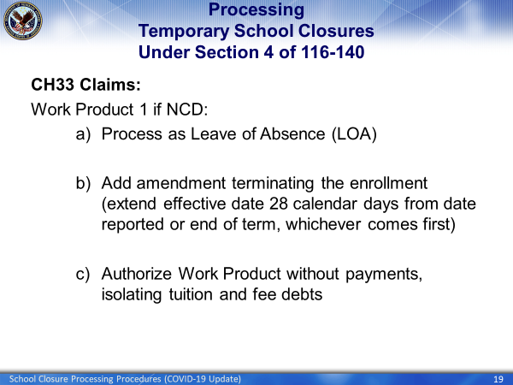 | DISPLAY slide 19 “Processing Temporary School Closures Under Section 4 of 116-140”  EXPLAIN that this slide goes over how to process the first work product if the beneficiary attended an IHL
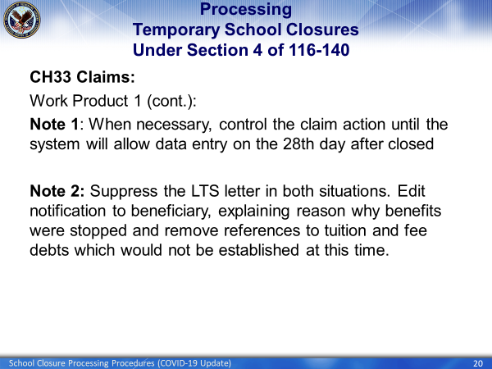 | DISPLAY slide 20 “Processing Temporary School Closures Under Section 4 of 116-140”  REMIND the class that system generated letters should be suppressed when generated during multi- work product process and do not correctly or completely indicate actions taken.  GIVE this example: certain system generated letters generate when authorizing with no payments or manual payments which either requires editing or is not a final action. In those situations, the letters should be suppressed
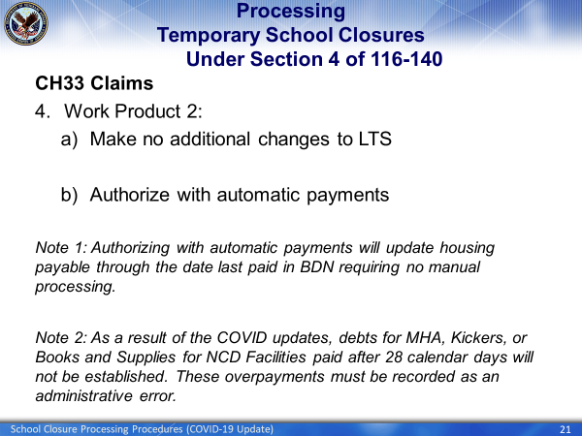 | DISPLAY slide 21 “Processing Temporary School Closures Under Section 4 of 116-140”  EXPLAIN that slide shows how to process the second work product
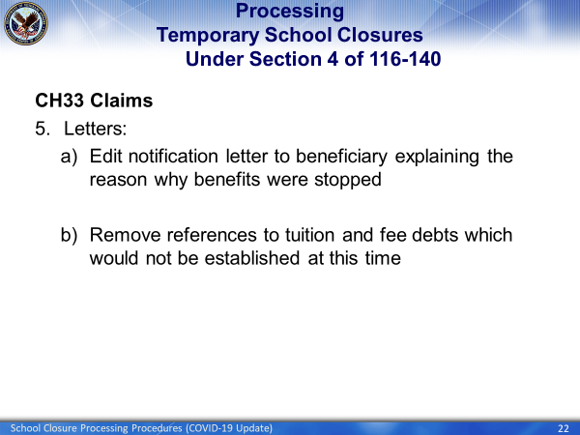 | DISPLAY slide 22 “Processing Temporary School Closures Under Section 4 of 116-140”  EXPLAIN what action needs to be taken when editing the notification letter being sent to the student.
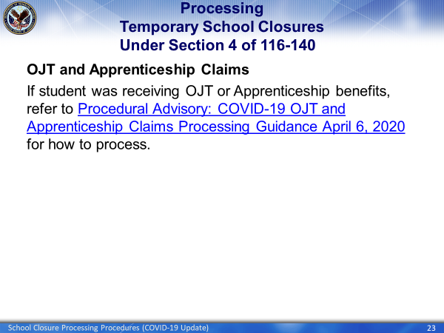 | DISPLAY slide 23 “Processing Temporary School Closures Under Section 4 of 116-140”  EXPLAIN that the student needs to refer to Procedural Advisory: COVID-19 OJT and Apprenticeship Claims Processing Guidance April 6, 2020 when processing an OJT/Apprenticheship claim.
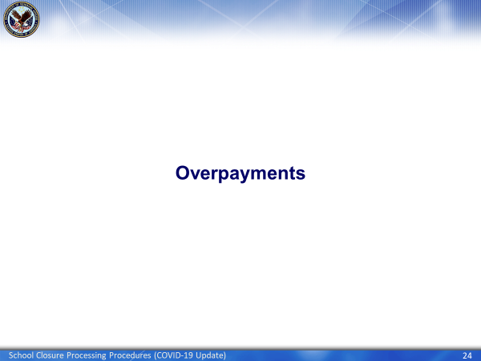 | DISPLAY slide 24 “Overpayments”  EXPLAIN that these next few slides will discuss how to process each overpayment created as a result of the termination due to the temporary school closure
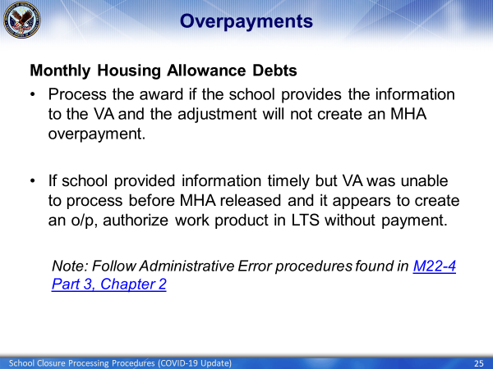 | DISPLAY slide 25 “Overpayments”  DISCUSS what steps should be taken when processing Monthly Housing Allowance Debts
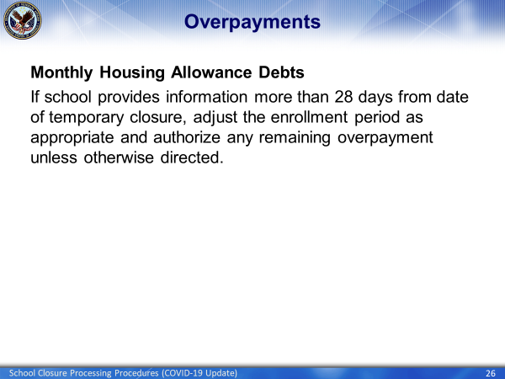 | DISPLAY slide 26 “Overpayments”  CONTINUE discussing what steps should be taken when processing Monthly Housing Allowance Debts
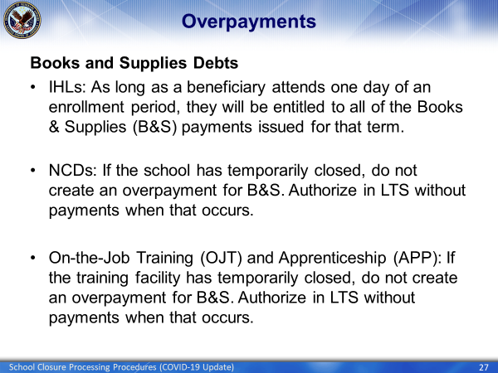 | DISPLAY slide 27 “Overpayments”  EXPLAIN what steps should be taken when processing Books and Supplies Debts
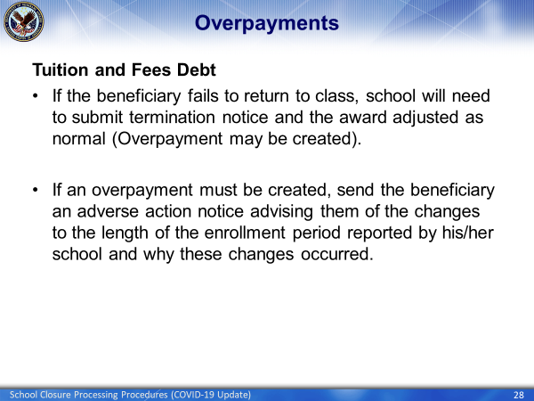 | DISPLAY slide 28 “Overpayments”  EXPLAIN to the class that the presumption is that after a temporary school closure due to COVID-19 or any other reason, when it resumes training, students won’t be charged additional tuition and fees.
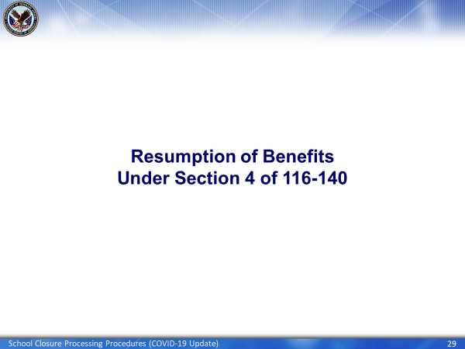 | DISPLAY slide 29 “Resumption of Benefits  Under Section 4 of 116-140”  EXPLAIN That this next slide will explain how to resume benefits after a temporarily closed school reopens
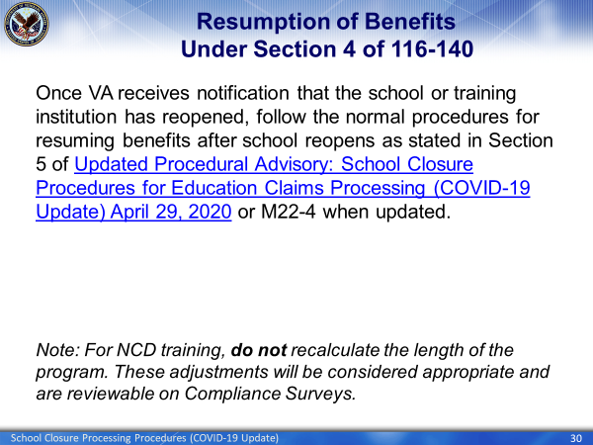 | DISPLAY slide 30 “Resumption of Benefits  Under Section 4 of 116-140”  EXPLAIN that once VA receives notification that the school or training institution has reopened, follow the normal procedures for resuming benefits after school reopens as stated in Section 5 of Updated Procedural Advisory: School Closure Procedures for Education Claims Processing (COVID-19 Update) April 29, 2020 or M22-4 when updated.  EXPLAIN that For NCD training, do not recalculate the length of the program. These adjustments will be considered appropriate and are reviewable on Compliance Surveys.
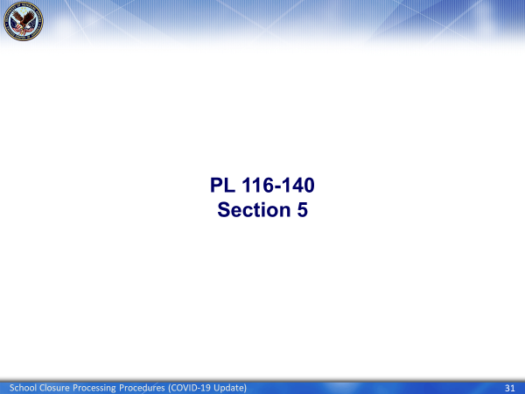 | DISPLAY slide 31 “PL 116-140 Section 5”  EXPLAIN These next several slides will give a high-level review of Section 5 of PL 116-140
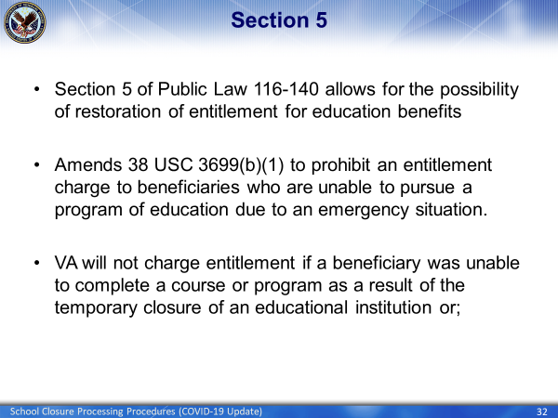 | DISPLAY slide 32 “Section 5”  EXPLAIN that Section 5:  - Allows for the possibility of restoration of entitlement for education benefits  - Amends 38 USC 3699(b)(1) to prohibit an entitlement charge to beneficiaries who are unable to pursue a program of education due to an emergency situation.  - States that VA will not charge entitlement if a beneficiary was unable to complete a course or program as a result of the temporary closure of an educational institution or
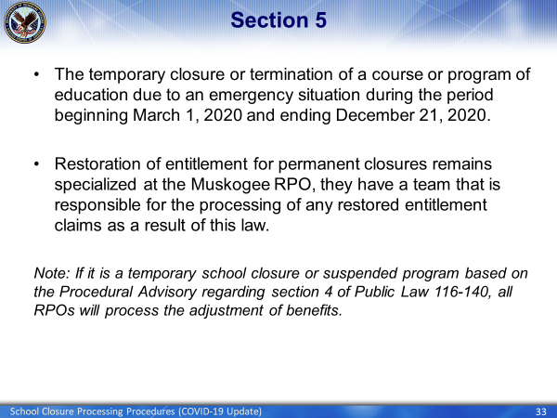 | DISPLAY slide 33 “Scenarios”  EXPLAIN that Section 5 also:  - Is for the temporary closure or termination of a course or program of education due to an emergency situation during the period beginning March 1, 2020 and ending December 21, 2020.  - States that restoration of entitlement for permanent closures remains specialized at the Muskogee RPO, they have a team that is responsible for the processing of any restored entitlement claims as a result of this law.  NOTE that If it is a temporary school closure or suspended program based on the Procedural Advisory regarding section 4 of Public Law 116-140, all RPOs will process the adjustment of benefits.
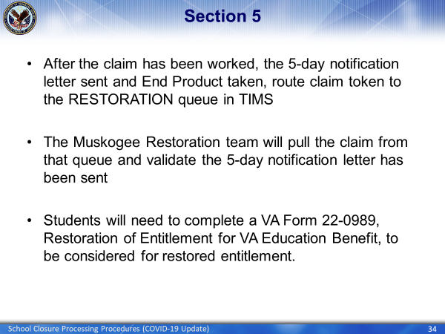 | DISPLAY slide 34 “Section 5”  EXPLAIN that:  - After the claim has been worked, the 5-day notification letter sent and End Product taken, route claim token to the RESTORATION queue in TIMS  - The Muskogee Restoration team will pull the claim from that queue and validate the 5-day notification letter has been sent  - Students will need to complete a VA Form 22-0989, Restoration of Entitlement for VA Education Benefit, to be considered for restored entitlement.
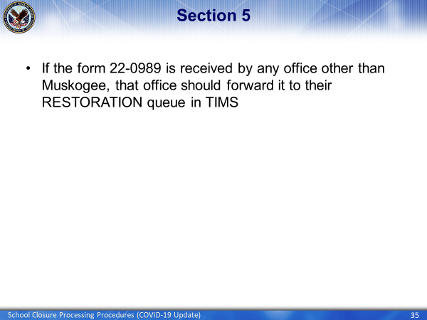 | DISPLAY slide 35 “Final Steps”  EXPLAIN that if the form 22-0989 is received by any office other than Muskogee, that office should forward it to their RESTORATION queue in TIMS
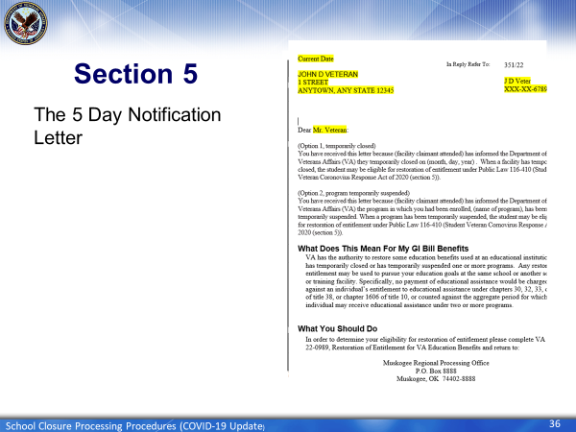 | DISPLAY slide 36 “Final Steps”  EXPLAIN that this slide shows a copy of the 5 day Notification Letter.
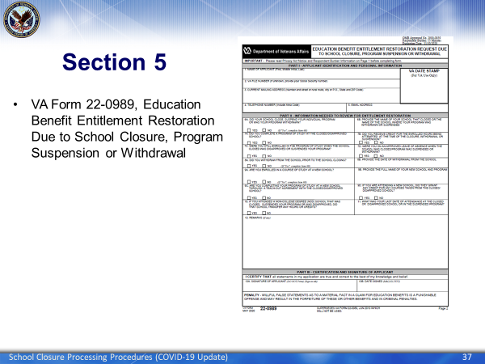 | DISPLAY slide 37 “Final Steps”  EXPLAIN that this slide shows a sample copy of the VA Form 22-0989  EXPLAIN that this the VA Form 22-0989, Education Benefit Entitlement Restoration Due to School Closure, Program Suspension or Withdrawal is what needs to be completed.
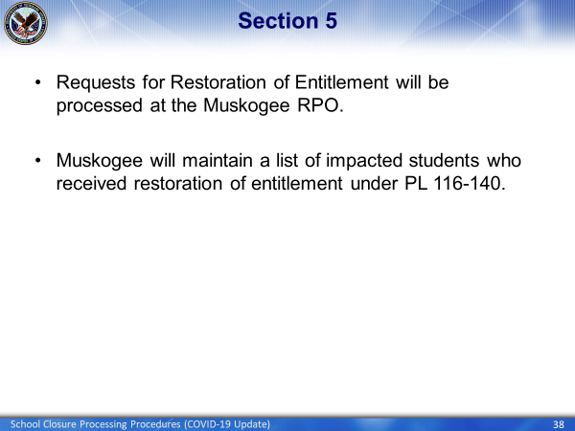 | DISPLAY slide 38 “Section 5”  EXPLAIN that requests for Restoration of Entitlement will be processed at the Muskogee RPO.  EXPLAIN that Muskogee will maintain a list of impacted students who received restoration of entitlement under PL 116-140
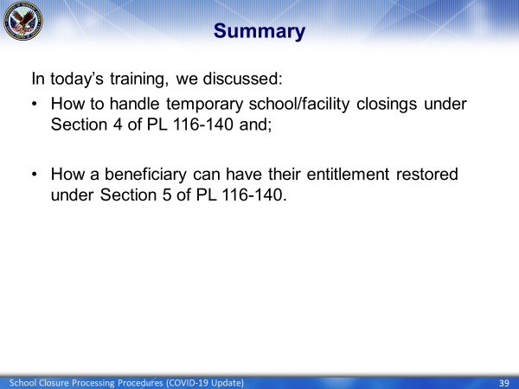 | DISPLAY slide 39 “Summary”  SUMMARIZE today’s presentation
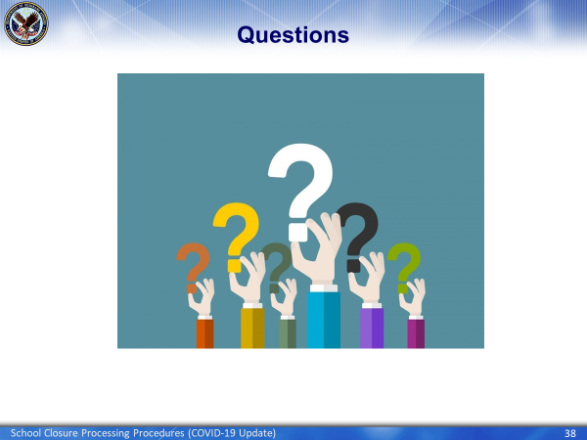 | DISPLAY slide 40 “Questions”  ASK if there are any questions regarding this training.
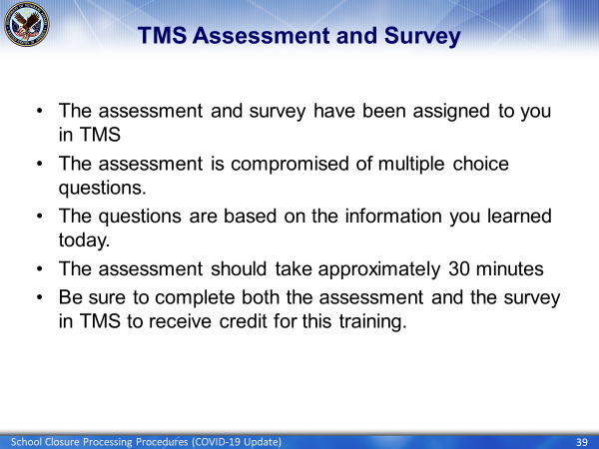 | DISPLAY slide 41 “TMS Assessment and Survey”  INFORM the class that they will need to go to TMS to take the assessment and survey to get credit for this training.

