Education Service
Processing Housing Relief Requests for Colmery Cases
Lesson Plan

March 2020
Version 1.0

Lesson Overview
Topic | Description
Time Estimate: | 1 hour
Purpose of the Lesson: | The purpose of this lesson is to provide the Regional Processing Offices (RPO) the procedures needed to review Colmery Housing Relief claims under a consolidated equitable relief package and submit approvals to the Secretary of Veterans Affairs (SecVA) for consideration.
Prerequisite Training Requirements: | None
Target Audience: | This lesson is designed for the following audiences:  - Veterans Claims Examiners
Lesson References: | - Procedural Advisory: Colmery Housing Relief for Section 501
Lesson Objectives: | After you have completed the Processing Housing Relief Requests for Colmery Cases Presentation, you will be able to:  - Identify and process claimants who have submitted a request for Colmery Housing Relief under Section 501/107  - Submit approvals via SharePoint to the Quality Assurance Team (QAT) in Education Service for consideration by the Secretary of Veterans Affairs (SecVA).  - If denied, notify the claimant of denial of their housing relief request.  - If approved by the SecVA, process the approval and notify the claimant of the approval.
What You Need: | Processing Housing Relief Requests for Colmery Cases Training Presentation
Post Training Requirements: | Upon completion of the classroom portion of the lesson, participants are required to complete an online lesson assessment and survey in Talent Management System (TMS).  To demonstrate successful completion of the lesson participants must pass the assessment with a score of at least 80%.  Participants must also complete the online survey to earn credit for completion of the lesson.

PowerPoint Slides | Instructor Activities
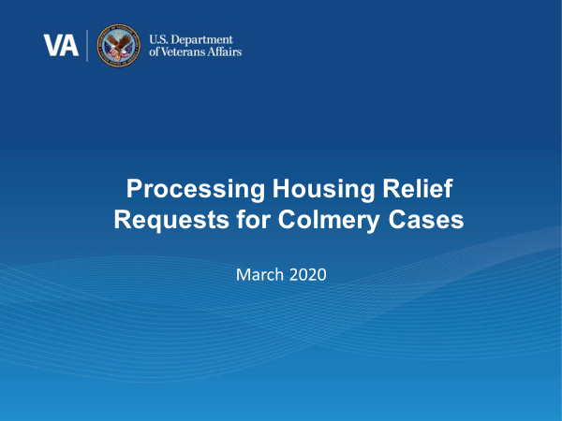 | DISPLAY slide 1. “Processing Housing Relief Requests for Colmery Cases”  INTRODUCE yourself as the instructor and fellow instructors (if any).  INTRODUCE the lesson.
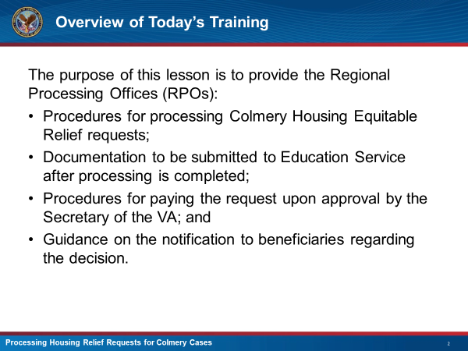 | DISPLAY slide 2. “Overview”  EXPLAIN The purpose of this lesson is to provide the Regional Processing Offices (RPOs):  - Procedures for processing Colmery Housing Equitable Relief requests;  - Documentation to be submitted to Education Service after processing is completed;  - Procedures for paying the request upon approval by the Secretary of the VA; and  - Guidance on the notification to beneficiaries regarding the decision.
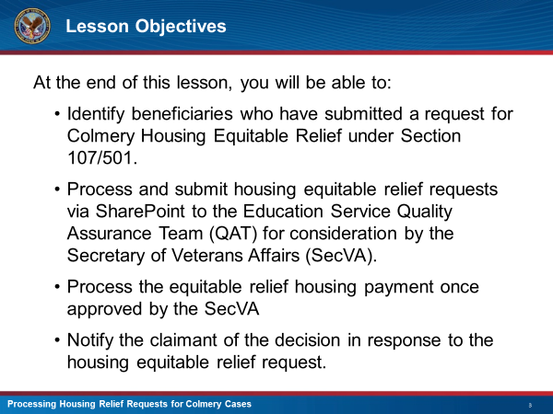 | DISPLAY slide 3. “Lesson Objectives”  EXPLAIN That you will go over how to:  - Identify beneficiaries who have submitted a request for Colmery Housing Equitable Relief under Section 107/501.  - Process and submit housing equitable relief requests via SharePoint to the Education Service Quality Assurance Team (QAT) for consideration by the Secretary of Veterans Affairs (SecVA).  - Process the equitable relief housing payment once approved by the SecVA  - Notify the claimant of the decision in response to the housing equitable relief request.
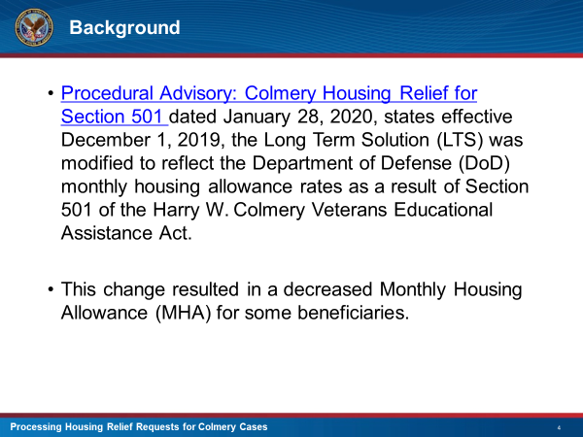 | DISPLAY slide 4. ”Background”  INFORM the class that the per Procedural Advisory “Colmery Housing Relief for Section 501” LTS was modified to reflect DoD rates as a result of Section 501 of the Colmery Act  EXPLAIN this change resulted in some claimants seeing their MHA decrease  EXPLAIN this program is a temporary plan to assist the claimants transition from the old MHA rate to the new rate based on the Colmery change
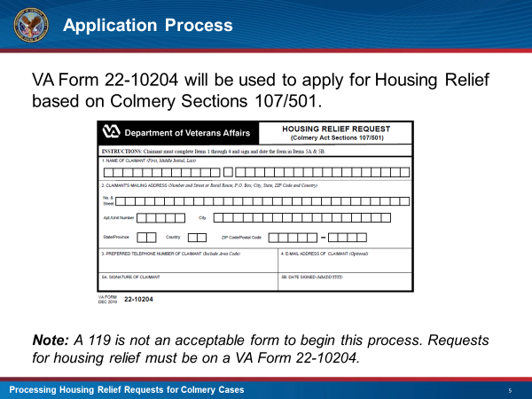 | DISPLAY slide 5 “Application Process”  SHOW the class what the Colmery Housing Request form looks like  EXPLAIN that a Colmery Housing Request should be completed on this Housing Relief Request Form (VA Form 22-10204)  REMIND the class that a request can only be processed if the VA Form 22-10204 is on file  INFORM the class that this form can be submitted through three different possible sources:  - The GI Bill Oracle System (formerly Right Now Web (RNW))  - The Education Call Center  - Forms mailed directly to the RPOs and received by Upstream for intake.
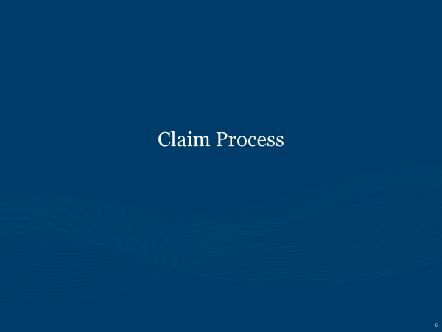 | DISPLAY slide 6 “Claim Process”  EXPLAIN that you will now be going over the steps that need to be taken once a VA Form 22-10204 is received
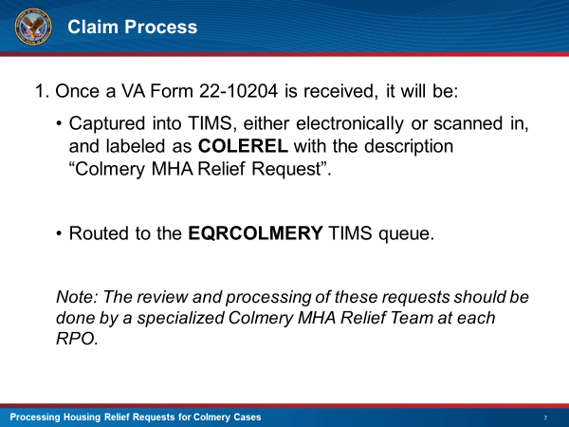 | Display slide 7 “Claim Process”  EXPLAIN that once a request has been identified as a Housing Relief request, the following steps should occur:  - Request captured into TIMS and labeled COLEREL using the description “Colmery MHA Relief Request” in the Remarks Field  - The token should then be routed to the EQRCOLMERY queue either manually or by TIMS  EXPLAIN that a specialized team should process these requests
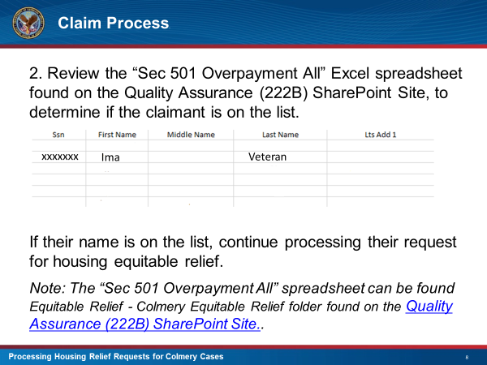 | DISPLAY slide 8 “Claims Process”  EXPLAIN that before processing the request, the “Section 501 Overpayment All” spreadsheet should be reviewed to see if claimant’s name is on it  EXPLAIN that if the claimant’s name is on the list, it is okay to process the request for equitable relief  EXPLAIN that if the claimant’s name is not on the list, VCE must determine if the criteria for a 501 adjustment has been met. If so, VCE can continue with processing the request
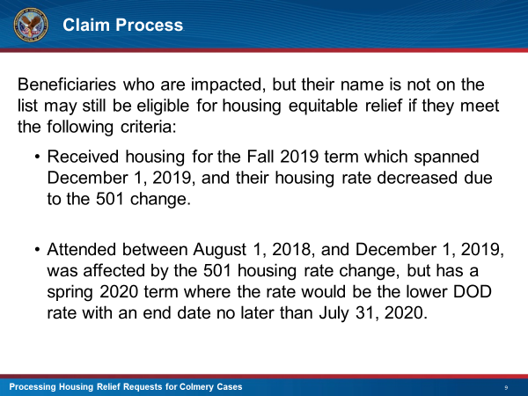 | DISPLAY slide 9 “Claims Process”  EXPLAIN how claimants not on the “Section 501 Overpayment All” spreadsheet could still be entitled to housing relief if they meet the criteria found on this slide
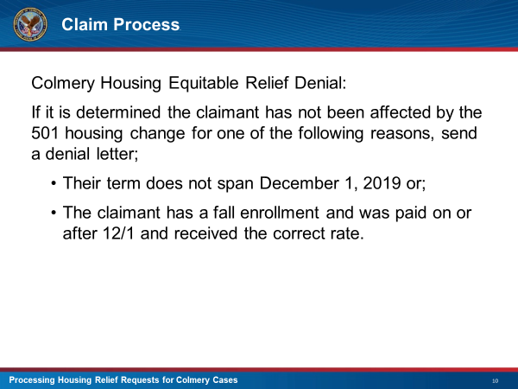 | DISPLAY slide 10 “Claims Process”  INFORM the class that if the claimant cannot be identified as having been affected by a 501 adjustment, deny their request.  Do not grant appellate rights.
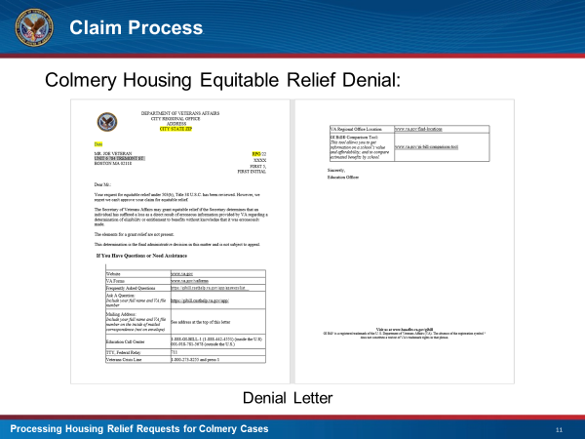 | DISPLAY slide 11 “Claims Process”  EXPLAIN this is a sample copy of the denial letter that is sent if the claimant does not meet the eligibility requirements for housing relief.
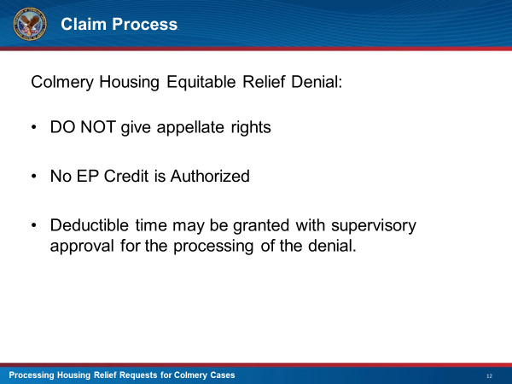 | DISPLAY slide 12 “Claims Process”  EMPHASIZE that appellate rights should not be given.  INFORM the class no EP credit should be taken but that they can deduct the time they took for processing the denial.
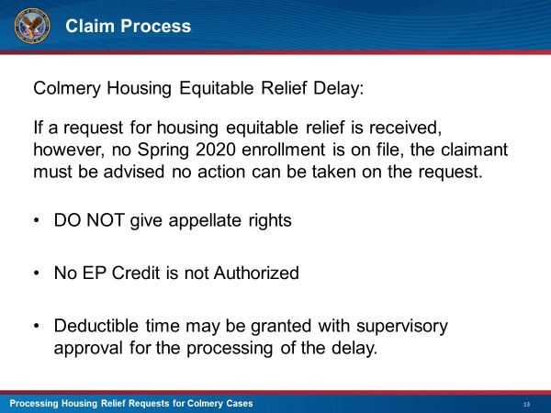 | DISPLAY slide 13 “Claims Process”  EXPLAIN If a request for housing equitable relief is received, but there is no Spring 2020 enrollment is on file, the claimant must be advised no action can be taken on their request.  REMIND the class not to give appellate rights and no EP credit can be taken.  EXPLAIN Deductible time may be granted with supervisory approval for the processing of the delay.
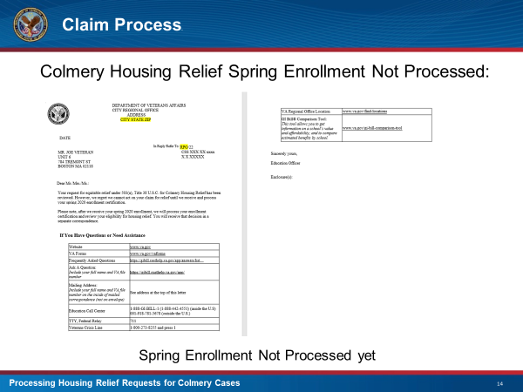 | DISPLAY slide 14 “Claims Process”  EXPLAIN this is a sample copy of the letter that is sent when the claimant’s Spring 2020 term has not been processed yet.
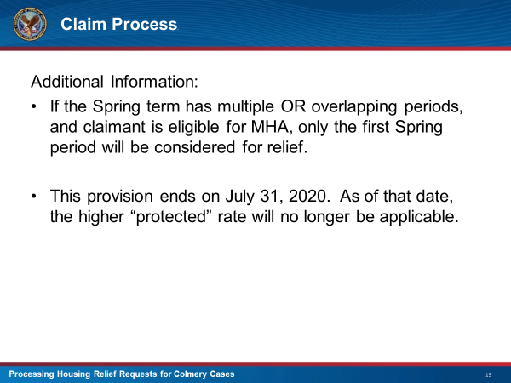 | DISPLAY slide 15 “Claims Processing”  EXPLAIN that if the claimant has multiple or overlapping Spring 2020 terms, only the first one will be considered  INFORM the class that this provision ends July 31, 2020 and after this date, claimants will no longer receive the higher “protected” rate
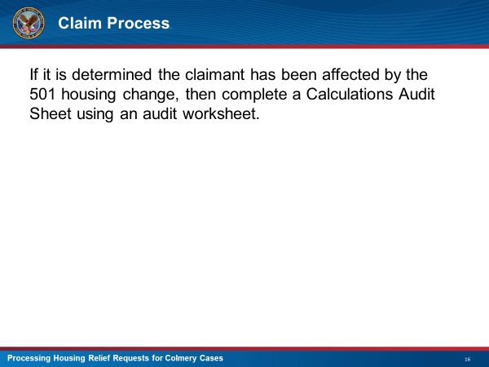 | DISPLAY slide 16 “Claims Process”  INFORM the class that once it is determined the claimant has been affected by the 501 housing change, they would need to complete a Calculations Audit Sheet using their available audit worksheet  EXPLAIN that the worksheet will need to be used to compare the new housing rate vs. the prior housing rate.
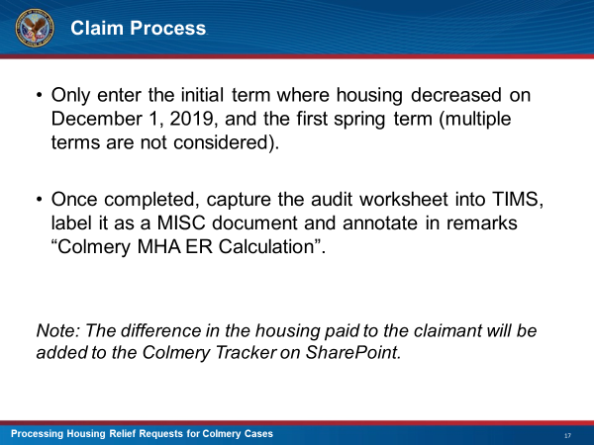 | DISPLAY slide 17 “Claims Process”  DISCUSS what information should be input on the audit worksheet  ADVISE the class that the information on the spreadsheet is then added to the Colmery Tracker that will be forwarded to Education Services and that a copy of the spreadsheet should captured into the claimant’s TIMS file  EXPLAIN That the Tracker that needs to be updated will be labeled as “Colmery Tracker – Updated 022420”
 | DISPLAY slide 18 “Knowledge Check”  INFORM the class that you will now have a knowledge check to go over what they have learned so far.
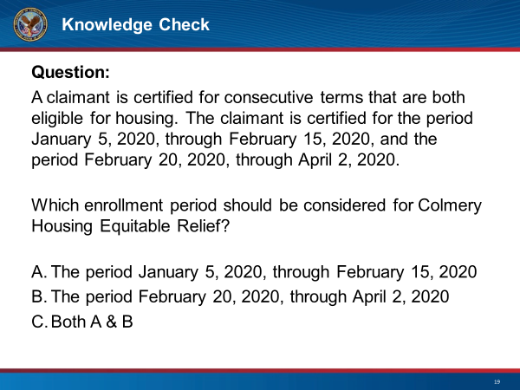 | DISPLAY slide 19 “Knowledge Check”  ASK class, based on the scenario on this slide, what enrollment period would be eligible for Colmery Relief?
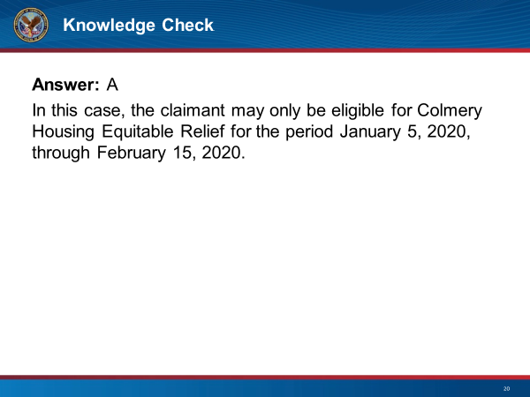 | DISPLAY slide 20 “Knowledge Check”  DISCUSS the answer to the Knowledge Check  ASK if there are any questions about what has been discussed so far before moving on to the next topic
 | DISPLAY slide 21 “Example”  EXPLAIN that you will now go over an example case where the claimant is eligible for Colmery Relief
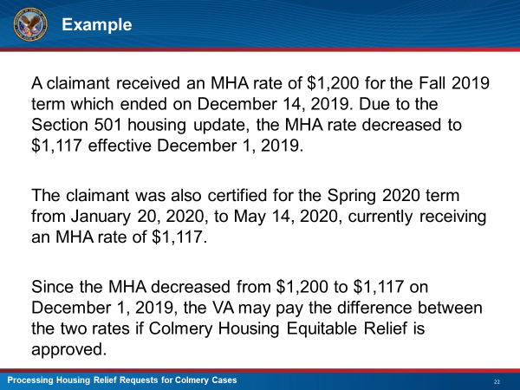 | DISPLAY slide 22 “Example”  DISCUSS why the claimant is entitled to Colmery Relief based on the scenario shown on this slide.
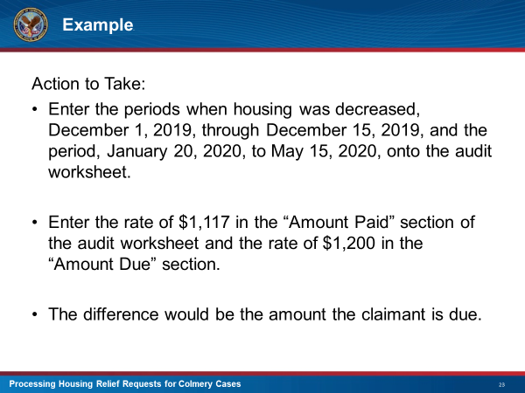 | DISPLAY slide 23 “Example”  DISCUSS what actions the student should take after determining the claimant is entitled to Colmery Relief.
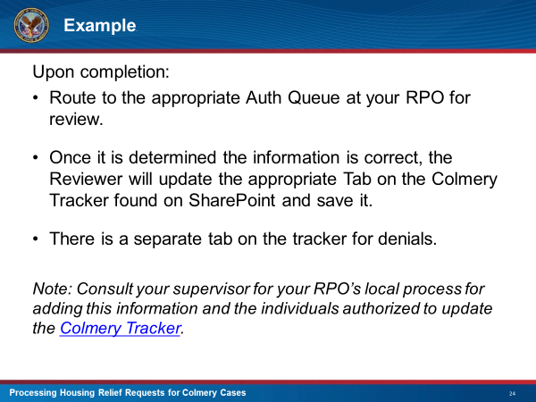 | DISPLAY slide 24 “Example”  DISCUSS what action should be taken after the spreadsheets are completed.  EXPLAIN if the claimant is not eligible for Colmery Relief, there is a separate tab on the Colmery Tracker that needs to be completed.
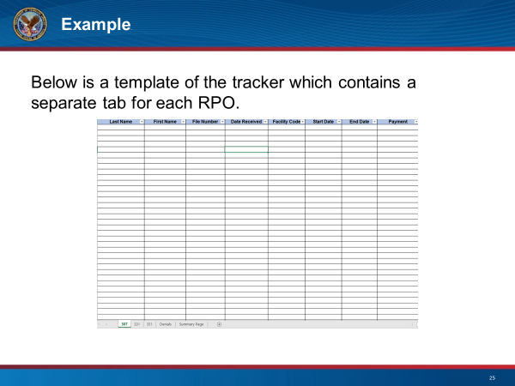 | DISPLAY slide 25 “Example”  EXPLAIN this is a sample of the Colmery Tracker that is to be completed and forwarded to Eductation Services on a bi-weekly basis  NOTE that eact RPO has their own tab to complete and that all denials will be input on the same tab
 | DISPLAY slide 26 “Scenarios”  EXPLAIN that these next several slides will go over different scenarios that the processor may come across.
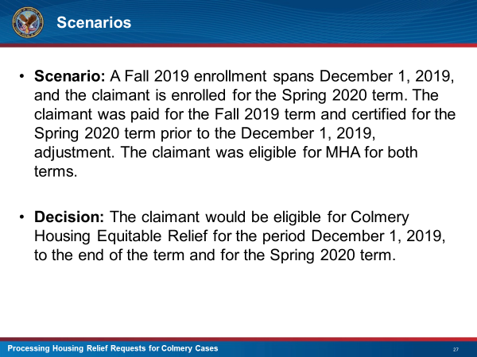 | DISPLAY slide 27 “Scenarios”  DISCUSS the scenario found on this slide  EXPLAIN how the decision was reached
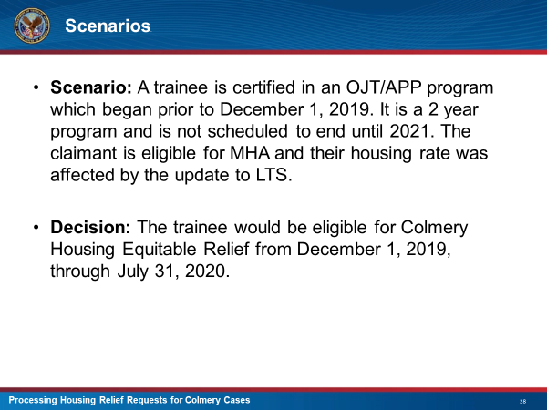 | DISPLAY slide 28 “Scenarios”  DISCUSS the scenario found on this slide  EXPLAIN how the decision was reached
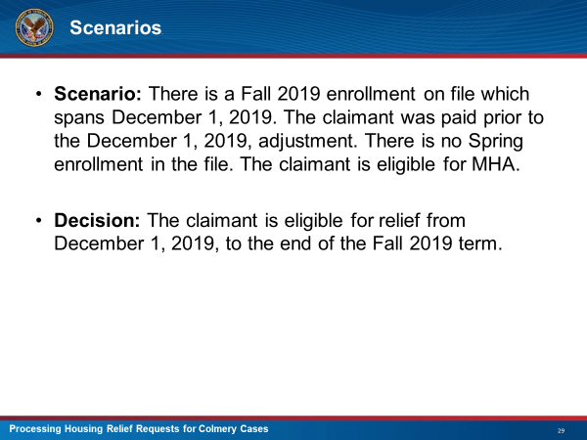 | DISPLAY slide 29 “Scenarios”  DISCUSS the scenario found on this slide  EXPLAIN how the decision was reached
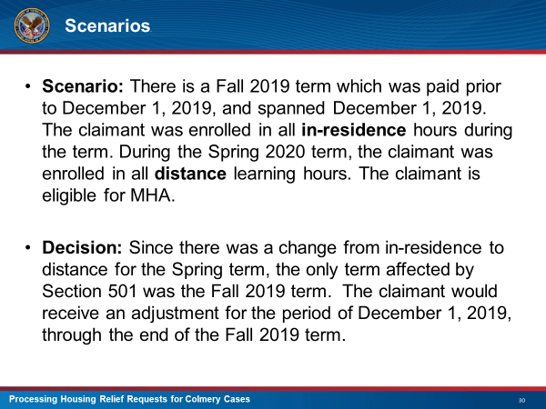 | DISPLAY slide 30 “Scenarios”  DISCUSS the scenario found on this slide  EXPLAIN how the decision was reached
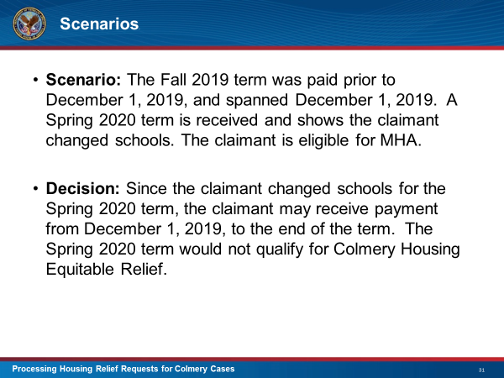 | DISPLAY slide 31 “Scenarios”  DISCUSS the scenario found on this slide  EXPLAIN how the decision was reached
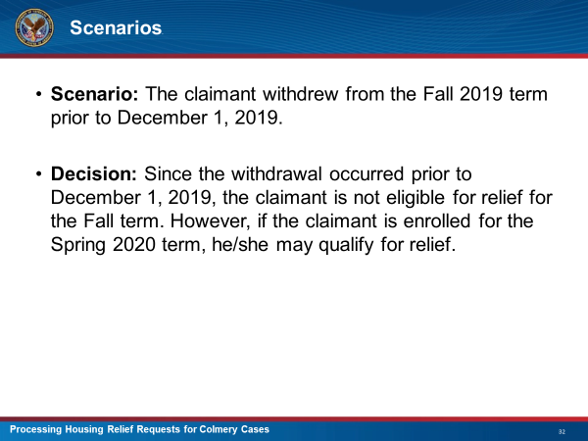 | DISPLAY slide 32 “Scenarios”  DISCUSS the scenario found on this slide  EXPLAIN how the decision was reached
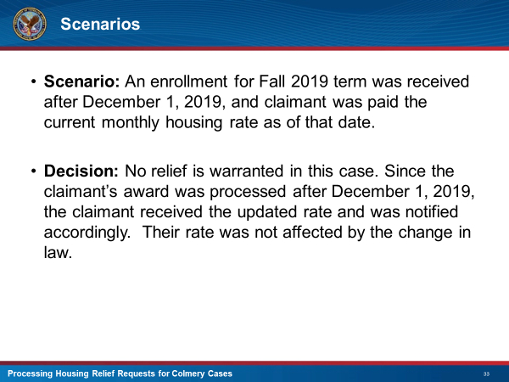 | DISPLAY slide 33 “Scenarios”  DISCUSS the scenario found on this slide  EXPLAIN how the decision was reached
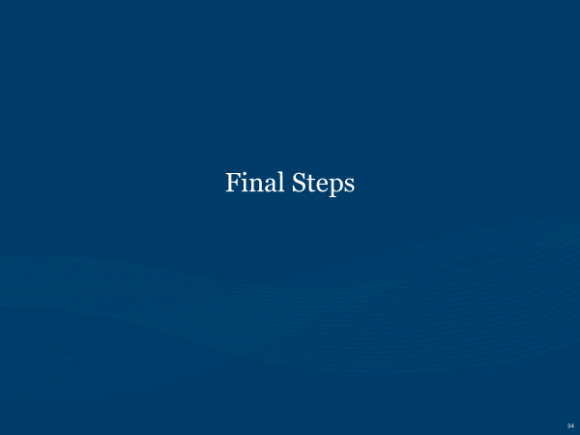 | DISPLAY slide 34 “Final Steps”  EXPLAIN that you will now discuss what happens after the Colmery Tracker is completed and forwarded to Education Services
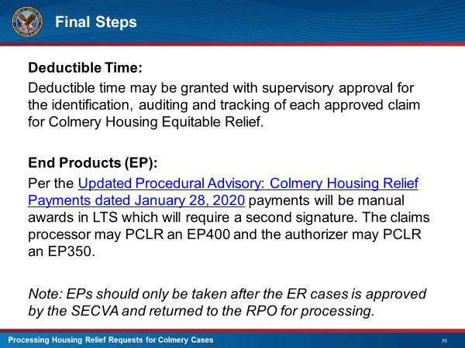 | DISPLAY slide 35 “Final Steps”  EXPLAIN that since no actual award action has been taken yet, no EP credit can be taken and the processor will need to deduct the amount of time they spent working on the project.  EXPLAIN that once the Secretary of the VA approves the cases, the processors who work the awards in BDN, will then be able to take End Product credit for the station and themselves.
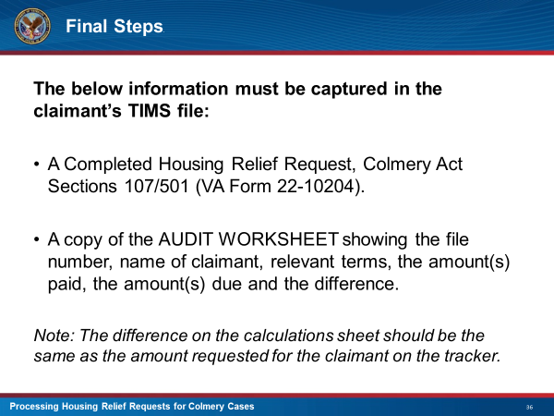 | DISPLAY slide 36 “Final Steps”  EXPLAIN what information needs to be captured into TIMS.
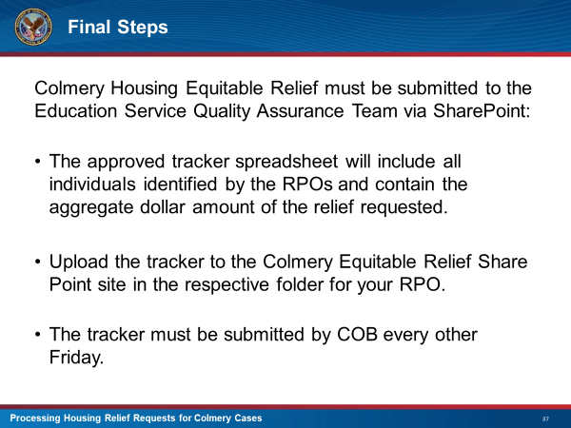 | DISPLAY slide 37 “Final Steps”  EXPLAIN that the person assigned to submit the Tracker to CO will be required to do it via SharePoint  REMIND the class that the tracker needs to be uploaded to the RPOs respective folder
 | DISPLAY slide 38 “Education Service Process”  EXPLAIN That you will now be going over the process Education Services will take once they receive the Tracker from the RPOs
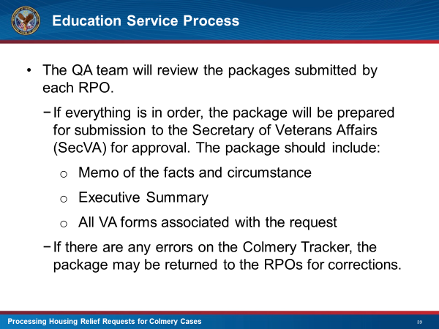 | DISPLAY slide 39 “Education Service Process”  LIST the steps that will be followed by Education Service after they have received the trackers from the RPOs
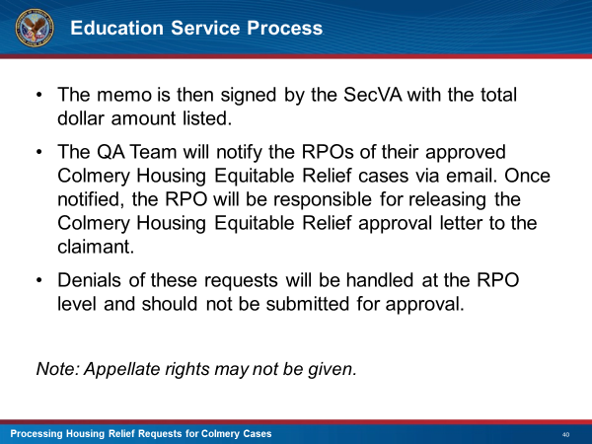 | DISPLAY slide 40 “Education Service Process”  CONTINUE listing the steps that Education Services will follow after the tracker is received.
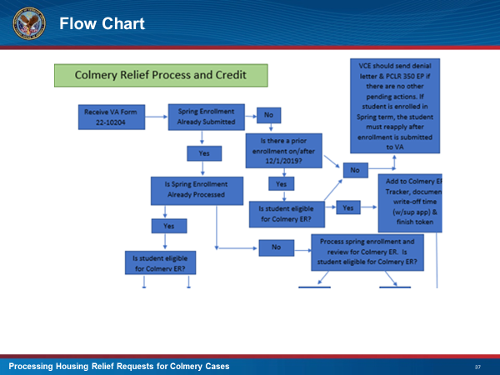 | DISPLAY slide 41 “Flow Chart”  SHOW the flow chart of the Colmery Relief Process  INFORM the class that the bottom half of the flow chart is on the next slide
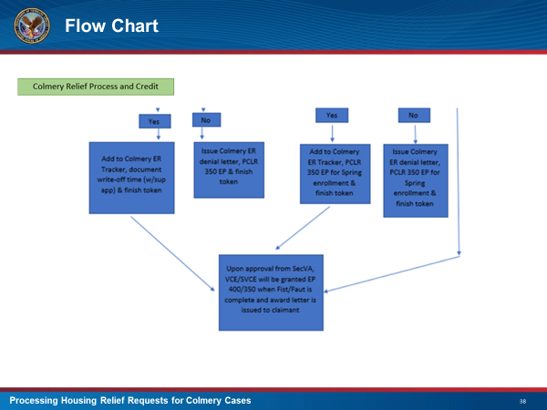 | DISPLAY slide 42 “Flow Chart”  DISCUSS the bottom half of the Colmery Relief Flow Chart.
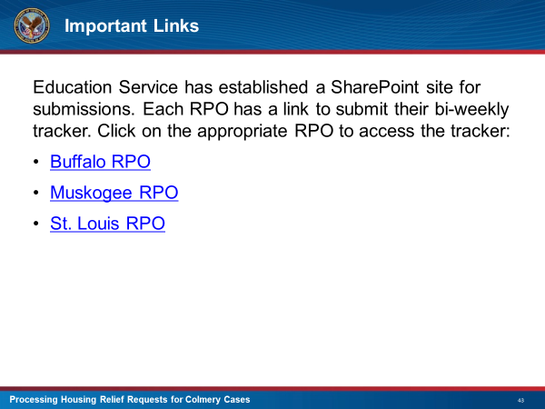 | DISPLAY slide 43 “Important Links”  EXPLAIN that this slide contains links to the SharePoint site where each RPO can submit their bi-weekly tracker.
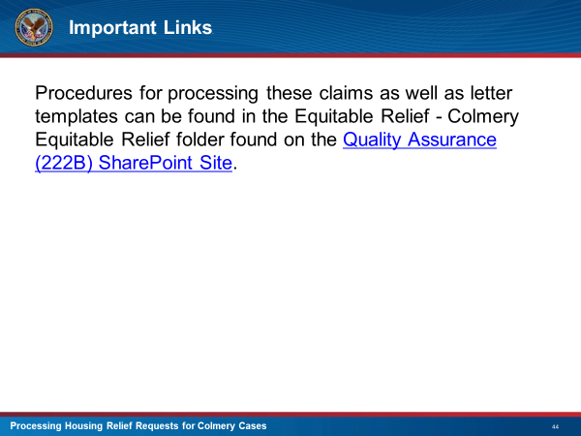 | DISPLAY slide 44 “Important Links”  EXPLAIN that processers can find the Colmery Relief Granted and Denial letter as well as procedures to follow by clicking on the link on this slide.
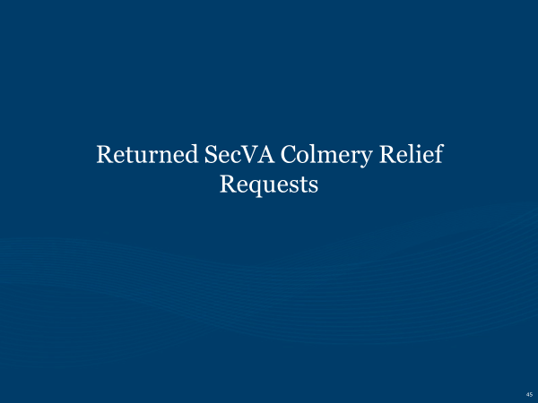 | DISPLAY slide 45 “Returned SecVA Colmery Relief Requests”  EXPLAIN that these next several slides will be going over how to process Colmery Housing Relief requests that have been reviewed by the SecVA, approved, and returned for processing.
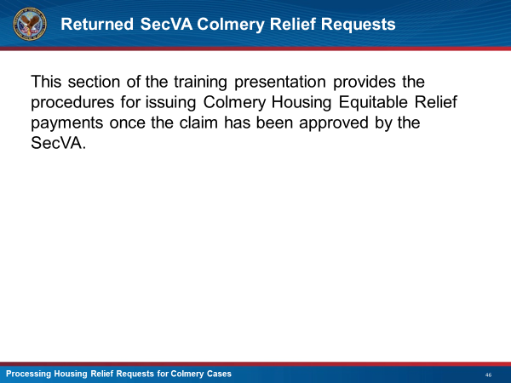 | DISPLAY slide 46 “Returned SecVA Colmery Relief Requests”  EXPLAIN You will be going over the procedures of awarding housing relief benefits after they have been approved by the SecVA
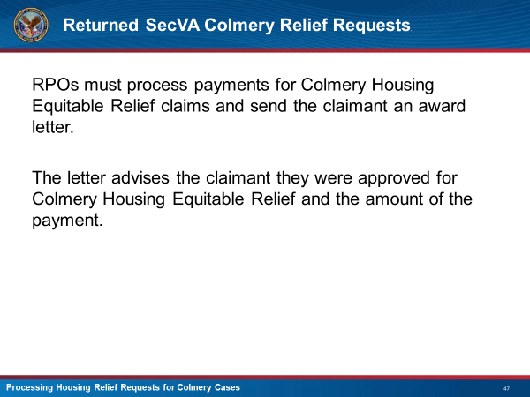 | DISPLAY slide 47 “Returned SecVA Colmery Relief Requests”  INFORM the class that once the returned requests are received, RPOs must process payments and send the claimant an award letter advising them of the decision and the amount they will receive.
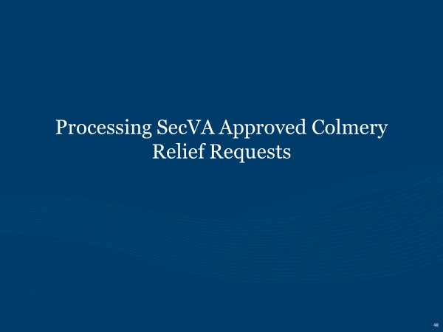 | DISPLAY slide 48 “Processing SecVA Approved Colmery Relief Requests”  EXPLAIN that you will be now be going over the steps that the class will take to process the relief payments in LTS.
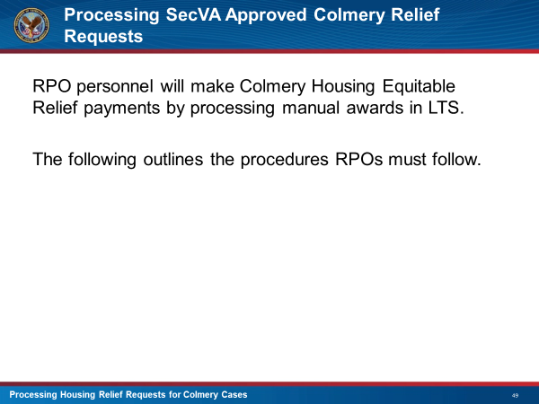 | DISPLAY slide 49 “Processing SecVA Approved Colmery Relief Requests”  EXPLAIN that by processing the manual awards in LTS, the RPOs will be able to make the payments directly to claimants
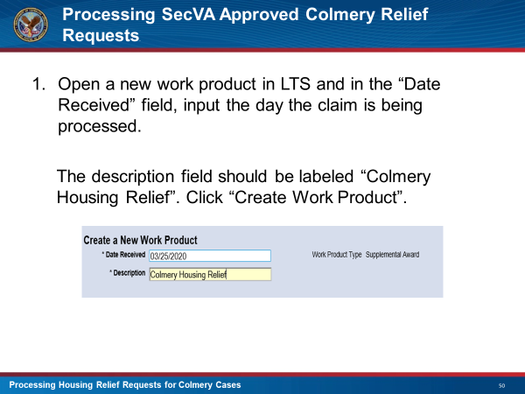 | DISPLAY slide 50 “Processing SecVA Approved Colmery Relief Requests”  DISCUSS the first step that will be taken to process the relief payment in LTS.
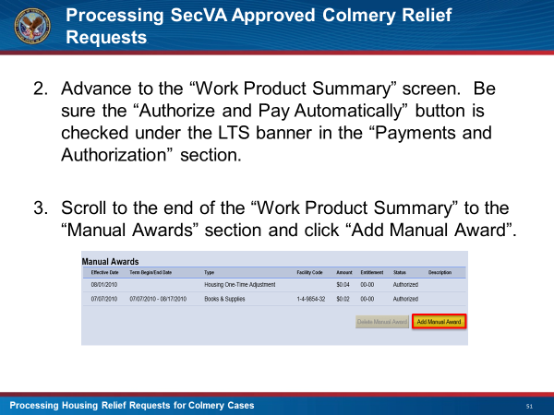 | DISPLAY slide 51 “Processing SecVA Approved Colmery Relief Requests”  DISCUSS the next two steps that will be taken to process the relief payment in LTS.
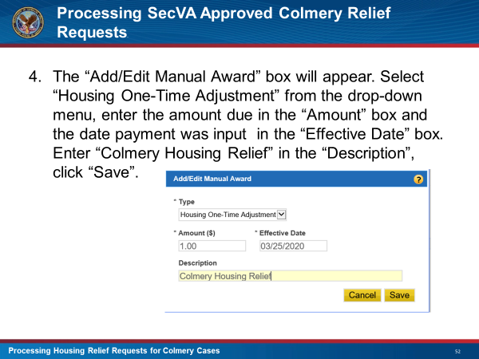 | DISPLAY slide 52 “Processing SecVA Approved Colmery Relief Requests”  DISCUSS the final step that will be taken to process the relief payment in LTS.
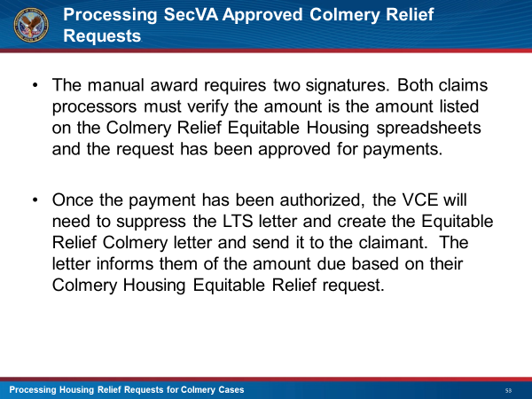 | DISPLAY slide 53 “Processing SecVA Approved Colmery Relief Requests”  EMPHASIZE that the award requires two signatures. They must verify that the amount to be paid is correct and listed on the Colmery Housing Relief Housing spreadsheet and that the request has been approved for payment.  REMIND the class that once the payment has been authorized, a letter advising the claimant of the action taken will need to be sent out.
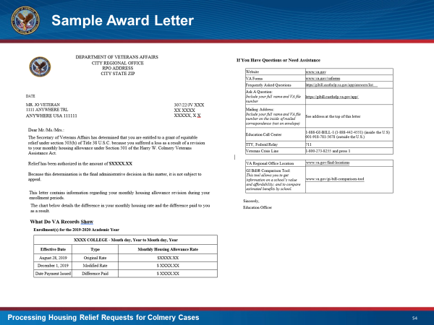 | DISPLAY slide 54 “Processing SecVA Approved Colmery Relief Requests”  EXPLAIN that this slide shows what the final award letter looks like.  REMIND the class that because this an equitable relief claim, the claimant is not given appellate rights.
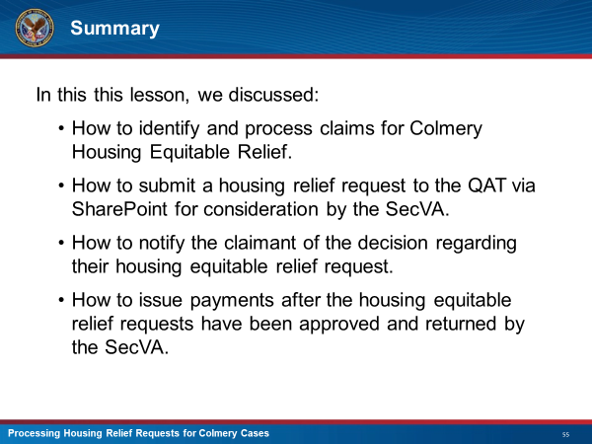 | DISPLAY slide 55 “Summary”  SUMMARIZE what was discussed in training today
 | DISPLAY slide 56 “Questions”  ASK if there are any questions regarding this training.
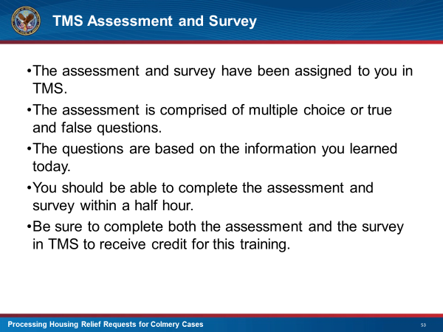 | DISPLAY slide 57 “TMS Assessment and Survey”  INFORM the class that they will need to go to TMS to take the assessment and survey to get credit for this training.

