

EDUCATION SERVICE

Transfer of Entitlement (TOE) Debts Update

Lesson Plan

May 2020 Version 1.0

Lesson Overview
Time Estimate: |  | 1 hour
Purpose of the Lesson: |  | The purpose of this training is to educate Claims Examiners on the updates associated with Transfer of Entitlement (TOE) Debts.
Prerequisite Training Requirements: |  | None
Target Audience: |  | Education Service Claims Examiners
Lesson References: |  | The following references support the lesson content:  - 38 USC 3319  - Procedural Advisory: Creation of TOE Debts
Lesson Objectives: |  | - Understand the updates related to TOE debts  - Perform the actions required by Regional Processing Offices (RPOs) to appropriately assign TOE debts
What You Need:
Post Training Requirements:

Instructor Notes
The purpose of this training is to introduce Claims Examiners to the new changes associated with Transfer of Entitlement overpayments.
PowerPoint Slides | Instructor Activities
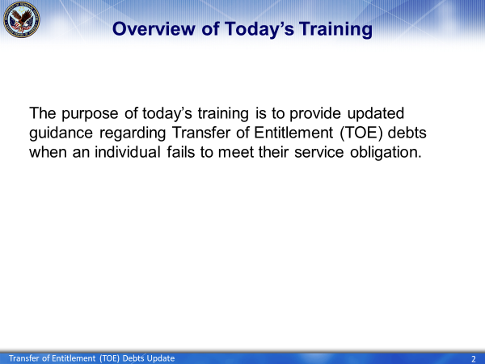 | DISPLAY slide 2
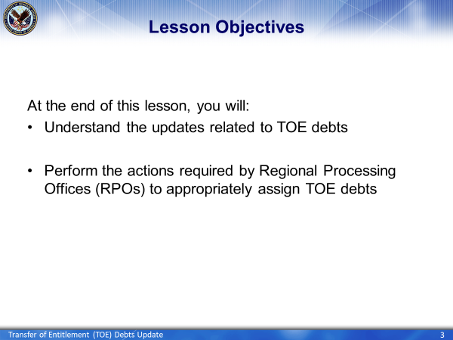 | DISPLAY slide 3  NAME the objectives
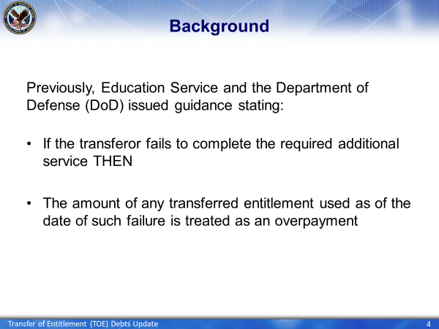 | DISPLAY slide 4  DISCUSS the previous guidance
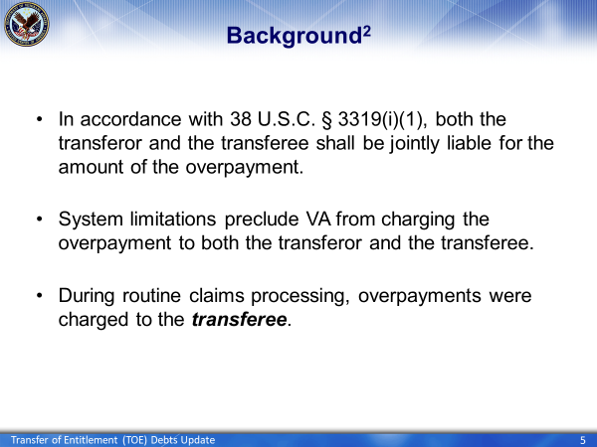 | DISPLAY slide 5  DISCUSS the law prior to March 6, 2020
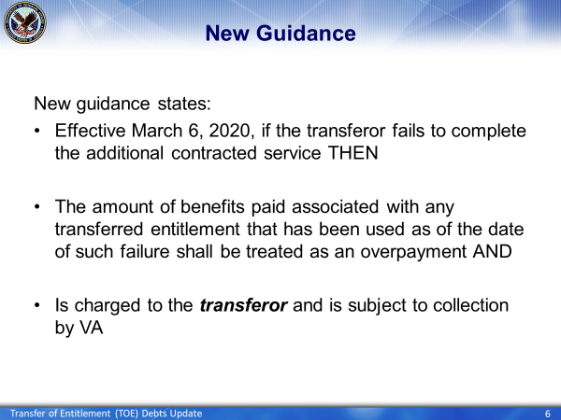 | DISPLAY slide 6  DISCUSS the new guidance, effective March 6, 2020
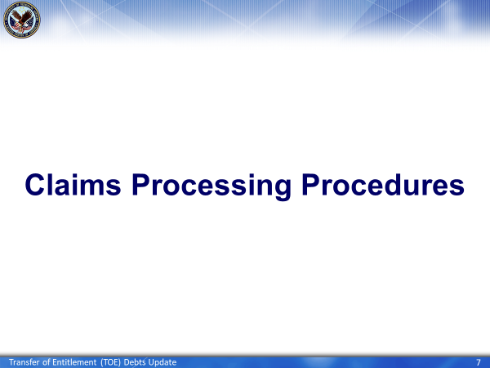 | DISPLAY slide 7  Now you will move into the claims processing procedures VCEs will take when encountering TOE Debts
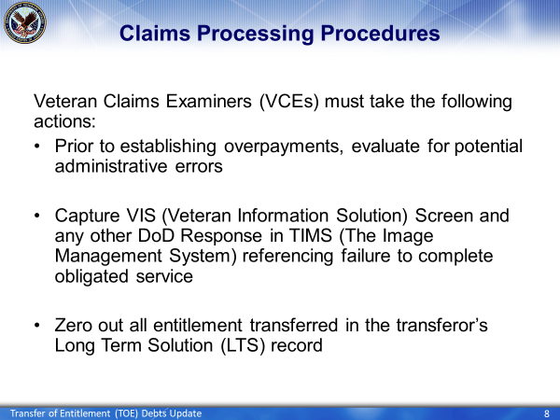 | DISPLAY slide 8  EXPLAIN the actions VCEs must take when encountering overpayments or debts created by a termination of benefits
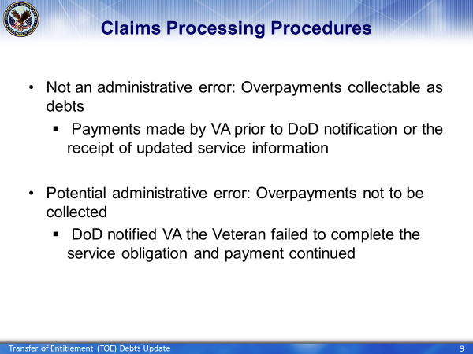 | DISPLAY slide 9  EXPLAIN the difference between an administrative error and a potential administrative error
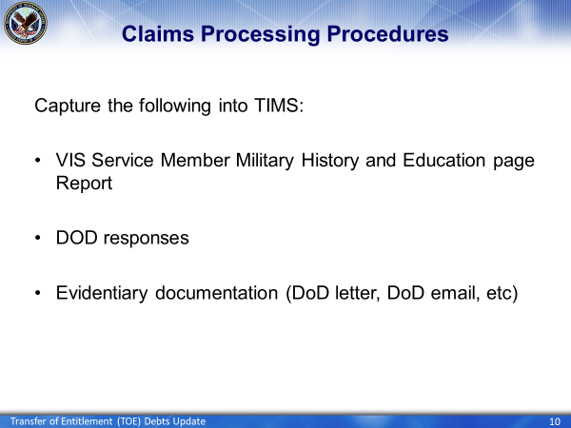 | DISPLAY slide 10  EXPLAIN the items that need to be captured into TIMS
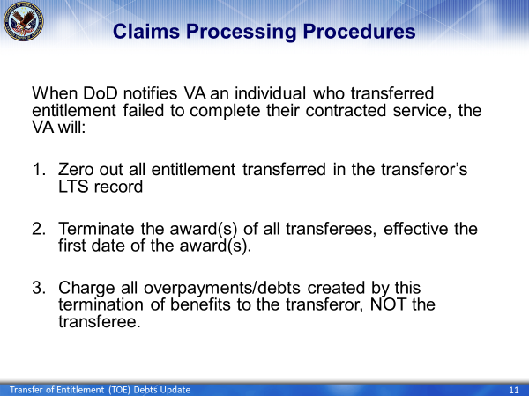 | DISPLAY slide 11  EXPLAIN the actions VCEs will take when a transferor fails complete obligated service
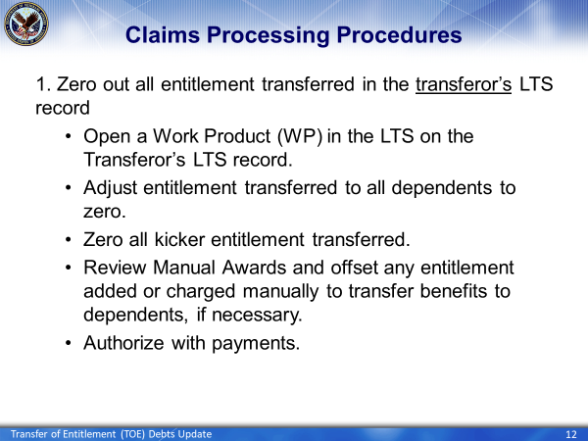 | DISPLAY slide 12  EXPLAIN the summary of steps involved in zeroing out all entitlement transferred in the transferor’s LTS record
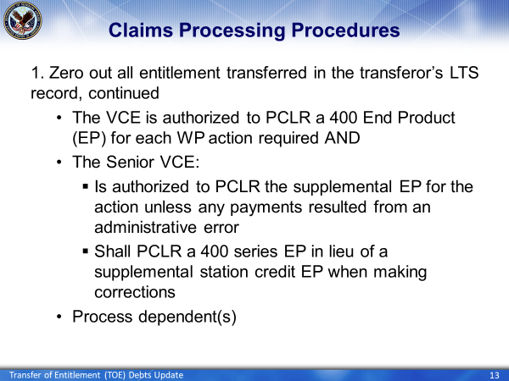 | DISPLAY slide 13  EXPLAIN the summary of steps involved in zeroing out all entitlement transferred in the transferor’s LTS record
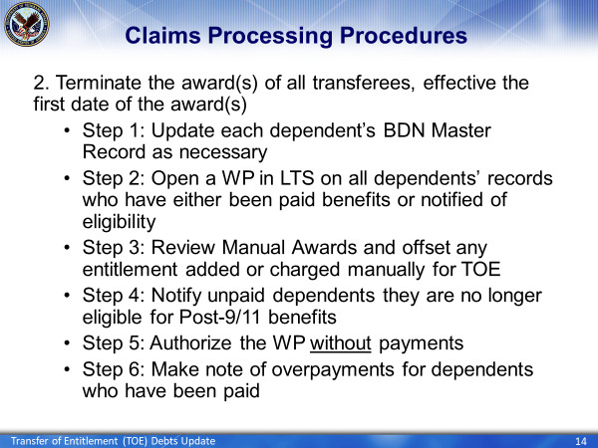 | DISPLAY slide 14  EXPLAIN the actions of the VCEs and Senior VCEs
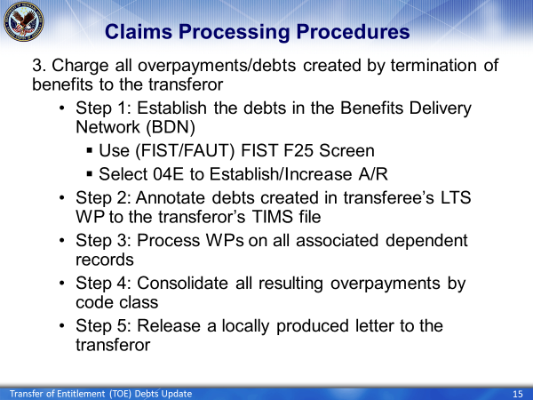 | DISPLAY slide 15  EXPLAIN the actions of the VCEs and Senior VCEs
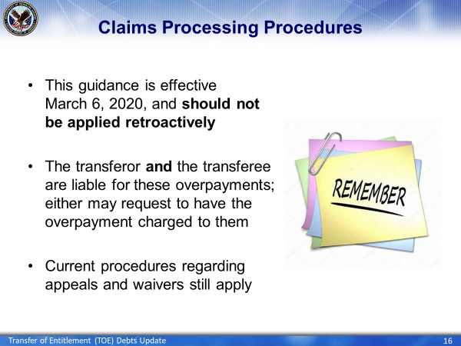 | DISPLAY slide 16  SUMMARIZE the discussed claims processing procedures
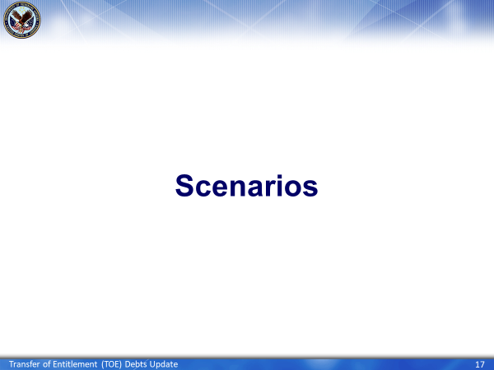 | DISPLAY slide 17
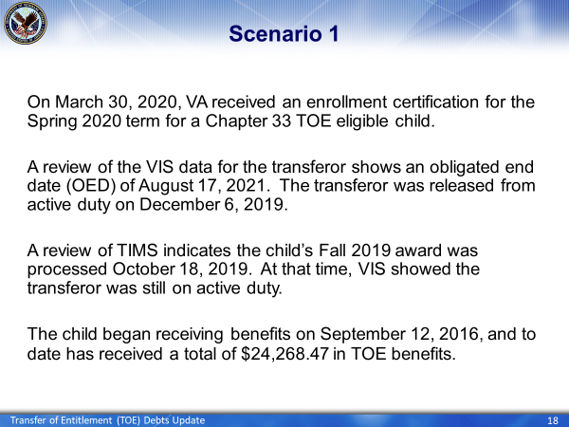 | DISPLAY slide 18  EXPLAIN the actions required by the VCE
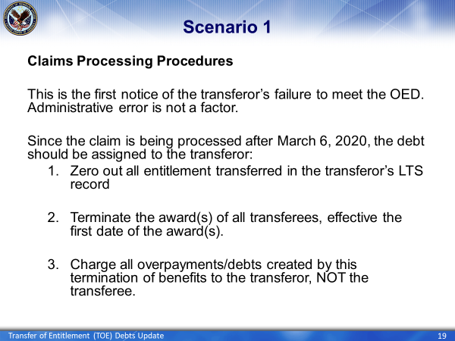 | DISPLAY slide 19  DISCUSS the aspects of Scenario 1
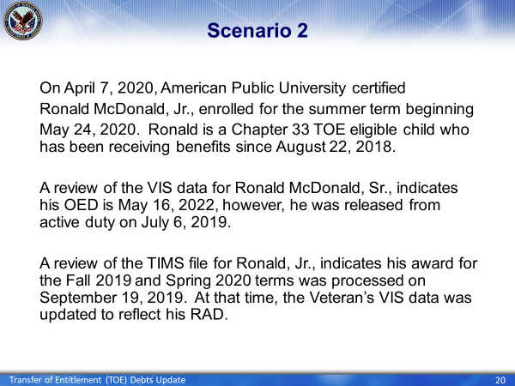 | DISPLAY slide 20  DISCUSS the aspects of Scenario 2
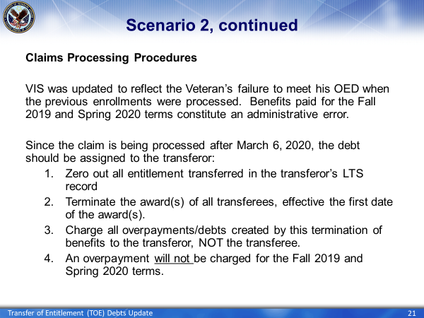 | DISPLAY slide 21  DISCUSS the aspects of Scenario 2
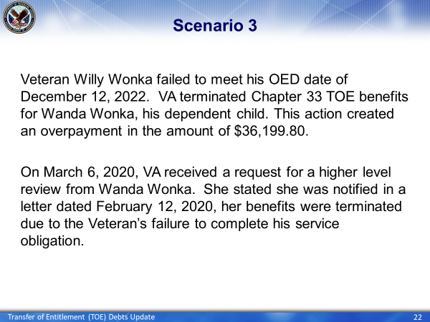 | DISPLAY slide 23  DISCUSS the aspects of Scenario 3
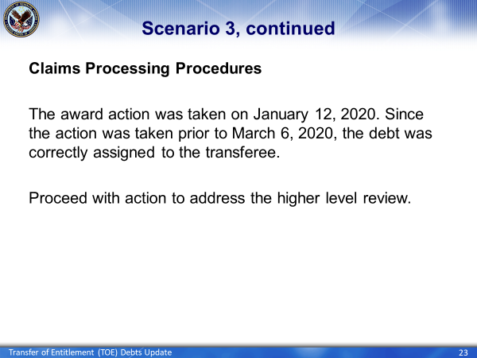 | DISPLAY slide 23  DISCUSS the aspects of Scenario 3
 | DISPLAY slide 24  PREPARE students for Knowledge Check Questions
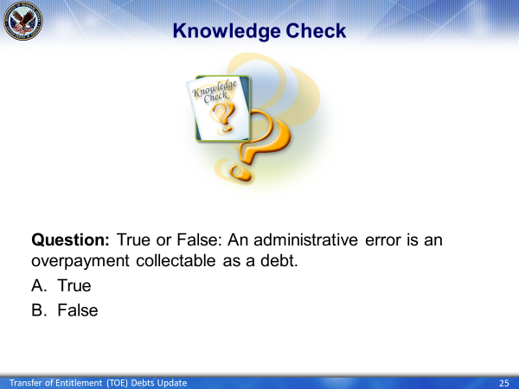 | DISPLAY slide 25  DISCUSS Knowledge Check Question
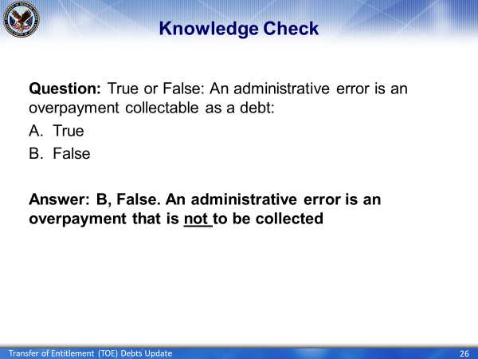 | DISPLAY slide 26  EXPLAIN Knowledge Check Answer
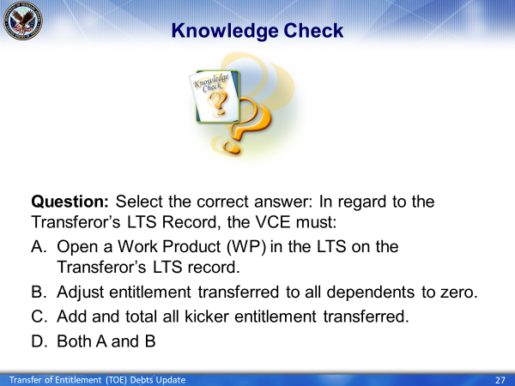 | DISPLAY slide 27  DISCUSS Knowledge Check Question
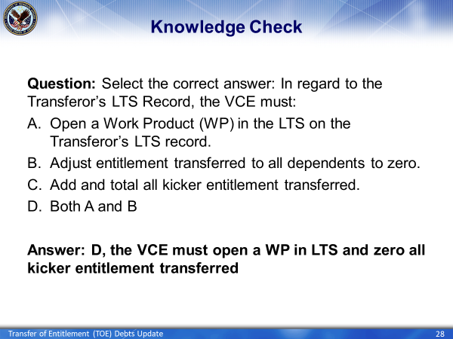 | DISPLAY slide 28  EXPLAIN Knowledge Check Answer
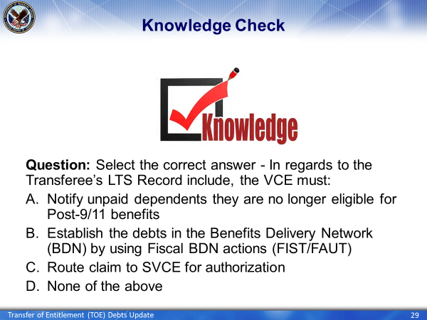 | DISPLAY slide 29  DISCUSS Knowledge Check Question
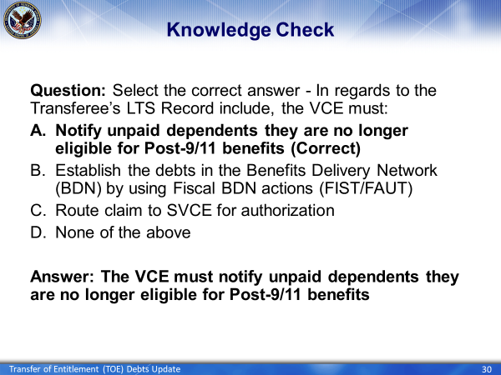 | DISPLAY slide 30  EXPLAIN Knowledge Check Answer
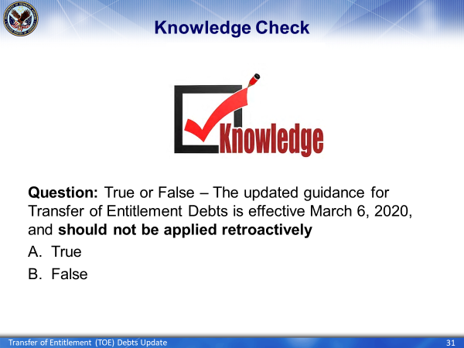 | DISPLAY slide 31  DISCUSS Knowledge Check Question
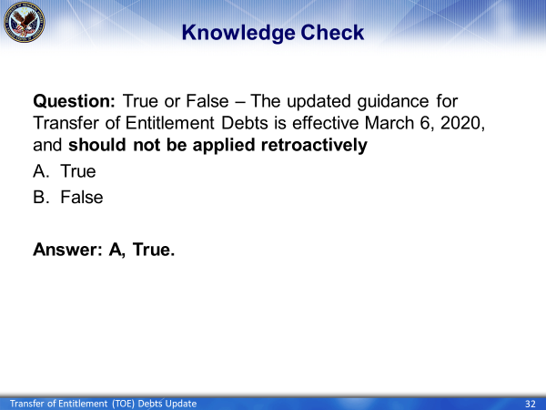 | DISPLAY slide 32  EXPLAIN Knowledge Check Answer
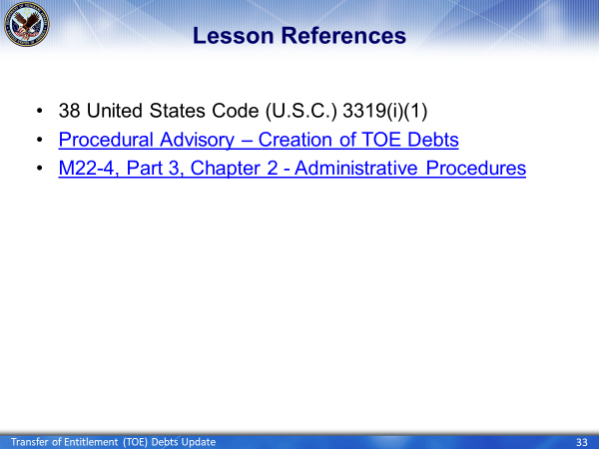 | DISPLAY slide 33
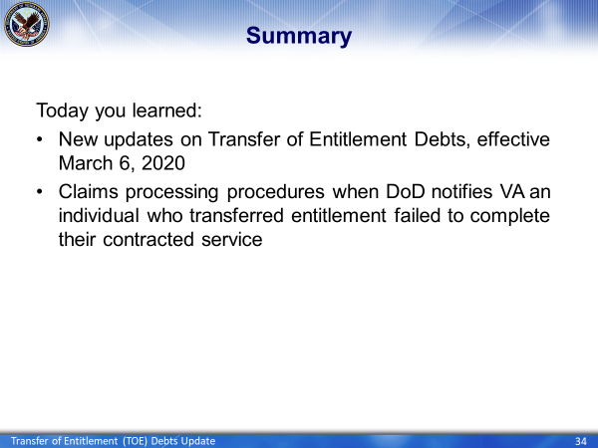 | DISPLAY slide 34
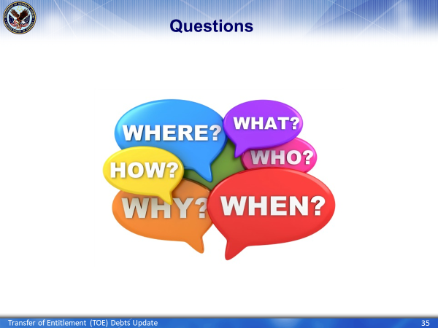 | DISPLAY slide 35  ALLOW students the opportunity to ask questions; PROVIDE answers and applicable feedback
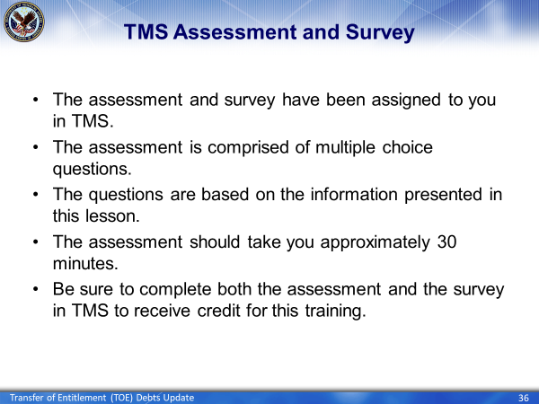 | DISPLAY slide 36  DISCUSS TMS Assessment and Survey

