
Education Service
Harry W. Colmery Veterans Educational Assistance Act of 2017
Sections 107 & 501 Training Course
Lesson Plan
Modules 1-4



Lesson Overview
Topic | Description
Time Estimate: | 2.5 hours
Purpose of the Lesson: | The purpose of this lesson is to provide guidance to Veterans Claim Examiners, Education Call Center Technicians, and other internal VA stakeholders affected by the 12/1 Retro Batch Process Timeline & VCE Action Report, the changes to Monthly Housing Allowance(MHA) rates, the 12/1 Retro Batch Work Products and the changes to letters in accordance with Sections 501 and 107 of PL 115-48, the Colmery Act, Forever GI Bill.
Prerequisite Training Requirements: | The following prerequisite training is required:  - None
Target Audience: | - Veteran Claim Examiners (VCEs)  - Education Call Center Technicians (ECCTs)
Lesson References: | The following references support the lesson content:  - Harry W Colmery Veterans Educational Assistance Act of 2017  - 38 U.S. Code section 3317(a)  - Procedural Advisory: The Long Term Solution 12/1 Retroactive Work Product (WP) and Updated Letter Functionality  - GI Bill Comparison Tool  - WEAMs
Lesson Objectives: | At the end of this lesson, you will be able to:  - Articulate the timeline and activities occurring before, during, and after the 12/1 Retro Batch Process runs.  - Identify the reasons why a 12/1 Retro Work Product would be off-ramped from automation.  - Understand how to use the Veteran Claims Examiner (VCE) Action Report to process 12/1 Retro Work Products.  - Identify changes to rules for payment of the Monthly Housing Allowance (MHA) under Chapter 33.  - Identify when new MHA payment rules go into effect and who they affect.  - Recognize the system changes to support new MHA payment processing rules.  - Articulate the timeline and activities occurring before, during, and after the 12/1 Retro Batch Process runs.  - Identify the reasons why a 12/1 retro WP would be off-ramped from automation.  - Understand how to use the Veteran Claims Examiner (VCE) Action Report to process 12/1 retro work products.  - Understand the changes to letter generation as part of the LTS Release 6.9 Go-Live  - Understand the new letters being created as part of the 501 Retro Work Product  - Understand processing changes due to the LTS Release 6.9 Go-Live
What You Need: | - Reserve adequate space equipped to project a PowerPoint presentation.  - Provide copies of the student guide or PowerPoint slides in advance of the lesson or provide directions on how to print from saved location and how to access any applicable supplemental training, refer to lesson plan and have a subject matter expert (SME) available if primary presenter is not an SME to assist with answering questions.  - Training should be instructor led with a means to ask questions during the training. It can be delivered virtually. However, it is recommended for live delivery if feasible.  - Questions received during the session which have pre-determined responses may be answered during the session. Any question requiring further review or a lengthier response will be recorded, answered and distributed to trainees after the session.  - Individuals who view a recorded live session to make-up the training should be provided a POC who is available for questions while the employee is taking the lesson.  - Knowledge Check questions have been provided in both slide format and can also be loaded into the Kahoot tool. Log into Kahoot through this link www.kahoot.it and create each question as a new item, indicate the correct response.
Post Training Requirements: | There will be an assessment to receive credit within TMS.

Education Service
Understanding the 12/1 Retro Batch Process Timeline & VCE Action Report (Module 1)
Lesson Plan

Instructor Notes
The purpose of this lesson is to provide guidance to Veteran Claim Examiners, Education Call Center Technicians , and other internal VA stakeholders affected by the 12/1 Retro Batch Process Timeline & VCE Action Report, in accordance with Sections 501 and 107 of PL 115-48, the Colmery Act, Forever GI Bill.

PowerPoint Slides | Instructor Activities
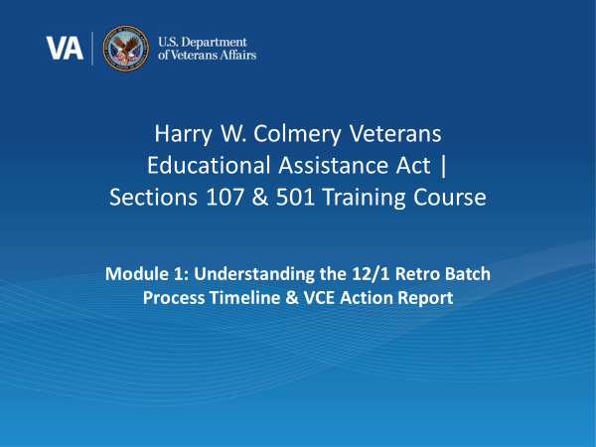 |  | DISPLAY slide 1  INTRODUCE yourself as the instructor / facilitator and welcome trainees to the session.  INTRODUCE the lesson.
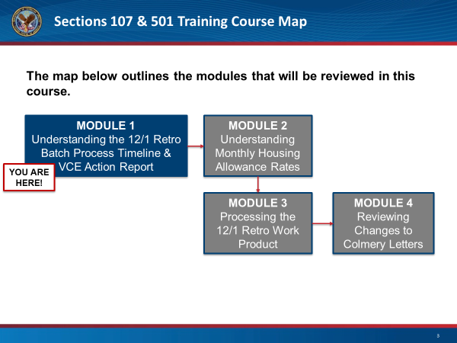 |  | DISPLAY slide 3: “Course Map”  REVIEW the course map and assure trainees they will have opportunities to ask questions at the end of the session. Additionally remind them there will be knowledge checks throughout.
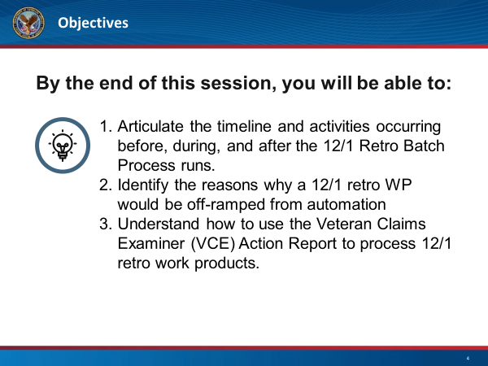 |  | DISPLAY slide 4  SUMMARIZE objectives for the session, emphasizing this module will focus on the implications of Section 107 & 501 on the 12/1 Retro Batch Process Timeline &VCE Action Report.
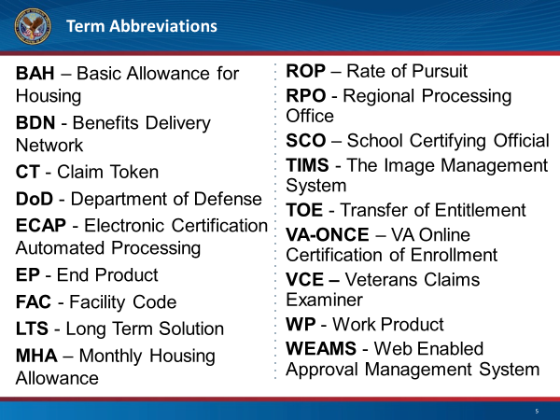 |  | DISPLAY slide 5  DISCUSS outlined terms abbreviations used within this training, direct students to the Knowledge Management Portal (KMP), M22-4 Part1, Chapter 2-Definitions.  DO NOT read through each term.
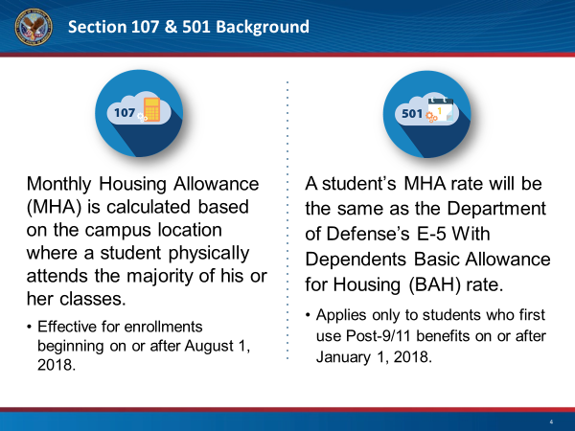 |  | DISPLAY slide 6  READ the basic background of the Forever GI Bill Sections 107 and 501 from the slide notes
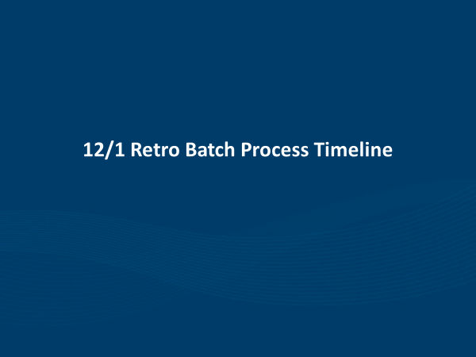 |  | DISPLAY slide 7  INTRODUCE this section covering Enhancements to VA Systems & 12/1 Timeline.
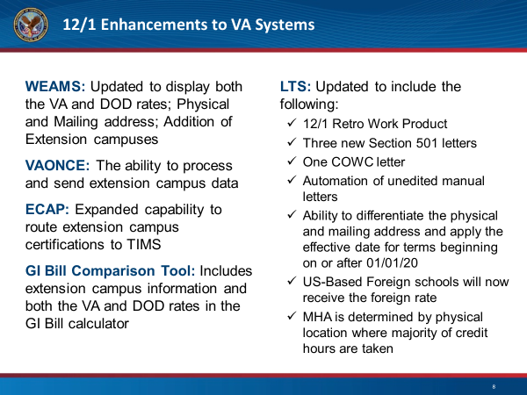 |  | DISPLAY slide 8  HIGHLIGHT key enhancements to various systems. Emphasize these changes will be described throughout the rest of the modules.
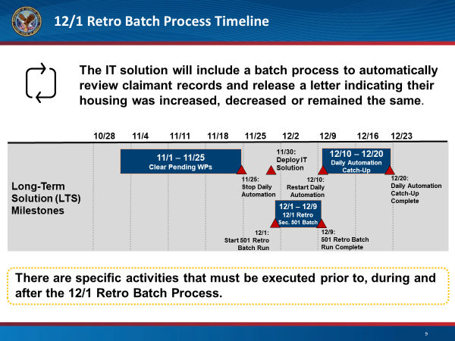 |  | DISPLAY slide 9  REVIEW each of the milestones and key activities of which a VCE should be aware.  EXPLAIN this information is for situational awareness, and review where we currently are in the process if delivered prior to 12/20.
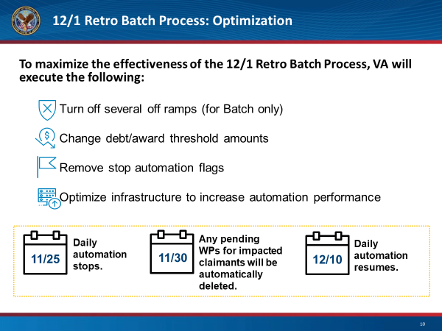 |  | DISPLAY slide 10  READ the actions VA will take to maximize effectiveness.  REVIEW dates at the bottom, highlighting the importance of each.
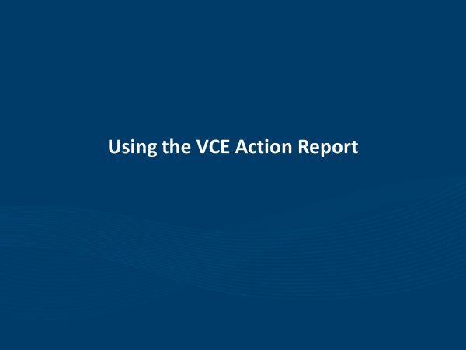 |  | DISPLAY slide 11  INTRODUCE this section covering an overview of the VCE Action Report, as well as reasons VCEs would need to take processing action on a 12/1 Retro WP.
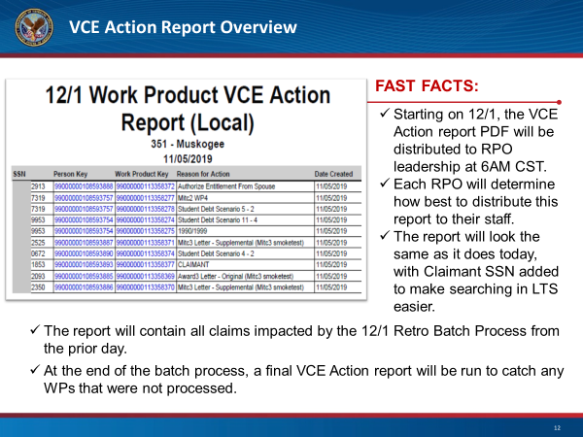 |  | DISPLAY slide 12  DIRECT participants to the graphic.  REVIEW fast facts listed on the slide.
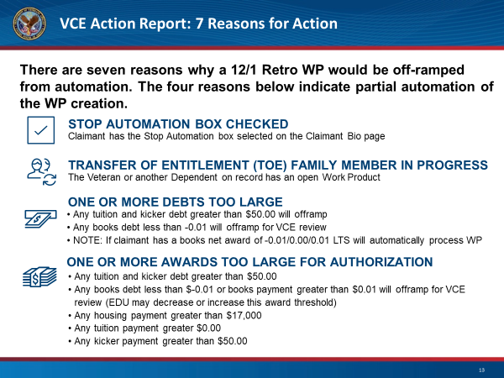 |  | DISPLAY slide 13  DISTINGUISH reasons a claim would be partially automated.  REMIND participants, as with regular automation, to continue to process a claim, the VCE will click the active hyperlink to the left of the edit button on the in progress WP with Auto LTS as the owner.
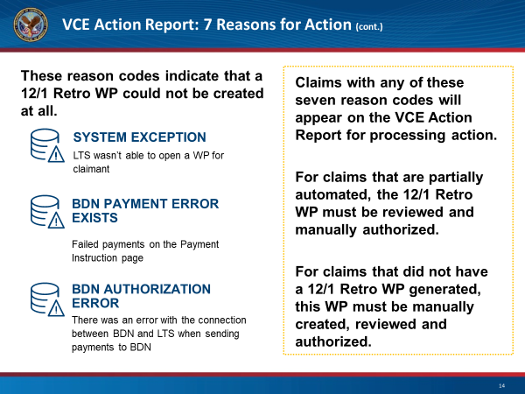 |  | DISPLAY slide 14  EXPRESS the three remaining reasons a 12/1 WP could not be created.  DIRECT participants to navigate to the WP History page and click on the add 12/1 Retro WP button to complete the necessary processing actions.
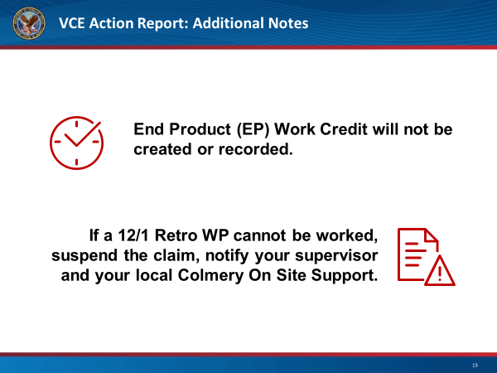 |  | DISPLAY slide 15  READ additional notes. Convey to participants they should follow the most current guidance.
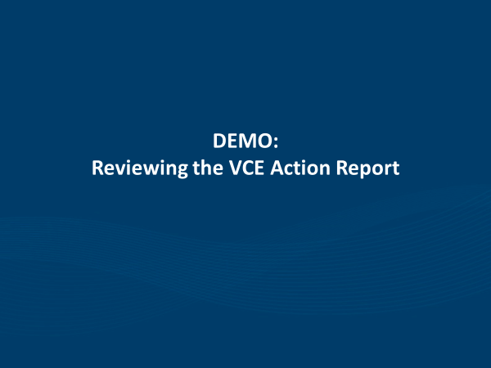 |  | DISPLAY slide 16  INTRODUCE demo walkthrough of VCE Action Report, highlighting a subsequent demo, Processing a 12/1 Retro WP with greater detail in the training.
 |  | DISPLAY slide 17  TRANSITION to takeaways section.
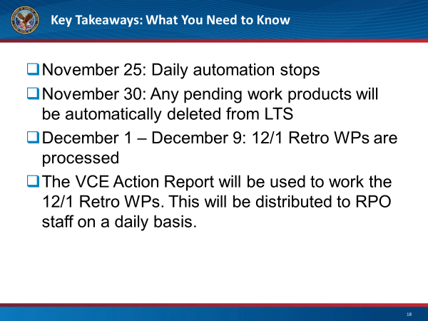 |  | DISPLAY slide 18  READ key takeaways and inform participants this concludes the first module.

Education Service
Virtual Training Webinar: Understanding MHA Rates (Module 2)
Lesson Plan

Instructor Notes
The purpose of this lesson is to provide guidance to Veterans Claim Examiners, Education Call Center Technicians, and other internal VA stakeholders affected by the changes to Monthly Housing Allowance(MHA) rates, in accordance with Sections 501 and 107 of PL 115-48, the Colmery Act, Forever GI Bill.

PowerPoint Slides | Instructor Activities
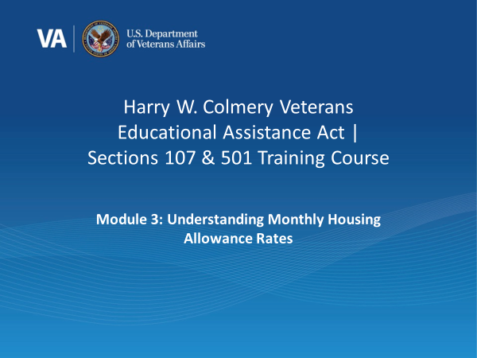 |  | DISPLAY slide 19  INTRODUCE the Understanding Monthly Housing Allowance Rates
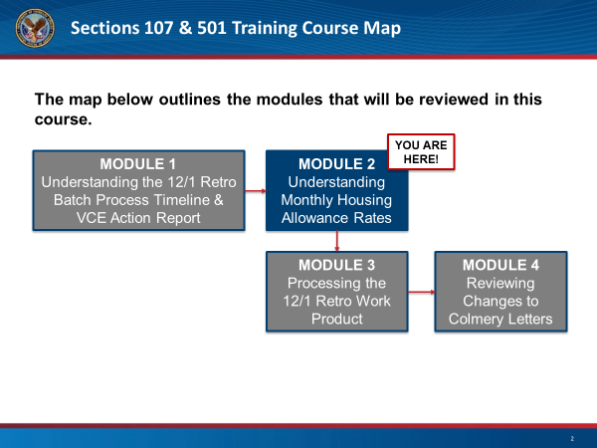 |  | DISPLAY slide 20: “Course Map”  REVIEW the course map briefly
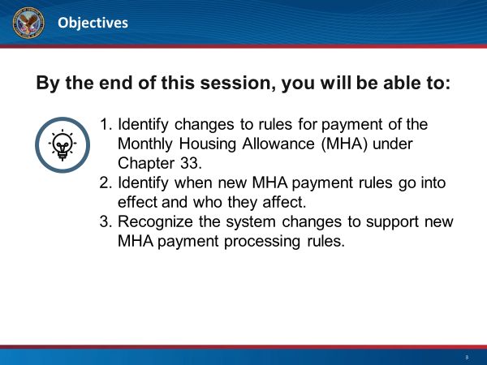 |  | DISPLAY slide 21  REVIEW objectives for the session, emphasizing this module will focus on the implications of Section 107 & 501 on Monthly Housing Allowance.
DISPLAY slide 22
READ the basic background of the Forever GI Bill Sections 107 and 501 from the slide notes.
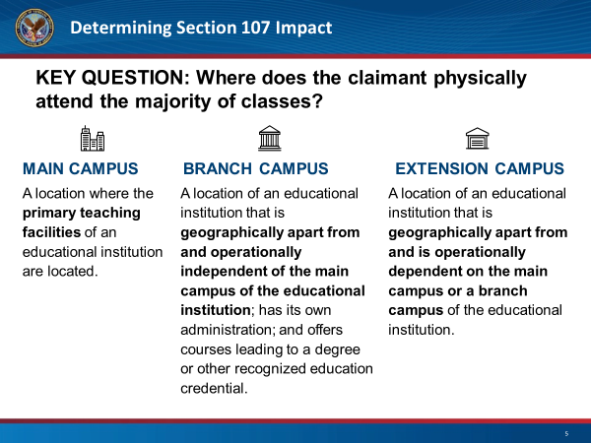 |  | DISPLAY slide 23  READ the definitions of a main campus, extension campus, and a branch campus.
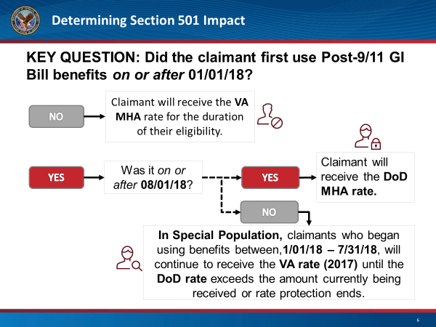 |  | DISPLAY slide 24  HIGHLIGHT the importance of the date benefits were first used when determining correct population. Review the flow chart, and remind participants there will be additional scenarios later.
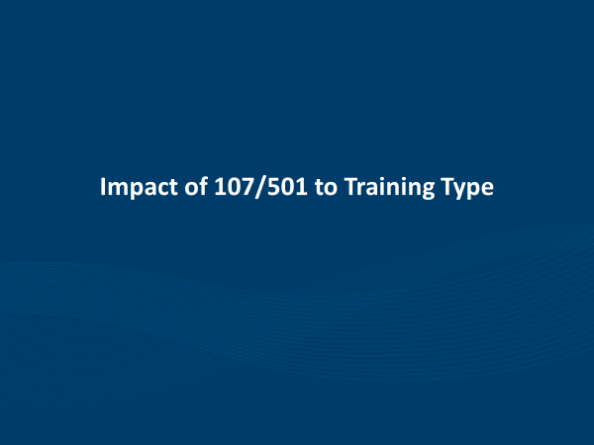 |  | DISPLAY slide 25  CLASSIFY this portion of the presentation as providing insight into MHA changes to impacted and non-impacted training types.
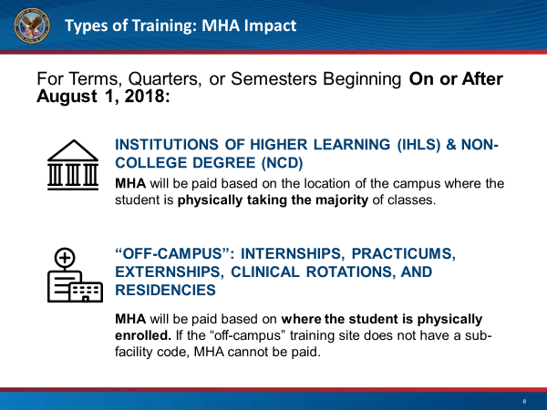 |  | DISPLAY slide 26  INDICATE various impacts to MHA for the programs listed, highlighting the importance of physical location in determining rate.
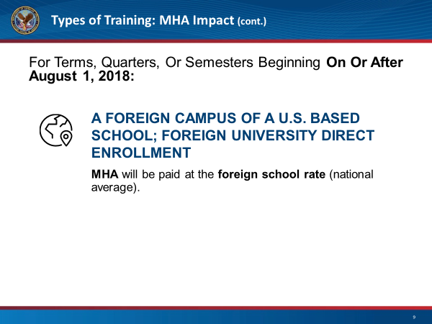 |  | DISPLAY slide 27  REVIEW various impacts to MHA for the foreign programs listed, highlighting the national average rate will be received.
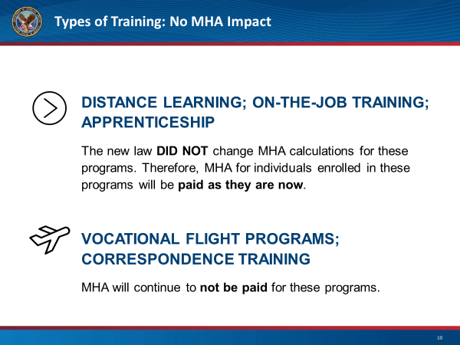 |  | DISPLAY slide 28  EXPLAIN MHA rate calculations did not change for Distance, OJT, or Apprenticeship trainings  STRESS MHA rates will continue to not be paid for Vocational Flight and Correspondence Trainings
 |  | DISPLAY slide 29  INTRODUCE the new terminology of Rate Protection and mention this practice was formerly known as “Grandfathering”
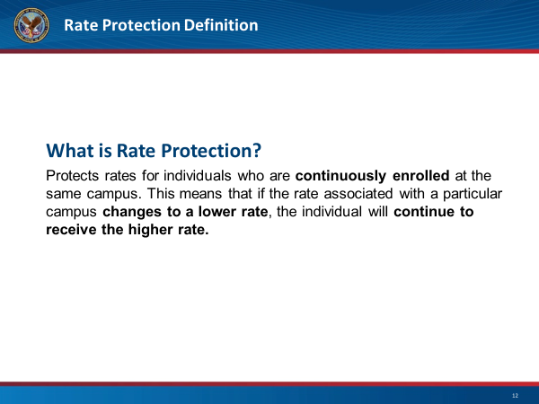 |  | DISPLAY slide 30  READ the definition of rate protection.
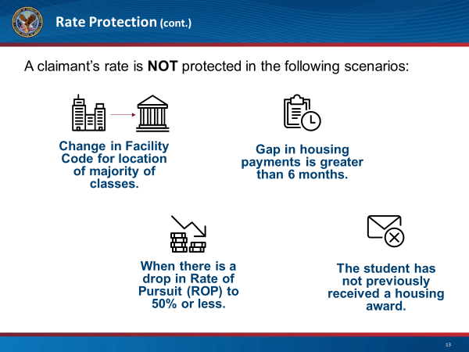 |  | DISPLAY slide 31  REVIEW the 4 scenarios in which a claimant would not receive the rate protection.
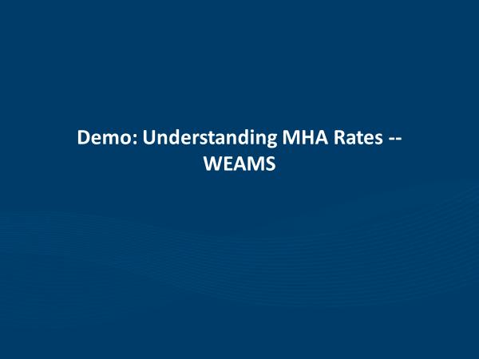 |  | DISPLAY slide 32  INTRODUCE the demo walkthrough- how to view and validate the rates in WEAMs, and how to determine which rate the claimant would receive.
 |  | DISPLAY slide 33  INFORM this section will provide a live walkthrough of several different types of scenarios and allow for a practical understanding of MHA impacts.
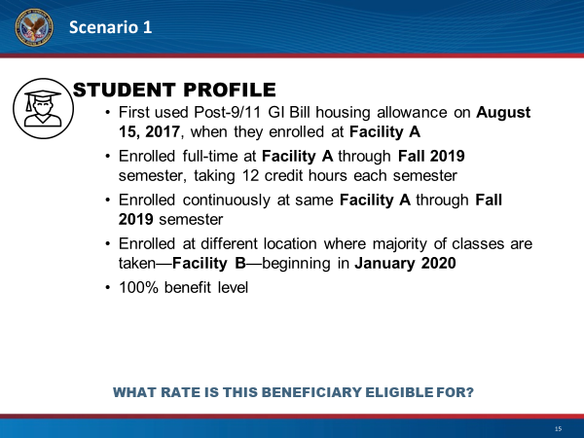 |  | DISPLAY slide 34  DESCRIBE scenario, highlighting importance of first used CH33 Entitlement before January 1, 2018, and the location changed where majority of classes physically attended.  Explanation: On December 1, 2019, you will continue to receive the VA Monthly Housing Allowance (MHA) Rate based on the location where you physically attend the majority of classes. This rate will change if the location where you physically attend the majority of classes changes.
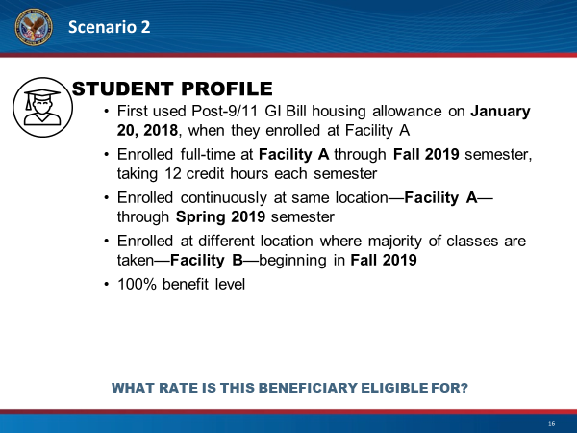 |  | DISPLAY slide 35  DESCRIBE scenario, highlighting importance of first used CH33 Entitlement on or after January 1, 2018, but before August 1, 2018. Violation of Rate Protection Occurs.  Explanation: Starting December 1, 2019, you will receive the VA Monthly Housing Allowance (MHA) AY17 Rate until the DoD Rate exceeds, or a violation of rate protection occurs, for the location where you physically attend the majority of classes.
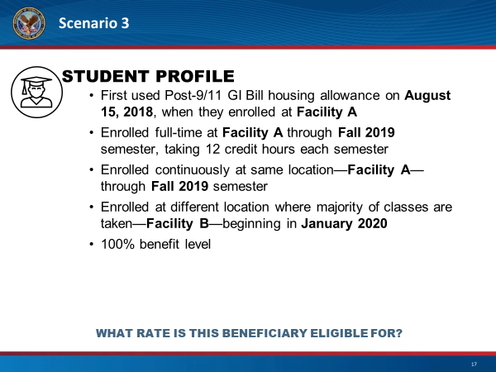 |  | DISPLAY slide 36  DESCRIBE scenario, highlighting importance of first used CH33 Entitlement on or after August 1, 2018. Location changed where majority of classes physically attended.  Explanation: Starting December 1, 2019, you will receive the VA Monthly Housing Allowance (MHA) AY17 Rate until the DoD Rate exceeds, or a violation of rate protection occurs, for the location where you physically attend the majority of classes
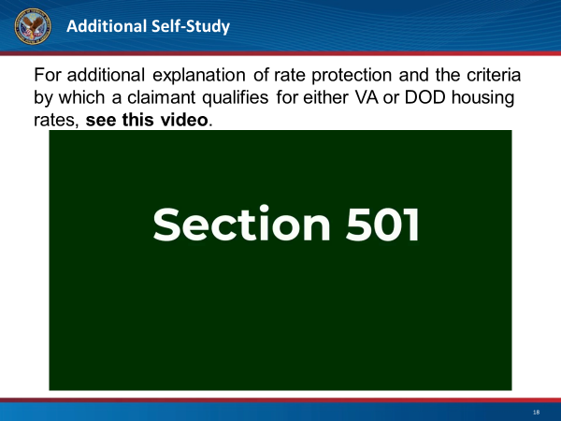 |  | DISPLAY slide 37  INFORM attendees of additional scenarios in a self-study video to aid in understanding of these changes.
 |  | DISPLAY slide 38  INTRODUCE Kahoot tool, and describe it as a game-based knowledge check, with points given for accuracy as well as speed.
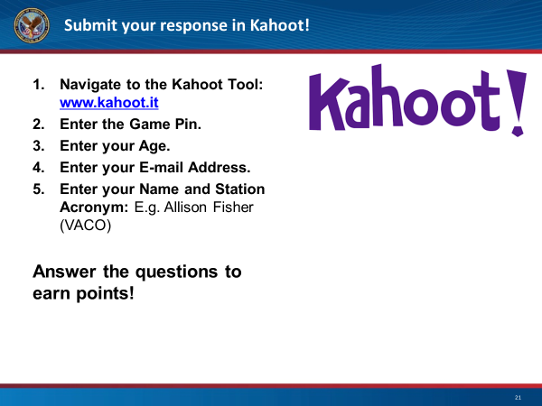 |  | DISPLAY slide 39  REVIEW steps for participants to log into Kahoot and allot 1-2 minutes for set up.
 |  | DISPLAY slide 40  TRANSITION to takeaways section.
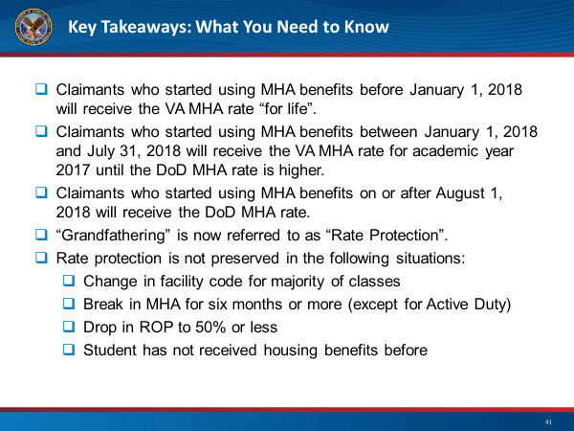 |  | DISPLAY slide 41  READ key takeaways and inform participants this concludes the second module.

Education Service
Virtual Training Webinar: Processing the 12/1 Retro Work Product (Module 3)
Lesson Plan

Instructor Notes
The purpose of this lesson is to provide guidance to Veterans Claim Examiners, Education Call Center Technicians , and other internal VA stakeholders affected by the 12/1 Retro Batch Work Products, in accordance with Sections 501 and 107 of PL 115-48, the Colmery Act, Forever GI Bill.

PowerPoint Slides | Instructor Activities
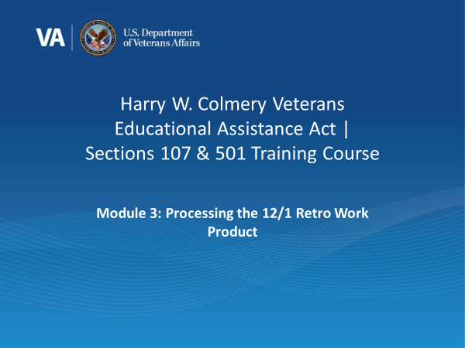 |  | DISPLAY slide 42  INTRODUCE the lesson.
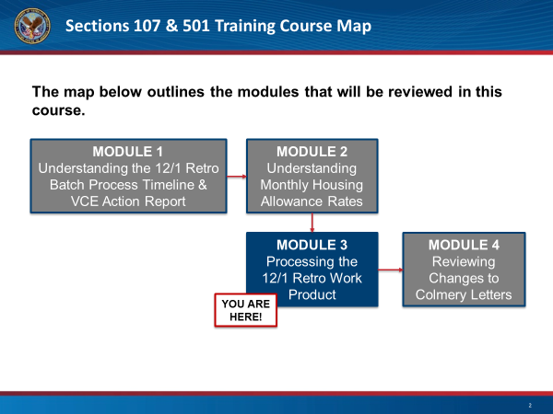 |  | DISPLAY slide 43: “Course Map”  REVIEW the course map briefly.
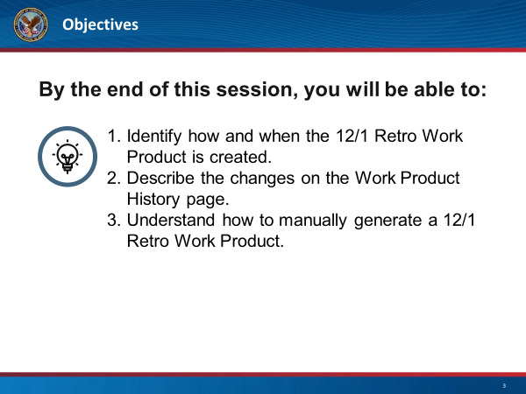 |  | DISPLAY slide 44  REVIEW objectives for the session, emphasizing this module will focus on the implications of Section 107 & 501 on all things processing during the 12/1 Retro Batch Process.
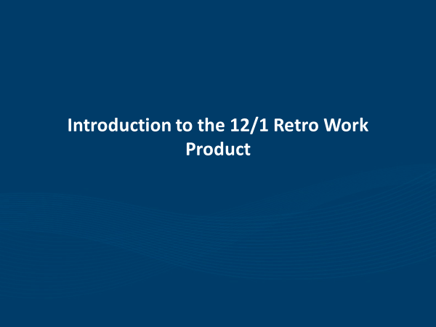 |  | DISPLAY slide 45  INTRODUCE a Section 501 Batch Process Overview, as well as automated vs manual creation.
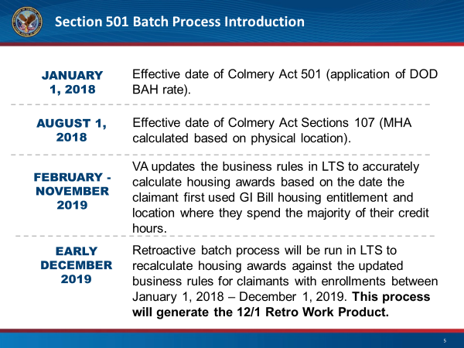 |  | DISPLAY slide 46  REVIEW the dates listed and relevant information for each.
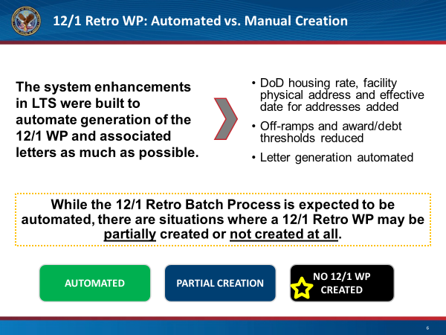 |  | DISPLAY slide 47  REVIEW various scenarios and explain why each would occur.
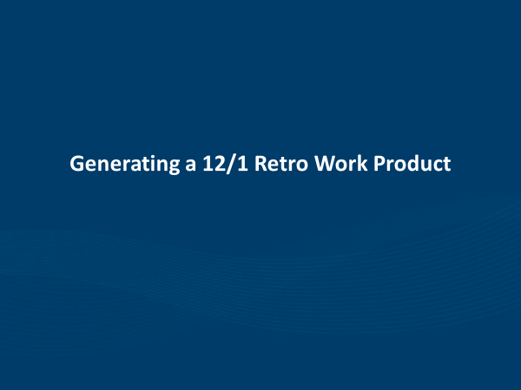 |  | DISPLAY slide 48  INTRODUCE a step-by-step walkthrough for processing a manually created 12/1 Retro Work Product.
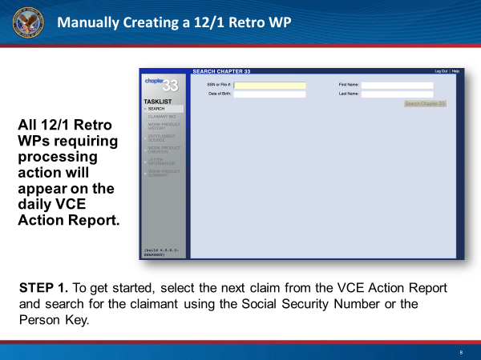 |  | DISPLAY slide 49  DISCUSS either manually creating or continuing a partially automated 12/1 Retro WP begins with entering the SSN on the VCE Action Report.  NOTE VCEs must open TIMS to check for any recent address changes reported and ensure BDN biographical information (i.e. address) matches what is in the LTS prior to authorizing.
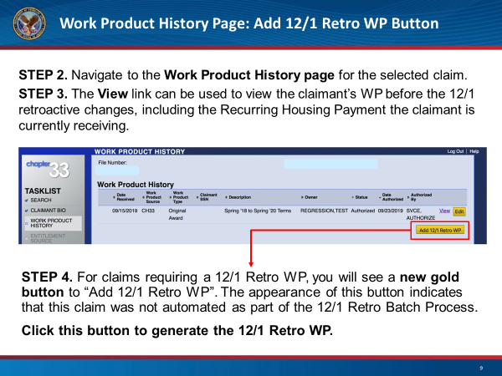 |  | DISPLAY slide 50  NOTE a full review of bio screen must occur at some point during the process (mentioned on prior slide) before authorizing.
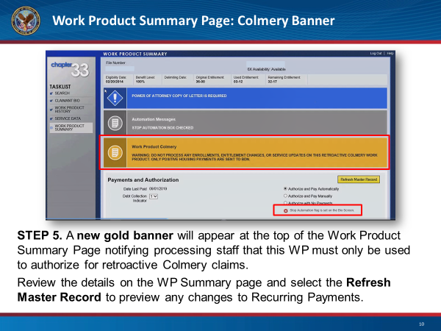 |  | DISPLAY slide 51  NOTE in the center of the slide the gold banner message identifying the 12/1 Work Product Colmery – the Warning states not to process enrollments , entitlement changes, or service updates and lets us know only positive housing payments will be sent to BDN. No debts or other non-MHA payments will be processed.
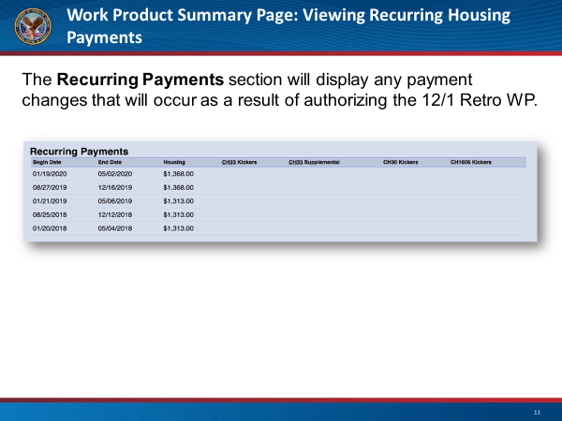 |  | DISPLAY slide 52  NOTE here we have the recurring payments section which displays the updated MHA payment schedule. Additionally on the WPS page, a VCE should review the enrollments section and make note of when the claimant first used chapter 33, this will help understand and actually anticipate the net result which will display in Net Awards.
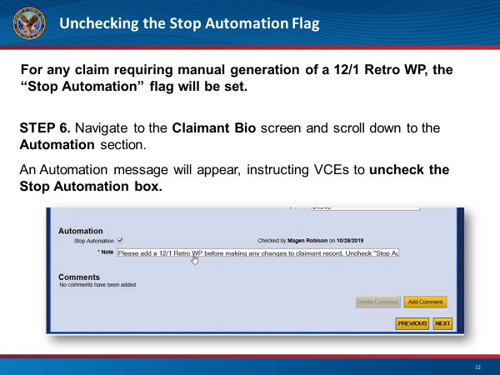 |  | DISPLAY slide 53  NOTE there is a special “Stop Automation” flag created during the Batch process. It clearly states to add the 12/1 Retro WP and to Uncheck the Stop Automation check box. Be sure to remove this Stop flag while processing the 12/1 Retro WPs.
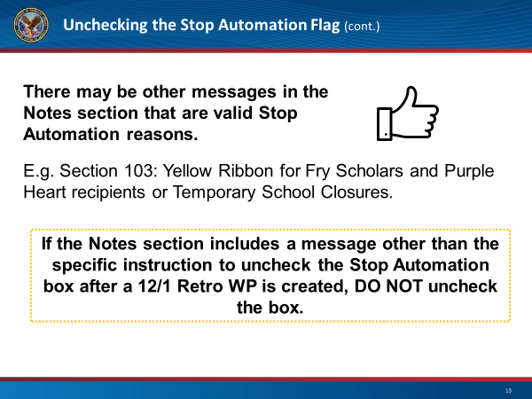 |  | DISPLAY slide 54  EXPRESS there are additional stop automation reasons.  READ yellow box.
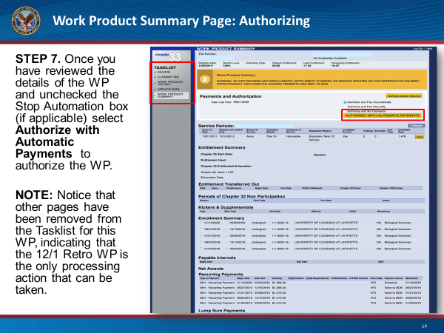 |  | DISPLAY slide 55  EMPHASIZE Fry Spouse is the only exception – these must be paid manually, follow local procedures. Entitlement & Enrollment tabs have been removed from the Tasklist.
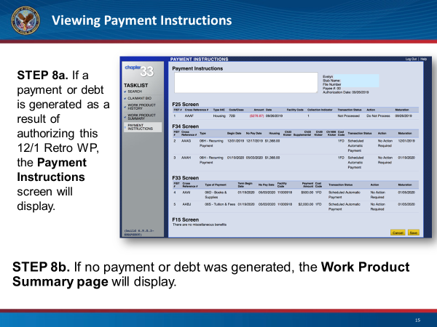 |  | DISPLAY slide 56  DEFINE anything non-housing is either a defect in production, or it is <$0.01. VCEs should not be FIST/FAUTing for fiscal authorization. Except Positive MHA payments for Fry Spouse only.
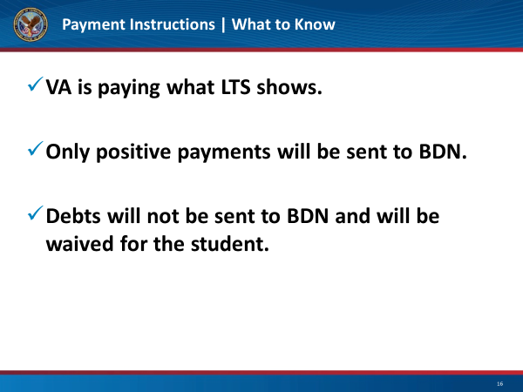 |  | DISPLAY slide 57  HIGHLIGHT these key points when processing a 12/1 Retro Work Product.
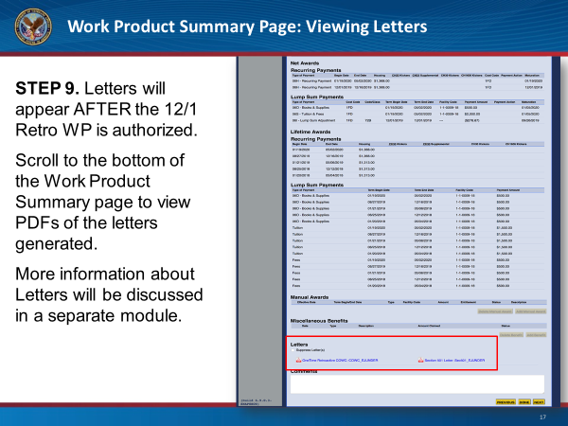 |  | DISPLAY slide 58  EXPRESS letters in the PDF format, will not be visible until after the WP is authorized. Additional information on letters will be provided in the next module.
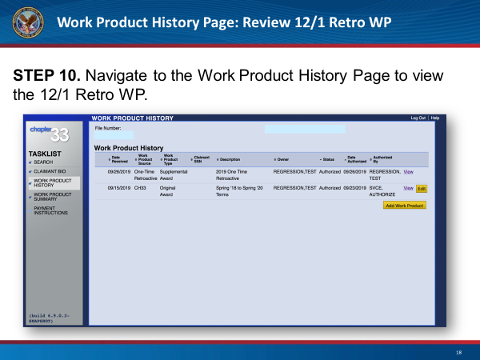 |  | DISPLAY slide 59  EXPLAIN the appearance of an active “Add Work Product” button instead of the “Add 12/1 Retro WP” button, will indicate the 12/1 Retro WP process is complete and normal processing may resume.
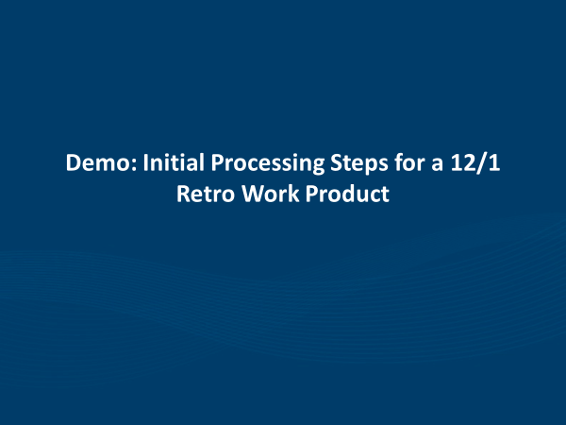 |  | DISPLAY slide 60  INTRODUCE demonstration showing the processing steps for a 12/1 Retro Work Product.
 |  | DISPLAY slide 61  TRANSITION to takeaways section.

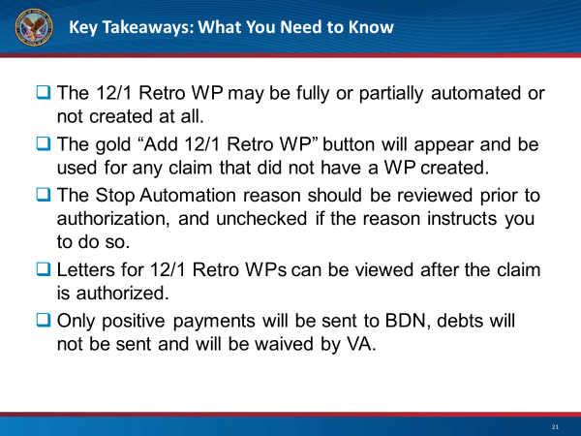 | DISPLAY slide 62  READ key takeaways and inform participants this concludes the third module.

Education Service
Virtual Training Webinar: Reviewing Changes to Colmery Letters (Module 4)
Lesson Plan

Instructor Notes
The purpose of this lesson is to provide guidance to Veterans Claim Examiners, Education Call Center Technicians, and other internal VA stakeholders affected by the changes to letters, in accordance with Sections 501 and 107 of PL 115-48, the Colmery Act, Forever GI Bill.

PowerPoint Slides | Instructor Activities
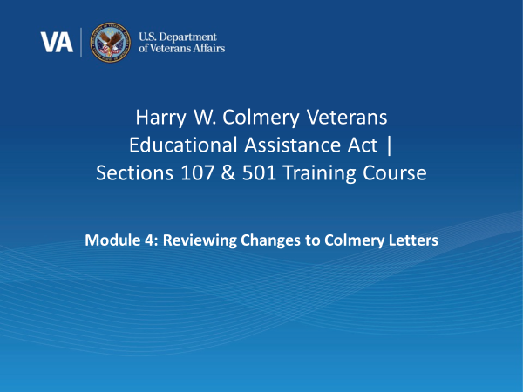 |  | DISPLAY slide 63  INTRODUCE the lesson.
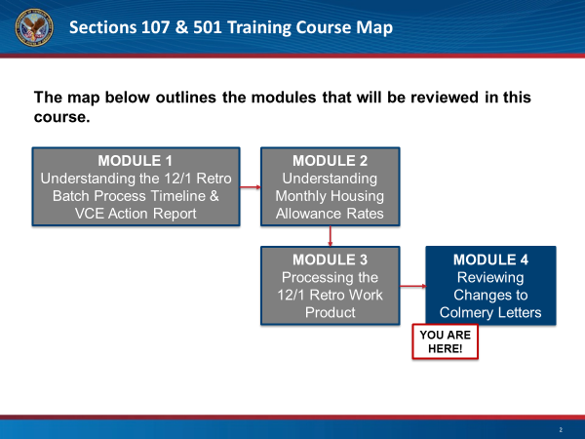 |  | DISPLAY slide 64: “Course Map”  REVIEW the course map briefly and announce we are at our final step.
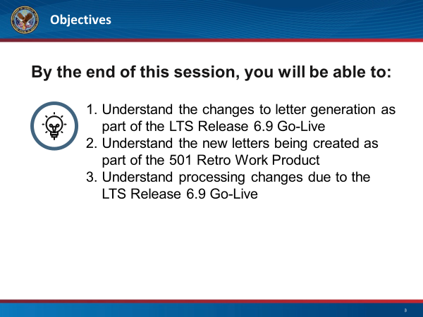 | DISPLAY slide 65  REVIEW objectives for the session.  NOTE these changes are effective immediately and will continue beyond the 12/1 Retro Batch run.
 | DISPLAY slide 66  INTRODUCE the Letters Content Changes section.
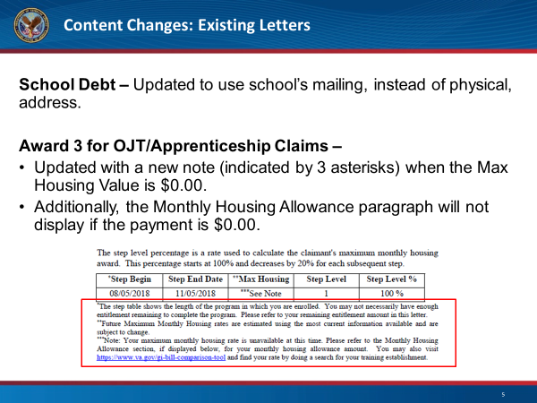 | DISPLAY slide 67  INTRODUCE the slide  READ the change to the School Debt Letter  EXPRESS the change to the Award 3 for OJT/Apprenticeship Claims Letter. For the first bullet, indicate within the image where the Max Housing value is. For the second bullet, indicate this paragraph of text is shown below in the red box and indicates to beneficiaries their maximum monthly housing rate is currently unavailable at this time, providing them instructions on how to proceed.
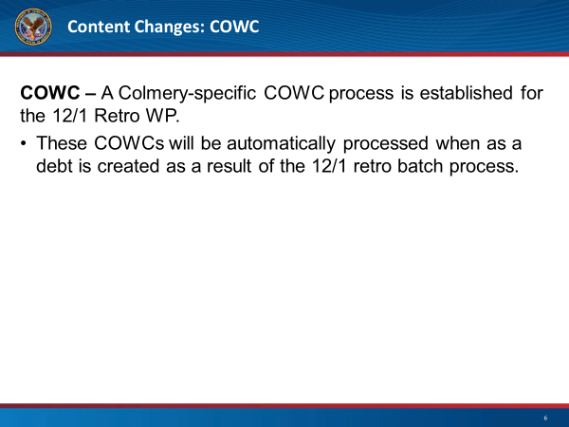 | DISPLAY slide 68  NOTE some of the participants may be familiar with the COWC letter.  INTRODUCE as part of the LTS Release 6.9 and the 501 Retro Batch process, a Colmery-specific COWC process will be established for the 12/1 Retro WP.  INDICATE this will be a temporary COWC for the 12/1 Retro Batch process.
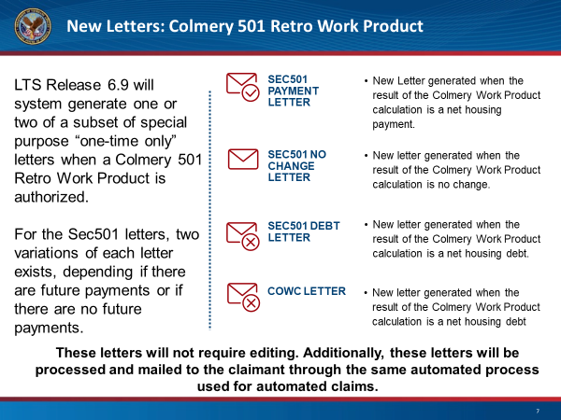 | DISPLAY slide 69  READ left hand side.  WALKTHROUGH each of the letters.  For the first letter, indicate an example where a beneficiary was being paid a lower rate than they should have been and will get a letter indicating VA has reviewed their claim and they will receive a check.  For the second letter, indicate an example where a beneficiary’s rate will not change.  For the final two letters, indicate a situation where a beneficiary was being paid a higher amount than they should have been and have a debt to VA. Reiterate this debt will be automatically waived by VA. As part of the documentation to indicate this, VA will send those with debts a COWC letter, indicating their case has been reviewed and the debt has been waived.  READ the bottom paragraph  PREFACE we will walk through the letter generation process in upcoming slides.
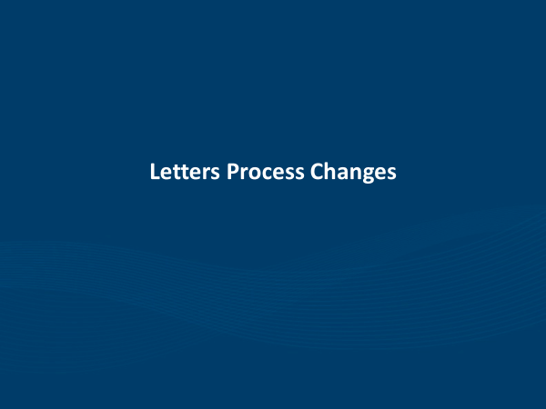 | DISPLAY slide 70  INTRODUCE the Letters Process Changes.
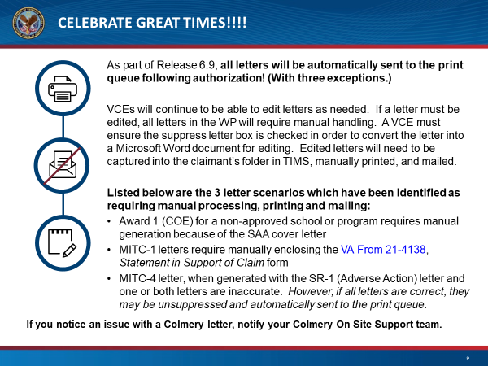 | DISPLAY slide 71  READ the title with enthusiasm.  READ the first paragraph. Note VA systems have been updated with the intent for the majority of the letters to now be automated.  READ the second and third paragraphs.  READ the fourth paragraph. Please note these are three examples and there may be other situations which require manually editing of letters.  PREFACE the fifth paragraph by stating there will be on-site support available during the week of 12/2 to provide assistance if any issues arise with the 12/1 Retro WP.  READ fifth paragraph, adding the Colmery On-Site support team will be able to escalate and help to triage issues as they arise.
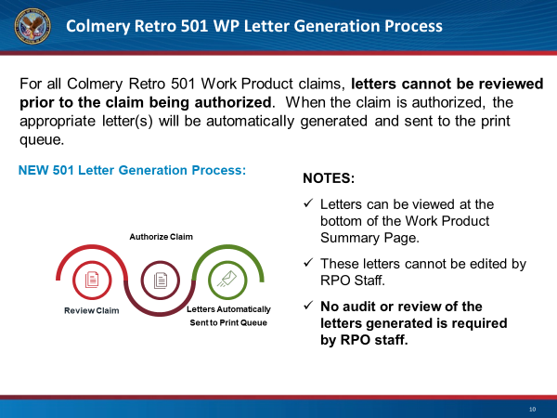 |  | DISPLAY slide 72  READ the first paragraph, indicating this is a temporary process only being used for 501 Retro WP claims  READ each of the steps for the letter generation process. Review the claim for completeness and accuracy. Authorize the Claim, as appropriate.  All letters will be automatically generated and will be sent to the print queue.
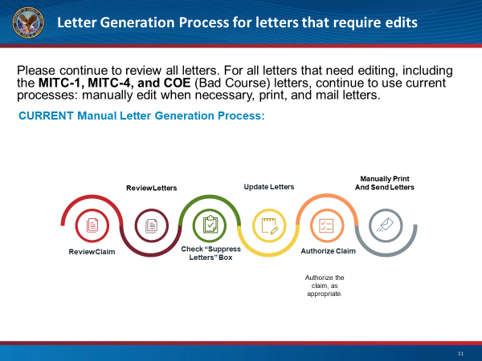 |  | DISPLAY slide 73  READ the first paragraph, indicating this is a continuation of current processes, where a letter needs to be edited. Indicate the MITC-1, MITC-4, and COE letters are known letters needing manual intervention, but there could be instances of other letters needing edit.  READ each of the steps for the letter generation process. Review the claim for completeness and accuracy. For letters requiring manual editing, check the “Suppress Letters” checkbox. This will change the letters from PDF to MS Word and allow edits to the letters. Update the letters with the correct and necessary information. Authorize the Claim, as appropriate. Continue with current process and manually print and send the letters.  REITERATE this is a continuation of current processes.
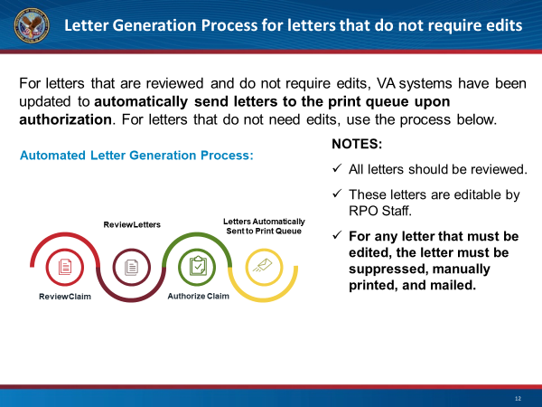 |  | DISPLAY slide 74  READ the first paragraph, indicating this is a new process which will be used for all letters not requiring edit.  READ each of the steps for the letter generation process. Review the claim for completeness and accuracy. Based on the type of claim, review the letters to ensure completeness and accuracy.: Authorize the Claim, as appropriate. All letters will be automatically generated and will be sent to the print queue.  READ each of the “Notes”  REITERATE all letters should still be reviewed.
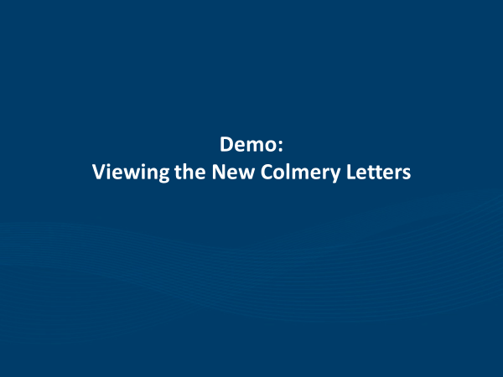 |  | DISPLAY slide 75  INTRODUCE the new section as a live walk-through of the Colmery letters, including the payment, no change, debt, and COWC letters.
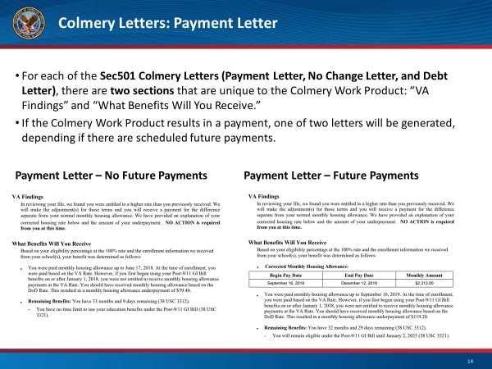 |  | DISPLAY slide 76  READ the first paragraph, indicating we will focus on the “VA Findings” and “What Benefits Will You Receive” sections for each of the letters.  READ the second paragraph. Express the first sentence within the “VA Findings” section, will indicate the beneficiary is entitled to the higher rate; and the second, the VA will pay them for the difference.  NOTE within the “What Benefits Will You Receive” section, beneficiaries will receive further clarity on how their rate was calculated. If there were future scheduled payments, there would be a table of what the current monthly housing allowance is and what a beneficiary should expect to see.
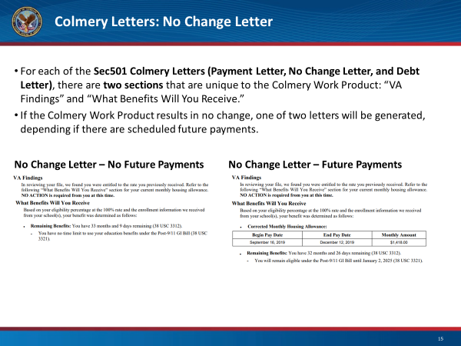 |  | DISPLAY slide 77  READ the first paragraph, indicating we will focus on the “VA Findings” and “What Benefits Will You Receive” sections for each of the letters.  READ the second paragraph. Express the first sentence within the “VA Findings” section will indicate the beneficiary is entitled to the same rate as they received.  NOTE Within the “What Benefits Will You Receive” section, beneficiaries will receive further clarity on how their rate was calculated. If there were future scheduled payments, there would be a table of what the current monthly housing allowance is and what a beneficiary should expect to see.
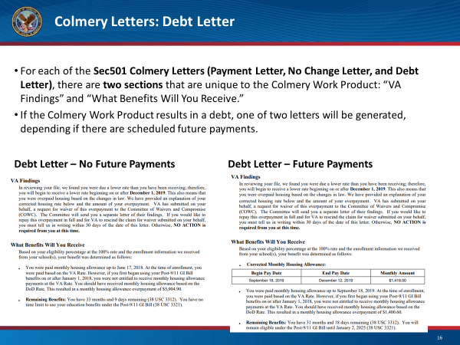 |  | DISPLAY slide 78  READ the first paragraph, indicate we will focus on the “VA Findings” and “What Benefits Will You Receive” sections for each of the letters.  READ the second paragraph. Express the first sentence within the “VA Findings” section, will indicate the beneficiary is entitled to a lower rate and the remainder identifies the VA has completed the COWC waiver on the veterans behalf.  NOTE Within the “What Benefits Will You Receive” section, beneficiaries will receive further clarity on how their rate was calculated. If there were future scheduled payments, there would be a table of what the current monthly housing allowance is and what a beneficiary should expect to see.
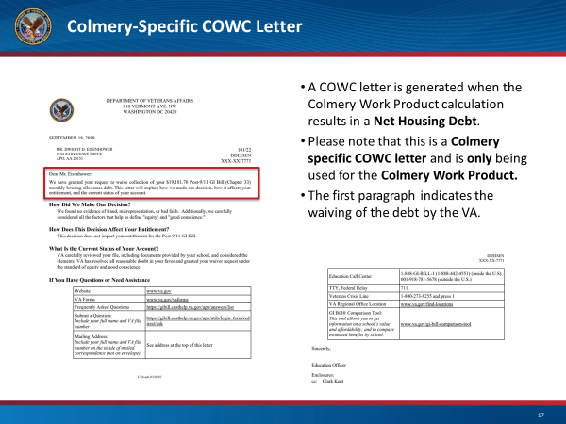 |  | DISPLAY slide 79  REITERATE this specific COWC letter is only for Colmery Work Products and will be automatically generated when the claim is authorized if the result is a Net Housing Debt.  INDICATE the first paragraph indicates the waiving of the debt by VA and there is no further action required by the veteran.  REITERATE all situations in which a debt is created by the Colmery WP will automatically create the COWC Letter and waive the debt. No debts will be issued to the veteran.
DISPLAY slide 80

INTRODUCE high-level, bottom line up front takeaways.

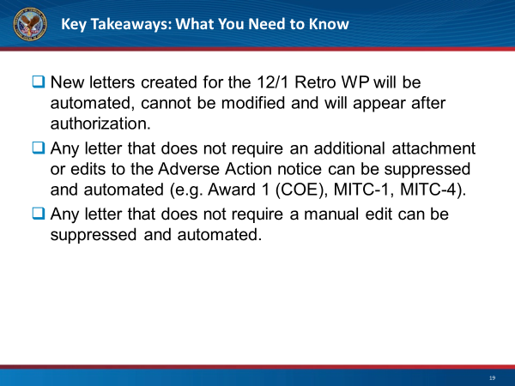 |  | DISPLAY slide 81  READ each of the bullets listed.
DISPLAY slide 82

REINTRODUCE Kahoot tool as a game-based knowledge check, with points given for accuracy as well as speed.
DISPLAY slide 83

REVIEW steps for participants to log into Kahoot and allot 1-2 minutes for set up.
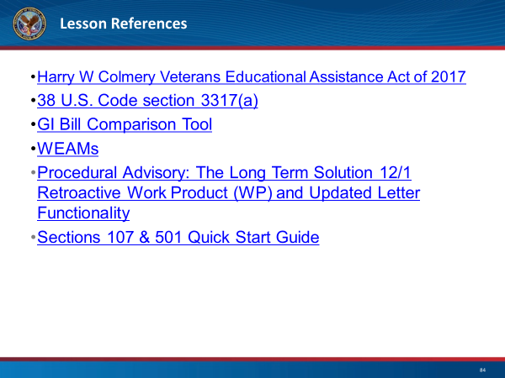 |  | DISPLAY slide 84  REVIEW lesson references, noting that the items grayed out will be provided in the future.
 |  | DISPLAY slide 85  IDENTIFY: This slide contains a thank you for the Subject Matter Experts(SMEs) who aided in the creation of these materials and demos.
 |  | DISPLAY slide 86  IDENTIFY: This slide stands as a thank you for all of the attendees.
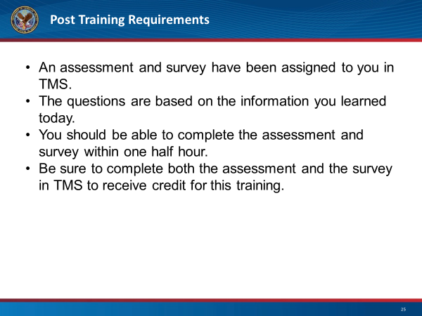 |  | DISPLAY slide 87  NOTE: This slide contains the post training requirements for this module.

