Education Service
Digitized Mail Handling Services (DMHS)
Centralized Mail (CM) Portal Super User Training Presentation
Lesson Plan

October 2019
Version 1.0

Lesson Overview
Topic | Description
Time Estimate: | 2 hours
Purpose of the Lesson: | The purpose of this presentation is to provide steps for how Super Users handle Returned Mail packets in the Centralized Mail (CM) Portal.
Prerequisite Training Requirements: | None
Target Audience: | This lesson is designed for the following audiences:  - Supervisors  - Super Users
Lesson References: | - Centralized Mail-Portal User Manual Version 1.3
Lesson Objectives: | After you have completed the Centralized Mail Super User Training Presentation lesson, you will be able to perform the functions of a Super User.
What You Need: | Digitized Mail Handling Services (DMHS) Centralized Mail (CM) Portal Super User Training Presentation
Post Training Requirements: | Upon completion of the classroom portion of the lesson, participants are required to complete an online lesson assessment and survey in Talent Management System (TMS).  To demonstrate successful completion of the lesson participants must pass the assessment with a score of at least 80%.  Participants must also complete the online survey to earn credit for completion of the lesson.

Instructor Notes
This lesson provides students with the steps for handling returned mail packets in the CM Portal as well as assigning packets to users and processing packets in the Authorization queue.
PowerPoint Slides | Instructor Activities
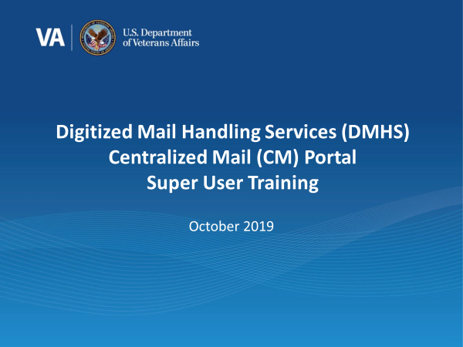 | DISPLAY slide 1. “Digitized Mail Handling Services (DMHS) Centralized Mail (CM) Portal Super User Training”  INTRODUCE yourself as the instructor and fellow instructors (if any).  INTRODUCE the lesson.
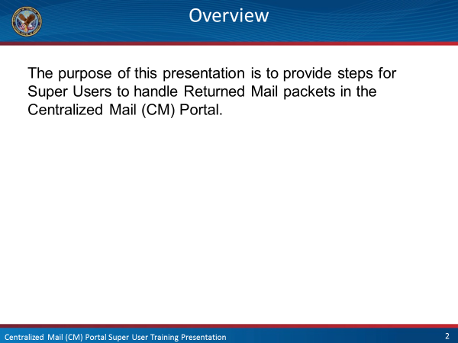 | DISPLAY slide 2. “Overview”  EXPLAIN that you will be discussing how Super Users will handle, assign, and authorize returned mail in the Centralized Mail portal.
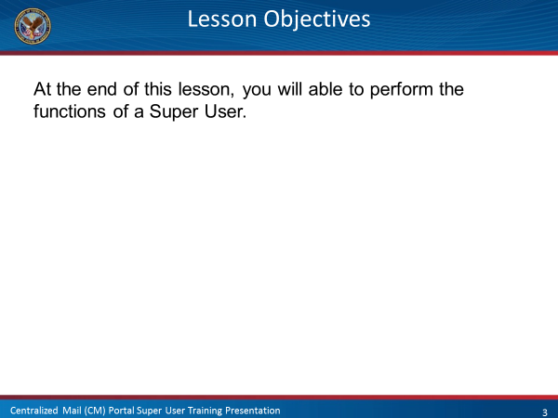 | DISPLAY slide 3. “Lesson Objectives”  EXPLAIN to the students that you will be discussing the responsibilities of a Super User  ENCOURAGE students to ask questions throughout the presentation.
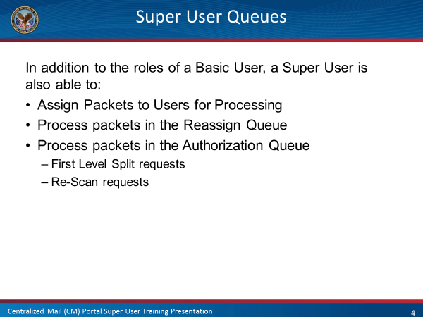 | DISPLAY slide 4. ”Super User Queues”  LIST the additional functions that a Super User has in the Mail Handling Process.  EXPLAIN you will discussing these steps during this presentation.
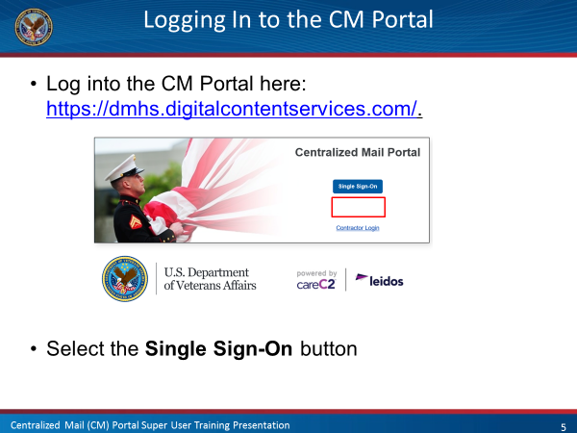 | DISPLAY slide 5 “Logging in to the CM Portal”  ACCESS https://dmhs.digitalcontentservices.com/  SHOW the link to the CM Portal  EXPLAIN to the class that you will remind them how to log in to the portal.
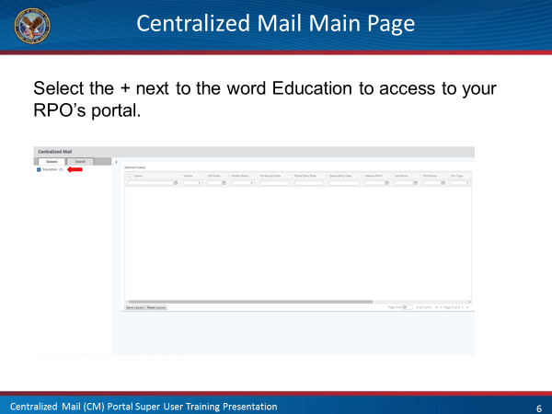 | DISPLAY slide 6 “Centralized Mail Main Page”  CONTINUE showing the class the steps they will need to follow in order to access their queues.
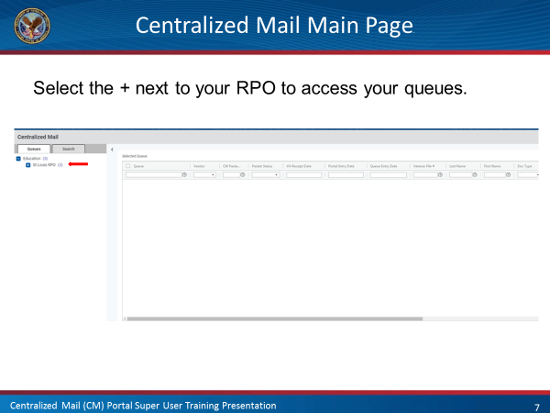 | DISPLAY slide 7 “Centralized Mail Main Page”  REMIND the students that they will use the Authentication Certificate to continue the log in process.
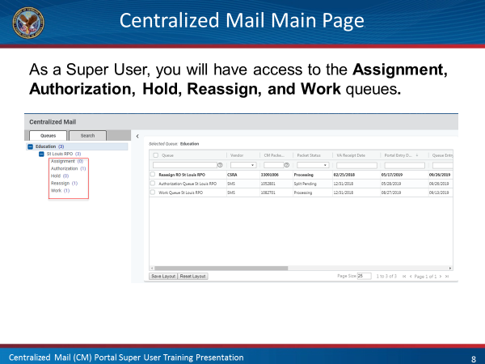 | DISPLAY slide 8 “Centralized Mail Main Page”  LIST the queues that a Super User will have access too.
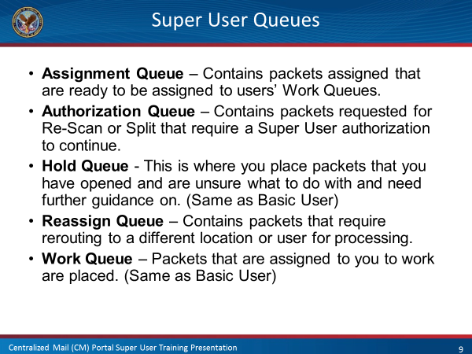 | DISPLAY slide 9 “Super User Queues”  DEFINE what each queue that the Super User has access to is used for.  EXPLAIN that you will be discussing each queue in further detail and how to use them throughout this presentation.
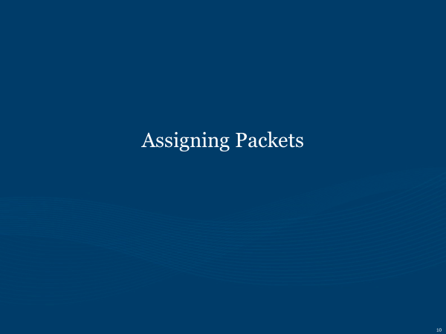 | DISPLAY slide 10 “Assigning Packets”  EXPLAIN that you will be discussing how to assign packets to users first.
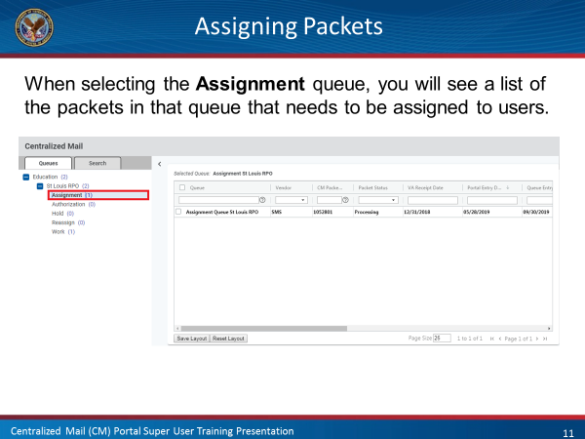 | DISPLAY slide 11 “Assigning Packets”  EXPLAIN that when the Super User selects the Assignment Queue, a list of all of the packets in that queue will be displayed.
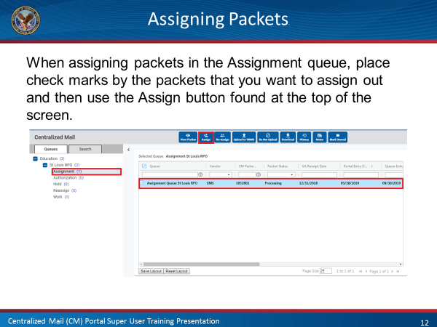 | DISPLAY slide 12 “Assigning Packets”  EXPLAIN that the Super User will first highlight all of the packets that they wish to assign to a user.  EXPLAIN that after the Super User has highlighted the packets to be assigned, they will then need to use the Assign button.
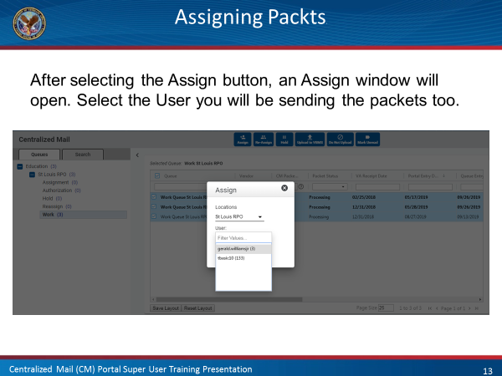 | DISPLAY slide 13 “Assigning Packets”  EXPLAIN that after using the Assign button, an assign window will open. The Super User will then scroll through the list of users and select who they wish to assign the packets too.
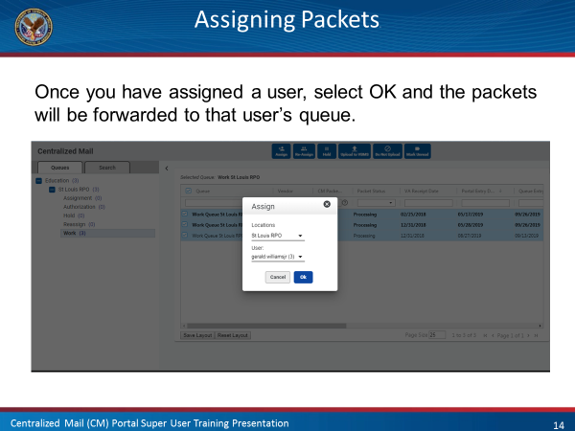 | DISPLAY slide 14 “Assigning Packets”  EXPLAIN that once the user has been selected, the Super User will then click on the OK button and the packets will then be forwarded to that user’s Work Queue for their action.
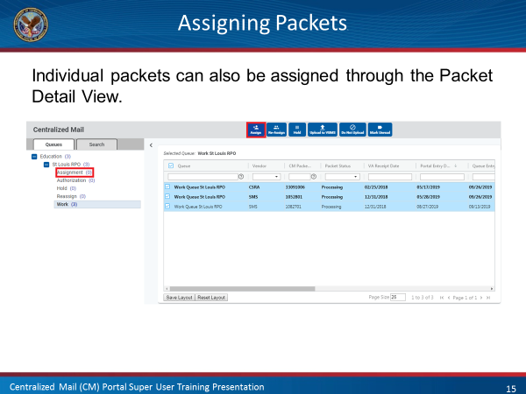 | DISPLAY slide 15 “Assigning Packets”  EXPLAIN to the class that you showed them how to assign packes from the Centralized Mail view and that you will now show them how to assign a packet through the Packet Detail view.
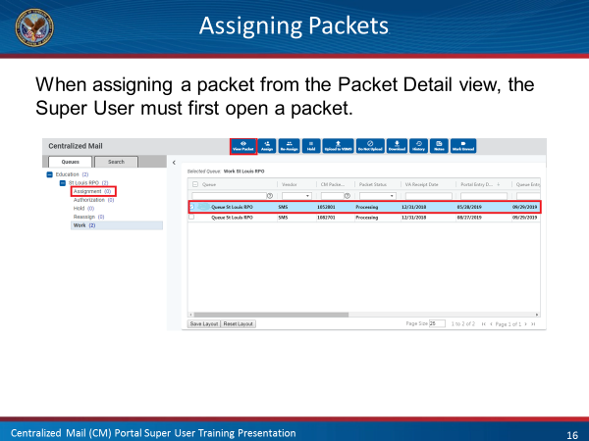 | DISPLAY slide 16 “Assigning Packets”  EXPLAIN that there are two possible ways to open a packet. The Super User can either double click on the Highlighted Packet or Highlight a packet and then select the View Packet button.  EXPLAIN that this process can only assign one packet at a time. If the Super User wishes to assign more than one packet at a time, they will have to do it from the Centralized Mail view.
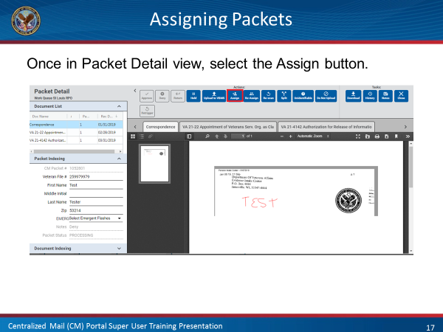 | DISPLAY slide 17 “Assigning Packets”  EXPLAIN that once in the Packet Detail View, the Super User will then use the Assign button.  EXPLAIN that once they have selected the Assign button, the Super User will then follow the steps detailed on slides 13 and 14 for how to assign the packet to a user.  SOLICIT the class for any questions they may have regarding how to assign packets to users.
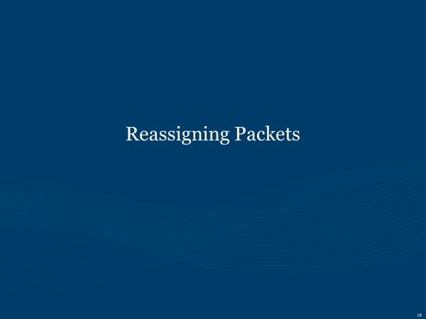 | DISPLAY slide 18 “Reassigning Packets”  EXPLAIN that you will now be discussing how to reassign packets to other RPOs.
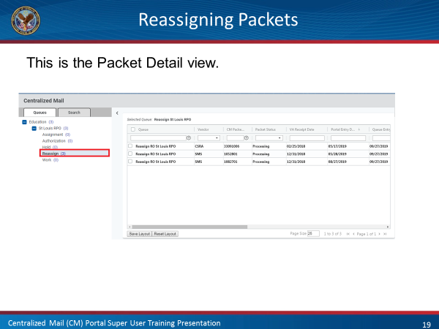 | DISPLAY slide 19 “Reassigning Packets”  OPEN the Centralized Mail and Highlight the Reassign Queue  EXPLAIN that packets can be reassigned one at a time or several at a time.  EXPLAIN that the options available are different depending on whether the Super User is reassigning one packet or more than one packet.
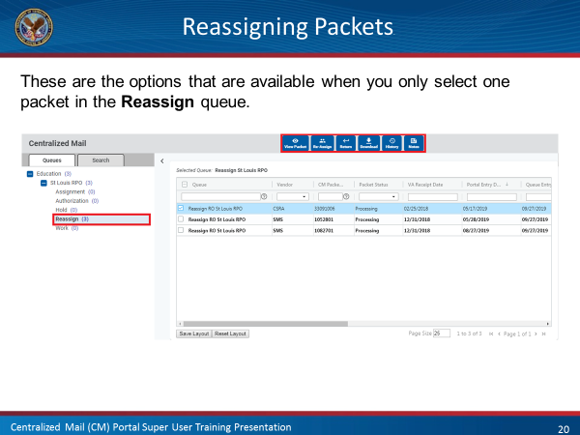 | DISPLAY slide 20 “Reassigning Packets”  LIST the available options that the Super User can use when only one packet is highlighted for reassigning.  EXPLAIN each option
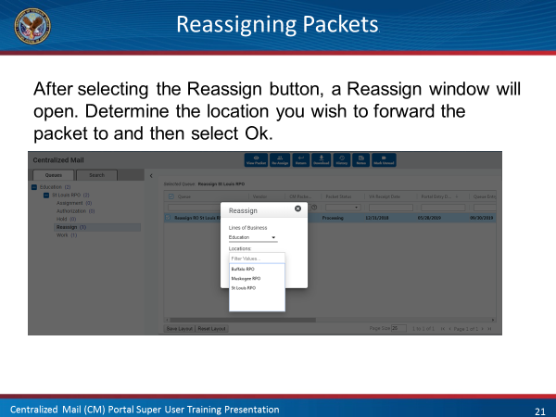 | DISPLAY slide 21 “Reassigning Packets”  EXPLAIN that as a Super User, their action will result in the packet being routed to the correct RPO.  EXPLAIN that after highlighting the packets they wish to reassign, the Super User will then used the Reassign button. Once pressed, reassign window will open and the Super User will then scroll through the list of RPOs and determine which RPO to send the the packet(s).
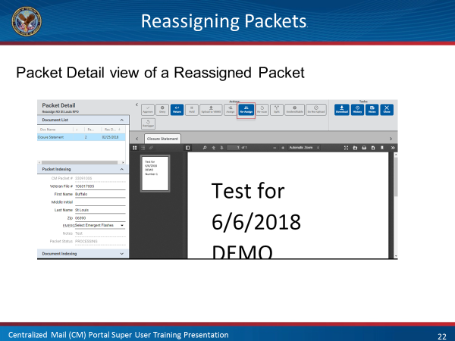 | DISPLAY slide 22 “Reassigning Packets”  EXPLAIN that you will now show them how to reassign a packet from the Packet Detail view.  EXPLAIN that this process can only reassign one packet at a time. If the Super User wishes to reassign more than one packet at a time, they will need to do it from the Centralized Mail view.  NOTE that the options available are different when working in the Packet Detail view and then list those options.
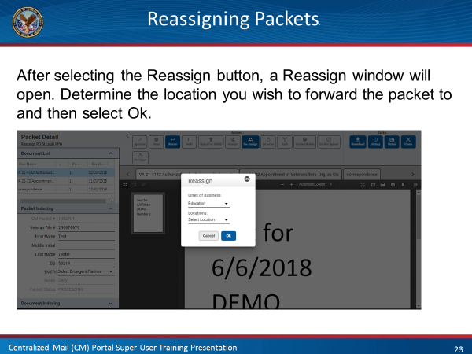 | DISPLAY slide 23 “Reassigning Packets”  EXPLAIN that after using the Reassign button a Reassign window will open and that the Super User will need to locate the RPO they wish to send the packet too based on the Basic User’s note.  ADVISE the class that they will select Ok after selecting the appropriate RPO.
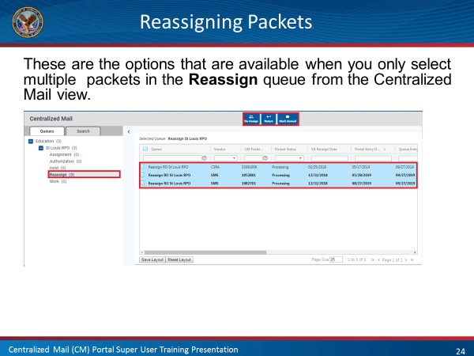 | DISPLAY slide 24 “Reassigning Packets”  EXPLAIN that you wil now be discussing the options available when reassigning multiple packets.  SHOW the class that they will only have 3 options available, Reassign, Return, and Mark Unread.  EXPLAIN that if they select Reassign, they will follow the steps detailed on slide 21 regarding reassigning packets. If they select Return, the packet will be returned to the User who forwarded it to the Reassign queue. If they select Mark Unread, it will remain in the Reassign Queue and marked as unread.  SOLICIT the class for any questions they may have regarding how to reassign packets to users.
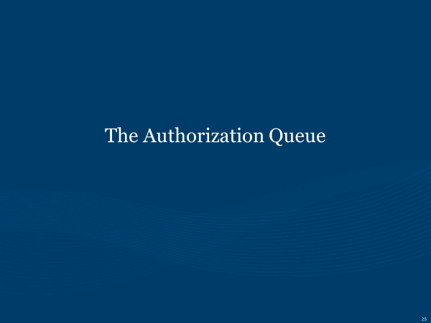 | DISPLAY slide 25 “The Authorization Queue”  EXPLAIN that you will now be discussing the authorization process in the mail portal.
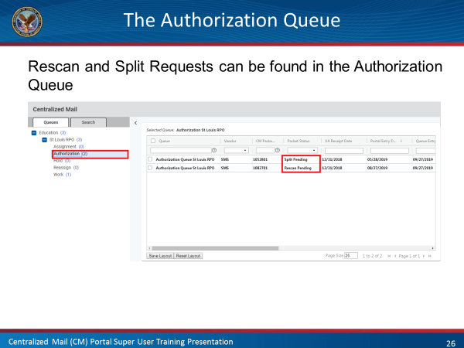 | DISPLAY slide 26 “The Authorization Queue”  EXPLAIN that the Authorization Queue can contain either packets that were sent for Rescanning or Splitting.  NOTE the Packet Status field on the Centralized Mail view shows what action is being requested on the packet.
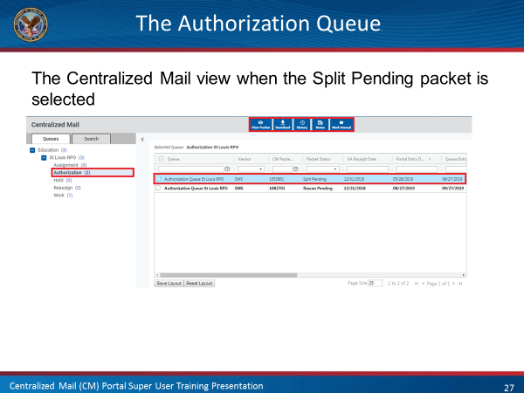 | DISPLAY slide 27 “The Authorization Queue”  EXPLAIN that you will first be discussing a Split Pending request.  EXPLAIN that in order to authorize or deny the Split request, the Super User must open the packet first. This can be done by either double clicking on the highlighted packet or highlighting the packet and selecting view packet.
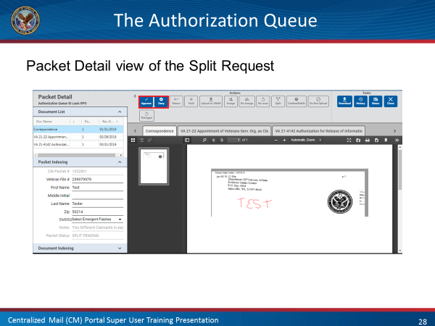 | DISPLAY slide 28 “The Authorization Queue”  EXPLAIN the Super User needs to review the packet before either approving or denying the split request.  ADVISE the class that approving the Split request will send the packet to the Vender for action. If the request is denied, the packet will be returned to the user.  SOLICIT for any questions regarding authorizing a Split request.
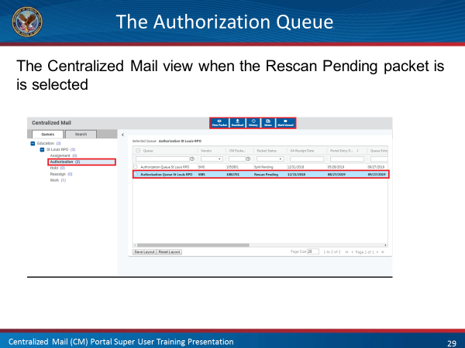 | DISPLAY slide 29 “The Authorization Queue”  EXPLAIN that you will now be discussing authorizing Rescan requests  ADVISE the class that the packet must be opened in order to authorize or deny a rescan request.
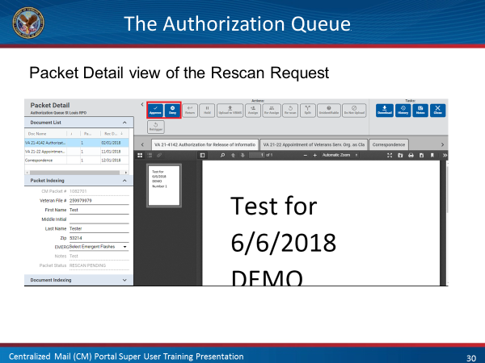 | DISPLAY slide 30 “The Authorization Queue”  EXPLAIN that authorizing a Rescan request is a 3 step process. After the Super User authorizes the request it is then forward to the Admin for final authorization.  EXPLAIN that denying the Rescan request sends the packet back to the User.  REMIND the class that as mentioned during the Basic User Training, if the packet is watermarked “Best Copy”, the Super User will automatically deny the Rescan request.
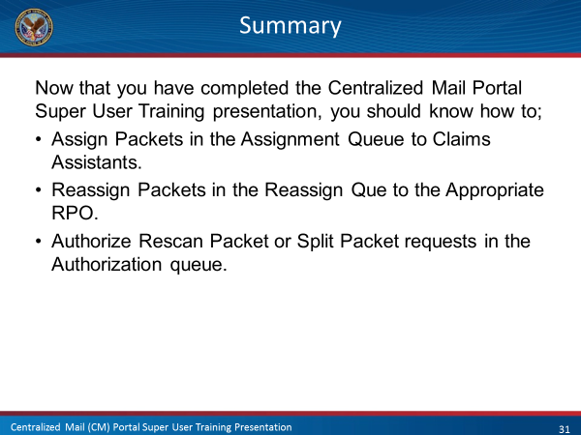 | DISPLAY slide 31 “Summary”  REVIEW the information discussed in today’s lesson.
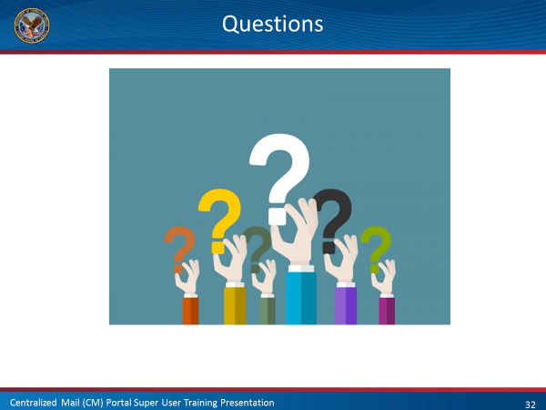 | DISPLAY slide 32 “Questions?”  ASK students if they have any questions about today’s CM Portal lesson.  RESPOND to all questions before tasking students to complete the assessment
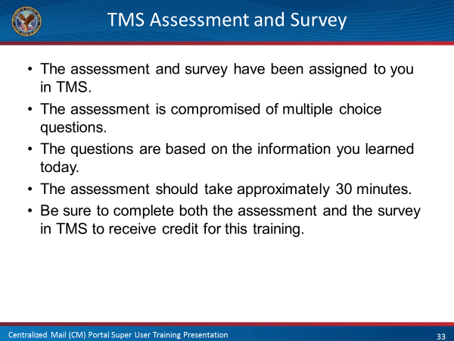 | DISPLAY slide 33 “TMS Assessment and Survey”  Conclude the training by doing the following:  CONFIRM the students know how to access the assessment and survey in TMS.  EXPLAIN that the assessment is TMS # and will cover what they learned in class today.  REMIND them that they must complete both the assessment and the survey in order to receive credit in TMS.  TELL students that the survey provides them an opportunity to improve the training and that their feedback is welcome.

