Education Service
Digitized Mail Handling Services (DMHS)
Centralized Mail (CM) Portal Basic User Training Presentation
Lesson Plan

September 2019
Version 1.0

Lesson Overview
Topic | Description
Time Estimate: | 1 hour
Purpose of the Lesson: | The purpose of this presentation is to provide high level steps for Basic Users to handle Returned Mail packets in the Centralized Mail (CM) Portal.
Prerequisite Training Requirements: | None
Target Audience: | This lesson is designed for the following audiences:  - Claims Specialists
Lesson References: | - Centralized Mail-Portal User Manual Version 1.3
Lesson Objectives: | After you have completed the Centralized Mail Basic User Training Presentation lesson, you will be able to:  - Open up the Centralized Mail Portal  - Locate a packet  - Download the packet to your computer  - Add the packet the TIMS  - And close out the packet
What You Need: | Digitized Mail Handling Services (DMHS) Centralized Mail (CM) Portal Basic User Training Presentation
Post Training Requirements: | Upon completion of the classroom portion of the lesson, participants are required to complete an online lesson assessment and survey in Talent Management System (TMS).  To demonstrate successful completion of the lesson participants must pass the assessment with a score of at least 80%.  Participants must also complete the online survey to earn credit for completion of the lesson.

Instructor Notes
This lesson provides students with the steps for logging in to the CM Portal, locating a packet, downloading it to the hard drive so that it can be uploaded to TIMS and finish the packet after uploaded.
PowerPoint Slides | Instructor Activities
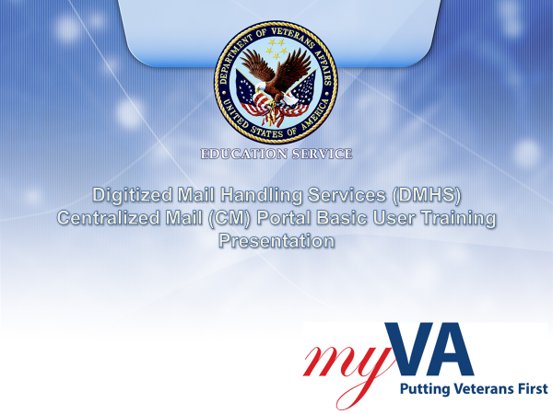 | DISPLAY slide 1. “Digitized Mail Handling Services (DMHS) Centralized Mail (CM) Portal Basic User Training”  INTRODUCE yourself as the instructor and fellow instructors (if any).  INTRODUCE the lesson.
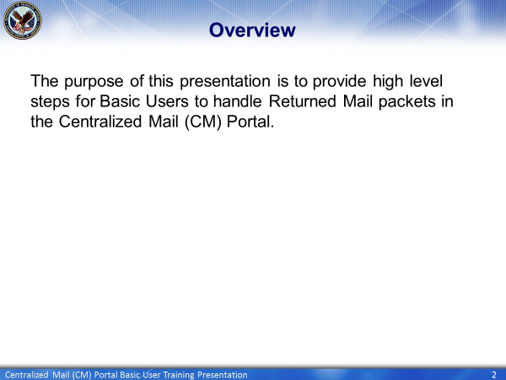 | DISPLAY slide 2. “Overview”  EXPLAIN that you will be discussing how Basic Users will handle returned mail in the Centralized Mail portal.
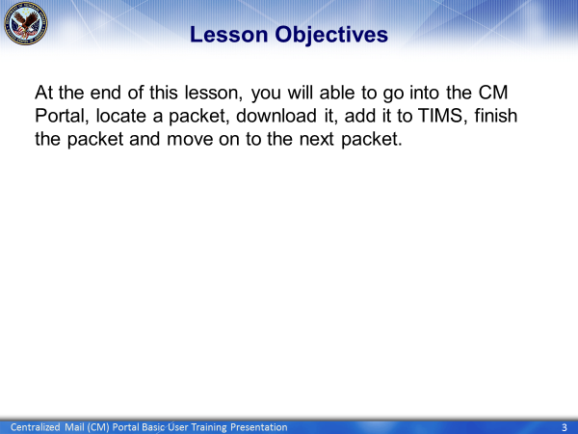 | DISPLAY slide 3. “Lesson Objectives”  EXPLAIN to the students that they will be learning how to locate a packet in the Centralized Mail Portal, download it to their computer and then add that document to TIMS, and then close out of the packet.  ADVISE them that they will need to close out of the packet correctly so that it is not erroneously uploaded to VBMS.  ENCOURAGE students to ask questions throughout the presentation.
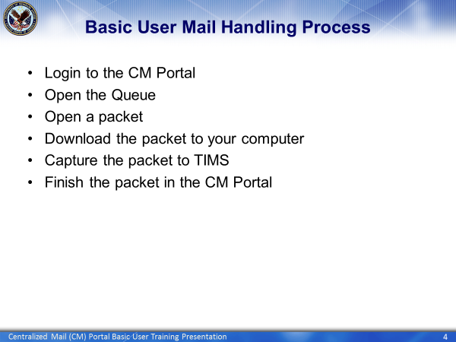 | DISPLAY slide 4. ”Basic User Mail Handling Process”  LIST the steps that are involved in the Mail Handling Process for Basic Users.  EXPLAIN you will discussing each step during this presentation.
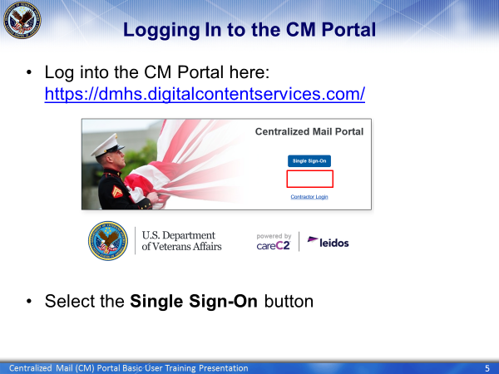 | DISPLAY slide 5 “Logging in to the CM Portal”  ACCESS https://dmhs.digitalcontentservices.com/  SHOW the link to the CM Portal  EXPLAIN that you will be demonstrating how to log in to the portal.
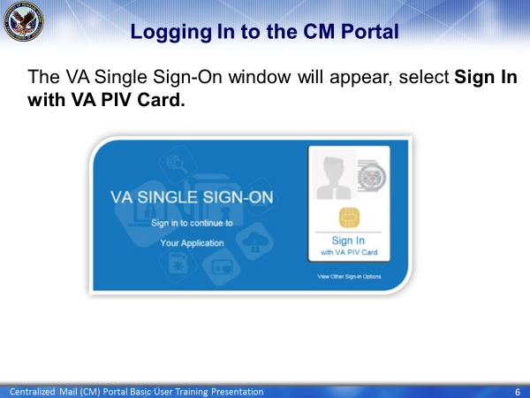 | DISPLAY slide 6 “Logging in to the CM Portal”  CONTINUE showing the students how to log in
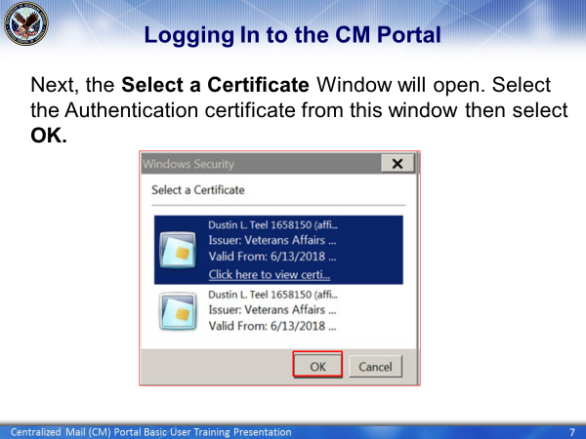 | DISPLAY slide 7 “Logging in to the CM Portal”  REMIND the students that they will need to use the Authentication Certificate to continue the log in process.  INFORM them this is where the user will select the correct certificate click enter.
WSMS Menu  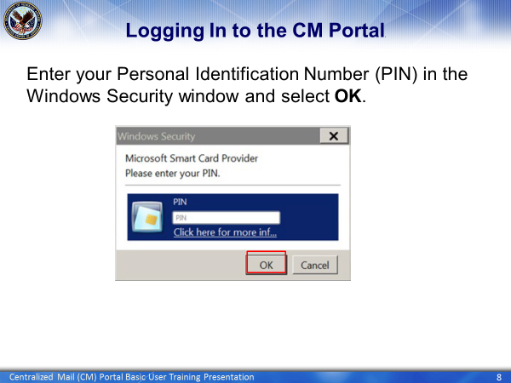 | DISPLAY slide 8 “Logging In to the CM Portal”  INFORM the the user that they will need to input their PIV PIN number here.
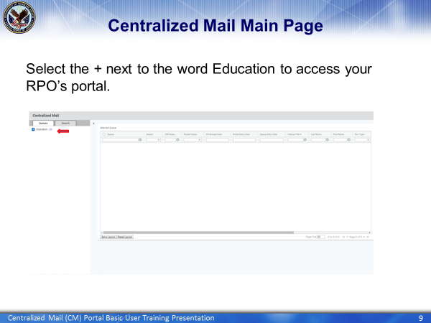 | DISPLAY slide 9 “Centralized Mail Main Page”  EXPLAIN that this is the first page the comes up after opending up the Portal. The user will be looking in the Education Queue  EXPLAIN that that the user will click on the plus sign to access their RPOs Queue.
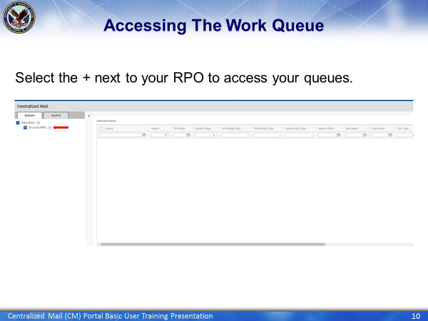 | DISPLAY slide 10 “Accessing the Work Queue”  EXPLAIN that this screen shows The user the RPO Queue  EXPLAIN that after going to their RPOs queue, the user will click on the plus sign by their RPO to access their individual queue.
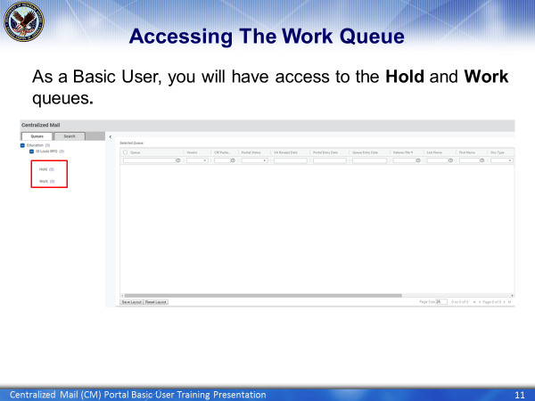 | DISPLAY slide 11 “Accessing the Work Queue”  EXPLAIN that Basic Users will only have access to 2 queues. The Hold Queue and Work Queue.
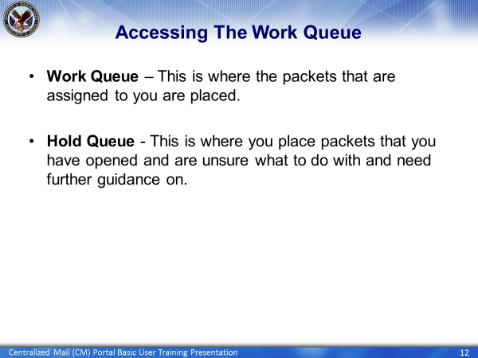 | DISPLAY slide 12 “Accessing the Work Queue”  DEFINE The Work Queue  DEFINE The Hold Queue
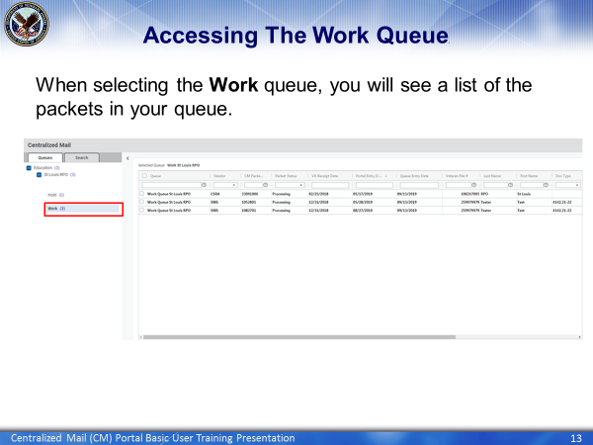 | DISPLAY slide 13 “Accessing the Work Queue”  EXPLAIN that by clicking on the Work Queue, the user will see all of the packets that are in the work queue ready to be reviewed.  EXPLAIN that the user will need to double click on the packet located in the Selected Queue view to open up a packet.
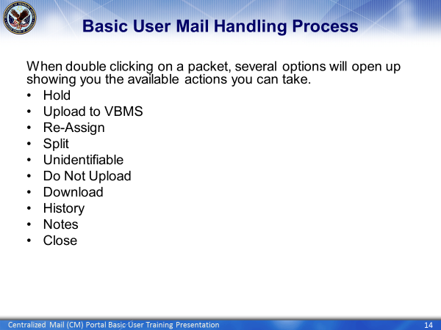 | DISPLAY slide 14 “Basic User Mail Handling Process”  LIST the available actions that the Basic User will have when they open a packet for review.  ADVISE the class that you will be discussing each option during this presentation. Contract Status and Worksite.
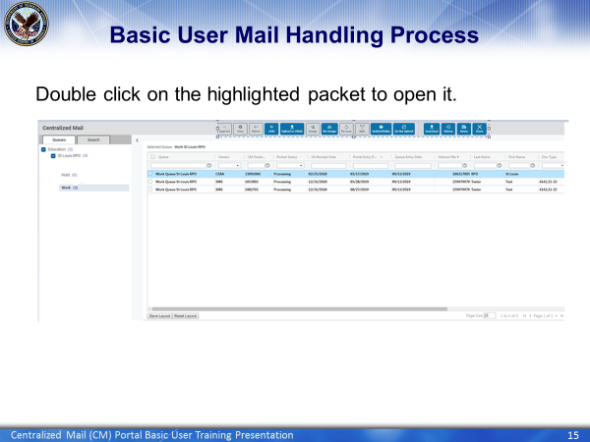 | DISPLAY slide 15 “Basic User Mail Handling Process”  REMIND the user that they must double click on the highlighted packet to open in and see the documents contained in that packet.  EXPLAIN to the class that they only have access to the blue buttons.
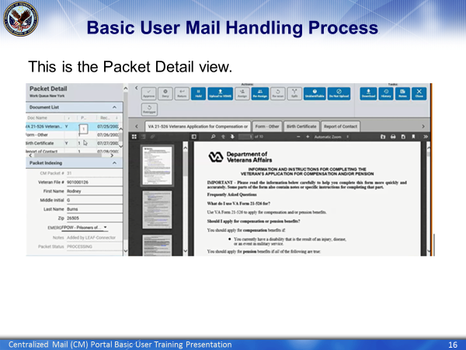 | DISPLAY slide 16 “Basic User Mail Handling Process.”  EXPLAIN that this is what a packet looks like in the Mail Portal when it is opened  LIST the three different windows that are open in the Packet Detail view.  EXPLAIN that the Document List view lists each document located in the packet.  EXPLAIN that each tab in the Document View window will display each document.  EXPLAIN the Packet Indexing window contains the below information and can be edited:  - Veteran File Number  - First Name  - Middle Initial  - Last Name  - Zip Code
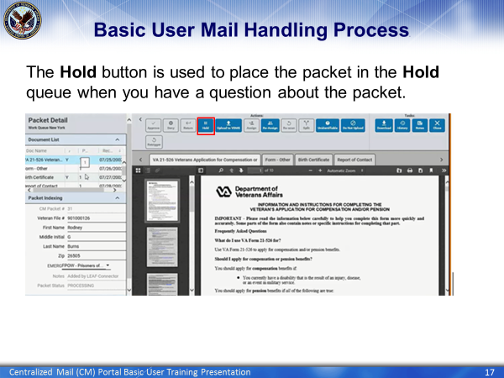 | DISPLAY slide 17 “Basic User Mail Handling Process”  EXPLAIN that you will be discussing each possible action that can be taken when working an open packet.  EXPLAIN the first button you will discuss is the Hold button.  EXPLAIN that this button is used when you have a question about the packet that you need answered before you can upload it to TIMS.  EXPLAIN that the packet will remain assigned to you and remain in the Hold queue until you either reroute it back to your Work queue or you upload the document to TIMS.
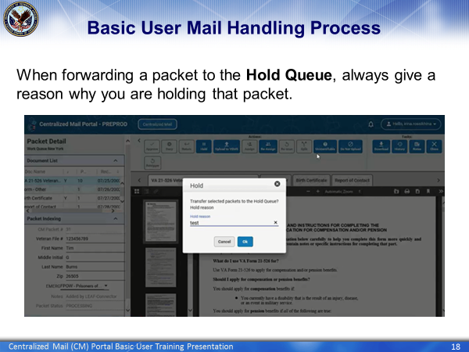 | DISPLAY slide 18 “Basic User Mail Handling Process”  EXPLAIN that after the user clicks on the Hold button, a window will open up asking the user why they are forwarding the packet to the Hold queue.  EXPLAIN that the user will need to give a reason for the Hold. They will not be able to proceed until they do.  EXPLAIN that once they give a reason, they will then need to click the OK button and the packet will then be sent to the Hold queue.
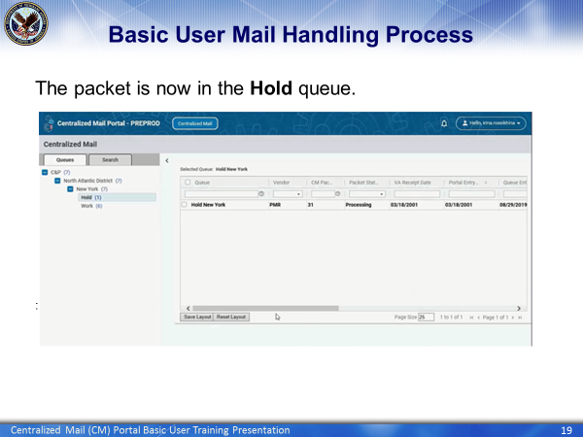 | DISPLAY slide 19 “Basic User Mail Handling Process”  OPEN the Centralized Mail and Highlight the Hold Queue  EXPLAIN that the packet is now in the Hold queue awaiting further action.  EXPLAIN that once the user gets their answer, they can either forward it to the Work queue or they can open it in the Hold queue and work it.
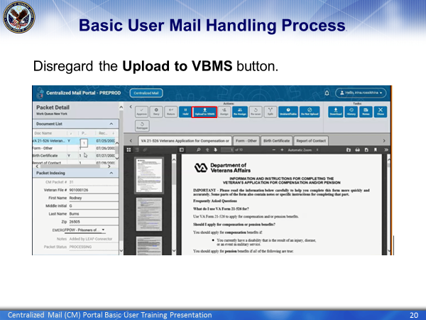 | DISPLAY slide 20 “Basic User Handling Process”  EXPLAIN that the user can disregard this button. It only applies to the Service Center.
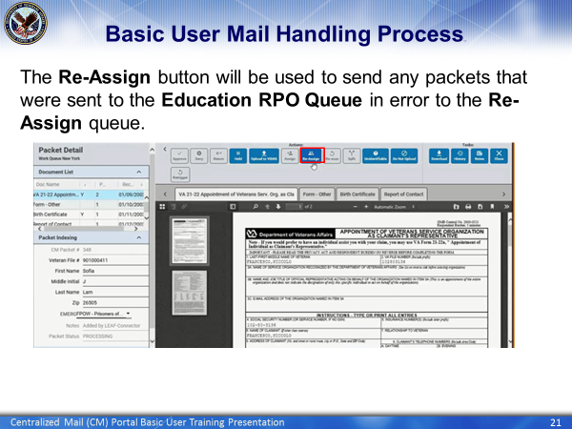 | DISPLAY slide 21 “Basic User Mail Handling Process”  EXPLAIN that you will now be discussing the Reassign button.  EXPLAIN that this option is used when after reviewing the packet, it is determined that it was sent to the wrong location.  EXPLAIN that the user is able to route the packet to this queue so that it can be forwarded to the correct location.  MENTION that after the packet is routed to the Reassign queue, only the Super User or Supervisor will have the ability to route the packet to the correct location.
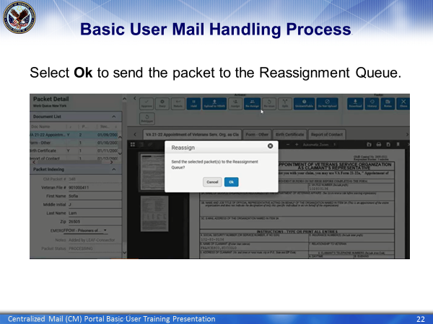 | DISPLAY slide 22 “Basic User Mail Handling Process”  EXPLAIN that after the user clicks on the Reassign button, a window will open up asking the user if they wish to send the selected packet to the Reassignment queue.  EXPLAIN that the user will then need to click the OK button to send to the packet to the Reassignment queue.
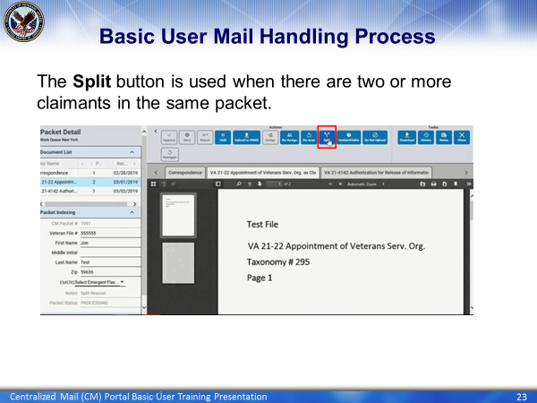 | DISPLAY slide 23 “Basic User Mail Handling Process”  EXPLAIN that you will now be discussing the Split function.  EXPLAIN that the Split function is used when there are two different claimants in the same packet and it needs to go to the vendor so that they can be separated into two packets.
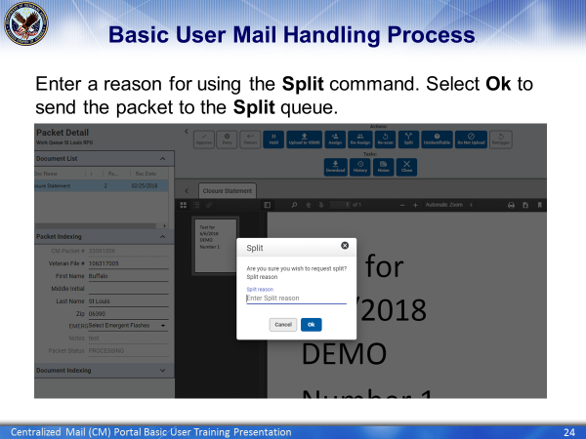 | DISPLAY slide 24 “Basic User Mail Handling Process”  EXPLAIN that after the user clicks on the Split button, a window will open up asking the user why they are forwarding the packet to the Split queue.  EXPLAIN that the user will need to give an explanation why they are forwarding it for Splitting. They will not be able to proceed until they do.  EXPLAIN that once they give a reason, they will then need to click the OK button and the packet will then be forwarded to the Authorization queue.  EXPLAIN that once in the Authorization queue, the Super User will need to authorize it before it goes to the Vendor.
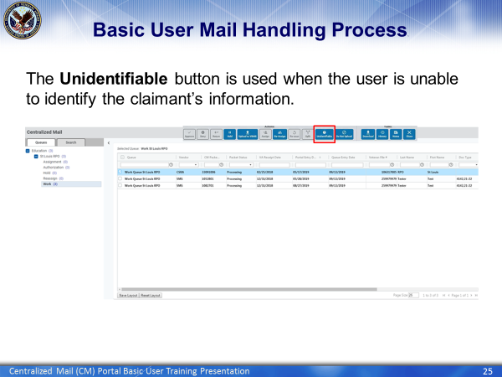 | DISPLAY slide 25 “Basic User Mail Handling Process”  EXPLAIN that you will now be discussing the Unidentifiable button.  EXPLAIN that the Unidentifiable button is used when after a thorough review of the packet, the user is unable to identify the claimant’s information.  EXPLAIN that if there is an indication on the packet that it is the best copy, that the user should not send it to the Vendor. They should place it on Hold and ask their supervisor what to do.  EXPLAIN that you need to identify the claimant so that you can upload the documents in the packet to the correct TIMS file.
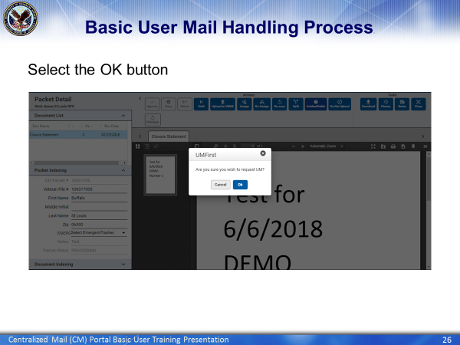 | DISPLAY slide 26 “Basic User Mail Handling Process”  EXPLAIN that after the user clicks on the Unidentifiable button, a window will open up asking the user if they wish to send the selected packet to the Vendor for review.  EXPLAIN that once the user clicks the OK button, the packet will be sent to the Vendor for review and possible action.
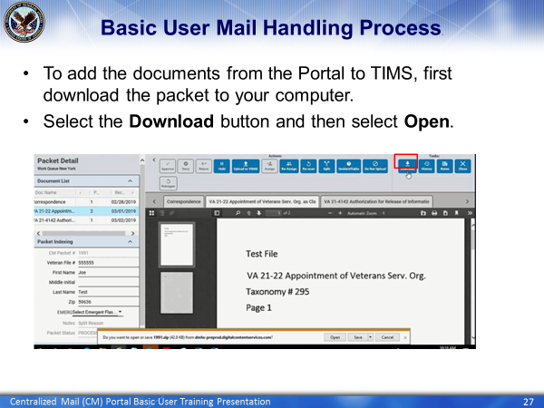 | DISPLAY slide 27 “Basic User Mail Handling Process”  EXPLAIN that before adding the documents in a packet to TIMS, the user should first download the packet to their computer.  EXPLAIN that the user will need to click on the Download button and then select the open button on the window found at the bottom of the screen.
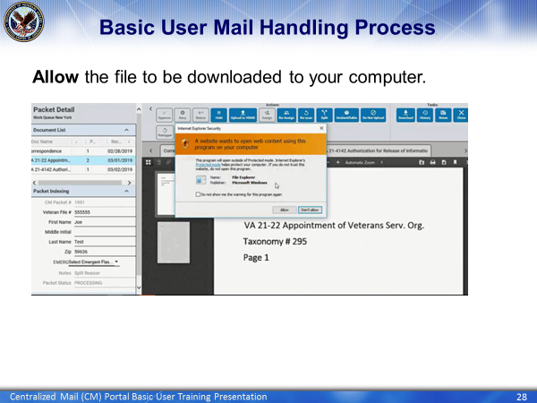 | DISPLAY slide 28 “Basic User Mail Handling Process”  ADVISE the class that when this window opens, the user will need to select Allow so that the packet downloads to their computer.
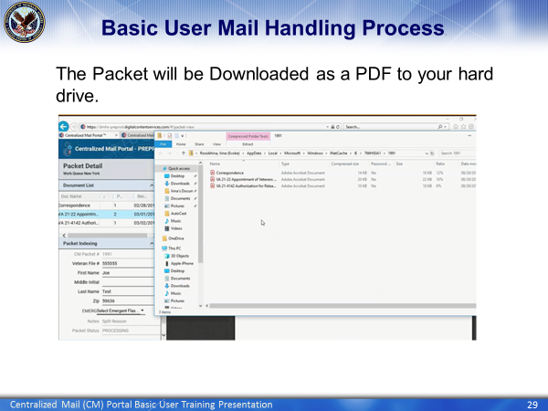 | DISPLAY slide 29 “Basic User Mail Handling Process”  EXPLAIN that once this is what the PDF files should look like once downloaded to your computer.  EXPLAIN that once the PDFs are added to the user’s computer, they will need to follow the steps for uploading documents to TIMS.
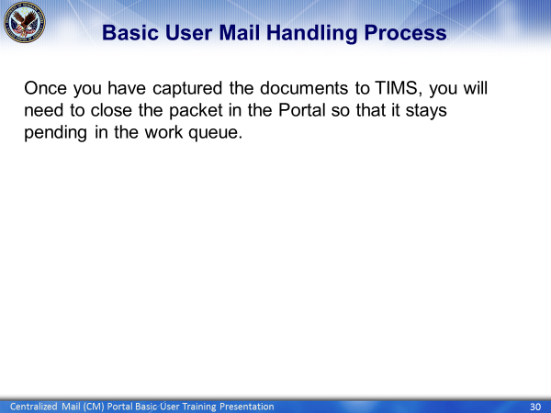 | DISPLAY slide 30 “Basic User Mail Handling Process”  EXPLAIN That once you have captured the documents to TIMS, the user will need to finish the packet in the Portal so that it does not get uploaded to VBMS.
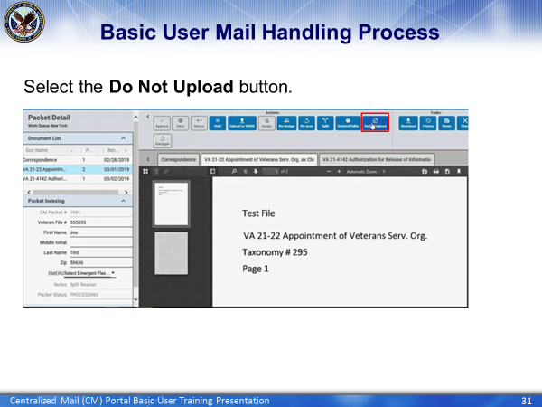 | DISPLAY slide 31 “Basic User Mail Handling Process”  EXPLAIN that you will now be discussing the next action to take after the documents are uploaded to TIMS.  EXPLAIN that you will now be talking about how to finish a packet by using the Do Not Upload button.  EXPLAIN that before using the Do Not Upload button, the user needs to verify that all of the documents in the packet were uploaded to TIMS. It will be finished and not accidently uploaded to VBMS.
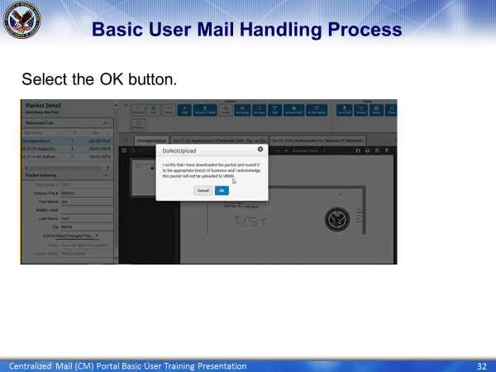 | DISPLAY slide 32 “Basic User Mail Handling Process”  EXPLAIN that after the user clicks on the Do Not Upload button, a window will open up asking the user if they downloaded the packet to the correct business line and that they acknowledge the package will not be uploaded to VBMS.  EXPLAIN that after the user clicks Ok, the packet will be finished and the packet will leave the user’s Work queue.
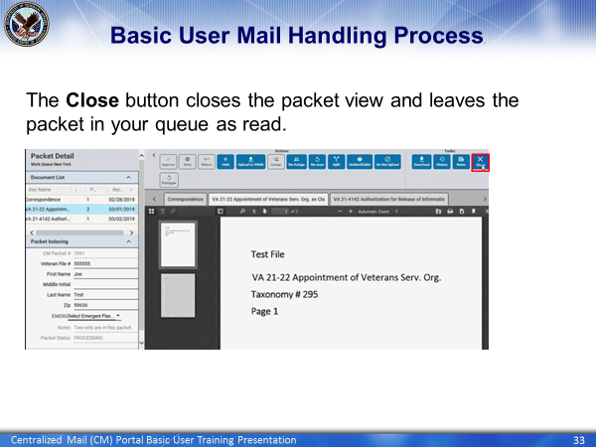 | DISPLAY slide 33 “Basic User Mail Handling Process”  EXPLAIN that whenever the Close button is used, it only closes the user out of the packet. The packet will remain in the user’s queue as read.  EXPLAIN that the only way to
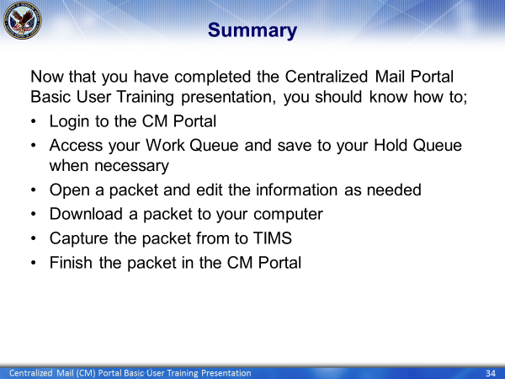 | DISPLAY slide 34 “Summary”  REVIEW the information discussed in today’s lesson.
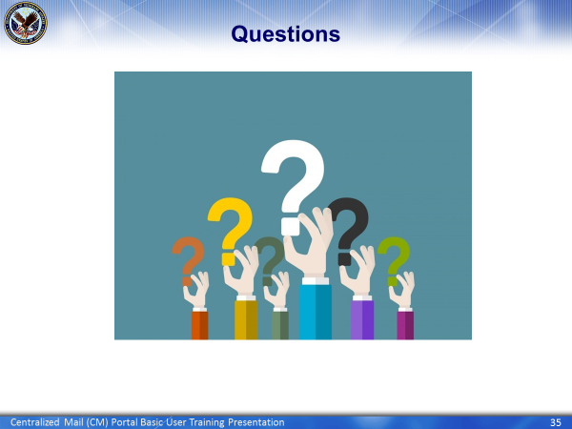 | DISPLAY slide 35 “Questions?”  ASK students if they have any questions about today’s CM Portal lesson.  RESPOND to all questions before tasking students to complete the assessment
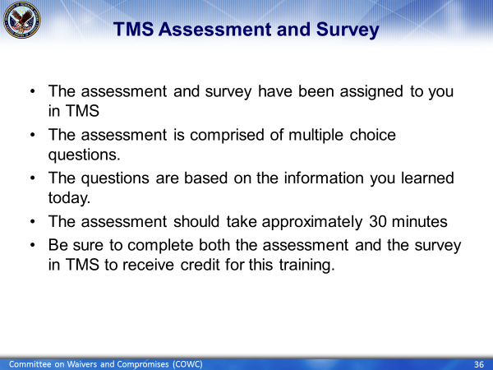 | DISPLAY slide 36 “TMS Assessment and Survey”  Conclude the training by doing the following:  CONFIRM the students know how to access the assessment and survey in TMS.  EXPLAIN that the assessment is TMS # and will cover what they learned in class today.  REMIND them that they must complete both the assessment and the survey in order to receive credit in TMS.  TELL students that the survey provides them an opportunity to improve the training and that their feedback is welcome.

