Education Service
Non-College Degree (NCD) Length of Course Processing and Development Procedures

Lesson Plan

September 2019
Version 1.0

Lesson Overview
Topic | Description
Time Estimate: | 1.0 hours
Purpose of the Lesson: | Provide Regional Processing Offices (RPOs) with guidance on identifying, processing and submitting Equitable Relief requests to Education Service’s Quality Assurance (QA) Team.
Prerequisite Training Requirements: | The following prerequisite training is required:  None
Target Audience: | Veterans Claims Examiners (VCEs), Education Case Managers (ECMs), Coaches, Management, and Management Analyst
Lesson References: | The following references support the lesson content:  - M22-4, Part 4, Chapter 1, 1.12(d)  - M22-4, Part 10, Compliance Survey. Chapter 06, Referrals  - Procedural Advisory: Reviewing and Capturing the Web Enabled Approval Management System (WEAMS) Screen When Awarding Benefits – Revised (April 30, 2019)
Lesson Objectives: | At the end of this lesson, you will be able to:  - Identify NCD programs requiring validation  - Validate certified clock hours  - Define the 10 percent exception  - Understand the development process  - Perform processing action(s) when certified clock hours exceed the approved program length  - Perform processing action(s) when an NCD program is not approved
What You Need: | NCD Length of Course Processing and Development Procedures Lesson Plan. Provide instructions and directions on how to print PowerPoint presentation from a saved location. Refer to lesson plan and have Subject Matter Expert (SME) available if primary presenter is not an SME to assist with answering questions. Training should be Instructor-led with a means to ask questions during the training. It will be delivered virtually. Individauls that view a recorded live session to make-up the training should be provided a POC who is available for questions while the employee is taking the lesson.
Post Training Requirements: | - Upon completion of the Webinar, participants are required to complete an online lesson assessment and survey in Talent Management System (TMS).  - To demonstrate successful completion of the lesson, participants must pass the assessment with a score of at least 80%.  - Participants must also complete the online survey to earn credit for completion of the lesson.

Instructor Notes
The lesson will provide Regional Processing Offices (RPOs) with processing and development guidance for Non-College Degree (NCD) programs certified in clock hours.
PowerPoint Slides | Instructor Activities
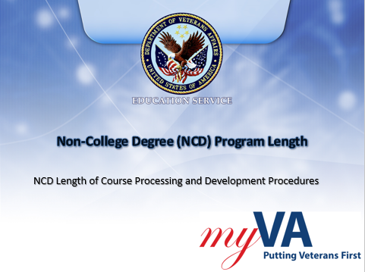 | DISPLAY slide 1  INTRODUCE yourself as the instructor and introduce any fellow instructors.  INTRODUCE the lesson.
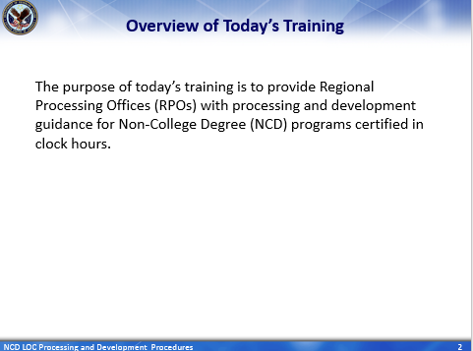 | DISPLAY slide 2  Overview of Today’s Training  INFORM students: The purpose of today’s training is to provide Regional Processing Offices (RPOs) with processing and development guidance for NCD programs certified in clock hours.
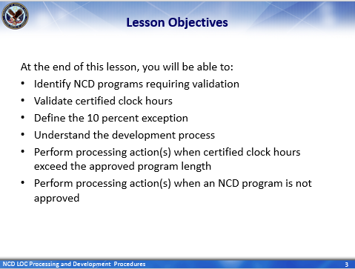 | DISPLAY slide 3  Lesson Objectives  REVIEW the lesson objectives and assure audience will have opportunities to practice what they learn  INFORM students: At the end of this lesson, you will be able to:  - Identify NCD programs requiring validation  - Validate certified clock hours  - Define the 10 percent exception  - Understand the development process  - Perform processing action(s) when certified clock hours exceed the approved program length  - Perform processing action(s) when an NCD program is not approved
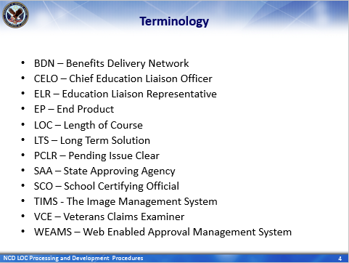 | DISPLAY slide 4  Terminology  READ/SUMMARIZE terminologies
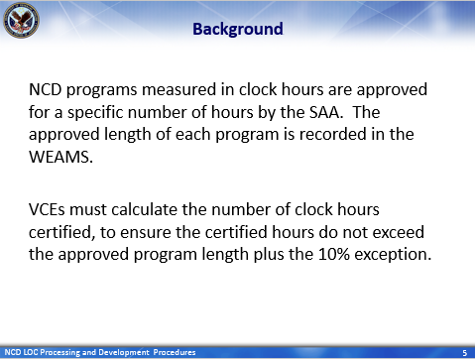 | DISPLAY slide 5  Background  SUMMARIZE slide:  An NCD program measured in clock hours is specific to the number of hours approved by the SAA and recorded in the WEAMS.  VCEs must calculate the number of clock hours certified, to ensure the certified hours do not exceed the approved program length plus the 10% exception.  Therefore, the following guidance is designed to help VCEs validate certified clock hours, understand development guidelines (if applicable) and process NCD awards when the program is within, or exceeds, the approved length.
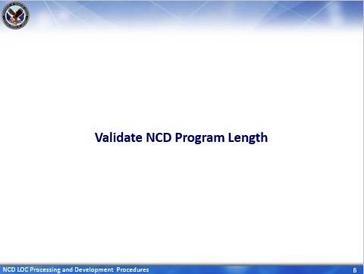 | DISPLAY slide 6  Validate NCD Program Length  INTRODUCE slide
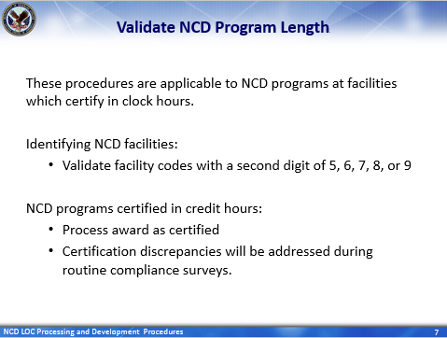 | DISPLAY slide 7  Validate NCD Program Length  SUMMARIZE slide  STRESS: These procedures are applicable to NCD programs at facilities which certify in clock hours.  Facility codes with a second digit of 5, 6, 7, 8, or 9 can be identified as an NCD facility and require validation to ensure enrollments certified in clock hours [for a particular program] do not exceed the approved program length plus 10% exception.  However, if it’s determined an enrollment is for an NCD program offered in credit hours, then process the award as certified.  Discrepancies in certification for these specific NCD programs will be addressed during routine compliance surveys. This is in accordance with M22-4, Part 10, Compliance Survey, Chapter 06, Referrals.
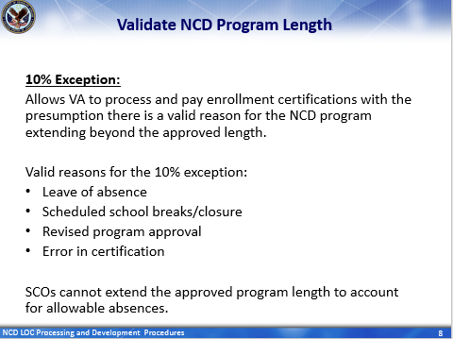 | DISPLAY slide 8  Validate NCD Program Length  READ/SUMMARIZE slide:  The 10% exception allows NCD programs certified in clock hours to be paid up to the approved program length, plus an additional 10%. Therefore, the 10% exception allows VA to process and pay enrollment certifications with the presumption there is a valid reason for the NCD program extending beyond the approved length.  Valid reasons for this exception may include:  - Leave of absence  - Scheduled school breaks/closure  - Revised program approval  - Error in certification  SCOs cannot extend [NCD] program length to account for allowable absences.  STRESS: Since clock hours cannot be extended beyond the approved program length and 10% exception for allowable absences, VCEs will not make adjustments for absences allowed within the school’s approved attendance policy. Enrollments cannot be extended for students who need additional hours because of absences.
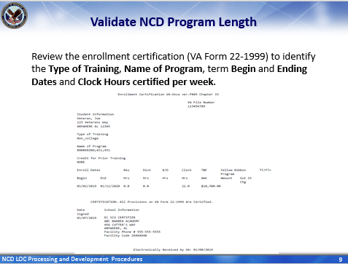 | DISPLAY slide 9  Validate NCD Program Length  INFORM students:  When processing an NCD claim which is certified in clock hours,  VCEs will review the 99 to identify the Type of Training, Name of Program, the term Begin and Ending dates and Clock Hours certified per week in order to determine if the NCD program exceeds or is within the approved program length plus 10% exception AND payable as certified.
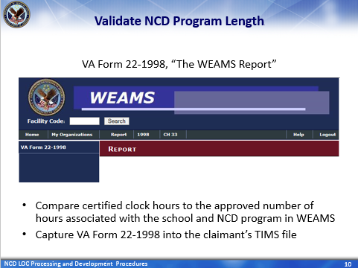 | DISPLAY slide 10  Validate NCD Program Length  INFORM: Once the information has been identified on the 99, VCEs will review the 1998 associated with the school and NCD program to compare the certified clock hours with the approved number of clock hours listed in WEAMS  This will help with determining if the certified number of hours [per week] are approved for the payment and can be processed as certified.  Remember to capture the 1998 [associated with the school and NCD program] into the claimant’s TIMS file.
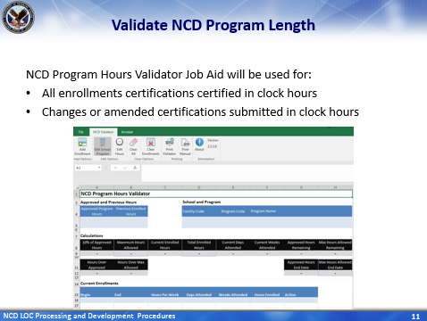 | DISPLAY slide 11  Validate NCD Program Length  INFORM: The NCD Program Hours Validator Job Aid must always be used for all enrollment certifications which are certified in clock hours and when processing any changes or amended certifications submitted in clock hours.  INFORM: This job aid has been included as an attachment in the M22-4, Part 4, Chapter 1, 1.12(d).
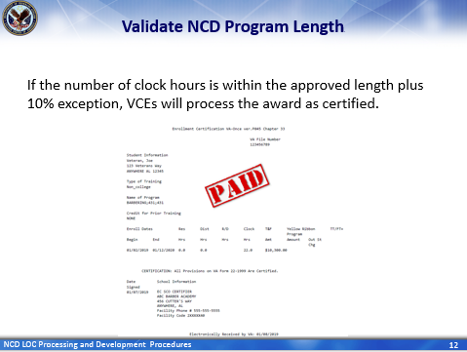 | DISPLAY slide 12  Validate NCD Program Length  SUMMARIZE slide:  If it’s determined the number of clock hours certified, on an initial or supplemental enrollment certification, is within the approved length plus 10% exception, then process the award as certified.
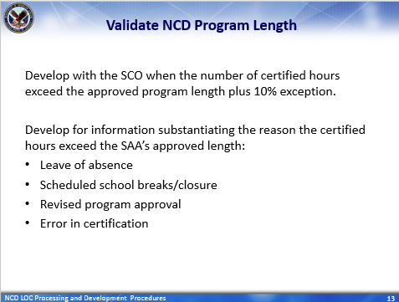 | DISPLAY slide 13  Validate NCD Program Length  READ/SUMMARIZE slide:  However, if it’s determined the number of certified clock hours, on an initial or supplemental enrollment certification, exceeds the approved program length plus 10% exception, then develop with the SCO.  Develop for information substantiating the reason the number of clock hours certified exceeds the SAA’s approved length [such as]:  - Leave of absence  - Scheduled school breaks/closure  - Revised program approval  - Error in certification
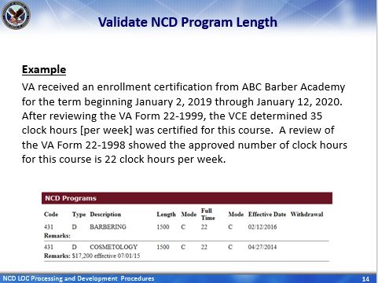 | DISPLAY slide 14  Validate NCD Program Length  READ/SUMMARIZE example slide:  That said, Let’s walk through an example of an NCD program reported in clock hours and the steps required before processing the award.  In this example, VA received an enrollment certification from ABC Barber Academy that began January 2, 2019 through January 12, 2020. After reviewing the 99, it was determined the SCO certified 35 clock hours per week [for this Barbering course].  A review of the VA Form 22-1998 [in WEAMS] shows the approved number of hours for [for this particular] Barbering course is 22 clock hours per week.  Therefore, the NCD Program Hours Validator Job Aid must used to determine if the number of clock hours [certified by the SCO] is within, or exceeds, the approved length approved plus 10% exception.
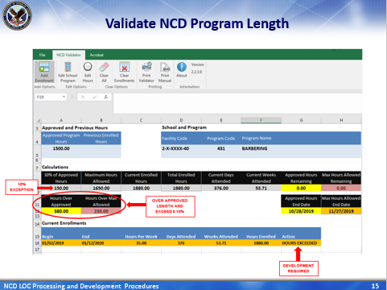 | DISPLAY slide 15  Validate NCD Program Length  STRESS: As mentioned earlier, the NCD Program Hours Validator Job Aid will always be used for all enrollment certifications which are certified in clock hours and when processing any changes or amended certifications submitted in clock hours.  In this example, the NCD Program Hours Validator Job Aid, shows the 35 clock hours per week, certified by the SCO, does exceed the approved length and additional the 10% exception; therefore development to the SCO is required.
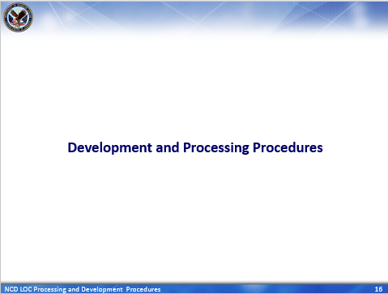 | DISPLAY slide 16  Development and Processing Procedures  INTRODUCE slide: Development and Processing Procedures
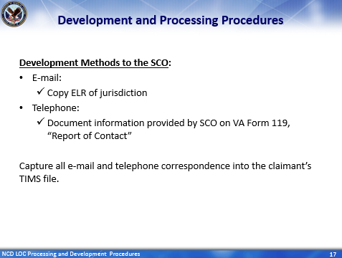 | DISPLAY slide 17  Development and Processing Procedures  STRESS: In an effort to expedite payment of benefits, the first course of development can be by e-mail and/or telephone.  READ/SUMMARIZE slide. [When developing to the SCO by]:  E-mail:  - Copy ELR of jurisdiction  Telephone the SCO:  - Document information provided by SCO on VA Form 119, “Report of Contact” and  Capture all e-mail and telephone correspondence into the claimant’s TIMS folder.
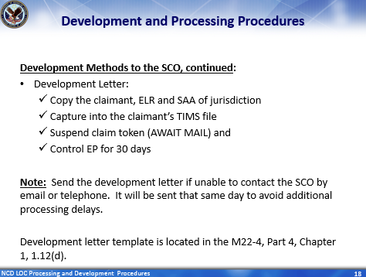 | DISPLAY slide 18  Development and Processing Procedures  READ/SUMMARIZE slide: Claims processors can also send a development letter to the SCO. When sending the development letter be sure to also send a copy to the claimant, ELR of jurisdiction and SAA of jurisdiction. Additionally:  - Captured the letter into the claimant’s TIMS file  - Suspend claim token (AWAIT MAIL) and  - Control end product for 30 days  STRESS note: If VCEs are unable to contact the SCO, by e-mail or telephone, then send the development letter that same day to avoid additional processing delays.  The development letter template is located in the M22-4, Part 4, Chapter 1, 1.12(d).
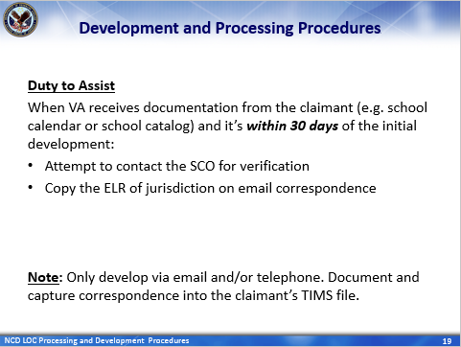 | DISPLAY slide 19  Development and Processing Procedures  STRESS: If the claimant provides VA with documentation within 30 days of initial development and no response has been received from the SCO, then duty to assist will apply; since this information must be verified by the SCO before benefits can be paid.  Attempt to contact the SCO by email or telephone. There is no need to send a 2nd development letter when VA receives documentation from the claimant within 30 days of the initial development.  When sending an e-mail in this case, only:  - Copy Education Liaison Representative (ELR) of jurisdiction  READ note: Only develop via email and/or telephone. Document and capture correspondence into the claimant’s TIMS file.
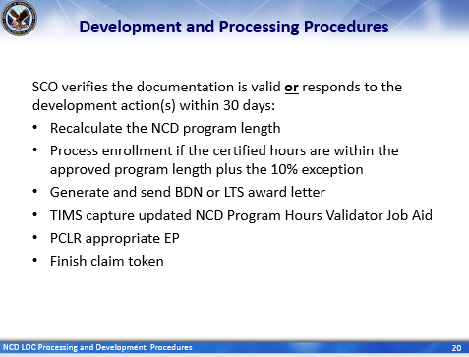 | DISPLAY slide 20  Development and Processing Procedures  INFORM: If SCO verifies the claimant’s documentation is valid or responds to the development action(s) within 30 days [of initial development] :  - Recalculate the NCD program length [using the NCD Program Hours Validator Job Aid]  REMIND: Remember, the NCD Program Hours Validator Job Aid must always be used for all enrollment certifications which are certified in clock hours and when processing any changes or amended certifications submitted in clock hours. [thereafter]  - Process enrollment if the certified hours are within the approved program length plus 10% exception  - Generate and send BDN or LTS award letter  - Capture updated NCD Program Hours Validator Job Aid into the claimant’s TIMS file  - PCLR the appropriate EP and  - Finish claim token
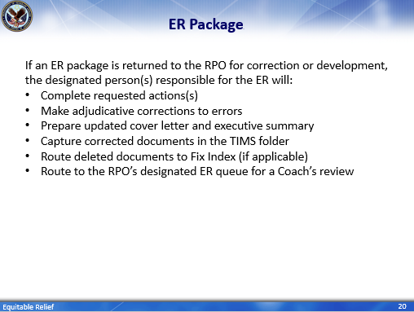 | DISPLAY slide 20  Development and Processing Procedures  READ/SUMMARIZE slide:  If an ER package is returned to the RPO for correction or development, the designated person(s) responsible for the ER will:  - Complete requested action(s) [i.e. necessary development]  - Make [the] adjudicative corrections to errors  - Prepare updated cover letter and executive summary [to reflect changes/corrections]  - Capture corrected documents in the [claimant’s] TIMS folder  - Route deleted documents to Fix Index (if applicable)  - Route to the RPO’s designated ER queue for a Coach’s review
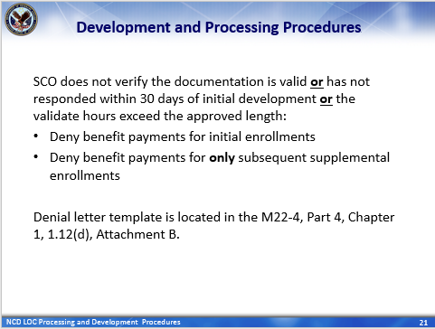 | DISPLAY slide 21  Development and Processing Procedures  INFORM: If the SCO does not verify the claimant’s documentation is valid or has not responded within 30 days of initial development or the validate hours exceeds the approved program length [then]:  - Deny benefit payments for initial enrollments  - Deny benefits payments for only subsequent supplemental enrollment certifications  Template for the denial letter is located in the M22-4, Part 4, Chapter 1, 1.12(d), Attachment B.
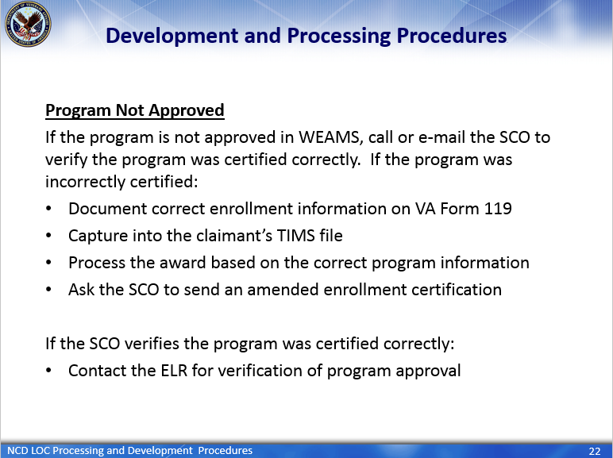 | DISPLAY slide 22  Development and Processing Procedures  READ/SUMMARIZE slide: Program Not Approved  If the program is not approved in WEAMS, then call or e-mail the SCO to verify the program was certified correctly. If the program was incorrectly certified [then], document and capture enrollment information VA Form 119, process the award based on the correct program information [provided by the SCO] and ask the SCO to send an amended enrollment certification to VA [with the correct program information].  If the SCO verifies the program was certified correctly, [then] contact the ELR [of jurisdiction] for verification of program approval.
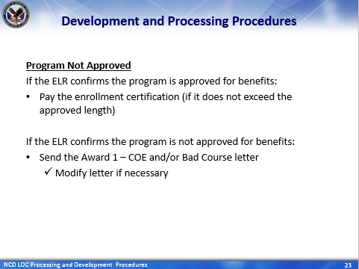 | DISPLAY slide 23  Development and Processing Procedures  READ/SUMMARIZE slide: Program Not Approval  If the ELR confirms the program is approved for benefits, [then we should] pay the enrollment as certified.  If the ELR confirms the program is not approved, [then] send the Award 1 – COE and/or Bad Course letter [with any necessary modifications]
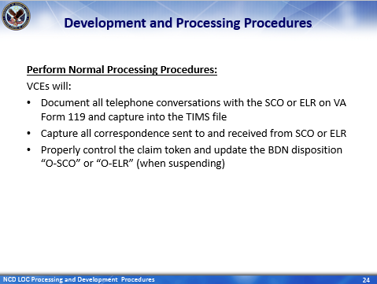 | DISPLAY slide 24  Development and Processing Procedures  READ/SUMMARIZE slide: Perfom Normal Processing Procedures  VCEs will perform these normal processing procedures; which include:  - Documenting TIMS using a VA Form 119 immediately following any phone conversations with SCO or ELR whether successful or unsuccessful.  - Capturing all correspondence sent to and received from the SCO or ELR [on the day they are sent or received]  - Properly control the claim in TIMS and update the BDN disposition “O-SCO” or “O-ELR” as appropriate [when suspending].
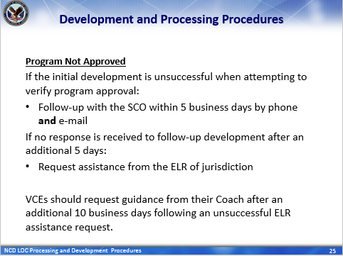 | DISPLAY slide 25  Development and Processing Procedures  READ/SUMMARIZE slide: Program Not Approval  If the initial development is unsuccessful when attempting to verify program approval, then follow-up with the SCO within 5 business days using both phone and mail.  Request assistance from the ELR of jurisdiction if no response is received to follow-up school development after an additional 5 business days.  Request guidance from your coach after an additional 10 business days following an unsuccessful ELR assistance request.
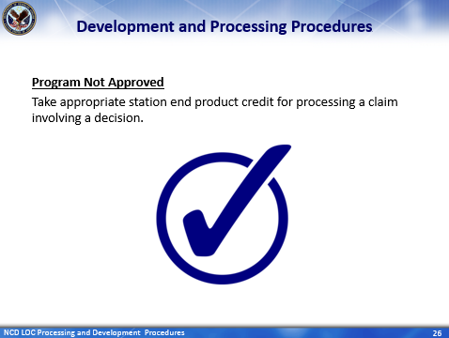 | DISPLAY slide 26  Development and Processing Procedures  READ/SUMMARIZE slide  Take appropriate station end product credit for processing a claim involving a decision [upon completion].
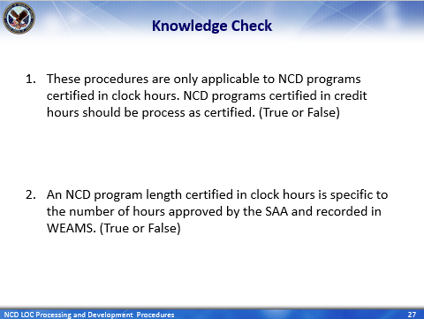 | DISPLAY slide 27  Knowledge Check  INTRODUCE KNOWLEDGE CHECKS  ASK the question and have student’s type response in the Webinar’s QA box  ENTERTAIN responses in the Webinar’s QA box
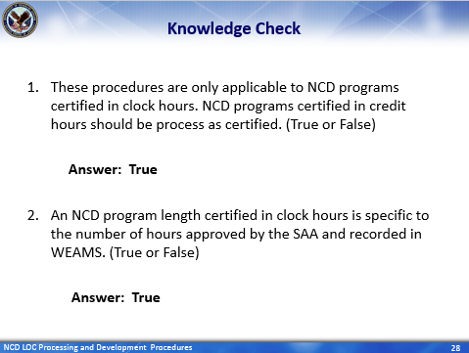 | DISPLAY slide 28  Knowledge Check  PROVIDE the answer.  CLARIFY responses as needed and paraphrase a “correct” response for each question.
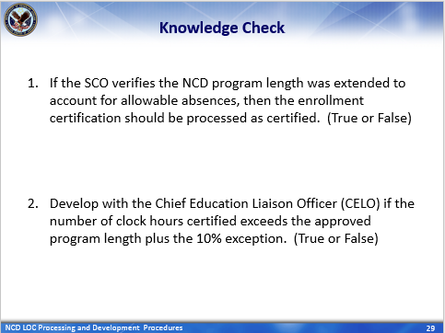 | DISPLAY slide 29  Knowledge Check  ASK the question and have student’s type response in the Webinar’s QA box  ENTERTAIN responses in the Webinar’s QA box
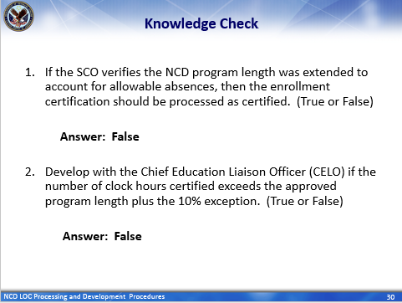 | DISPLAY slide 30  Knowledge Check  PROVIDE the answer.  CLARIFY responses as needed and paraphrase a “correct” response for each question.
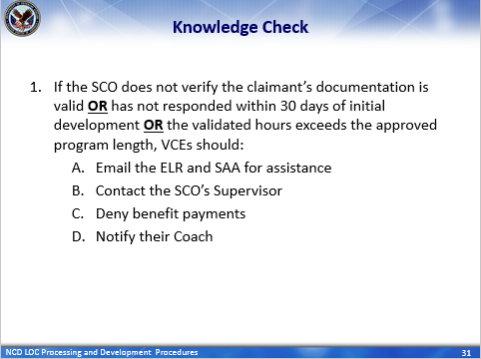 | DISPLAY slide 31  Knowledge Check  ASK the question and have student’s type response in the Webinar’s QA box  ENTERTAIN responses in the Webinar’s QA box
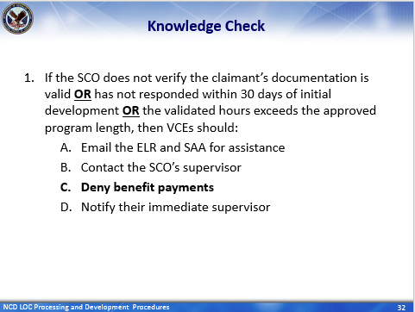 | DISPLAY slide 32  Knowledge Check  PROVIDE the answer.  CLARIFY responses as needed and paraphrase a “correct” response for each question.
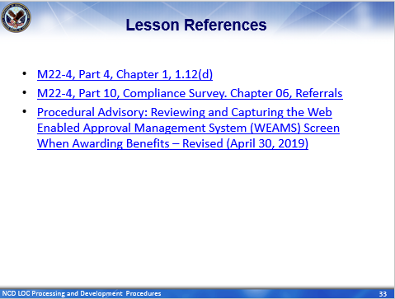 | DISPLAY slide 33  Lesson References  INFORM students of lesson references.
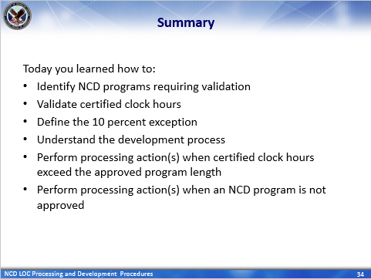 | DISPLAY slide 34  Summary  SUMMARIZE today’s lesson.  INFORM students:  Today you learned how to:  - Identify NCD programs requiring validation  - Validate certified clock hours  - Define the 10 percent exception  - Understand the development process  - Perform processing action(s) when certified clock hours exceed the approved program length  - Perform processing action(s) when an NCD program is not approved
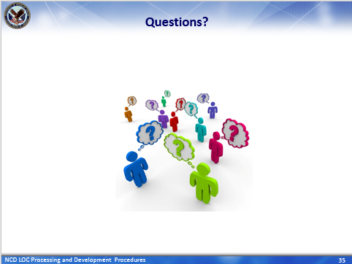 | DISPLAY slide 35  Questions?  STRESS/INFORM students: Enter questions pertaining to this today’s training in the QA box. Please limit questions to the scope of the topic. The questions and answers will be compiled and released to employees as soon as possible.
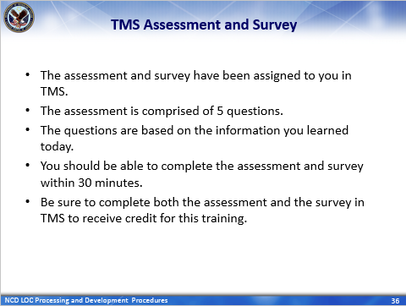 | DISPLAY slide 36  TMS Assessment and Survey  CONFIRM that the students know how to access the assessment and survey in TMS.  EXPLAIN that the assessment is TMS# and will cover what they learned in class today.  REMIND them that they must complete both the assessment and the survey in order to receive credit in TMS for their training.  TELL students that the survey provides them an opportunity to improve the training and that their feedback is welcome.

Questions about this training should be directed through your supervisor and management or Training Coordinator to the National Training Team.

