Education Service
Using Share for Reviewing Benefit Payments
Education Compliance Survey Specialist (ECSS)
Lesson Plan
April 2019

Lesson Overview
Topic | Description
Time Estimate:
Purpose of the Lesson: | The purpose of the lesson is to review benefit payments during compliance survey reviews.
Prerequisite Training Requirements: | Students should have received training on the following:  Overview of Benefit Programs  Overview of Systems  Using the Benefit Delivery Network (BDN)
Target Audience: | The lesson is designed for New Education Compliance Survey Specialist.
Lesson References: | - System Advisory: Share Pay History (2012)  - RPO Letter 22-07-03
Lesson Objectives: | - Demonstrate how to navigate to the different screens in Share.  - Differentiate between the Share Inquiry Procedures.  - Identify the Share navigation components and their functions.  - Identify Post 9-11 GI Bill (Chapter 33) Education checks issued and returned.
What You Need: | The instructor will need to make sure all students have computers, log in and passwords in order to access the system successfully present the lesson and navigate to the appropriate screens to demonstrate what the ECSS will be looking for during a compliance survey.
Post Training Requirements: | Upon completion of the classroom portion of the lesson, participants are required to complete an online lesson assessment and survey in Talent Management System (TMS).  To demonstrate successful completion of the lesson participants must pass the assessment with a score of at least 80%.  Participants must also complete the online survey to earn credit for completion of the lesson.

Instructor Notes

PowerPoint Slides | Instructor Activities
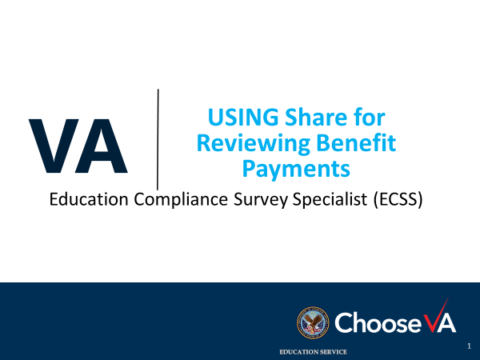 | DISPLAY slide  Introduce yourself as the instructor and introduce the lesson.
Icebreaker Activity  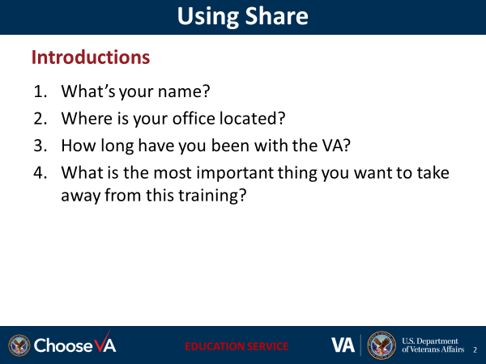 | DISPLAY slide  Start lesson with a motivating statement, ice breaker, or knowledge check to gauge familiarity with the subject.  - Having the students introduce themselves is optional and up to the instructor. If student introductions will not be done, remove this slide from your presentation.
Overview of Today’s Training

Lesson Objectives  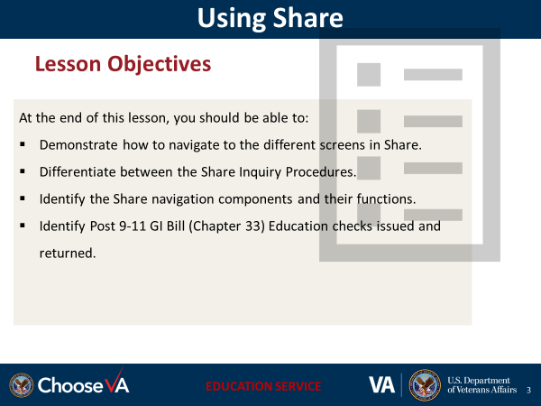 | DISPLAY slide  Review the lesson learning objectives.
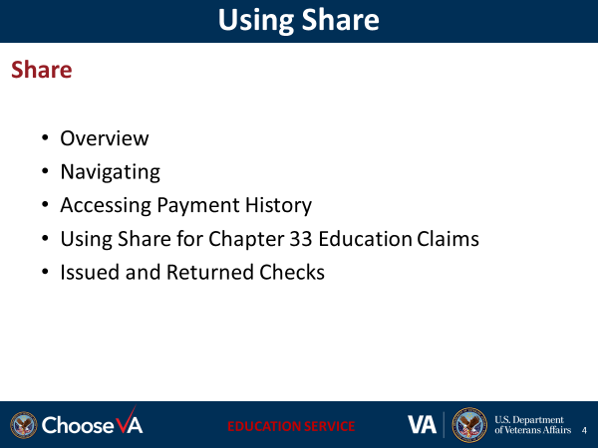 | DISPLAY slide
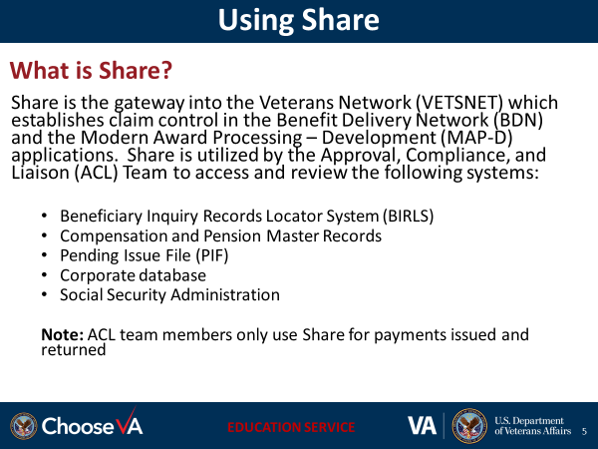 | DISPLAY slide  Beneficiary Inquiry Records Locator System (BIRLS)  Corporate Record  Pending Issue File (PIF)  Payment History File (PHF) Corporate database  Social Security Administration (SSA)  Although several systems can be accessed through Share, ACL team members will primarily use Share for Chapter 33 payment information.
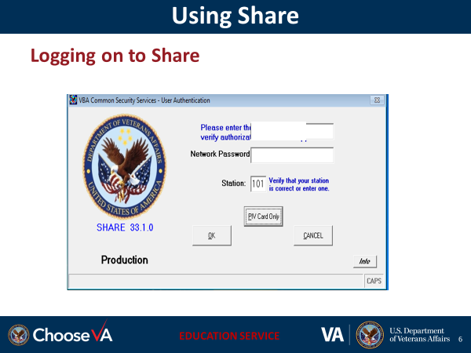 | Instructor:  Demonstrate to the students how to log into the system in order to access the system.  Include options to use username and password or PIV log in
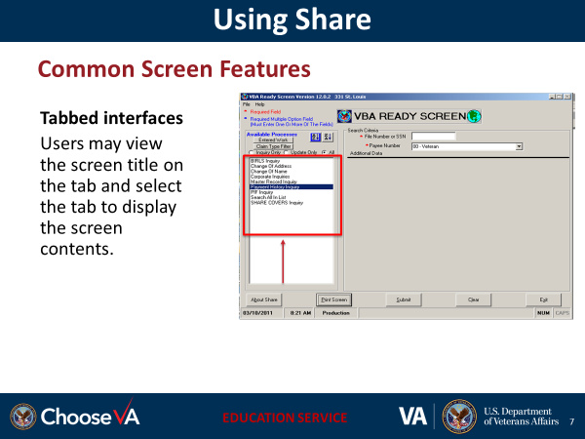 | We will review the above features later in within the Share system
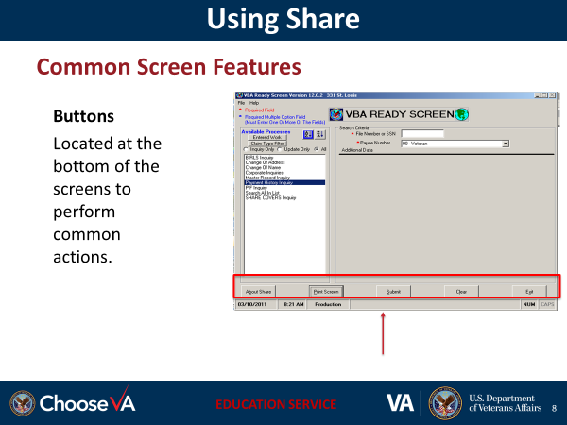 | We will review the above features later in within the Share system
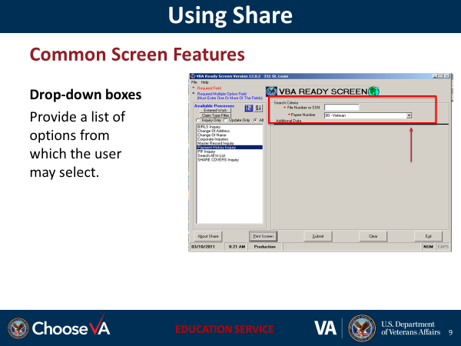 | We will review the above features later in within the Share system
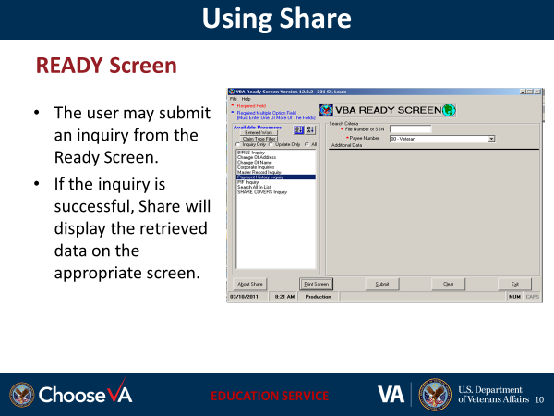 | READY Screen will be displayed in the next slide and during hands on training to provide users with a visual of what to expect  Explain which fields are required  Briefly touch on each of the type of inquiries which can be performed, placing emphasis on the Payment Inquiry as the primary inquiry they will be performing
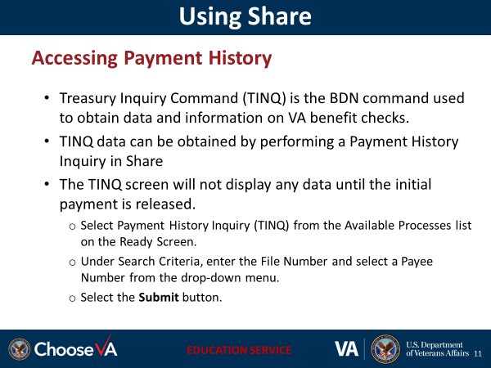 | Instructor: See slide 18/19 for the screen to review. We will also review these screens in the system
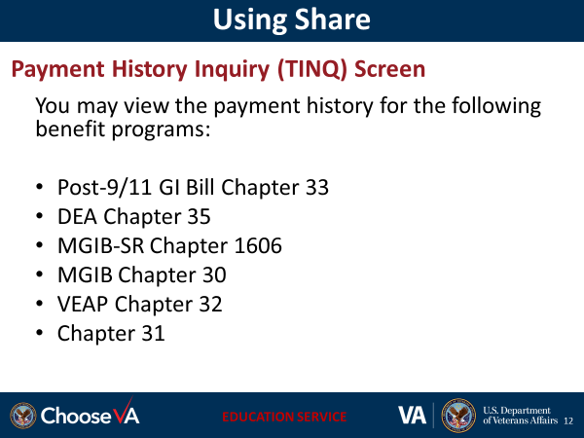 | Instructor notes:  With the payment history inquiry, you can view historical payment data and returned payment data.  You may view the payment history for all of these education benefits, including Chapter 31 employment benefit. However, this training will provide screen views of the chapter 33 payment inquiries.
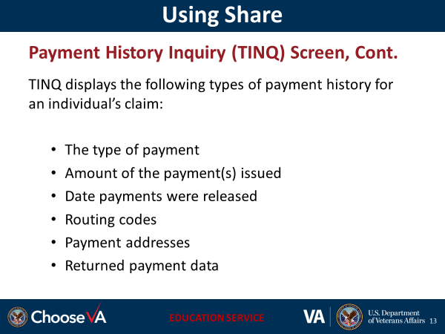 | Instructor notes:  This TINQ screen indicates the type of payment, the amount and the date the payment was disseminated, and where (address) the payment was sent.
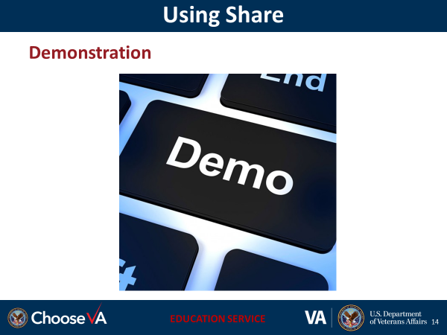 | In this demonstration, the instructor should demonstrate to the students how to log on to Share and access the following screens:  - Ready screen  - Payment History Inquiry screen  TINQ screen from the ready screen by clicking the from the drop down
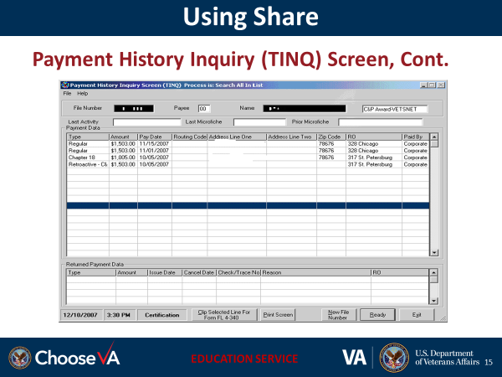 | Let’s look at an inquiry screen in the system.  Instructor will guide students through the live system to display the TINQ screen  Inform the students that:  - A maximum of 18 payments may be displayed under Payment Data  - A maximum of 6 payments may be displayed under the Returned Payment Data
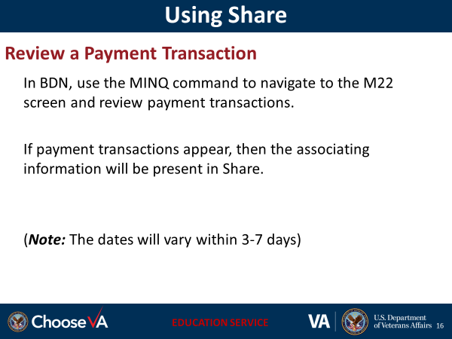
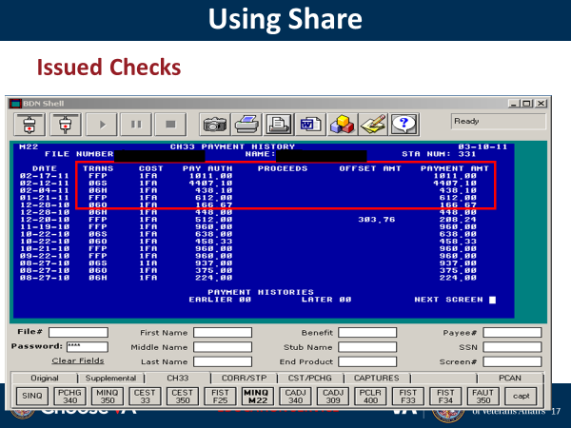 | The M22 screen in BDN will display the date of the transaction which generated the payment, the type of transaction which generated the payment and the amount of the payment.
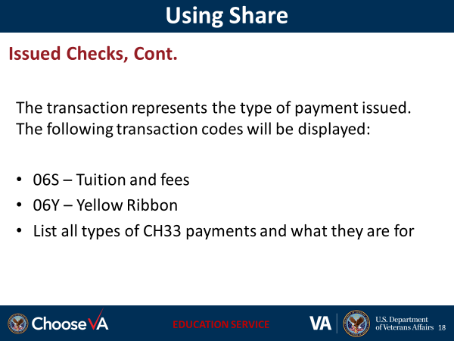
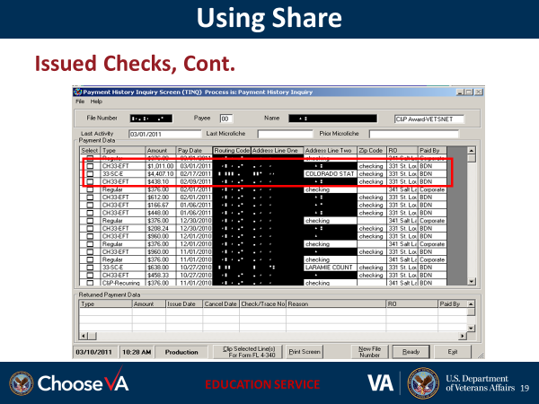 | Payments listed on the BDN TINQ screen will also display in Share.  Instructor should discuss each of the fields displayed for each payment. For payment type, explain each type of payment (CH33-EFT, CH33-SCE, etc.)
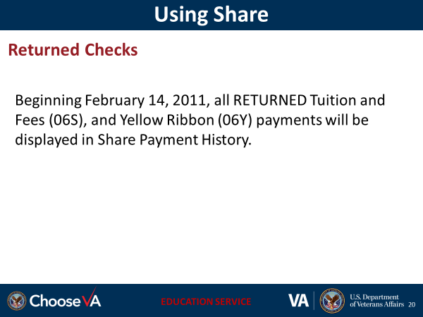
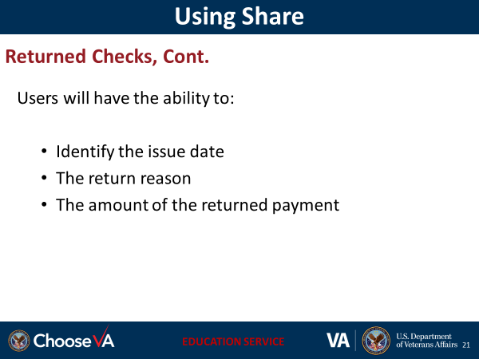 | Instructor should review the returned checks in the system.  Please review the screen shot on the next slide
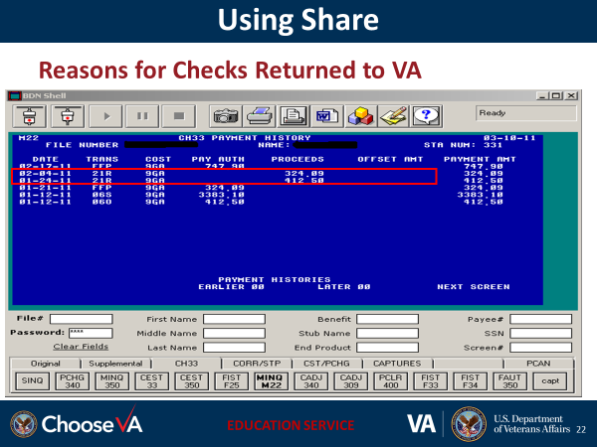 | The M22 will indicate the return check and the amount with an R in the transaction code (i.e. 21R)  The amount of the returned check will be listed as proceeds
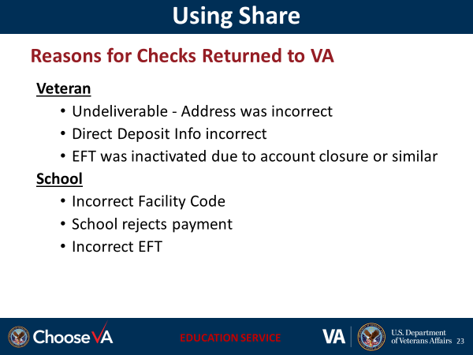
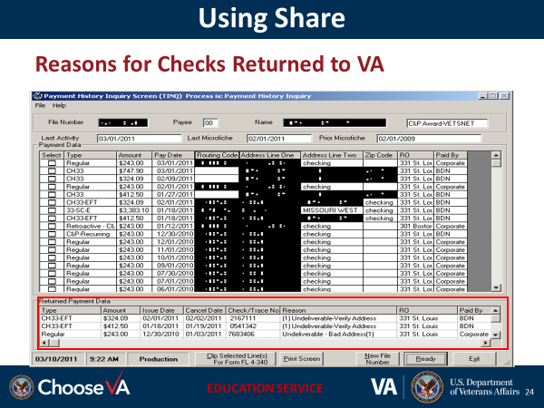 | The TINQ screen will provide the reason for the return check, the amount and dates of issuance, cancellation, and check tracer number
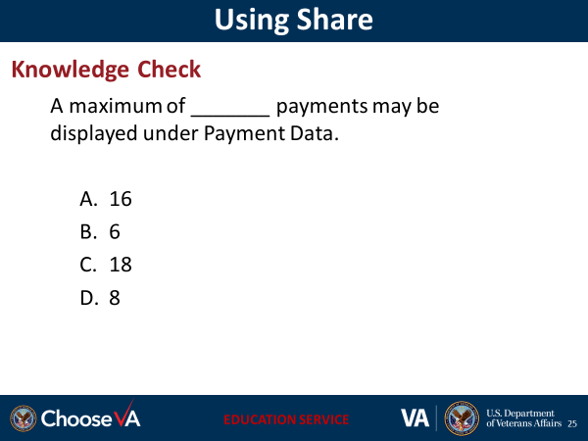 | Answer:  - C
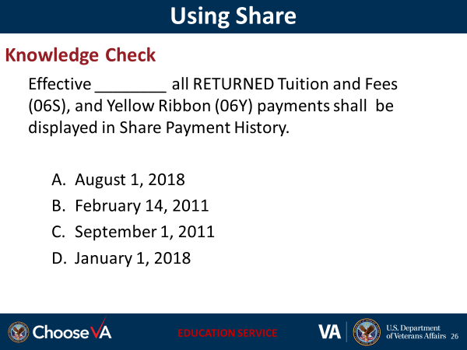 | Answer: B
