Education Service
VA Systems Overview for New Education Compliance Survey Specialist
Lesson Plan
April 2019

Lesson Overview
Topic | Description
Time Estimate:
Purpose of the Lesson: | The purpose of the lesson is to provide New Compliance Survey Specialist (ECSS) with the knowledge of all IT systems utilized to review education claims for compliance surveys.
Prerequisite Training Requirements: | New ECSSs should have received the VA Education Benefits Program Overview training prior to receiving this training.
Target Audience: | The lesson is designed for New Education Compliance Survey Specialist.
Lesson References:
Lesson Objectives: | - Identify the various VA systems used for conducting Compliance Surveys.  - Describe the components of each system.
Post Training Requirements: | Upon completion of the classroom portion of the lesson, participants are required to complete an online lesson assessment and survey in Talent Management System (TMS).  To demonstrate successful completion of the lesson participants must pass the assessment with a score of at least 80%.  Participants must also complete the online survey to earn credit for completion of the lesson.

Instructor Notes

PowerPoint Slides | Instructor Activities
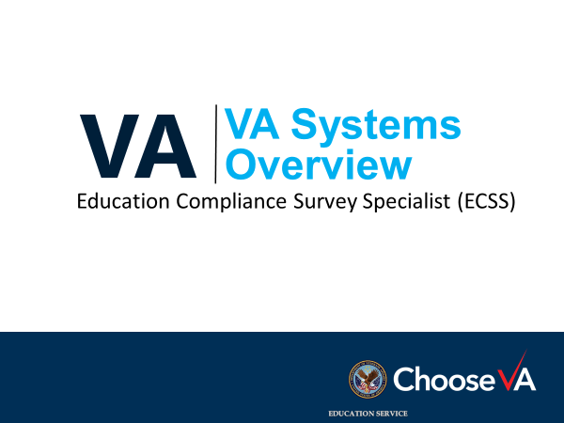 | DISPLAY slide
Lesson Objectives  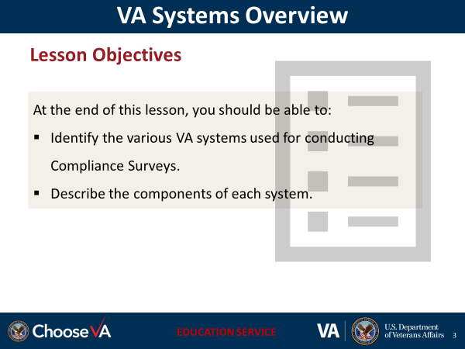 | DISPLAY slide  Review the lesson learning objectives.
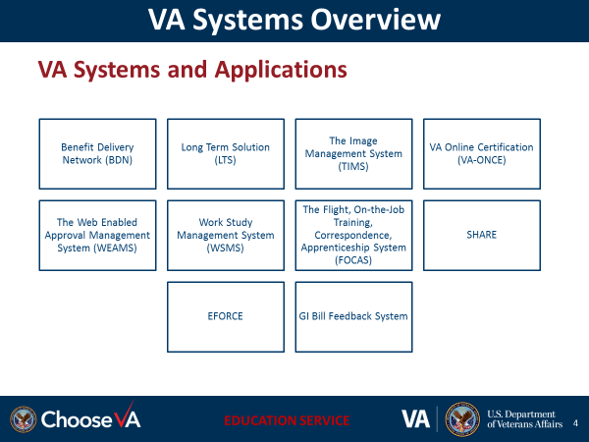 | DISPLAY slide
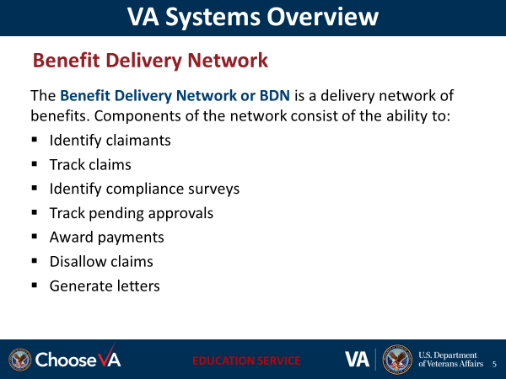 | DISPLAY slide
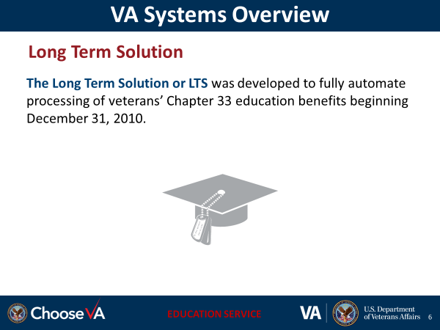 | DISPLAY slide
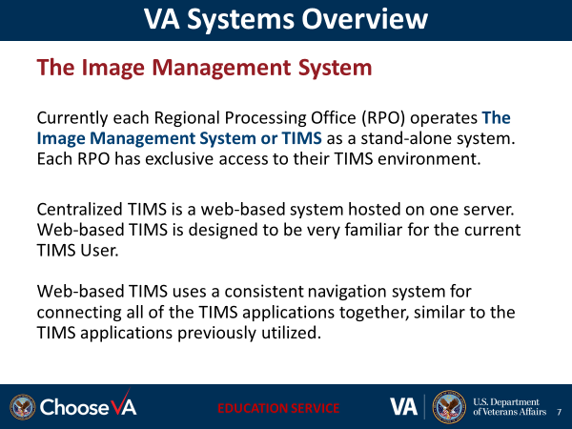 | DISPLAY slide
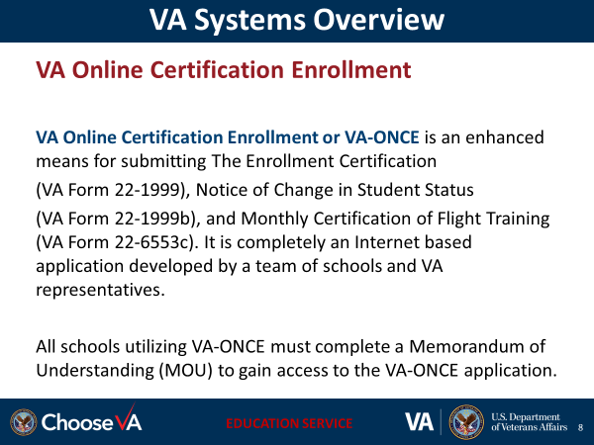 | DISPLAY slide
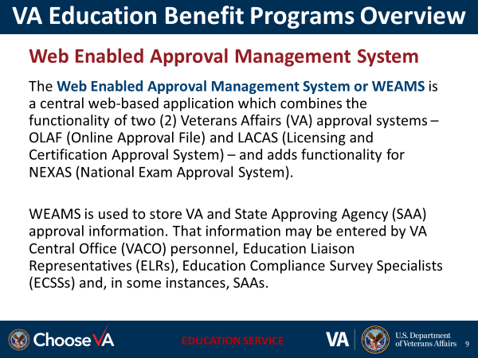 | DISPLAY slide
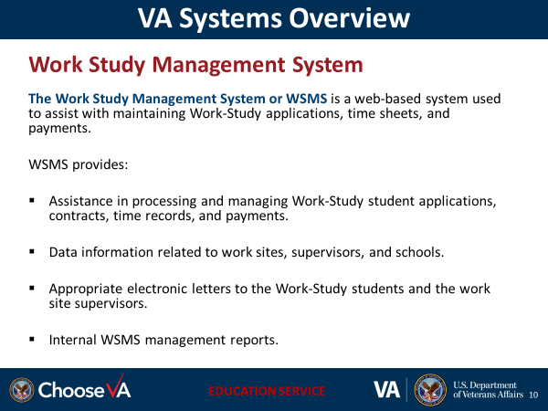 | DISPLAY slide
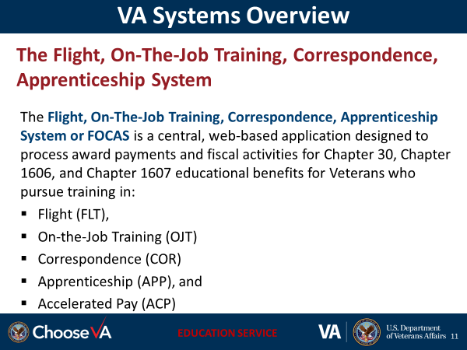 | DISPLAY slide
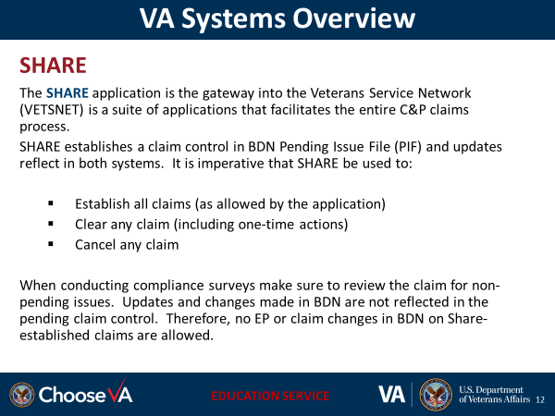 | DISPLAY slide
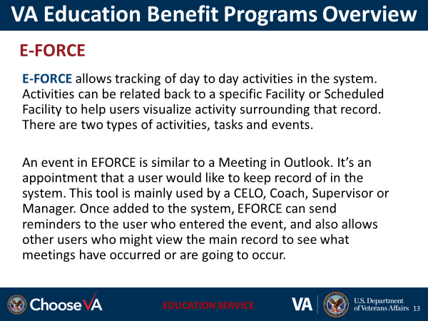 | DISPLAY slide
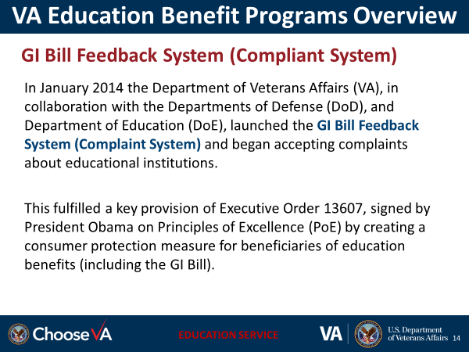 | DISPLAY slide
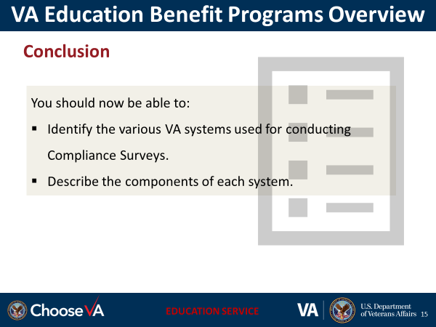 | DISPLAY slide
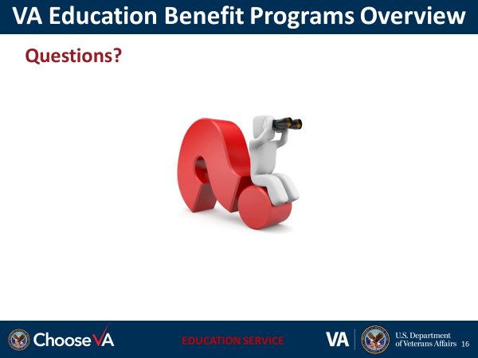 | DISPLAY slide
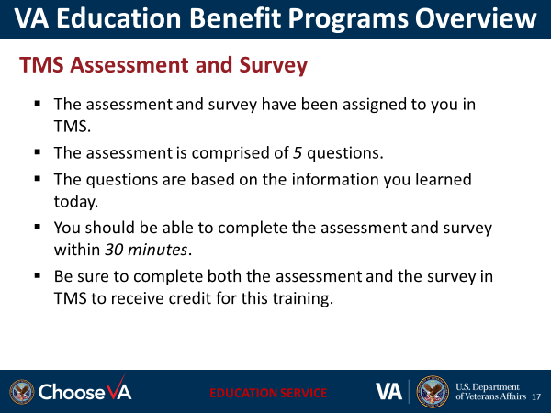 | DISPLAY slide

