Education Service
VA Education Benefit Programs Overview
Self Paced Lesson

[April 2019]

Lesson Overview
Topic | Description
Time Estimate:
Purpose of the Lesson: | The purpose of the lesson is to provide New Education Compliance Survey Specialist knowledge about various VA Education Benefit Programs.
Prerequisite Training Requirements: | None
Target Audience: | The lesson is designed for New Education Compliance Survey Specialist across all regions.
Lesson References: | PART 01, GENERAL. CHAPTER 03, OVERVIEW AND HISTORY OF EDUCATION PROGRAMS
Lesson Objectives: | At the end of this lesson, you should be able to:  - List the various VA Education Benefit Programs.  - Describe the differences between VA Education Benefit Programs.
Post Training Requirements: | Upon completion of the classroom portion of the lesson, participants are required to complete an online lesson assessment and survey in Talent Management System (TMS).  To demonstrate successful completion of the lesson participants must pass the assessment with a score of at least 80%.  Participants must also complete the online survey to earn credit for completion of the lesson.

Instructor Notes
If you have any questions please contact your Education Liasion Representative (ELR).
PowerPoint Slides | Instructor Activities
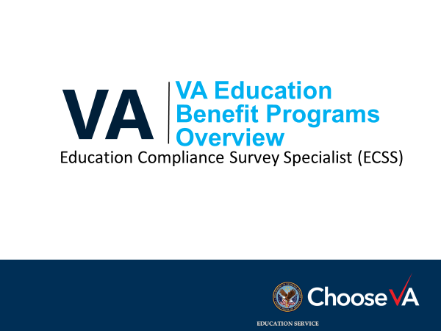
Overview of Today’s Training  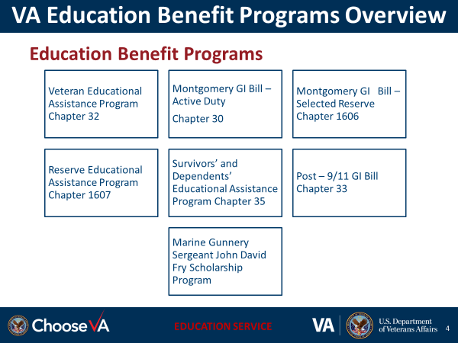 | DISPLAY slide  Overview of the lesson.
Lesson Objectives  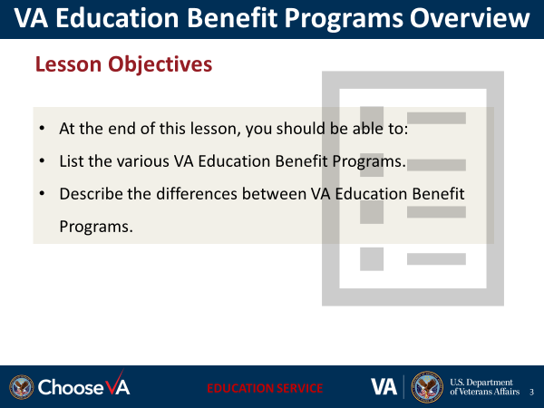 | DISPLAY slide  Review the lesson learning objectives.
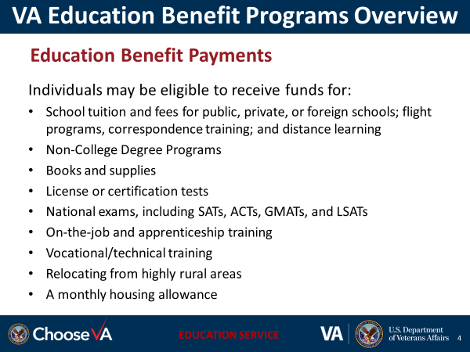 | DISPLAY slide 4
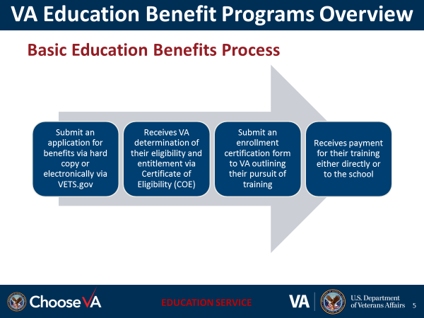 | DISPLAY slide 5
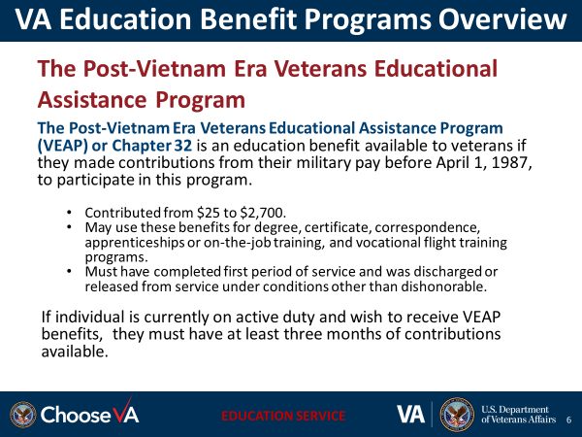 | DISPLAY slide 6
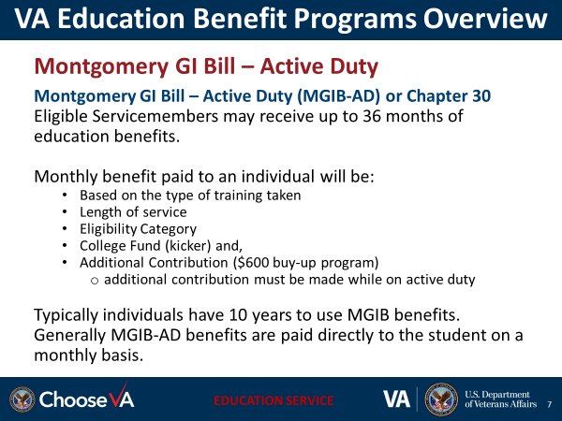 | DISPLAY slide 7
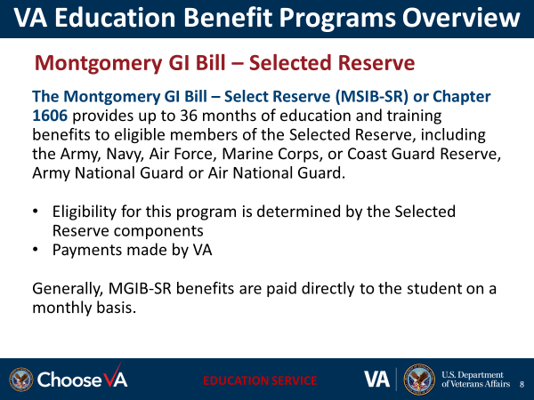 | DISPLAY slide 8
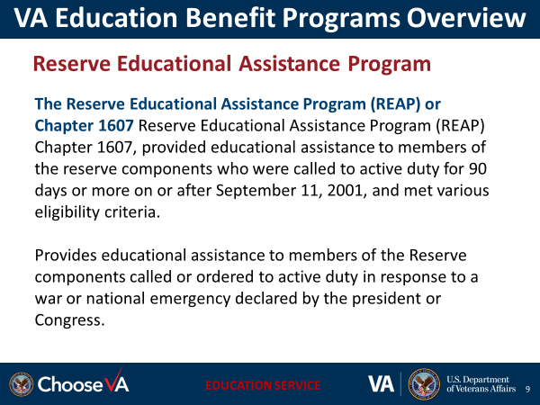 | DISPLAY slide 9
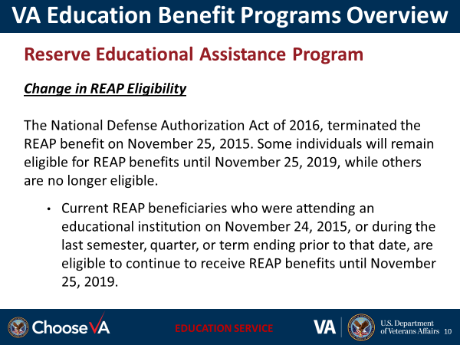 | DISPLAY slide 10
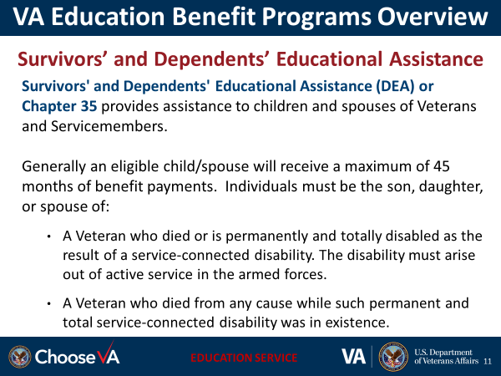 | DISPLAY slide 11
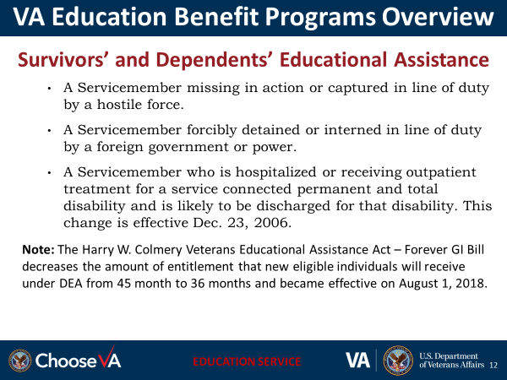 | DISPLAY slide 12
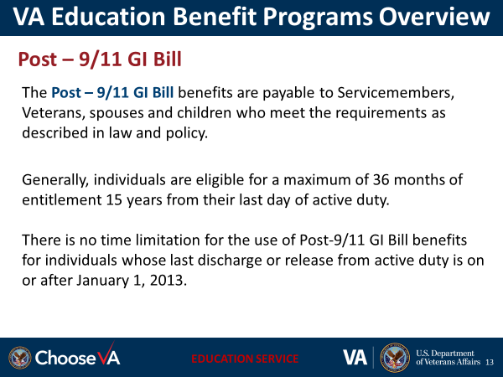 | DISPLAY slide 13
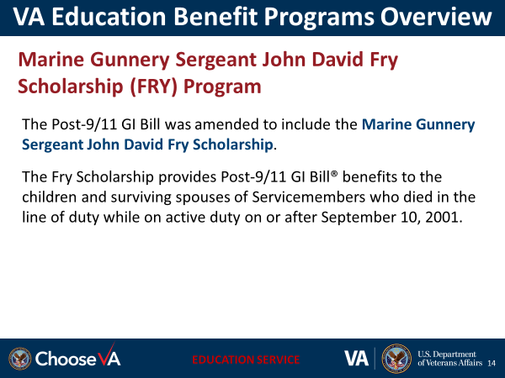 | DISPLAY slide 14
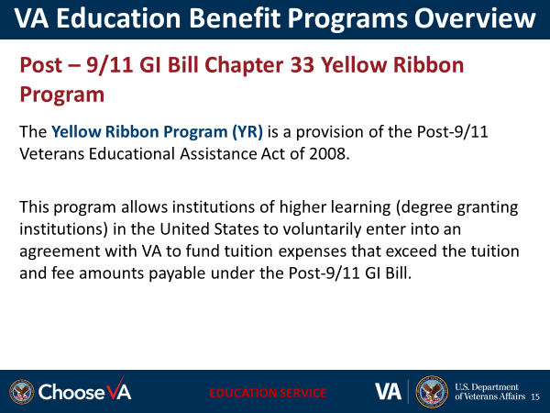 | DISPLAY slide 15
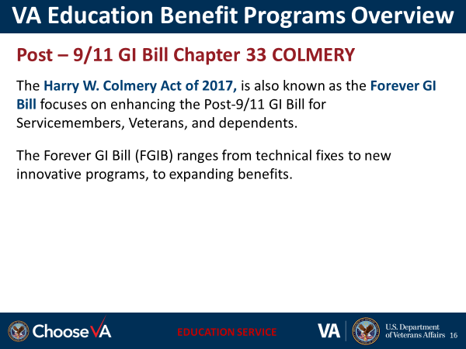 | DISPLAY slide 16
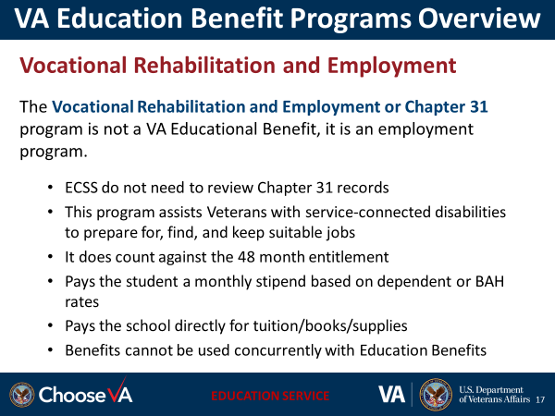 | DISPLAY slide 17
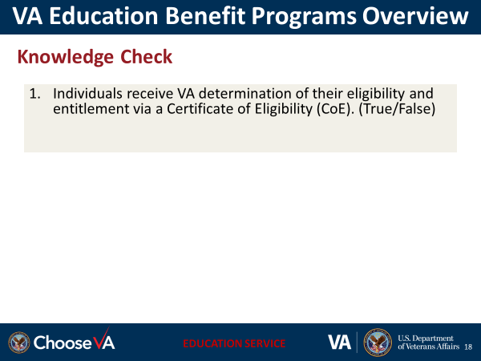 | DISPLAY slide 18
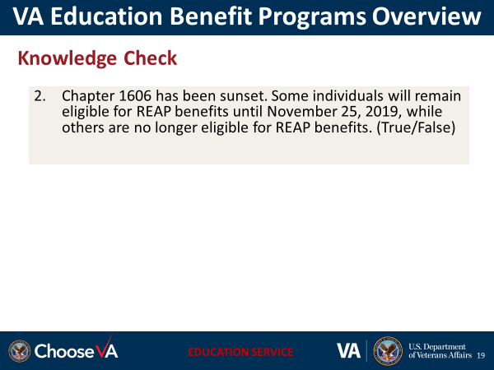 | DISPLAY slide 19
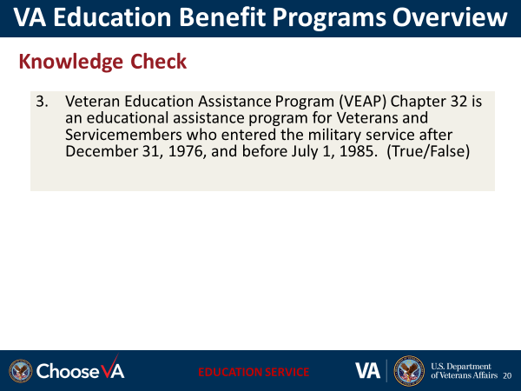 | DISPLAY slide 20
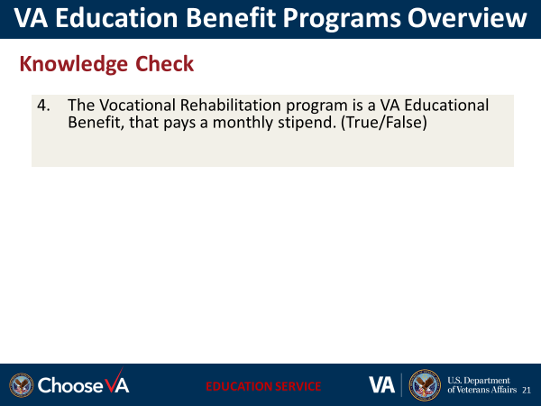 | DISPLAY slide 21
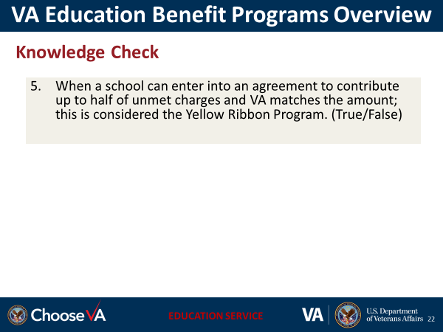 | DISPLAY slide 22
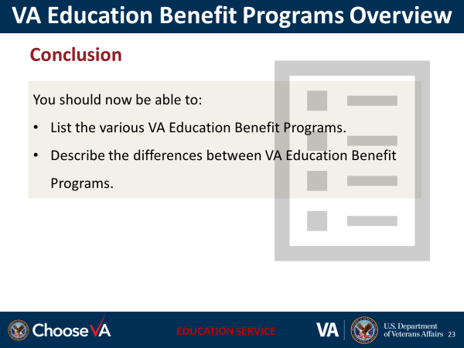 | DISPLAY slide 23
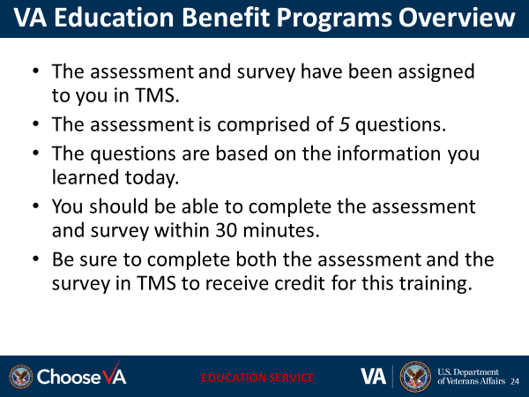 | DISPLAY slide 24
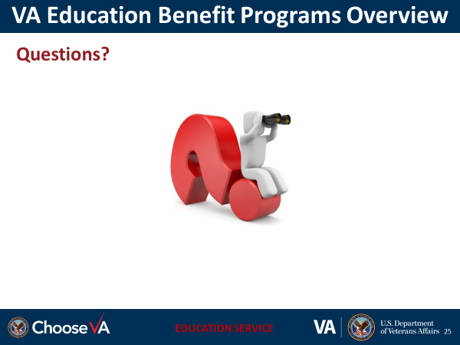 | DISPLAY slide 25  Please contact your Education Liaision Representative (ELR).

