Education Service
Benefit Delivery Network (BDN) for New Education Compliance Survey Specialist
Lesson Plan
April 2019

Lesson Overview
Topic | Benefit Delivery Network (BDN) for New Education Compliance Survey Specialist (ECSS)
Time Estimate:
Purpose of the Lesson: | The purpose of the lesson is provide New ECSSs with the necessary knowledge and skills to navigate and review claimaints information in VA’s system in order to conduct compliance surveys.
Prerequisite Training Requirements: | Students should have completed prerequisite training to include:  Overview of VA Benefit Programs  Overview of VA Systems
Target Audience: | The lesson is designed for new Education Compliance Survey Specialist.
Lesson References: | - M22-3 - Section II  - M22-4, Part 2, Chapter 3  - M22-4, Part 9, Chapter 9  - M22-4 Part 10, Chapter 2.05  - M22-4 Part 10, Chapter 9.03
Lesson Objectives: | - Access the Benefit Delivery Network (BDN) to review claims.  - Demonstrate how to navigate the Benefit Delivery Network (BDN) screens.  - Differentiate between the Inquiry, Identification and Master Record Screens  - Identify End Products for conducting Compliance Surveys.
What You Need: | The instructor will need to make sure all students has log in and passwords, and computers to access the BDN Network to successfully present the lesson and demonstrate with hands-on activities.
Post Training Requirements: | Upon completion of the classroom portion of the lesson, participants are required to complete an online lesson assessment and survey in Talent Management System (TMS).  To demonstrate successful completion of the lesson participants must pass the assessment with a score of at least 80%.  Participants must also complete the online survey to earn credit for completion of the lesson.

Instructor Notes

PowerPoint Slides | Instructor Activities
[Lesson Title]  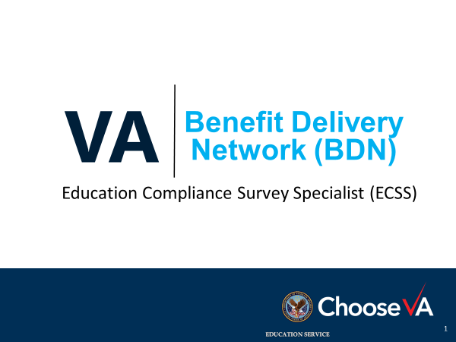 | DISPLAY slide  Introduce yourself as the instructor and introduce the lesson.
Icebreaker Activity  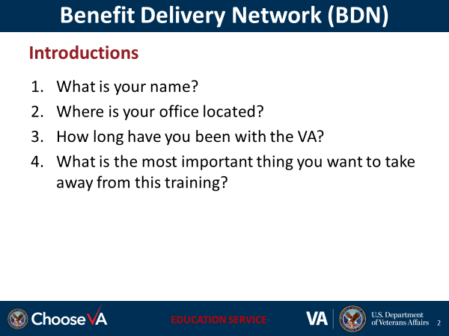 | DISPLAY slide  Start the lesson with a motivating statement, ice breaker, or knowledge check to gauge familiarity with the subject.
Overview of Today’s Training

Lesson Objectives  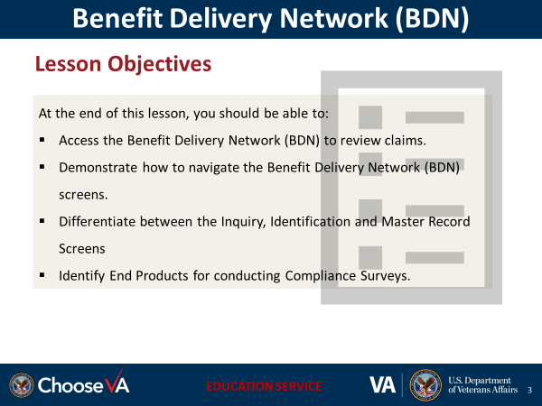 | DISPLAY slide  Review the lesson learning objectives.
[Slide Title]  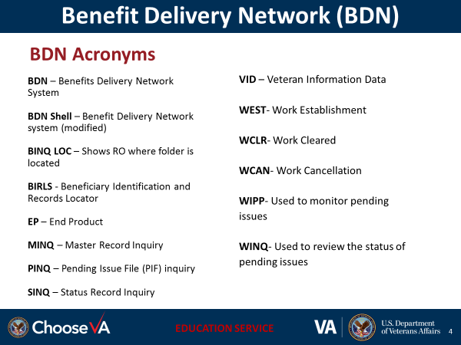 | DISPLAY slide
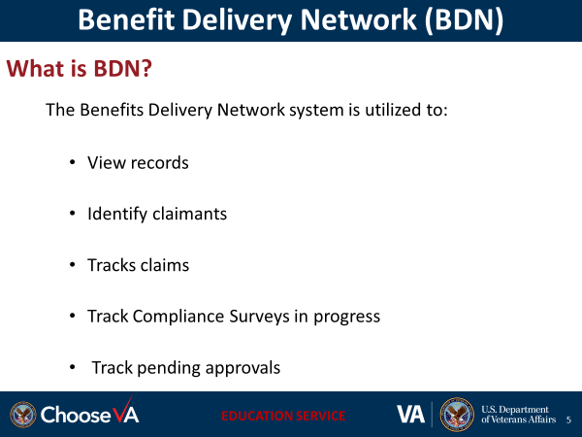 | DISPLAY slide
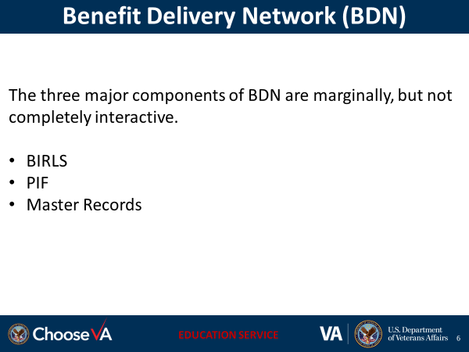 | DISPLAY slide
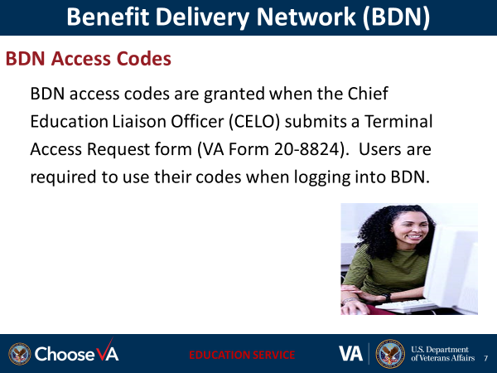 | DISPLAY slide  Instructor:  Verify all students have received their access codes to log into BDN during this session.
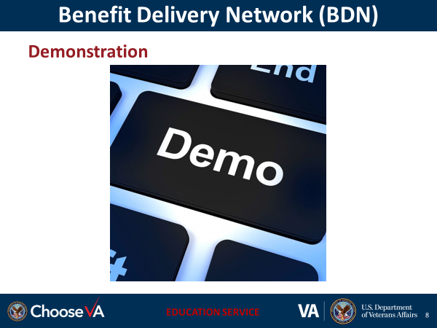 | DISPLAY slide
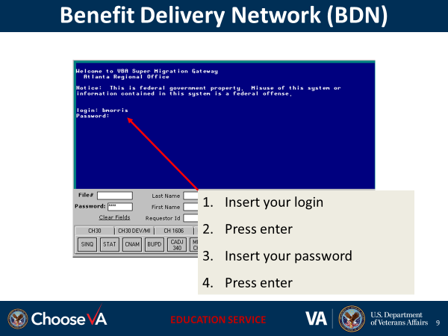 | Illu DISPLAY slide  strate logging into BDN with students, and communicate the requirements for passwords in BDN.
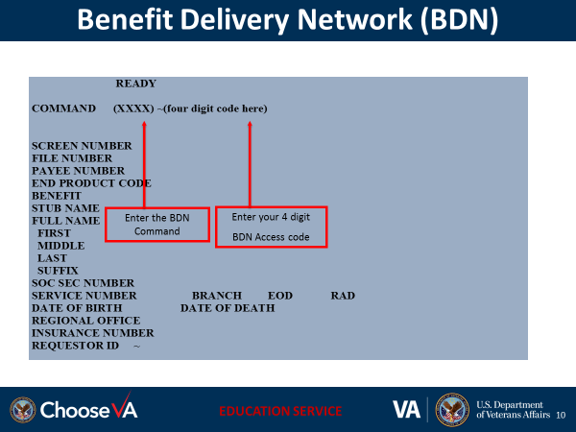 | DISPLAY slide  The Ready Screen in BDN may also be viewed as such in the system. Indicate where to insert the BDN Command and the students access code
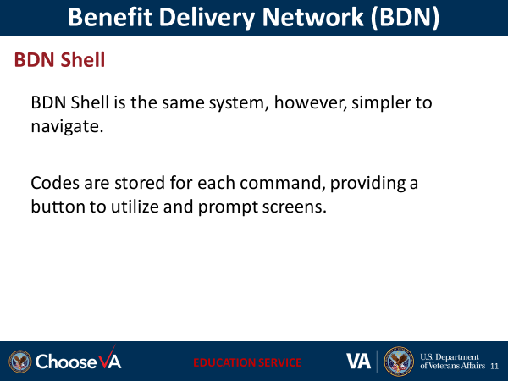 | DISPLAY slide
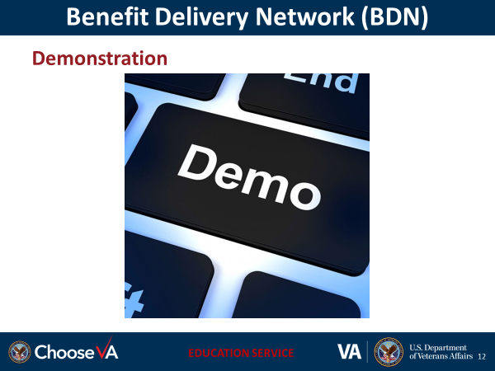 | DISPLAY slide
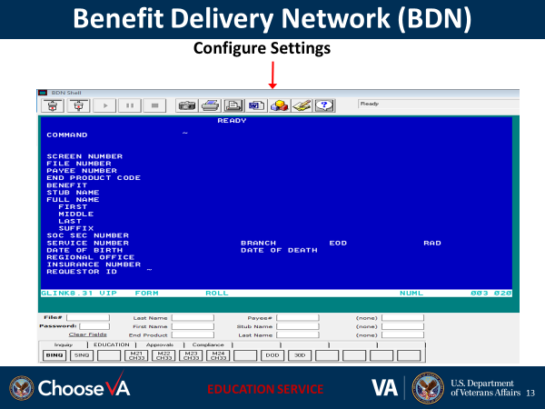 | DISPLAY slide  In order to configure BDN Shell with specific commands, you must use the configure setting tab at the top of the screen.  Illustrate the configure tab for students.
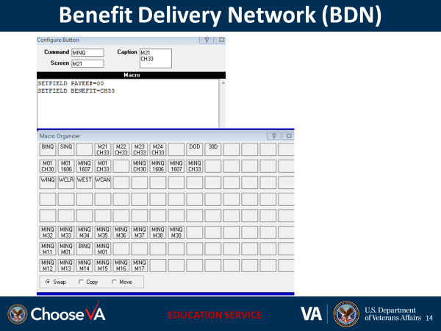 | DISPLAY slide
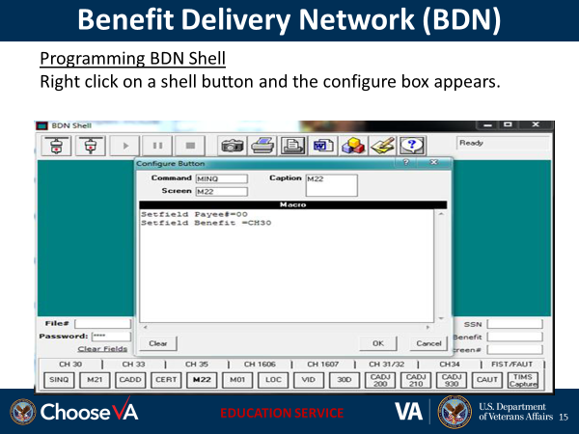 | DISPLAY slide  Illustrate to the students inserting the commands, captions and screen for BDN Shell screen set up.
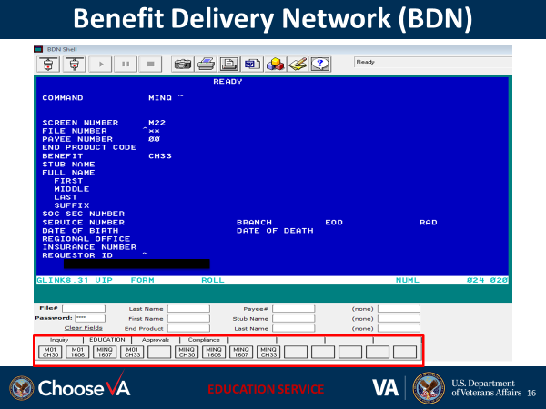 | DISPLAY slide  After configuration, at the bottom of the BDN screen you will notice the preferences selected in the red box beginning from left to right.
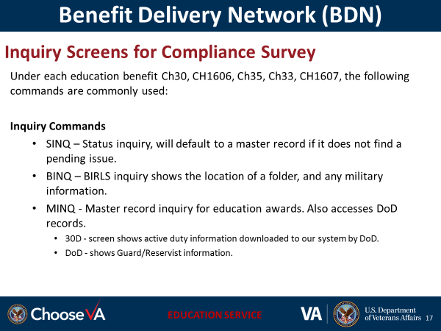 | DISPLAY slide  Instructor Notes:  Allow students to navigate the screens and activate each command above
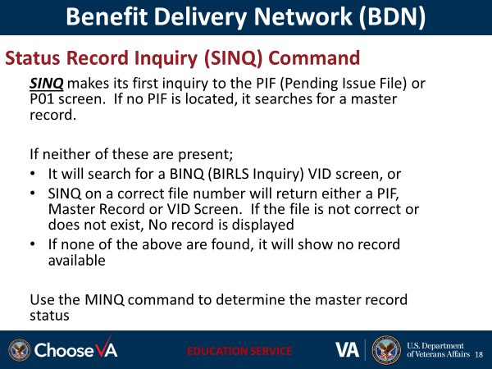 | DISPLAY slide
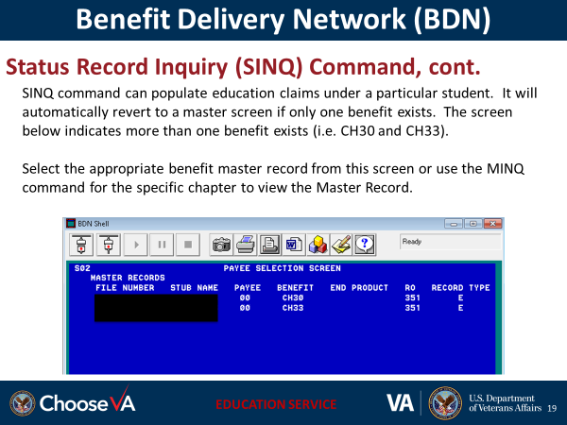 | DISPLAY slide  Instructor Notes:  Provide an example of only one benefit, where the SINQ command will navigate to the Master record, and  Provide an example where the individual has more than one benefit and allow the students to review the screen.
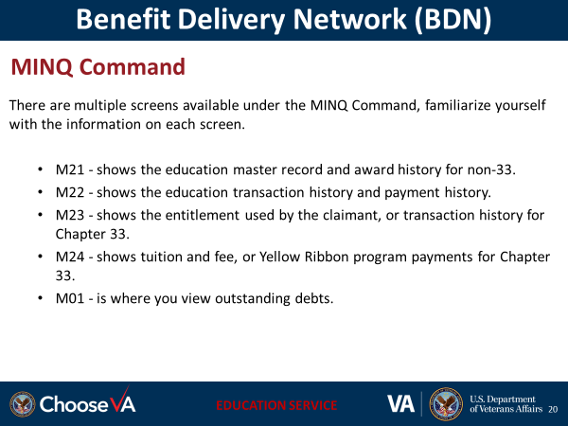 | DISPLAY slide  Instructor Notes:  Allow students to navigate and review each of the screens on this slide
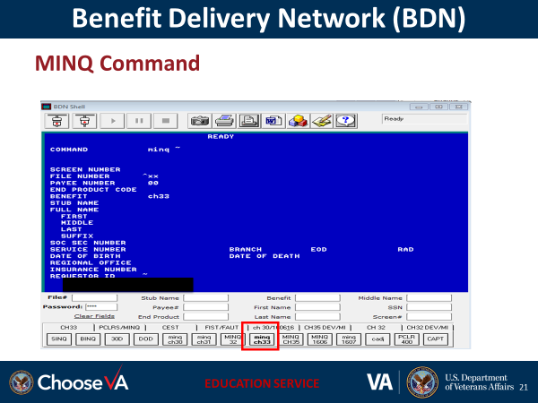 | I DISPLAY slide  nstructor Notes:  Explain this is the Ch33 Ready screen. In order access the Ch33 Master Record click the “MINQ ch33” button.  This is the Ch33 Ready screen. In order access the Ch33 Master Record click the “MINQ ch33” button.
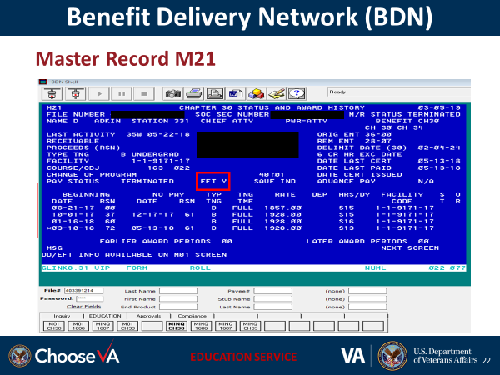 | DISPLAY slide  Instructor Notes:  Discuss the M21 screen and explain the:  The type of training the individual is pursuing. This claimant is in Graduate school.  Complete enrollment information is included on the M21 (begin and end dates of school, training time, and the schools facility code  Verify the Direct Deposit Information (Yes or No)  Important message field that may include if an individual has a Kicker (buy up) which will increase the rate of payment
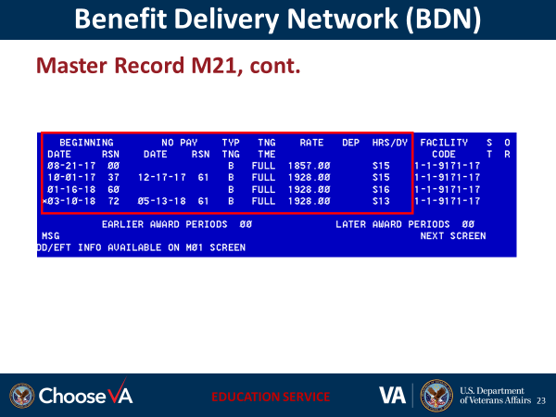 | DISPLAY slide  Instructor Notes:  Discuss the M21 screen and explain the:  - Beginning and No Pay date is the date the training began  - Reason codes indicates the if a claim is original or supplemental, or if the individual graduated or exhausted their benefits  - Type of training, (A, B, or C); training time, monthly rate the individual received and number and type of hours attempted or completed  May also see “X” as type of training for Restoration of Entitlement, or D for Chapter 35 deficiency training.
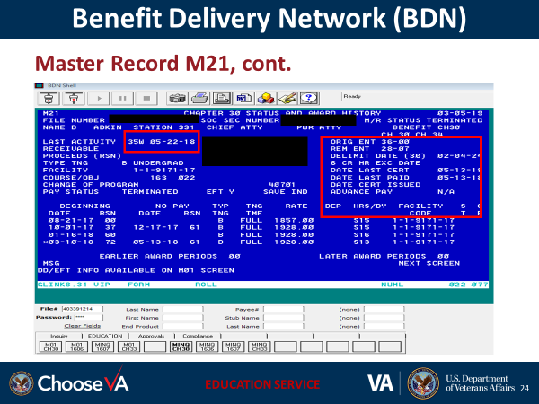 | DISPLAY slide  Instructor Notes:  Discuss the M21 screen and explain the:  Date and code for the last action taken with this claim,  Entitlement and delimiting date  Date of the last certification of enrollment processed and paid.
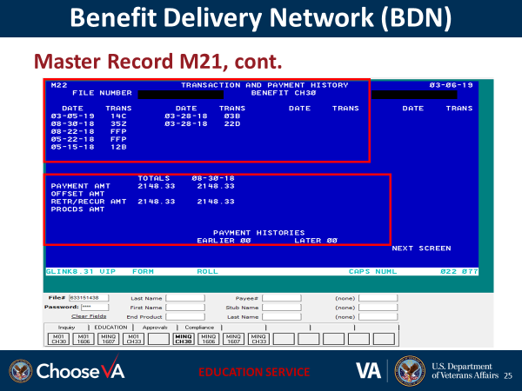 | DISPLAY slide  Instructor Notes:  Discuss the M22 Payment History Record:  - Last transaction and date of the action taken on this claim.  - Award date, payment, amount, debt, and funds claimant received.
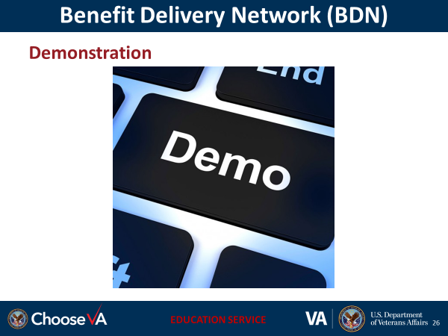 | DISPLAY slide
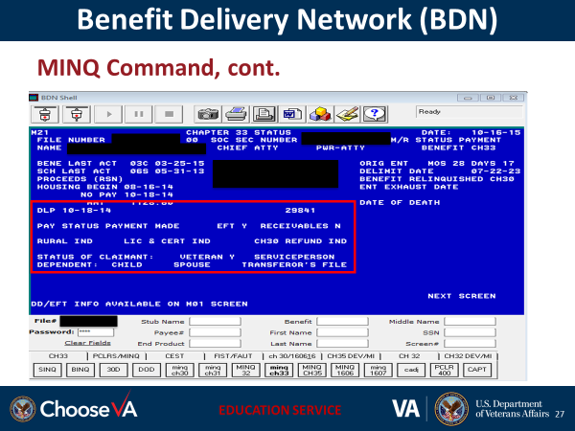 | DISPLAY slide  Instructor Notes:  Communicate to the students the fields of the M21 that will be pertinent for the surveys.
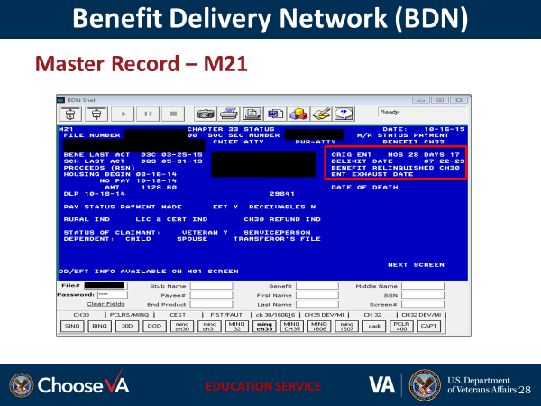 | DISPLAY slide  Instructor Notes:  Verify the claimant original entitlement, delimiting date, benefit relinquished, and entitlement exhaust date.
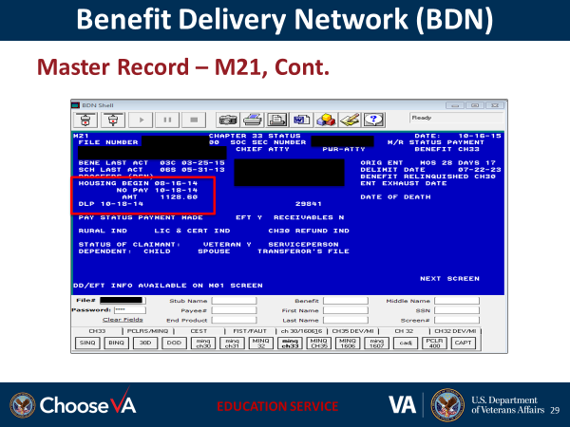 | DISPLAY slide  Instructor Notes:  Verify housing begin date, date last paid and amount of housing paid.
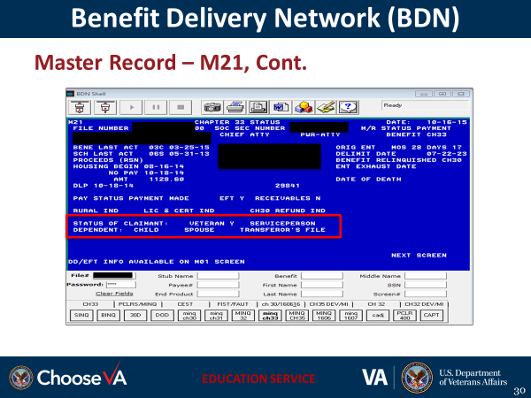 | DISPLAY slide  Instructor Notes:  Verify status of the claimant to determine if he/she is a Veteran, serviceperson, dependent (child or spouse) and transferor’s file number
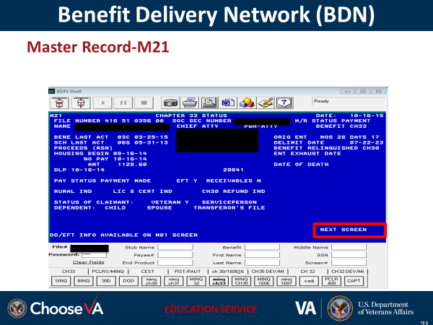 | DISPLAY slide  Instructor Notes:  Navigate to the M22 screen by entering ”M22” in the “Next Screen” field on the M21 screen.
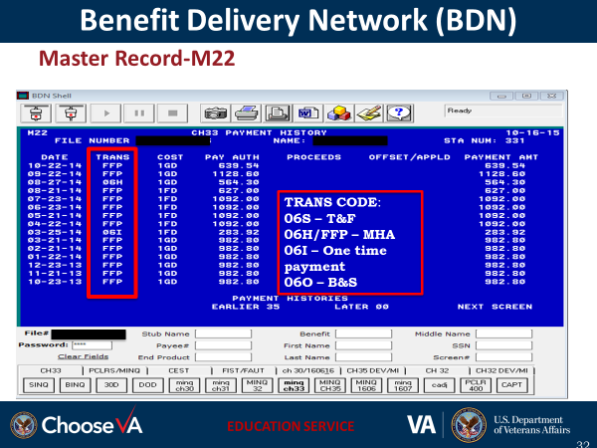 | DISPLAY slide  Instructor:  Communicate to the students the M22 screen shows 20 transactions and the date of payment histories
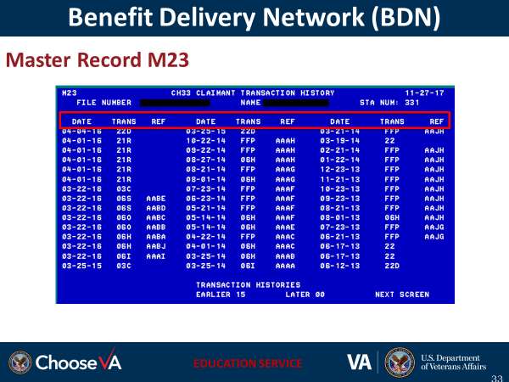 | DISPLAY slide  Instructor Notes:  The M23 screen provides the CH33 Transaction History. Payments & Overpayments but no amounts, only the type of transaction.
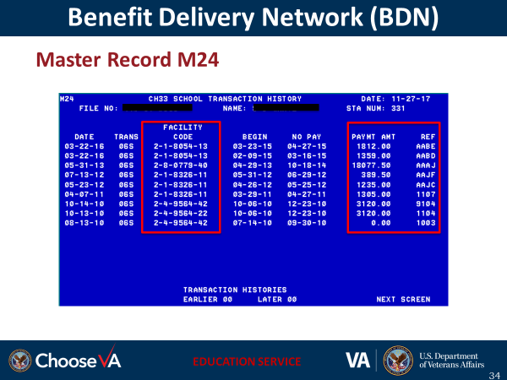 | DISPLAY slide  Instructor Notes:  M24 shows Chapter 33 tuition and fee, or Yellow Ribbon program payments sent to the facility
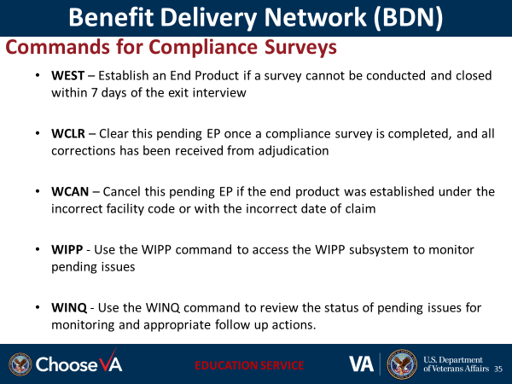 | DISPLAY slide
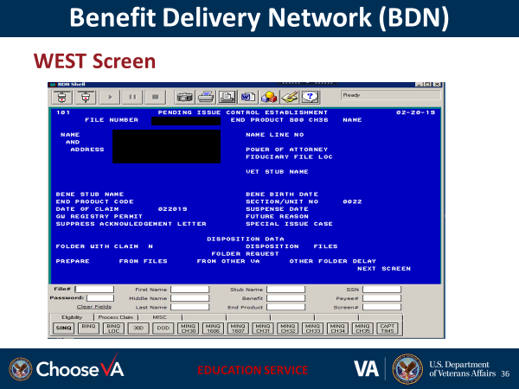 | DISPLAY slide  Instructor Notes:  Explain the WEST command to establish a pending end product. Allow student to navigate to the screen for reviewing.
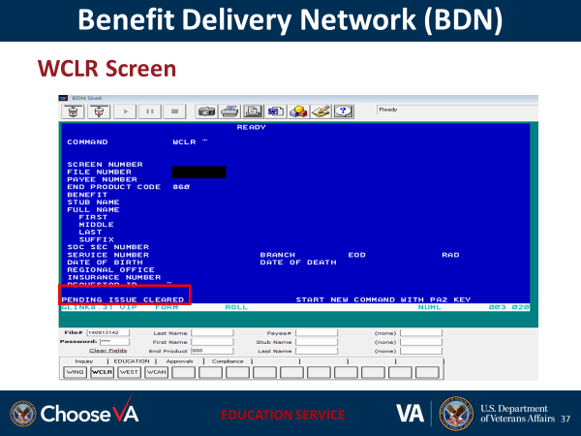 | DISPLAY slide  Instructor Notes:  Explain the WCLR Command when clearing pending Eps, once a compliance survey is completed, and all corrections has been received from adjudication. Allow student to navigate to the screen for reviewing
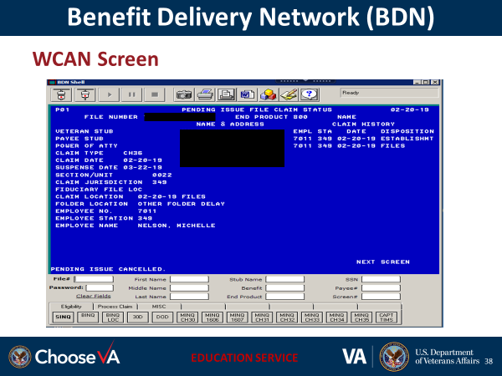 | DISPLAY slide  Instructor Notes:  Explain the WCAN command to cancel a previously established pending issue. The WCAN command does not generate any work measurement credit. Allow student to navigate to the screen for reviewing.
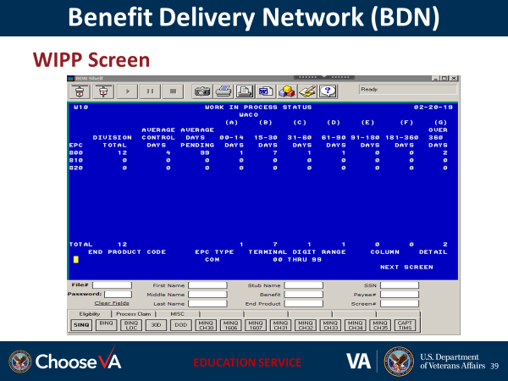 | DISPLAY slide  Instructor Notes:  Explain the WIPP command to access the WIPP Subsystem to monitor pending issues. Additional information is available on overall processing time and maturing issues. Allow student to navigate to the screen for reviewing.
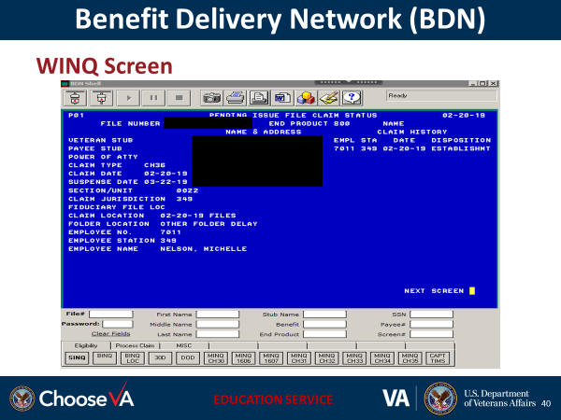 | DISPLAY slide  Instructor Notes:  Explain the WINQ command to review the status of pending issues for monitoring and appropriate follow-up actions. Allow student to navigate to the screen for reviewing.
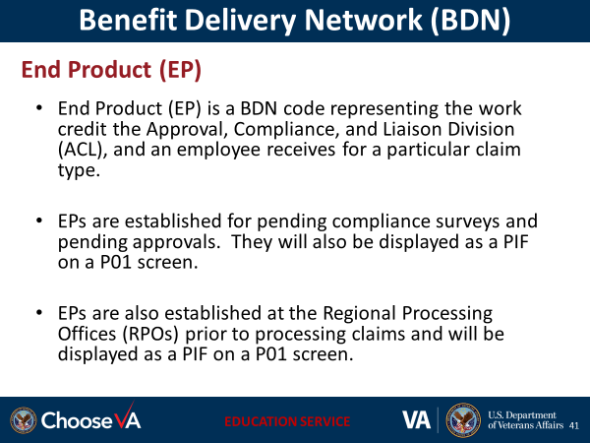 | DISPLAY slide
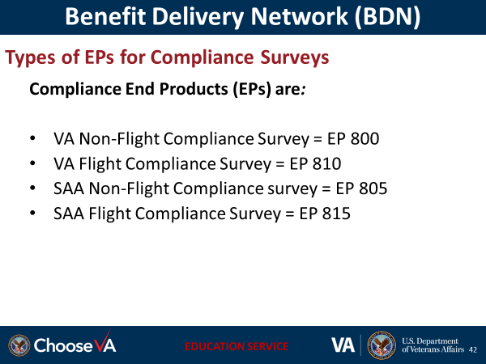 | DISPLAY slide  You may see these established on a claim you are using as a sample when conducting a compliance survey. Please leave them pending and do not alter.  Briefly discuss the Types of codes used for claims processing  - Processing Original Claims End Products (EPs) are:  Chapter 30 = EP 200  Chapter 33 = EP 340  Chapter 1606 = EP 260  Chapter 1607 = EP 360  - Processing Supplemental Claims End Products (EPs) are:  Chapter 30 = EP 210  Chapter 33 = EP 350  Chapter 1606 = EP 280  Chapter 1607 = EP 380
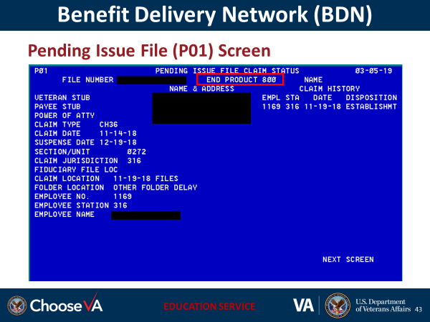 | DISPLAY slide  Discuss P01 screen to show the following:  - EP 800 indicates this is a Compliance Survey conducted  - This claim was established on 11/19/18 in Atlanta (STA 316)
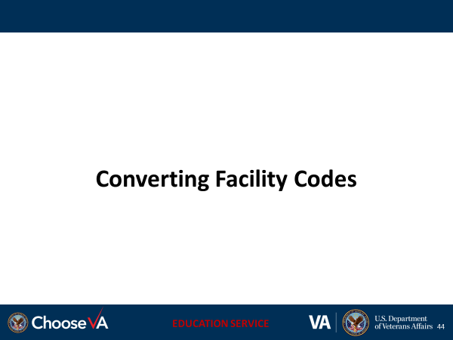 | DISPLAY slide
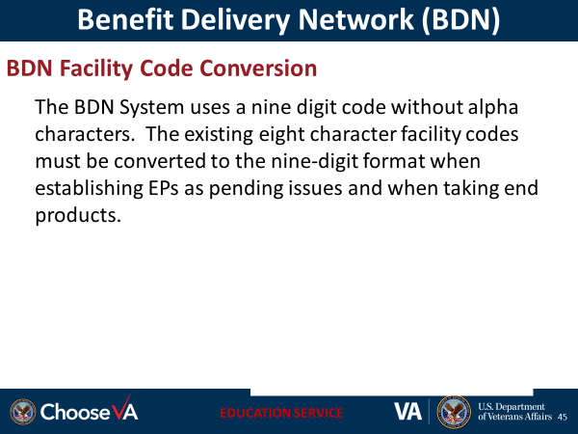 | DISPLAY slide  Instructor note:  If a Name code has alpha character(s), convert the alpha character(s) to two or three digit numbers in accordance with the table on the next slide.
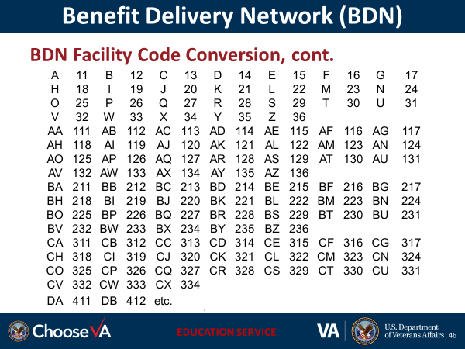 | DISPLAY slide  Instructor Notes:  Explain to the students: A facility code of 3-1-1234-46 is assigned to a college.  To process a BDN transaction, enter the facility code as 3-1-01234-46  If a Name code has alpha character(s), convert the alpha character(s) to two or three digit numbers in accordance with the table above
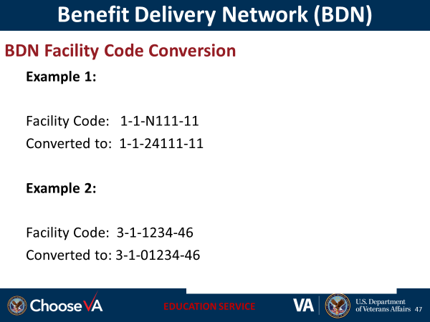 | DISPLAY slide
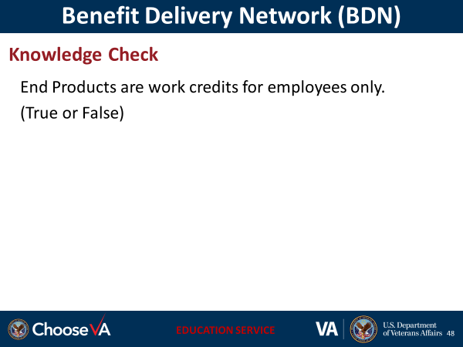 | DISPLAY slide  Answers:  - False – EPs are work credits for the ACL employee and Regional Processing Offices RPOs.
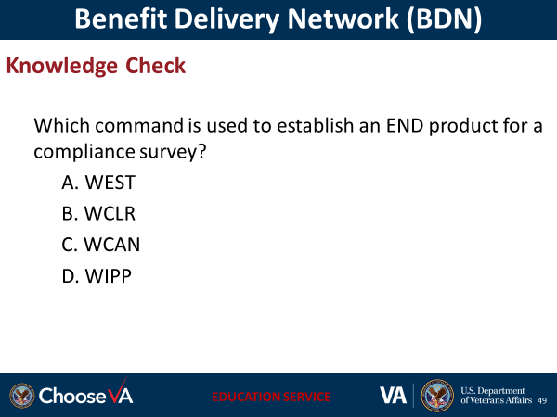 | DISPLAY slide  Answer: A
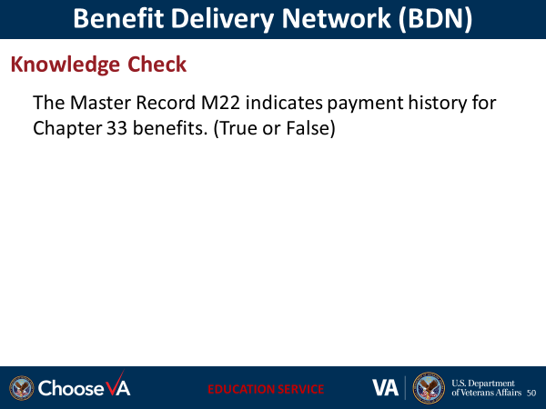 | DISPLAY slide  True
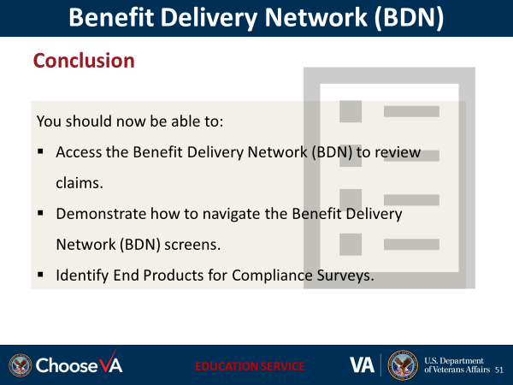 | DISPLAY slide
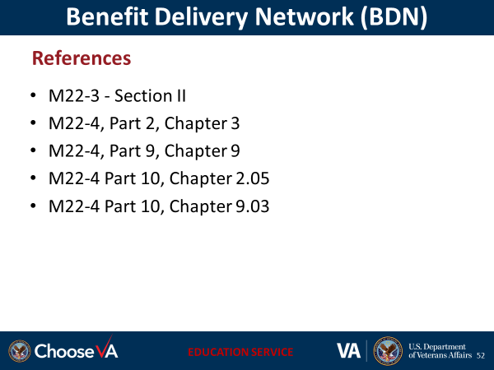 | DISPLAY slide
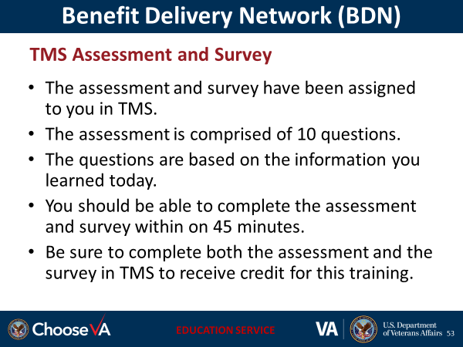 | DISPLAY slide
 | DISPLAY slide

