Education Service
VA Education Forms Overview
Lesson Plan
April 2019

Lesson Overview
Topic | Description
Time Estimate:
Purpose of the Lesson: | Provide New Education Compliance Survey Specialist (ECSS) knowledge about VA Forms utilized to carry out their roles and responsibilities.
Prerequisite Training Requirements: | New ECSS should have received training on the various education benefits administered.
Target Audience: | The lesson is designed for New Education Compliance Survey Specialist.
Lesson References:
Lesson Objectives: | - Identify the forms utilized for conducting Compliance Surveys.  - List the various forms utilized for processing VA Education Claims.
What You Need: | The instructor will need copies forms to for compliance surveys and student forms: See slide 4 and 5 for forms to be discussed.
Post Training Requirements: | Upon completion of the classroom portion of the lesson, participants are required to complete an online lesson assessment and survey in Talent Management System (TMS).  To demonstrate successful completion of the lesson participants must pass the assessment with a score of at least 80%.  Participants must also complete the online survey to earn credit for completion of the lesson.

Instructor Notes

PowerPoint Slides | Instructor Activities
 | DISPLAY slide  Introduce yourself as the instructor and introduce the lesson.
Icebreaker Activity  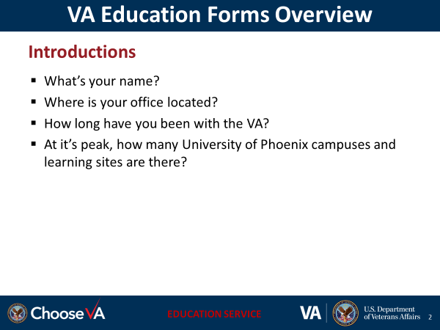 | DISPLAY slide  Have the students introduce themselves is optional and up to the instructor.  Start lesson with a motivating statement, ice breaker, or knowledge check to gauge familiarity with the subject.
Overview of Today’s Training | Provide an overview of the lesson by discussing the topics or key points of instruction.
Lesson Objectives  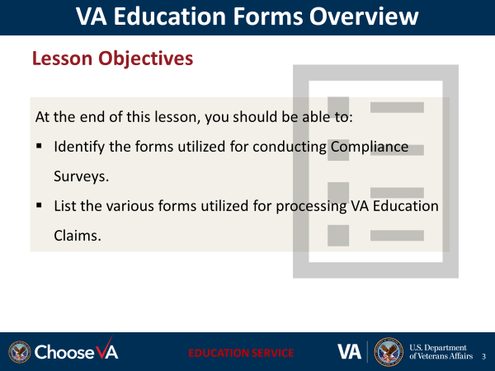 | DISPLAY slide  Review the lesson learning objectives.
[Slide Title]  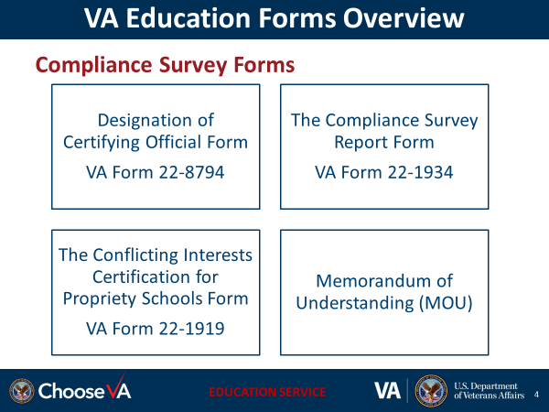 | DISPLAY slide
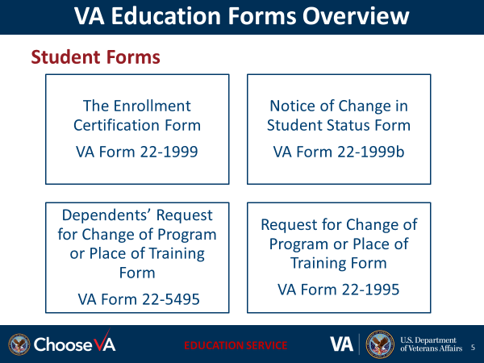 | DISPLAY slide
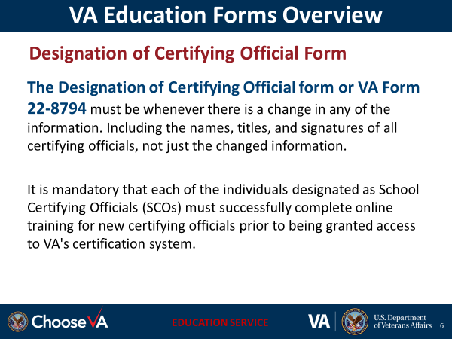 | DISPLAY slide
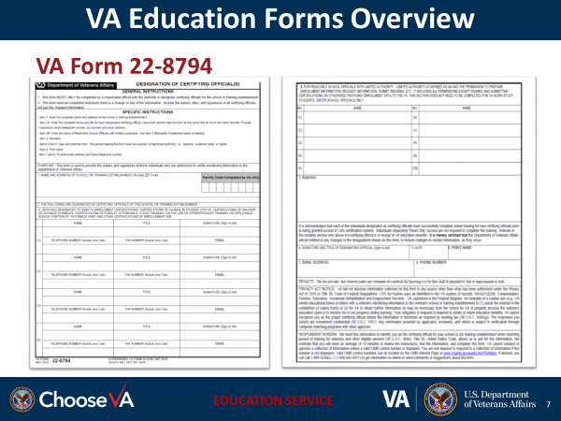 | DISPLAY slide
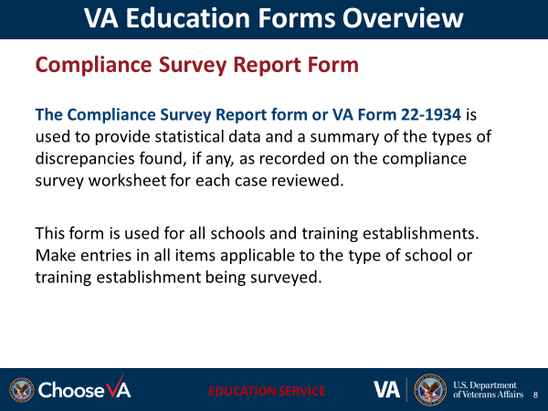 | DISPLAY slide
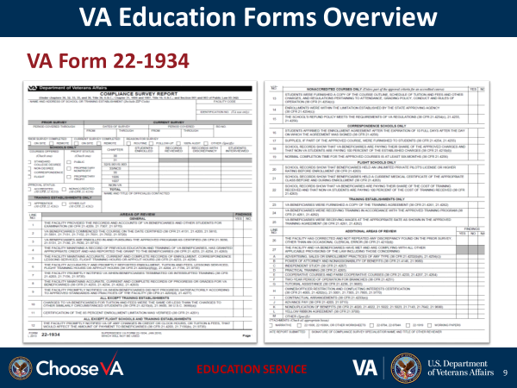 | DISPLAY slide
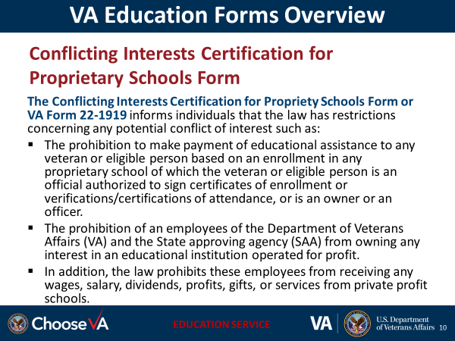 | DISPLAY slide
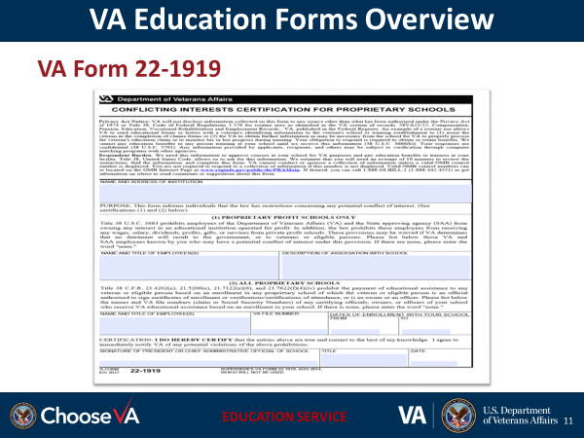 | DISPLAY slide
 | DISPLAY slide
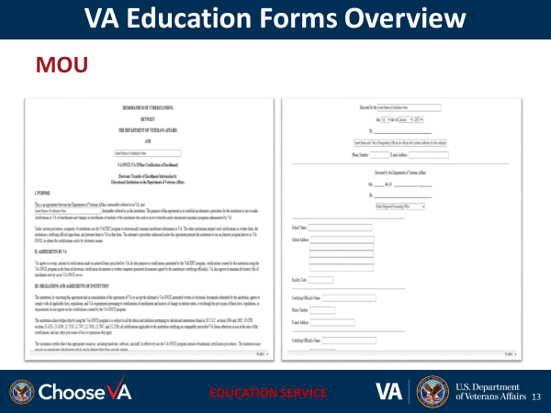 | DISPLAY slide
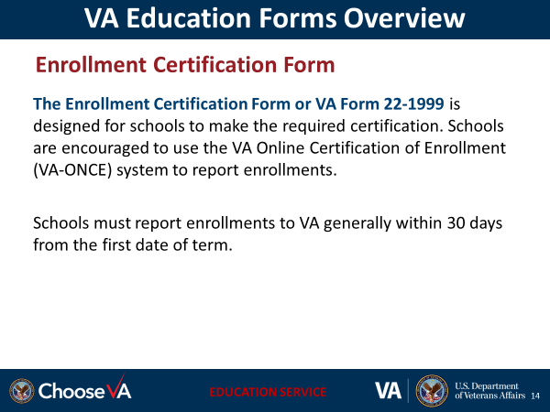 | DISPLAY slide
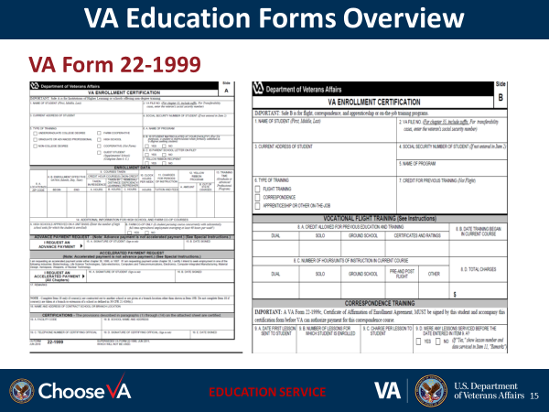 | DISPLAY slide
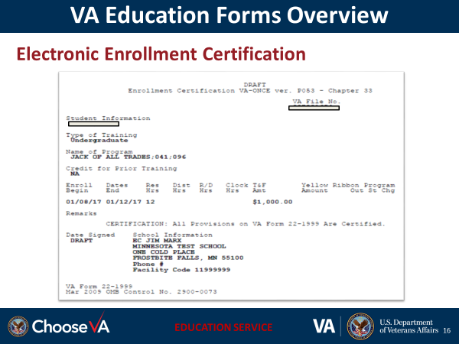 | DISPLAY slide
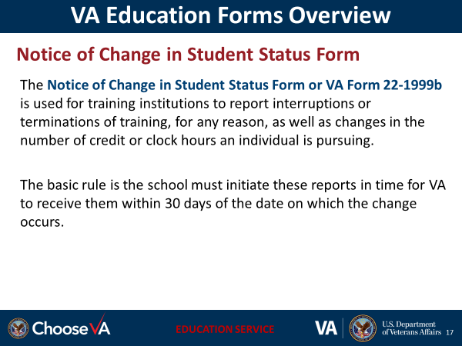 | DISPLAY slide
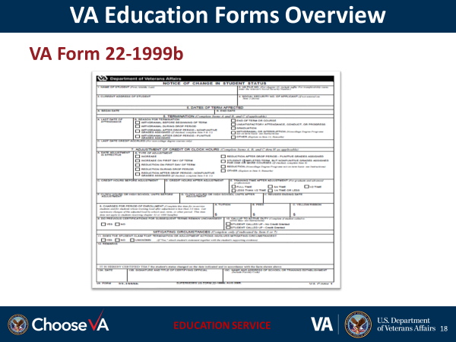 | DISPLAY slide
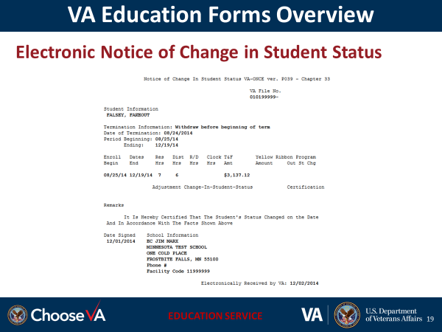 | DISPLAY slide
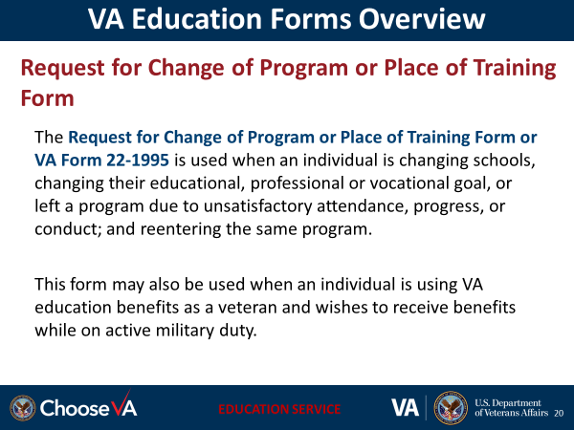 | DISPLAY slide
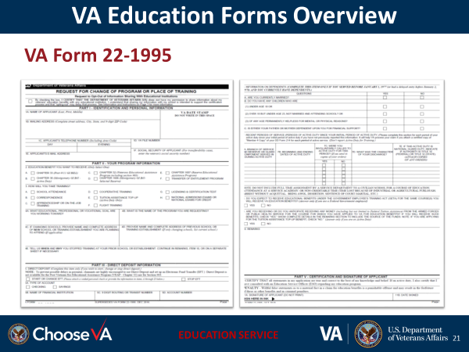 | DISPLAY slide
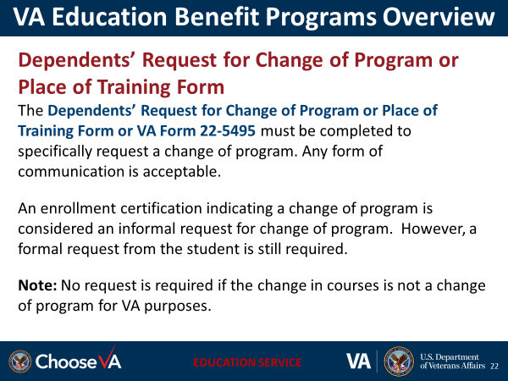 | DISPLAY slide
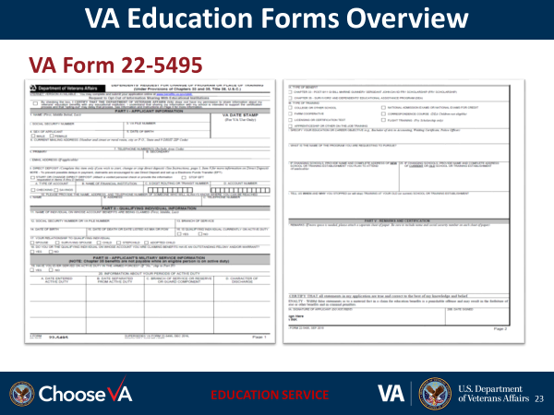 | DISPLAY slide
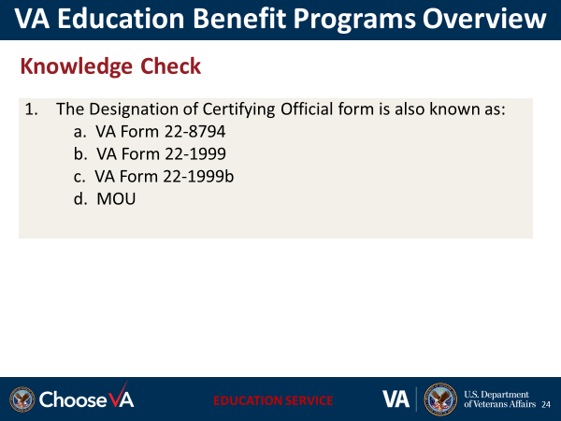 | DISPLAY slide
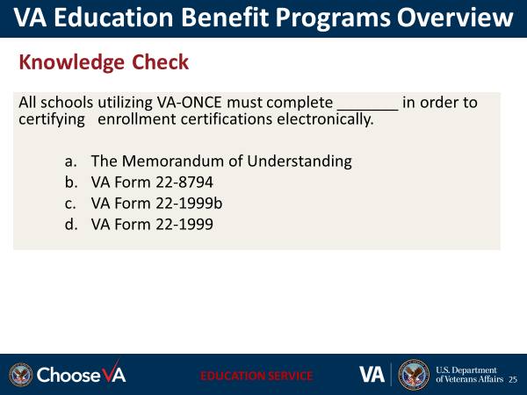 | DISPLAY slide
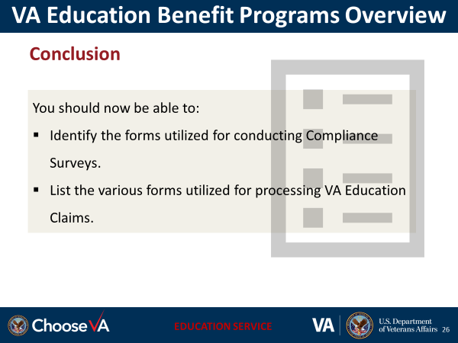 | DISPLAY slide
 | DISPLAY slide
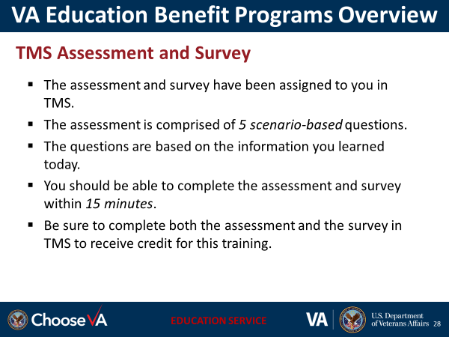 | DISPLAY slide

