Education Service
Equitable Relief Training

Lesson Plan

May 2019
Version 1.0

Lesson Overview
Topic | Description
Time Estimate: | 1.5 hours
Purpose of the Lesson: | Provide Regional Processing Offices (RPOs) with guidance on identifying, processing and submitting Equitable Relief requests to Education Service’s Quality Assurance (QA) Team.
Prerequisite Training Requirements: | The following prerequisite training is required:  None
Target Audience: | Regional Processing Office (RPO) Equitable Relief Team(s)
Lesson References: | The following references support the lesson content:  - 10 U.S.C. 109  - 10 U.S.C. 2107(b)  - 38 U.S.C. 503(b)  - 38 U.S.C. 3311(d)  - M22-4, Part 3, Chapter 1, 1.14  - M22-4, Part 3, Chapter 2, 2.06  - M22-4, Part 12 – Chapter 33, 02 – Eligibility, Sub-Chapter 5, 5.02(a)  - Procedural Advisory: Equitable Relief Claims with a Pending Appeal (March 22, 2016)  - Procedural Advisory: Submission of Equitable Relief Claims, October 7, 2014  - Revised Training Reminder: Processing Deductible Service Under the Post-9/11 GI Bill (Chapter 33) in the Long Term Solution (April 25, 2013)  - Training Reminder: Service Academy Attendance, Graduation, and Eligibility for the Post-9/11 GI Bill (March 18, 2014)
Lesson Objectives: | At the end of this lesson, you will be able to:  - Define Equitable Relief  - Understand the Secretary of Veterans Affairs’ authority  - Identify the Equitable Relief document type  - Request documentation to support an Equitable Relief claim  - Prepare an Equitable Relief package  - Complete follow-up actions with Education Service  - Process an Equitable Relief decision
What You Need: | Equitable Relief Lesson Plan. Provide instructions and directions on how to print PowerPoint presentation from a saved location. Refer to lesson plan and have Subject Matter Expert (SME) available if primary presenter is not an SME to assist with answering questions. Training should be Instructor-led with a means to ask questions during the training. It will be delivered virtually. Individauls that view a recorded live session to make-up the training should be provided a POC who is available for questions while the employee is taking the lesson.
Post Training Requirements: | - Upon completion of the Webinar, participants are required to complete an online lesson assessment and survey in Talent Management System (TMS).  - To demonstrate successful completion of the lesson, participants must pass the assessment with a score of at least 80%.  - Participants must also complete the online survey to earn credit for completion of the lesson.

Instructor Notes
The lesson will provide Regional Processing Offices (RPOs) with guidance on identifying, processing and submitting Equitable Relief requests to Education Service’s Quality Assurance (QA) Team.
PowerPoint Slides | Instructor Activities
 | DISPLAY slide 1  INTRODUCE yourself as the instructor and introduce any fellow instructors.  INTRODUCE the lesson.
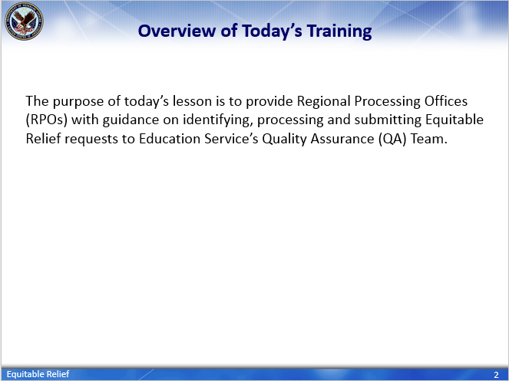 | DISPLAY slide 2  Overview of Today’s Training  INFORM students: The purpose of today’s lesson is to provide Regional Processing Offices (RPOs) with guidance on identifying, processing and submitting Equitable Relief requests to Education Service’s Quality Assurance (QA) Team.
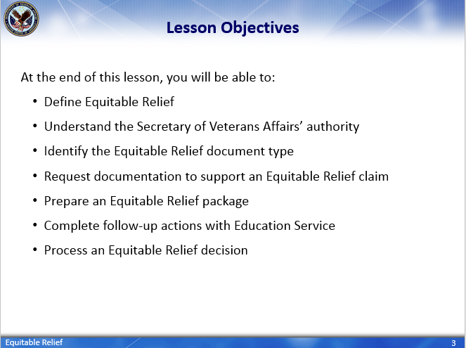 | DISPLAY slide 3  Lesson Objectives  REVIEW the lesson objectives and assure VCEs will have opportunities to practice what they learn  INFORM students: At the end of this lesson, you will be able to:  - Define Equitable Relief  - Understand the Secretary of Veterans Affairs’ authority [regarding Equitable Relief decisions]  - Identify the Equitable Relief document type  - Request documentation to support an Equitable Relief claim  - Prepare an Equitable Relief package  - Complete follow-up actions with Education Service  - Process an Equitable Relief decision
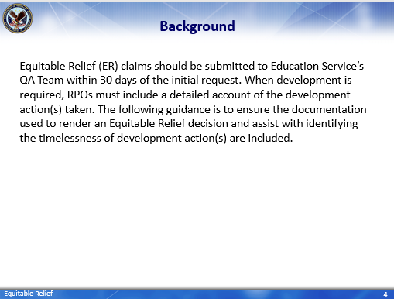 | DISPLAY slide 4  Background  READ/SUMMARIZE slide:  Equitable Relief (ER) claims should be submitted to Education Service’s QA (Quality Assurance) Team within 30 days of the initial request. When development is required, RPOs must include a detailed account of the development action(s) taken. The following guidance is to ensure the documentation used to render an Equitable Relief decision and assist with identifying the timelessness of development action(s) are included.
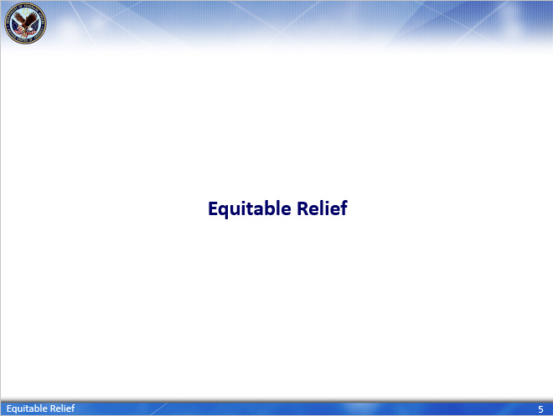 | DISPLAY slide 5  Equitable Relief  ASK the question “What is Equitable Relief?”
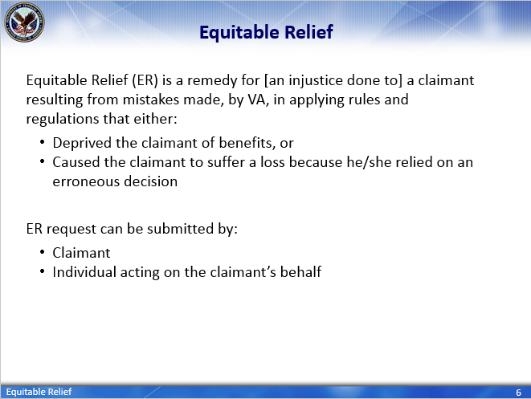 | DISPLAY slide 6  Equitable Relief  SUMMARIZE slide  INFORM: Anyone can act on the claimant’s behalf, to include an individual in claims processing.
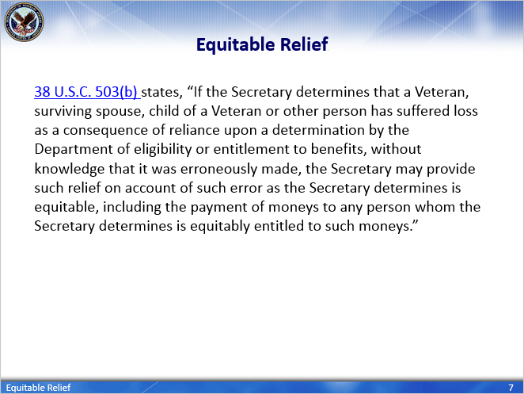 | DISPLAY slide 7  Equitable Relief  READ/SUMMARIZE slide:  Equitable Relief is governed by 38 USC 503(b) which states:  If the Secretary determines that a Veteran, surviving spouse, child of a Veteran or other person has suffered loss as a consequence of reliance upon a determination by the Department of eligibility or entitlement to benefits, without knowledge that it was erroneously made, the Secretary may provide such relief on account of such error as the Secretary determines is equitable, including the payment of moneys to any person whom the Secretary determines is equitably entitled to such moneys.
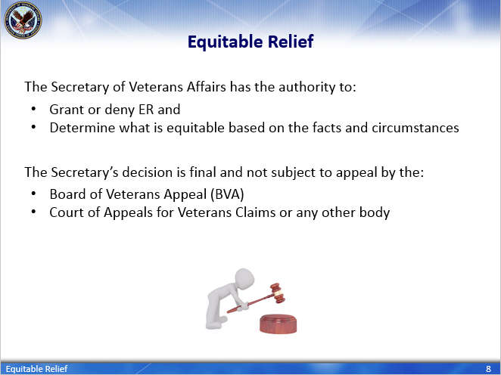 | DISPLAY slide 8  Equitable Relief  SUMMARIZE slide:  Therefore, the authority to grant or deny Equitable Relief rests solely with the Secretary of VA. The Secretary will determine what is equitable based on the facts and circumstances [of the claimant’s case].  The Secretary’s decision is final and not subject to appeal to the Board of Veterans Appeals, Court of Appeals for Veterans Claims, or any other body.
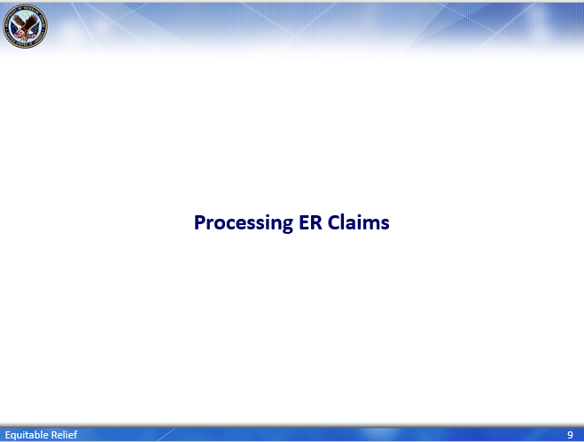 | DISPLAY slide 9  Processing ER claims  INTRODUCE slide
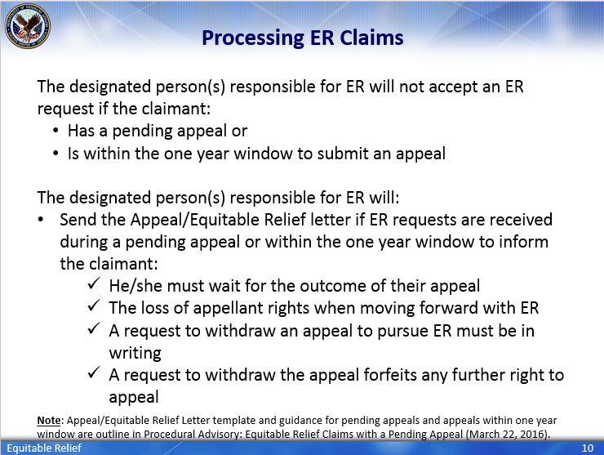 | DISPLAY slide 10  Processing ER claims  READ/SUMMARIZE slide:  The designated person(s) responsible for ER will not accept an ER request if the claimant:  - Has a pending appeal or  - Is within the one year window to submit an appeal  The designated person(s) responsible for ER will:  - Send the Appeal/Equitable Relief letter if ER requests are received during a pending appeal or within the one year window [to submit an appeal] to inform the claimant:  - He/she must wait for the outcome of their appeal  - The loss of appellant rights when moving forward with ER  - A request to withdraw an appeal to pursue ER must be in writing  - A request to withdraw the appeal forfeits any further right to appeal  Note: Follow the guidance is outlined in Procedural Advisory: Equitable Relief Claims with a Pending Appeal (March 22, 2016).
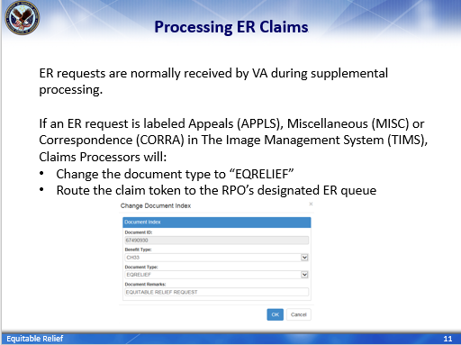 | DISPLAY slide 11  Processing ER Claims  SUMMARIZE slide:  Equitable Relief requests are normally received by VA during supplemental processing.  If an ER request is labeled Appeals (APPLS), Miscellaneous (MISC) or Correspondence (CORRA) in The Image Management System (TIMS), Claims Processors will:  - Change the document type to “EQRELIEF” [when ER documents are identified] and  - Route the [claimant’s] TIMS folder to the RPO’s designated ER queue [for assignment and processing]
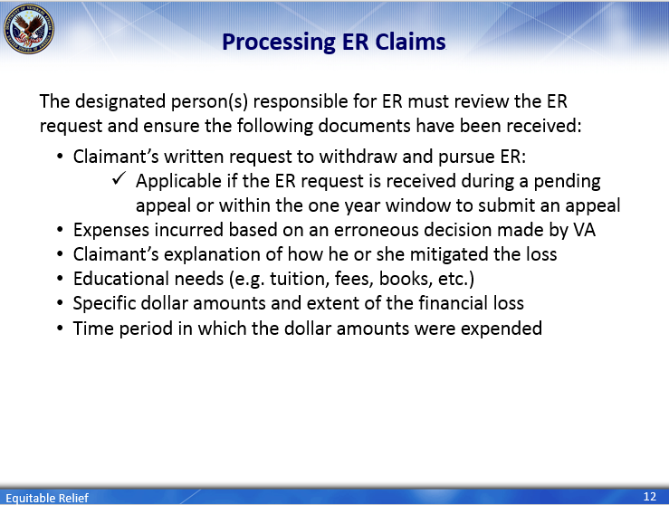 | DISPLAY slide 12  Processing ER Claims  READ/SUMMARIZE slide:  The designated person(s) responsible for ER must review the ER request and ensure the following documents have been received:  - Claimant’s written request to withdraw and pursue ER:  - Applicable if the ER request is received during a pending appeal or within the one year window to submit an appeal  - Expenses incurred based on an erroneous decision made by VA  - Claimant’s explanation of how he or she mitigated the loss  - Educational needs (e.g. tuition, fees, books, etc.)  - Specific dollar amounts and extent of the financial loss  - Time period in which the dollar amounts were expended
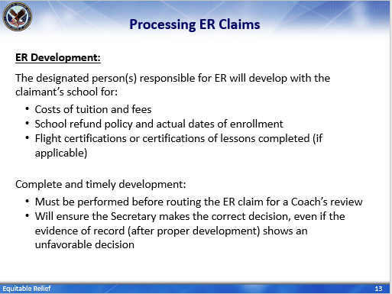 | DISPLAY slide 13  Processing ER Claims  READ/SUMMARIZE slide:  ER Developmment:  The designated person(s) responsible for ER will develop with the claimant’s school for:  - Costs of tuition and fees  - School refund policy and actual dates of enrollment  - Flight certifications or certifications of lessons completed (if applicable)  Complete and timely development:  - Must be performed before routing the ER claim for a Coach’s review [and]  - Will ensure the Secretary makes the correct decision, even if the evidence of record (after proper development) shows an unfavorable decision
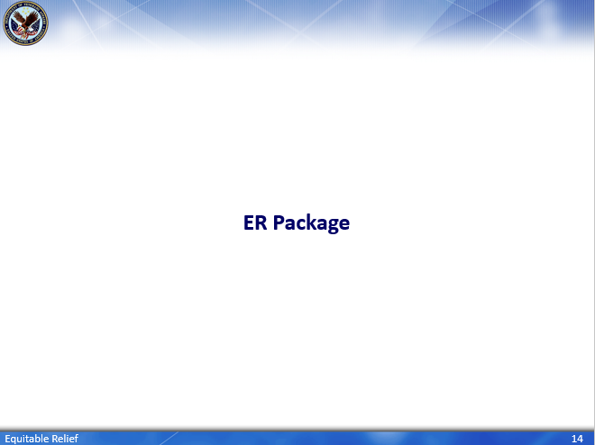 | DISPLAY slide 14  ER Package  INTRODUCE slide
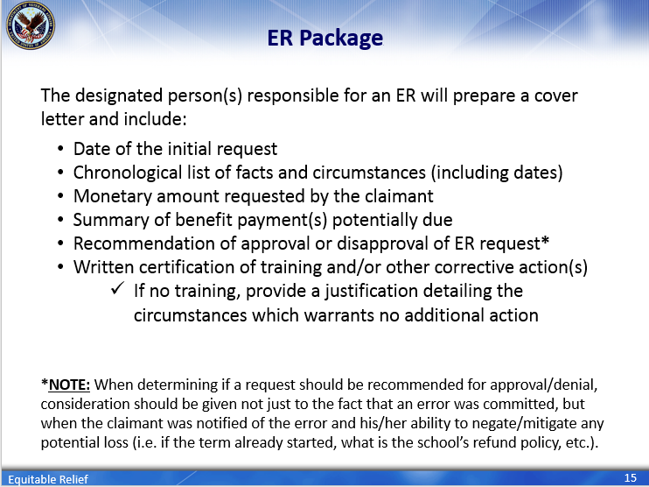 | DISPLAY slide 15  ER Package  READ/SUMMARIZE slide:  After development is complete and the applicable documentation has been received (i.e. from the claimant, DoD, claimant’s school, etc.), The next course of action is for the designated person(s) responsible for an ER to prepare a cover letter and it should include:  - Date of the initial request  - Chronological list of facts and circumstances [of alleged error] including dates  - Monetary amount requested by the claimant  - Summary of benefit payment(s) potentially due  - Recommendation of approval or disapproval of ER request  - Written certification of training and/or other corrective action(s)  - If no training, provide a justification detailing the circumstances which warrants no additional action.  NOTE: When determining if a request should be recommended for approval/denial, consideration should be given not just to the fact that an error was committed, but when the claimant was notified of the error and his/her ability to negate/mitigate any potential loss (i.e. if the term already started, what is the school’s refund policy, etc.)
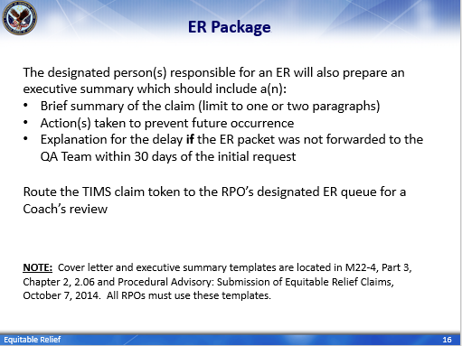 | DISPLAY slide 16  ER Package  READ/SUMMARIZE slide:  The designated person(s) responsible for an ER will also prepare an executive summary which should include:  - [A] Brief summary of the claim (limit to one or two paragraphs)  - Action(s) taken to prevent future occurrence  - [An] Explanation for the delay if the ER packet was not forwarded to the QA Team within 30 days of the initial request  Route the TIMS folder to the RPO’s designated ER queue a Coach’s review.  NOTE: Cover letter and executive summary templates are located in M22-4, Part 3, Chapter 2, 2.06 and Procedural Advisory: Submission of Equitable Relief Claims, October 7, 2014. All RPOs must use these templates.
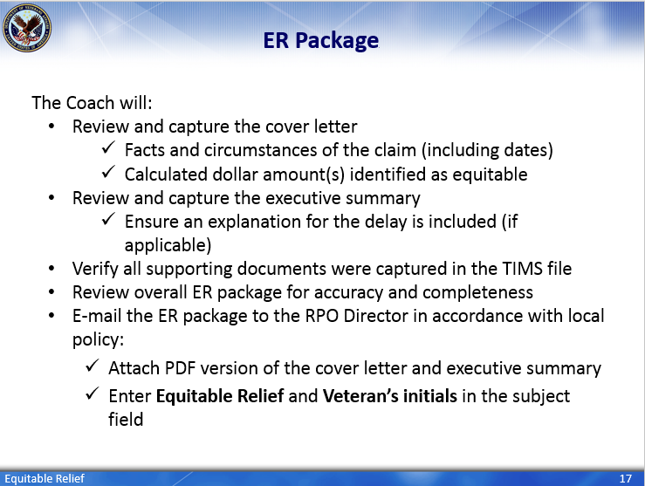 | DISPLAY slide 17  ER Package  READ/SUMMARIZE slide:  The Coach will:  - Review and capture the cover letter [to ensure]  - Facts and circumstances of the claim (including dates) [and] calculated dollar amount(s) identified as equitable [are accurate/correct]  - Review and capture the executive summary  - Ensure an explanation for the delay is included (if applicable)  - Verify all supporting documents were captured in the TIMS file  - Review the ER package for accuracy and completeness  - E-mail the ER package to the RPO Director in accordance with local policy [and]:  - Attach a PDF version of the cover letter and executive summary  - Enter Equitable Relief and Veteran’s initials in the subject field
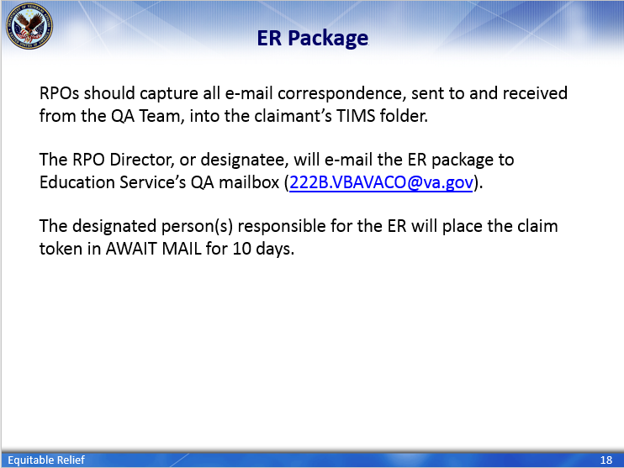 | DISPLAY slide 18  ER Package  STRESS: RPOs should capture all e-mail correspondence, sent to and received from the QA Team, into the claimant’s TIMS folder.  READ/SUMMARIZE: The RPO Director, or designatee, will e-mail the ER package to Education Service’s QA mailbox (222B.VBAVACO@va.gov).  The designated person(s) responsible for the ER will place the claim token in AWAIT MAIL for 10 days.
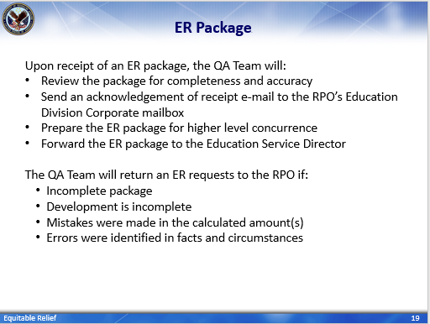 | DISPLAY slide 19  ER Package  READ/SUMMARIZE slide:  Upon receipt of an ER package, the QA Team will:  - Review the ER package for completeness and accuracy  - Send an acknowledgement of receipt e-mail to the RPO’s Education Division Corporate mailbox  - Prepare the ER package for higher level concurrence  - Forward the ER package to the Education Service Director  The QA Team will return an ER requests to the RPO if:  - Incomplete package  - Development is incomplete  - Mistakes were made in the calculated amount(s)  - Errors were identified in facts and circumstances
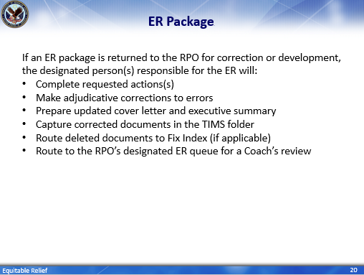 | DISPLAY slide 20  ER Package  READ/SUMMARIZE slide:  If an ER package is returned to the RPO for correction or development, the designated person(s) responsible for the ER will:  - Complete requested action(s) [i.e. necessary development]  - Make [the] adjudicative corrections to errors  - Prepare updated cover letter and executive summary [to reflect changes/corrections]  - Capture corrected documents in the [claimant’s] TIMS folder  - Route deleted documents to Fix Index (if applicable)  - Route to the RPO’s designated ER queue for a Coach’s review
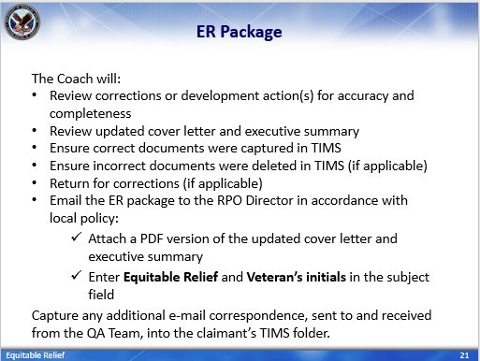 | DISPLAY slide 21  ER Package  READ/SUMMARIZE slide:  The Coach will:  - Review corrections or development action(s) for accuracy and completeness  - Review updated cover letter and executive summary  - Ensure correct documents were captured in TIMS  - Ensure incorrect documents were deleted (if applicable)  - Return [to designated person responsible for the ER] for corrections (if applicable)  - Email the ER package to the RPO Director in accordance with local policy:  - Attach a PDF version of the updated cover letter and executive summary  - Enter Equitable Relief and Veteran’s initials in the subject field  STRESS: Capture any additional e-mail correspondence, sent to and received from the QA Team, into the claimant’s TIMS folder.
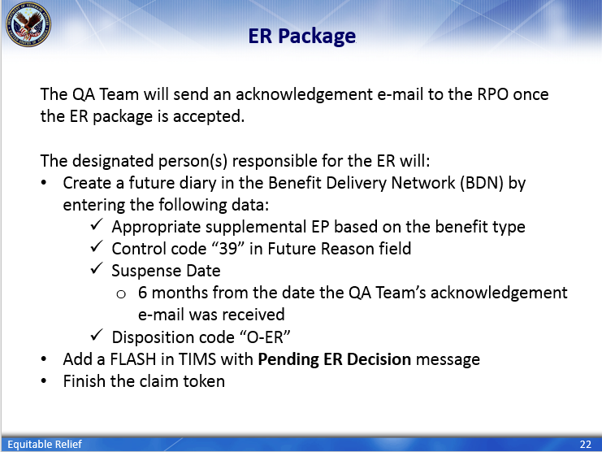 | DISPLAY slide 22  ER Package  READ/SUMMARIZE slide:  The QA Team will send an acknowledgement e-mail to the RPO once the ER package is accepted.  The designated person(s) responsible for the ER will:  - Create a future diary in the Benefit Delivery Network (BDN) by entering the following data:  - Appropriate supplemental EP based on the benefit type  - Control code “39” in Future Reason field  - Suspense Date  - 6 months from the date the QA Team’s acknowledgement e-mail was received  - Disposition code “O-ER”  - Add a FLASH in TIMS with Pending ER Decision message [and] Finish the claim token
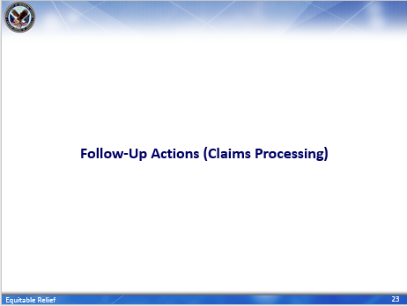 | DISPLAY slide 23  Follow-up Actions (Claims Processing)  INTRODUCE slide
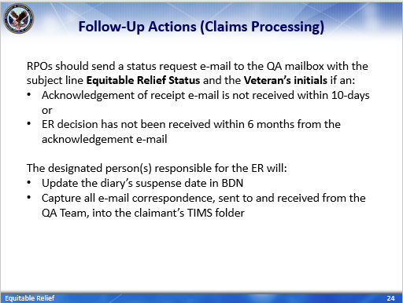 | DISPLAY slide 24  Follow-up Actions (Claims Processing)  READ/SUMMARIZE slide:  RPOs should send a status request e-mail to the QA mailbox with the subject line Equitable Relief Status and the Veteran’s initials if an:  - Acknowledgement of receipt e-mail is not received within 10-days or  - ER decision has not been received within 6 months from the acknowledgement e-mail  The designated person(s) responsible for the ER will:  - Update the diary’s suspense date in BDN  - Capture all e-mail correspondence, sent to and received from the QA Team, into the claimant’s TIMS folder
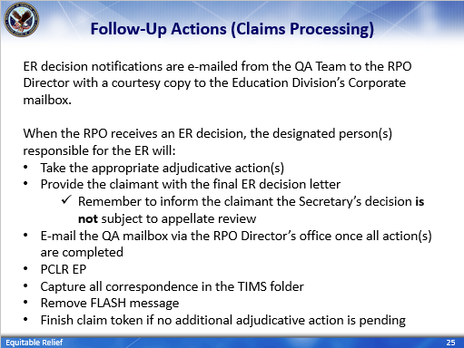 | DISPLAY slide 25  Follow-up Actions (Claims Processing)  READ/SUMMARIZE slide:  ER decision notifications are e-mailed from the QA Team to the RPO Director with a courtesy copy to the Education Division’s Corporate mailbox.  When the RPO receives an ER decision, the designated person(s) responsible for the ER will:  - Take the appropriate adjudicative action(s) [based on the Secretary’s decision]  - Provide the claimant with the final ER decision letter  - Remember to inform the claimant the Secretary’s decision is not subject to appellate review  - E-mail the QA mailbox via the RPO Director’s office once all action(s) are completed  - PCLR EP  - Capture all correspondence in the TIMS folder  - Remove FLASH message [from the TIMS folder]  - Finish claim token if no additional adjudicative action is pending
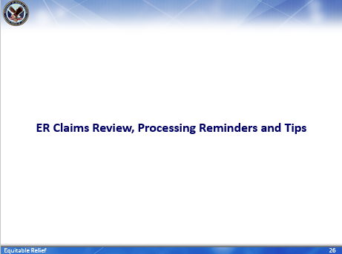 | DISPLAY slide 26  ER Claims Review, Processing Reminders and Tips  INTRODUCE slide.  INFORM: Next, we are going to review two ER claims along and provide some processing reminders and tips to assist with identifying, processing and submitting ER requests to Education Service’s Quality Assurance Team.
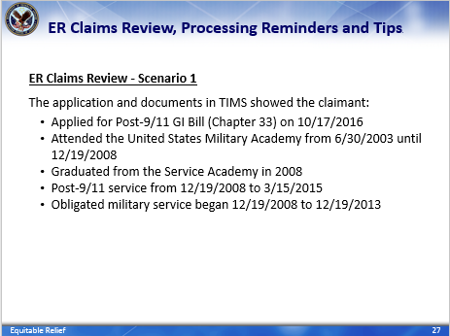 | DISPLAY slide 27  ER Claims Review, Processing Reminders and Tips  SUMMARIZE ER claim review:  ER Claims Review – Scenario 1  The application and documents in TIMS showed the claimant:  - Applied for Post-9/11 GI Bill (Chapter 33) on 10/17/2016  - Attended the United States Military Academy from 6/30/2003 until 12/19/2008  - Graduated from the Military Academy in 2008  - [Had] Post-9/11 service from 12/19/2008 to 3/15/2015 [with]  - Obligated military service began 12/19/2008 to 12/19/2013
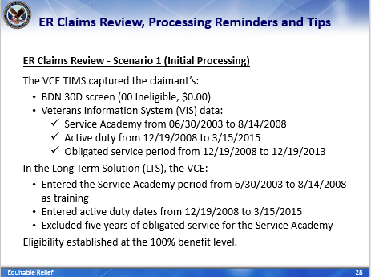 | DISPLAY slide 28  ER Claims Review, Processing Reminders and Tips  SUMMARIZE ER Claims Review:  ER Claims Review – Scenario 1 (Initial Processing)  The VCE TIMS captured the claimant’s:  - BDN 30D screen (00 Ineligible, $0.00)  - Veterans Information System (VIS) data [which indicated the claimant was]:  - Service Academy from 06/30/2003 to 8/14/2008  - Active duty service period from 12/19/2008 to 3/15/2015  - Obligated Service Period from 12/19/2008 to 12/19/2013  In the Long Term Solution (LTS), the VCE:  - Entered the Service Academy period from 6/30/2003 to 8/14/2008 as training  - Entered active duty dates from 12/19/2008 to 3/15/2015  - Excluded five years of obligated service for the Service Academy  LTS established eligibility at the 100% benefit level.
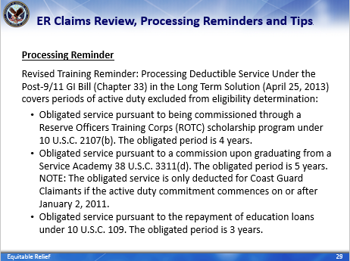 | DISPLAY slide 29  ER Claims Review, Processing Reminders and Tips  SUMMARIZE processing reminder and obligated service:  Processing Reminder  Revised Training Remainder: Processing Deductible Service Under the Post-9/11 GI Bill (Chapter 33) in the the LTS [dated April 25, 2013] covers periods of service that should be excluded from eligibility determinations. It was issued to the RPOs to assist in the identification and deduction of excluded periods of service in the LTS since certain periods of active duty service are prohibited from being used to establish eligibility. These periods of service include:  - Obligated service pursuant to being commissioned through a Reserve Officers Training Corps (ROTC) scholarship program under 10 U.S.C. 2107(b). The obligated period is 4 years.  - Obligated service pursuant to a commission upon graduating from a Service Academy. The obligated period is 5 years. [NOTE: The obligated service is only deducted for Coast Guard claimants if the active duty commitment commences on or after January 2, 2011].  - Obligated service pursuant to the repayment of education loans under 10 U.S.C. 109. The obligated period is 3 years.
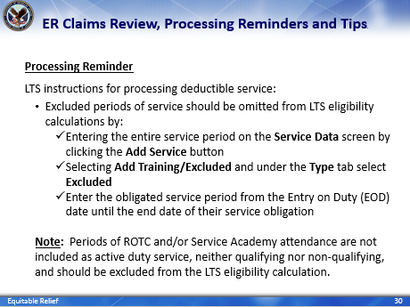 | DISPLAY slide 30  ER Claims Review, Processing Reminders and Tips  SUMMARIZE processing reminder and LTS instructions:  Processing Reminder  The LTS instructions for processing deductible service [under the Chapter 33 outlined in this training reminder] indicates:  - Excluded periods of service should be omitted from LTS eligibility calculations by:  - Entering the entire service period on the Service Data screen by clicking the Add Service button  - Selecting Add Training/Excluded and under the Type tab select Excluded  - Enter the obligated service period from the Entry on Duty (EOD) date until the end date of their service obligation  Note: Periods of ROTC and/or Service Academy attendance are not included as active duty service, neither qualifying nor non-qualifying, and should be excluded from the LTS eligibility calculation.
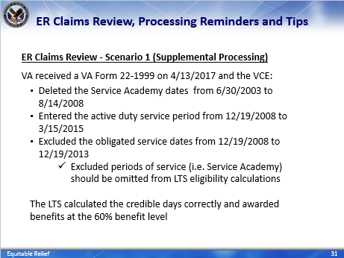 | DISPLAY slide 31  ER Claims Review, Processing Reminders and Tips  SUMMARIZE ER Claims Review:  ER Claims Review – Scenario 1 (Supplemental Processing)  VA Form 22-1999 was received by VA April 13, 2017 and the VCE:  - Deleted the Service Academy dates from 6/30/2003 - 8/14/2008 [since periods of ROTC and/or Service Academy attendance are not included as active duty service, neither qualifying nor non-qualifying, in LTS]  - Entered the active duty service period from 12/19/2008 to 3/15/2015  - Excluded the obligated service dates from 12/19/2008 to 12/19/2013  - Excluded periods of service (i.e. Service Academy) should be omitted from LTS eligibility calculations  The LTS calculated the credible days correctly and awarded benefits at the 60% benefit level
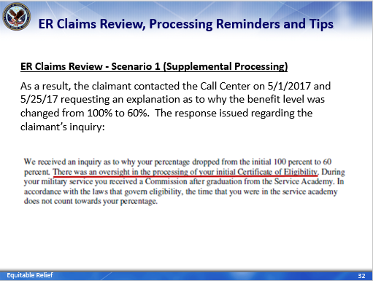 | DISPLAY slide 32  ER Claims Review, Processing Reminders and Tips  SUMMARIZE slide:  ER Claims Review – Scenario 1 (Supplemental Processing)  As a result, the claimant called Call Center on 5/1/2017 and 5/25/17 requesting an explanation as to why their benefit level was changed from 100% to 60%. The response to the claimant regarding their inquiry stated, “there was an oversight in the processing of your initial Certificate of Eligibility.”
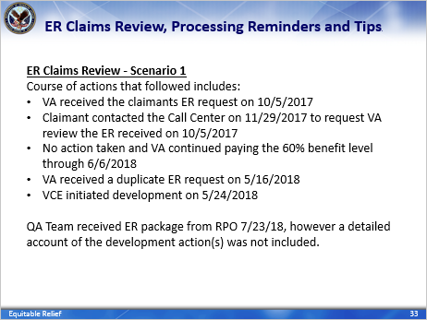 | DISPLAY slide 33  ER Claims Review, Processing Reminders and Tips  SUMMARIZE Claims Review:  ER Claims Review – Scenario 1  Course of action that followed includes:  - VA received the claimants ER request on 10/5/2017.  - Claimant contacted the Call Center on 11/29/2017 to request VA review the ER received on 10/5/2017  - No action taken and VA continued paying the 60% benefit level through 6/6/2018  - VA received a duplicate ER request on 5/16/2018 [and]  - VCE initiated development on 5/24/2018  [The] QA Team received [this] ER package from RPO 7/23/18, however a detailed account of the development action(s) was not included.
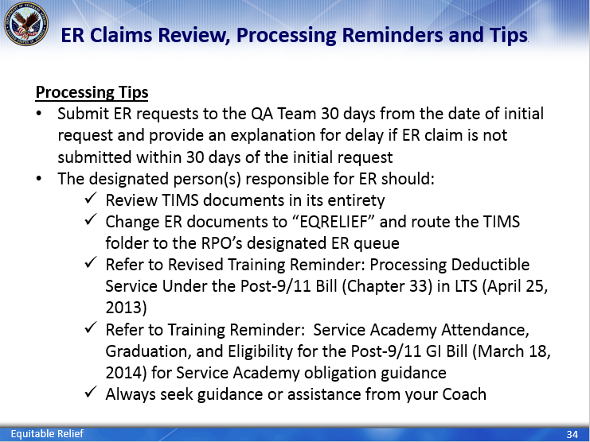 | DISPLAY slide 34  ER Claims Review, Processing Reminders and Tips  SUMMARIZE processing tips:  Processing Tips  - Submit ER requests to the QA Team 30 days from the date of initial request and provide an explanation for [the] delay if [the] ER claim is not submitted within 30 days of the initial request.  The designated person(s) responsible for ER should:  - Review TIMS documents in its entirety  - Change ER documents to “EQRELIEF” and route the TIMS folder to the RPO’s designated ER queue for [assignment and processing]  - Refer to Revised Training Reminder: Processing Deductible Service Under the Post-9/11 Bill (Chapter 33) in LTS (April 25, 2013) [to assist with the identification and deduction of excluded periods of service in the LTS].  - Refer to Training Reminder: Service Academy Attendance, Graduation, and Eligibility for the Post-9/11 GI Bill (March 18, 2014) [which indicatges time spent attending a service academy and obligated periods of service following graduation cannot be used to establish Chapter 33 eligibility].  - Always seek guidance or assistance from your Coach [when unsure about how to proceed].
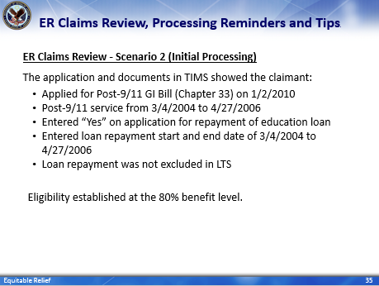 | DISPLAY slide 35  ER Claims Review, Processing Reminders and Tips  SUMMARIZE ER Claim Review:  ER Claims Review - Scenario 2 (Initial Processing)  The application and documents in TIMS showed the claimant:  - Applied for Post-9/11 GI Bill (Chapter 33) on 1/2/2010  - Post-9/11 service from 3/4/2004 to 4/27/2006  - Entered “Yes” on application for repayment of education loan  - Entered loan repayment start and end date of 3/4/2004 to 4/27/2006  - Loan repayment was not excluded in LTS [LRP timeframe would have been from 3/4/2004 until 3/4/2007]  LTS established eligibility at the 80% benefit level.
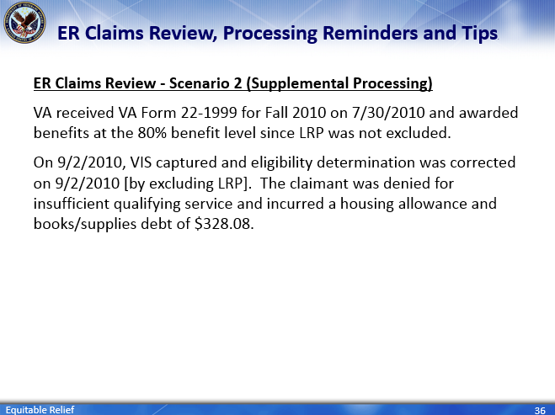 | DISPLAY slide 36  ER Claims Review, Processing Reminders and Tips  SUMMARIZE ER Claims Review:  ER Claims Review – Scenario 2 (Supplemental Processing)  VA received an enrollment certification for Fall 2010 on 7/30/2010 and [the claimant was] awarded benefits at the 80% benefit level since LRP was not deducted.  On September 2, 2010, VIS [was] captured [in the claimant’s TIMS folder] and eligibility determination was corrected. The claimant was denied [benefits] for insufficient qualifying service and incurred a housing allowance and books/supplies debt of $328.08.
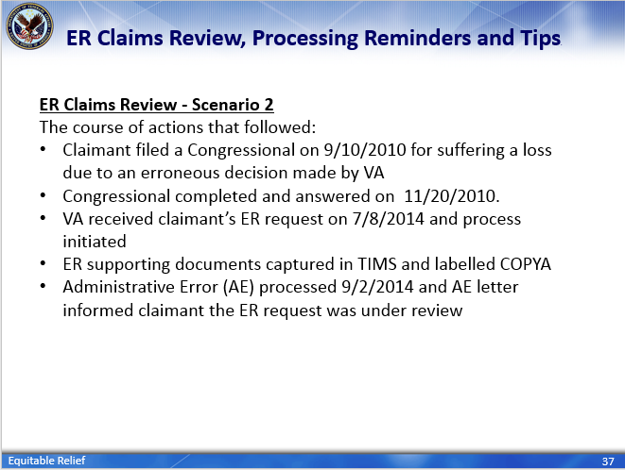 | DISPLAY slide 37  ER Claims Processing Reminders and Tips  READ/SUMMARIZE ER Claims Review:  ER Claims Review - Scenario 2  The course of actions that followed:  - Claimant filed a Congressional on 9/10/2010 for suffering a loss due to an erroneous decision made by VA  - Congressional completed and answered on 11/20/2010.  - VA received claimant’s ER request on 7/8/2014 and process initiated  - ER supporting documents captured in TIMS and labelled COPYA  - Administrative Error (AE) processed 9/2/2014 and AE letter informed claimant their ER request was under review
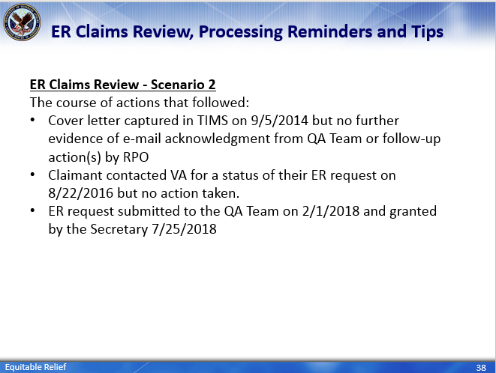 | DISPLAY slide 38  ER Claims Processing Reminders and Tips  READ/SUMMARIZE slide.  ER Claims Review - Scenario 2  The course of actions that followed:  - Cover letter captured in TIMS on 9/5/2014 but no further evidence of e-mail acknowledgment from QA Team or follow-up action(s) by RPO  - Claimant contacted VA for a status of their ER request on 8/22/2016 but no action taken.  - ER request submitted to the QA Team on 2/1/2018 and granted by the Secretary 7/25/2018
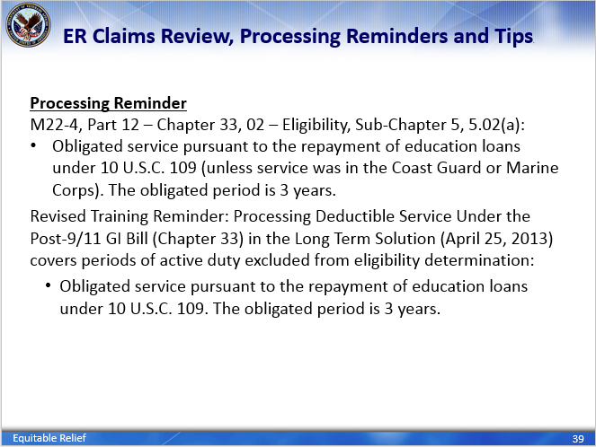 | DISPLAY slide 39  ER Claims Review, Processing Reminders and Tips  READ/SUMMARIZE reference material for LRP  Reference for loan repayment can be found in the M22-4, Part 12 – Chapter 33, 02 – Eligibility, Sub-Chapter 5, 5.02(a).  Refer to Revised Training Reminder: Processing Deductible Service Under the Post-9/11 Bill (Chapter 33) in LTS (April 25, 2013) [to assist with the identification and deduction of excluded periods of service in the LTS].
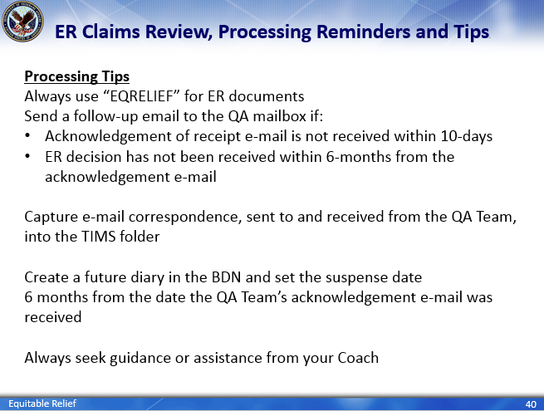 | DISPLAY slide 40  ER Claims Review, Processing Reminders and Tips  READ/SUMMARIZE processing tips.  Processing Tips  Always use “EQRELIEF” for ER documents  Send a follow-up email to the QA mailbox if:  - Acknowledgement of receipt e-mail is not received within 10-days  - ER decision has not been received within 6-months from the acknowledgement e-mail  Capture e-mail correspondence, sent to and received from the QA Team, into the TIMS folder  Create a future diary in the BDN and set the suspense date 6 months from the date the QA Team’s acknowledgement e-mail was received  Always seek guidance or assistance from your Coach [when unsure about how to proceed].
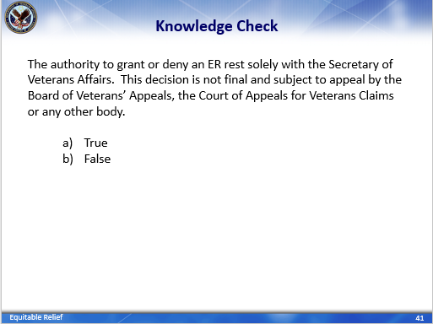 | DISPLAY slide 41  Knowledge Check  INTRODUCE KNOWLEDGE CHECKS  ASK the question and have student’s type response in the Webinar’s QA box  ENTERTAIN responses in the Webinar’s QA box
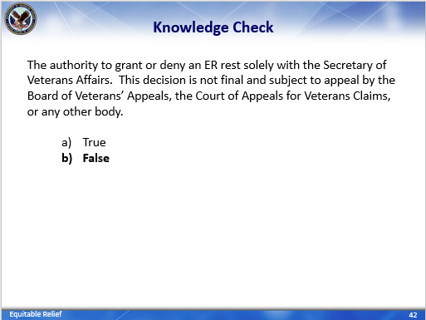 | DISPLAY slide 42  Knowledge Check  PROVIDE the answer.  CLARIFY responses as needed and paraphrase a “correct” response for each question.  INFORM: The authority to grant or deny Equitable Relief rests solely with the Secretary of Veterans Affairs. The Secretary will determine what is equitable based on the facts in the individual case [and] this decision is final and not subject to appeal to the Board of Veterans Appeals (BVA), the Court of Appeals for Veterans Claims, or any other body.
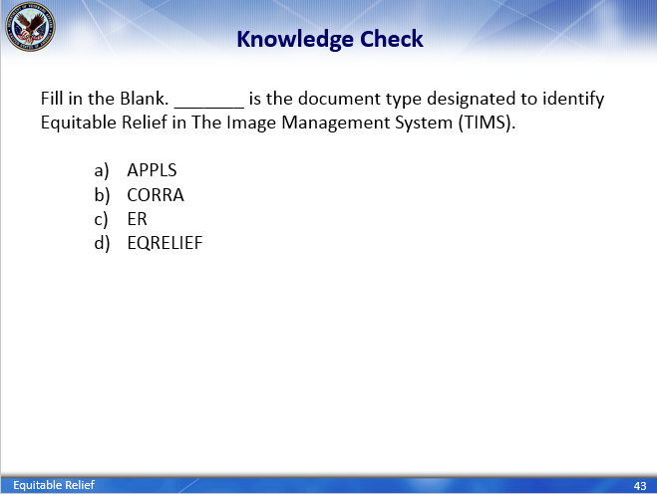 | DISPLAY slide 43  Knowledge Check  ASK the question and have student’s type response in the Webinar’s QA box  ENTERTAIN responses in the Webinar’s QA box
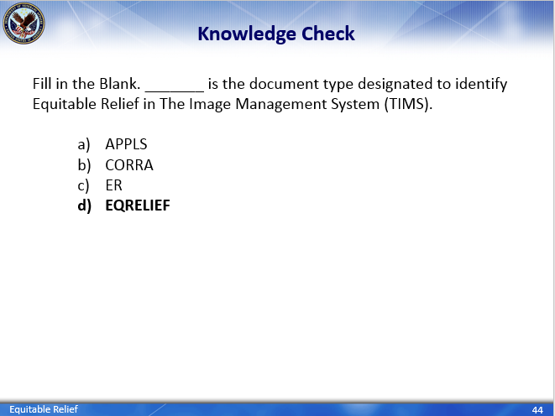 | DISPLAY slide 44  Knowledge Check  PROVIDE the answer.  CLARIFY responses as needed and paraphrase a “correct” response for each question.  INFORM: As mentioned in an earlier slide, Equitable Relief request are normally received by VA during supplemental processing.  If an ER request is labeled Appeals (APPLS), Miscellaneous (MISC) or Correspondence (CORRA) in The Image Management System (TIMS), Claims Processors will:  - Change the document type to “EQRELIEF” [when ER documents are identified] and  - Route the [claimant’s] TIMS folder to the RPO’s designated ER queue [for assignment and processing]
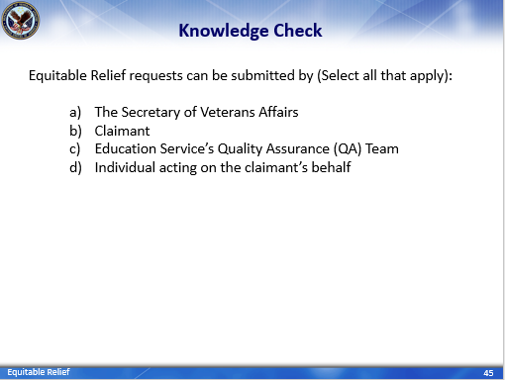 | DISPLAY slide 45  Knowledge Check  ASK the question and have student’s type response in the Webinar’s QA box  ENTERTAIN responses in the Webinar’s QA box
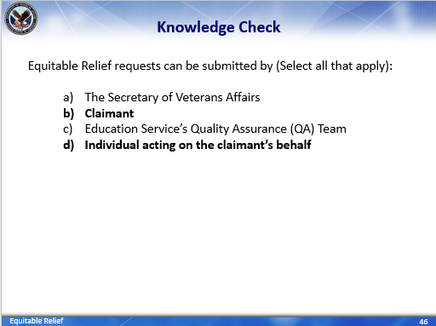 | DISPLAY slide 46  Knowledge Check  PROVIDE the answer.  CLARIFY responses as needed and paraphrase a “correct” response for each question.  INFORM: ER request can be submitted by the claimant or anyone acting on the claimant’s behalf, this includes individuals in claims processing.
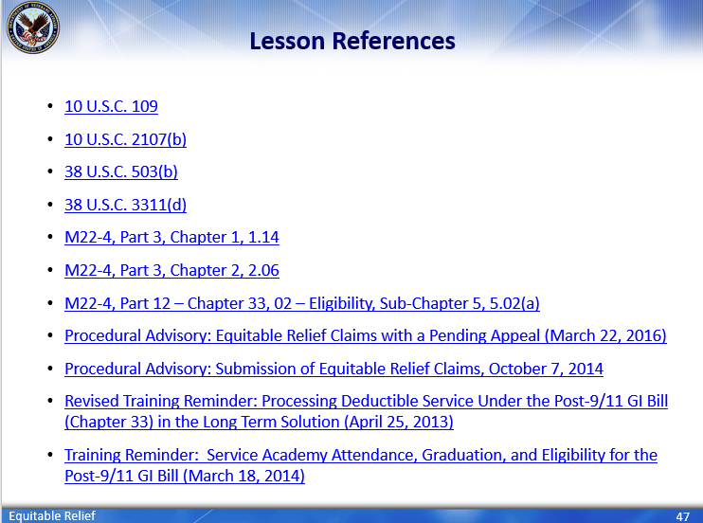 | DISPLAY slide 47  Lesson References  INFORM students of lesson references.
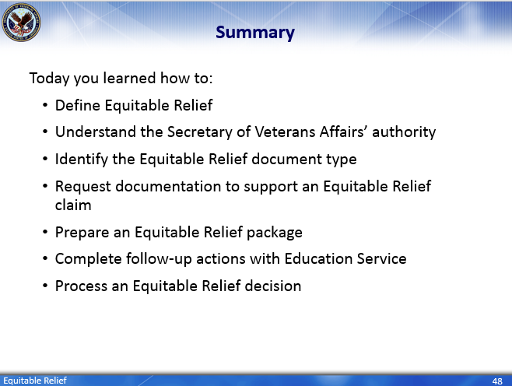 | DISPLAY slide 48  Summary  SUMMARIZE today’s lesson.  INFORM students:  Today you learned how to:  - READ/SUMMARIZE slide: Today you learned how to:  - Define Equitable Relief  - Understand the Secretary of Veterans Affairs’ authority [regarding an Equitable Relief decision]  - Identify the Equitable Relief document type  - Request documentation to support an Equitable Relief claim  - Prepare an Equitable Relief package  - Complete follow-up actions with Education Service  - Process an Equitable Relief decision
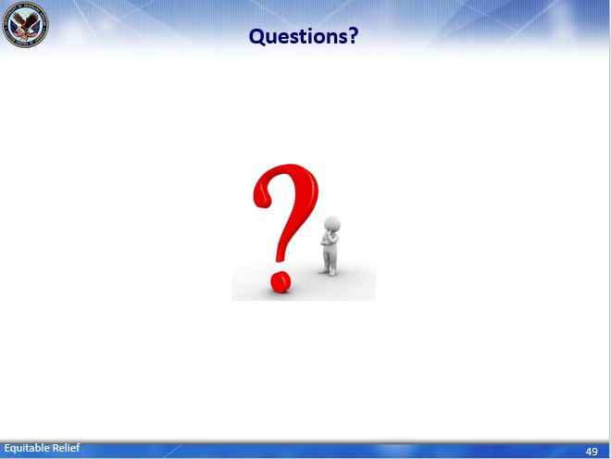 | DISPLAY slide 49  Questions?  INFORM students that they can enter questions pertaining to this Equitable Relief training in the QA box. Please limit questions to the scope of the topic. The questions and answers will be compiled and released to employees as soon as possible.  PRESENTER might be asked to answer
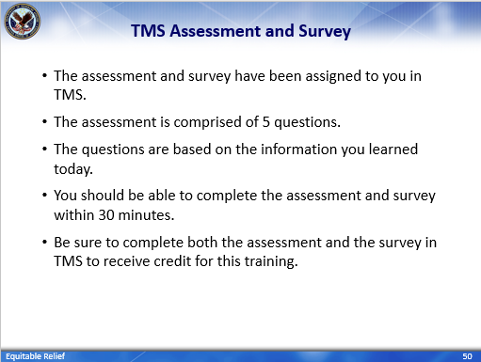 | DISPLAY slide 50  TMS Assessment and Survey  CONFIRM that the students know how to access the assessment and survey in TMS.  EXPLAIN that the assessment is TMS# and will cover what they learned in class today.  REMIND them that they must complete both the assessment and the survey in order to receive credit in TMS for their training.  TELL students that the survey provides them an opportunity to improve the training and that their feedback is welcome.

Questions about this training should be directed through your supervisor and management or Training Coordinator to the National Training Team.

