Education Service

**Harry W. Colmery Veterans Educational Assistance Act**

**Section 109 of PL 115-48**

Restoration of Entitlement to Educational Assistance and Other Relief for Veterans Affected by School Closure or Disapproval

Lesson Plan

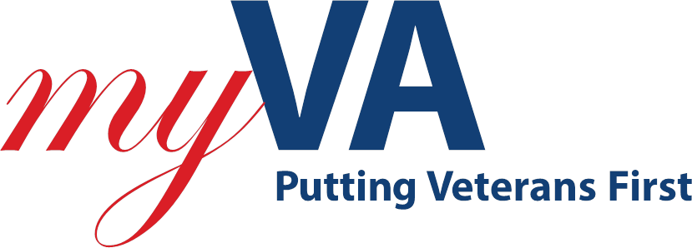

April 2019

Version 1.0

| Topic | Description |
| --- | --- |
| Time Estimate: | 30 minutes |
| Purpose of the Lesson: | Provide guidance to the Regional Processing Offices (RPOs) to ensure proper handling and processing of Chapter 33 requests under Section 109 of PL 115-48, the Colmery Act, Forever GI Bill. |
| Prerequisite Training Requirements: | None |
| Target Audience: | Entry-level, intermediate, or journey-level Veterans Claims Examiners (VCE), Education Case Managers (ECM) and their supervisors. |
| Lesson References: | * Public Law 115-48 (Introduces 109) * M22-4, Chapter IV, 11.25 (Award Issues) * GI Bill Website (Forever GI Bill-Restoration) |
| Lesson Objectives: | * Describe Section 109 of the Colmery Act * Recognize Types of Restoration under Section 109 * Apply Processing Guidelines associated with Section 109 * Relate Notification Steps as they relate to Section 109 |
| What You Need: | Section 109 PowerPoint |
| Post Training Requirements: | Participants are required to complete an online lesson assessment and survey in Talent Management System (TMS). |

Instructor Notes

The lesson will to provide Veterans Claims Examiners (VCEs) the knowledge of claims involving restoration of entitlement due to the closure or disapproval of a training facility and how they are processed.

| PowerPoint Slides | Instructor Activities |
| --- | --- |
|  | **DISPLAY** slide **1**  **INTRODUCE** yourself as the instructor and introduce any fellow instructors.  **INTRODUCE** the lesson. |
|  | **DISPLAY** slide **2**  **READ** the Overview of Today’s Training |
|  | **DISPLAY** slide **3**  **READ** the lesson Objectives |
|  | **DISPLAY** slide 4  **DESCRIBE** Section 109 as a provision of the Colmery Act that restores entitlement to beneficiaries affected by school closures or disapprovals beginning January 1, 2015. If a student is unable to complete their course or program or if there is a change in law or VA interpretation leading to a disapproval **AND** credit is not received or training time lost toward the completion of the course or program, entitlement may be restored. |
|  | **DISPLAY** slide 5  **DIFFERENTIATE the two types of restoration of entitlement cases. Special application cases will have all lost entitlement restored while regular cases will not be charged for the specific entitlement used for a term, quarter or semester. Further discussion will follow in the next few slides.** |
|  | **DISPLAY** slide **6**  **RELATE** the key to Special Application cases is the student must have attended an IHL between January 1, 2015, and August 16, 2017; last attended within 120 days of the closure **AND** not enrolled in a comparable program prior to August 16, 2017. If enrolled in a comparable program, any transferred credits from the closed school would exclude the student from the special application provision. |
|  | **DISPLAY** slide **7**  **DISCUSS** Regular Restoration cases apply if the facility closed on or after January 1, 2015 and they were attending an IHL, NCD, or OJT/Apprenticeship site **AND** the Beneficiary did not receive credit or lost training time toward the completion of their program of education. |
|  | **DISPLAY** slide **8**  **STATE** Regular Restoration cases will be paid a monthly housing allowanceuntil the end of the current term, quarter, or semester for the next 120 days- whichever is less. |
|  | **DISPLAY** slide **9**  **EXPLAIN** Processing of all Restoration of Entitlement is handled at the Muskogee RPO. Claims should be routed to the RESTORATION queue. Requests should be scanned into TIMS and indexed as RESTORE. |
|  | **DISPLAY** slide **10**  **INFORM** If a claimant contacts via to inform them their school has closed, direct them to the GI Bill website under the Forever GI Bill. There they will find a form to fill out for Restoration. |
|  | **DISPLAY** slide **11**  **SHARE** resources used are found via the links shown. |
|  | **DISPLAY** slide **12**  **SUMMARIZE** |
|  | **DISPLAY** slide **13**  **ASK for questions on the topics discussed in this training and entertain responses. (If trainees are reluctant, propose questions yourself to begin the dialog.)**  **CLARIFY responses as needed and paraphrase question clearly for all to hear before providing a “correct” responses.**  **NOTE: Limit questions to scope of topic. Do not guess. Unless information is covered in the training, make note of question and provide a follow-up response to all trainees as soon as possible.** |
|  | **DISPLAY slide 14**  **CONFIRM** that thestudents know how to access the assessment and survey in TMS.  **EXPLAIN** that the assessment is TMS# and will cover what they learned in class today.  **REMIND** them that they must complete both the assessment and the survey in order to receive credit in TMS for their training.  **TELL** students that the survey provides them an opportunity to improve the training and that their feedback is welcome. |

Questions about this training should be directed through your supervisor and management or Training Coordinator to the [National Training Team](mailto:225A.VBACO@va.gov)