Education Service
Error Trend Analysis Training

Survivors’ and Dependent Educational Assistance (DEA, CH35)
Marine Gunnery Sergeant John David Fry Scholarship (FRY, CH33)

Lesson Plan

September 2018
Version 1.0

Lesson Overview
Topic | Description
Time Estimate: | 1.5 hours
Purpose of the Lesson: | The purpose of today’s lesson is to provide Regional Processing Offices (RPOs) with refresher training on certain rules and procedures associated with processing original Survivors’ and Dependent Educational Assistance (DEA, CH35) and Marine Gunnery Sergeant John David Fry Scholarship (FRY, CH33) claims.
Prerequisite Training Requirements: | The following prerequisite training is required:  None
Target Audience: | Entry-level, Intermediate, or Journey-Level Veterans Claims Examiners (VCE), Education Case Managers (ECM) and their Supervisors.
Lesson References: | The following references support the lesson content:  - 38 U.S. Code § 3501(a)(1)(A)  - Advisory: Fry Scholarship Period of Eligibility (January 29, 2013)  - Procedural Advisory: Awarding Benefits for Fry Scholarship Recipients Under 18 Years Old (February 08, 2013)  - SHARE Application  - The Image Management System (TIMS)  - Veterans Benefits Management System (VBMS)
Lesson Objectives: | - Identify documents needed to process original DEA or Fry Scholarship claims  - Locate and obtain Veteran information in VA Systems to process DEA or Fry Scholarship claims  - Understand rules and procedures to prevent processing delays for certain original DEA or Fry Scholarship claims
What You Need: | Survivors’ and Dependent Educational Assistance (DEA, CH35) and Marine Gunnery Sergeant John David Fry Scholarship (Fry, CH33) Error Trend Analysis Training PowerPoint. Provide directions on how to print the PowerPoint presentation from saved location with training advertisement. Have a subject matter expert (SME) available if primary presenter is not an SME to assist with answering questions. Training should be delivered virtually (Webinar) with a means to ask questions during the training and, except for make-up sessions, always to live participants. Individuals that view a recorded live session to make-up the training should be provided a POC who is available for questions while the employee is taking the lesson.
Post Training Requirements: | Upon completion of the classroom portion of the lesson, participants are not required to complete an online lesson assessment or survey in Talent Management System (TMS).

Instructor Notes
The lesson will provide Regional Processing Offices (RPOs) with refresher training on rules and procedures associated with processing certain original Survivors and Dependent Educational Assistance (DEA, CH35) and Marine Gunnery Sergeant John David Fry Scholarship (Fry, CH33). This lesson is intended to help minimize processing errors and delays. Questions received from the field office are also included and answers provided. There are knowledge checks at the end of the lesson.
PowerPoint Slides | Instructor Activities
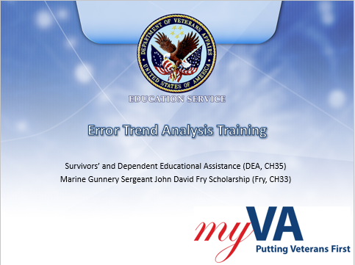 | DISPLAY slide 1  INTRODUCE yourself as the instructor and introduce any fellow instructors.  INTRODUCE the lesson.
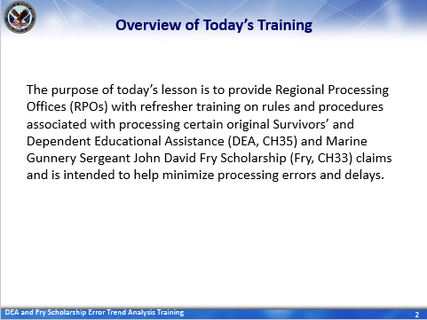 | DISPLAY slide 2  “Overview of Today’s Training”  PROVIDE an overview of the day’s schedule  DISCUSS how the subject fits into the lesson purpose, goals, and importance
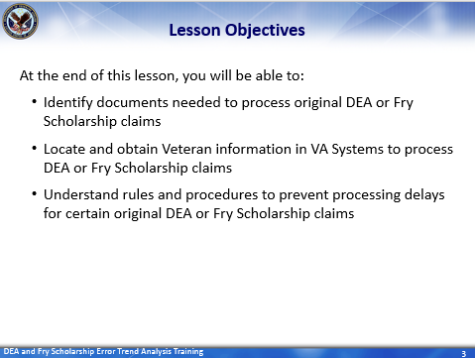 | DISPLAY slide 3  REVIEW the lesson objectives and assure VCEs will have opportunities to practice what they learn through knowledge checks at the end of the lesson as well as future processing of original DEA and Fry Scholarship claims.  INFORM students: At the end of this lesson, you will be able to:  - Identify documents needed to process original DEA or Fry Scholarship claims  - Locate and obtain Veteran information in VA Systems to process DEA or Fry Scholarship claims  - Understand rules and procedures to prevent processing delays for certain original DEA or Fry Scholarship claims
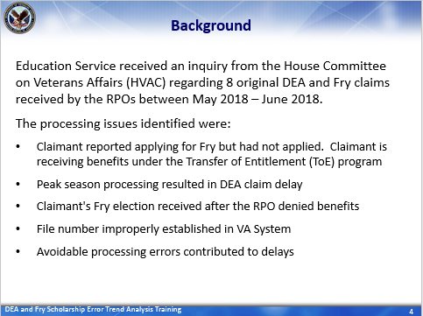 | DISPLAY slide 4  READ the “Background”  INFORM students that the primary focus of today’s lesson will be on the “Avoidable processing errors” which ultimately:  - Caused a delay in notifying claimants of their eligibility for benefits under DEA or Fry Scholarship and  - Affects the RPOs timeliness goals for original claims
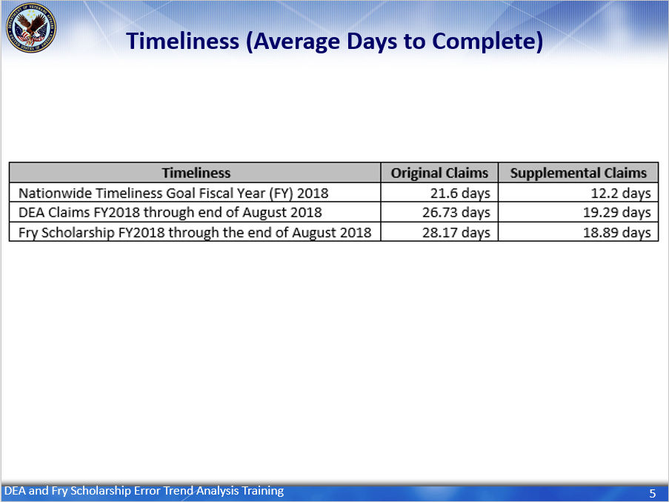 | DISPLAY slide 5  DISCUSS the nationwide timeliness goals and the RPO averages for DEA and Fry Scholarship claims through the end of August.  INSTRUCTOR’S NOTE: As a reminder, the nationwide timeliness goals for original claim is 21.6 days and 12.2 days for supplemental claims. As of the end of August 2018 the FYTD average the three RPOs is 26.73 days for original DEA claims and 19.29 days for supplemental claims to be completed AND 28.17 days for original Fry Scholarship claims and 18.89 days for supplemental Fry Scholarship claims to be completed.
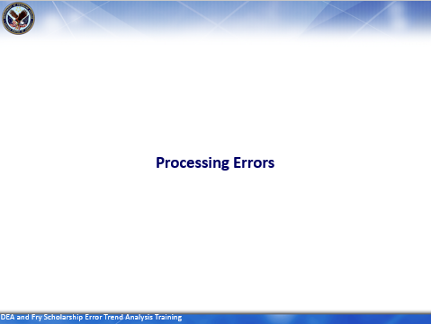 | DISPLAY slide 6  INFORM: The purpose of DEA and FRY Scholarship Error Trend Training:  INSTRUCTOR’S NOTE: Again, the purpose of today’s lesson is to provide RPOs with refresher training on rules and procedures associated with processing certain original DEA and Fry claims and is intended to help minimize processing errors. For this reason, we are only reviewing those claims were avoidable processing errors contributed to delays.
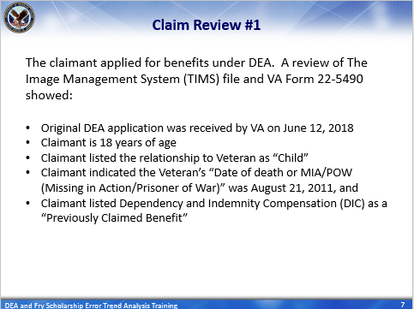 | DISPLAY slide 7  READ the narrative for the claim review.  REITERATE/SUMMARIZE claim review.
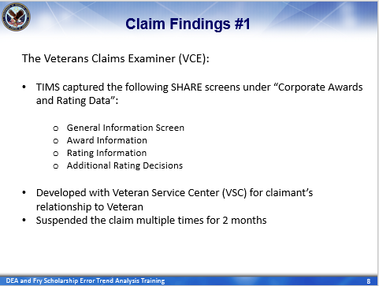 | DISPLAY slide 8  SUMMARIZE the findings regarding the VCE’s processing actions.
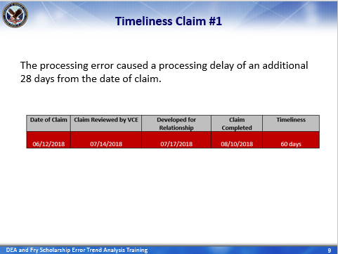 | DISPLAY slide 9  EMPHASIS: This error was identifying by the RPO on August 10, 2018 and the claim was processed and completed. The error in processing caused a delay of an additional 28 days from the date of claim.
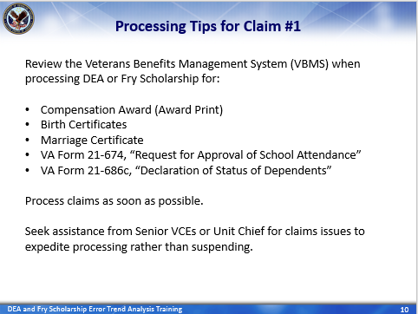 | DISPLAY slide 10  READ processing tips and  EXPLAIN/REITERATE: VCEs should review VBMS for the following documents to establish dependency for DEA or Fry Scholarship claims.  - Compensation Award (Award Print)  - Birth Certificates  - Marriage Certificate  - VA Form 21-674, “Request for Approval of School Attendance”  - VA Form 21-686c, “Declaration of Status of Dependents”
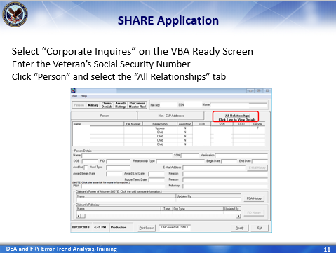 | DISPLAY slide 11  INFORM and STRESS: In addition to VBMS, dependent information is also listed in SHARE and can be viewed under the “Person tab” and selecting “All Relationships.” To access this information, VCEs will:  - Select “Corporate Inquires” on the VBA Ready Screen, then  - Enter the Veteran’s Social Security Number, and  - Click on the “Person” tab and select the “All Relationships” tab
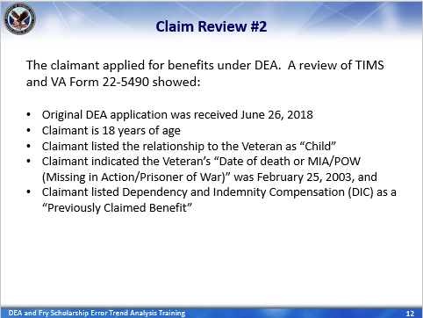 | DISPLAY slide 12  READ the narrative for the claim review.  REITERATE/SUMMARIZE claim review.
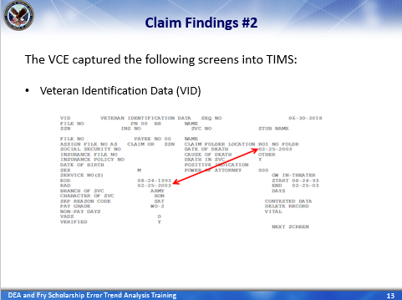 | DISPLAY slide 13  INFORM VCE captured the Veteran’s VID screen in BDN which shows the Veteran’s RAD and Date of Death are the same. Though VID is not the authoritative source, it does show there is no conflict between the date of death and date the Veteran was released from active duty (RAD).
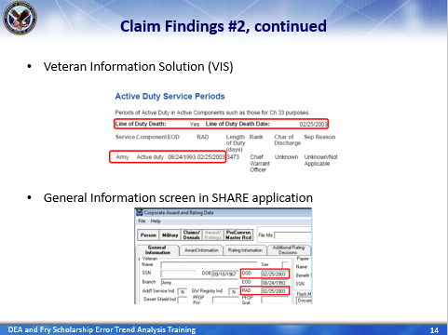 | DISPLAY slide 14  INFORM VCE also captured the Veteran’s VIS, which is an authoritative source, and the General Information screen from SHARE into the claimant’s TIMS file The VIS shows the Veteran’s RAD and line of duty death date are the same AND the General Information tab in SHARE shows the Veteran’s date of death and RAD are the same as well.
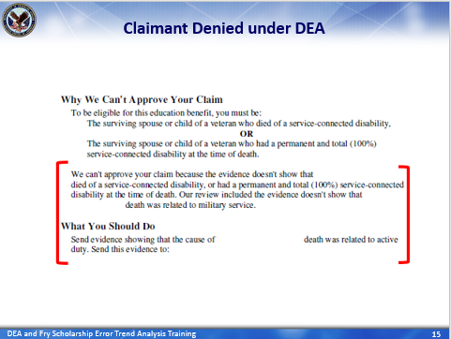 | DISPLAY slide 15  INSTRUCTOR’S NOTE/SUMMARIZE: Despite the evidence reviewed and captured by the VCE, the claimant was denied under DEA because (according to the letter) “the evidence doesn’t show the Veteran died of a service-connected disability or had a permanent and total (100%) service-connected disability at the time of death.” The denial letter also informs the claimant that, “Our review concluded the evidence doesn’t not show the (Veteran’s) death was related to military service.”  Even though:  - The VID showed the Veteran’s RAD and Date of Death are the same,  - The VIS showed the line of duty death date and RAD are the same, and  - The General Information data in SHARE showed the date of death and RAD are the same  We asked this dependent to “send evidence showing that the cause of the Veteran’s death was related to active duty.”
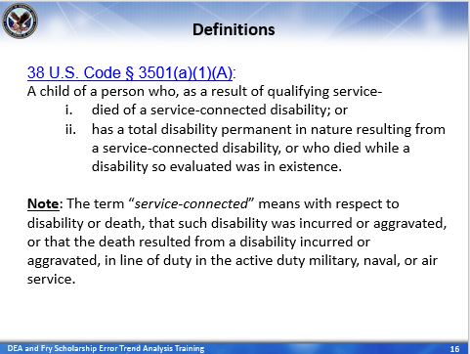 | DISPLAY slide 16  READ the definition and note.
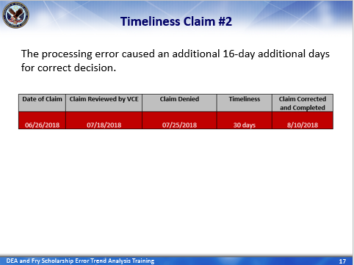 | DISPLAY slide 17  INFORM/EMPHASIS: This error was identifying by the RPO on August 10, 2018 and the claim was processed and completed. The processing error caused a processing delay of an additional 16-days to correct the decision.
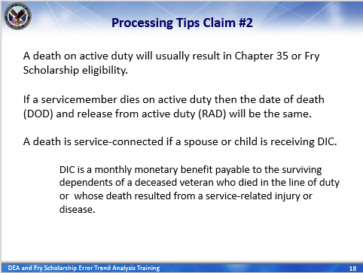 | DISPLAY slide 18  REVIEW/DISCUSS: “Processing Tips Claim #2”  STRESS the processing tips  .
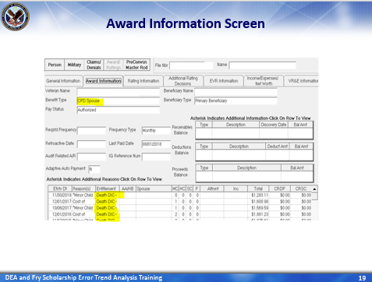 | DISPLAY slide 19  INFORM: Dependency and Indemnity Compensation information can also be found in SHARE. To access this information, VCEs will:  - Select “Corporate Inquires” on the VBA Ready Screen,  - Enter the Veteran’s Social Security Number, and  - Click on the “Awards/Rating” tab and select the Award Information” tab
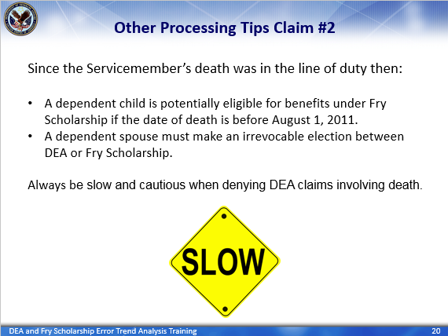 | DISPLAY slide 20  READ the slide  STRESS: Always be slow and cautious when denying DEA claims involving death.
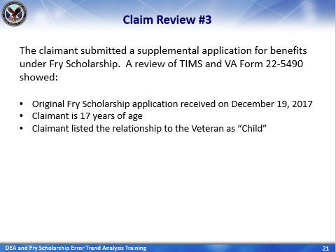 | DISPLAY slide 21  READ the narrative for the claim review.  REITERATE/SUMMARIZE claim review
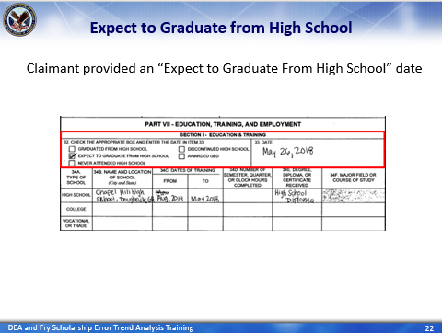 | DISPLAY slide 22  INFORM: The claimant provided an “Expect to Graduate” from High School date of May 26, 2018 on the VA Form 22-5490.
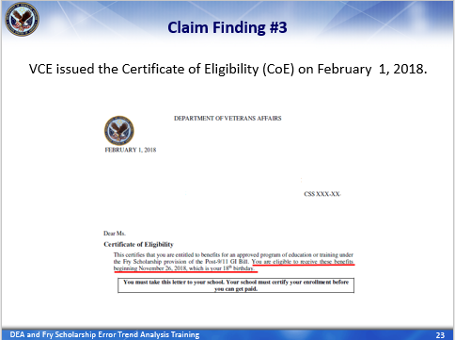 | DISPLAY slide 23  INFORM: The VCE issued the claimant a Certificate of Eligibility under Fry and indicated she was eligible to receive these benefits beginning November 26, 2018, which is her 18th birthday.”
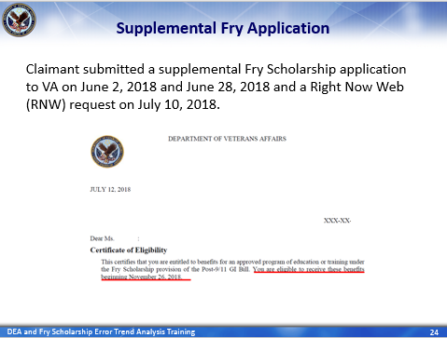 | DISPLAY slide 24  INFORM: Subsequently, the claimant submitted supplemental applications to VA on June 2, 2018 and June 28, 2018. She also submitted a Right Now Web request on July 10, 2018 requesting a new COE and included her high school diploma. Even so, the VCE issued a COE indicating she was “eligible to receive her Fry Scholarship benefits beginning November 26, 2018. This error was also identified by the RPO on August 10, 2018.
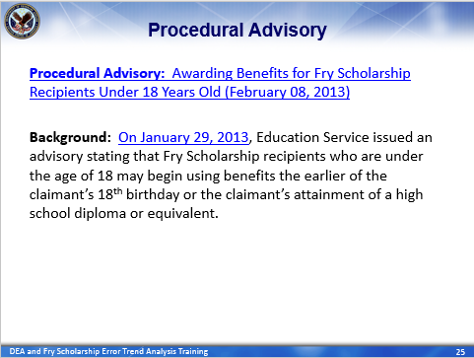 | DISPLAY slide 25  READ/SUMMARIZE the slide  DISCUSSS the procedural advisories
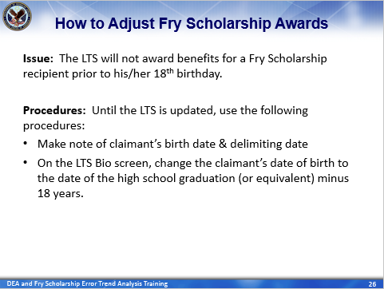 | DISPLAY slide 26  BRIEFLY DISCUSS the LTS processing procedures for Fry Scholarship recipient under the age of 18 years old (this information is directly from the  Procedural Advisory: Awarding Benefits for Fry Scholarship Recipients Under 18 Years Old (February 08, 2013)
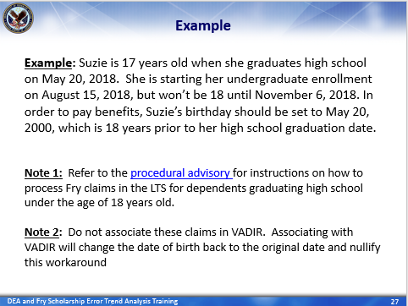 | DISPLAY slide 27  SUMMARIZE the example  STRESS Notes 1 and 2  REITERATE: VCEs should refer to the “Awarding Benefits for Fry Scholarship Recipients Under 18 Years Old” procedural advisory (in the KM portal) for more instructions on how to process Fry claims in the LTS when ad dependent graduates high school under the age of 18 years old.
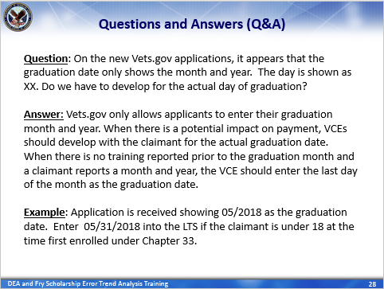 | DISPLAY slide 28  INFORM: The following questions, regarding the HVAC claims, were asked by VCEs at the Muskogee RPO and we wanted to share both the questions and answers during this training session.  READ the question and answer  SUMMARIZE the example
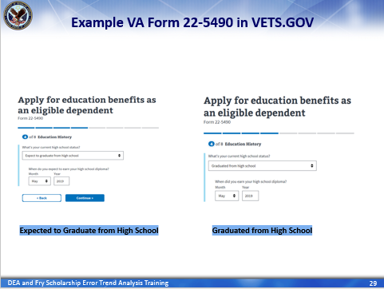 | DISPLAY slide 29  EXPLAIN: This is an example of what the applicant completes on the VA Form 22-5490 in Vets.gov. Notice, this online application does not provide the applicant the option to input an “Expected to Graduate from High School” day nor a “Graduated from High School” date.
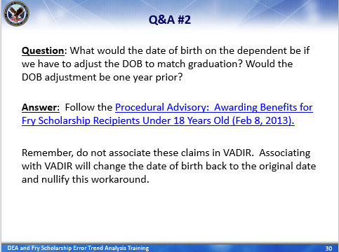 | DISPLAY slide 30  READ the question and answer  STRESS: Remember, do not associate these claims in VADIR. Associating with VADIR will change the date of birth back to the original date and nullify this workaround.
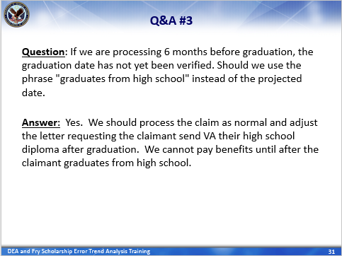 | DISPLAY slide 31  READ the question and answer
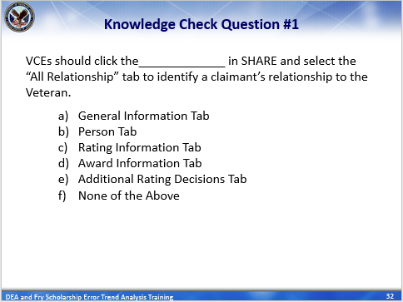 | DISPLAY slide 32  INTRODUCE knowledge checks  ASK the question: VCEs should click the (blank) in SHARE and select the “All Relationship” tab to identify a claimant’s relationship to the Veteran  ASK attendees to enter the correct answer in the Webinar chat box  ENTERTAIN responses
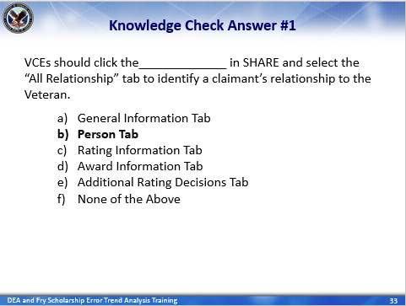 | DISPLAY slide 33  PROVIDE the answer: The correct answer is B (false).  CLARIFY responses as needed and paraphrase a “correct” response for each question.  EXPLAIN: Dependent information is listed in SHARE and can be accessed by clicking on the “Person” tab and by selecting “All Relationships.”  To access this information, VCEs will:  - Select “Corporate Inquires” on the VBA Ready Screen, then  - Enter the Veteran’s Social Security Number, and  - Click on the “Person” tab and select the “All Relationships” tab  If specific information is needed to process an original DEA claim (that cannot be in VIS, VBMS, or SHARE), then send an Extract Request Form to the RPO with jurisdiction over the veteran’s C&P folder.
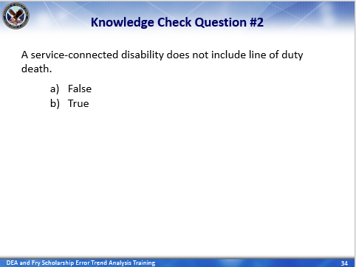 | DISPLAY slide 34  ASK the question: A service-connected disability does not include a line of duty death.  ASK attendees to enter the correct answer in the Webinar chat box  ENTERTAIN responses
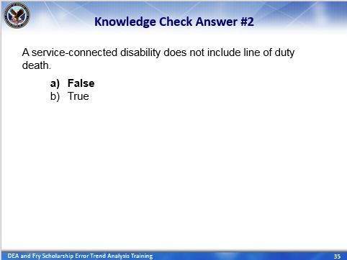 | DISPLAY slide 35  PROVIDE the answer: The correct answer is A (false).  CLARIFY responses as needed and paraphrase a “correct” response for each question.  REITERATE: The term “service-connected” means with respect to disability or death, that such disability was incurred or aggravated, or that the death resulted from a disability incurred or aggravated, in line of duty in the active duty military, naval, or air service. Therefore, VCEs should be slow and cautious when denying DEA claims involving death.
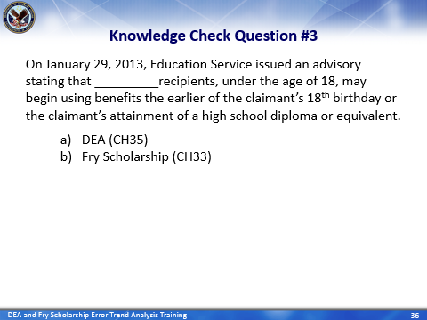 | DISPLAY slide 36  ASK the question: On January 29, 2013, Education Service issued an advisory stating that (blank) recipients, under the age of 18, may begin using benefits the earlier of the claimant’s 18th birthday or the claimant’s attainment of a high school diploma or equivalent.  ASK attendees to enter the correct answer in the Webinar chat box  ENTERTAIN responses
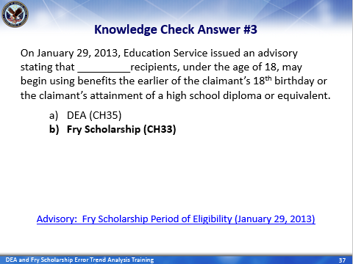 | DISPLAY slide 37  PROVIDE the answer: The correct answer is B, Fry Scholarship. On January 29, 2013, Education Service issued an advisory that Fry scholarship recipients, under the age of 18, may begin using benefits the earlier of the claimant’s 18th birthday or the claimant’s attainment of a high school diploma or equivalent.  CLARIFY responses as needed and paraphrase a “correct” response for each question.  STRESS: VCE’s should review the Fry Scholarship Period of Eligibility Advisory AS WELL AS following the processing guidance outline in Procedural Advisory: Awarding Benefits for Fry Scholarship Recipients Under 18 Years Old (February 08, 2013).
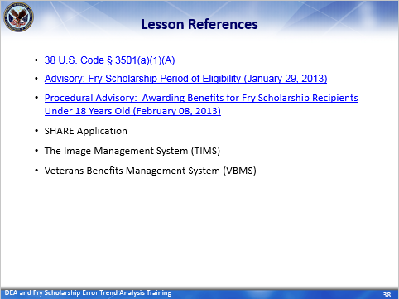 | DISPLAY slide 38  INFORM participants of lesson references.
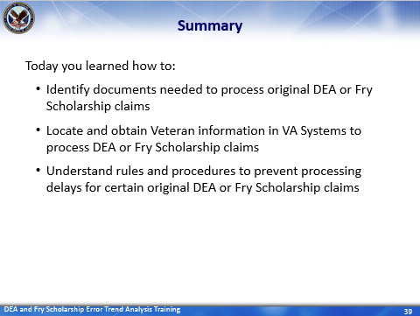 | DISPLAY slide 39  SUMMARIZE today’s lesson.  INFORM students: Today you learned how to:  - Identify documents needed to process original DEA or Fry Scholarship claims  - Locate and obtain Veteran information in VA Systems to process DEA or Fry Scholarship claims  - Understand rules and procedures to prevent processing delays for certain original DEA or Fry Scholarship claims
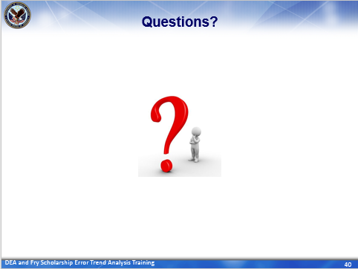 | DISPLAY slide 40  ASK for questions on the topics discussed in this training and entertain responses. (If employees are reluctant, propose questions yourself to begin the dialog.)  CLARIFY responses as needed and paraphrase question clearly for all to hear before providing a “correct” responses.  NOTE: Limit questions to scope of topic. Do not guess. Unless information is covered in the training, make note of question and provide a follow-up response to all employees as soon as possible.

Questions about this training should be directed through your supervisor and management or Training Coordinator to the National Training Team.

