Education Service
Harry W. Colmery Veterans Educational Assistance Act
Section 113 of PL 115-48

Monthly Stipend for Certain Members of the Reserve Components of the Armed Forces Receiving
Post-9/11 Educational Assistance

Lesson Plan

June 2018
Version 1.0

Lesson Overview
Topic | Description
Time Estimate: | 1.5 hours
Purpose of the Lesson: | Provide guidance to the Regional Processing Offices (RPOs) to ensure proper handling and processing of monthly housing allowance (MHA) payments under Section 113 of PL 115-48, the Colmery Act, Forever GI Bill
Prerequisite Training Requirements: | The following prerequisite training is required:  None
Target Audience: | Entry-level, Intermediate, or Journey-Level Veterans Claims Examiners (VCE), Education Case Managers (ECM) and their Supervisors.
Lesson References: | The following references support the lesson content:  - 38 U.S.C. 3313, “Educational Assistance: Amount; Payment”  - Harry W Colmery Veterans Educational Assistance Act of 2017  - Department of Veterans Affairs Expiring Authorities Act of 2017  - Processing Guidance for Section 113 of the Harry W. Colmery Veterans Education Assistance Act (Forever GI Bill), Procedural Advisory dated July 5, 2018  - Lesson Handouts  - RPO Audit Worksheet  - The Long Term Solution (LTS)
Lesson Objectives: | - Identify claims affected by PL 115-48, Section 113  - Calculate correct prorated MHA payment  - Process the MHA over- or underpayment in LTS
What You Need: | The Section 113 PowerPoint, Lesson Handouts, RPO Audit Worksheet, and Long Term Solution (LTS). Provide copies of handouts in advance of the lesson or provide directions on how to print from saved location with training advertisement, refer to lesson plan and have a subject matter expert (SME) available if primary presenter is not an SME to assist with answering questions. Training should be instructor led with a means to ask questions during the training. It may be delivered virtually however, except for make up sessions, always to live particpants. Individauls that view a recorded live session to make-up the training should be provided a POC who is available for questions while the employee is taking the lesson.
Post Training Requirements: | Upon completion of the classroom portion of the lesson, participants are required to complete an online lesson assessment and survey in Talent Management System (TMS).  To demonstrate successful completion of the lesson participants must pass the assessment with a score of at least 80%.  Participants must also complete the online survey to earn credit for completion of the lesson.

Instructor Notes
The lesson will provide instructions for proper processing of Monthly Housing Allowance (MA) under Section 113 of PL 115-48 (Forever GI Bill). The lesson identifies current LTS functionality for MHA payments and explains how to manually calculate and process the correct MHA payment in LTS as it relates to Section 113. There are knowledge checks throughout the lesson.

PowerPoint Slides | Instructor Activities
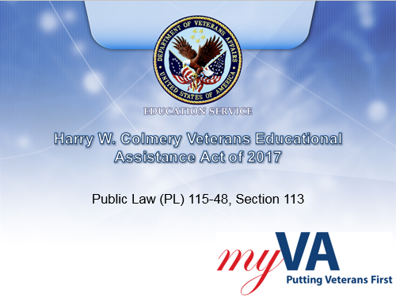 | DISPLAY slide 1  INTRODUCE yourself as the instructor and introduce any fellow instructors.  INTRODUCE the lesson.
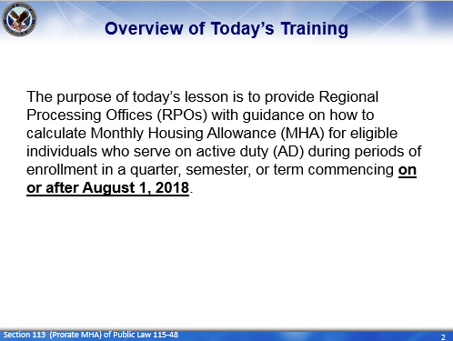 | DISPLAY slide 2  “Overview of Today’s Training”  PROVIDE an overview of the day’s schedule  DISCUSS how the subject fits into the lesson purpose, goals, and importance
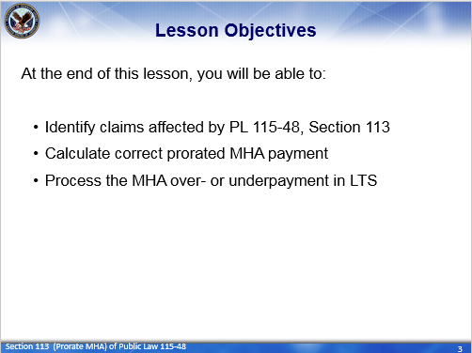 | DISPLAY slide 3  REVIEW the lesson objectives and assure VCEs will have opportunities to practice what they learn  INFORM students: At the end of this lesson, you will be able to:  - Identify claims affected by PL 115-48, Section 113  - Calculate the correct prorated MHA payment due the claimant  - Process the MHA over- or underpayment in the LTS
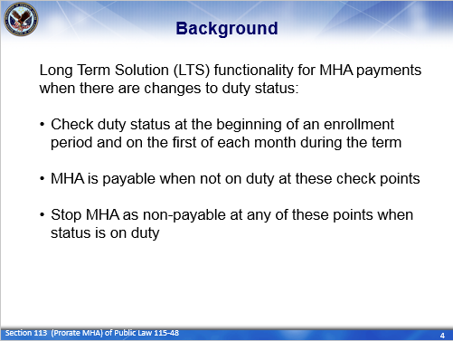 | DISPLAY slide 4  DISCUSS the current functionality of the Long Term Solution (LTS)  INSTRUCTOR’S NOTE: The LTS current functionality for MHA payments where there are changes in duty status is to:  - Check the claimant’s duty status at the beginning of an enrollment period and on the first of each month during the term.  - MHA is payable is payable when an individual is not on duty at these check points or  - MHA is stopped when at these check points when an individual’s duty status is on duty.
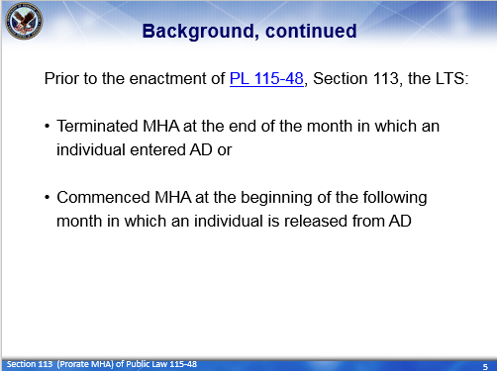 | DISPLAY slide 5  DISCUSS LTS functionality prior to PL 115-48, Section 113.  INSTRUCTOR’S NOTE: So prior to PL 115-48, Section 113, the LTS:  - Terminated MHA at the end of the month in which an individual entered active duty or  - Commenced (or started) MHA at the beginning of the following month in which an individual was released from active duty
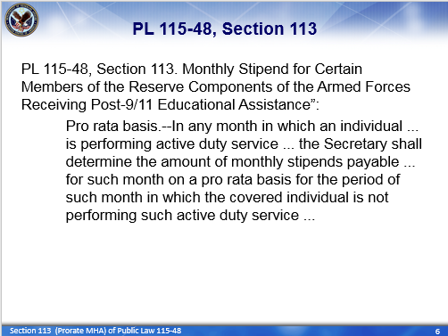 | DISPLAY slide 6  READ slide
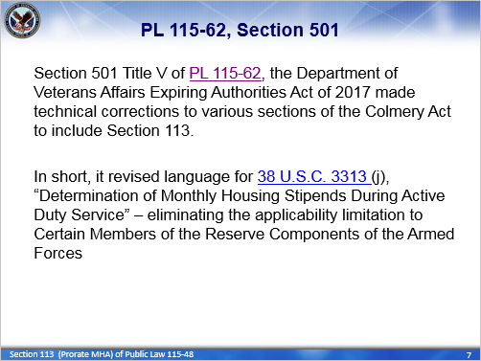 | DISPLAY slide 7  READ slide.  EXPLAIN: Because Section 113 implied this provision of the Colmery Act is only applicable to “Certain” Members of the Reserve Components, Section 501 Title V of PL 115-62 made a technical correction to further amend the new subsection (j) under U.S.C. 3313 (making it applicable to everyone).  Therefore, PL 115-48, Section 113 and Section 501 Title V of PL 115-62 requires VA to prorate the MHA payment under Post-9/11 GI Bill for everyone who enters or is released from active duty.
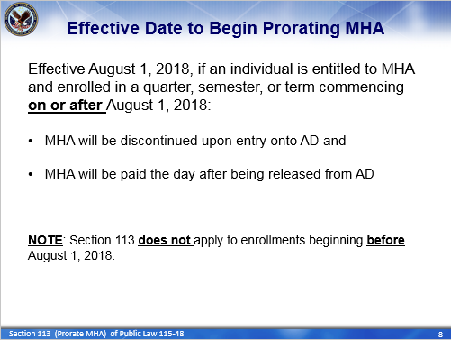 | DISPLAY slide 8  INFORM that effective August 1, 2018, if an individual is entitled to MHA and enrolled in a quarter, semester, or term commencing on or after August 1, 2018 then:  - MHA is discontinued upon entry onto active duty and paid the day after being released from active duty (if still enrolled in the term).
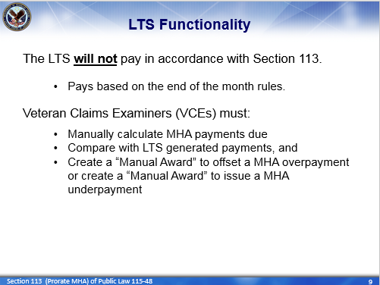 | DISPLAY slide 9  EXPLAIN: Updated LTS functionality for MHA payments has not been implemented to support Section 113 for terms beginning August 1, 2018. Until an IT solution is implemented Veterans Claims Examiners (VCE) must do the following when a claimant active duty status changes during an enrollment period.  - Manually calculate the correct MHA payments that’s due the claimant  - Compare amounts with LTS generated payments, and  - Create a “Manual Award” to offset a MHA overpayment or create a “Manual Award” to issue a MHA underpayment
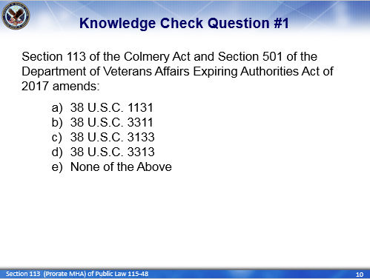 | DISPLAY slide 10  ASK the question: Section 113 of the Colmery Act and Section 501 of the Department of Veterans Affairs Expiring Authorities Act of 2017 amends:  - 38 U.S.C. 1131  - 38 U.S.C. 3311  - 38 U.S.C. 3133  - 38 U.S.C. 3313  - None of the Above  ENTERTAIN responses
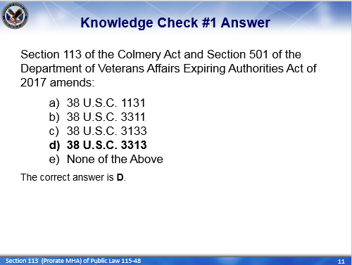 | DISPLAY slide 11  CLARIFY responses as needed and paraphrase a “correct” response for each question.  PROVIDE and EXPLAIN: The correct answer is D. Section 113 of the Colmery Act in conjunction with Section 501 of PL 115-62, “Department of Veterans Affairs Expiring Authorities Act of 2017,” amends 38 U.S.C. 3313; by adding a new subsection (j).
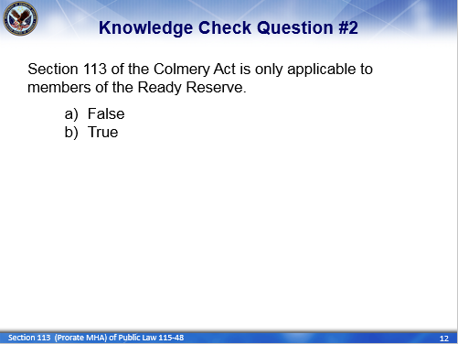 | DISPLAY slide 12  ASK the question: Section 113 of the Colmery Act is only applicable to members of the Ready Reserve.  ENTERTAIN responses
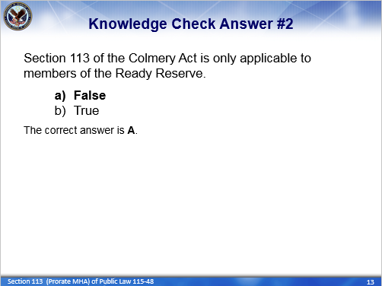 | DISPLAY slide 13  PROVIDE the answser: The correct answer is A (False).  CLARIFY responses as needed and paraphrase a “correct” response for each question.  STRESS: Effective August 1, 2018, VA is required to prorate MHA payments under the Post-911 GI Bill for everyone (be it Guard, Reserve, or Servicemember) who enters or is released from AD while enrolled in a quarter, semester, or term, commencing on or after August 1, 2018.
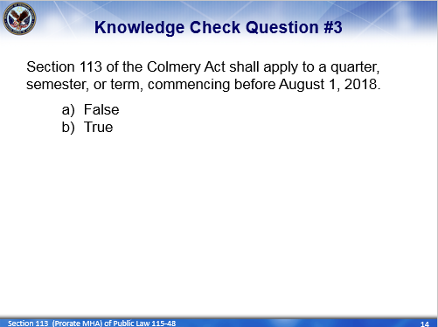 | DISPLAY slide 14  ASK the question: Section 113 of the Colmery Act shall apply to a quarter, semester, or term, commencing before August 1, 2018.  - False  - True  ENTERTAIN responses
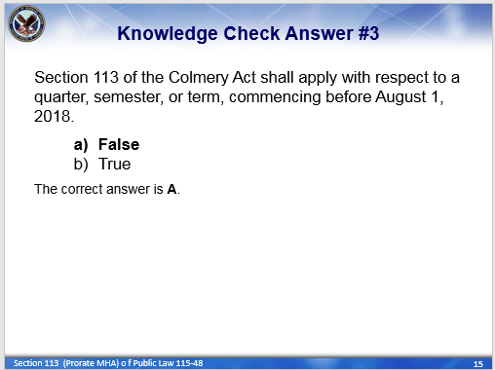 | DISPLAY slide 15  PROVIDE the answer: The correct answer is A (False).  CLARIFY responses as needed and paraphrase a “correct” response for each question.  EXPLAIN: As mentioned a moment ago, Section 113 of the Colery Act shall apply to a quarter, semester, or term, commencing on or after August 1, 2018. Therefore, if a quarter, semester, or term starts on or before July 31, 2018, then it does not fall under the guidelines of Section 113.
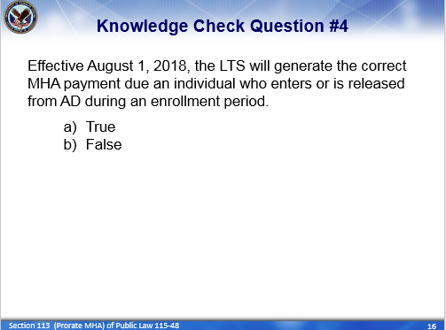 | DISPLAY slide 16  ASK the question: Effective August 1, 2018, the LTS will generate the correct MHA payment due an individual who enters or is released from AD during an enrollment period.  - True  - False  ENTERTAIN responses
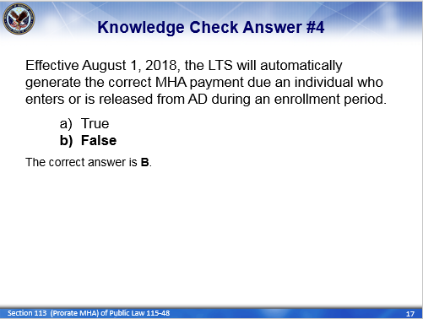 | DISPLAY slide 17  PROVIDE the answer: The correct answer is B (false).  CLARIFY responses as needed and paraphrase a “correct” response for each question.  EXPLAIN: The LTS will continue to pay in accordance with the existing end of the month rules (on and after August 1, 2018). So until an adjustment in LTS programming can be implemented, VCEs must manually calculate the correct MHA payment due for individuals who enter or are released from AD during an enrollment period.
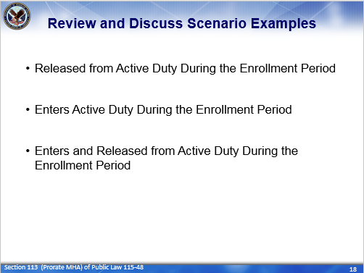 | DISPLAY slide 18  REVIEW and Discuss scenario examples using lesson handout.  STRESS: Section 113 is effective August 1, 2018 and is applicable to any individual who is entitled to MHA while enrolled in a quarter, semester, or term commencing on or after August 1, 2018.  - MHA will be discontinued upon entry onto active duty and paid the day after being released from active duty  Therefore manual calculations of MHA payments is need if an individual is:  - Released from Active Duty during an enrollment period  - Enters Active Duty during an enrollment period  - Enters and is then released from Active Duty during an enrollment period  So, let’s take a look at each of these examples.  PROVIDE trainees with a copy of the lesson handout BEFORE the training section begins.  READ and DISCUSS each scenario. and the proper processing steps.  STRESS all paragraphs, in the lesson handout, beginning with “NOTE” and “IMPORTANT.”  STRESS Changes to service/eligibility or use of Manual Awards requires a minimum of two signatures for authorization.  RETURN to the PowerPoint presenation, after reviewing and discussing each scenario, and conclude the lesson.
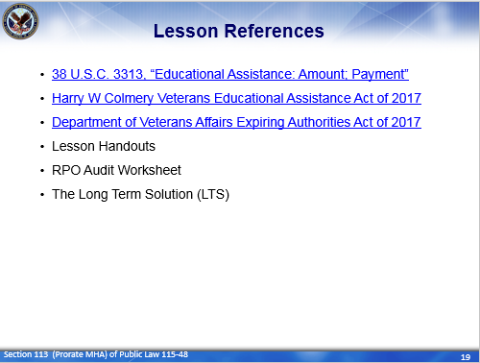 | DISPLAY slide 19  INFORM participants of lesson references.
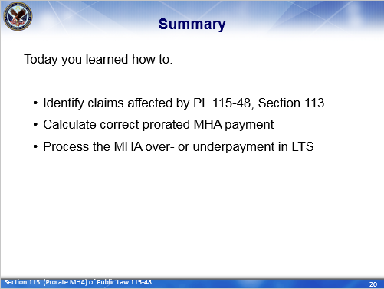 | DISPLAY slide 20  REVIEW the Summary of the lesson.  INFORM students: Today you learned how to:  - Identify claims affected by PL 115-48, Section 113  - Calculate the correct prorated MHA payment due the claimant after entering or being released from active duty, and  - How to process the correct MHA overpayment or underpayment in LTS.
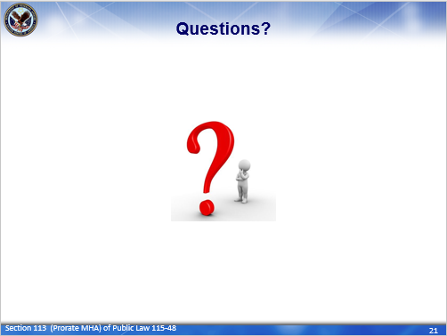 | DISPLAY slide 21  ASK for questions on the topics discussed in this training and entertain responses. (If employeess are reluctant, propose questions yourself to begin the dialog.)  CLARIFY responses as needed and paraphrase question clearly for all to hear before providing a “correct” responses.  NOTE: Limit questions to scope of topic. Do not guess. Unless information is covered in the training, make note of question and provide a follow-up response to all employeess as soon as possible.
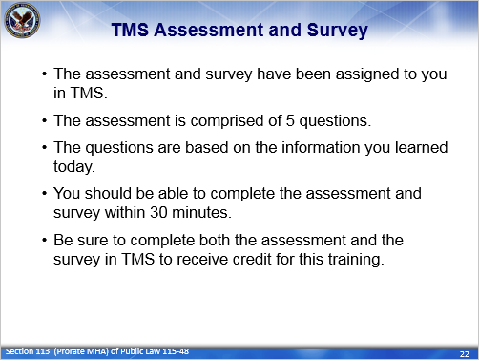 | DISPLAY slide 22  CONFIRM that the students know how to access the assessment and survey in TMS.  EXPLAIN that the assessment is TMS# and will cover what they learned in class today.  REMIND them that they must complete both the assessment and the survey in order to receive credit in TMS for their training.  TELL students that the survey provides them an opportunity to improve the training and that their feedback is welcome.

Questions about this training should be directed through your supervisor and management or Training Coordinator to the National Training Team.

