Slide 1 - Welcome

Slide notes

Welcome to My Education Benefits -

Transfer of Entitlement (TOE)

Applicant View.

Select “Begin”

Slide 2 - Today's Training
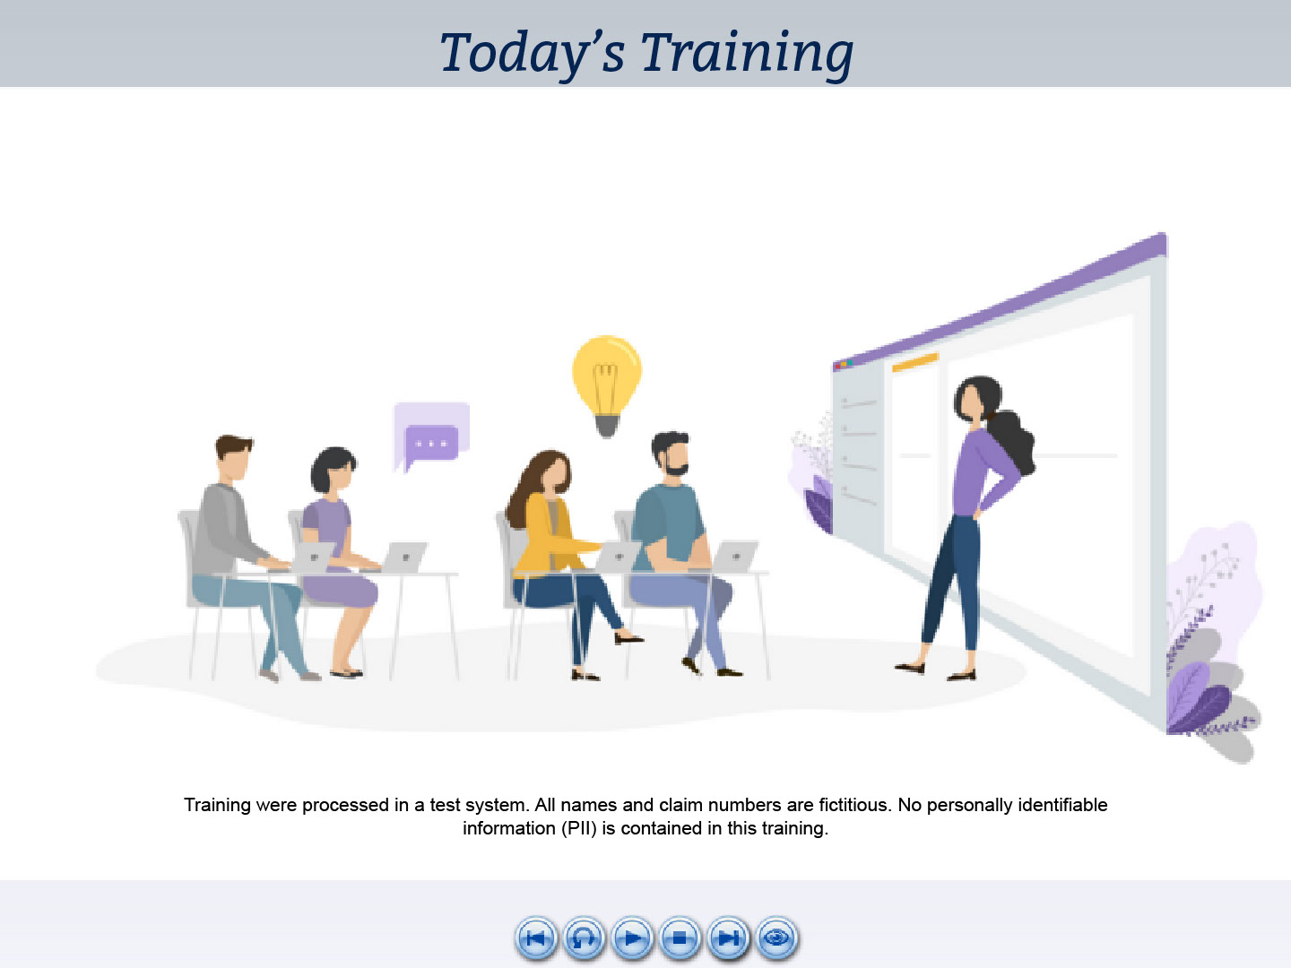
Slide notes

Today’s training is intended to show

what My Education Benefits or MEB

looks like from the view of a person applying for Transferred Education benefits.

Please note, the examples you will see during this training

were processed in a test environment.

All information you see is fictitious

and does not represent actual beneficiaries.

Slide 3 - Navigation Controls
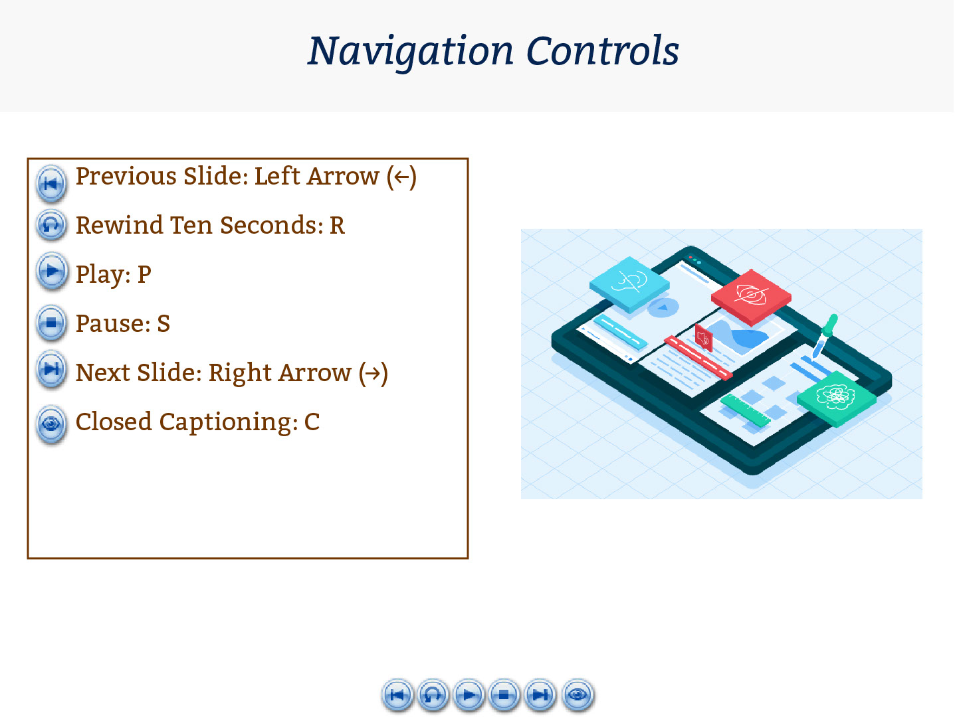
Slide notes

You can use the navigation buttons at the bottom of the screen

to move forward and backward throughout this module.

Also, you may use the keyboard shortcuts listed on-screen.

Slide 4 - Objectives
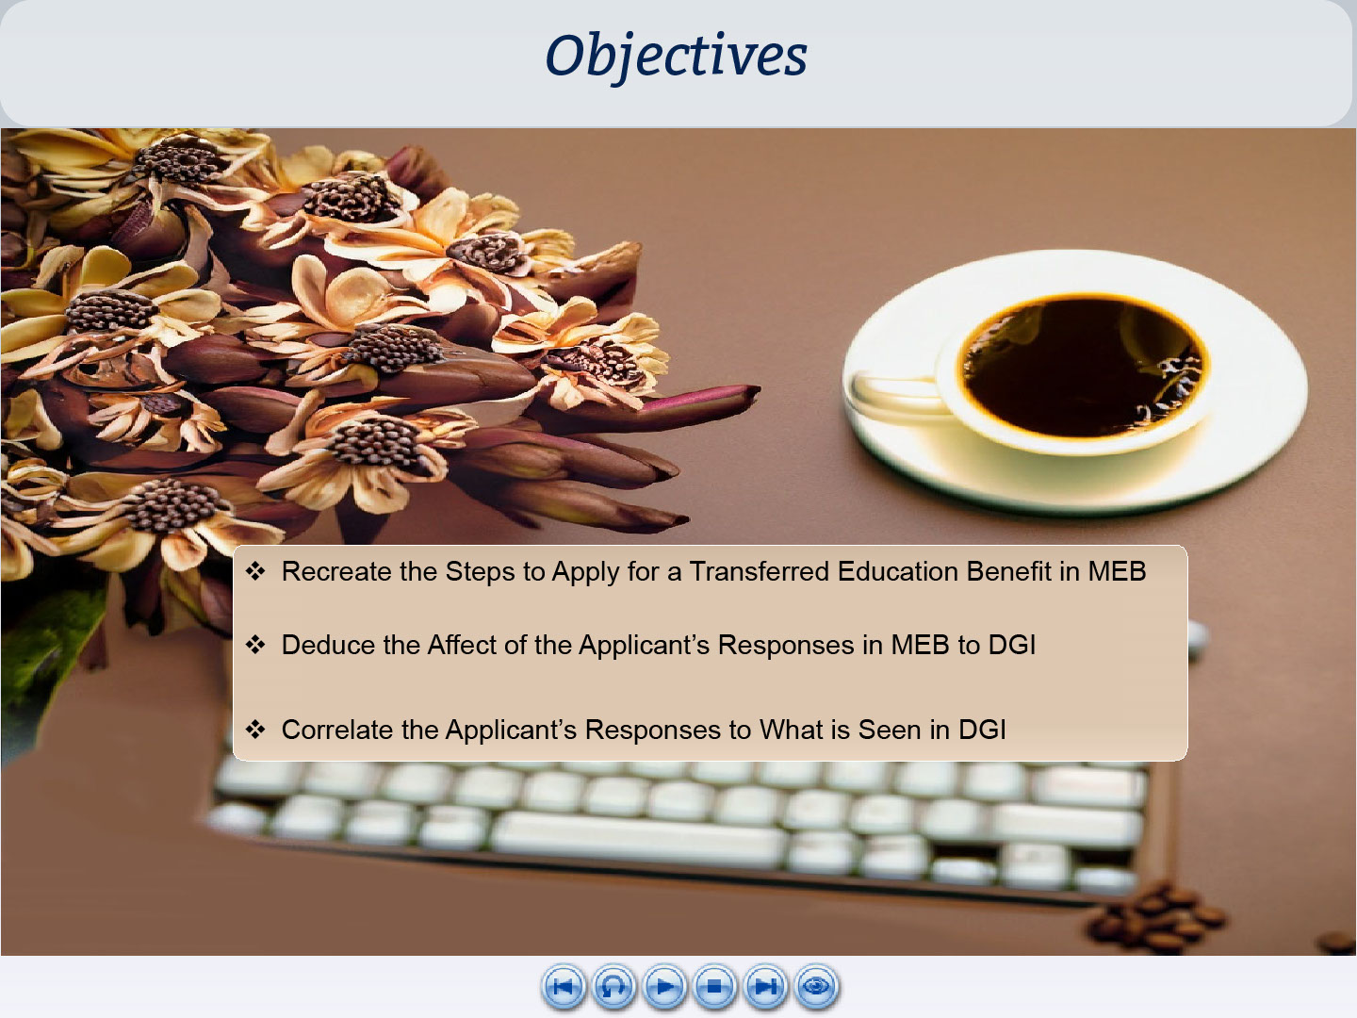
Slide notes

At the conclusion of this lesson,

you should be able to recreate the steps

to apply for a transferred education benefit in MEB

and deduce how the response options available

to the beneficiary

correlate to what is seen by a VCE in DGI.

Slide 5 - Glossary
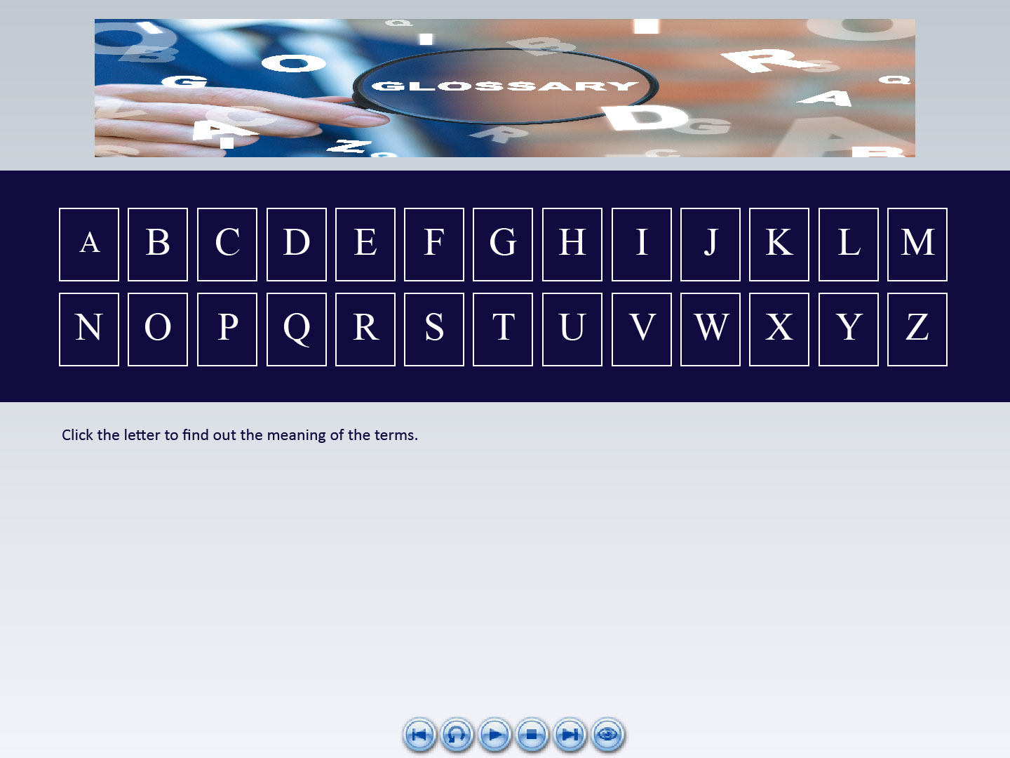
Slide notes

A glossary for terms,

acronyms

and abbreviations

used throughout this training

has been provided for reference.

Slide 6 - Demo Intro

Slide notes

Let’s jump right into our demonstration

of a person applying for TOE benefits

using MEB.

Since the MEB Applicant View training

was a prerequisite for this training,

some of these steps will seem familiar.

As we view the interactions,

I will share what this means

to the VCE.

Slide 7 - How do I apply?
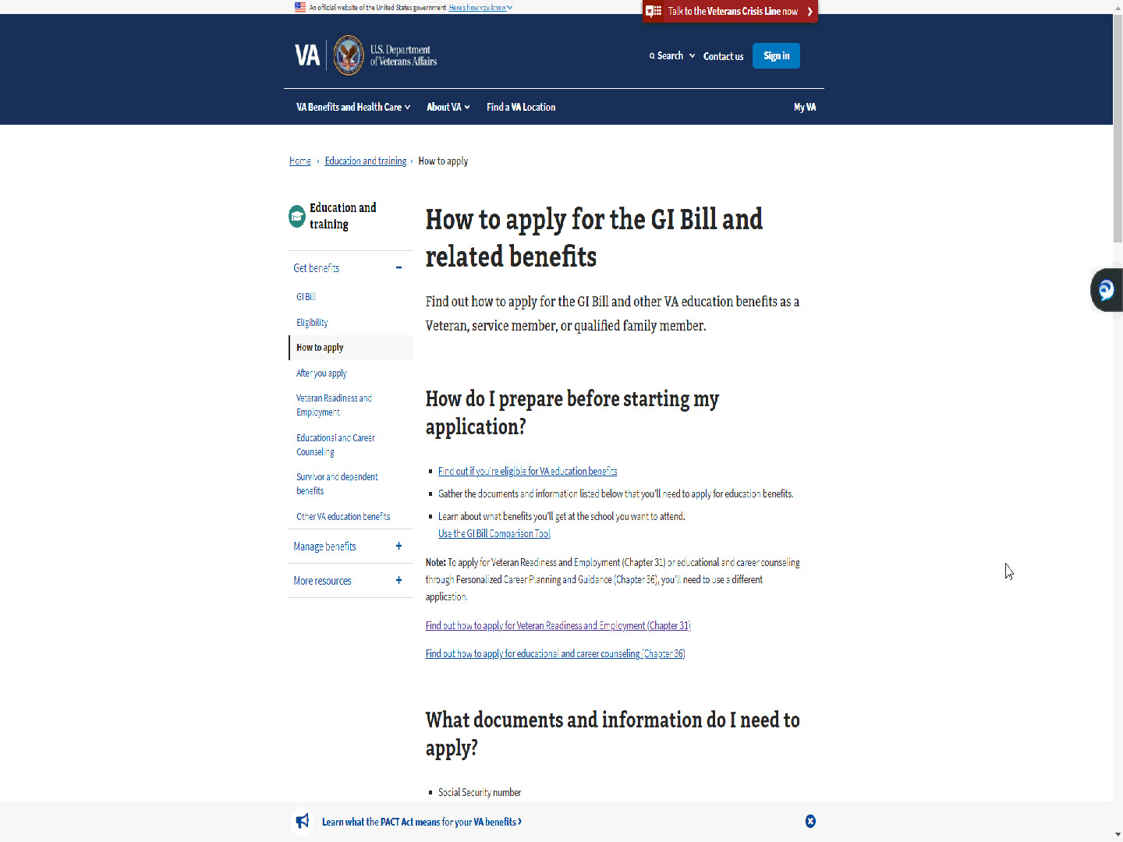
Slide notes

As shown in the MEB Applicant View training,

the applicants will begin

on the education page in VA.gov

and select “How to apply”.

Slide 8 - Find your education benefits form
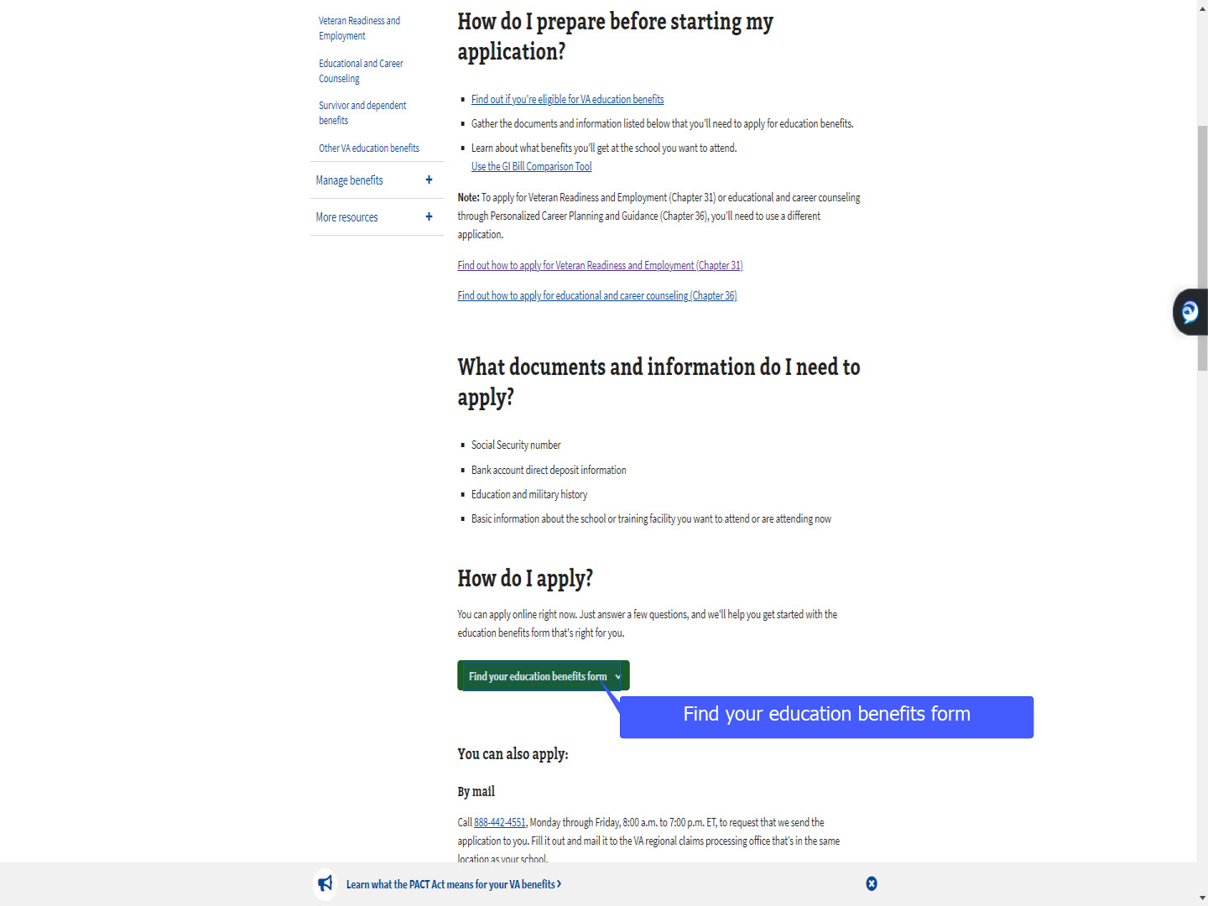
Slide notes

They will select “Find your education benefits form”,

Slide 9 - Slide 9
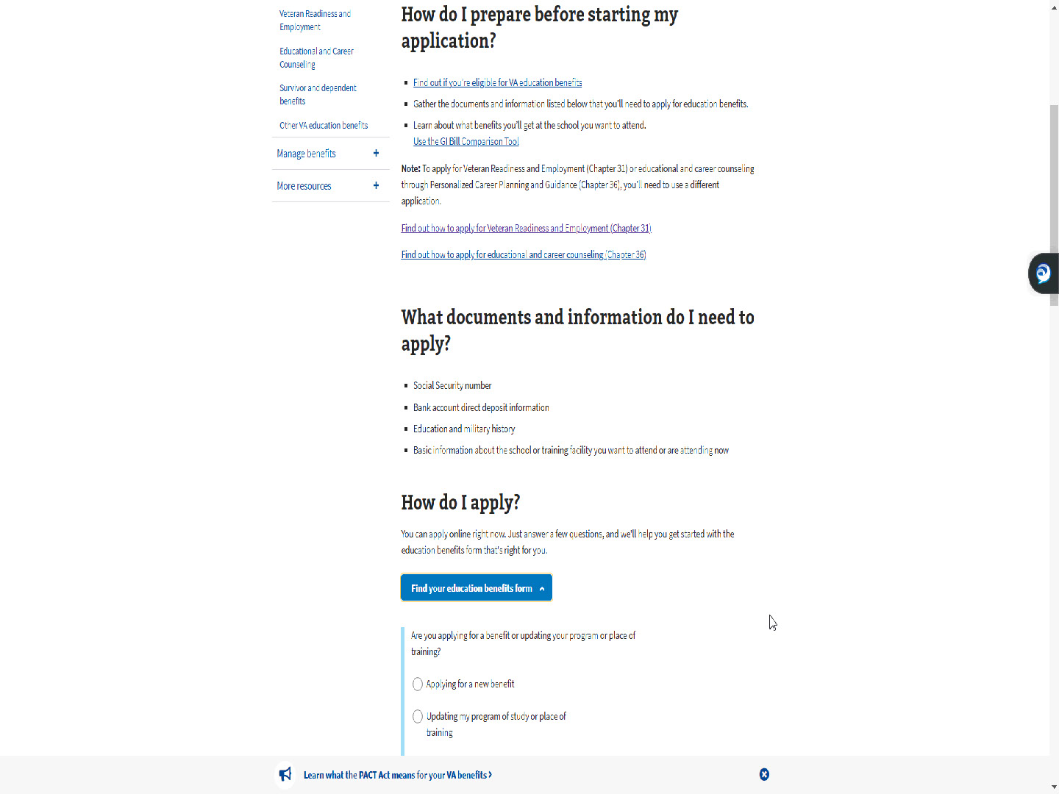
Slide notes

Slide 10 - Applying for a new benefit
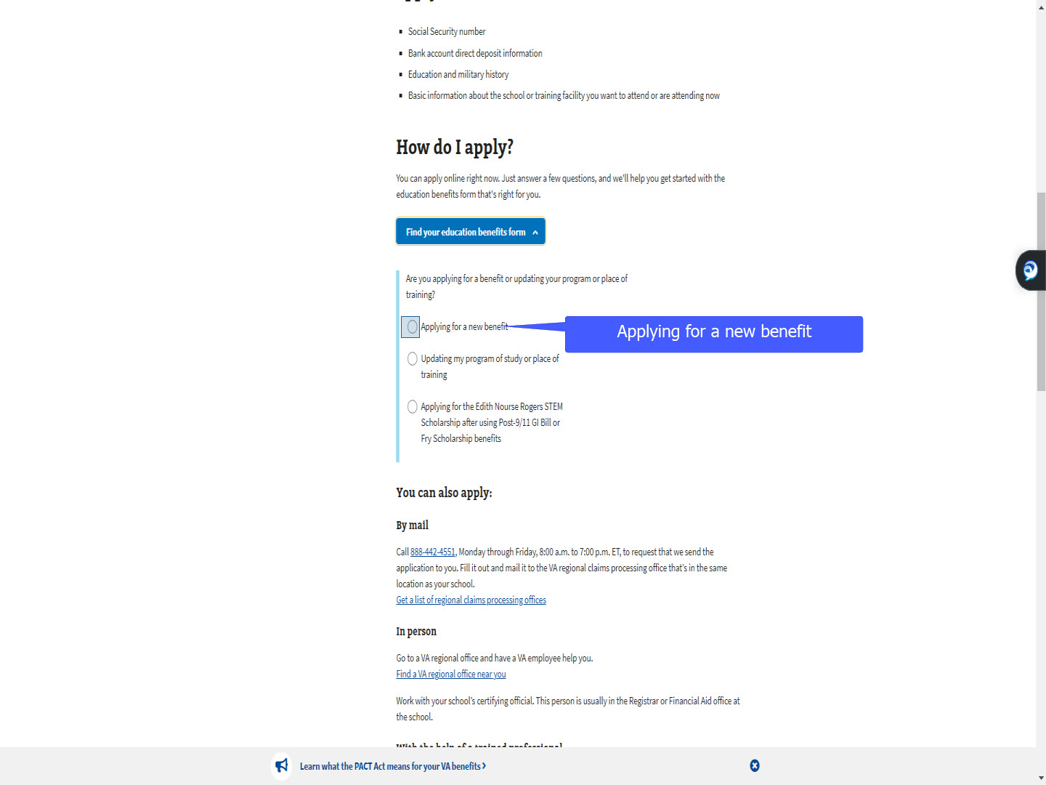
Slide notes

then select “Applying for a new benefit”.

Slide 11 - Slide 11
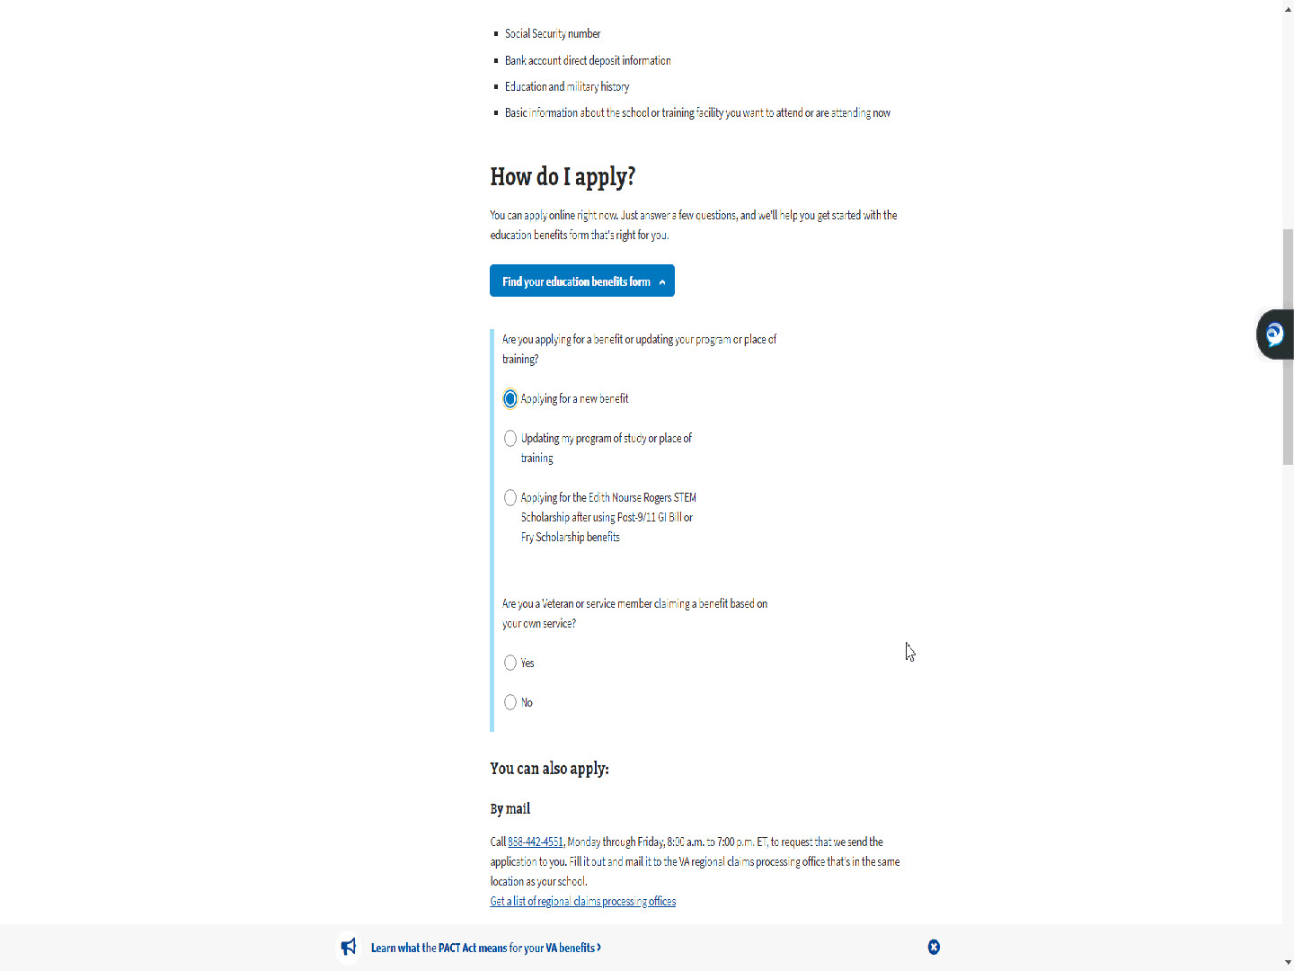
Slide notes

Slide 12 - Using own service
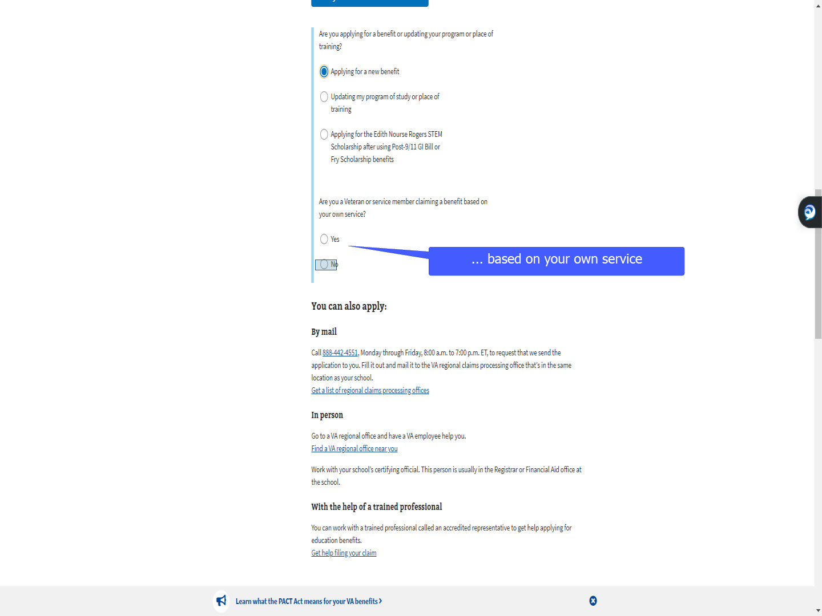
Slide notes

The difference for a TOE applicant is

they will select “No”

to answer the question

“Are you a Veteran or service member

claiming a benefit based on your own service?”

Slide 13 - Slide 13
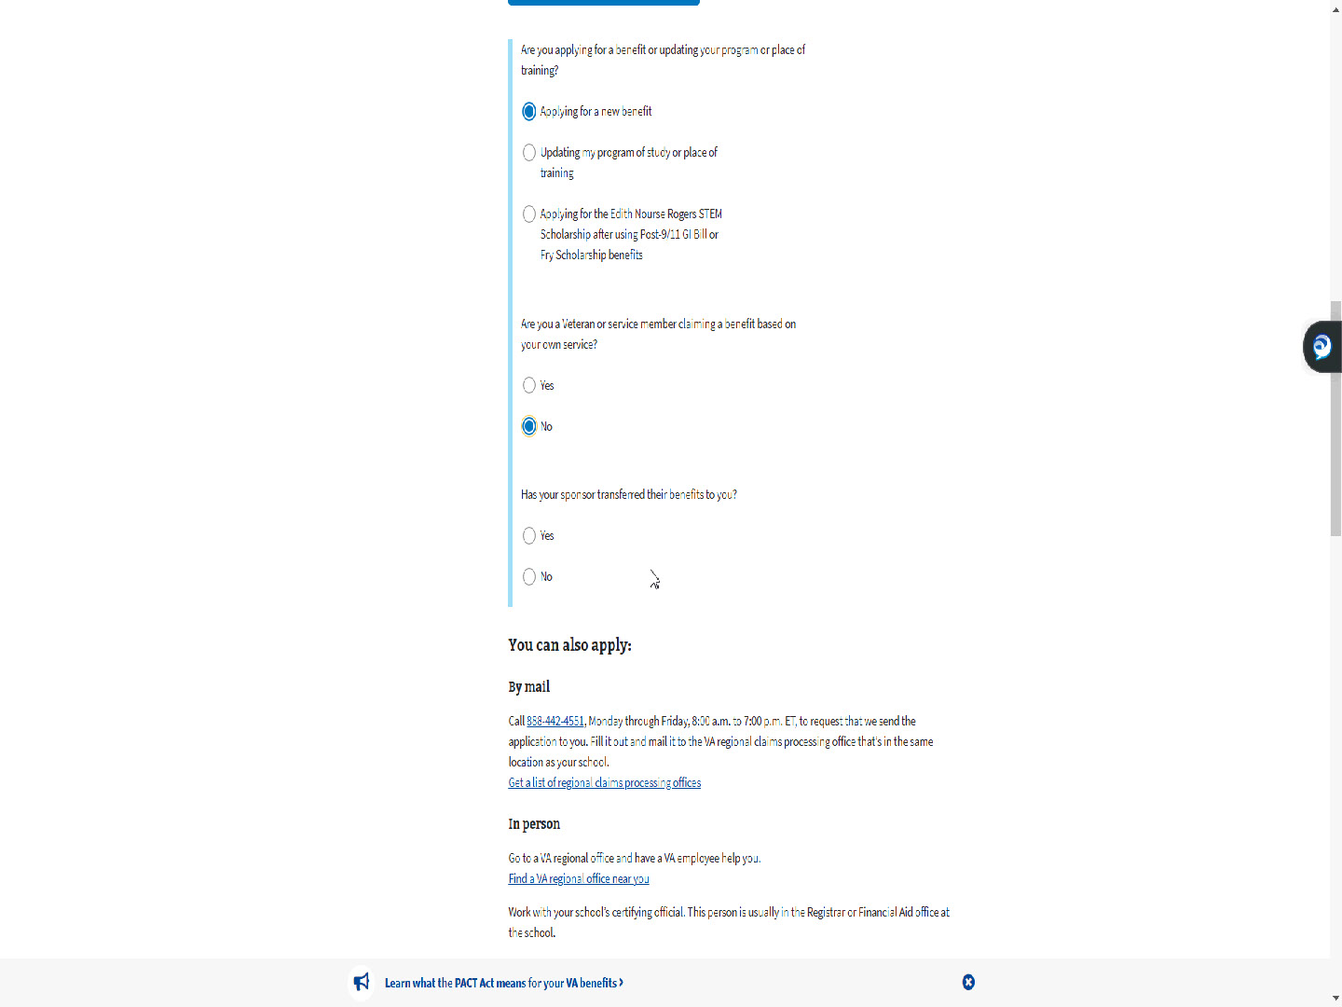
Slide notes

Slide 14 - Has your sponsor transferred their benefits to you
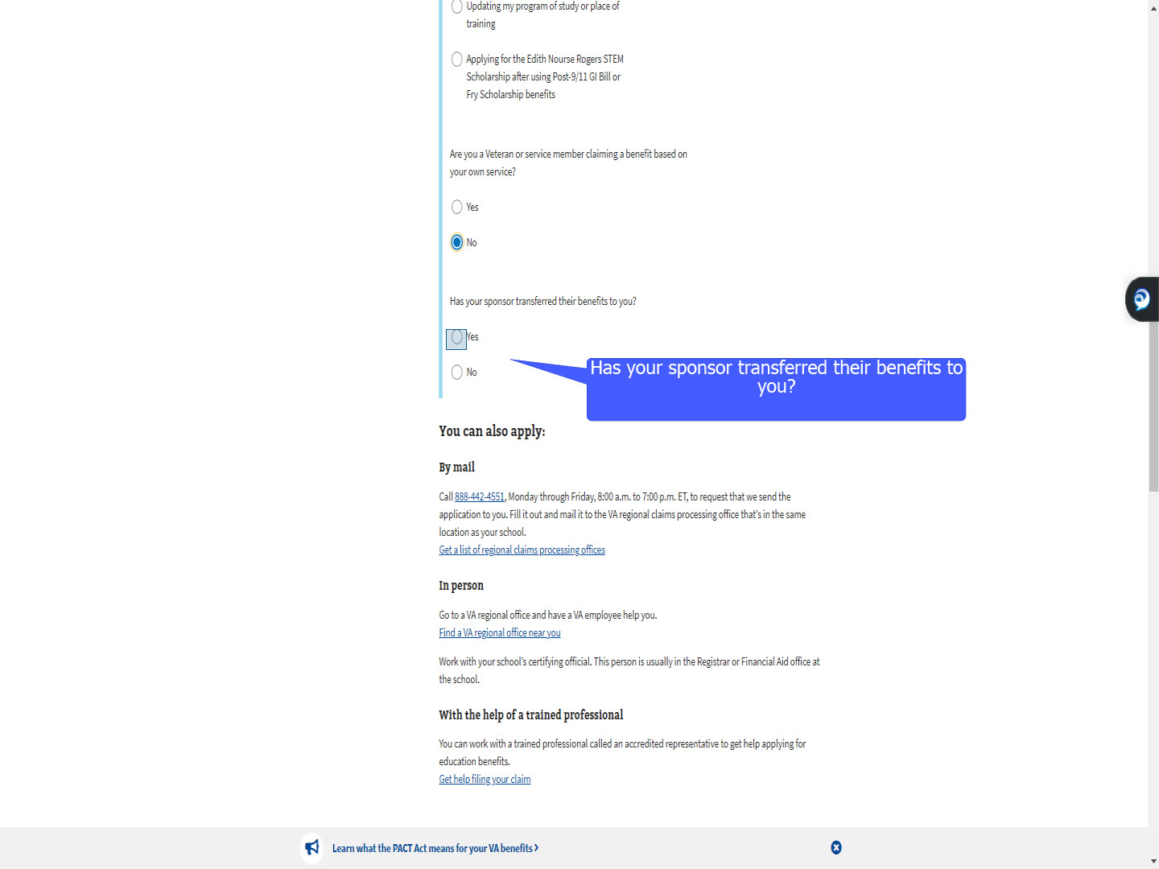
Slide notes

As a result of selecting “No”

MEB prompts the question

“Has your sponsor transferred their benefits to you?”

Slide 15 - No transferred benefits
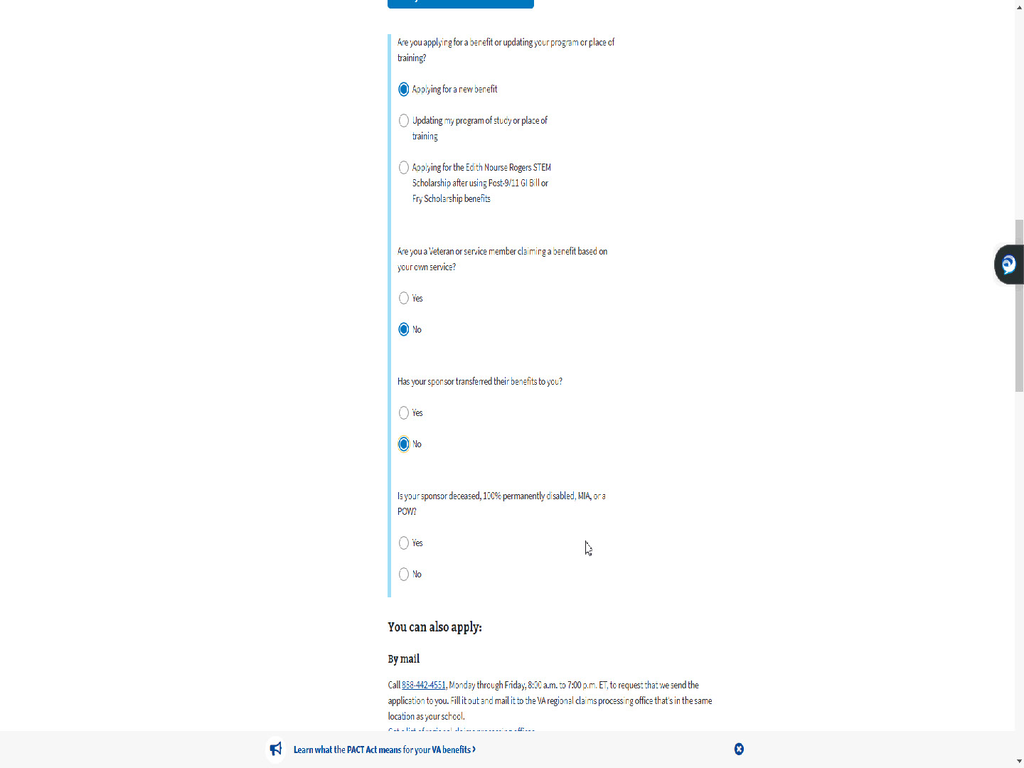
Slide notes

If the applicant selects “No”,

MEB asks if the sponsor is deceased,

100% permanently disabled,

MIA or a POW.

If the applicant responds “Yes”,

they are routed outside of MEB

to apply for Fry or CH35.

Slide 16 - No sponsor disability
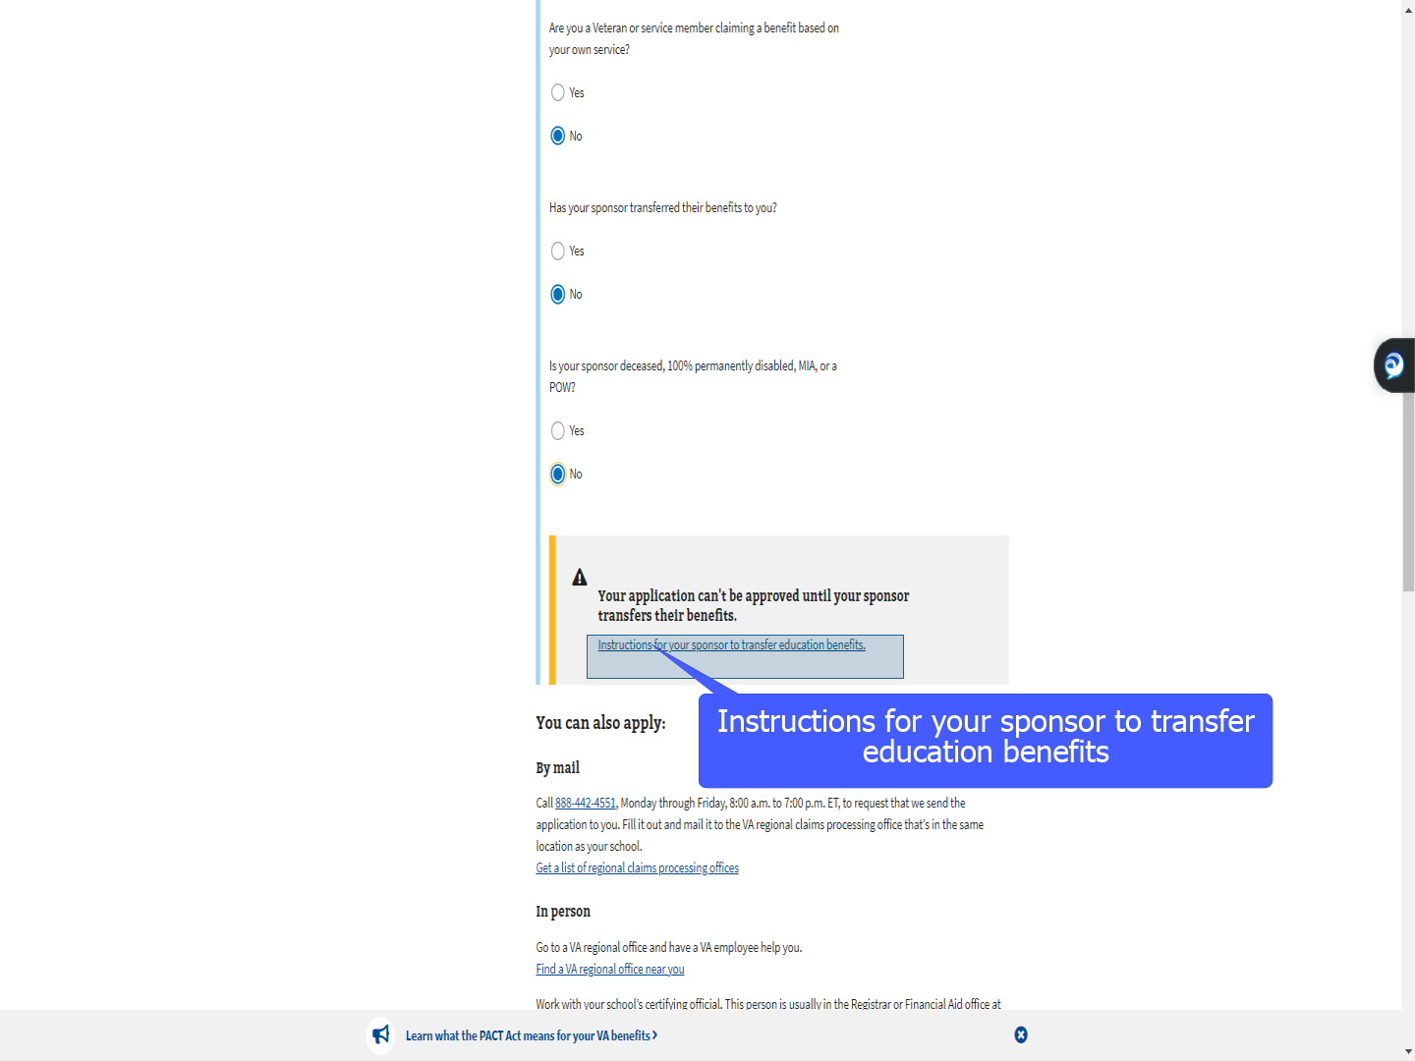
Slide notes

If the applicant selects “No”,

a window pops up stating

“Your application can’t be approved

until your sponsor transfers their benefits”.

A link is provided with instructions for the sponsor.

It will open a new window.

Slide 17 - How to Transfer and Use Benefits
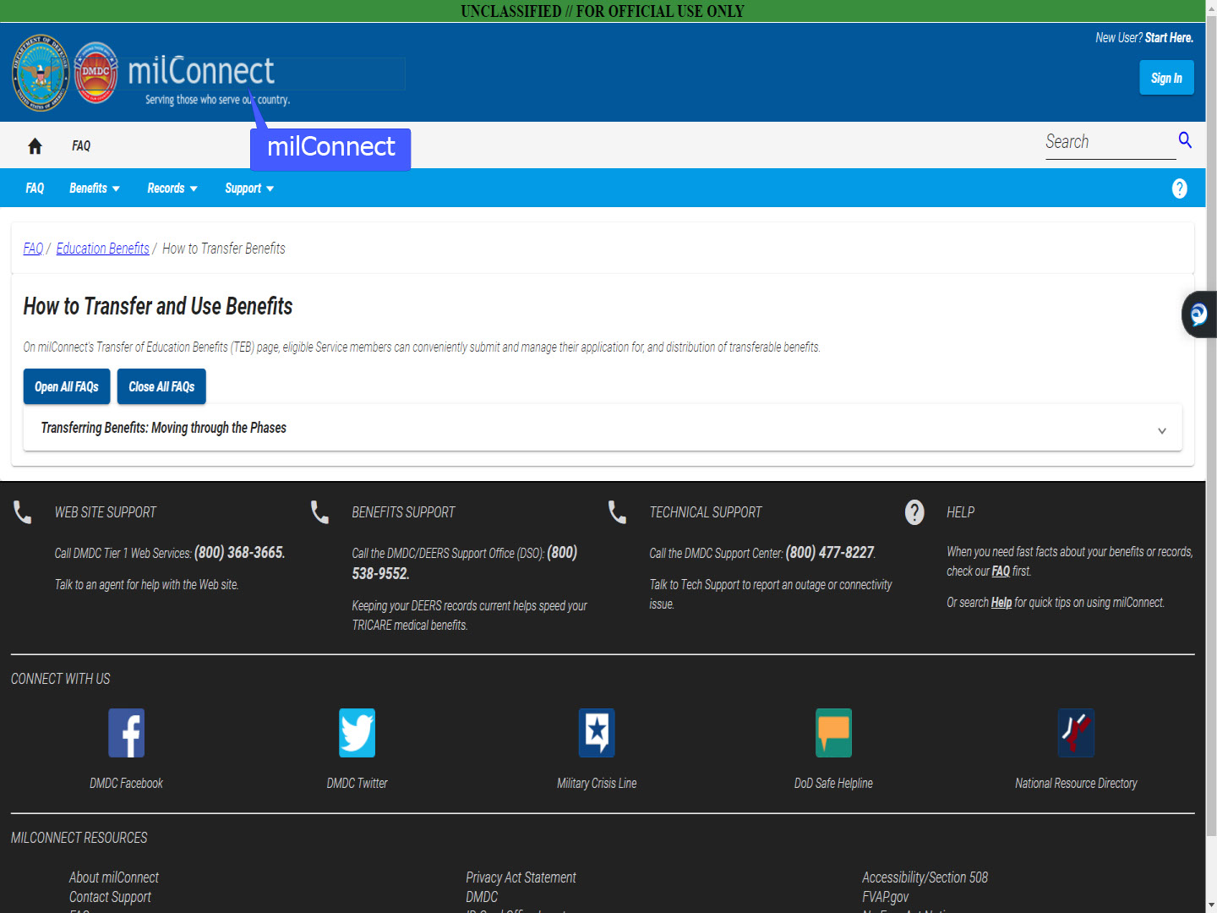
Slide notes

The applicant is taken to milConnect.

There they are provided information

on “How to Transfer and Use Benefits”.

Slide 18 - Apply Now
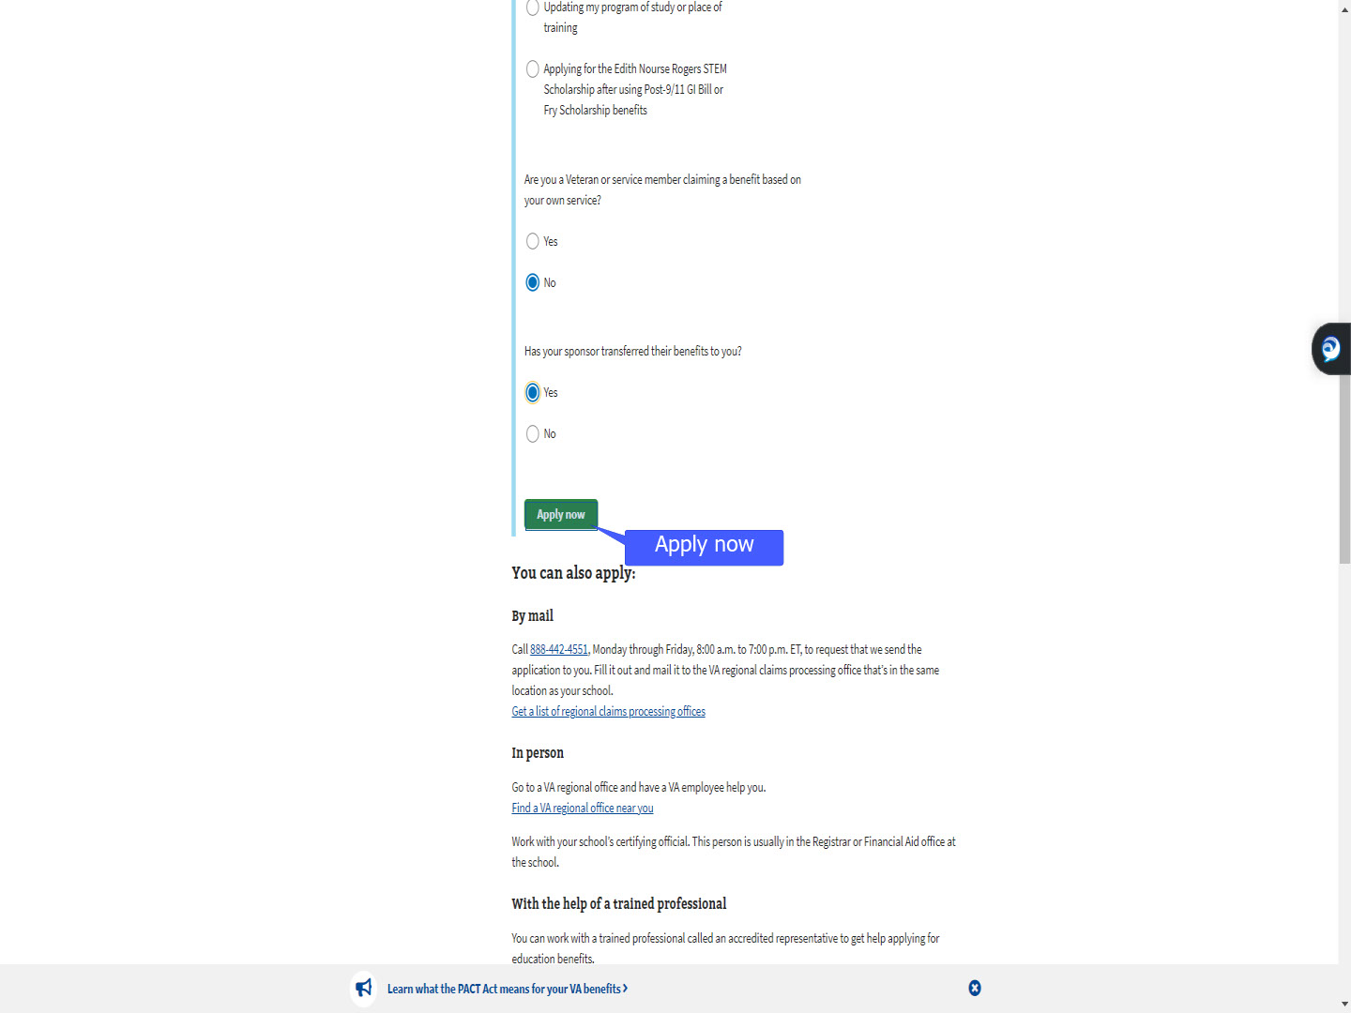
Slide notes

For today’s demonstration,

We will select “Yes”,

to acknowledge benefits have been transferred,

then select “Apply now”.

Slide 19 - Slide 19
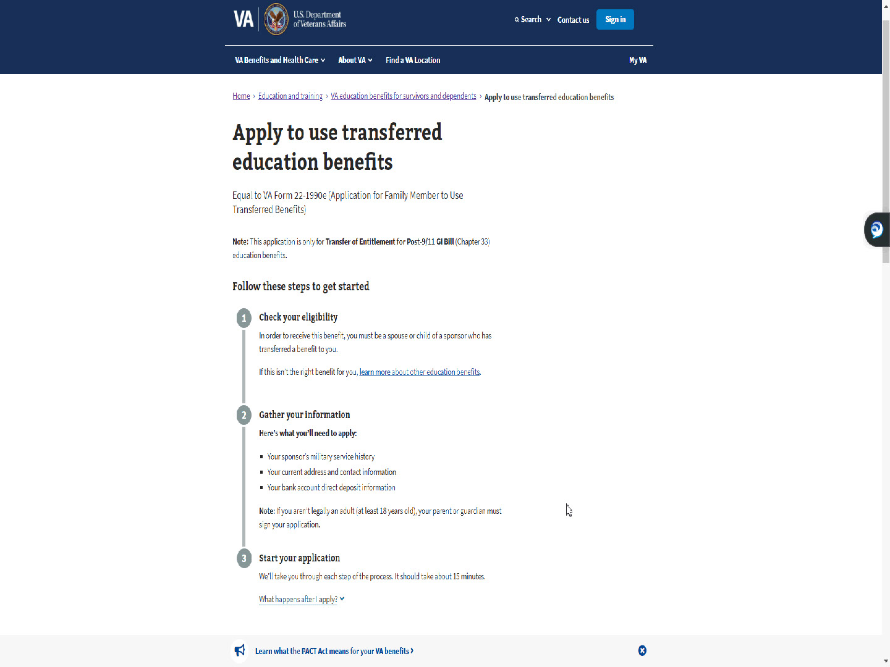
Slide notes

As with the Chapter 33

“Self” application in MEB,

information is provided to assist with applying

Slide 20 - What happens after I apply?
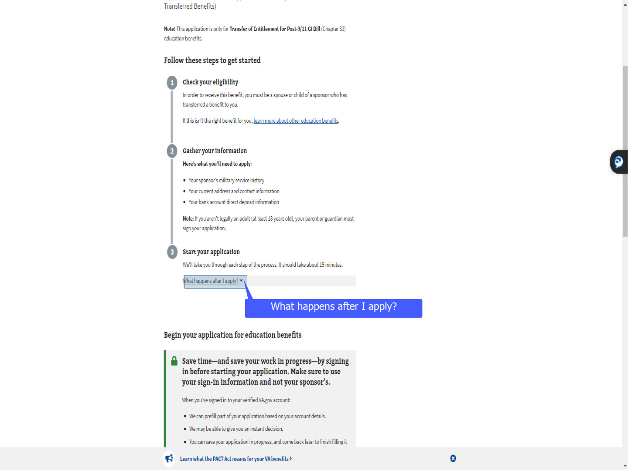
Slide notes

and provide a snippet

of what happens after.

Slide 21 - Slide 21
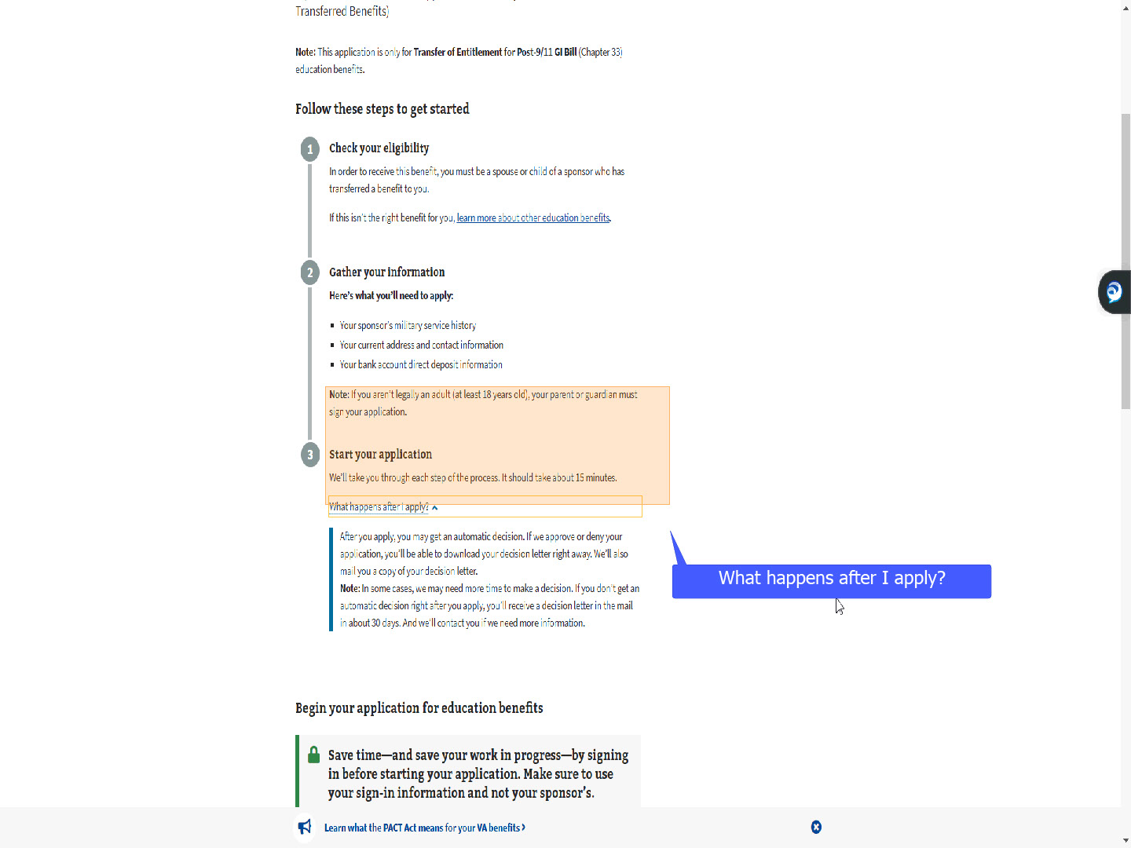
Slide notes

and provide a snipped

of what happens after.

Slide 22 - Slide 22
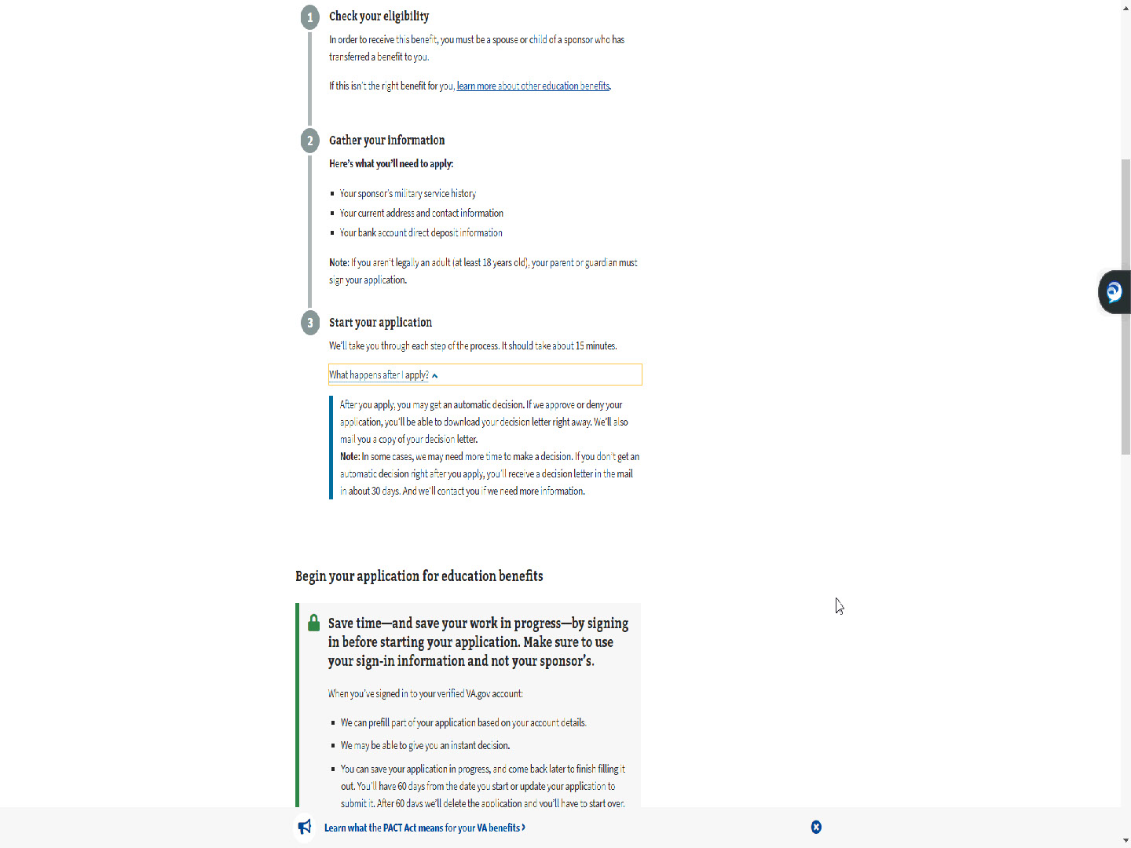
Slide notes

The applicant will scroll down

Slide 23 - Sign in to start your application
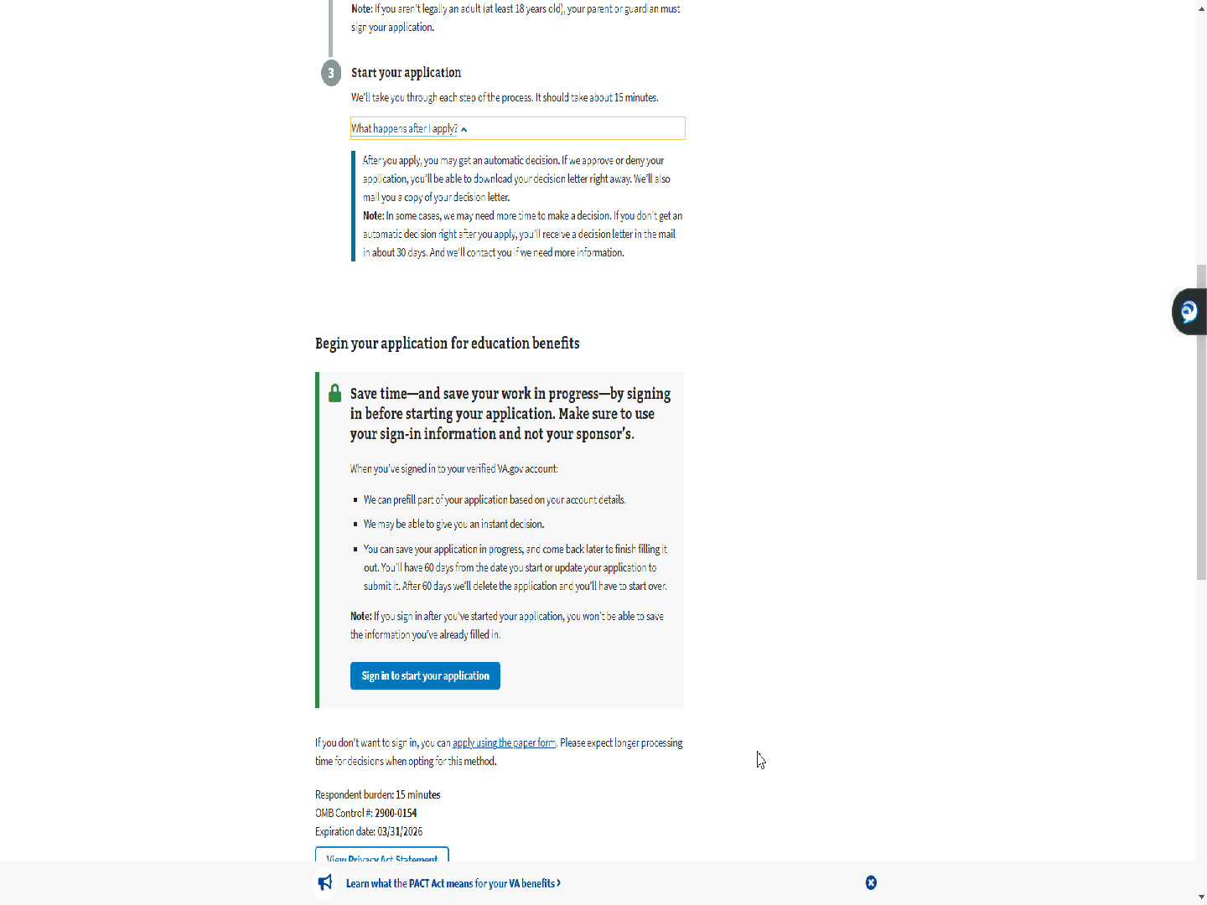
Slide notes

and select “Sign in to start your application”.

Slide 24 - Slide 24
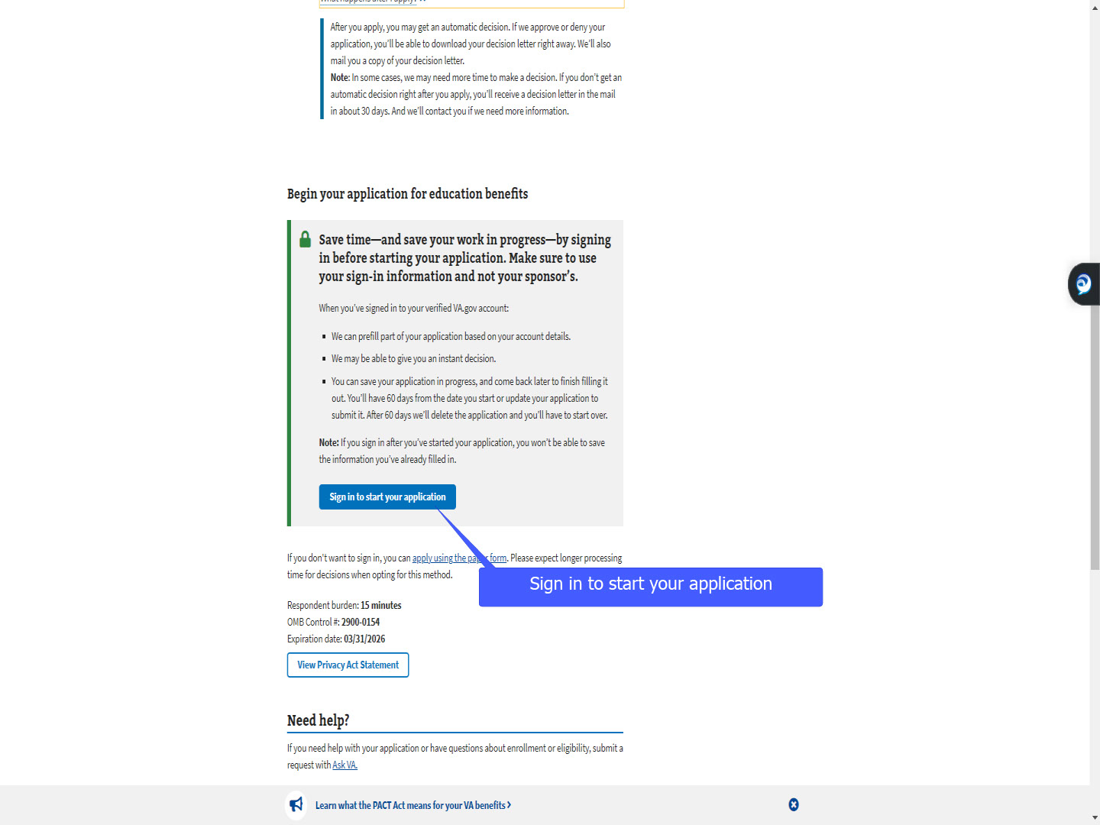
Slide notes

Slide 25 - Apply using the paper form
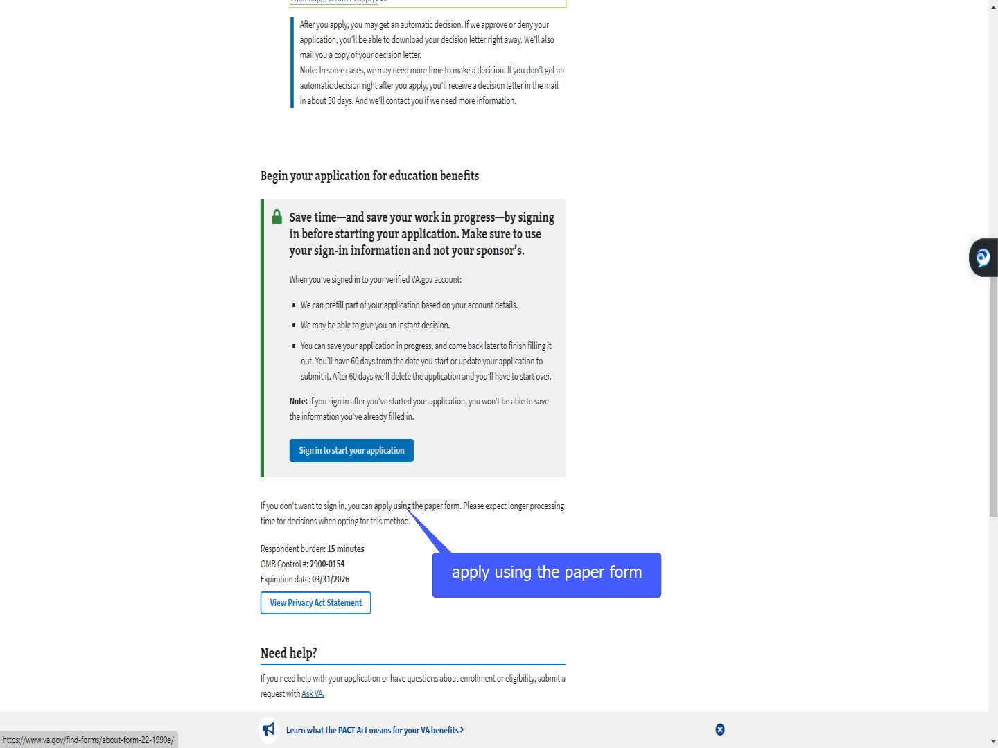
Slide notes

If the applicant does not want to sign in,

a link is provided to apply using the paper form.

Slide 26 - ID.me
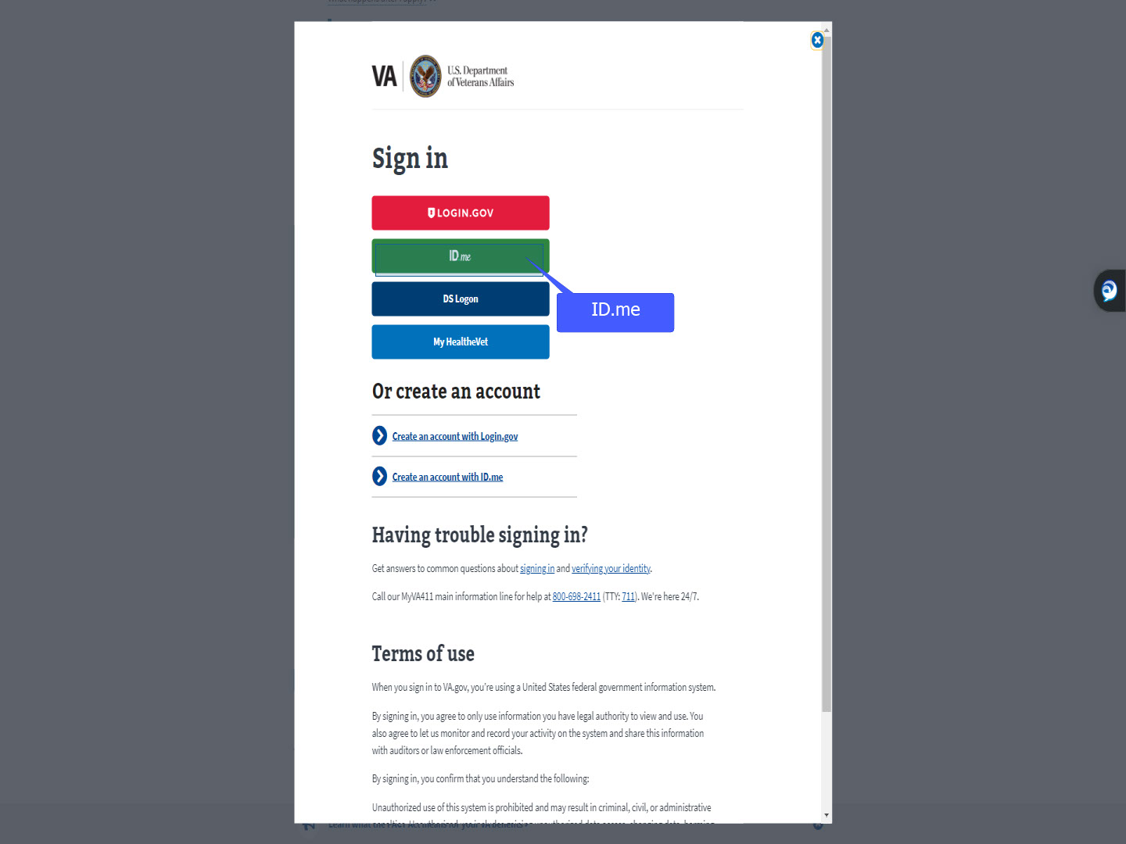
Slide notes

As with all online applications,

the applicant will need to authenticate their identity.

For today’s training,

we will use ID.me.

Slide 27 - Slide 27
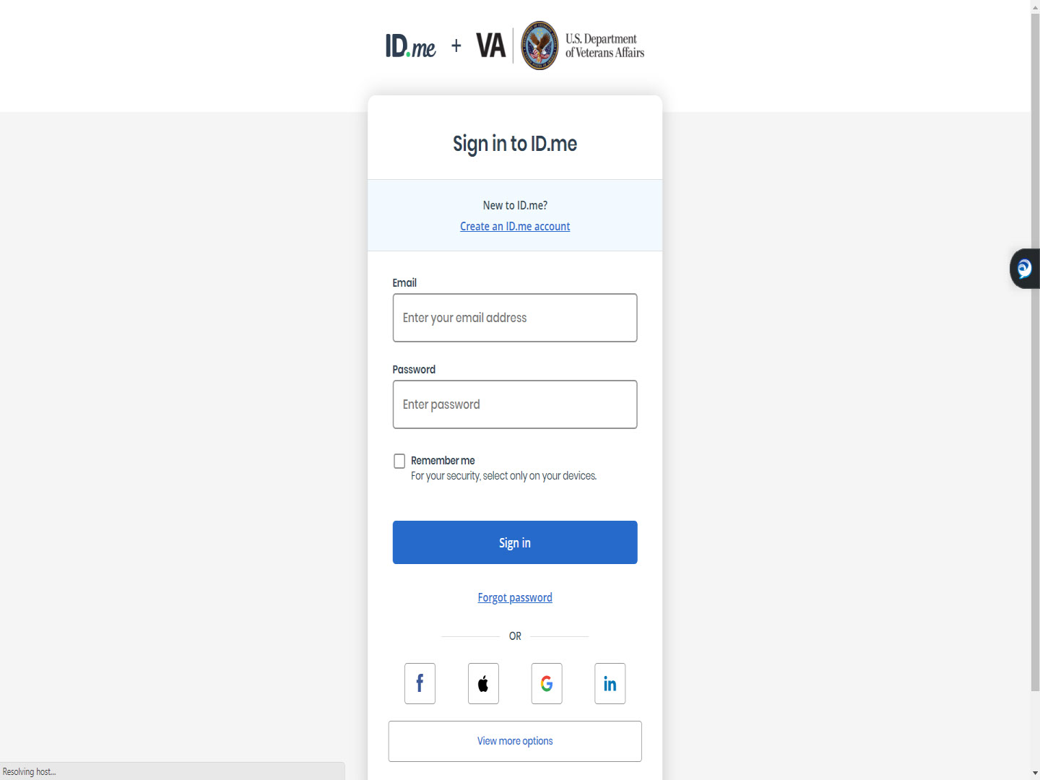
Slide notes

Slide 28 - Sign In- ID.me
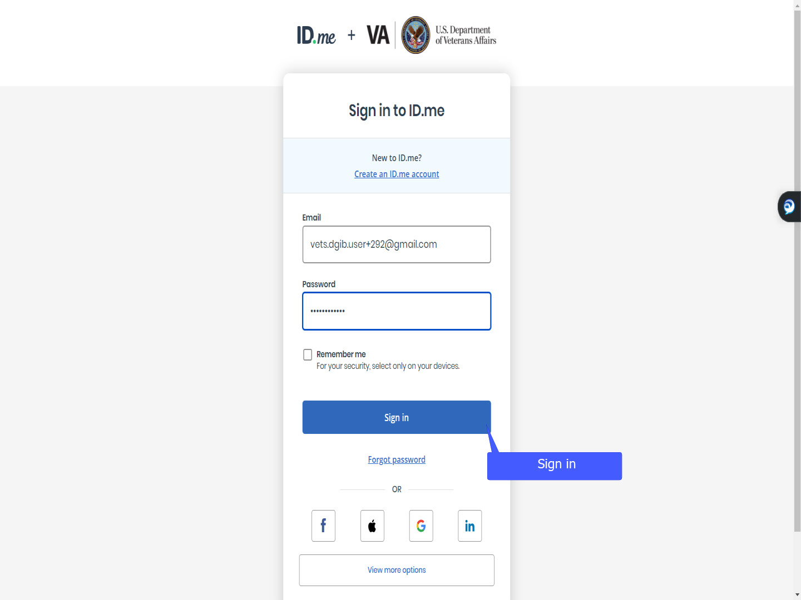
Slide notes

Slide 29 - ID.me verification
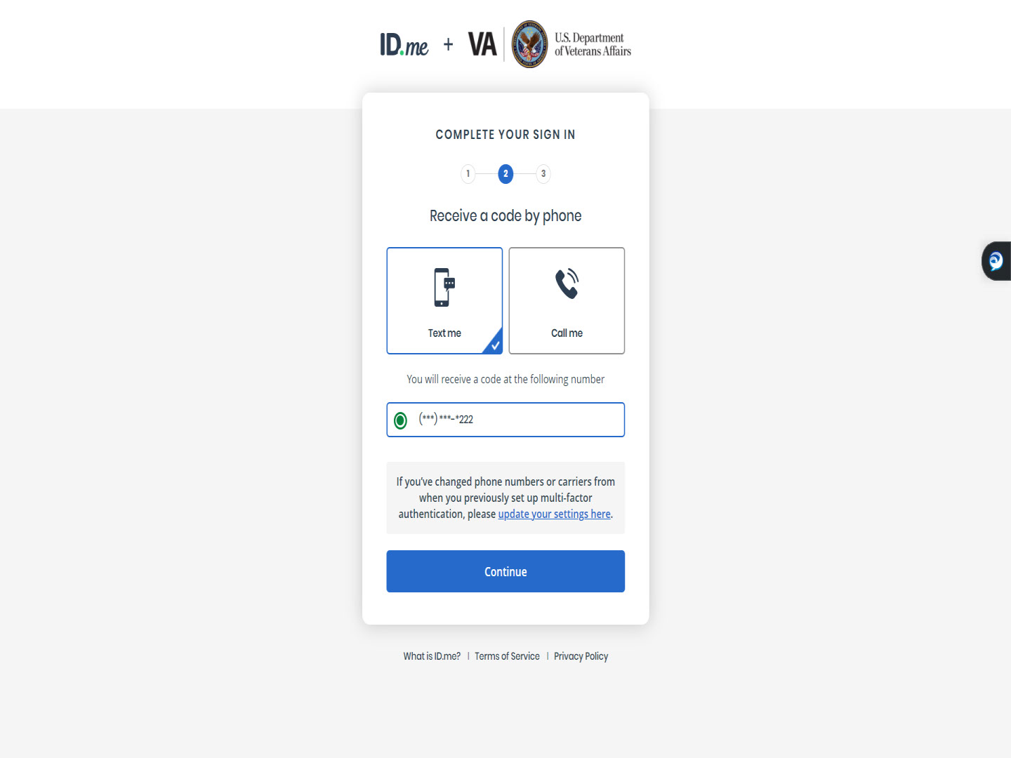
Slide notes

Slide 30 - 6-digit code
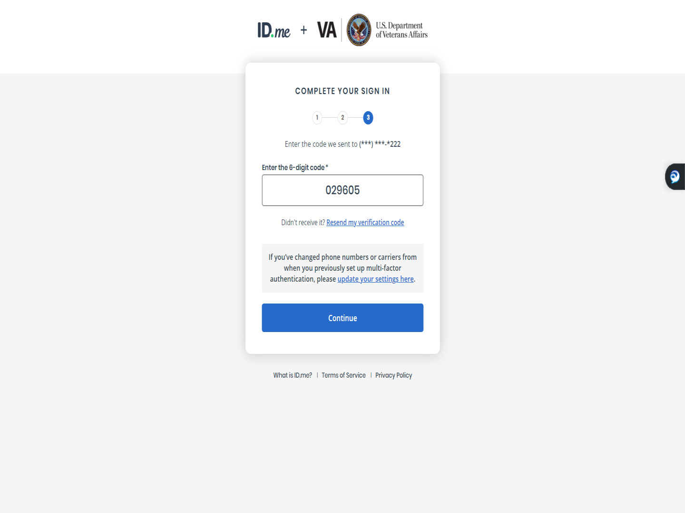
Slide notes

Slide 31 - Slide 31
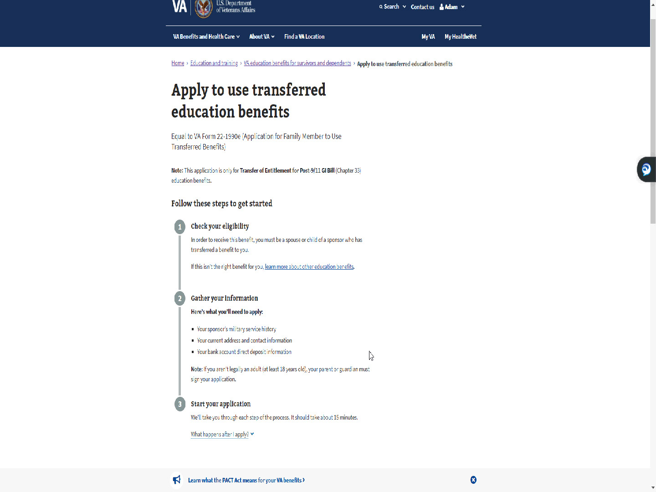
Slide notes

Slide 32 - Slide 32
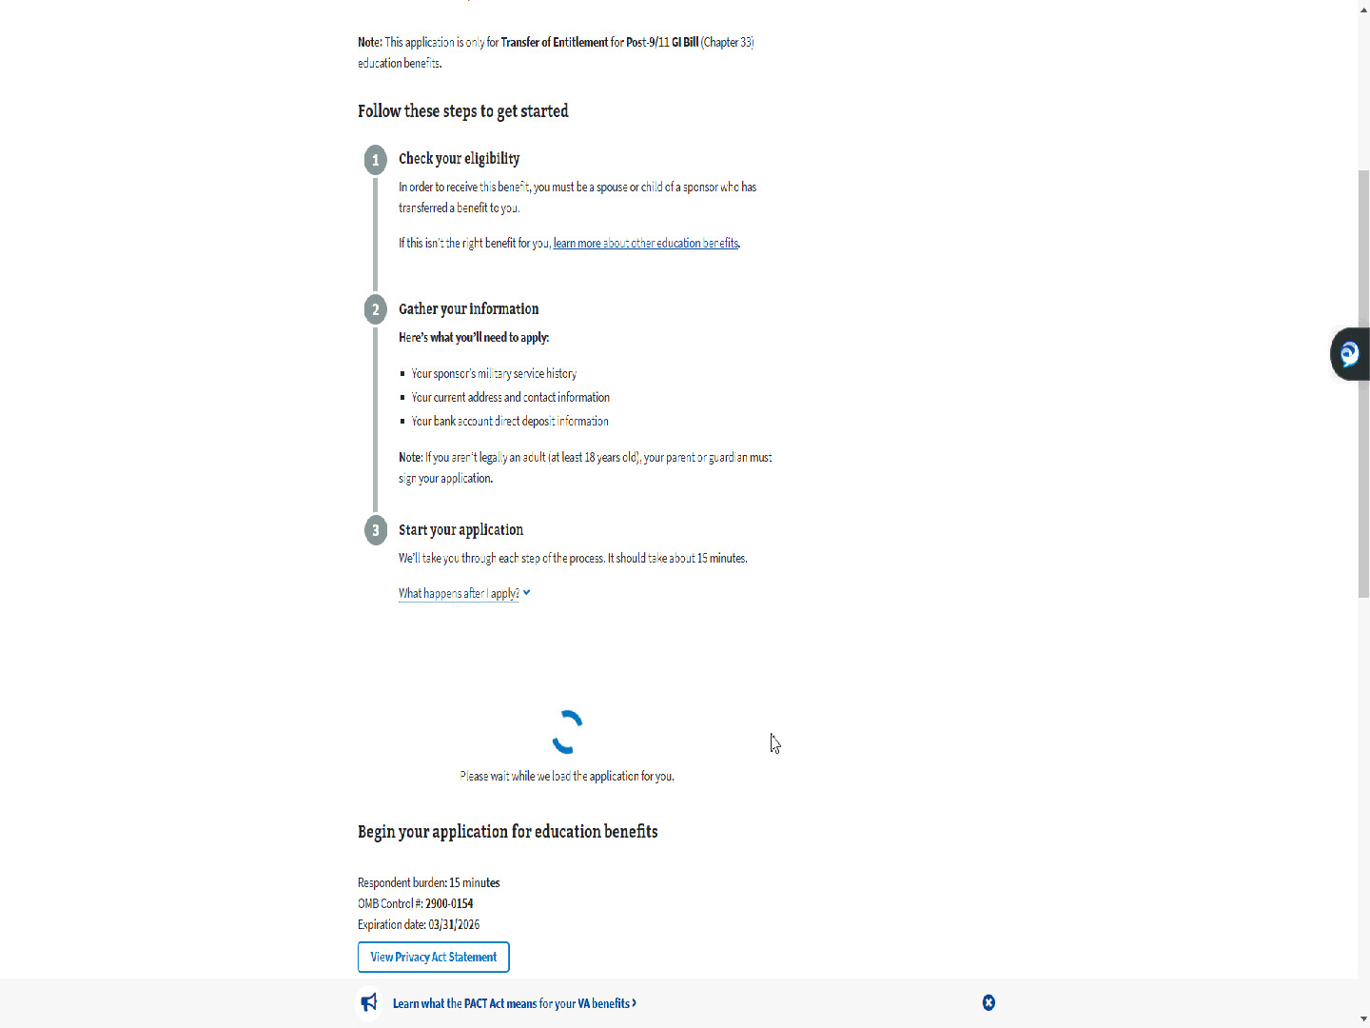
Slide notes

Now the applicant is verified,

and the application process will begin.

Slide 33 - Step 1: Your information
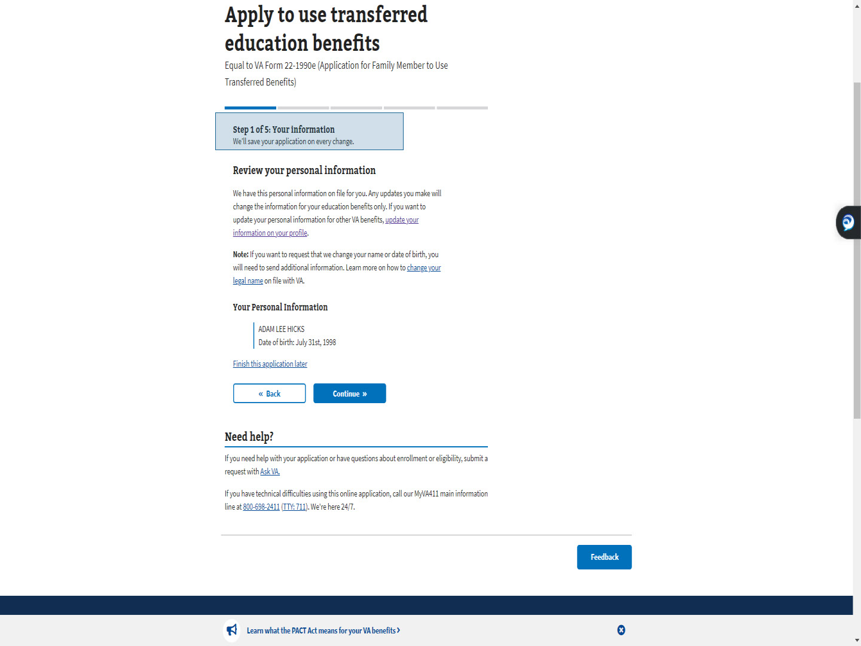
Slide notes

Similar to the MEB Self applicant,

Step 1 is Your information.

Slide 34 - Update your VA profile
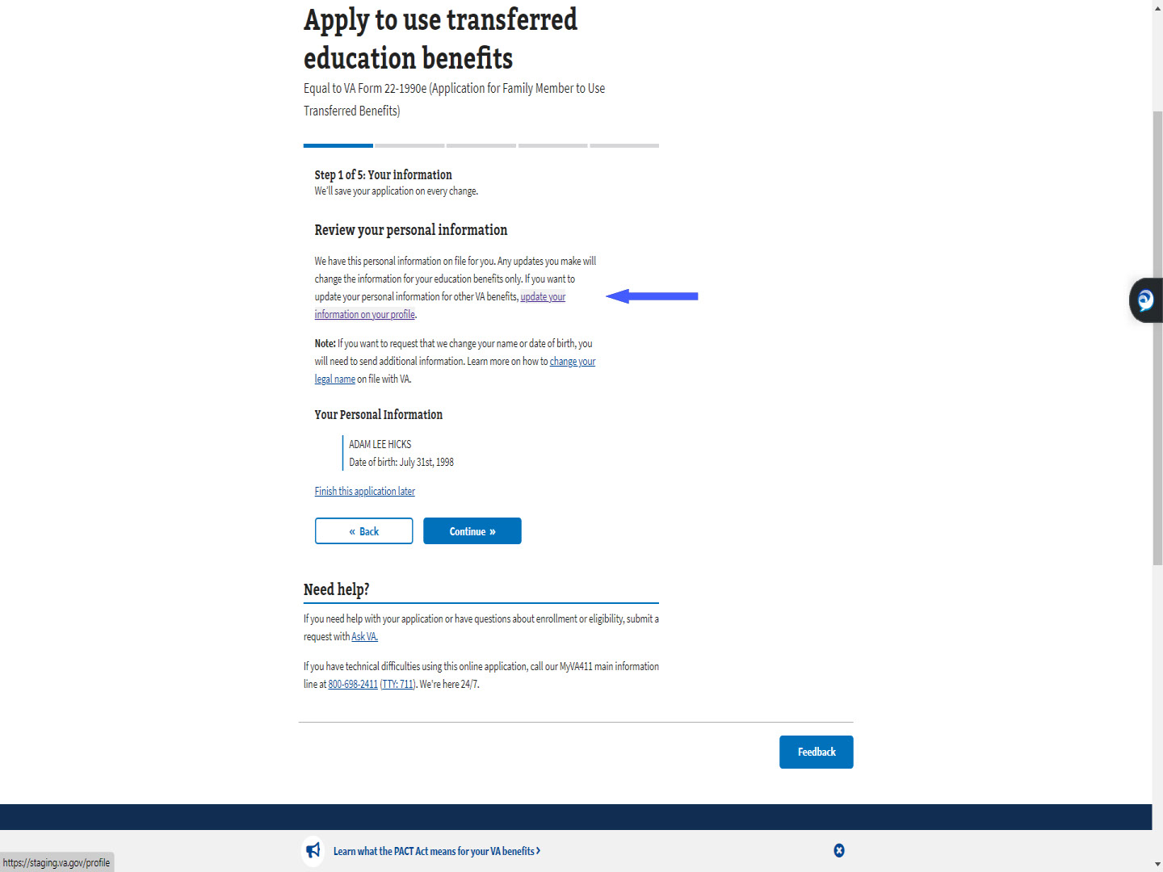
Slide notes

Links are available to assist the applicant

if the information is incorrect.

They are “update your information on your profile”,

which updates the VA profile for all benefits,

Slide 35 - Change your legal name
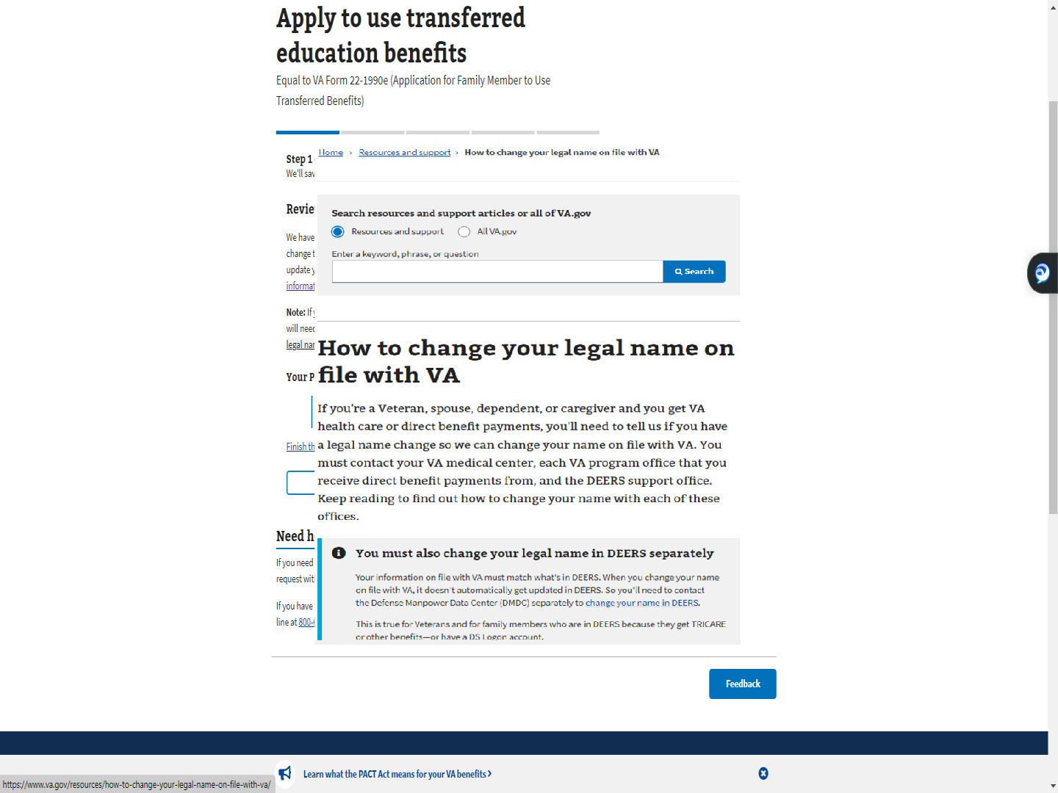
Slide notes

and “Change your legal name”,

which opens a separate resource window.

Slide 36 - Continue
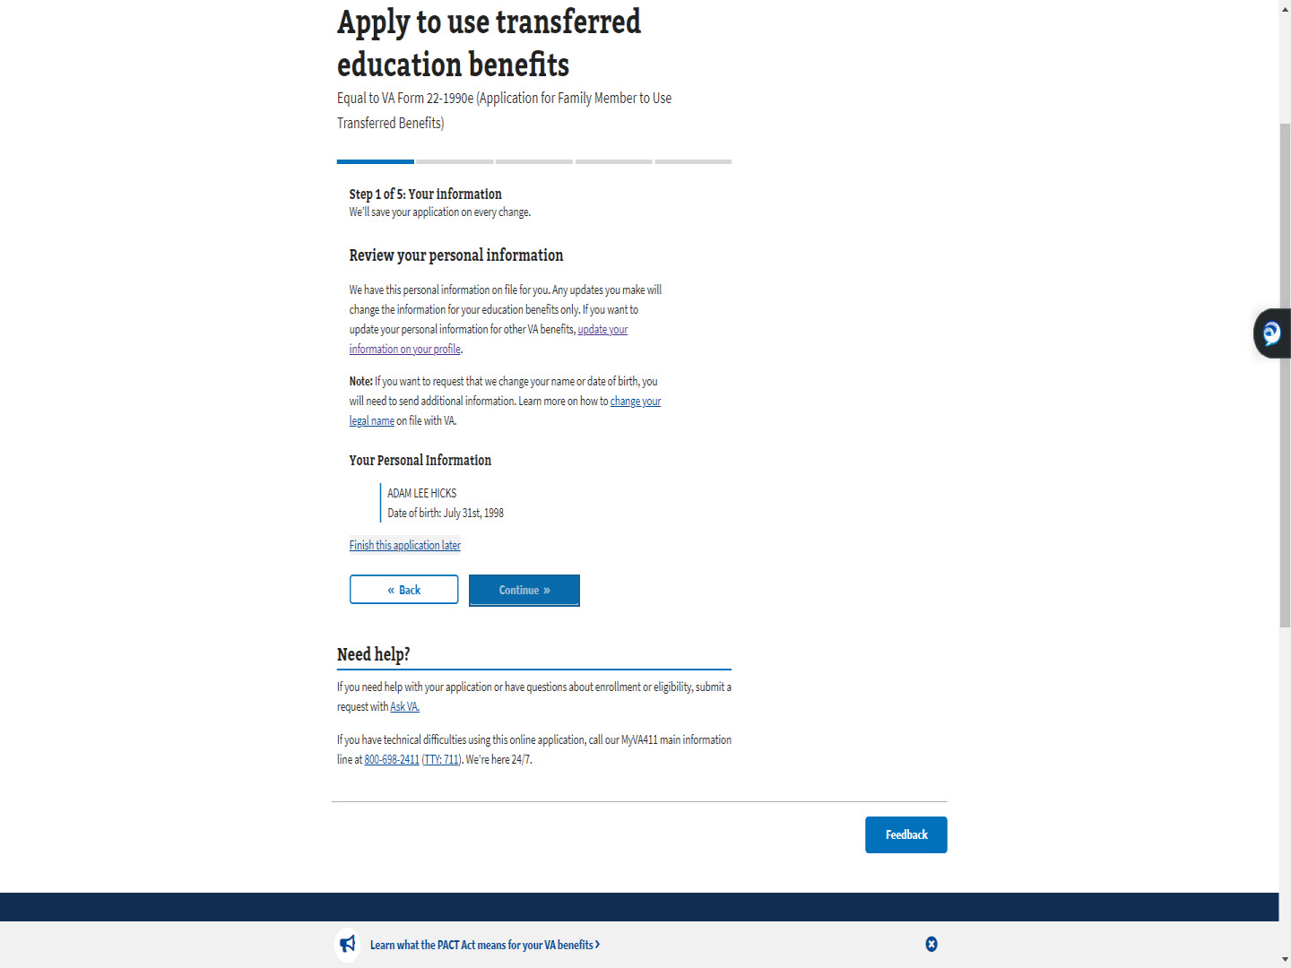
Slide notes

For this demo,

we will accept what is shown

and select “Continue”.

Slide 37 - Knowledge Checks

Slide notes

Let’s do a few knowledge checks

to making sure you’re tracking so far.

Slide 38 - Multiple Choice
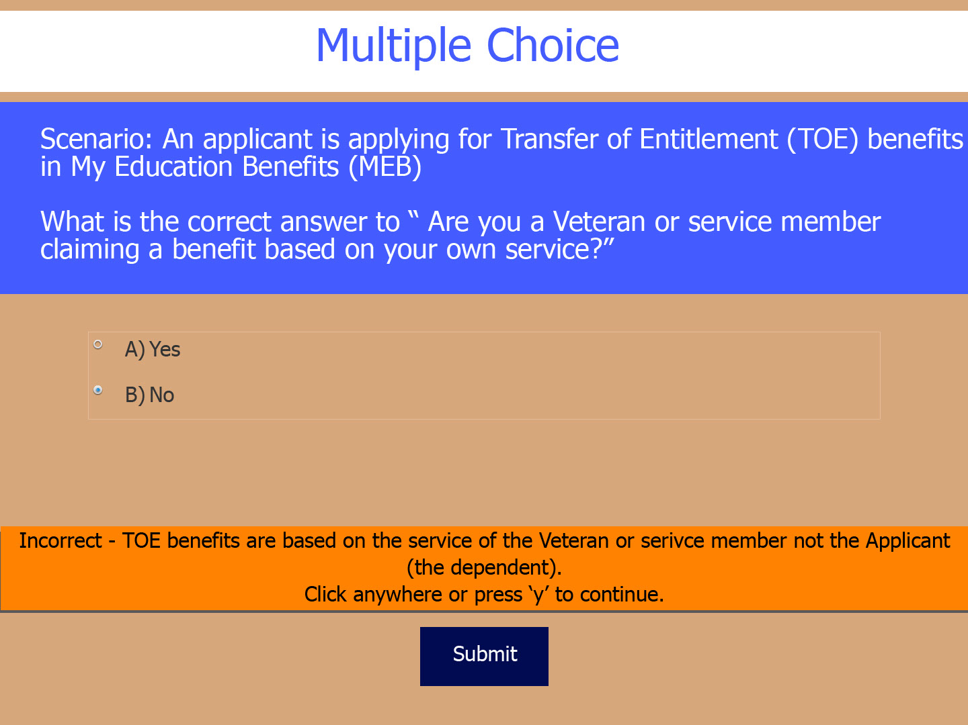
Slide notes

First, a multiple choice.

If a person is applying for TOE in MEB,

should the applicant respond “Yes” or “No”

to the question

“Are you a Veteran or service member

claiming a benefit based on your own service”?

Slide 39 - True or False
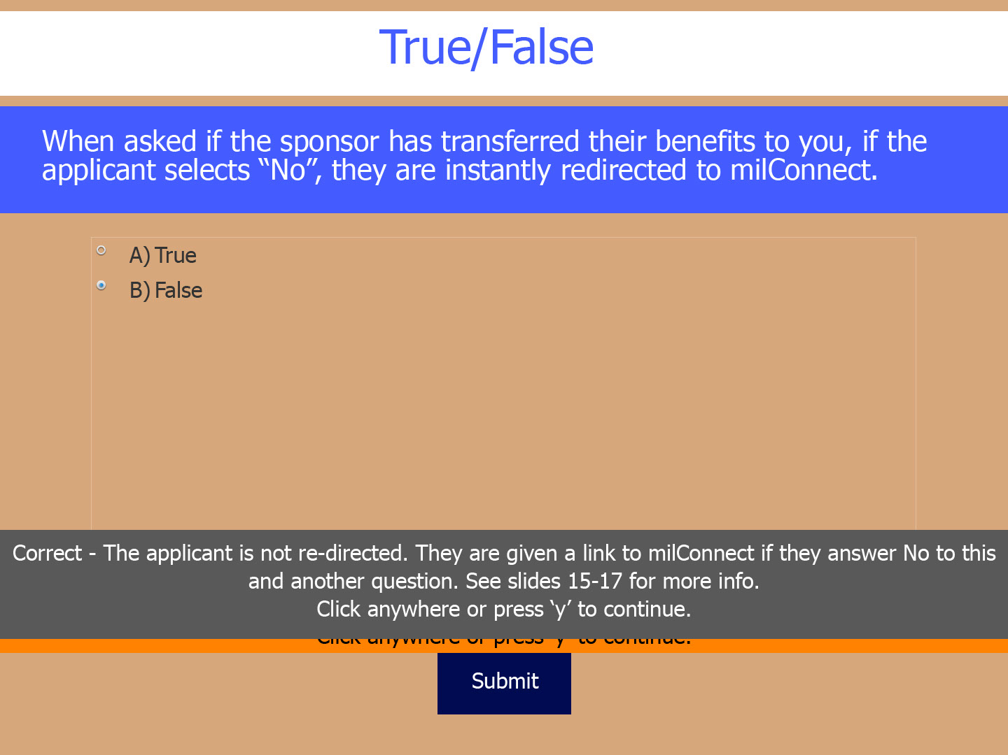
Slide notes

Next, True or False.

When asked the question

“Has the sponsor transferred their benefits to you”,

if they select “No”,

they are instantly redirected to the milConnect website.

Slide 40 - Multiple Choice
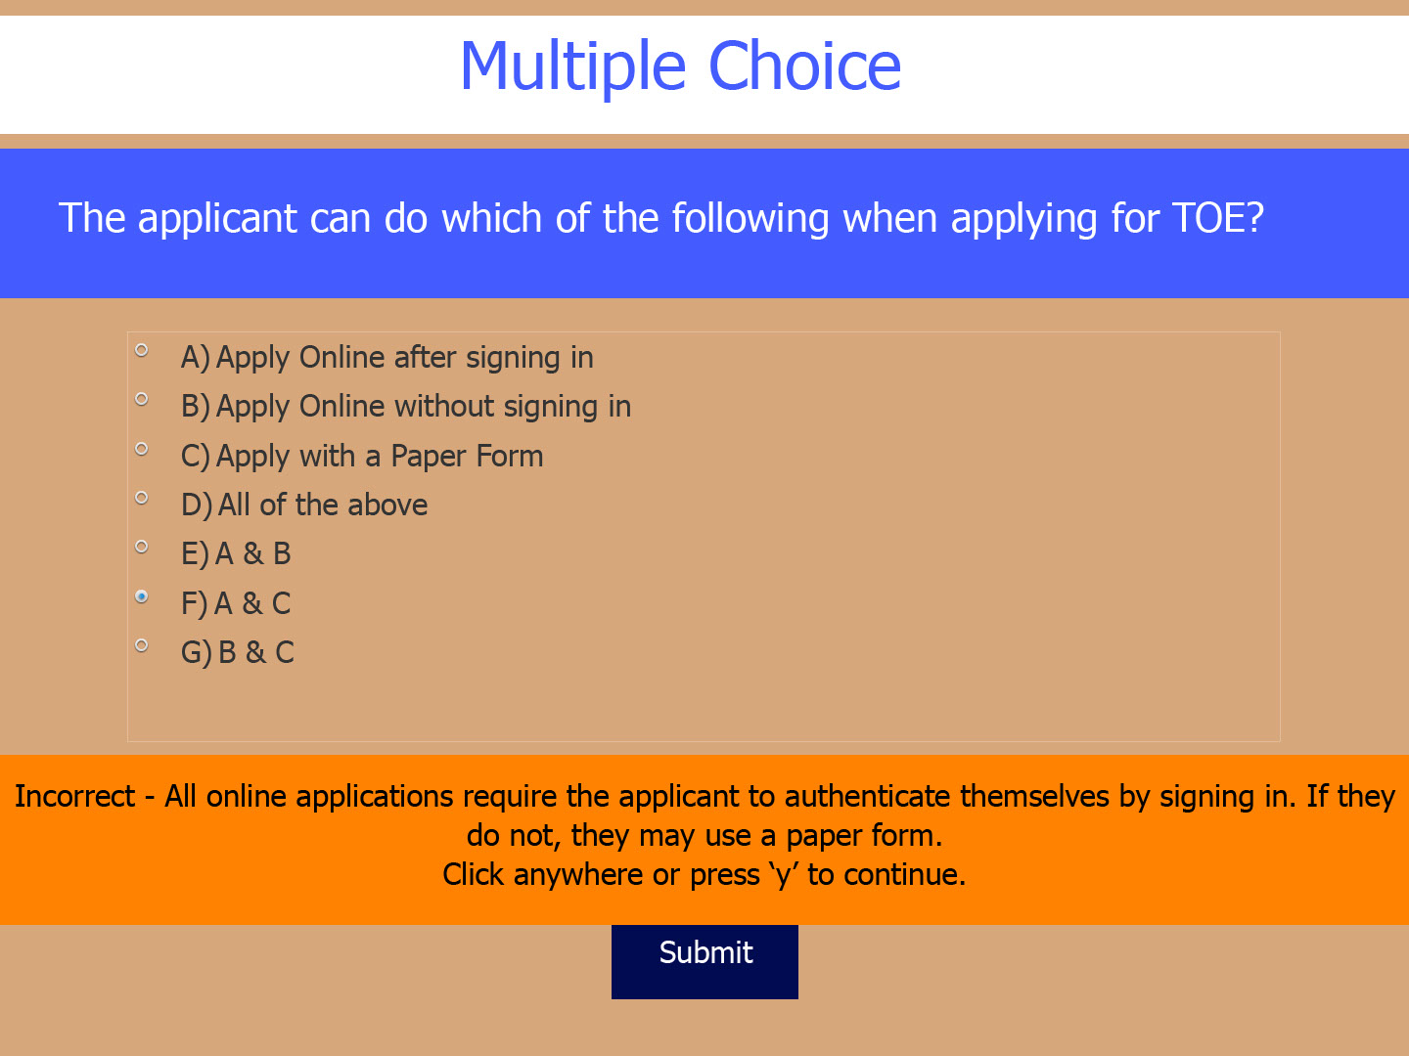
Slide notes

Last question.

Which of the following are ways one can apply for TOE?

Slide 41 - Back to the Demo

Slide notes

The PAWS is over.

Now back to the demo.

Slide 42 - Step 2: Sponsor information
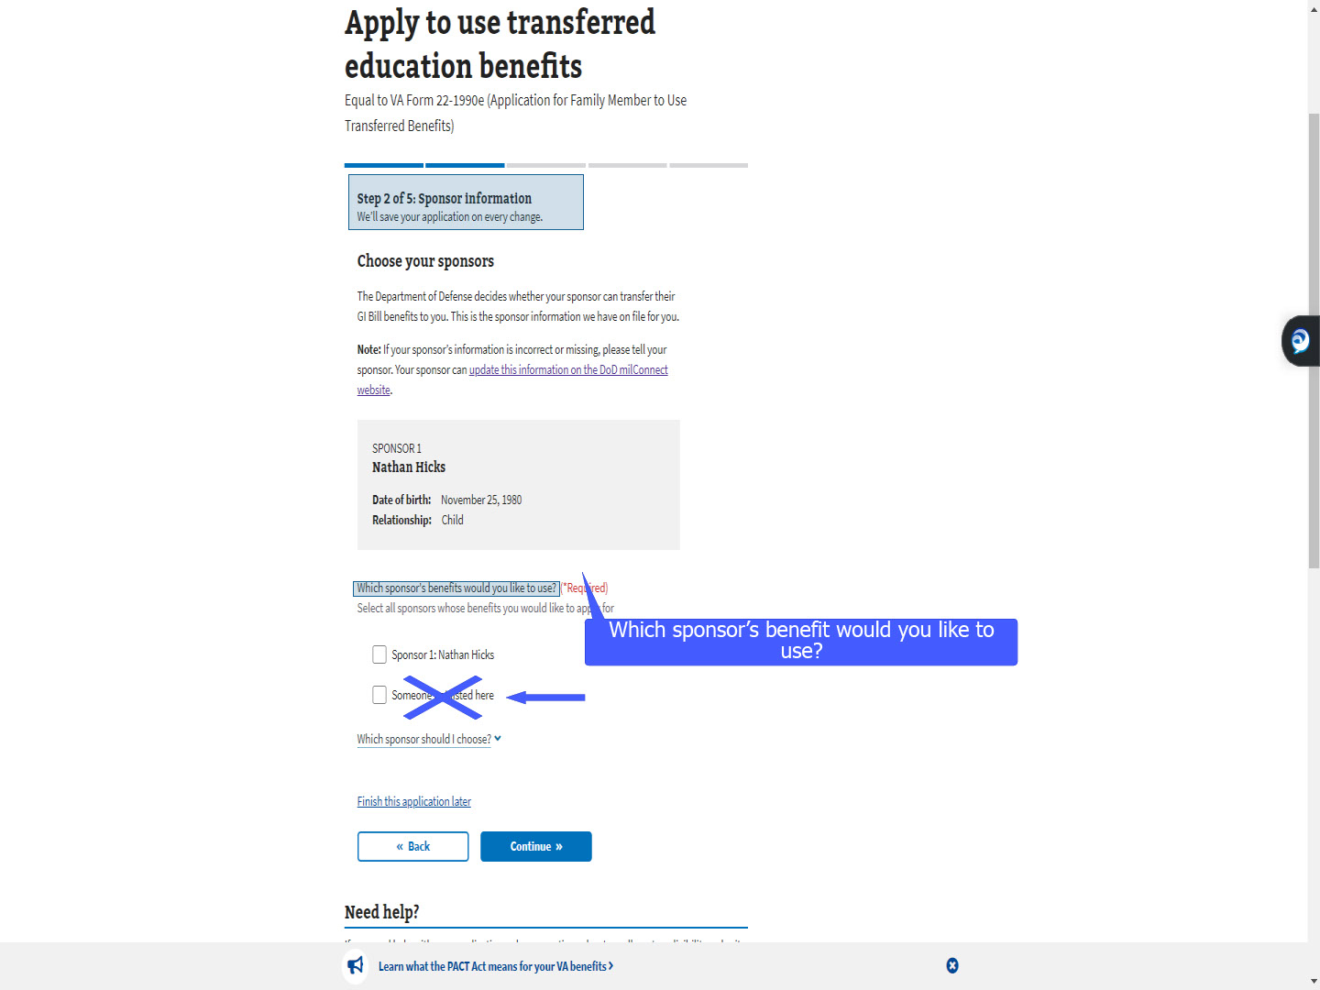
Slide notes

“Step 2 of 5: Sponsor information”

is next in the TOE MEB application.

The applicant will select which sponsor’s benefit

they would like to use.

Currently, the application gives the choice to select

“Sponsor not listed”.

This will be removed in a future release.

Slide 43 - Which sponsor should I choose
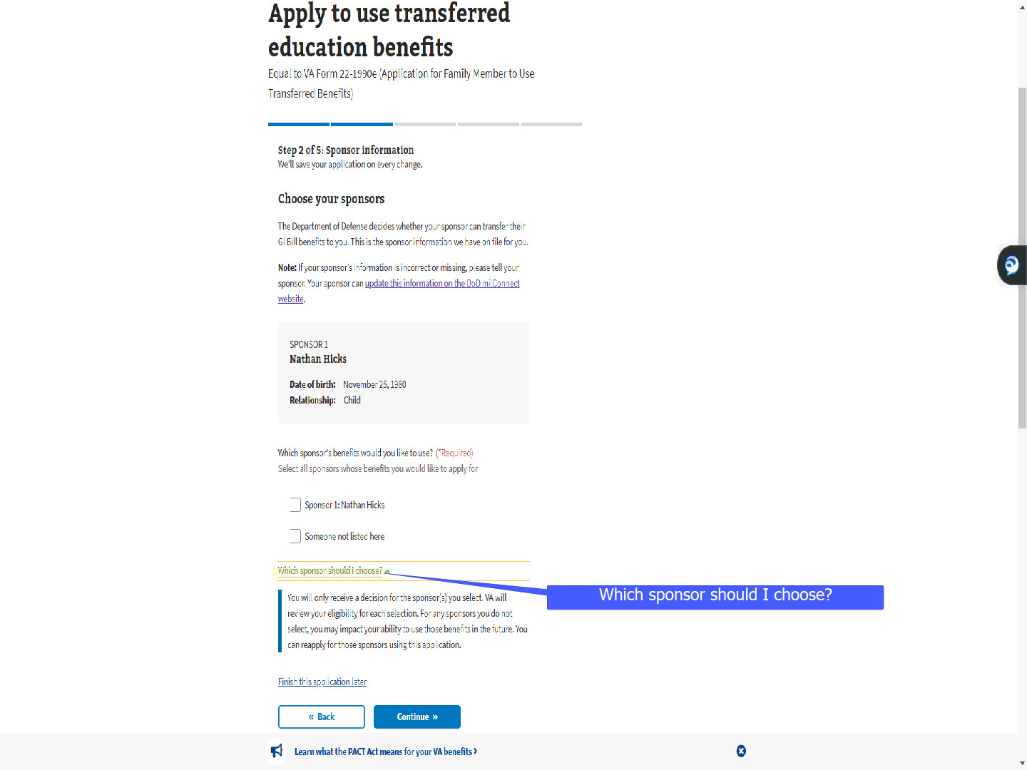
Slide notes

As we saw in the previous demonstration,

MEB has dropdowns with additional information.

For TOE, it offers help

on which sponsor the dependent should choose.

Slide 44 - Multiple Sponsors
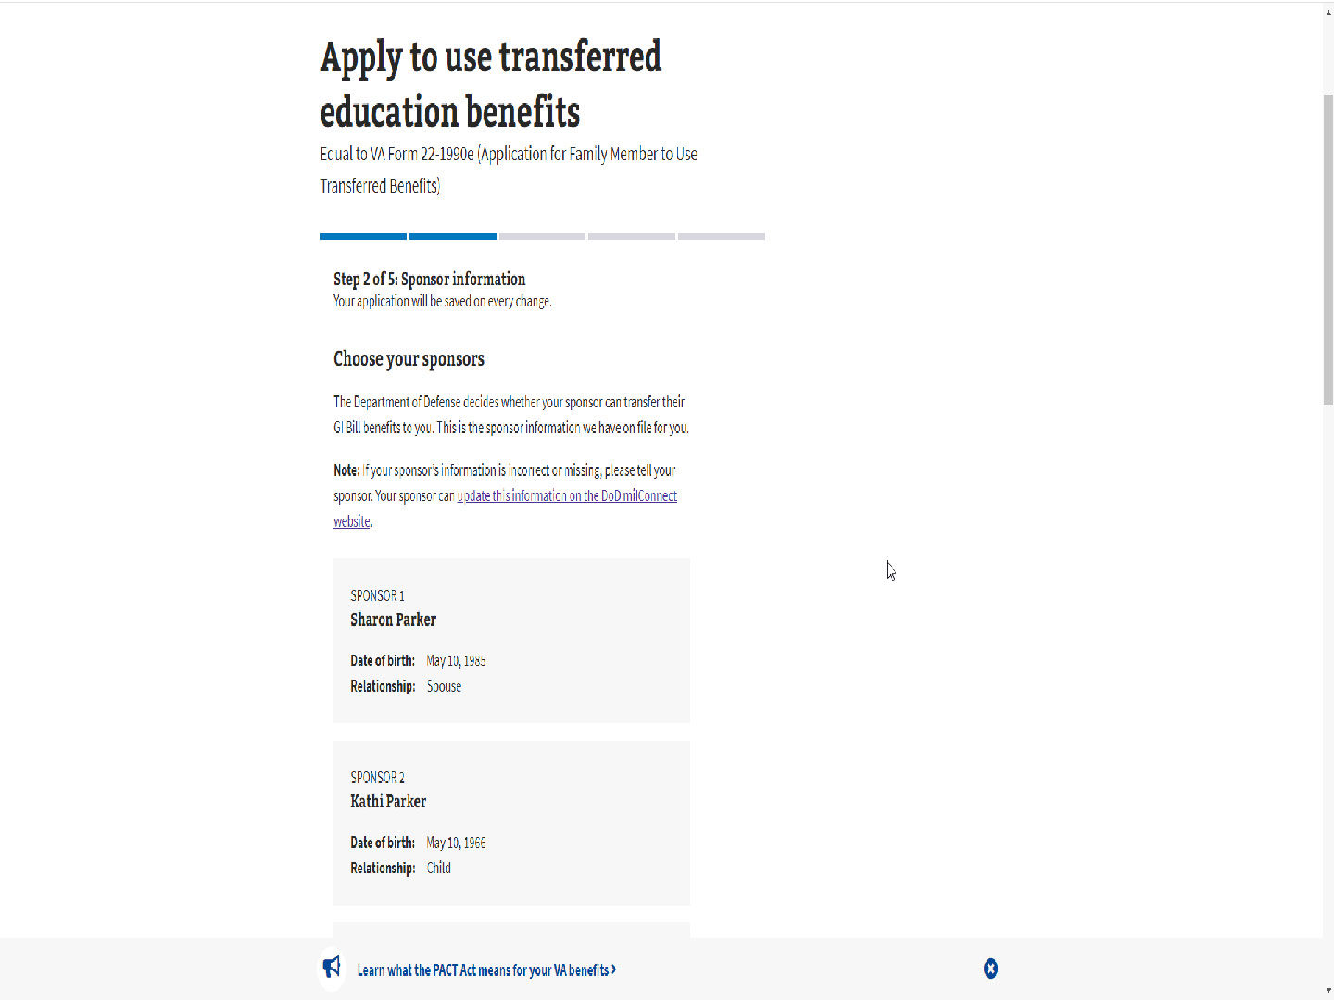
Slide notes

For some dependents,

there may be multiple sponsors.

Slide 45 - Select all sponsors whose benefits you would like to apply for
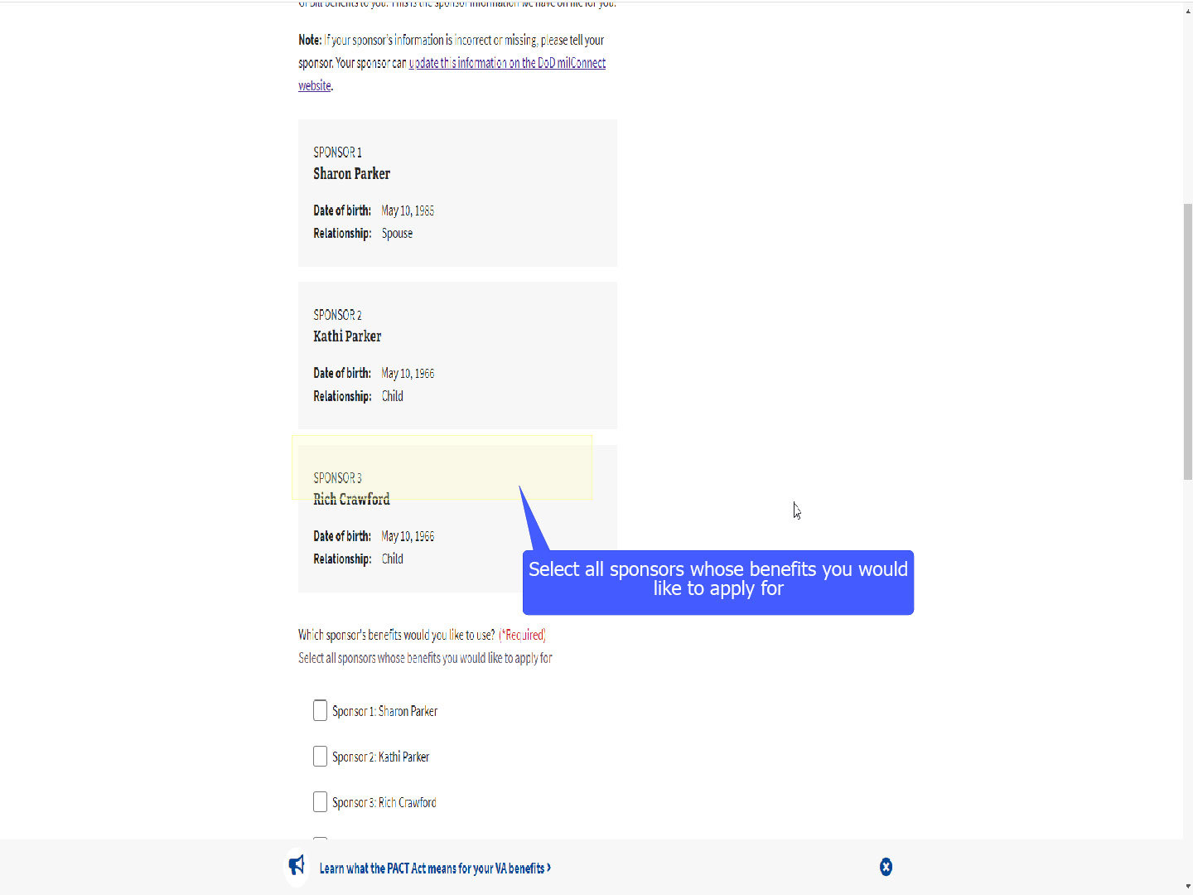
Slide notes

The applicant will select ALL the sponsor’s

whose benefit they would like to apply to use.

Slide 46 - Select multiple sponsor
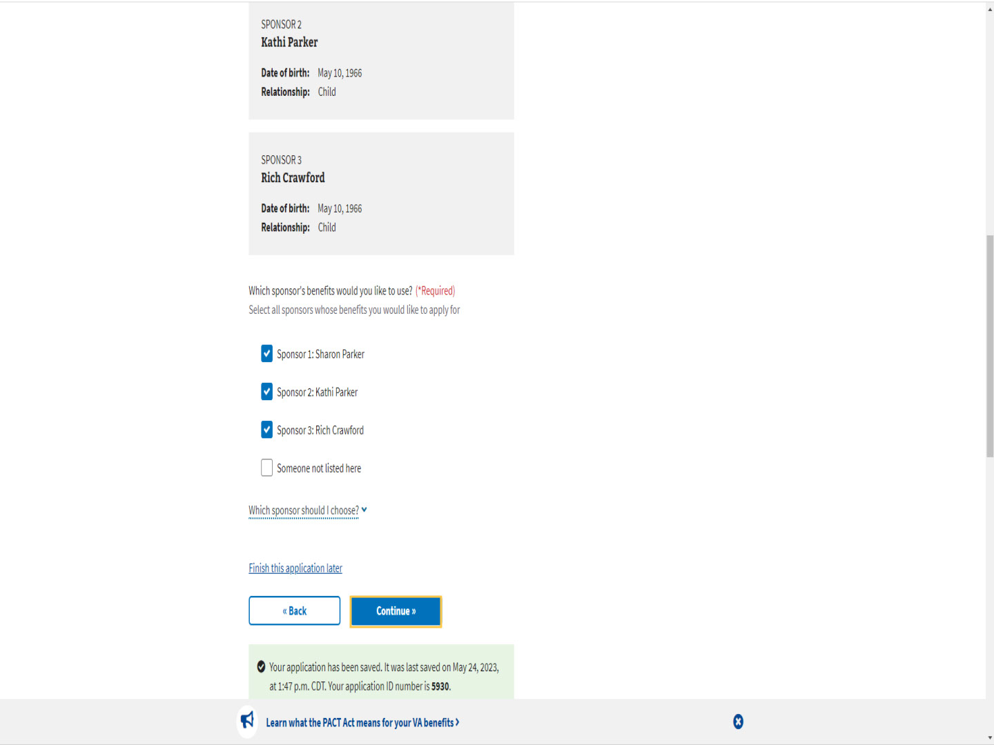
Slide notes

If they select multiple sponsors

and select continue,

Slide 47 - Which sponsor should I use first?
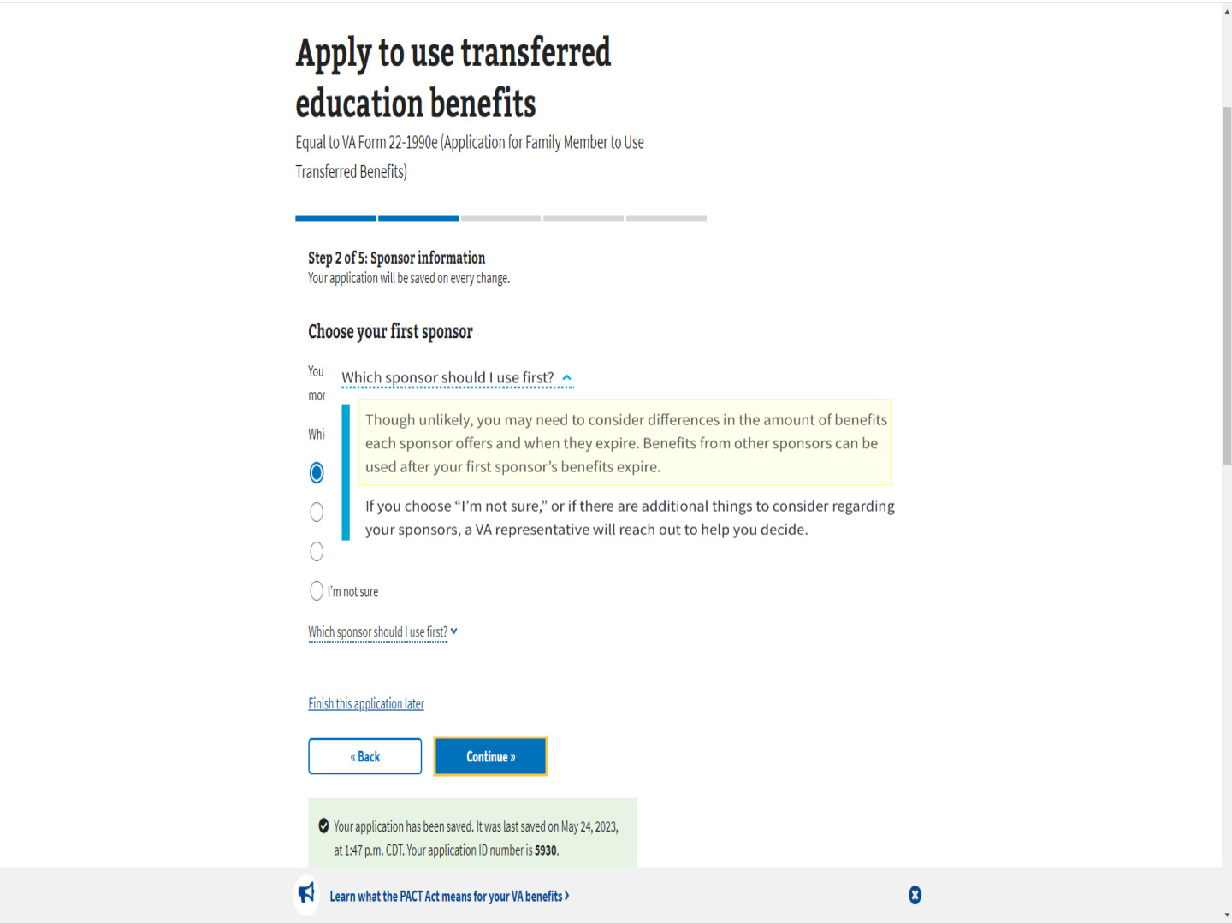
Slide notes

MEB offers a dropdown,

“Which sponsor should I use first?”

The pop-up states “Though unlikely,

you may need to consider differences in the amount of benefits

each sponsor offers and when they expire.

Benefits from other sponsors can be used

after your first sponsor’s benefits expire.

Slide 48 - Which sponsor should I use first cont.
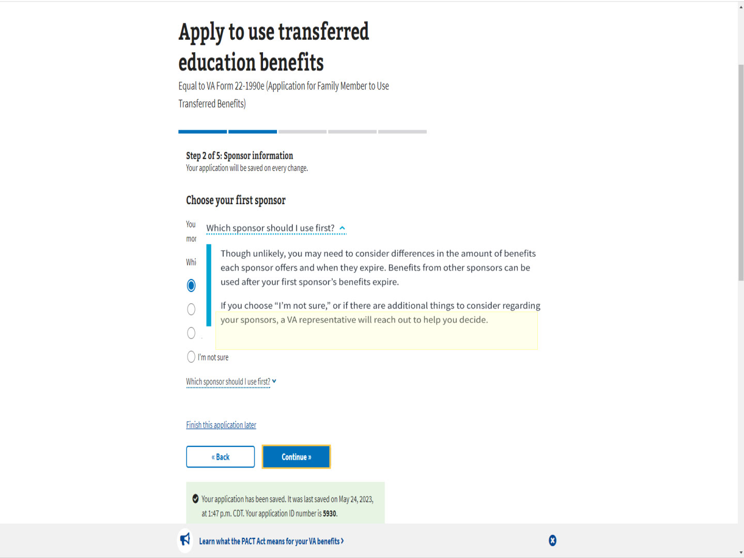
Slide notes

If you choose “I’m not sure”,

or if there are additional things to consider

regarding your sponsors,

a VA representative will reach out

to help you decide. “

Slide 49 - One Sponsor
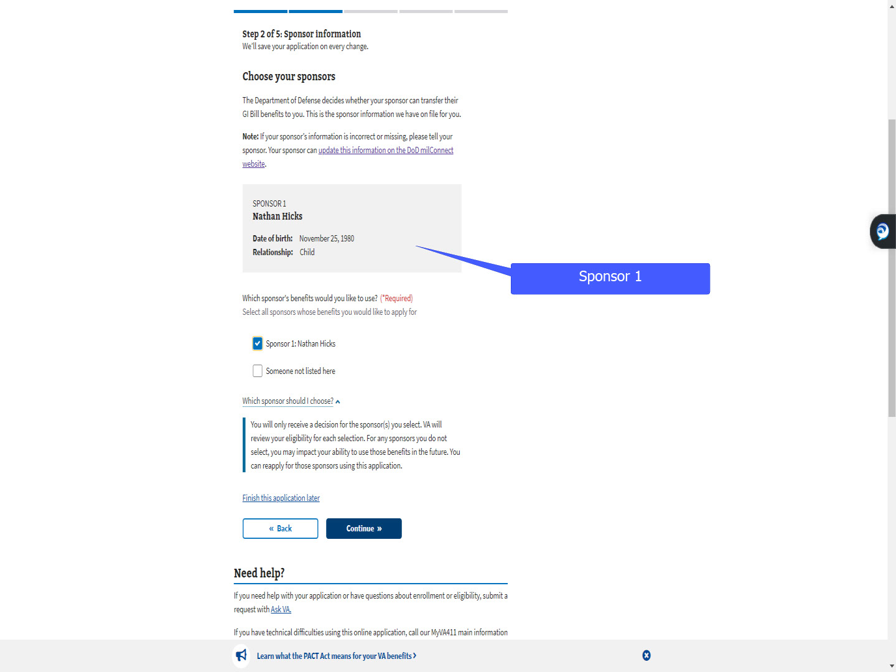
Slide notes

For today’s demonstration,

we will use an applicant with only one sponsor.

with only one sponsor.

Slide 50 - Verify your high school education
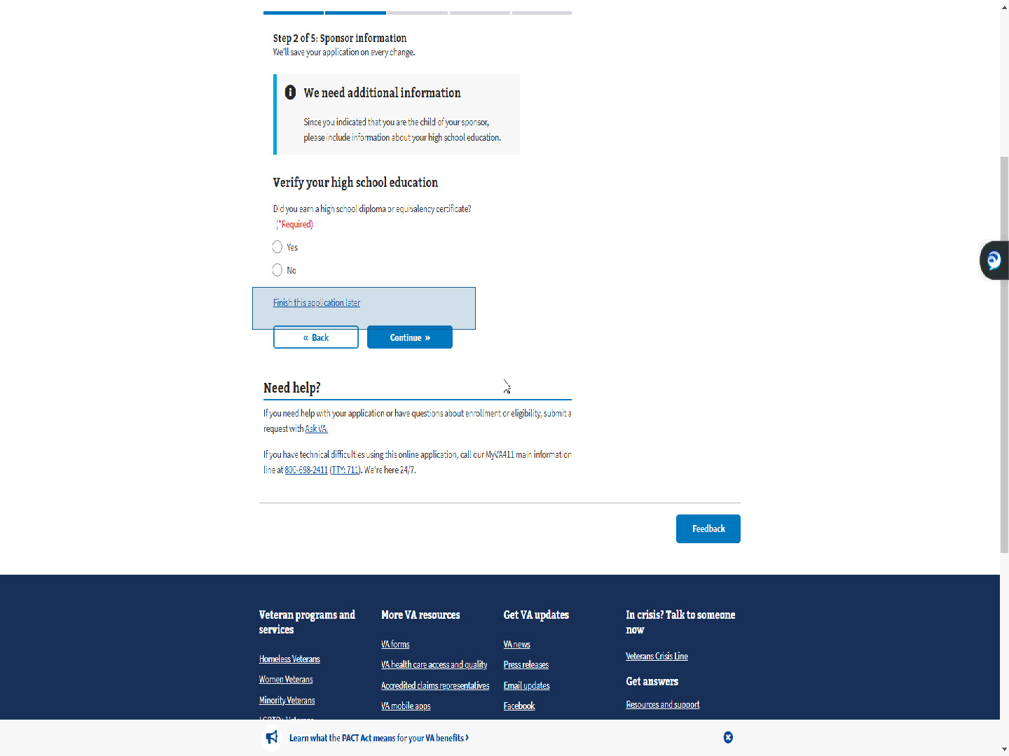
Slide notes

The next step under “Sponsor information” is

verifying their high school education

if they are a child of the sponsor.

Slide 51 - Slide 51
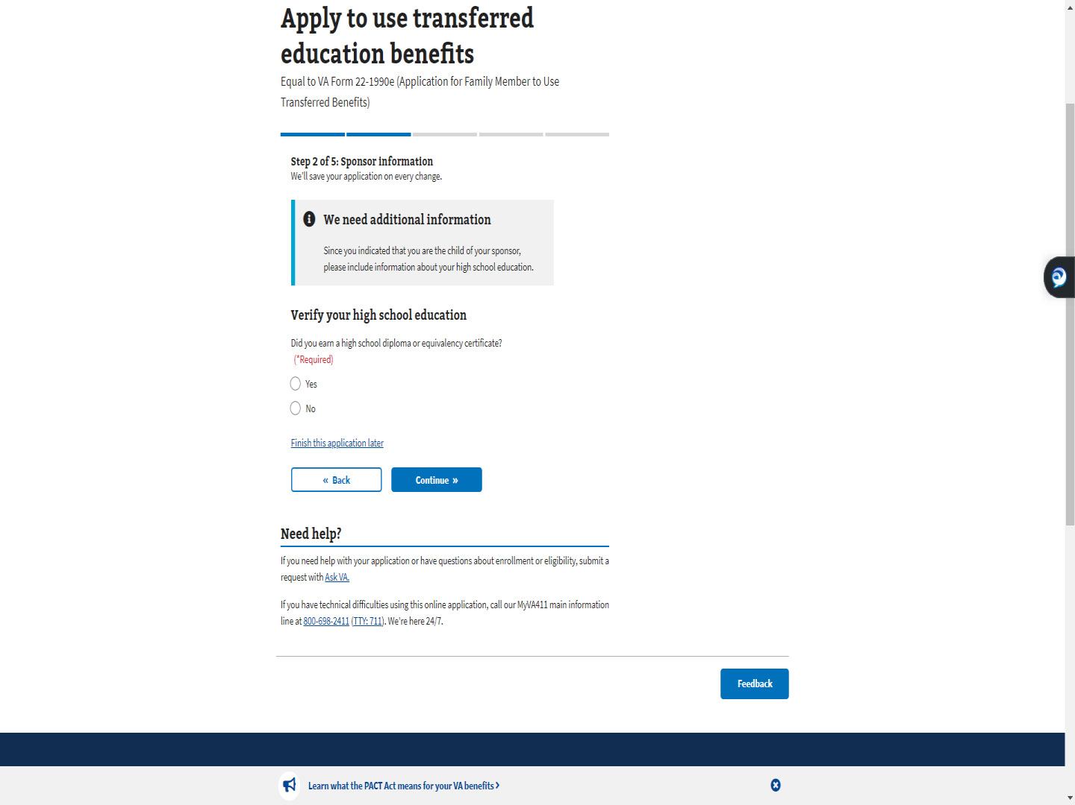
Slide notes

The child would select

“Yes” or “No’ as to whether they earned

a high school diploma or GED.

Slide 52 - Slide 52
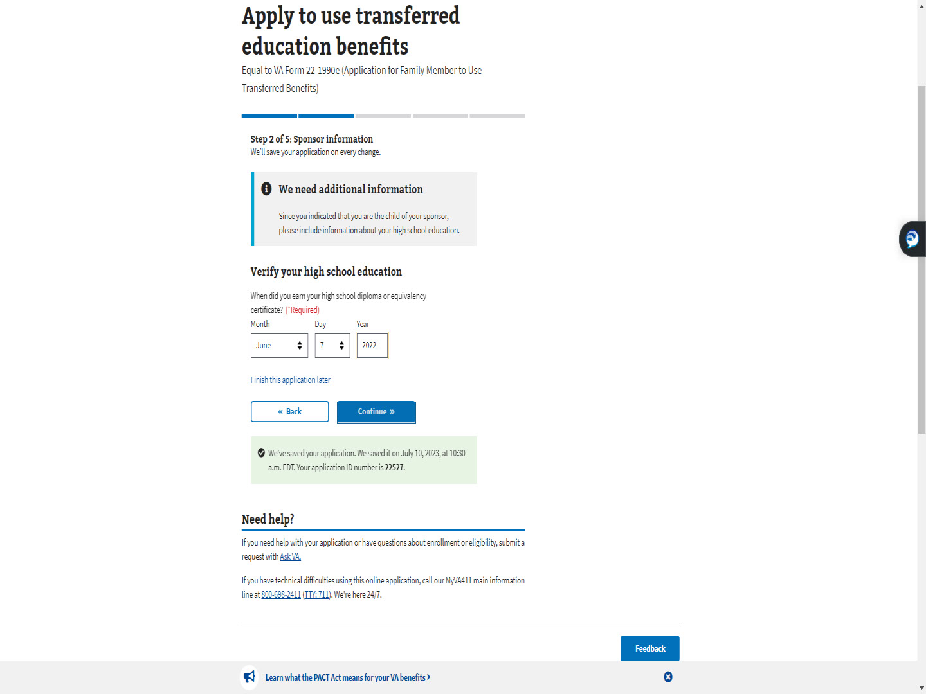
Slide notes

If they selected “Yes”,

MEB will ask for the date.

If they are a dependent spouse,

education is not addressed.

Slide 53 - Step 3: Contact information
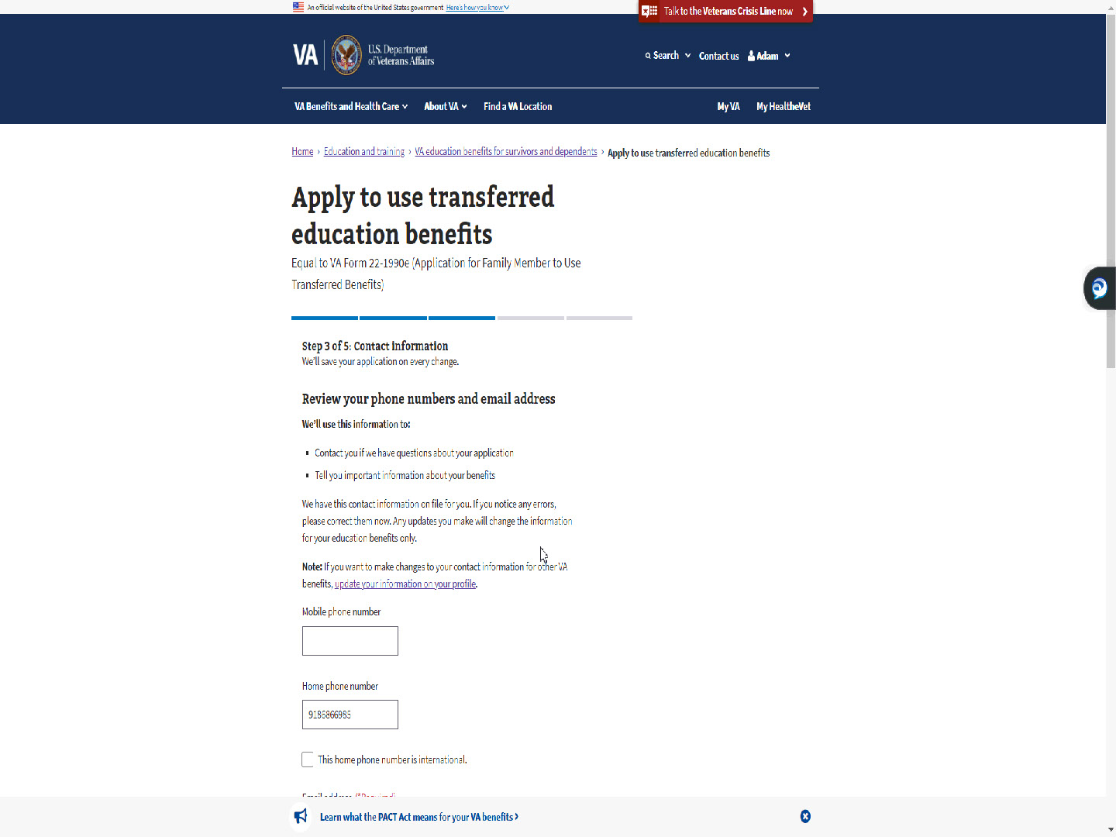
Slide notes

Step 3 of 5 is Contact Information.

The phone numbers and email address are pre-populated.

The TOE applicant can update this information

in MEB for their Education benefits.

Slide 54 - Slide 54
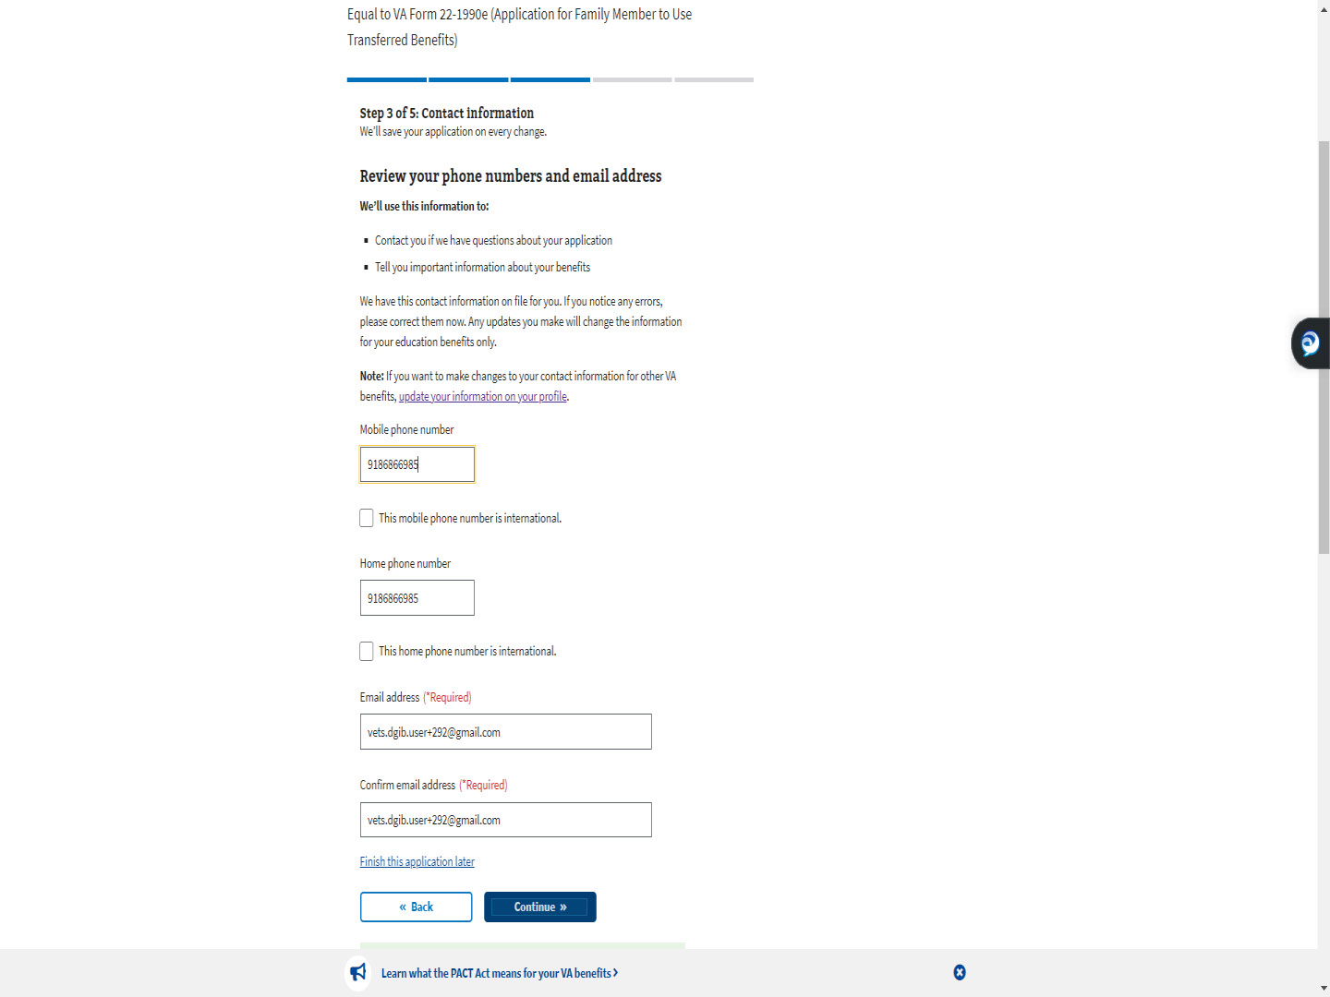
Slide notes

Slide 55 - VA profile vs MEB
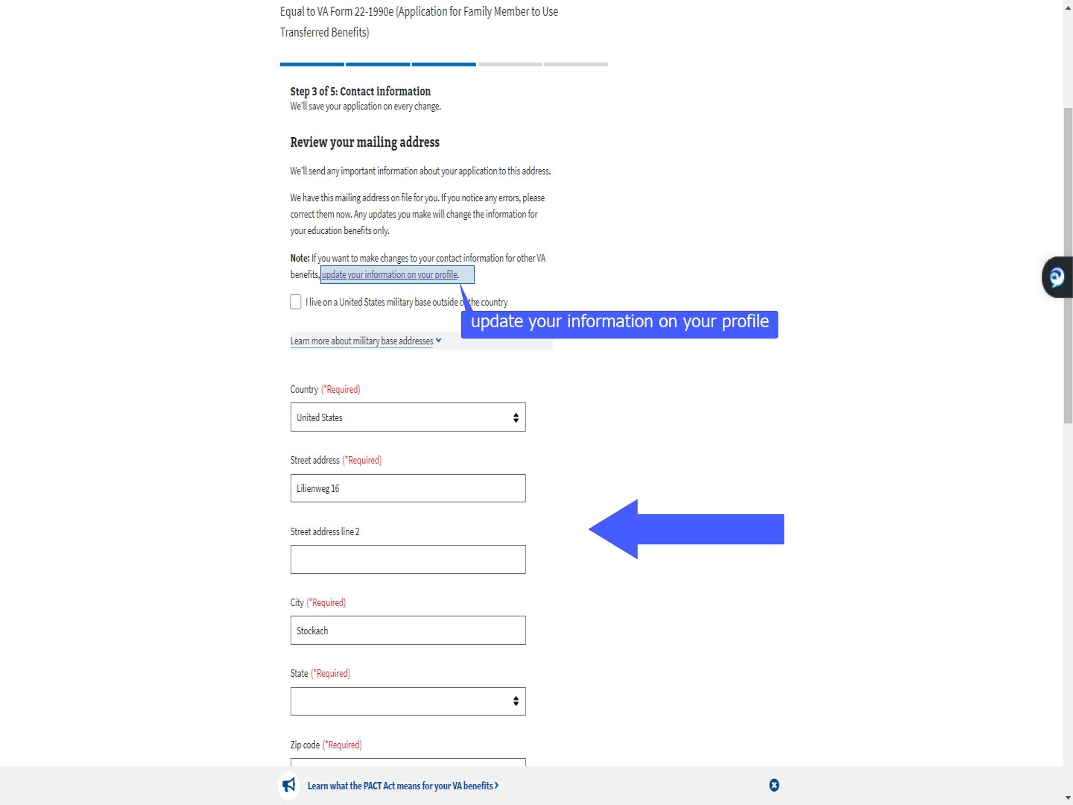
Slide notes

While reviewing their mailing address,

all “*Required” fields must be filled.

Updating the fields in MEB

does not update the address for other VA benefits.

If the applicant wants to update for all VA benefits,

to include compensation and pension,

they will need to click the link

“update your information on your profile”.

Slide 56 - Slide 56
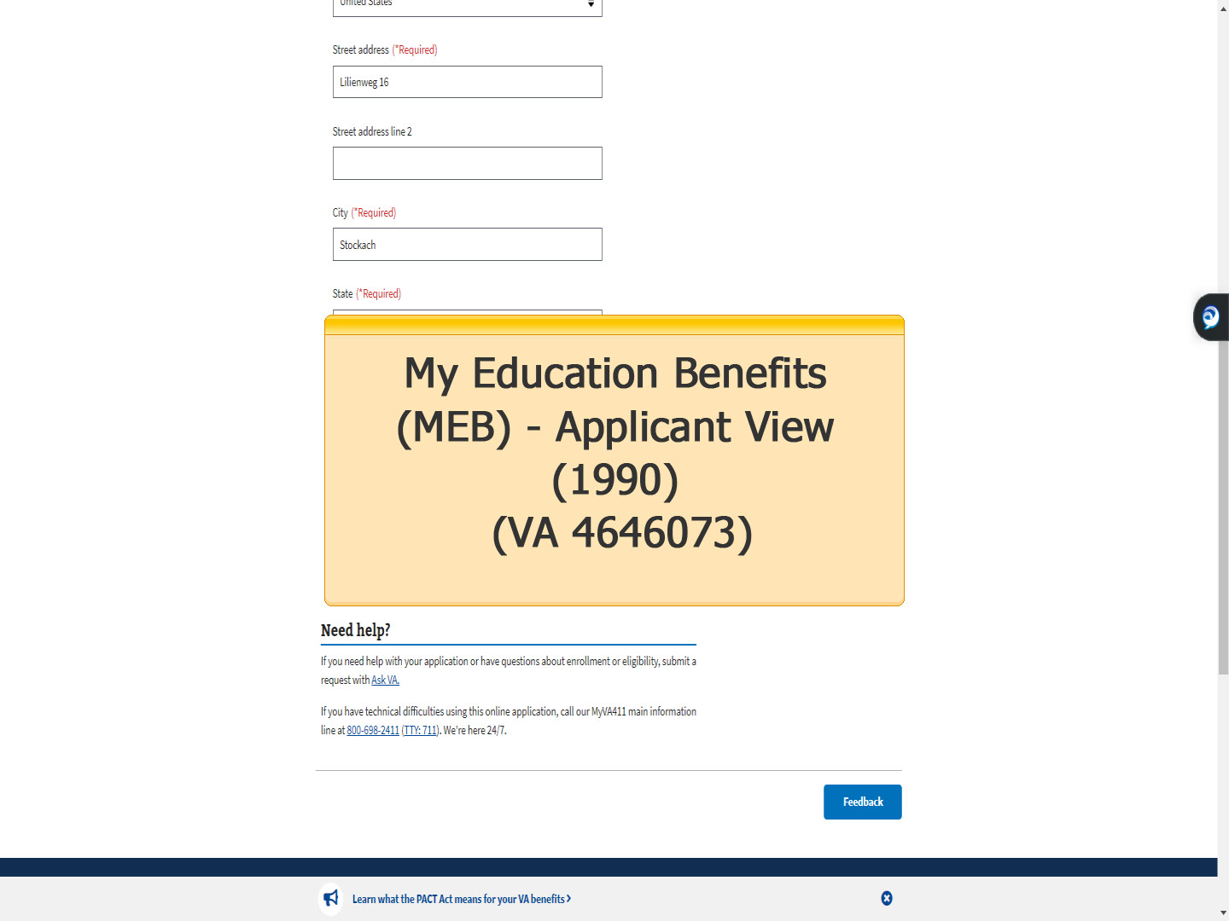
Slide notes

The MEB Applicant View (1990) training

covers the differences in the profiles

and provides more detailed information

on the contact information section of MEB.

Slide 57 - Contact method for follow-up
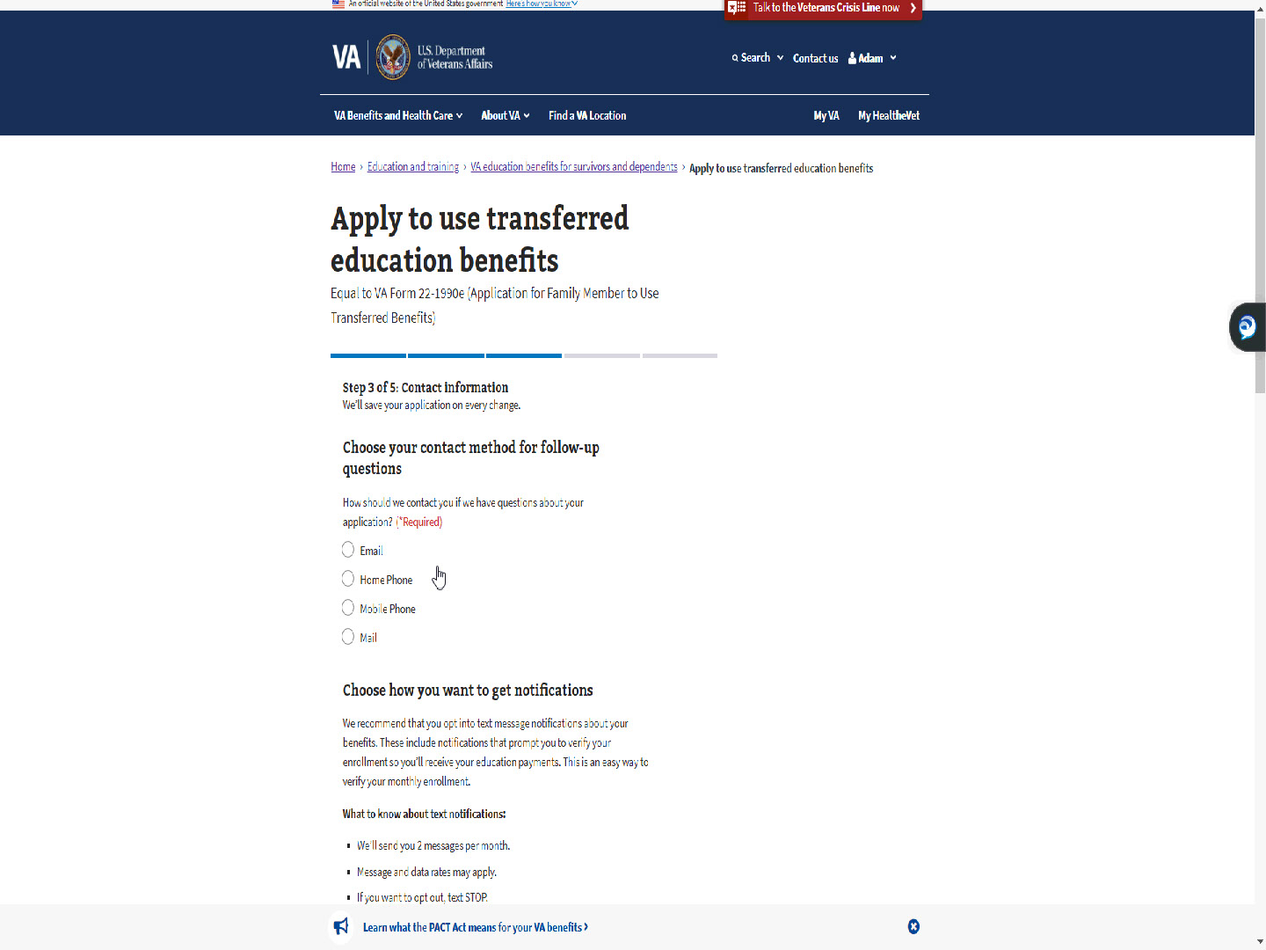
Slide notes

The TOE applicant will need to choose

a method of contact for

follow-up questions and notifications.

Slide 58 - Slide 58
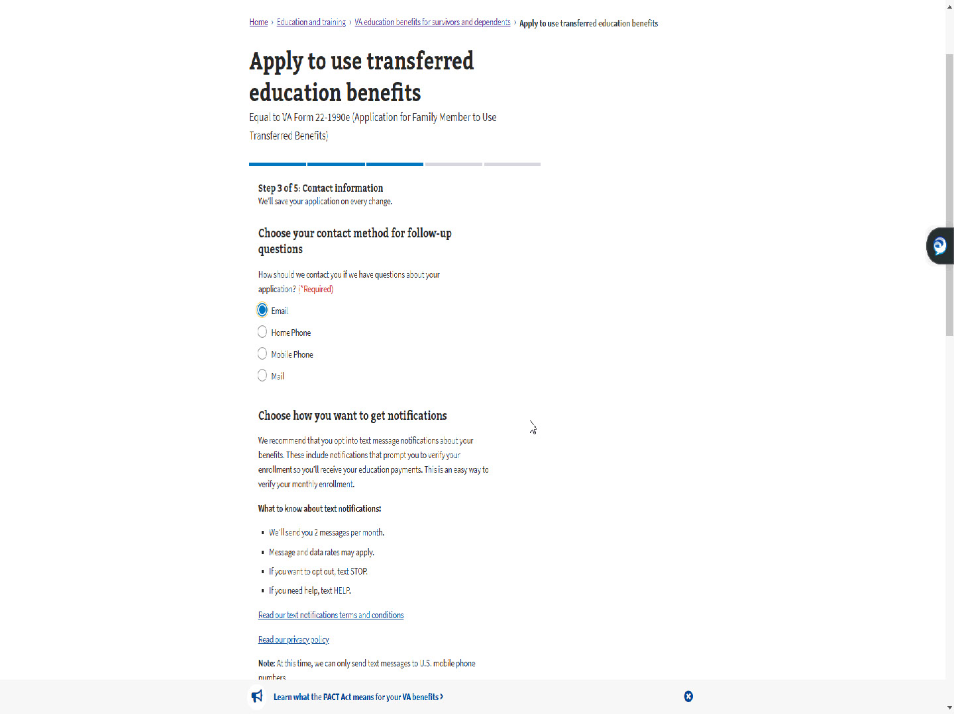
Slide notes

Slide 59 - Choose how you want to get notifications
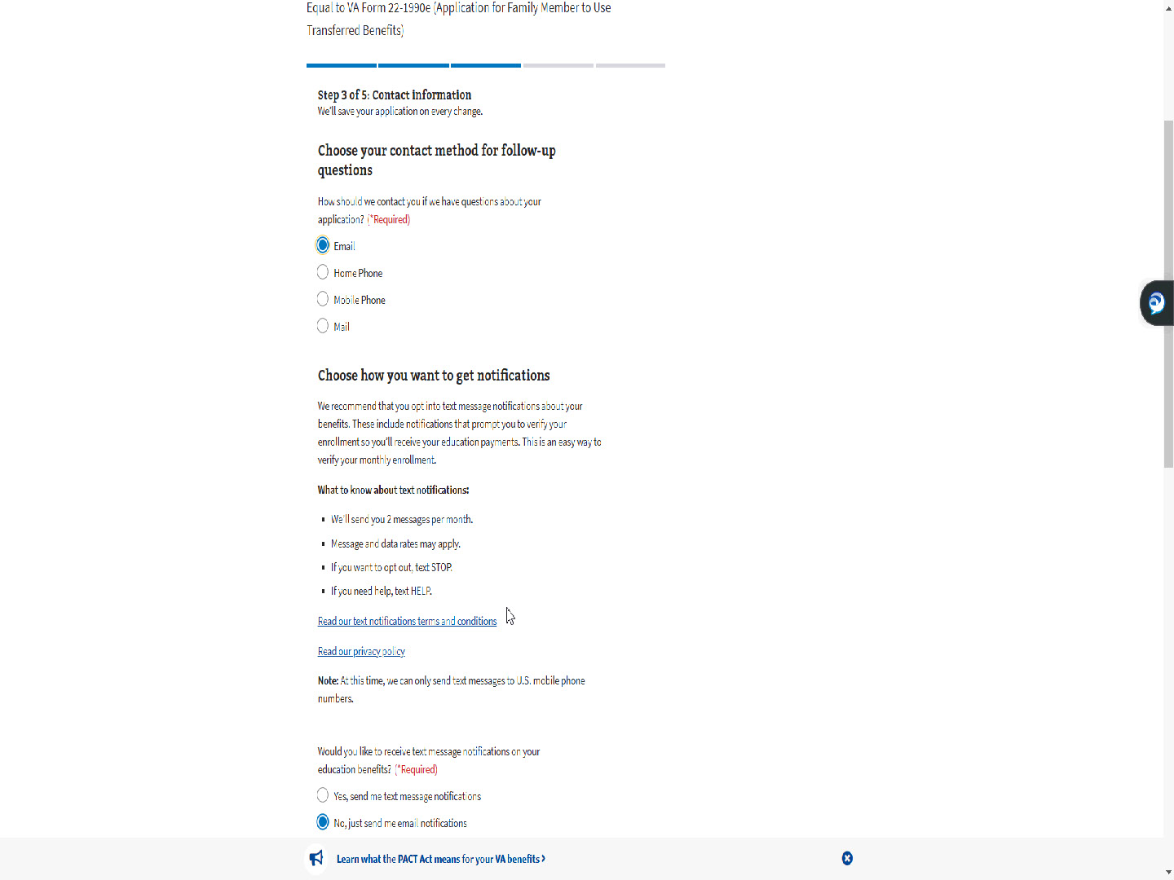
Slide notes

Similar to the Self MEB application,

the follow-up question defaults to “Email”.

Slide 60 - Default- No
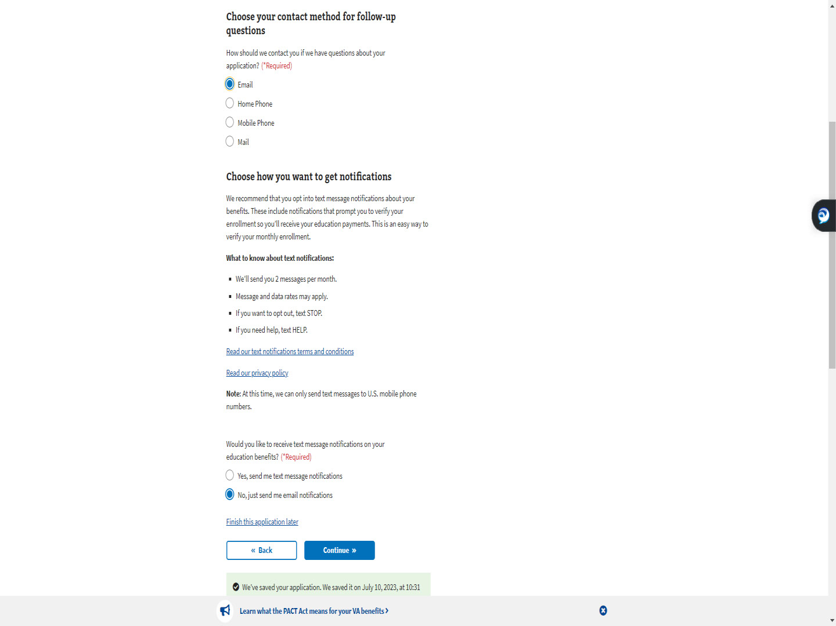
Slide notes

Unlike the Self MEB application,

text messaging defaults to “No”.

Slide 61 - Slide 61
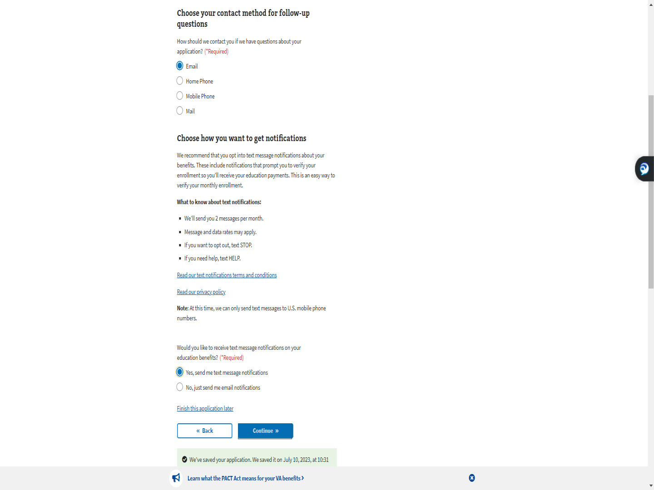
Slide notes

Slide 62 - Step 4: Direct deposit
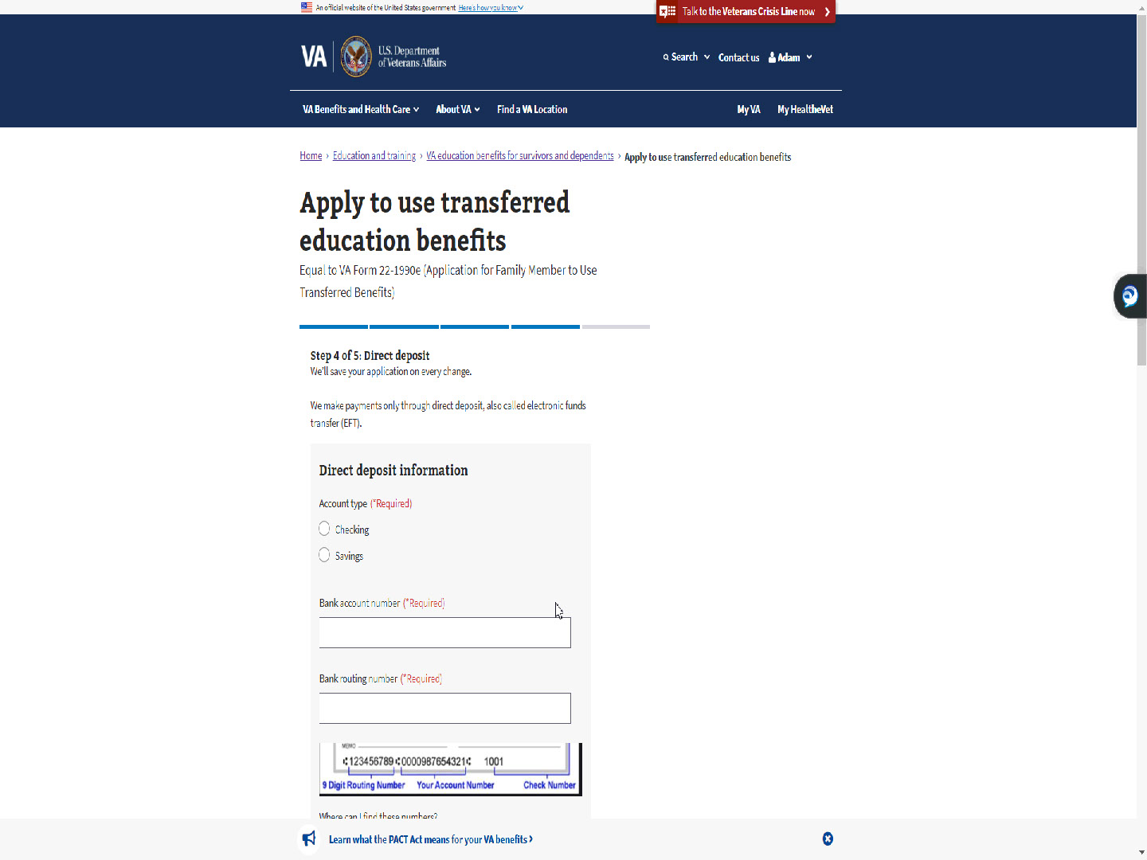
Slide notes

The next step is Step 4: Direct deposit.

Slide 63 - Slide 63
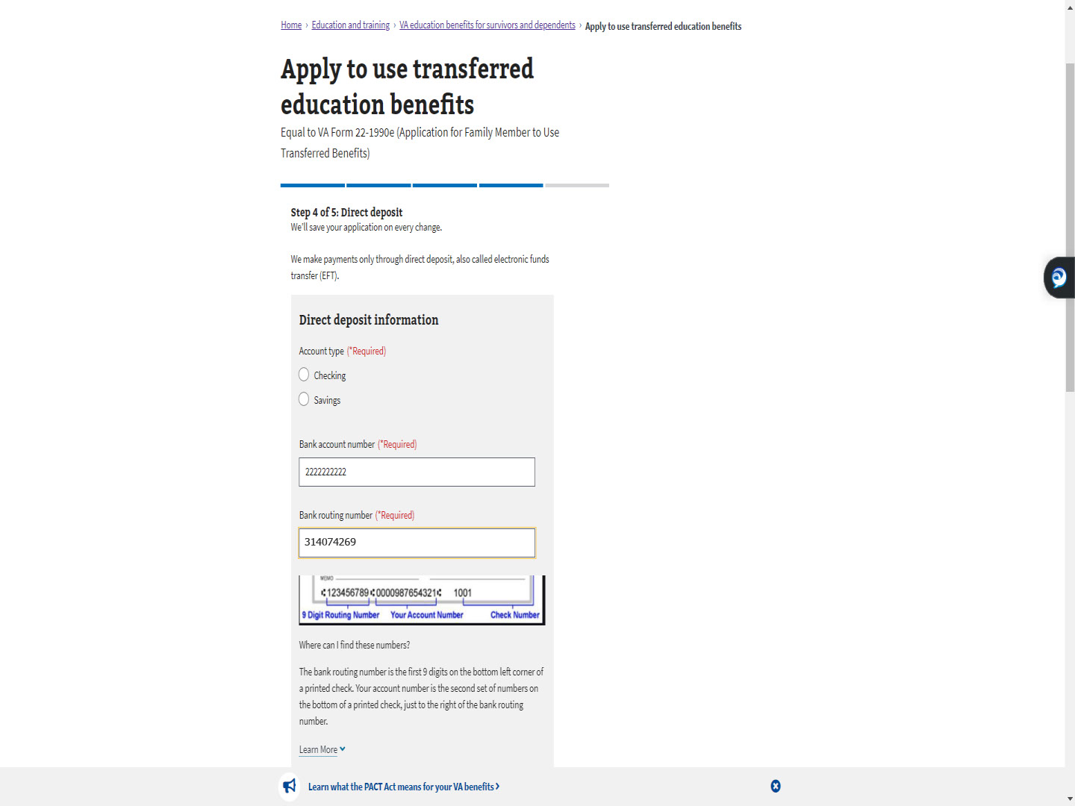
Slide notes

The applicant will enter their direct deposit information.

Slide 64 - Slide 64
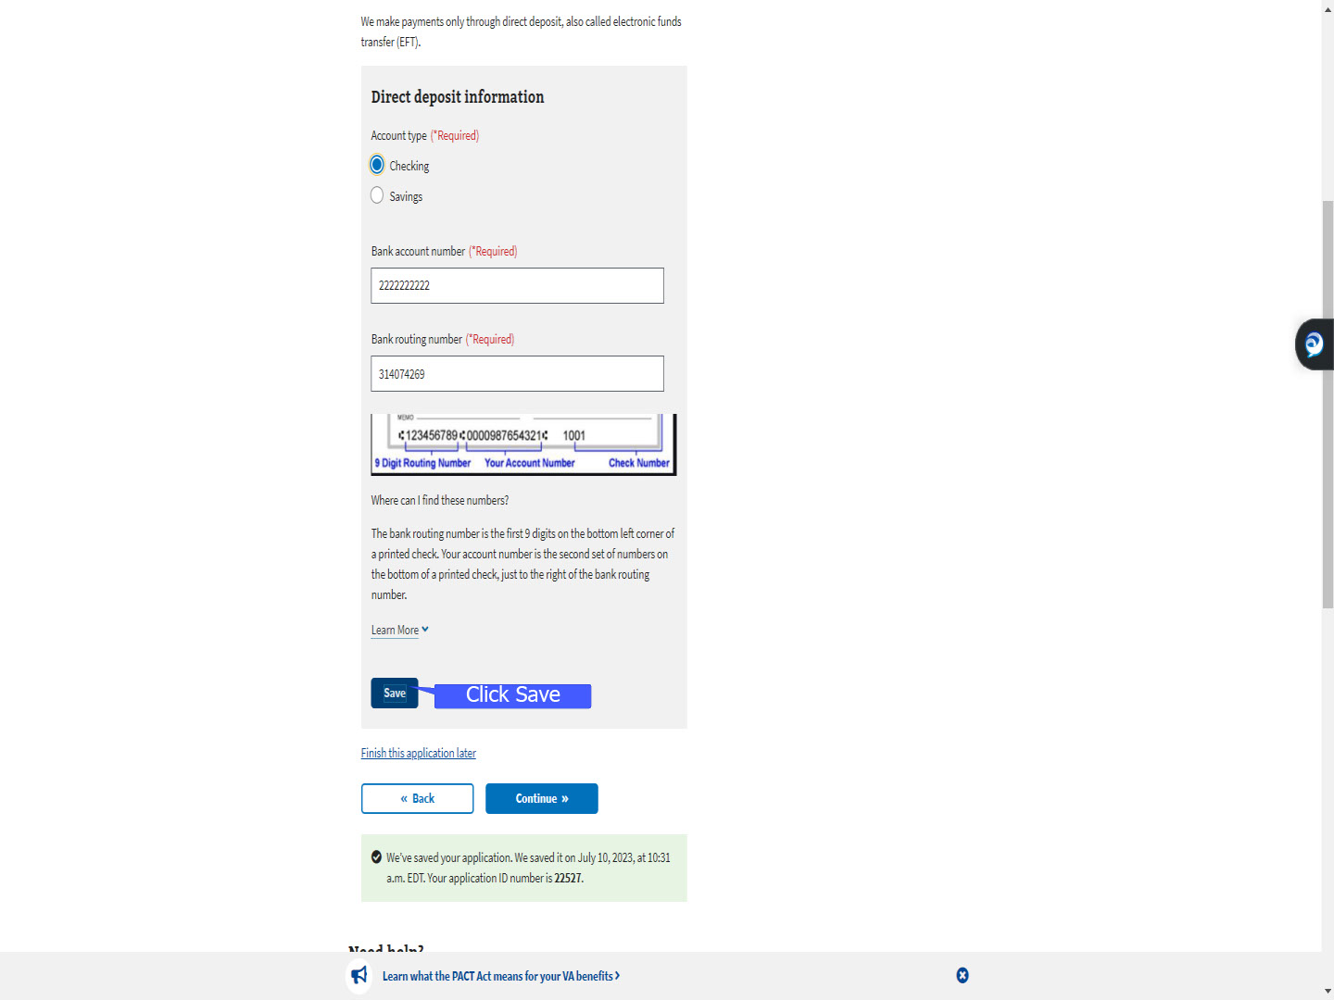
Slide notes

An update to MEB, now asks them to select “Save”.

Slide 65 - Slide 65
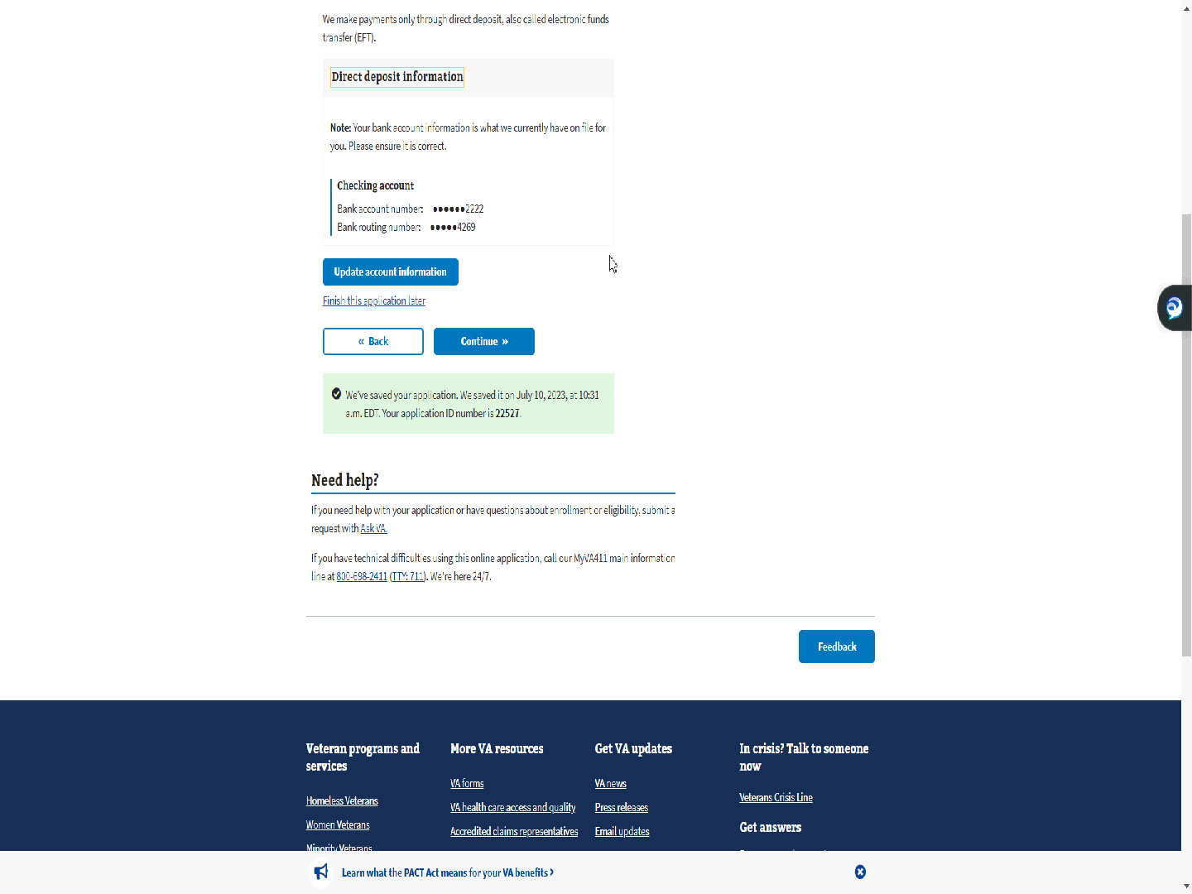
Slide notes

They are shown their direct deposit information

one more time and given the opportunity to

“Update account information” before advancing.

Slide 66 - Slide 66
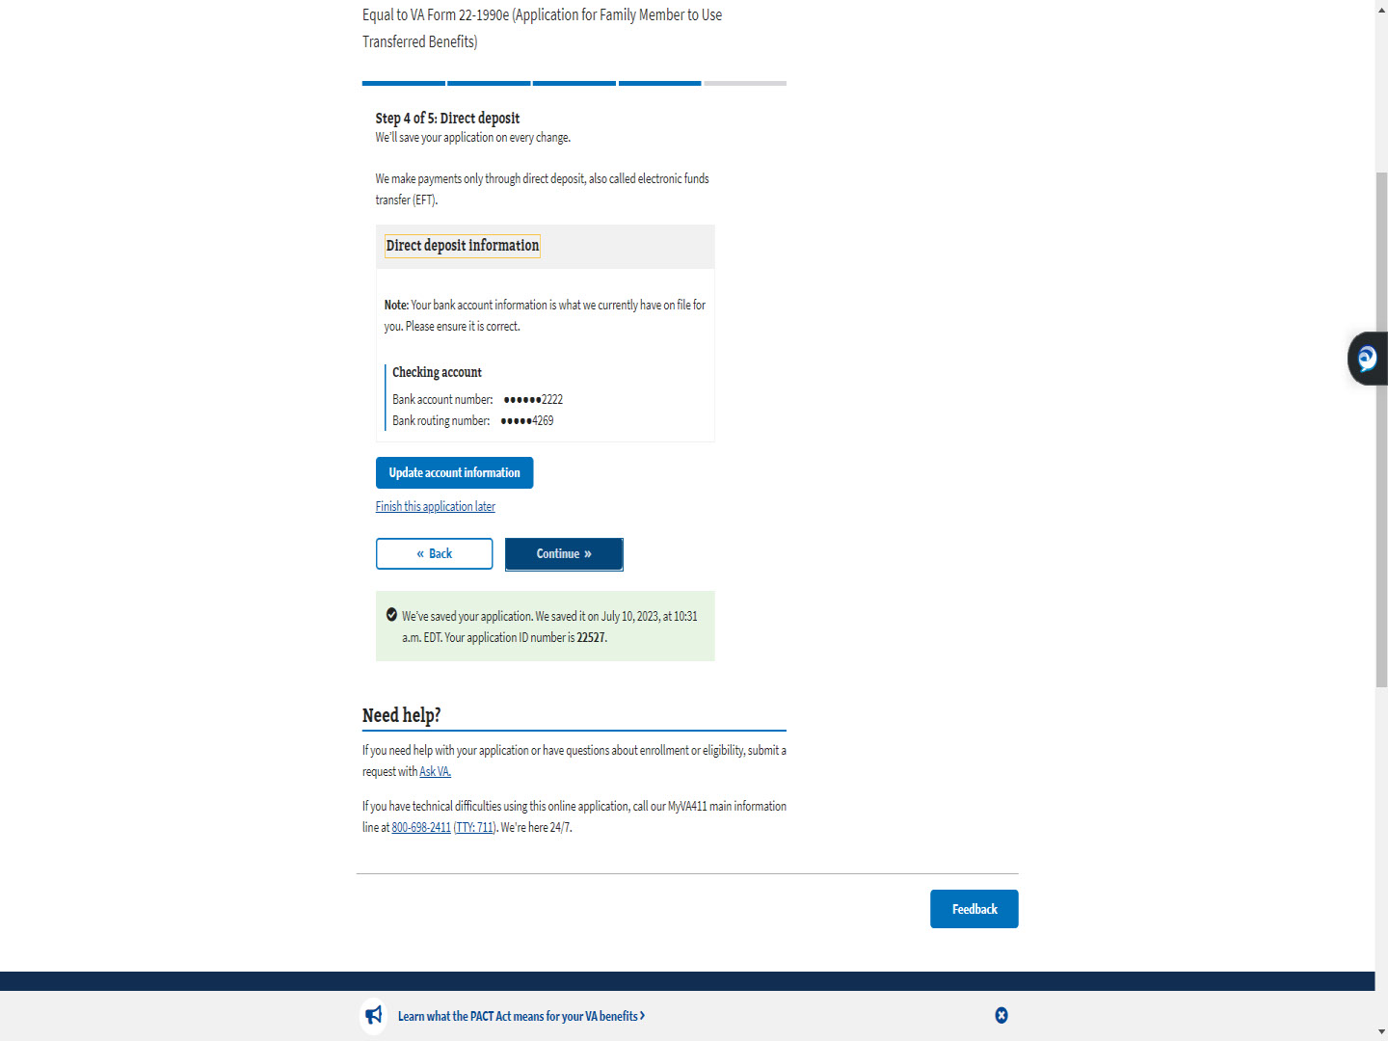
Slide notes

Slide 67 - Step 5: Review application
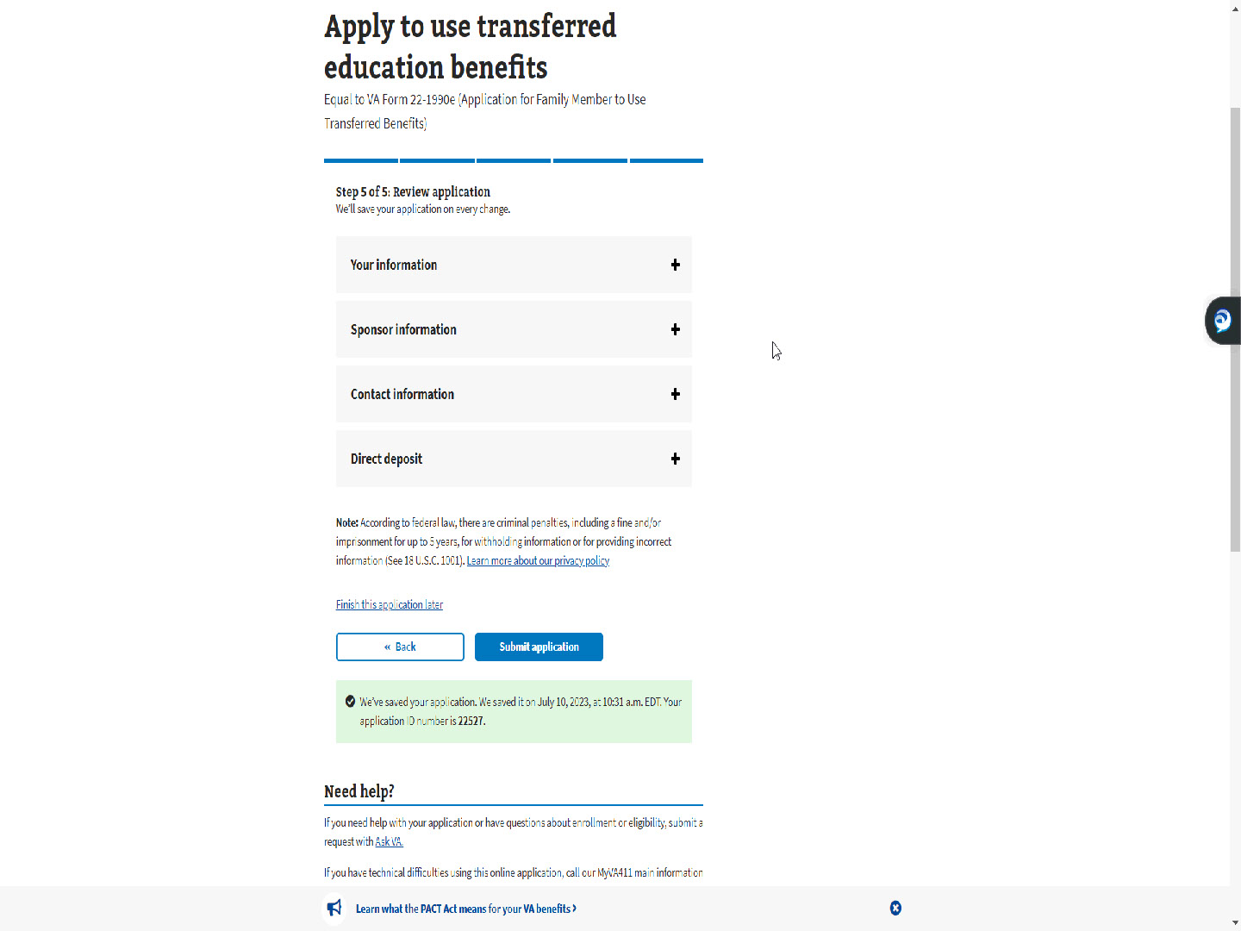
Slide notes

The final step is Step 5 of 5: Review application.

Slide 68 - Plus sign
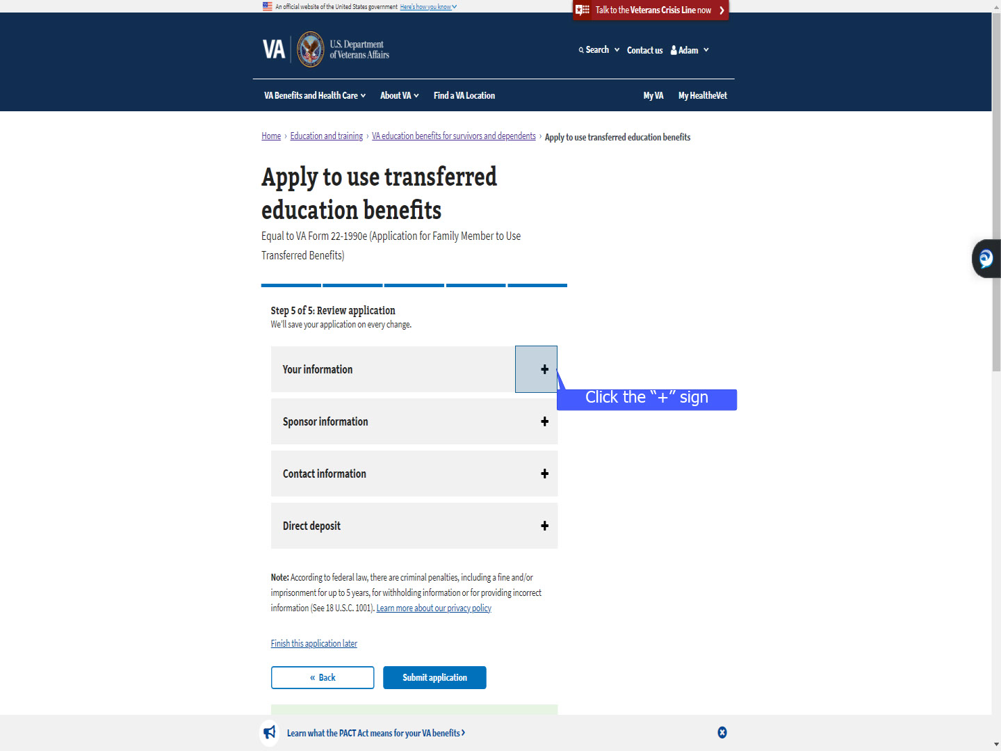
Slide notes

Selecting the “+” sign

allows the applicant to review the information

they have entered,

per section,

throughout the application process.

Slide 69 - Your information
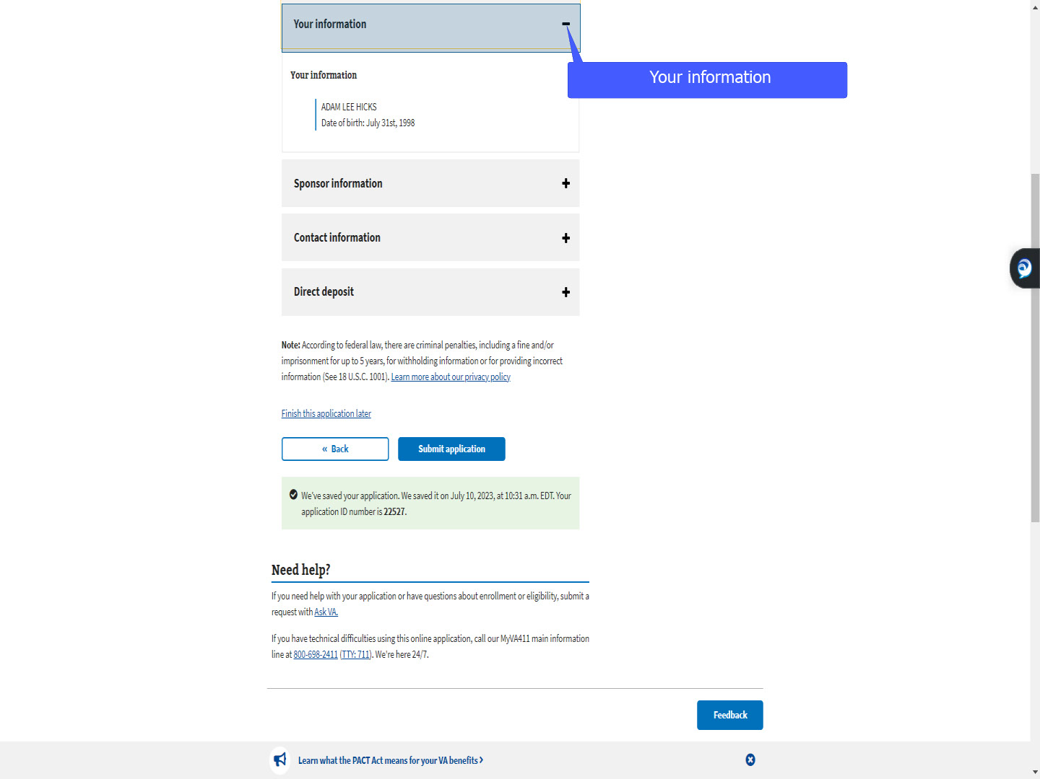
Slide notes

“Your information”

Slide 70 - Sponsor information
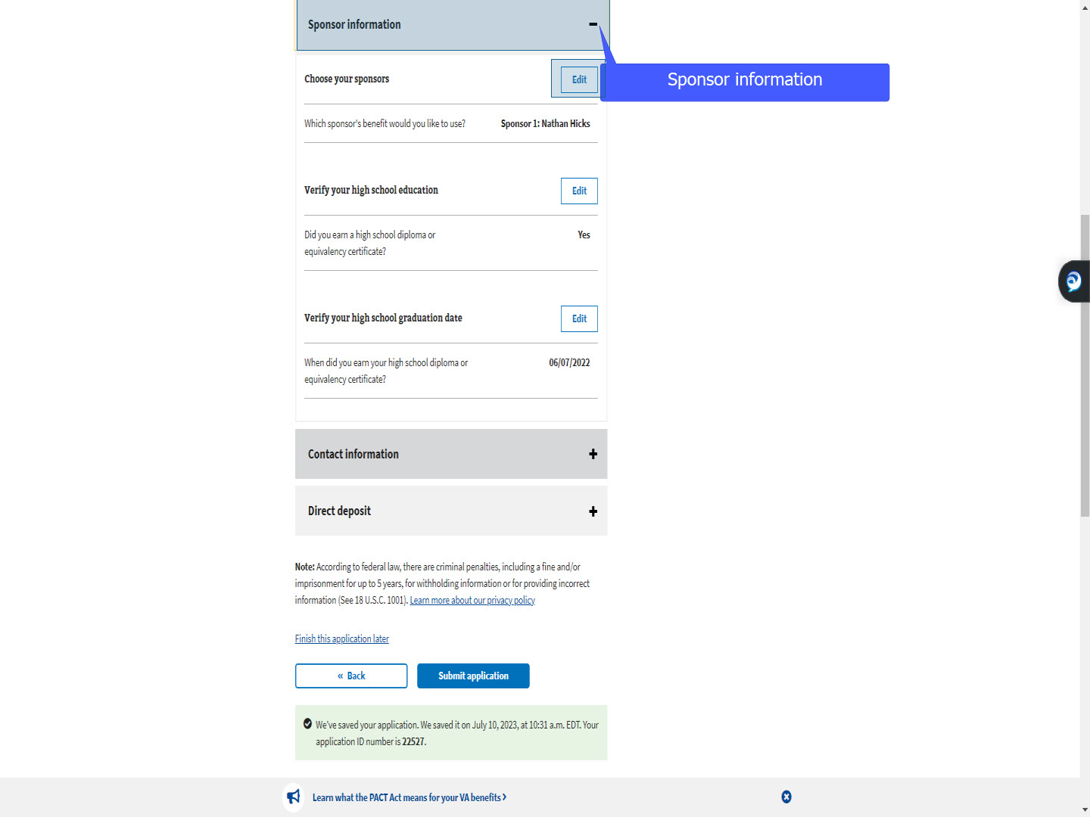
Slide notes

“Sponsor information”.

Note: The “Edit” button is introduced in this section.

The applicant can select “Edit”

and amend any information

previously entered.

Slide 71 - Contact information
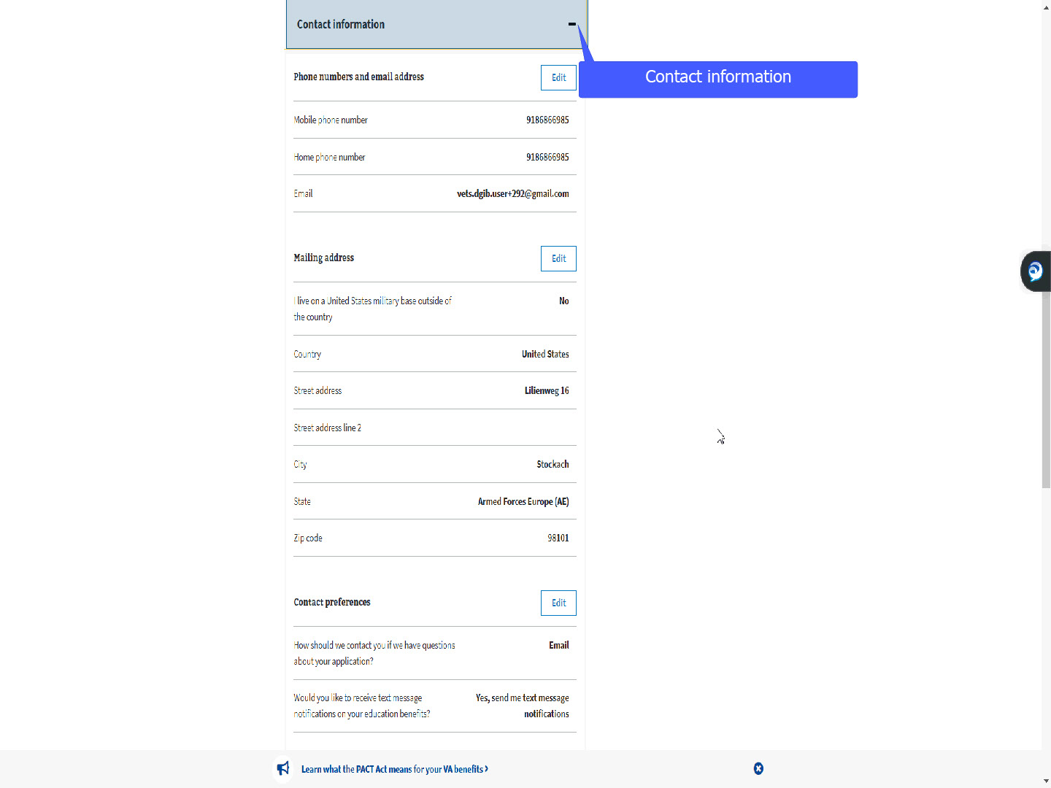
Slide notes

“Contact information”

Slide 72 - Direct deposit
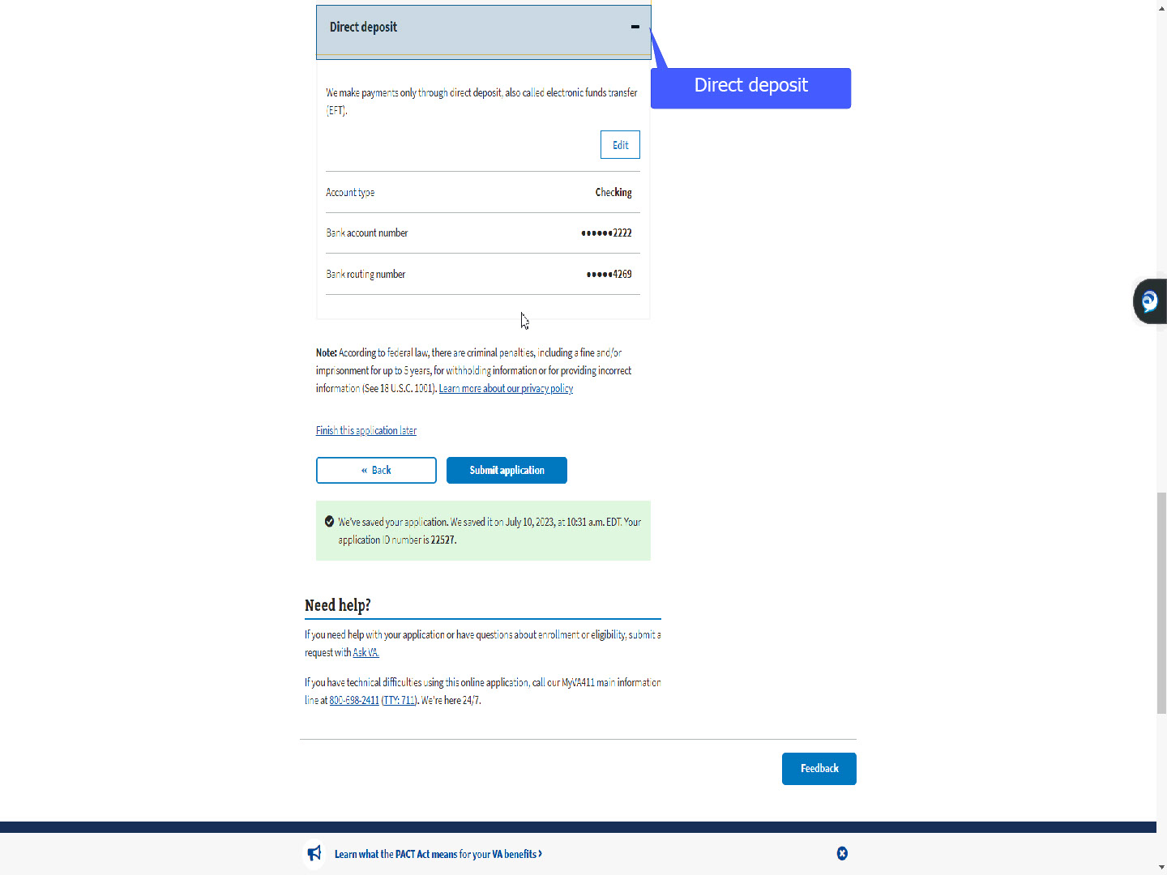
Slide notes

and “Direct Deposit”.

Slide 73 - Submit application
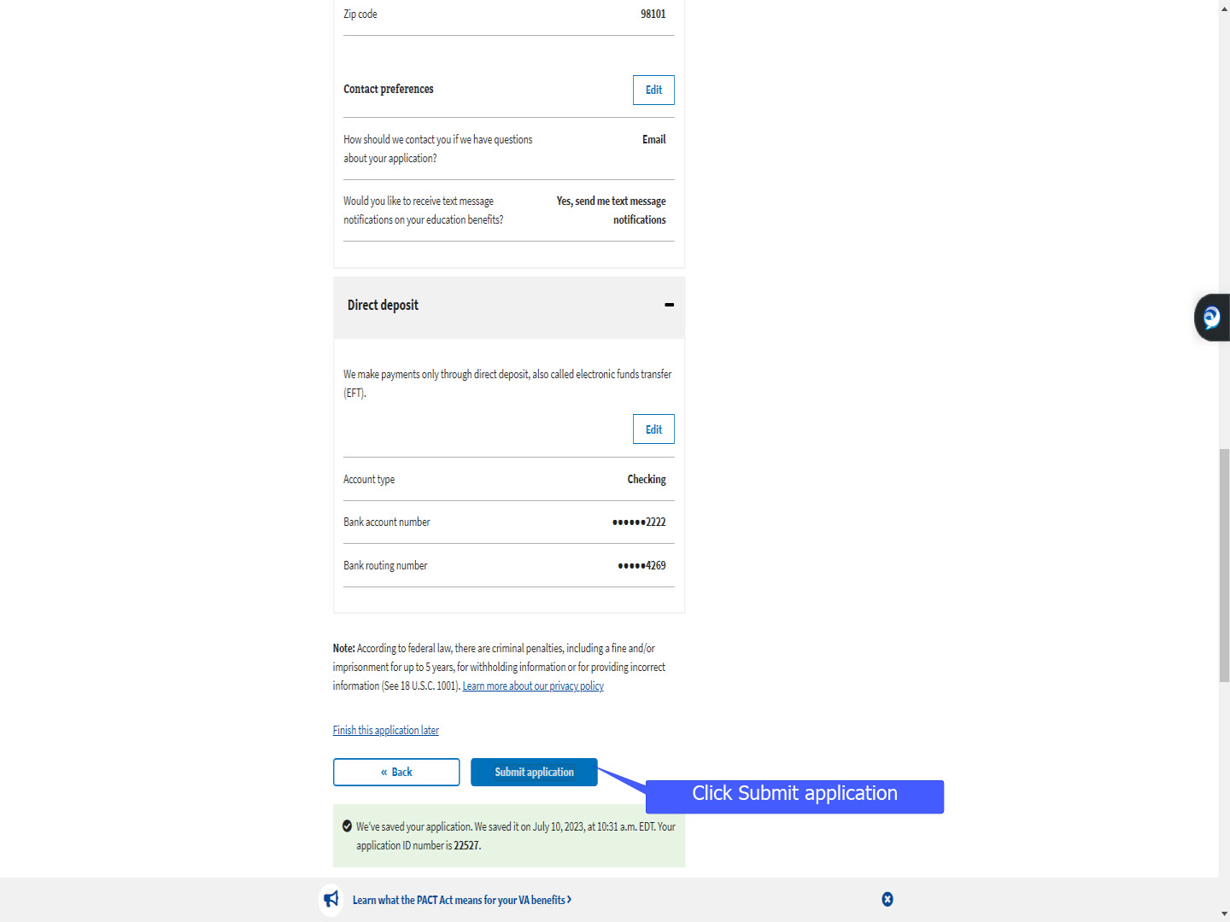
Slide notes

Once all has been reviewed,

the TOE applicant will “Submit” their application.

Slide 74 - TOE offramped
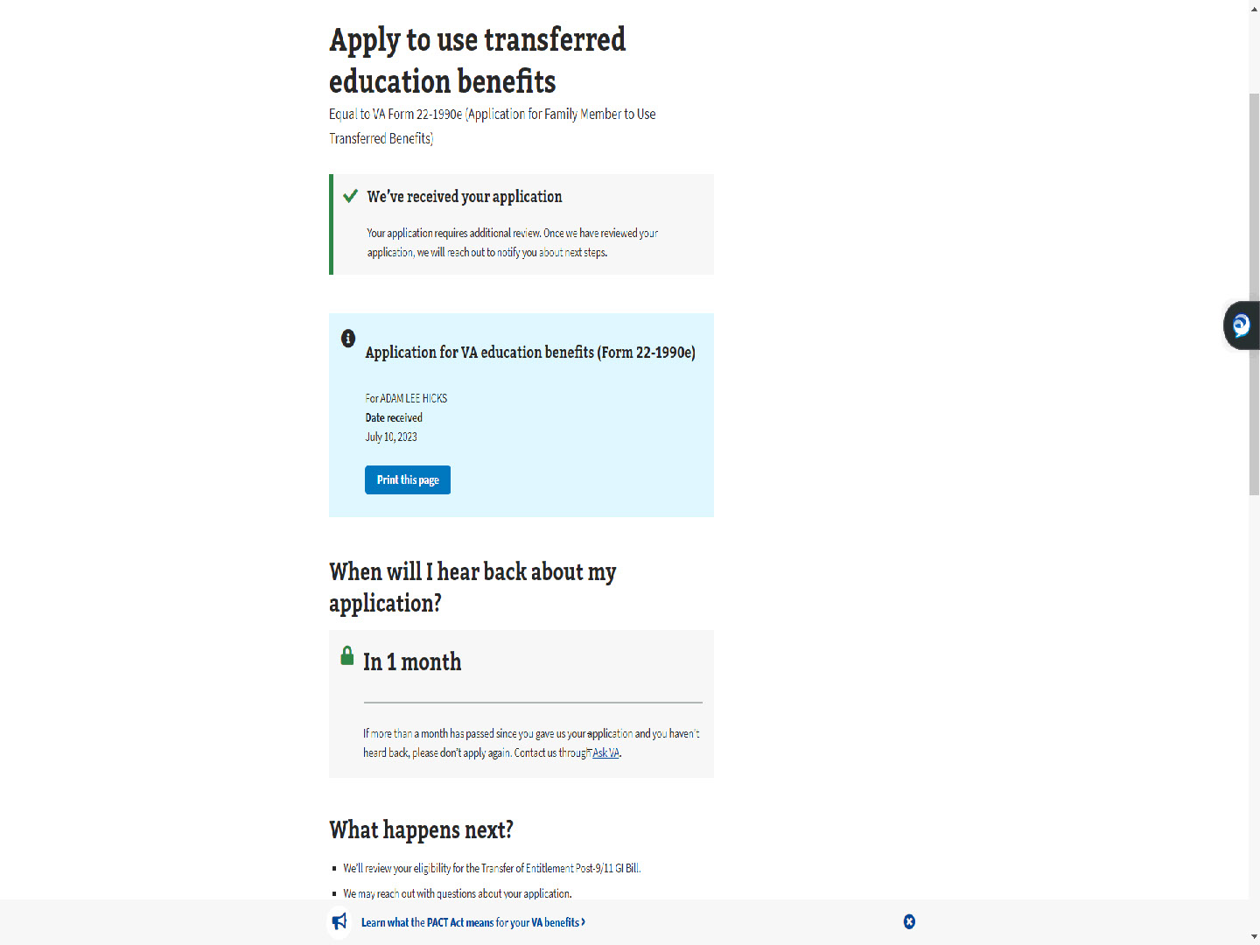
Slide notes

As of this training,

ALL TOE applications

are offramped for VCE intervention.

Slide 75 - Print this page
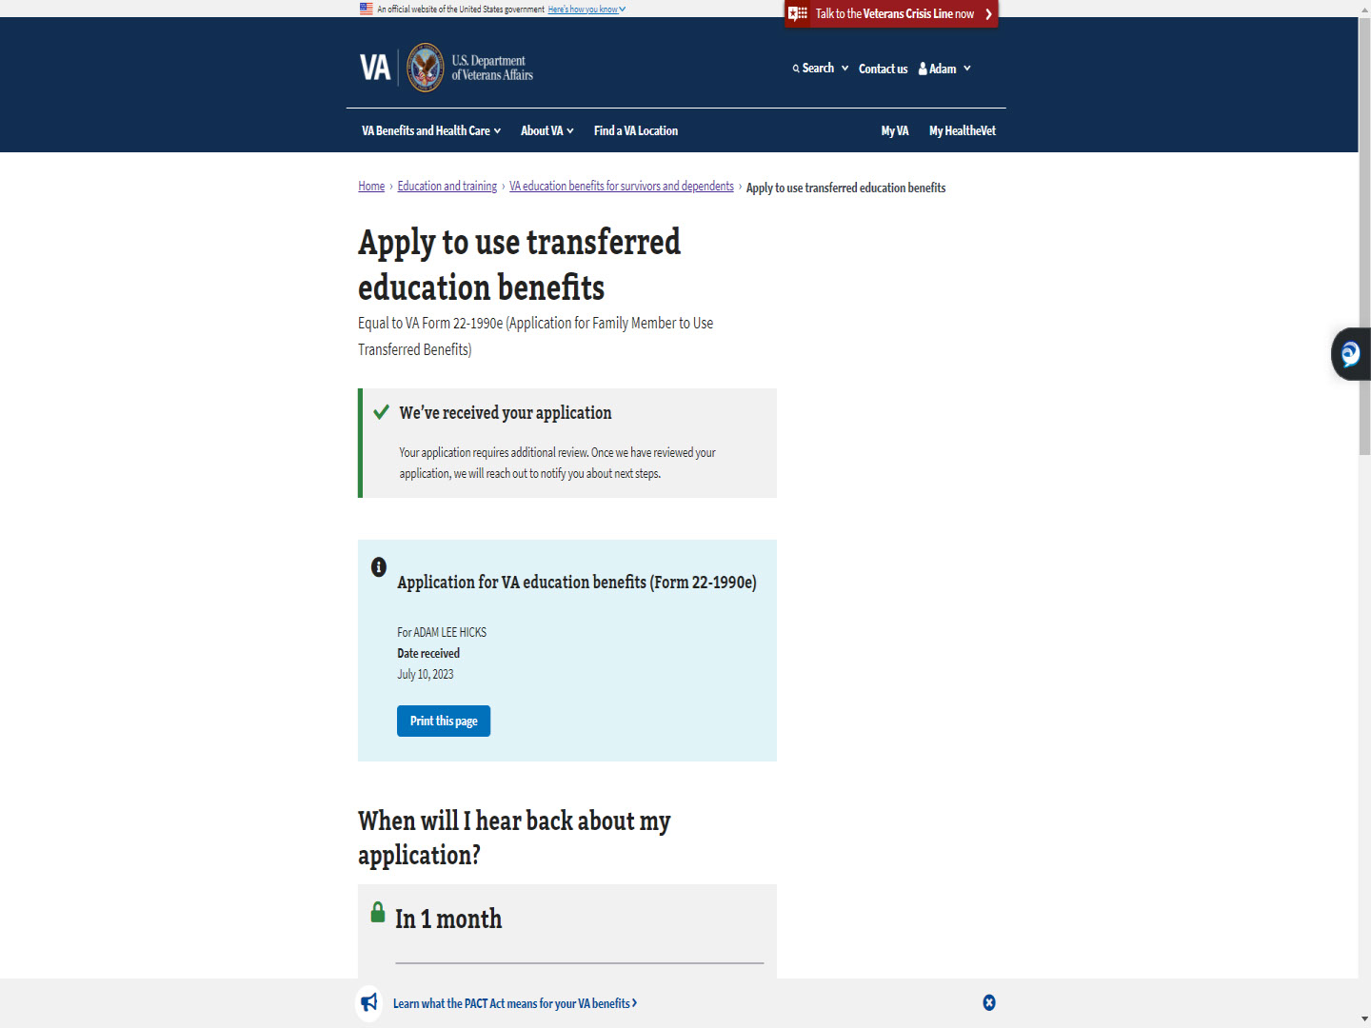
Slide notes

The applicant can print this page for their reference.

Slide 76 - Next Steps
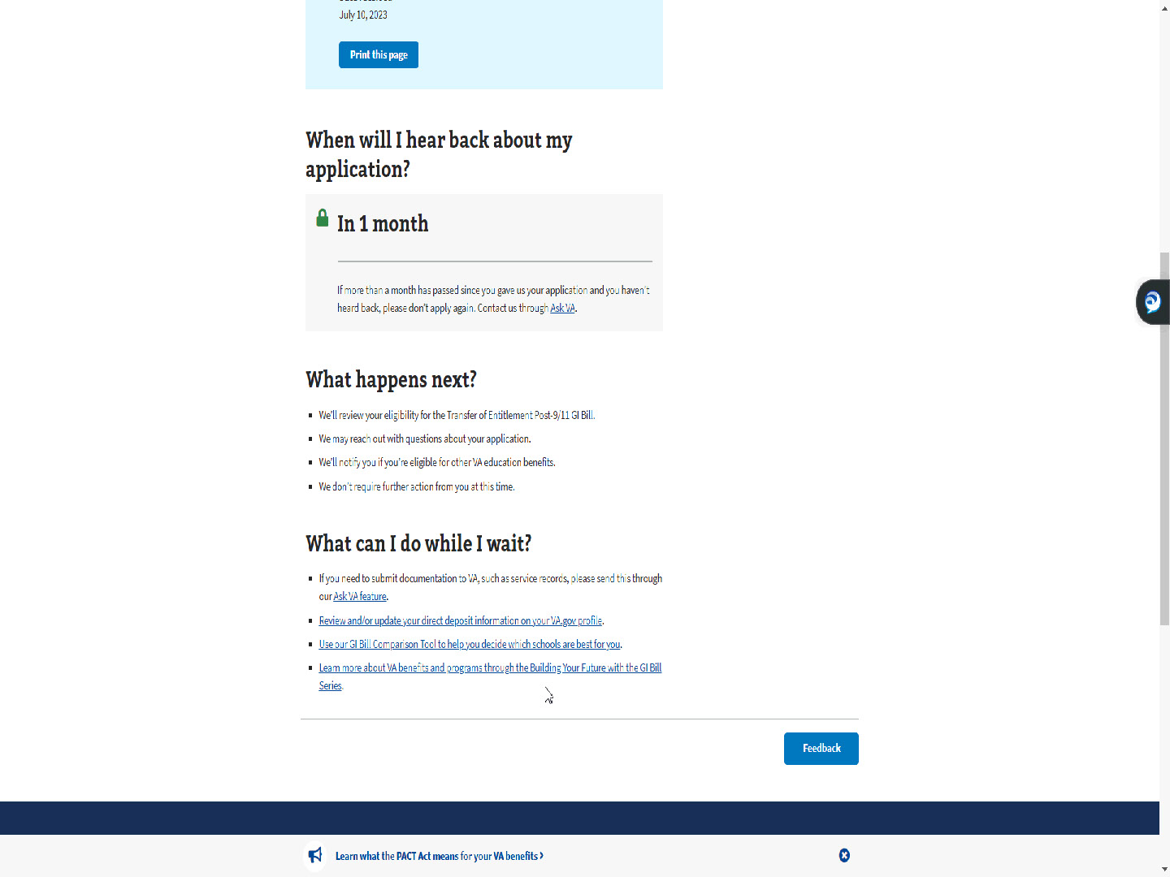
Slide notes

MEB offers a 1-month timeline for a response,

explains what happens next, and

tells the applicant what they can do while they wait.

Slide 77 - The End

Slide notes

This completes the application process in MEB

for a dependent requesting Transfer of Entitlement (TOE) benefits

under the Post-9/11 GI Bill.

I hope this demonstration provides insight

on why you see, what you see in DGI

or on the application in TIMS.

Slide 78 - TMS
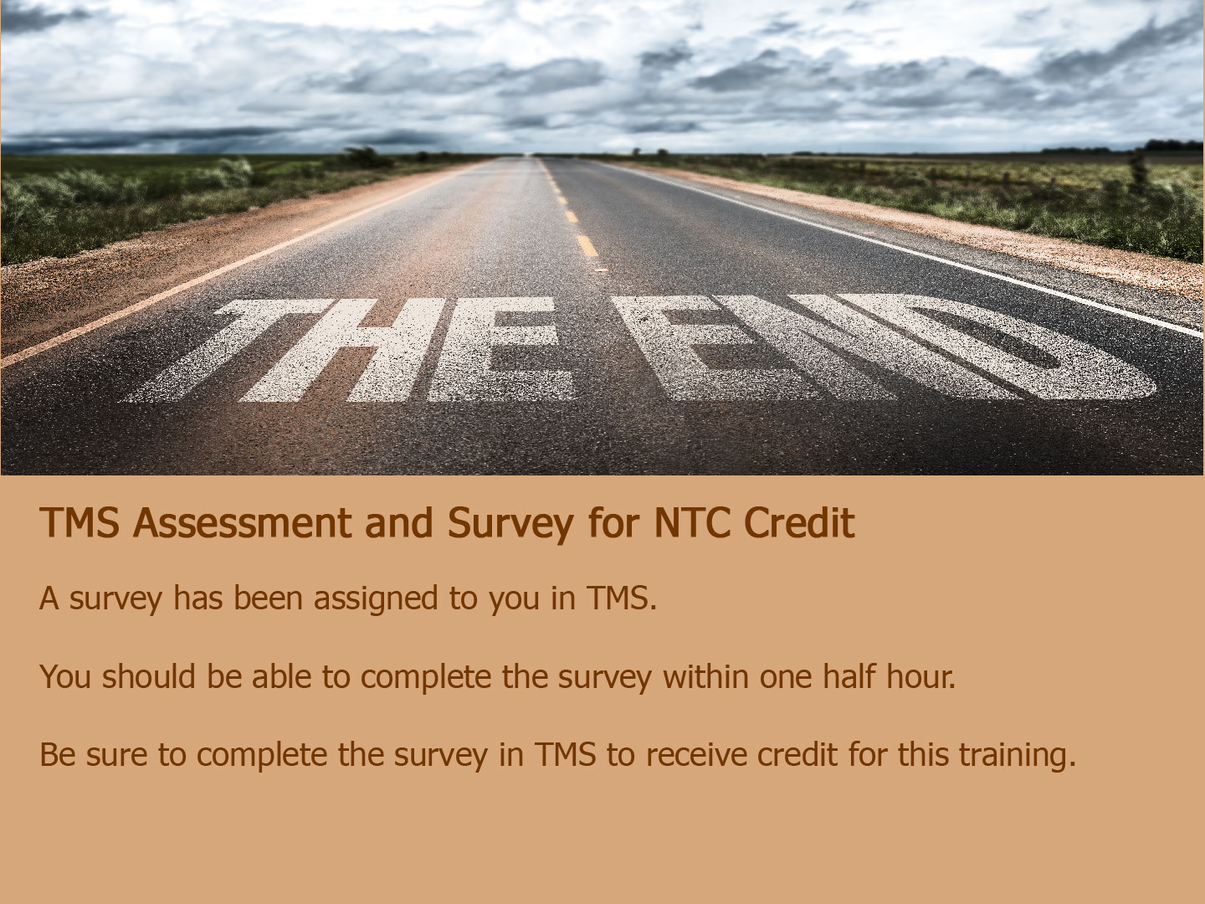
Slide notes

The survey has been assigned to you in TMS.

You should be able to complete the survey

within one half hour.

Be sure to complete the survey in TMS

to receive credit for this training.

Slide 79 - Thank You

Slide notes

Thank you for your time and attention, and

Thank You to Angela Phalen, the creator of the beautiful throw.

the creator of the beautiful handmade ‘wrap’ 😊.

This concludes the presentation.

You may exit

by clicking anywhere on your screen,

hitting enter,

or the right arrow on your keyboard.

Enjoy the rest of your day!

