Slide 1 - Welcome

Slide notes

Welcome to My Education Benefits-

Applicant View

Select “Begin”

Slide 2 - Today's Training

Slide notes

Today’s training is intended to show

what My Education Benefits or MEB

looks like from the Applicant’s view.

Please note, the examples you will see during this training

were processed in a test system.

All names and claim number you see are fictitious

and do not belong to actual beneficiaries.

No personally identifiable information or (PII)

is contained in this training.

Slide 3 - Navigation Controls
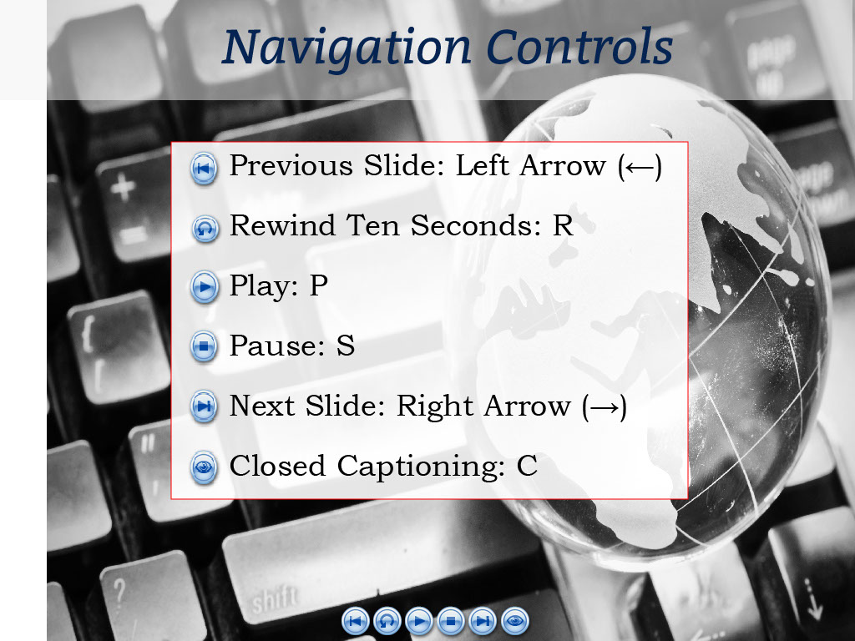
Slide notes

You can use the navigation buttons at the bottom of the screen

to move forward and backward throughout this module.

Also, you may use the keyboard shortcuts shown on-screen.

Slide 4 - Objectives
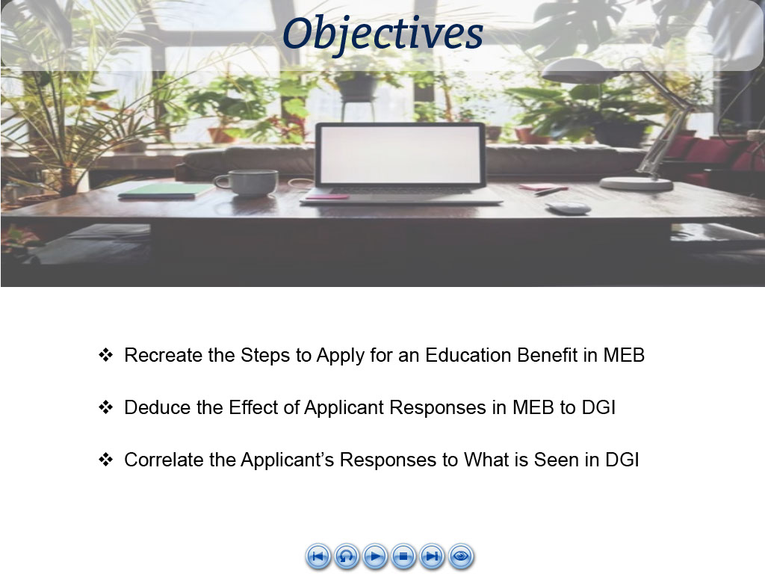
Slide notes

At the conclusion of this lesson,

you should be able to recreate

the steps to apply for an education benefit in MEB

and deduce how the response options available to the beneficiary

correlate to what is seen by a VCE in DGI.

Slide 5 - Glossary
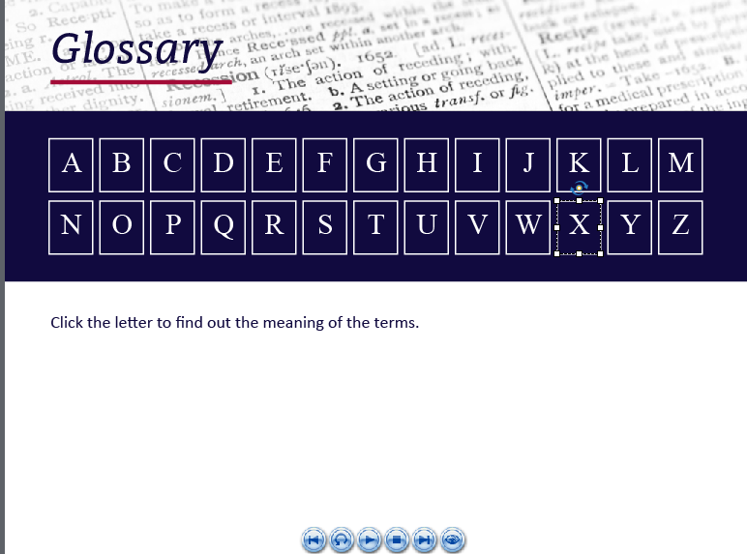
Slide notes

A glossary for terms,

acronyms

and abbreviations

used throughout this training

has been provided for reference.

Slide 6 - Demo Intro

Slide notes

We will begin with a demonstration

of a person applying for Education benefits

using MEB.

As we view the interactions,

I will share what this means

to the VCE.

Slide 7 - Begin Application
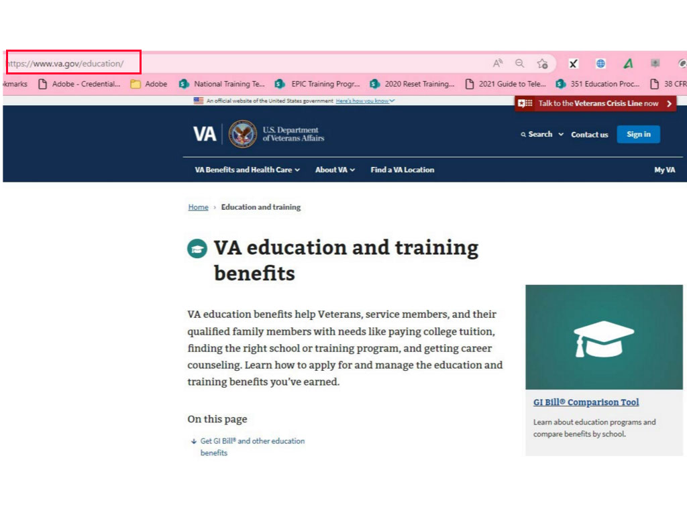
Slide notes

To start,

the applicant will begin

by accessing the Education section

of VA.gov,

Slide 8 - MEB Landing Page
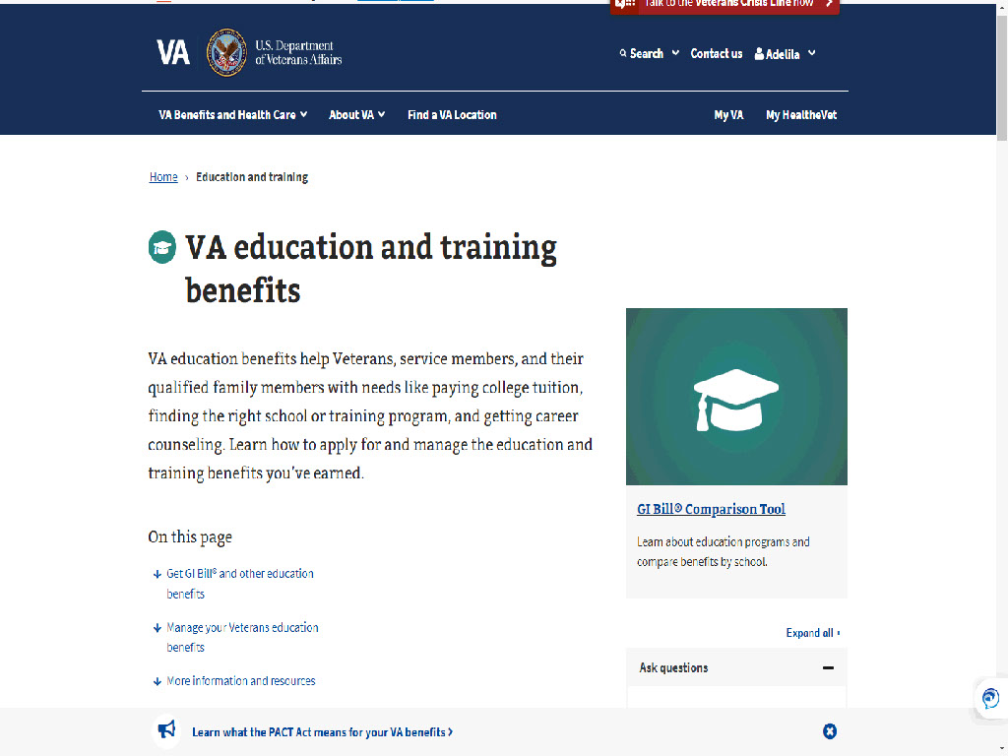
Slide notes

Slide 9 - How to apply
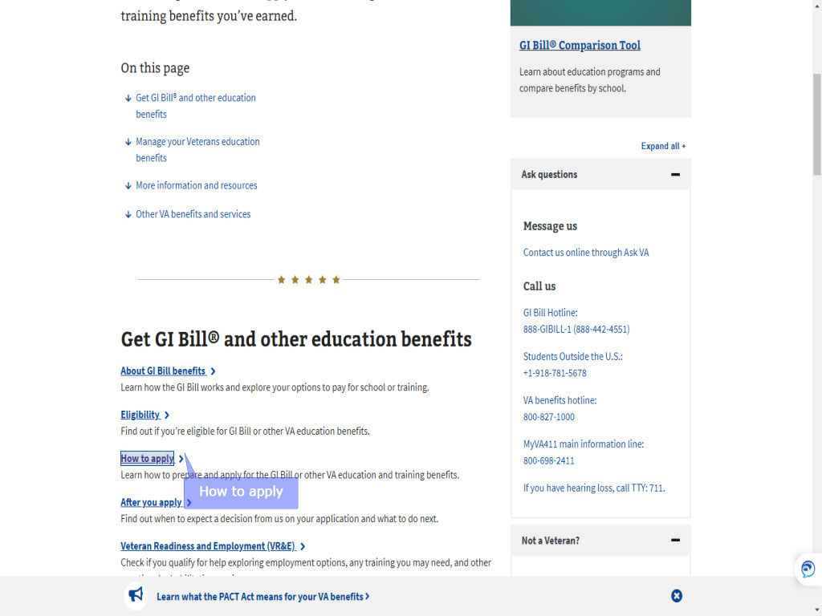
Slide notes

select “How to Apply”

then advance to

Slide 10 - Slide 10
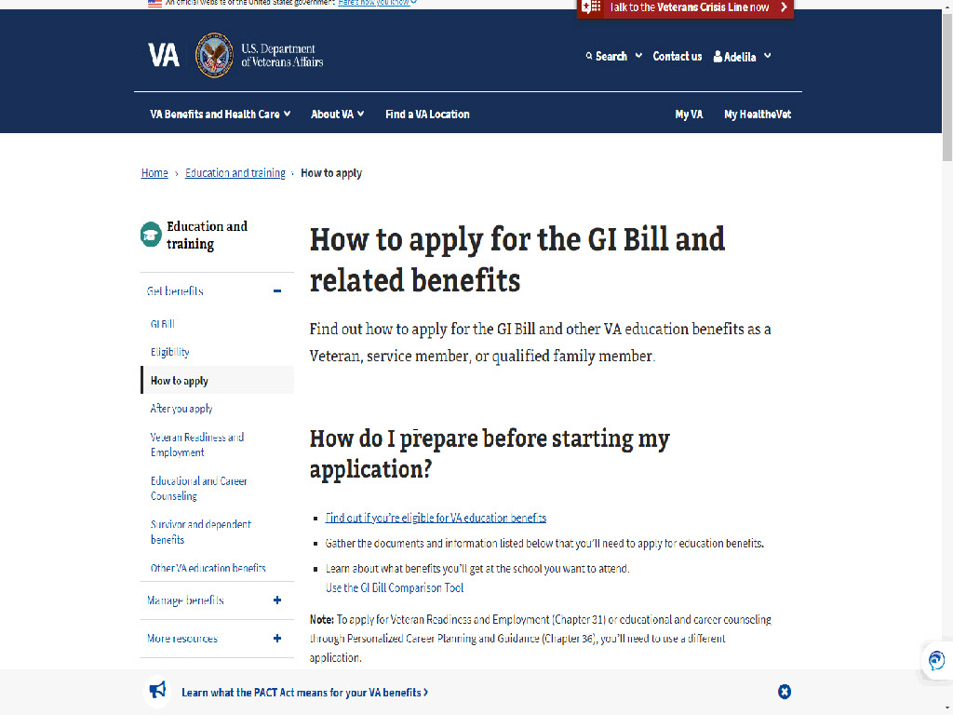
Slide notes

How To Apply For The GI Bill And Related Benefits | Veterans Affairs (va.gov).

Slide 11 - Slide 11
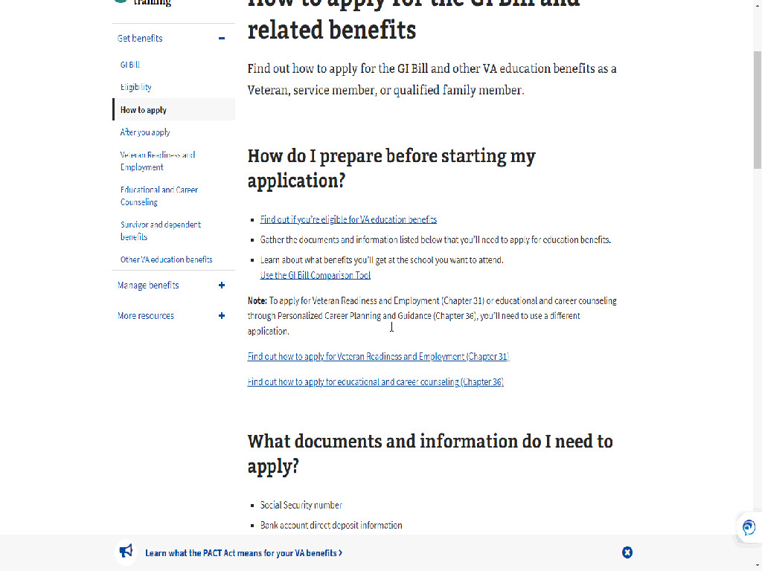
Slide notes

The MEB application

provides some background information on how

to prepare for the application

and what documents the applicant will need.

Slide 12 - Find your education benefits form
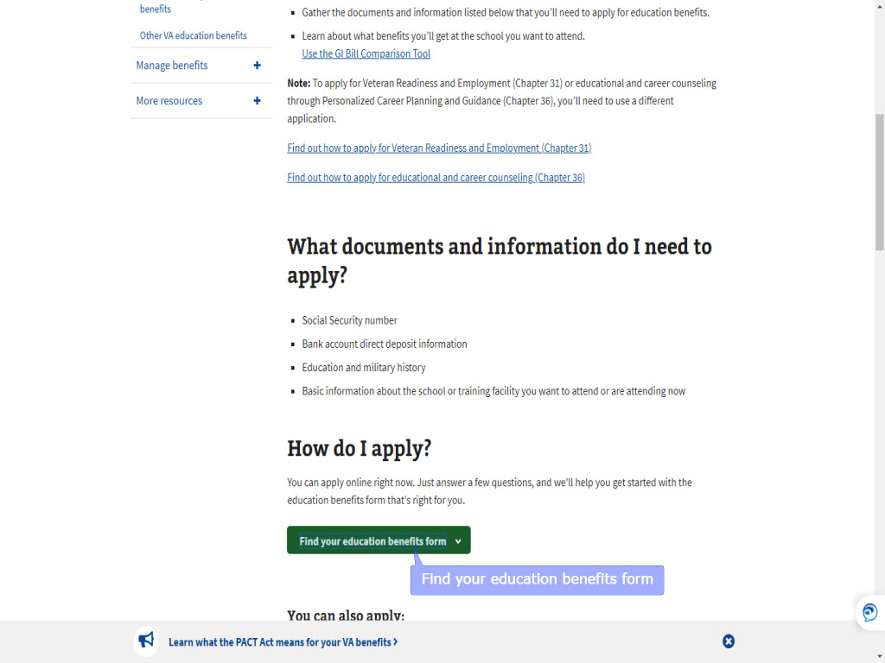
Slide notes

Under “How do I apply?”,

the applicant will select

“Find your education benefits form”

which will prompt a new window displaying:

Slide 13 - Slide 13
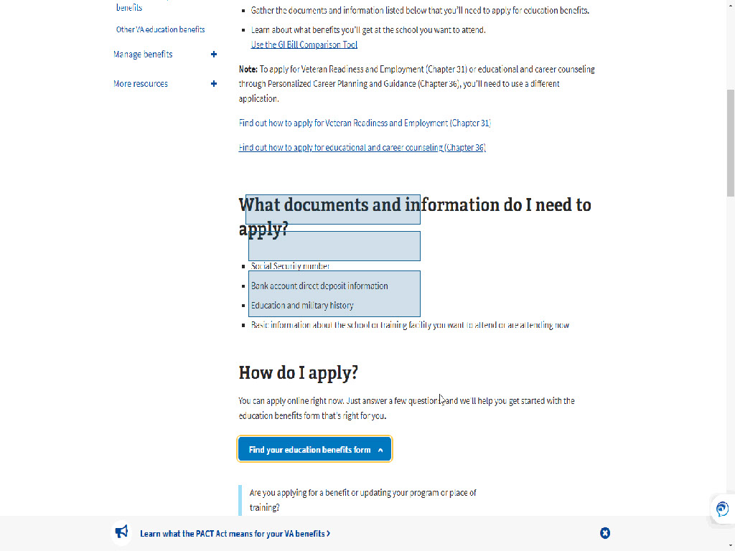
Slide notes

asking if the applicant is:

Applying for a new benefit

Updating my program of study or place of training,

or Applying for the Edith Nourse Rogers STEM Scholarship

after using Post-9/11 GI Bill

or Fry Scholarship benefits

Slide 14 - Apply for a new benefit
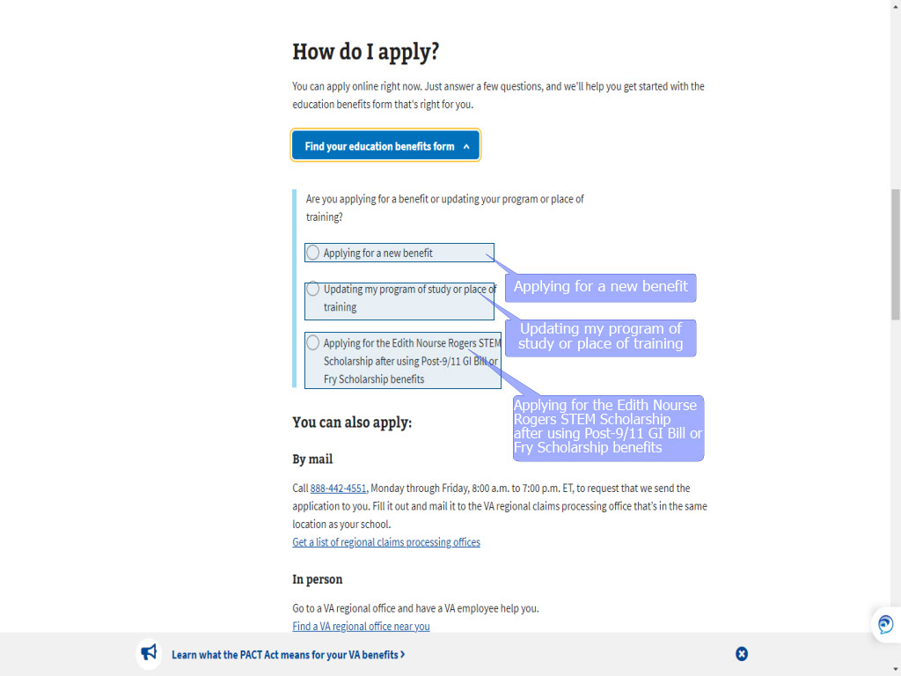
Slide notes

Selecting “Updating my program of study

or place of training”

takes the applicant along the “Legacy” application path

of a VA Form 22-1995/5495.

Choosing STEM follows a path similar

to what you will see for chapter 33

with a few different prompts.

For today’s training, we will select

Applying for a new benefit.

Slide 15 - Slide 15
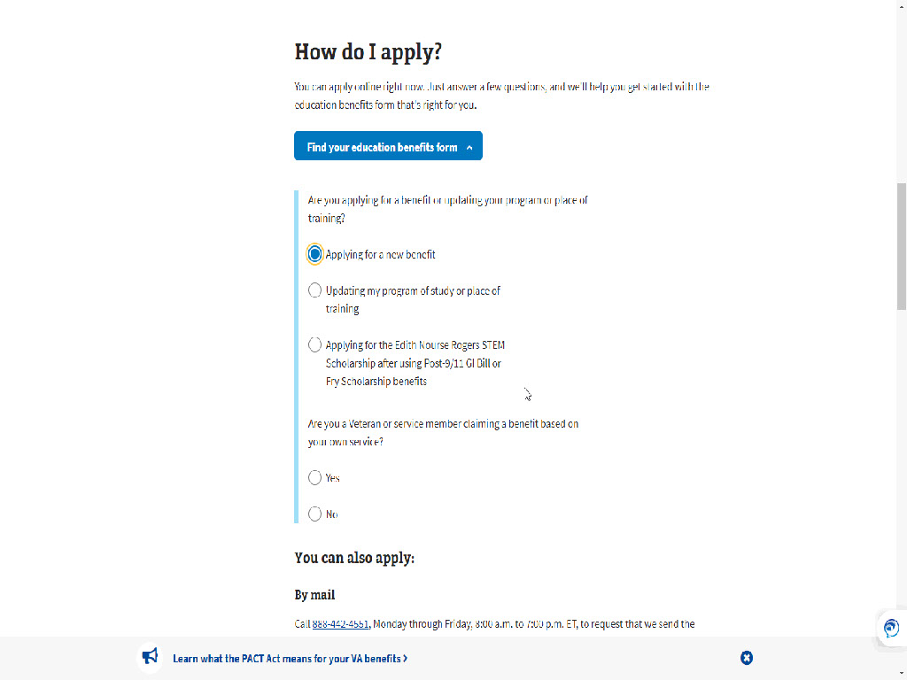
Slide notes

Once “Applying for a new benefit” has been selected,

Slide 16 - Based on your own service
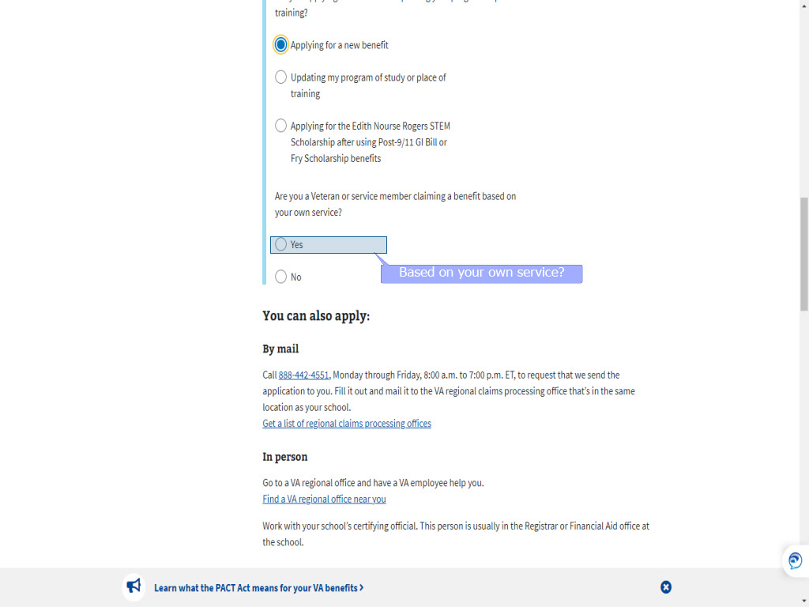
Slide notes

the applicant is asked to answer

Yes or No to the question:

Are you a Veteran or service member

claiming a benefit

based on your own service?

Slide 17 - Slide 17
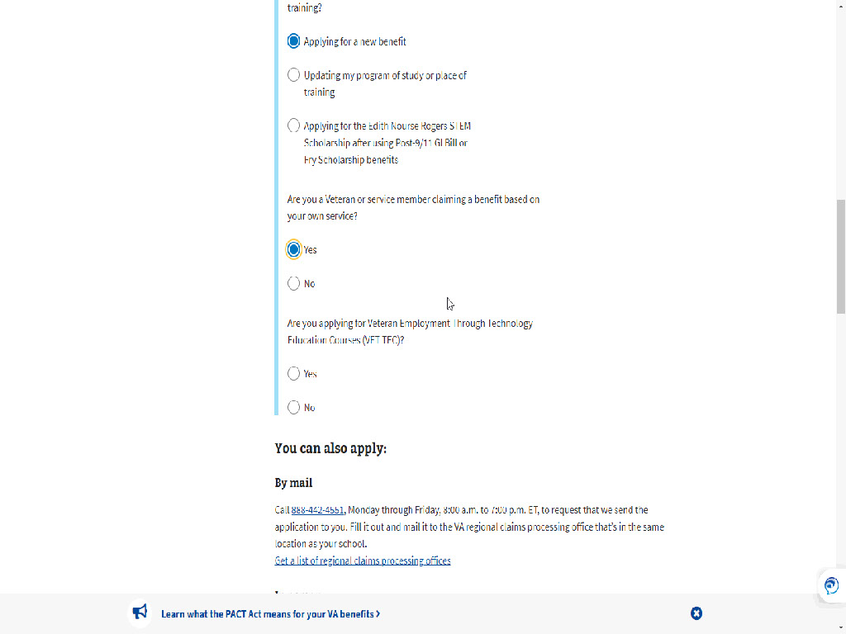
Slide notes

An applicant requesting

Transfer of Entitlement (TOE)

would select “No.

For today’s training we will select: Yes.

Slide 18 - VET TEC
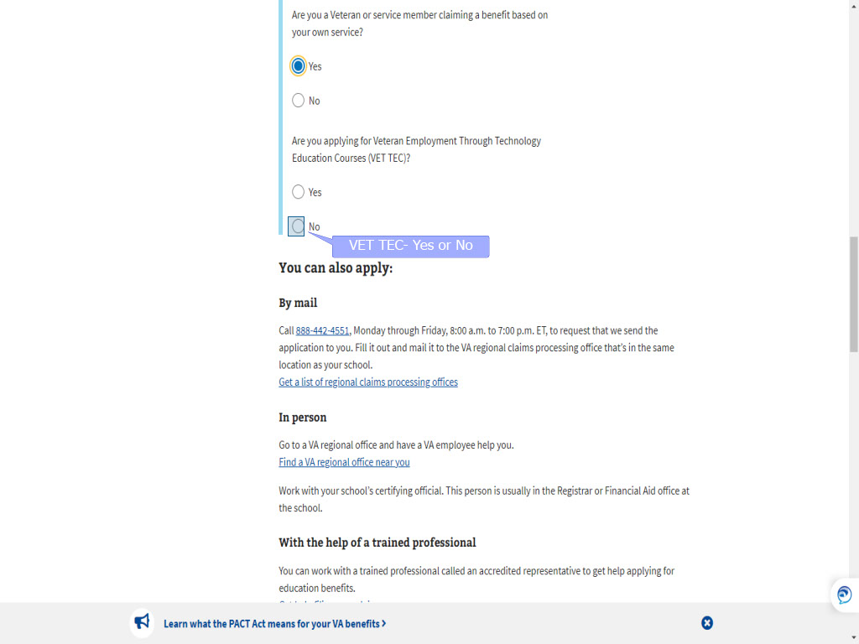
Slide notes

The subsequent prompts

narrow down which benefit

the applicant is requesting.

Because we selected “Yes”,

the prompts ask the applicant

to choose between VET TEC

Slide 19 - Post-9/11 GI Bill
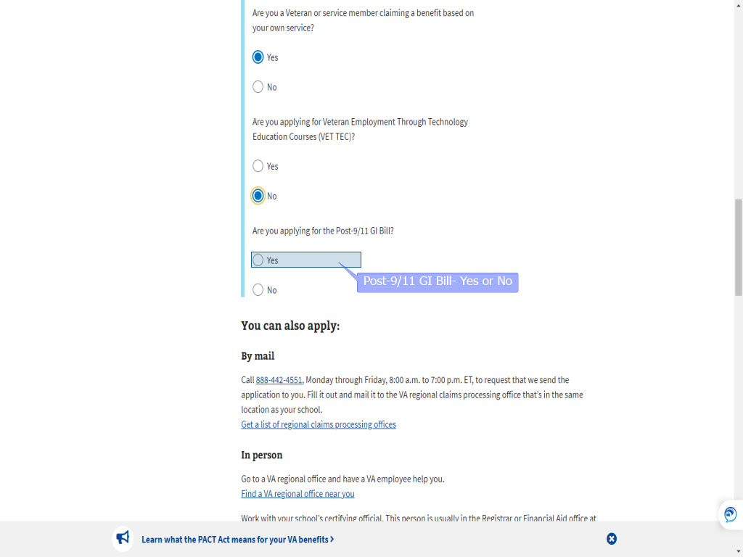
Slide notes

and the Post-9/11 GI Bill.

For today’s training,

we’ll select “Post-9/11 GI Bill.

Slide 20 - Apply Now
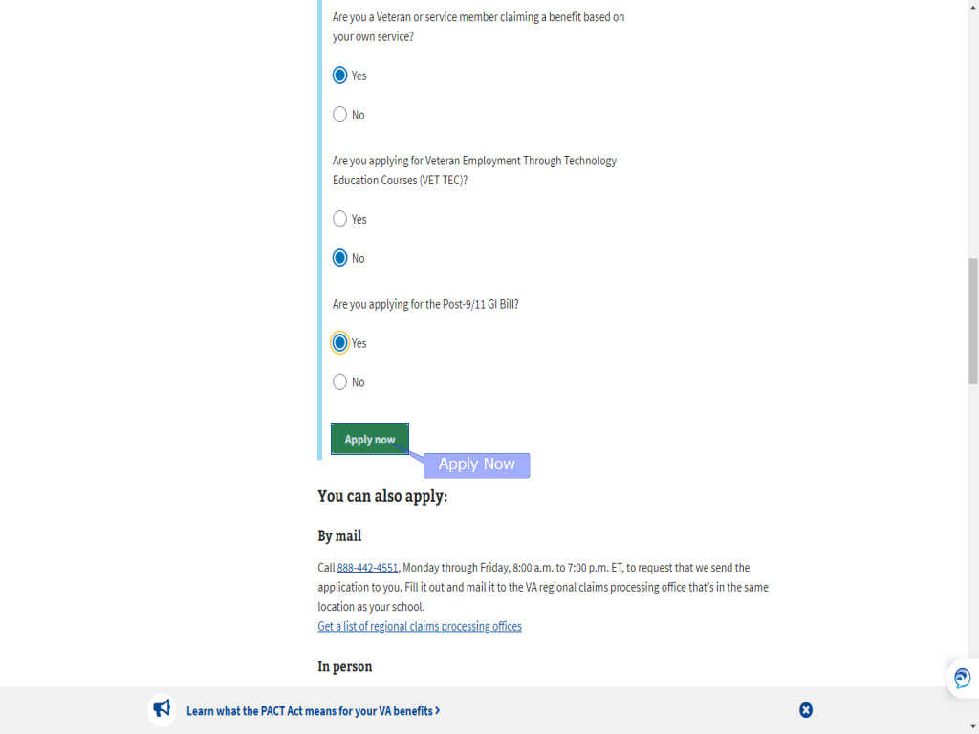
Slide notes

Once all prompts have been answered,

the applicant chooses “Apply now”.

Slide 21 - Slide 21
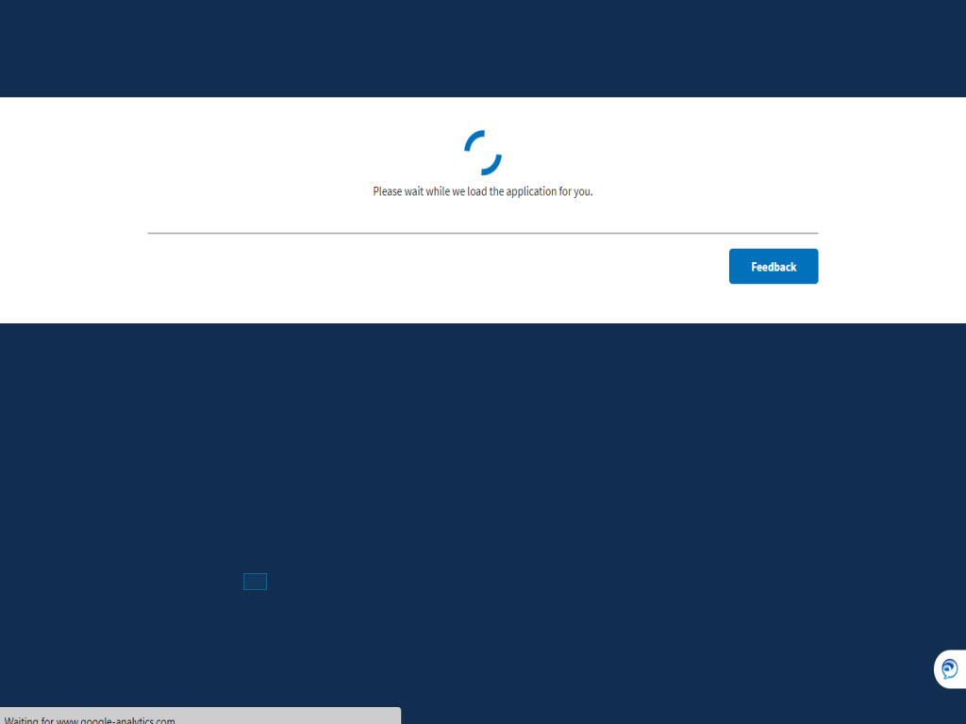
Slide notes

Slide 22 - Sign in to start application
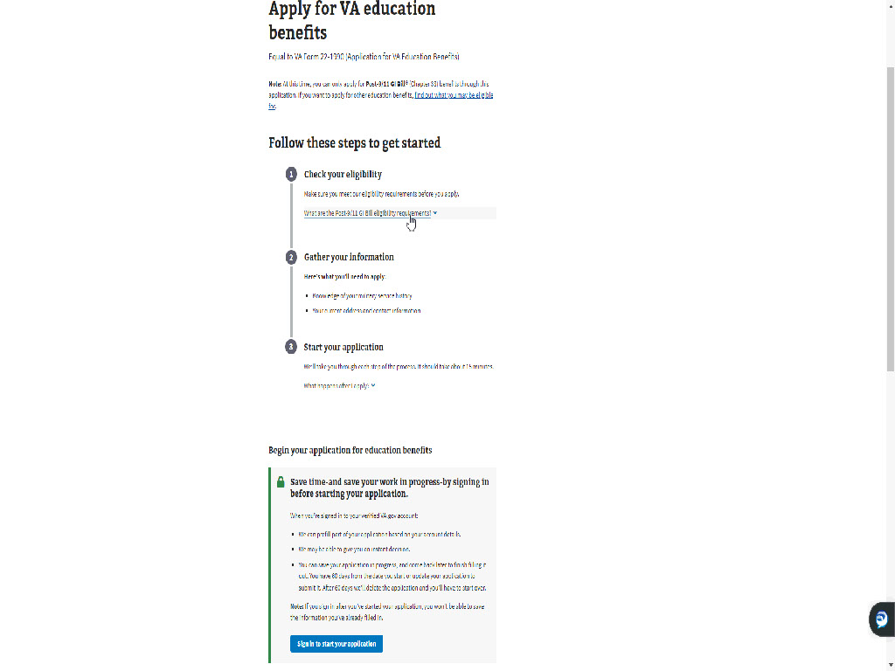
Slide notes

We are now on the

“Apply for VA education benefits” page.

Applicants must sign in to access the MEB application.

to access the MEB application.

Slide 23 - Apply using the paperform
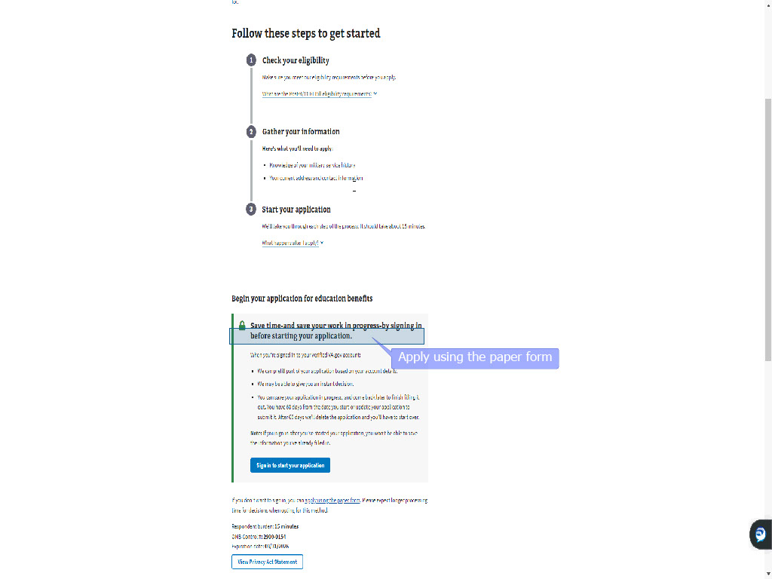
Slide notes

If the applicant does not wish to sign in,

a link is provided

to “Apply using the paper form”.

Slide 24 - Slide 24
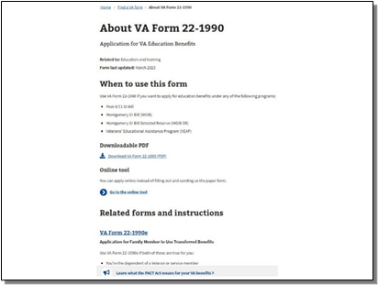
Slide notes

If the applicant clicks the link

they will be directed to Find a VA form

and the VA Form 22-1990.

If they change their mind,

there is a link to return to the Online tool.

Slide 25 - Return to online application
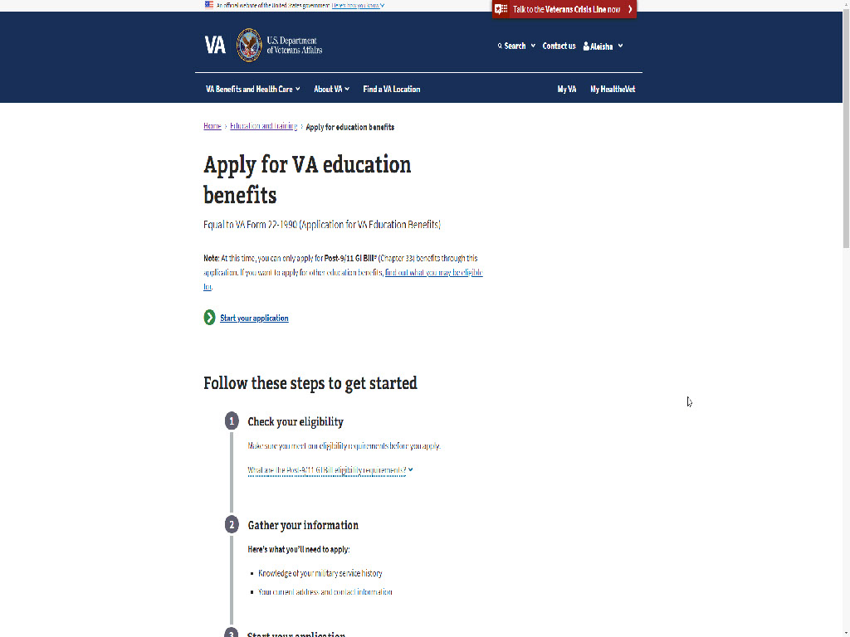
Slide notes

Slide 26 - Sign in to start your application
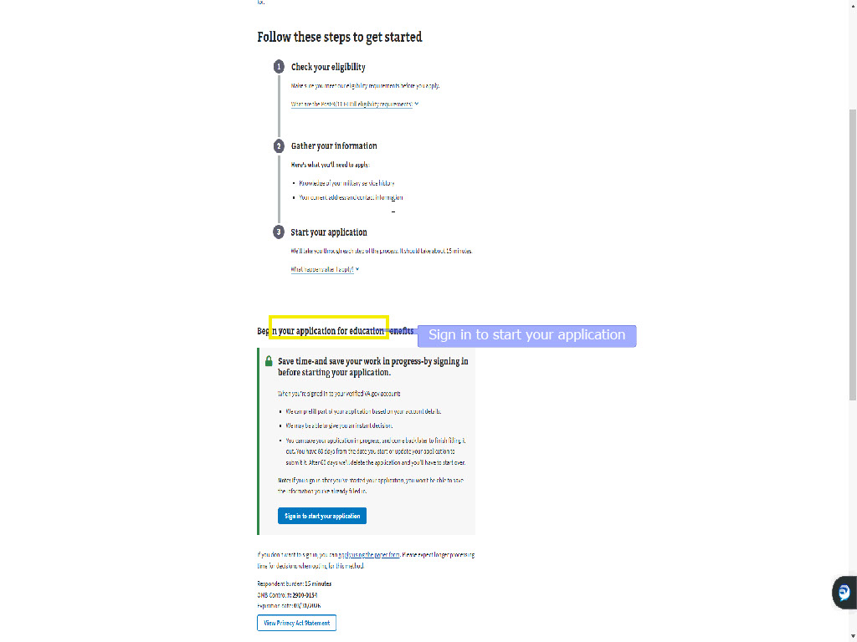
Slide notes

Signing in allows the applicant

to authenticate themselves

and use the My Education Benefits or

(MEB) application

because as you recall,

we selected to request

Post 9/11 GI Bill benefits.

Slide 27 - ID.me login email and password
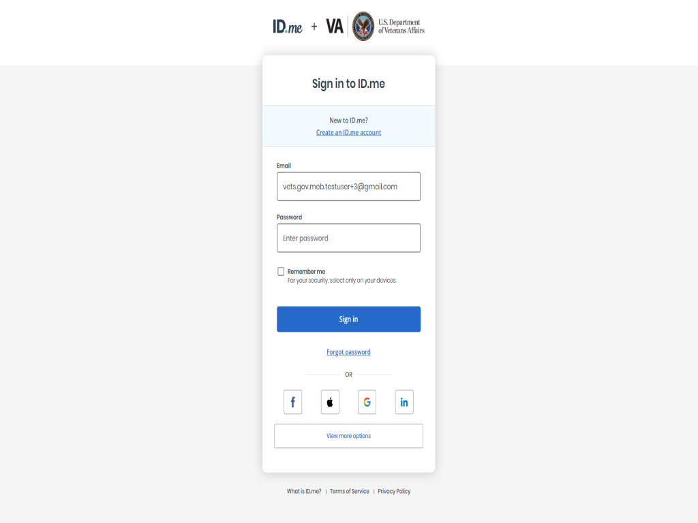
Slide notes

The applicant is given the option

to login through

Login.gov,

ID.me,

DS Logon,

My HealtheVet,

or create a new account.

Slide 28 - Slide 28
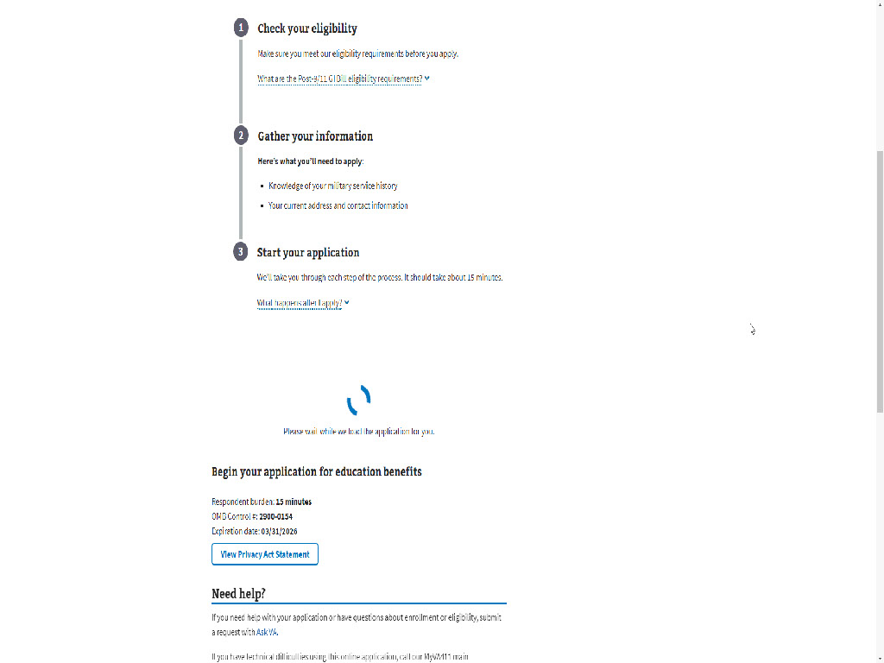
Slide notes

For this demonstration,

we will use ID.me

which requires a verification

sent to the applicant.

Slide 29 - Start your education application
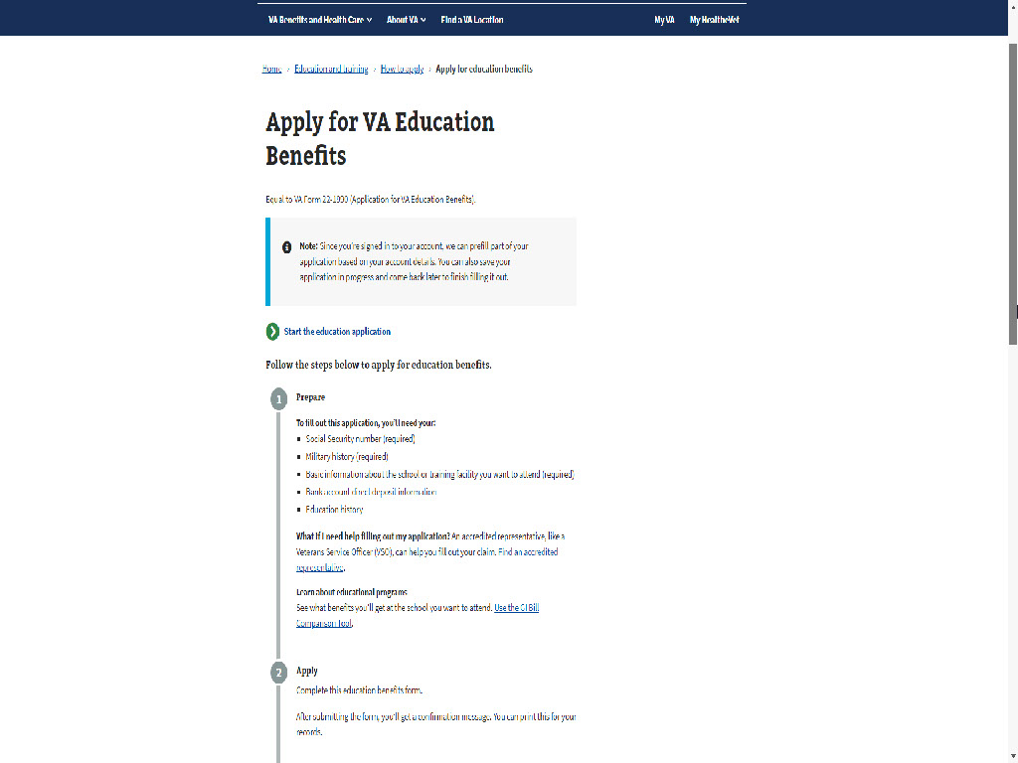
Slide notes

Once the applicant has been verified,

they will be instructed to

“Start your education application”

both at the top and bottom of the page.

Slide 30 - Prepare
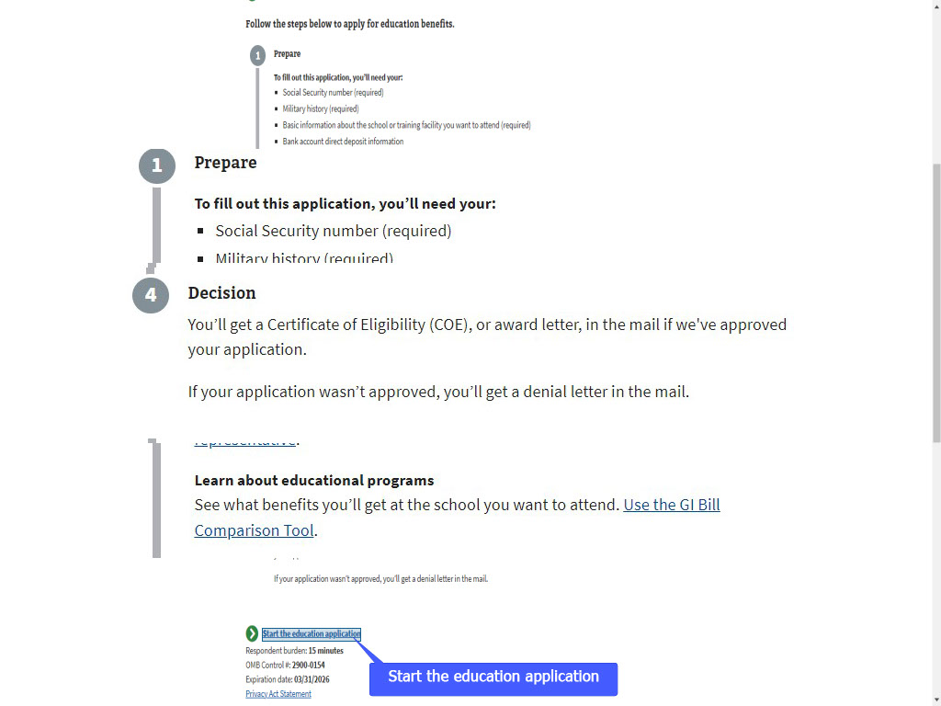
Slide notes

The “Start your Education Application” page

provides information similar to the

“How do I prepare” page earlier,

with links to an accredited representative

and the GI Bill Comparison tool.

The page also provides a few words

on Applying,

VA review,

and the Decision.

Let’s start the education application.
Slide 31 - Step 1: Your information
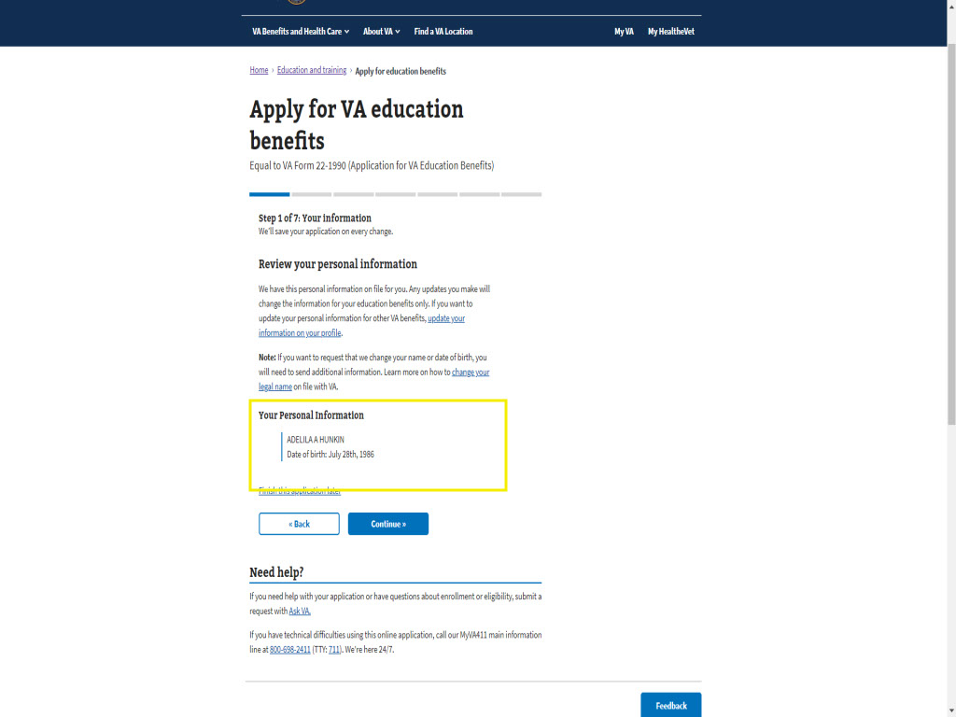
Slide notes

The first step of this 7-step process

is the applicant’s information

to include Name and Date of Birth

Because they signed in,

this information is prefilled.

Slide 32 - Slide 32
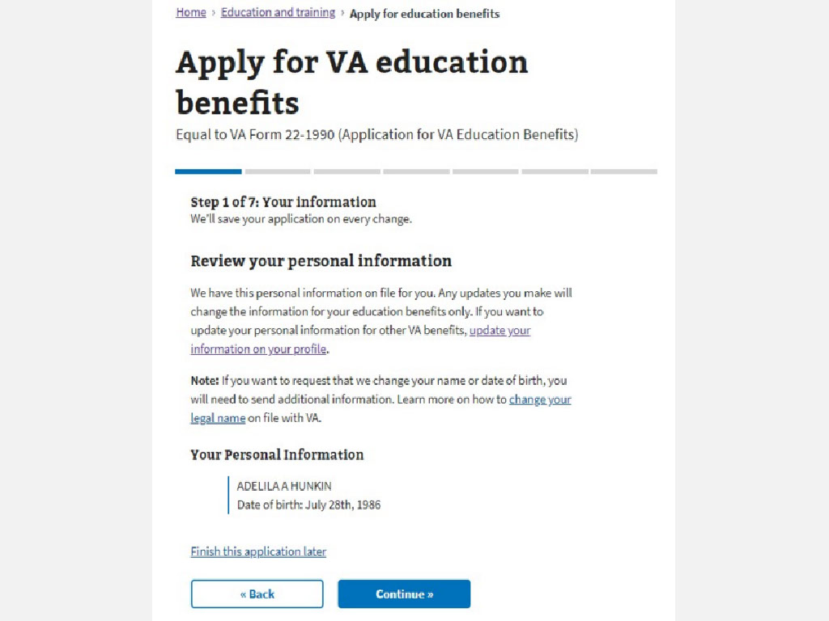
Slide notes

Slide 33 - Slide 33
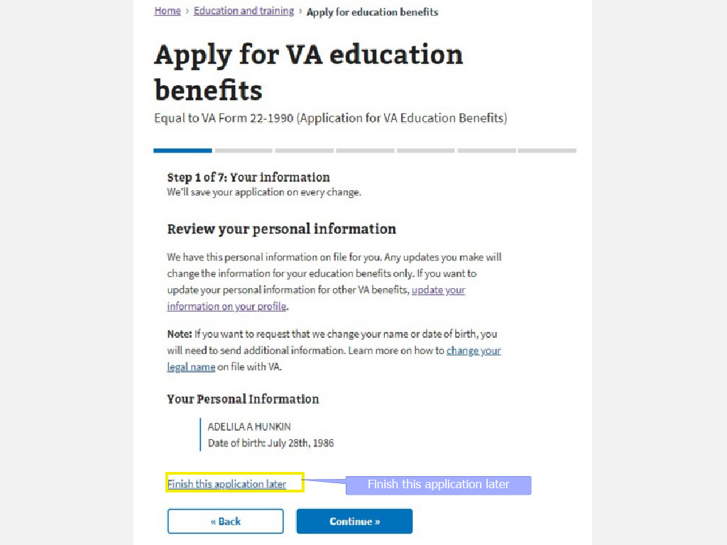
Slide notes

A link provided on each page hereafter

offers the option to

“Finish this application later”

because their information is stored

as a result of signing in.

Slide 34 - Step 2: Contact Information
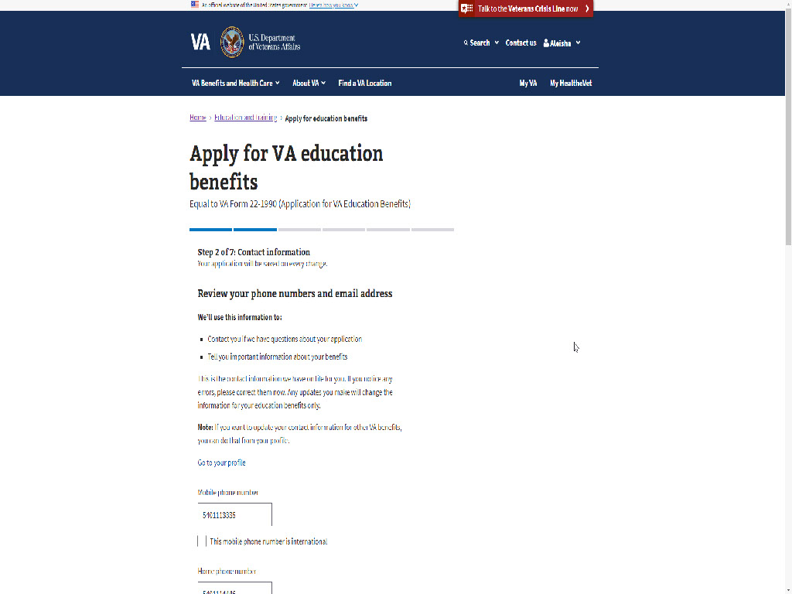
Slide notes

Step 2

is where the applicant will view their contact information.

view their contact information.

Here, their phone number(s)

and email address

are pre-populated.

Slide 35 - EDU vs VA Profile
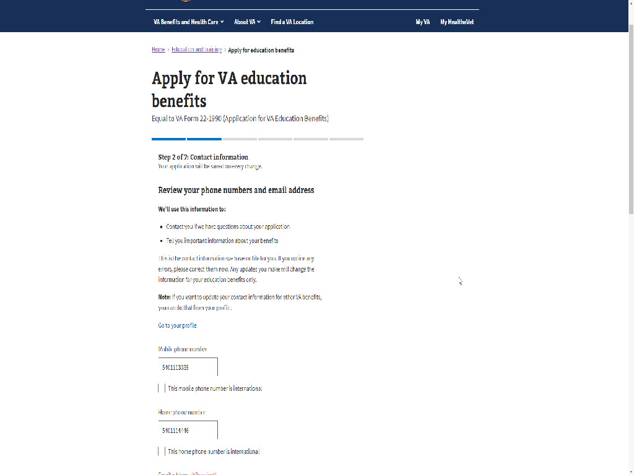
Slide notes

If the applicant needs to

update this information,

they can do so

in the application.

This update will only impact

Education benefits.

Slide 36 - VA Profile
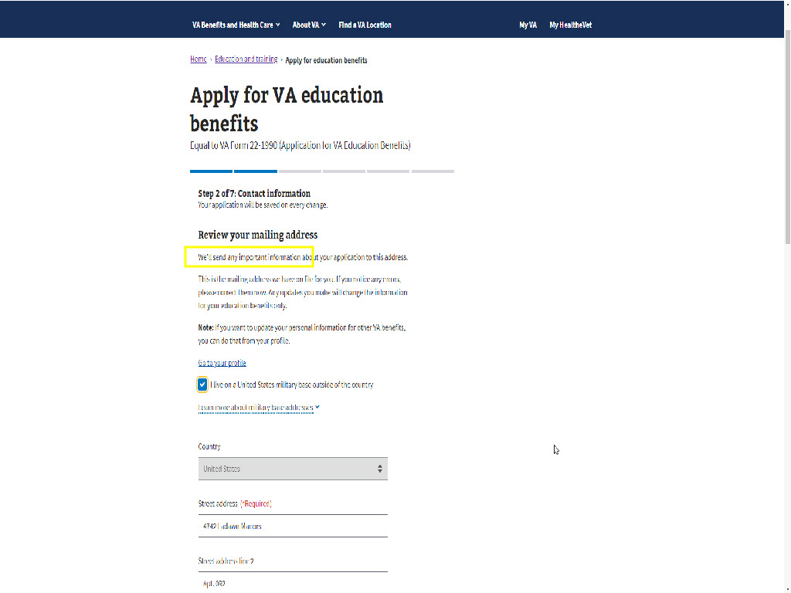
Slide notes

However,

if the applicant wants to update

their information

for other VA benefits

to include Education,

they can access their VA profile

by selecting “Go to your profile”.

Any updates made

outside of the MEB application

in the Profile,
Slide 37 - Slide 37
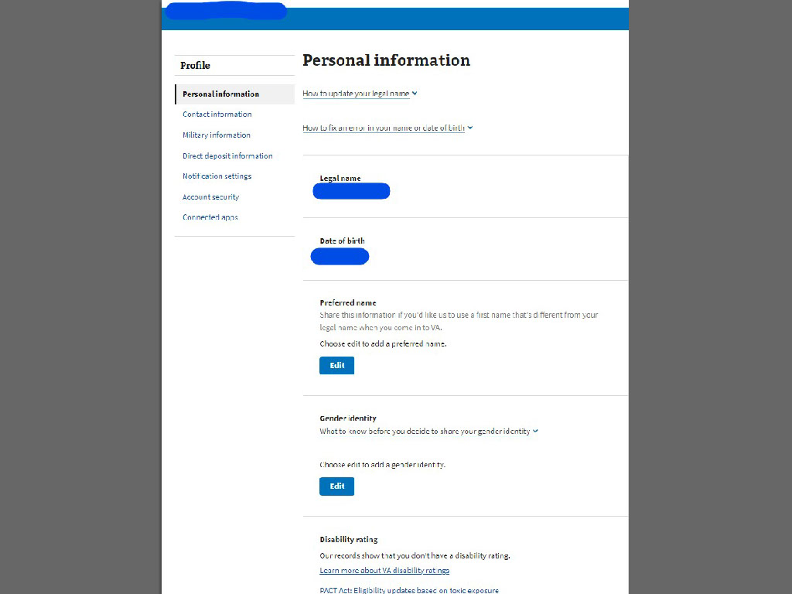
Slide notes

will impact and update

all VA benefits they are currently using

to include Disability compensation,

Pension benefits

and VR&E (Veteran Readiness and Employment)

just to name a few.

will impact and update

all VA benefits they are currently using

to include Disability compensation,

Pension benefits

and VR&E (Veteran Readiness and Employment),

just to name a few.
Slide 38 - Review your mailing address
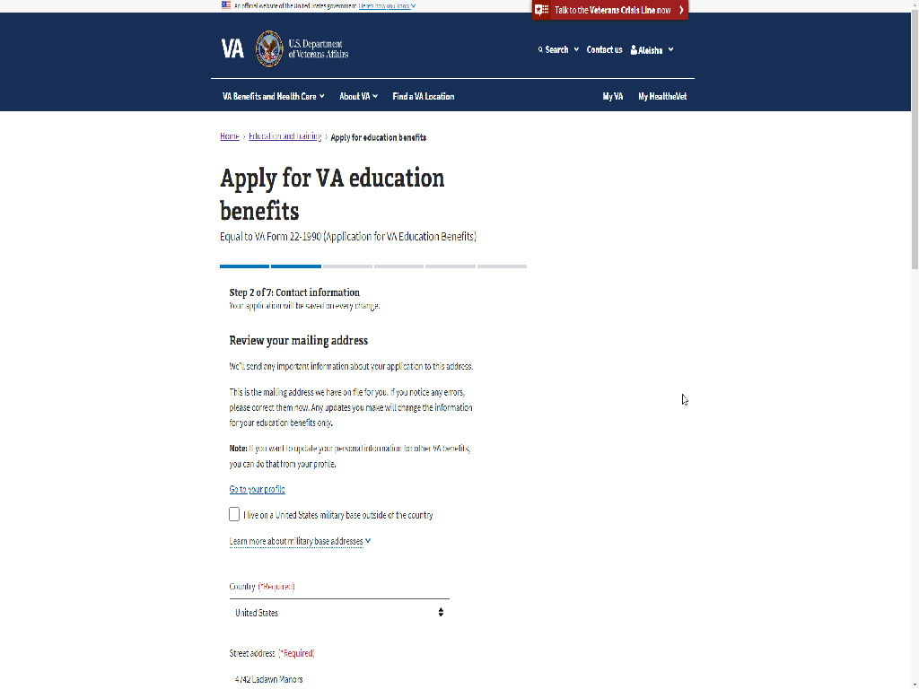
Slide notes

Next, the applicant is asked to review

their mailing address.

Slide 39 - Slide 39
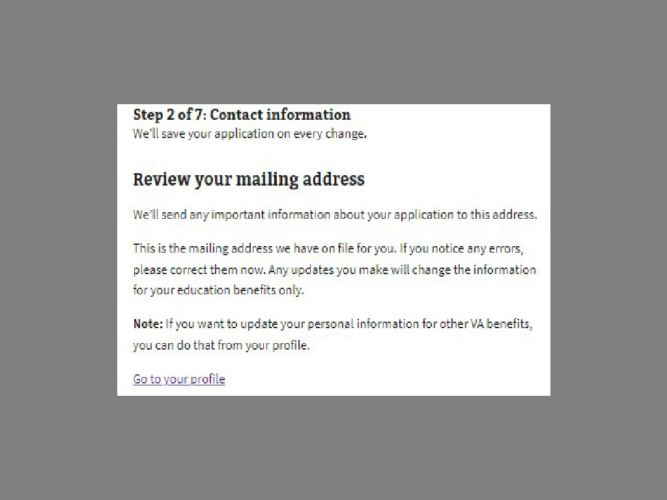
Slide notes

A warning message is displayed

displayed which reiterates what I just said

about updating in the application

versus in the VA profile.

Slide 40 - US military base
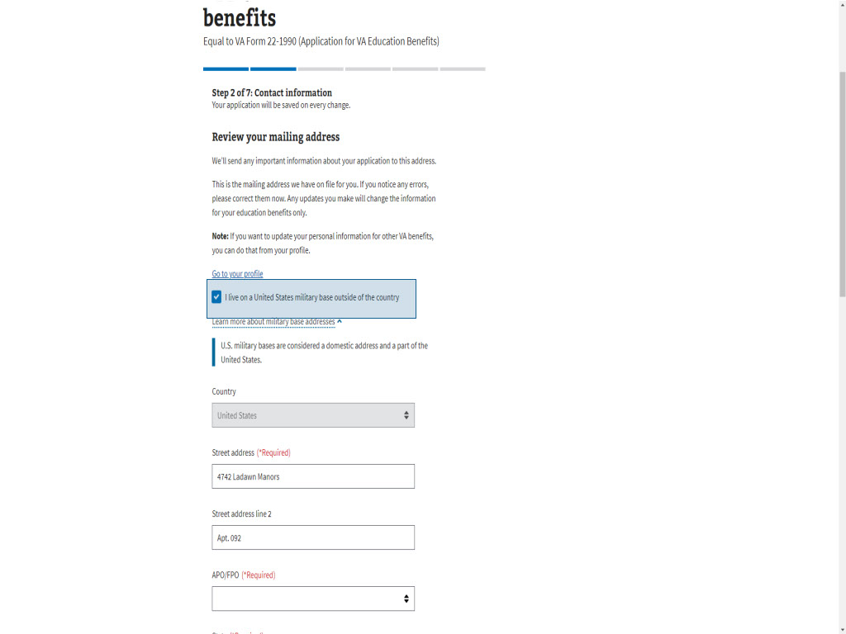
Slide notes

There is a box available

to be checked

if the applicant lives

on a United States military base

outside of the country

and provides a link

for more information

on base addresses.

Slide 41 - Continue
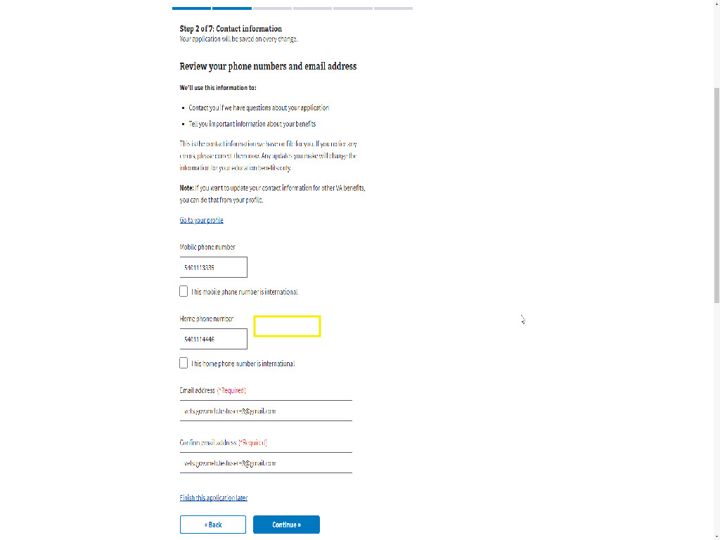
Slide notes

Slide 42 - Contact Preferences
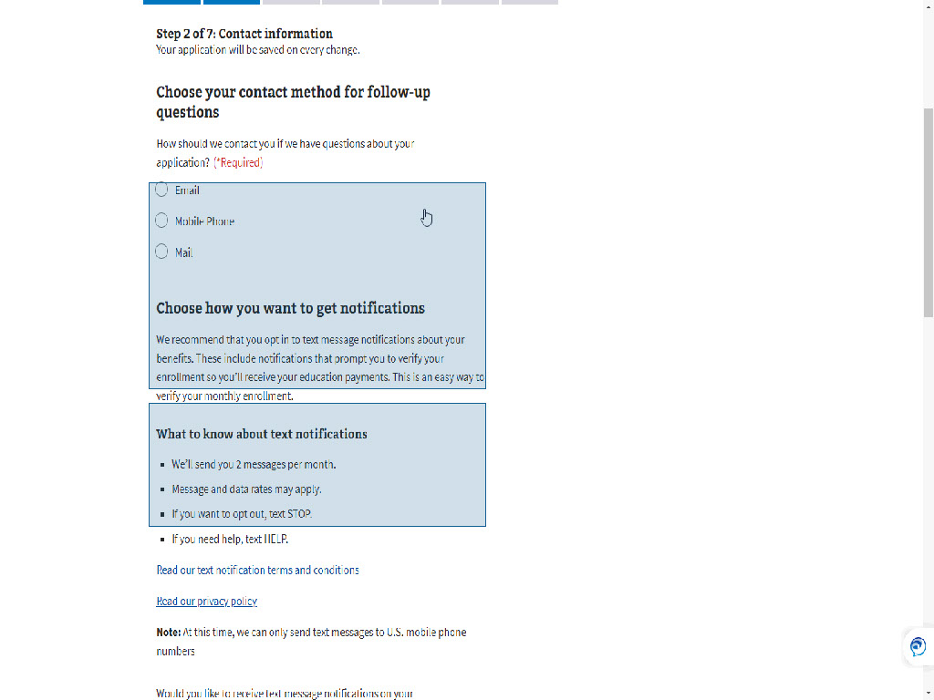
Slide notes

During step 2,

the application has

two (2) different questions

asking how the applicant

wants to be contacted:

One: If VA has questions

about their application

or to share important information

about their benefits.

Two: To verify their enrollment.
Slide 43 - EDU Application Follow-up
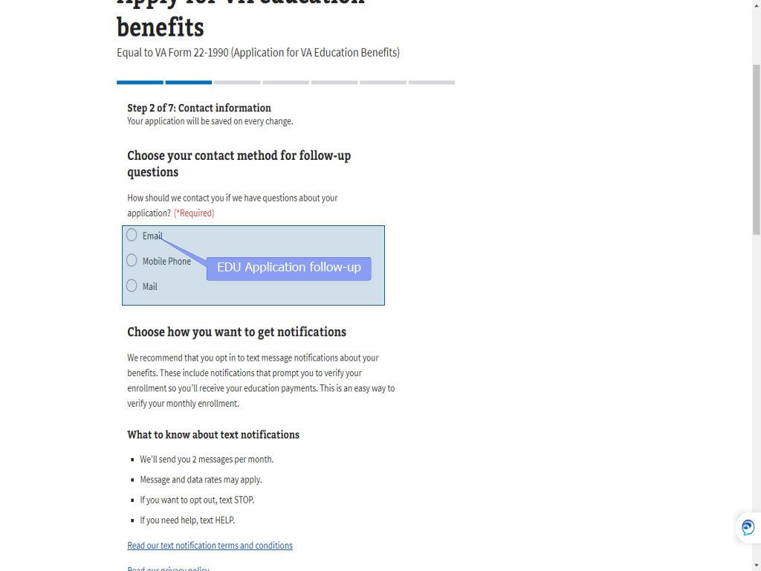
Slide notes

The options for application follow-up are

Email,

Mobile Phone

or Mail.

Slide 44 - Slide 44
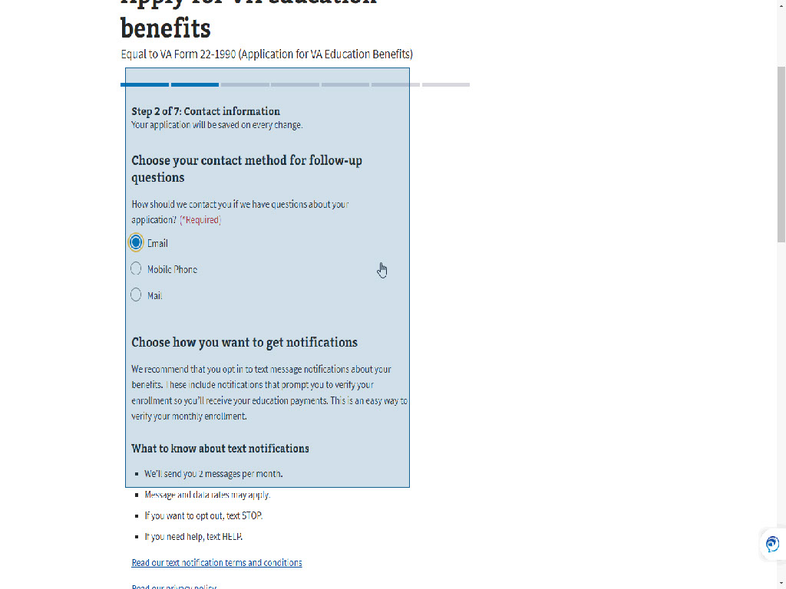
Slide notes

Next the application

suggests the applicant

opt into text messaging

and provides information on

“What to know about text notifications”.

Slide 45 - Text Default to Yes
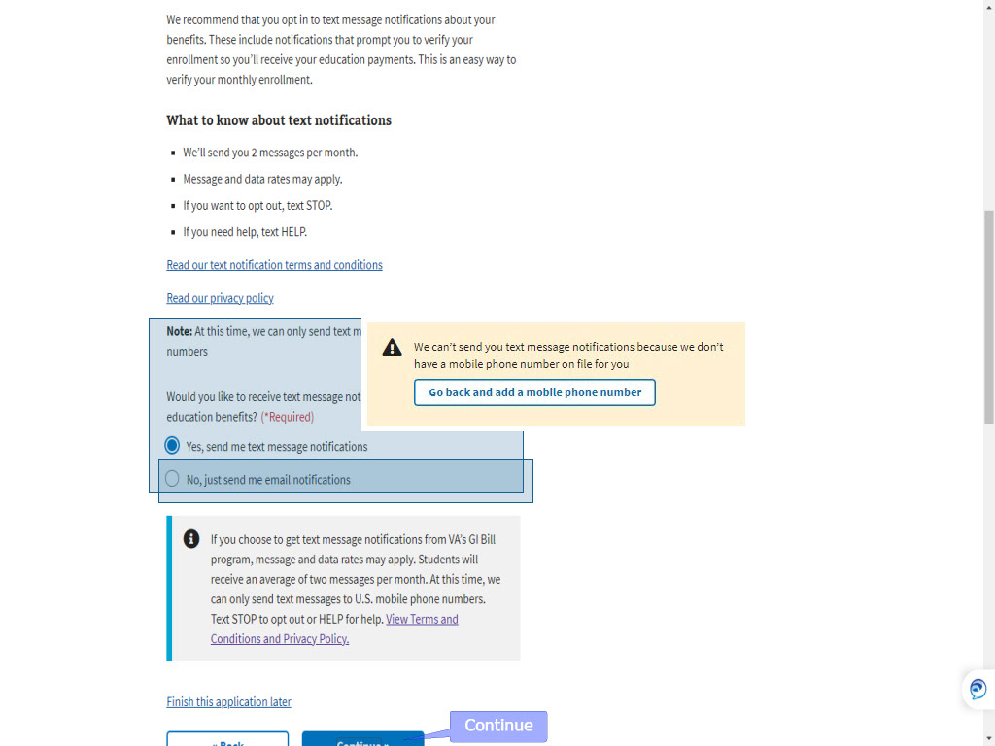
Slide notes

The Enrollment Verification option,

defaults to “Yes,

send me text message notifications”.

If the applicant did not include a mobile number

a message will appear.

The applicant has the option to select “

No, just send me email notifications”.

They must select one of the two options.

Slide 46 - Text Message Opt-in
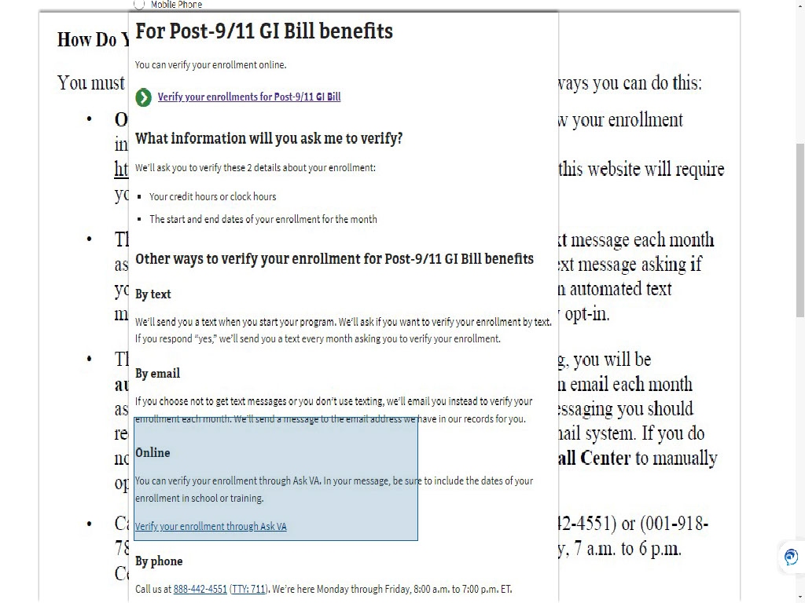
Slide notes

As we know,

Online Enrollment Verification

is now an option through MEB.

Information on this option

on VA.Gov

and included in the AWD3 Letter

when an enrollment exists.

As of this training,

it is not an option

during the application process.
For those applicants who opt-in for text messaging,
an informational pop-up will appear
with a few disclaimers and links.
Slide 47 - Step 3: Service History
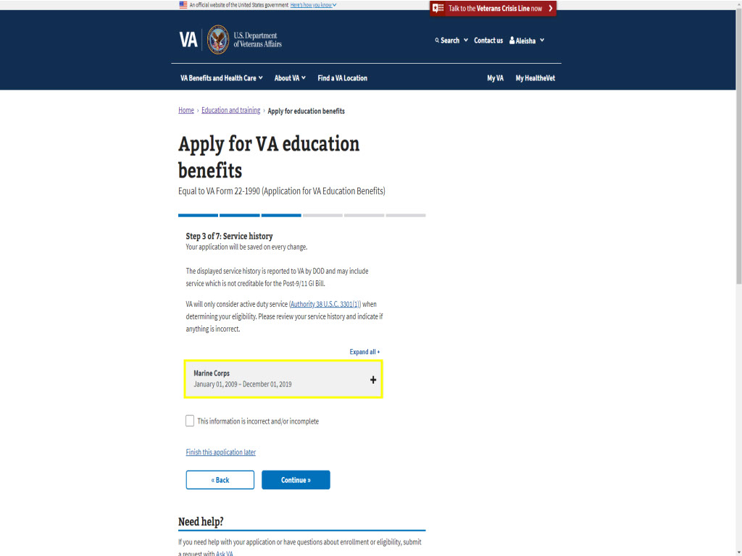
Slide notes

Step 3 is Service History.

The applicant will see a snapshot

of their service based on the information

provided from DOD to VA.

Slide 48 - Disagree with service
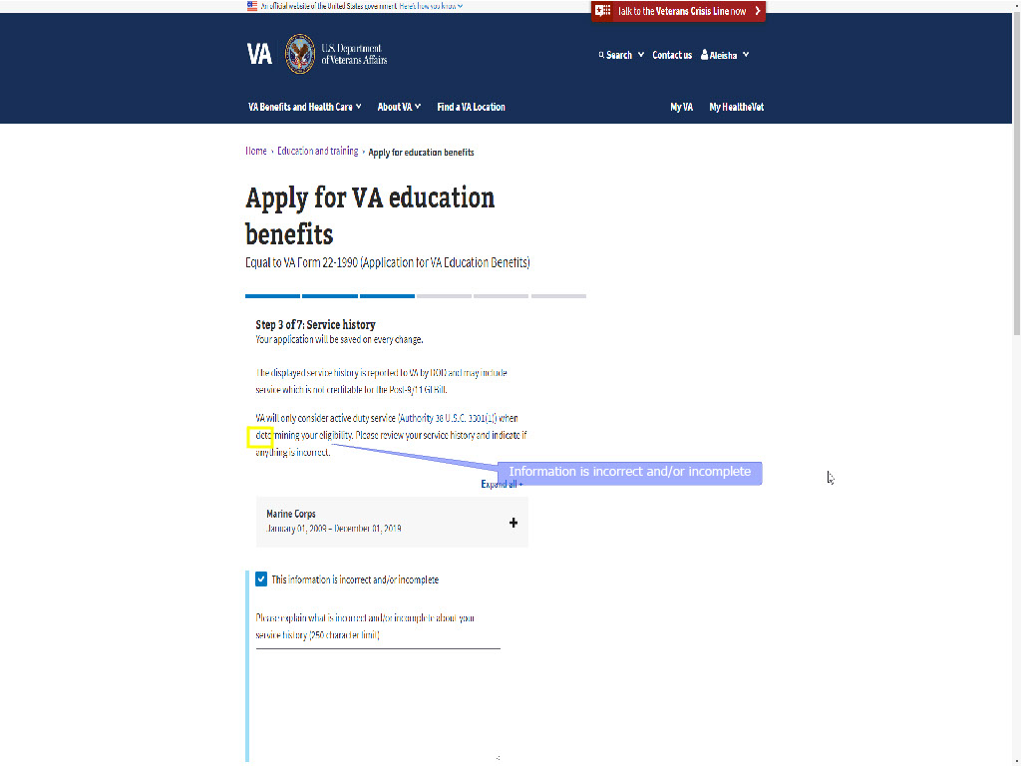
Slide notes

If the applicant disagrees

with what is displayed,

they can check the box titled

“This information is incorrect

and/or incomplete”.

Slide 49 - Enter Comments
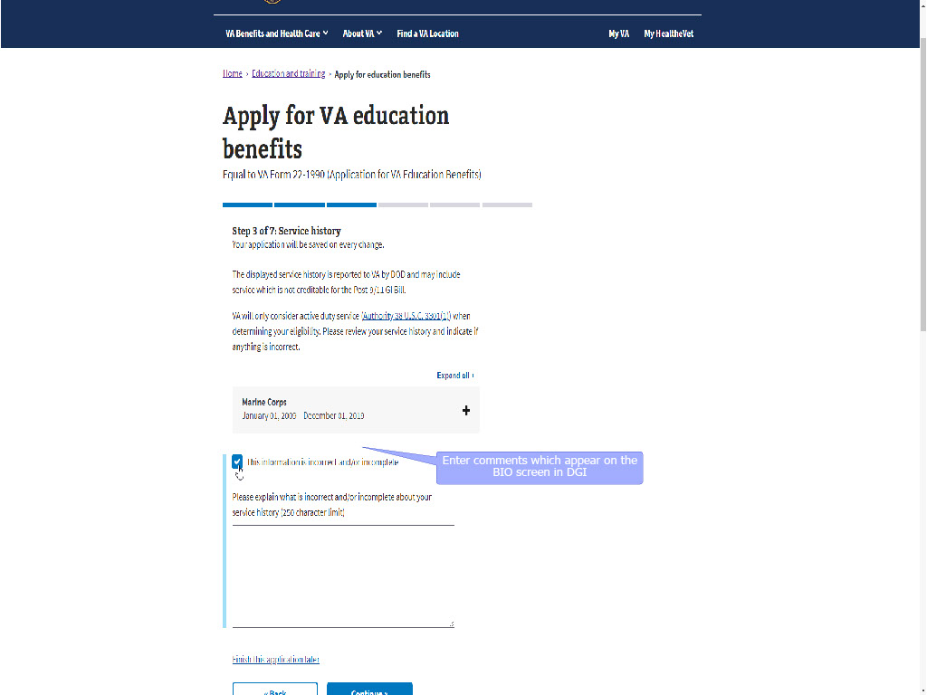
Slide notes

If this box is checked,

a comment entry box will open.

The information provided

within this comment entry box

will appear on the BIO screen in DGI

once the application is submitted.

Slide 50 - Slide 50
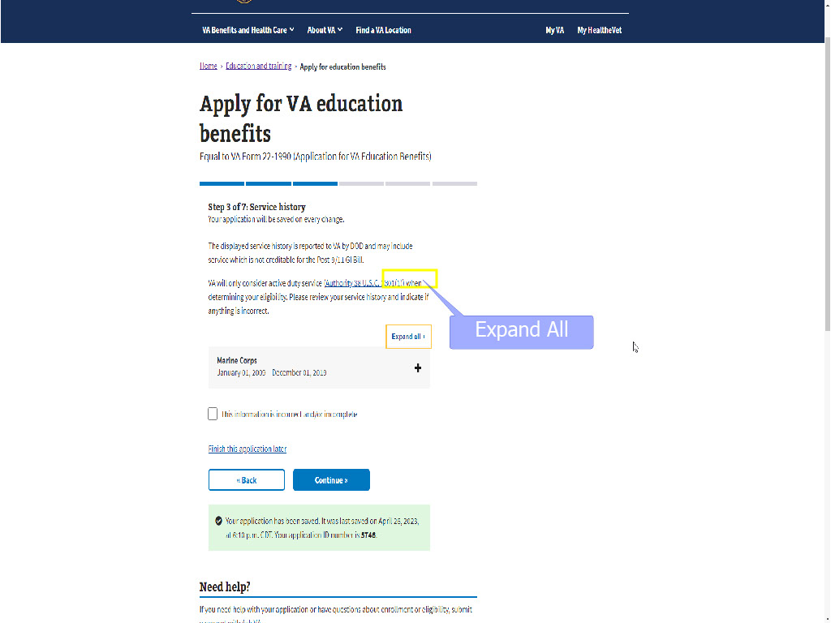
Slide notes

If the applicant

has multiple service periods,

they can click the “+” sign

next to “Expand All”

to view all their displayed service history.

Slide 51 - Plus Sign
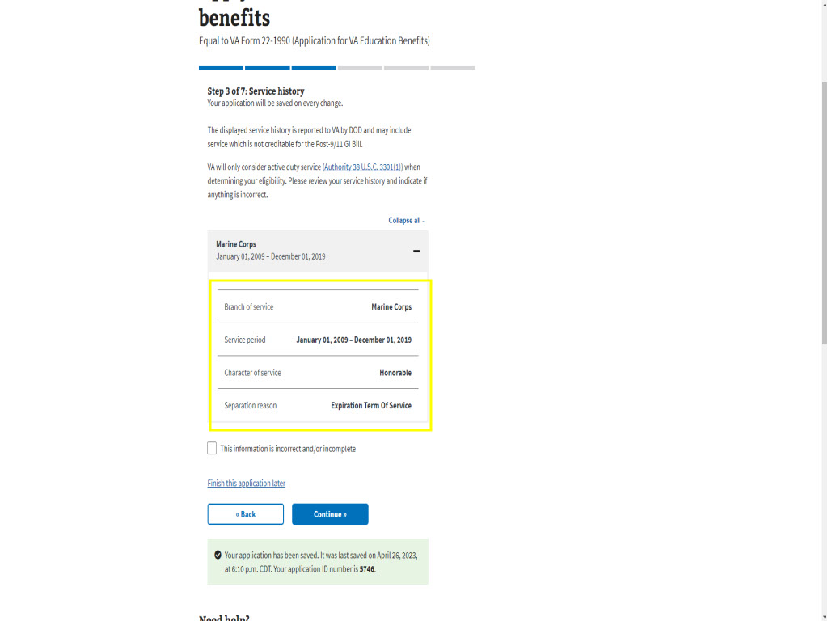
Slide notes

Once “Expand all”

or the “+” sign

next to the single period of service is selected,

is selected,

the applicant can view the displayed

Branch of Service

Service Period,

Character of Service,

Separation Reason

and Training Period.
Slide 52 - Slide 52
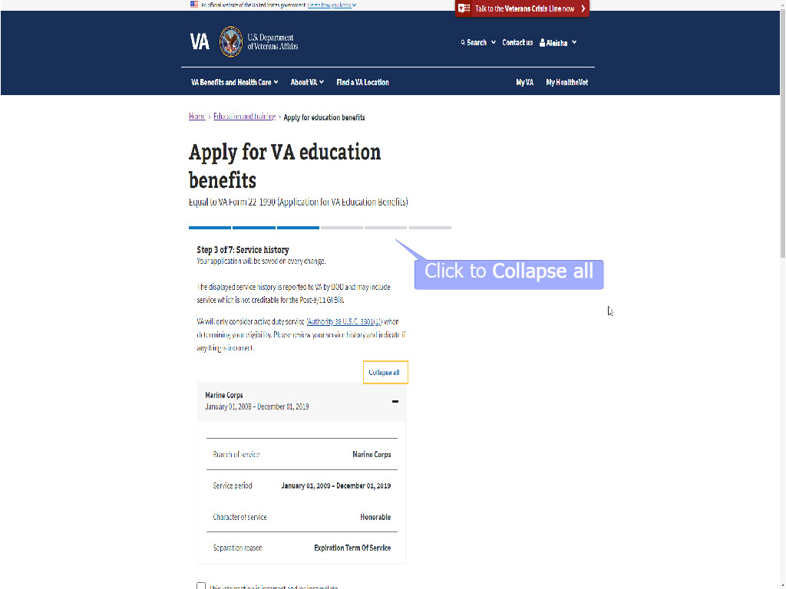
Slide notes

To close the service periods,

the applicant will select

“Collapse all”

or the “-”sign.

Slide 53 - Continue
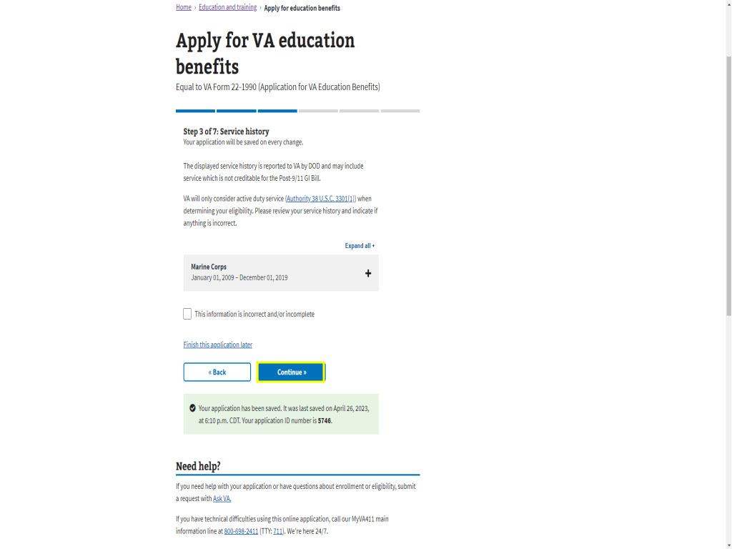
Slide notes

Slide 54 - Step 4: Benefit Selection
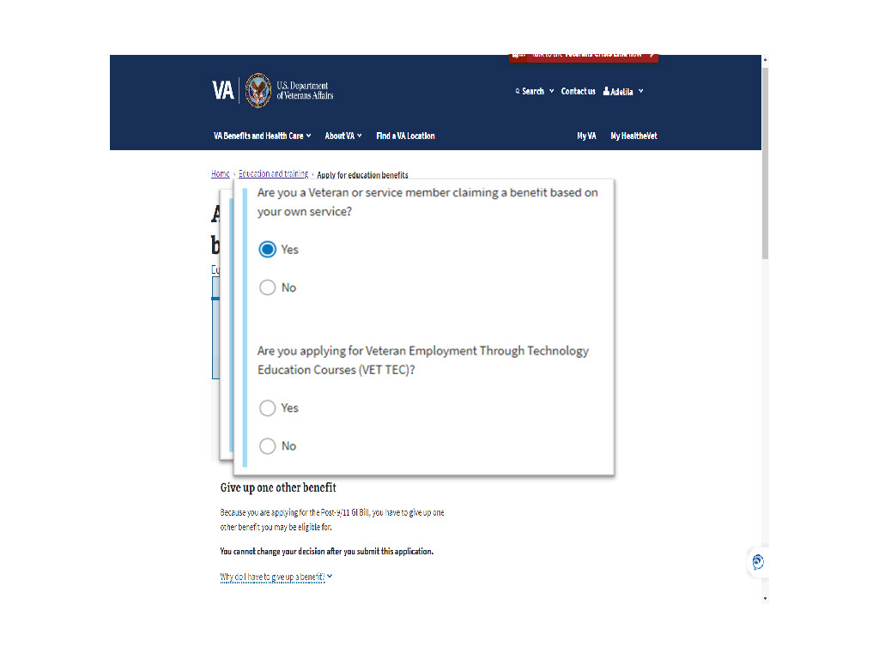
Slide notes

Next up is Step 4:

Benefit Selection.

Remember Post-9/11 GI Bill

was selected

when the application was started.

STEM and VET TEC

were other options

at the beginning of the application

based on the answers

to the introductory questions.
Slide 55 - Relinquishment
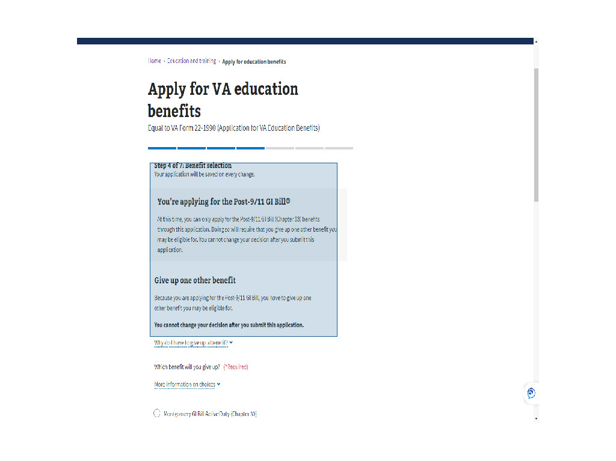
Slide notes

Because chapter 33 was selected,

the application mentions

giving up one other benefit.

It informs the applicant

they cannot change

their relinquishment

after the application is submitted.

Slide 56 - Why Relinquish
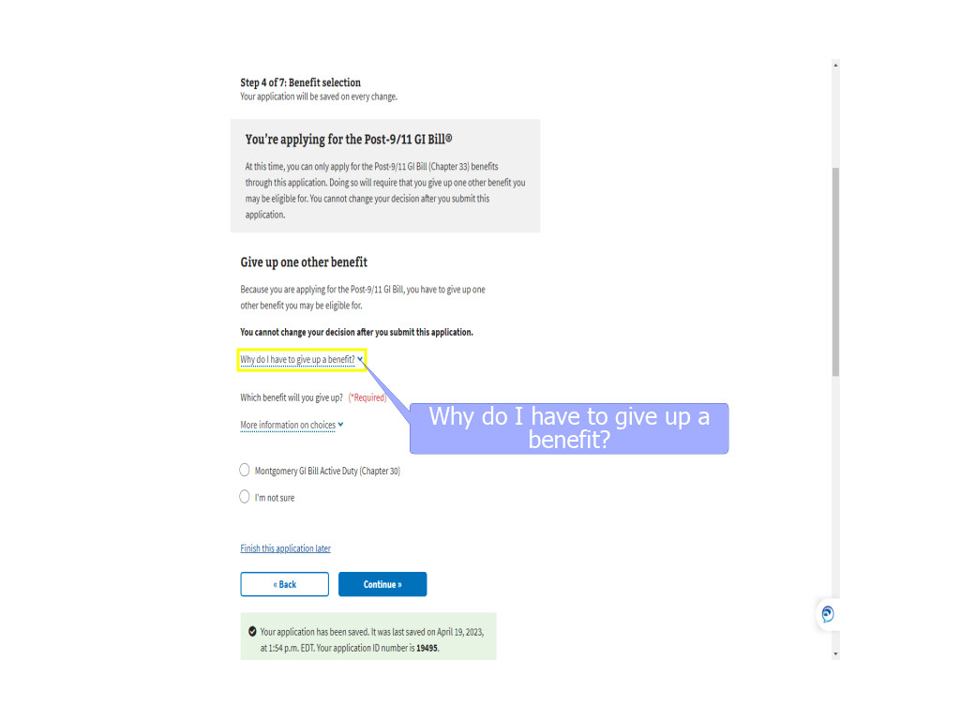
Slide notes

In addition,

if there is any confusion about

why they must relinquish,

information is available by selecting

a dropdown next to

“Why do I have to give up a benefit?”.

Slide 57 - Slide 57
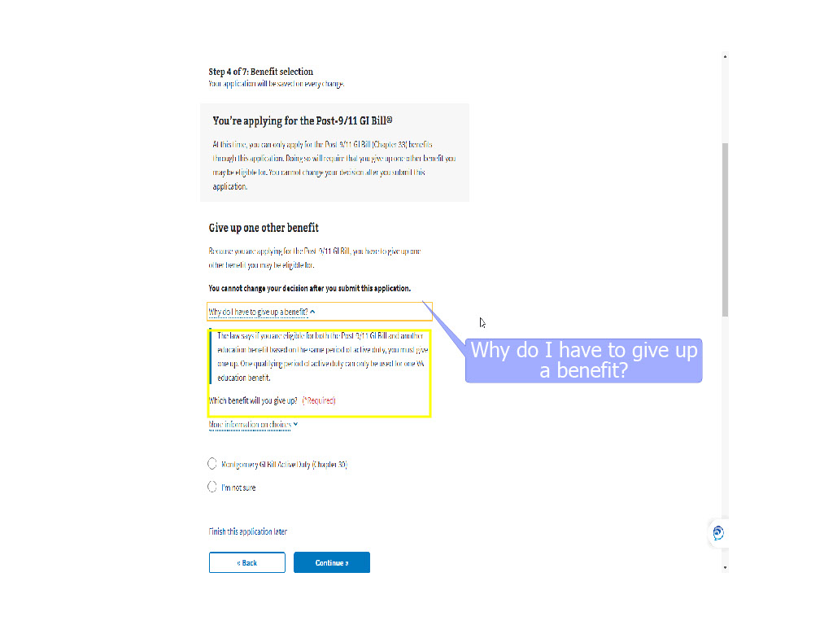
Slide notes

Slide 58 - More info
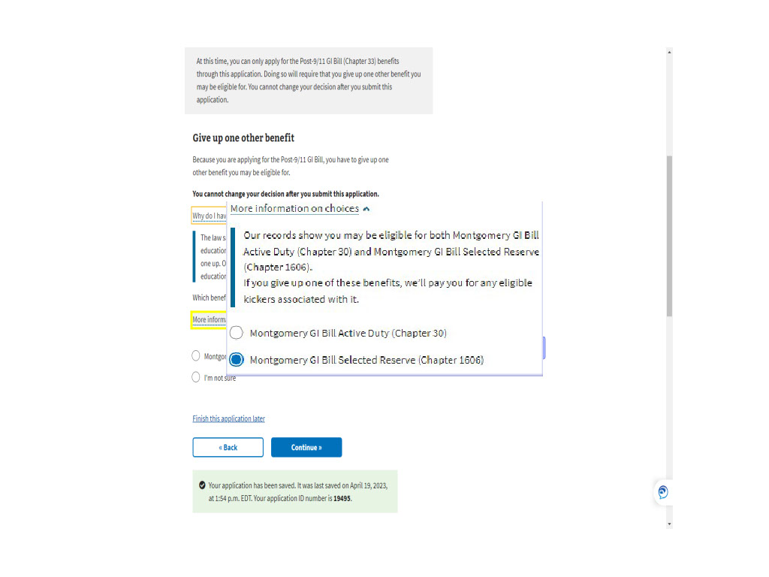
Slide notes

To provide even more clarity
on the relinquishment process,
the application has a
“More information on your choices” dropdown.
Dependent upon the benefits available for relinquishment,
the applicant may see:
‘Our records show
you may be eligible for the Montgomery GI Bill
for the Montgomery GI Bill
Active Duty (Chapter 30).
If you give up this benefit,
we’ll pay you for any eligible kickers
associated with it’
or
‘Our records show
you may be eligible for both
Montgomery GI Bill Active Duty (Chapter 30)
and Montgomery GI Bill Selected Reserve (Chapter 1606).
If you give up one of these benefits,
we’ll pay you for any eligible kickers
associated with it.
Slide 59 - Choose relinquished benefit
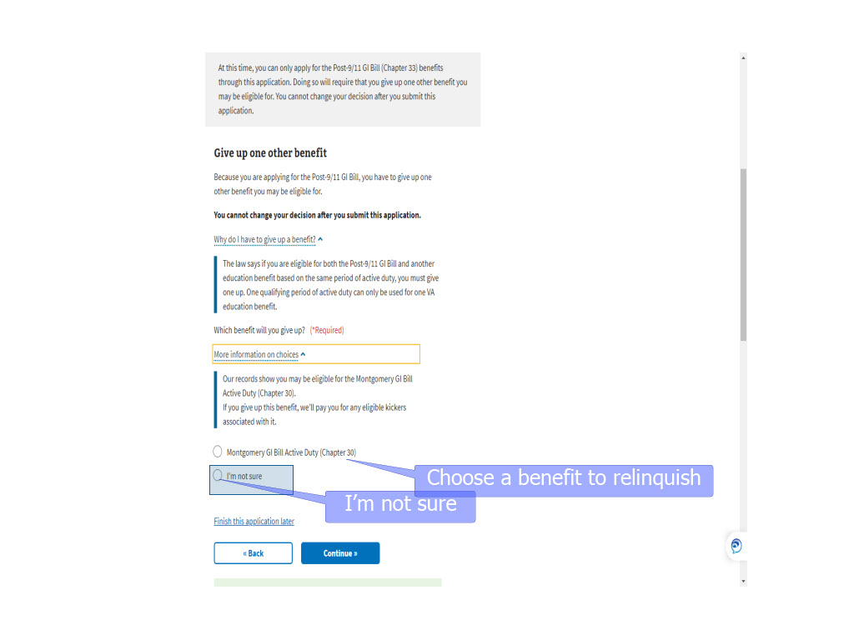
Slide notes

The applicant can select

“I’m not Sure”

and the application will be off ramped

for VCE intervention.

The applicant can select

one of the benefit options listed

Slide 60 - Slide 60
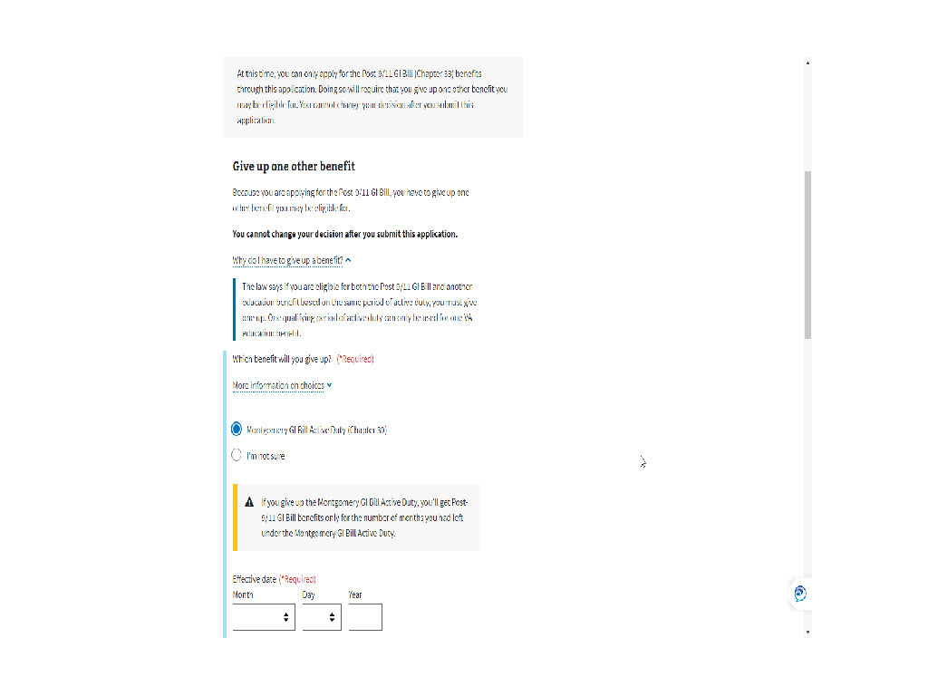
Slide notes

and a pop-up will appear

for a selection of a relinquishment effective date.

and a pop-up will appear

for a selection

selection of a relinquishment

effective date.

The applicant can select

“I’m not Sure”

and the application will be off ramped

for VCE intervention.
Slide 61 - Relinquishment Date
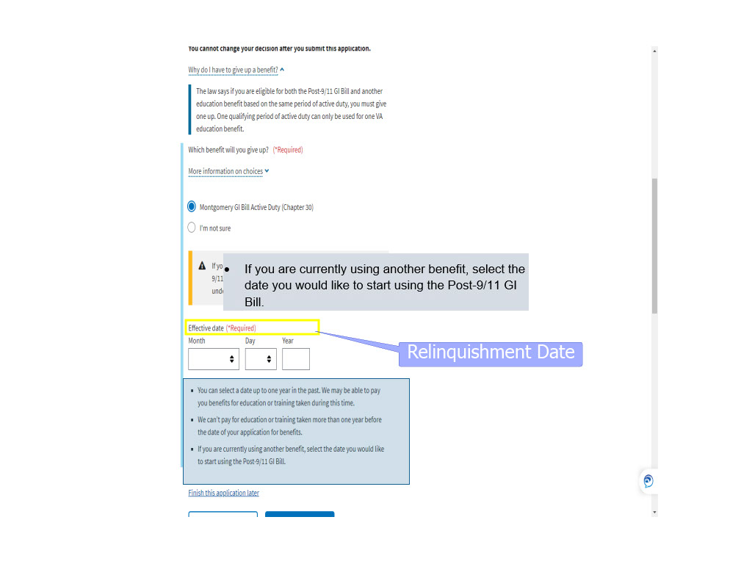
Slide notes

During the effective date selection process,
more information is given to assist the applicant
with selecting the best date for them.
Below the “Effective date (*Required) dropdowns,
, there are bullets explaining the rules for relinquishment:
You can select a date up to one year in the past.
We may be able to pay you benefits
for education or training taken during this time.
We can’t pay for education or training
taken more than one year
before the date of your application for benefits.
If you are currently using another benefit,
select the date you would like to start
using the Post-9/11 GI Bill.

Slide 62 - Month
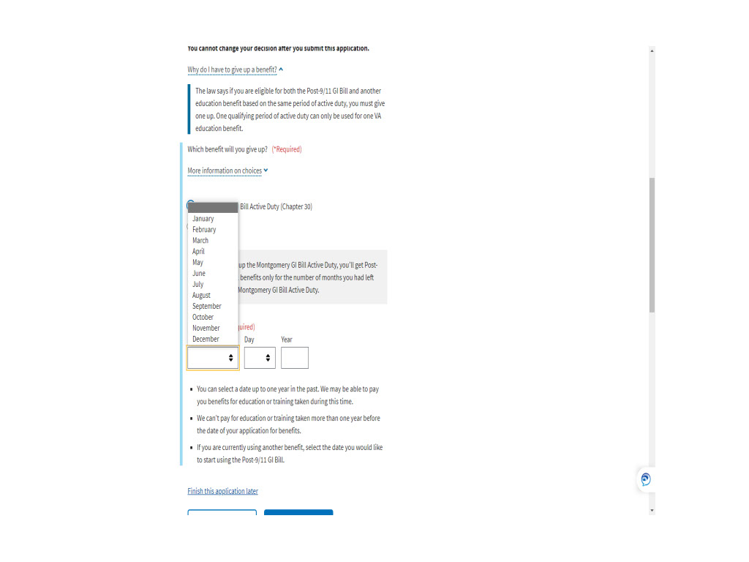
Slide notes

Slide 63 - Slide 63
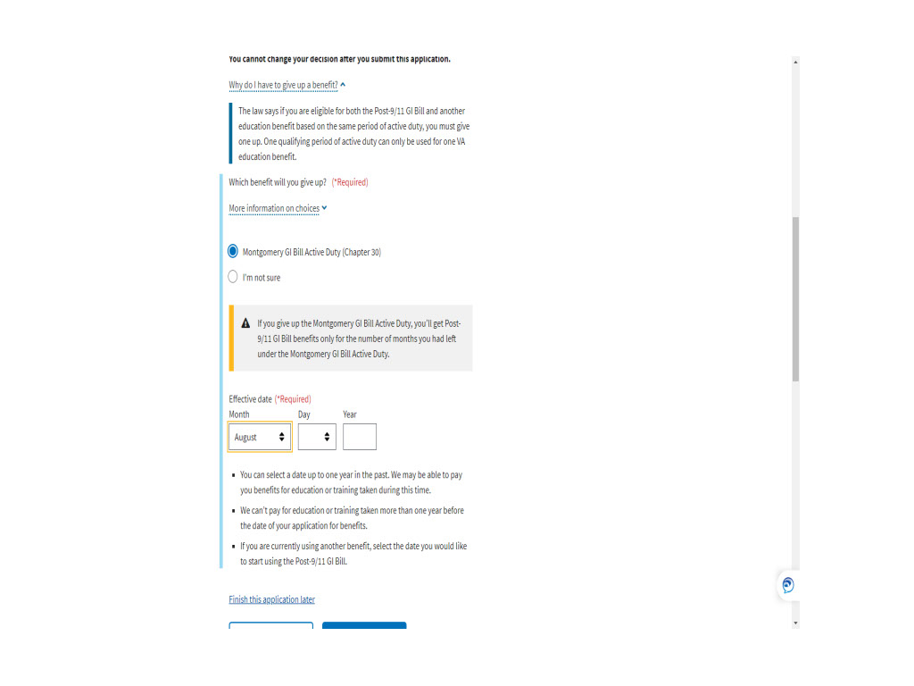
Slide notes

Slide 64 - Day
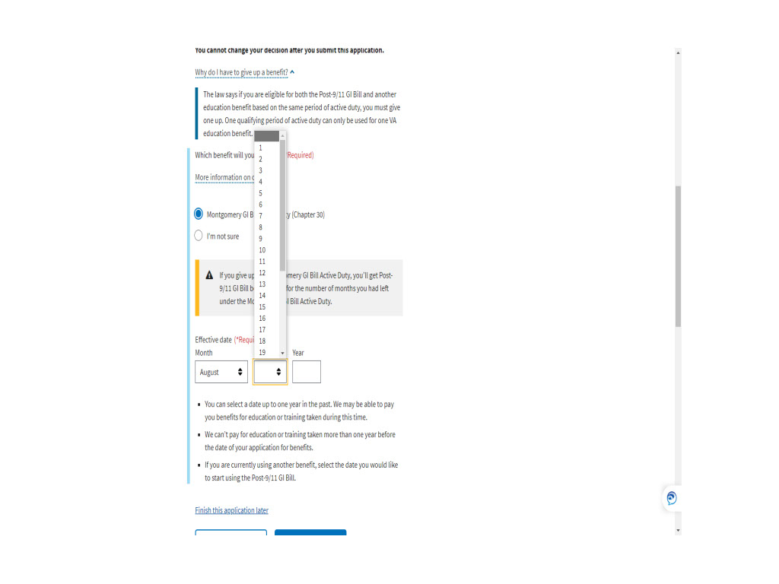
Slide notes

Slide 65 - Slide 65
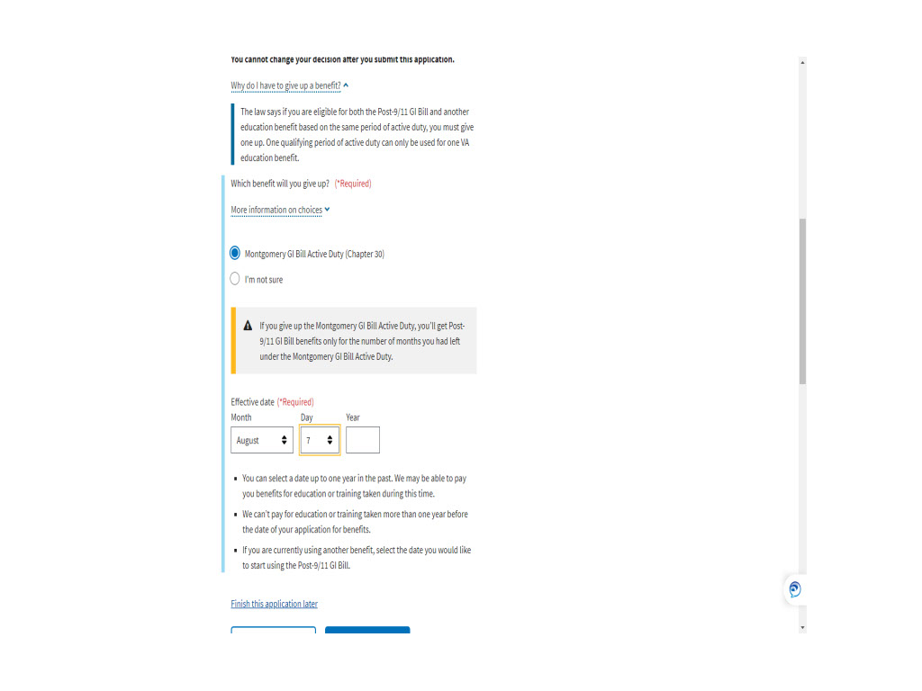
Slide notes

Slide 66 - Year
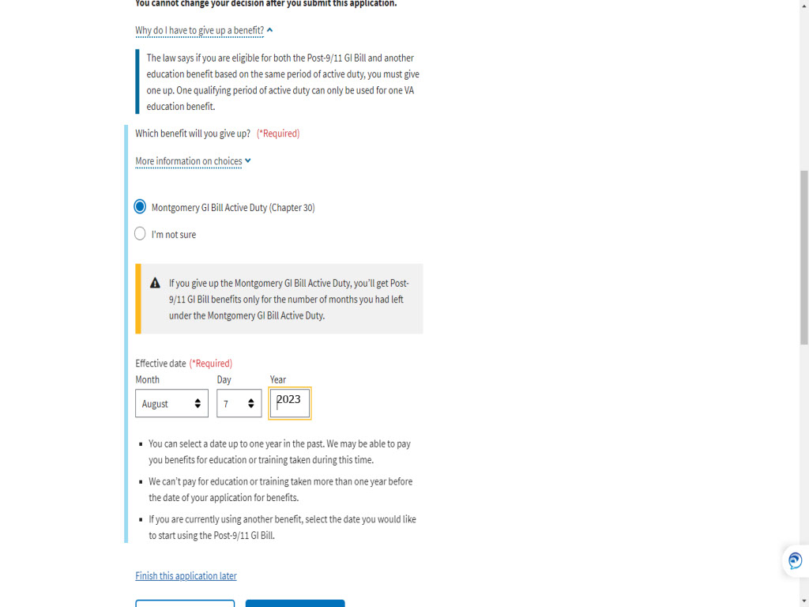
Slide notes

Slide 67 - Continue
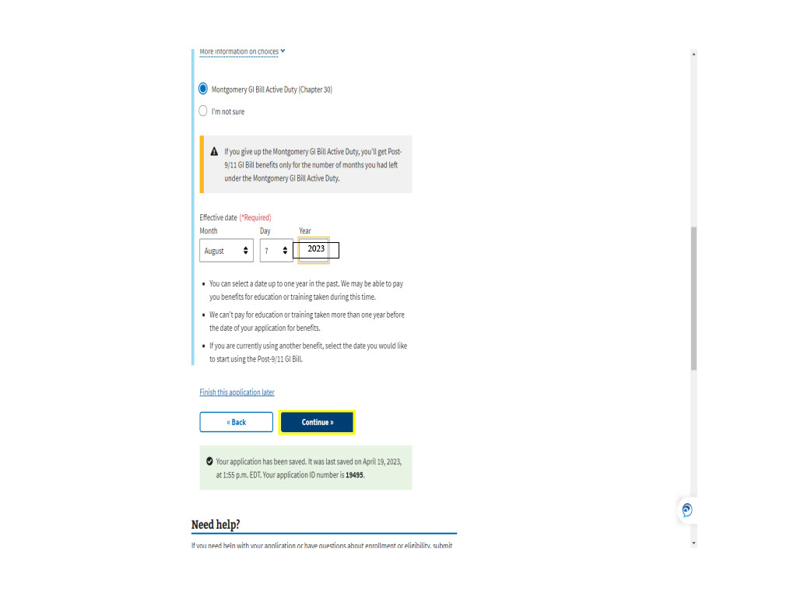
Slide notes

Slide 68 - Knowledge Checks

Slide notes

Now let’s take a quick break

and make sure you’re retaining

some of the information

shared so far.

Slide 69 - Multiple Choice
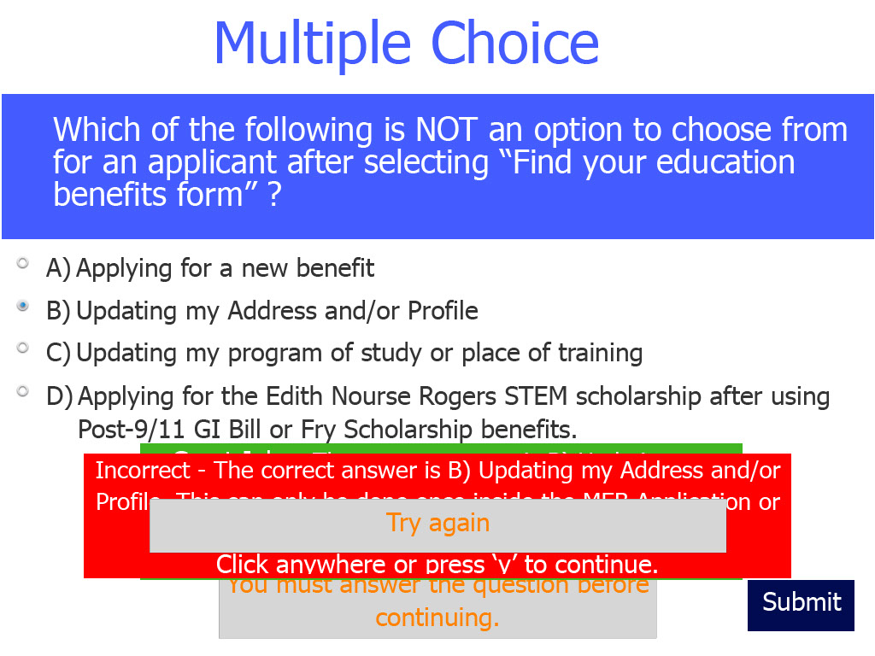
Slide notes

Let’s begin with a multiple choice question.

Which of the following

is NOT an option to choose from

for an applicant after selecting

“Find your education benefits form”?

Let’s start with multiple choice.

Which of the following

is NOT an option to choose from

from for an applicant after selecting

“Find your education benefits form”?
Slide 70 - True or False
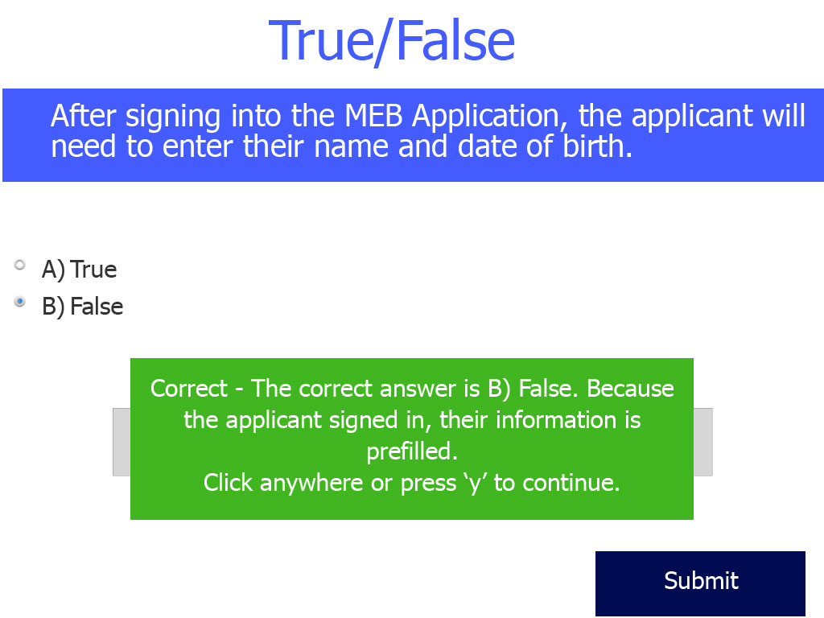
Slide notes

True or False

After signing into the MEB Application,

the applicant will need to enter their name

and date of birth.

Slide 71 - Fill In The Blank
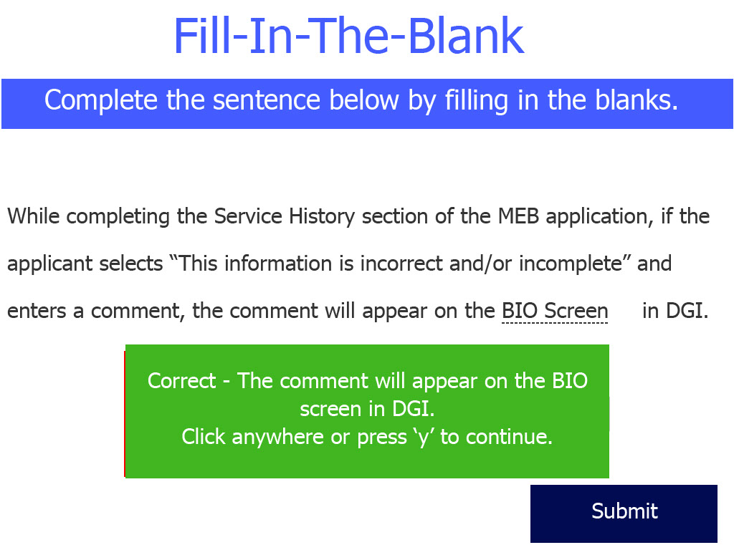
Slide notes

Fill-In-The-Blank

While completing the Service History section

of the MEB application,

if the applicant selects

“This information is incorrect and/or incomplete”

and enters a comment,

the comment will appear on the

“blank” in DGI.

Slide 72 - True or False
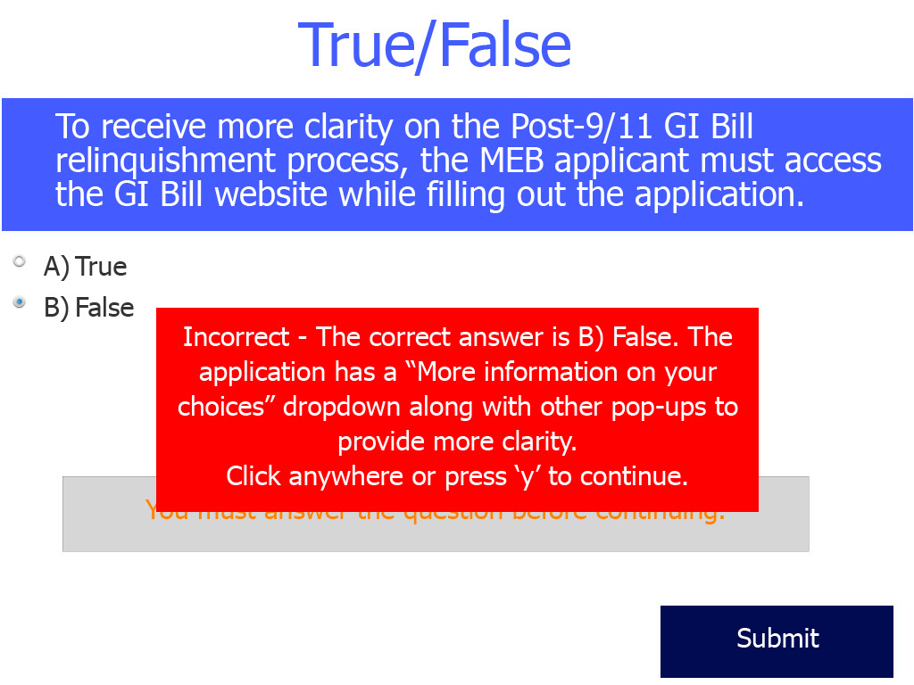
Slide notes

The last question is a “True or False”.

To receive more clarity

on the Post-9/11 GI Bill

relinquishment process,

the MEB applicant must access

the GI Bill website

while filling out the application.

Slide 73 - We Are Back

Slide notes

Slide 74 - Step 5: Additional Considerations
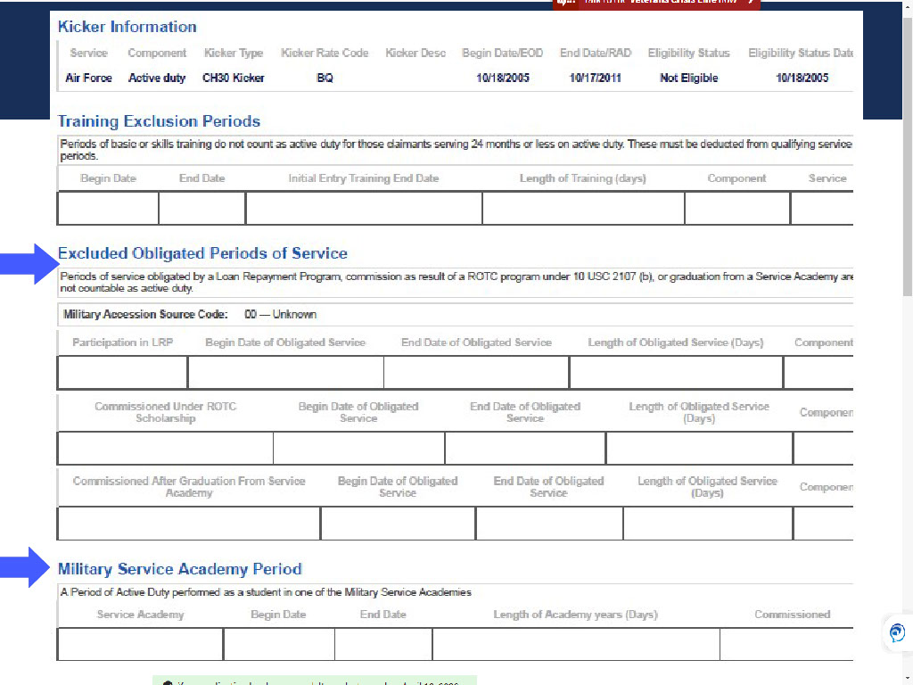
Slide notes

Moving on to Step 5:
Additional Considerations.
This step includes questions
about Kicker,
Commissioning,
ROTC,
and Loan Repayment.
As information sharing
between DOD and VA continues to evolve,
the best practice for a VCE
is to review the sections
-Excluded Obligated Periods of Service
and Military Service Academy Period
in VIS- when processing
supplemental claims.

Slide 75 - What is a Kicker
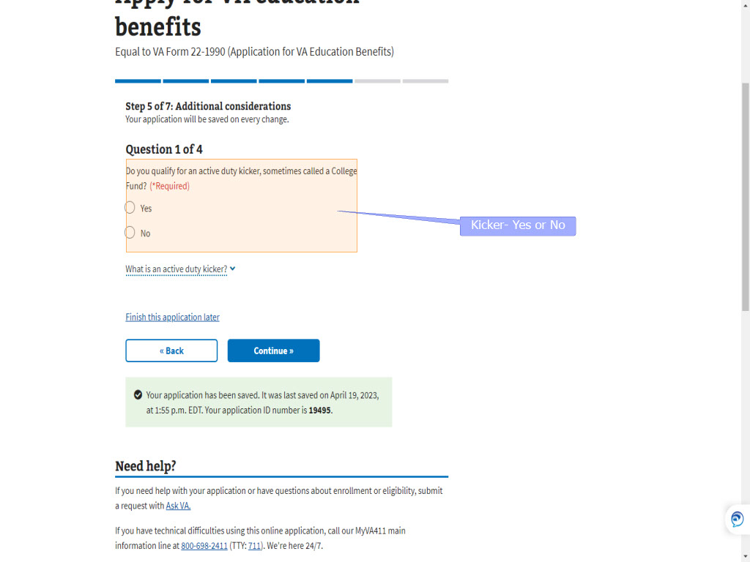
Slide notes

Question 1 asks the applicant

if they qualify for

an active-duty kicker.

Slide 76 - Kicker_yes or no
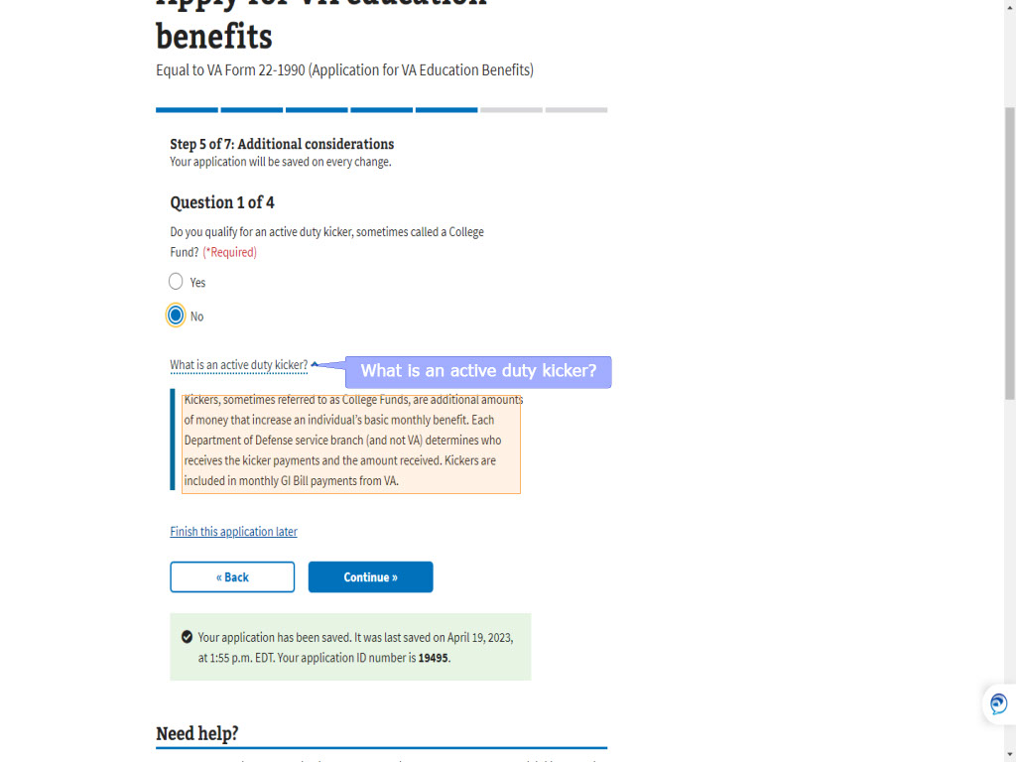
Slide notes

It also provides information on

“What is an active-duty kicker”

to better enable the applicant

to answer Yes or No.

Slide 77 - Stop Automation
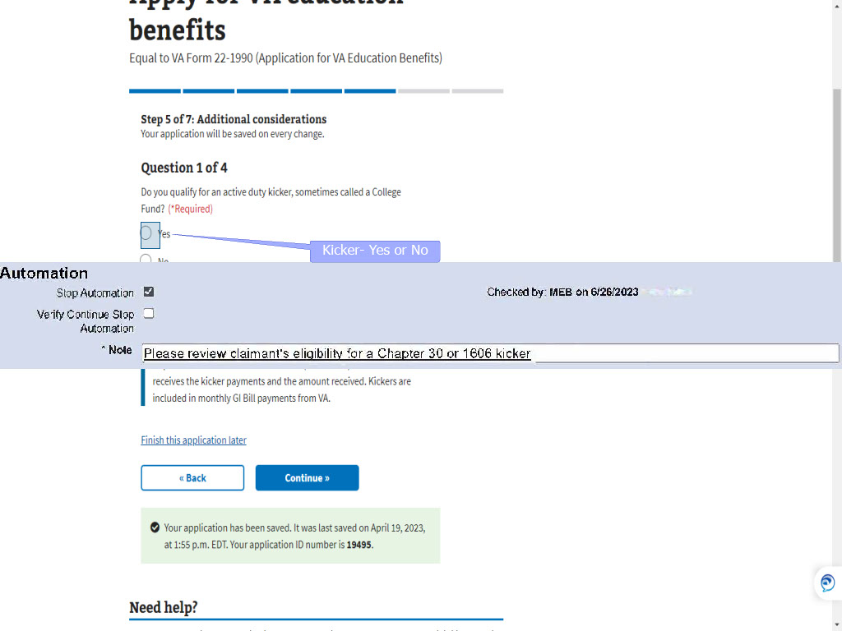
Slide notes

If the applicant answers “Yes”

or VADIR identifies a kicker,

a Stop Automation Flag

will be displayed in DGI

with a note to

“Please review claimant’s eligibility

for a Chapter 30

or 1606 kicker”.

Slide 78 - Slide 78
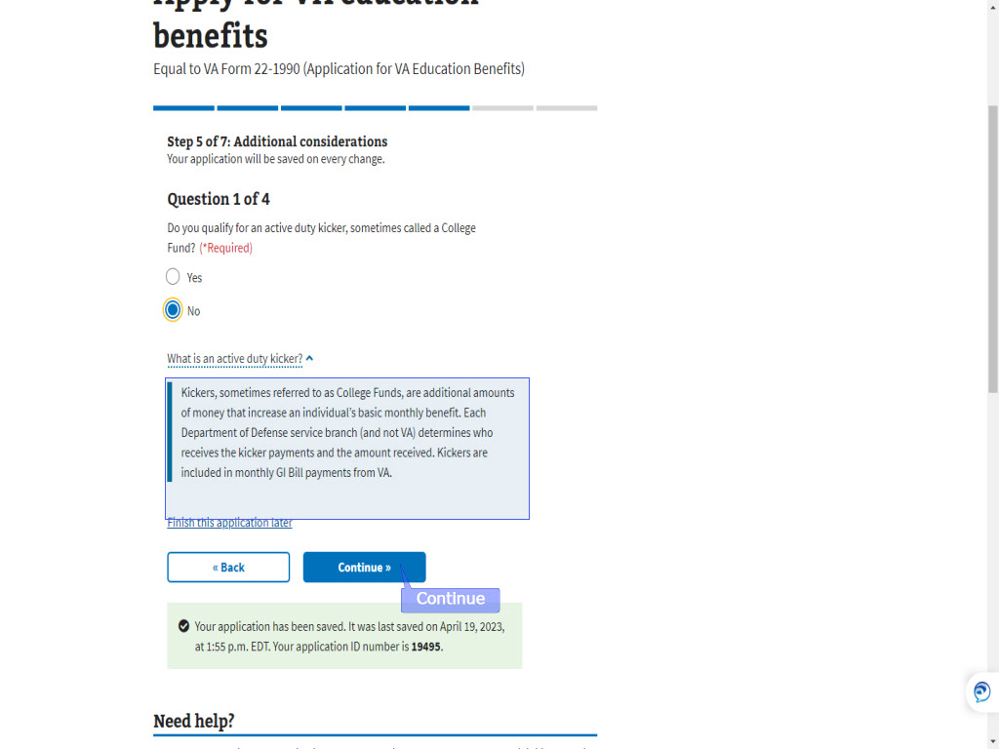
Slide notes

Slide 79 - Commissioned Officer
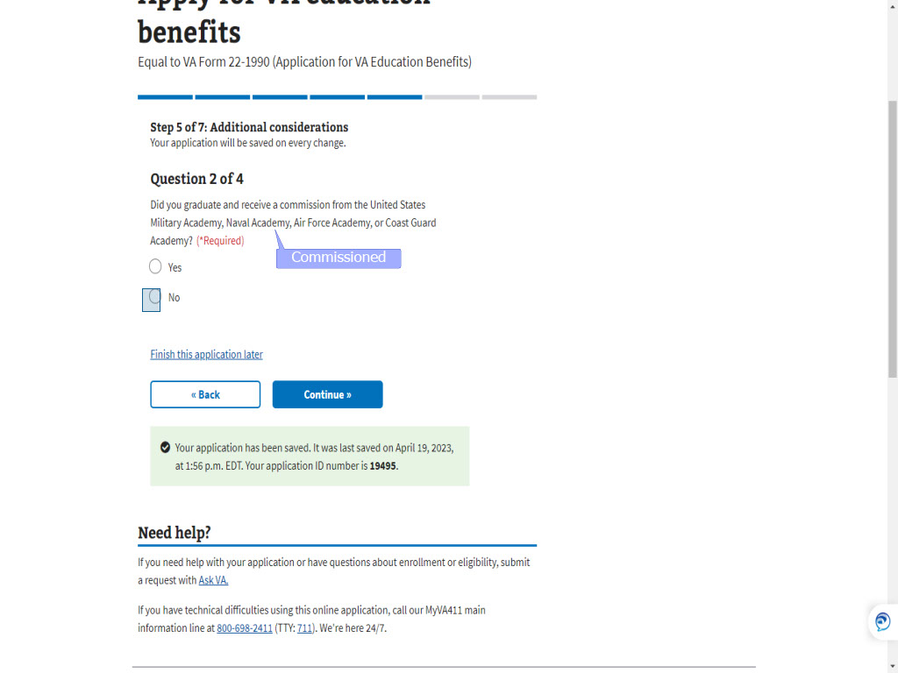
Slide notes

The next question

is about commissioning

from the US Military,

Naval,

Air Force

or Coast Guard Academy.

As we know,

there may be some periods

of exclusion

based upon their answer.
Slide 80 - Slide 80
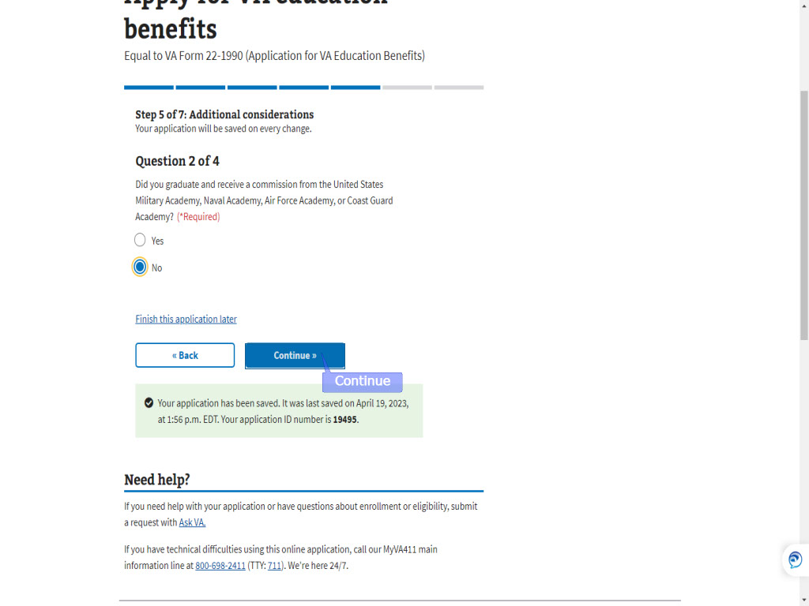
Slide notes

Slide 81 - ROTC
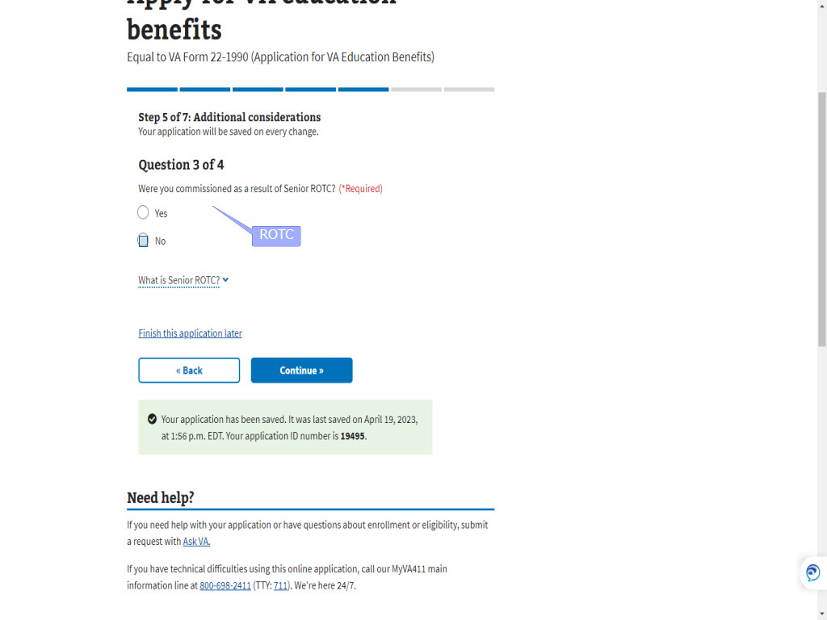
Slide notes

The third question asks

if they were commissioned

as a result of ROTC

or (Reserve Officer Training Corps).

Slide 82 - Slide 82
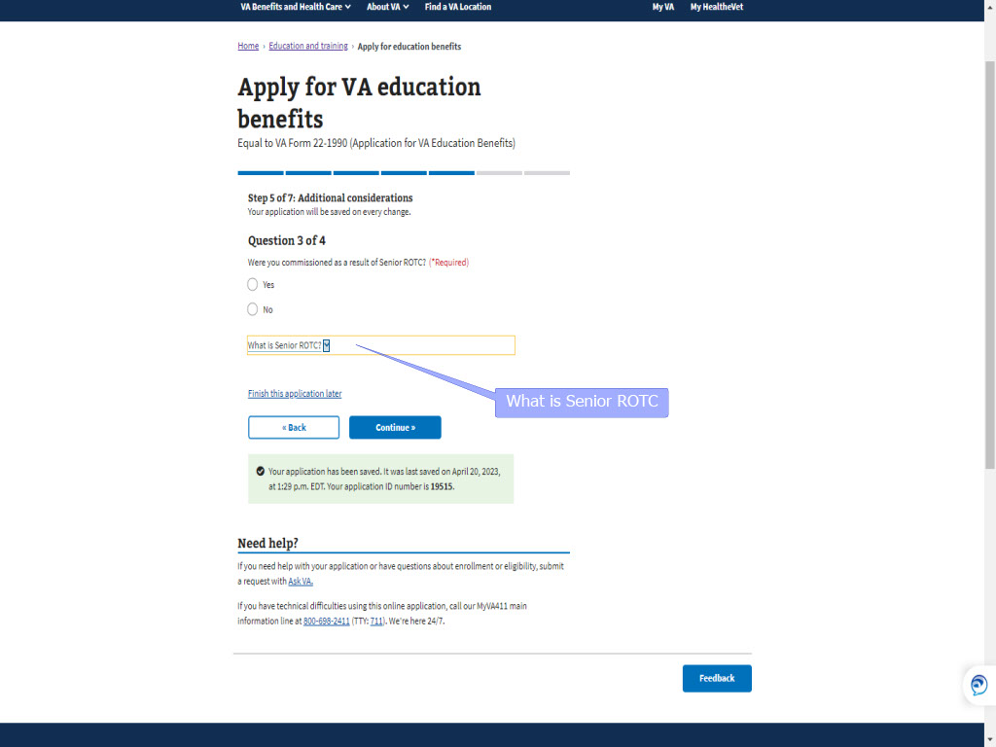
Slide notes

As with the previous questions,

, the applicant can select a dropdown

for more information

on “What is Senior ROTC”.

Slide 83 - What is SR ROTC
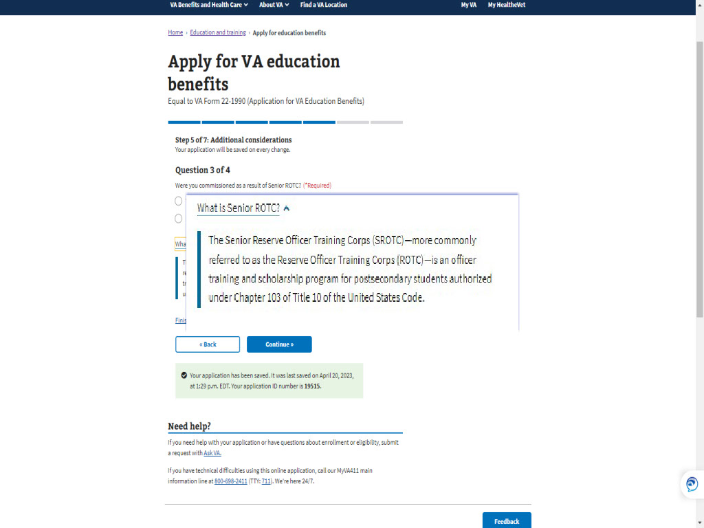
Slide notes

Slide 84 - Slide 84
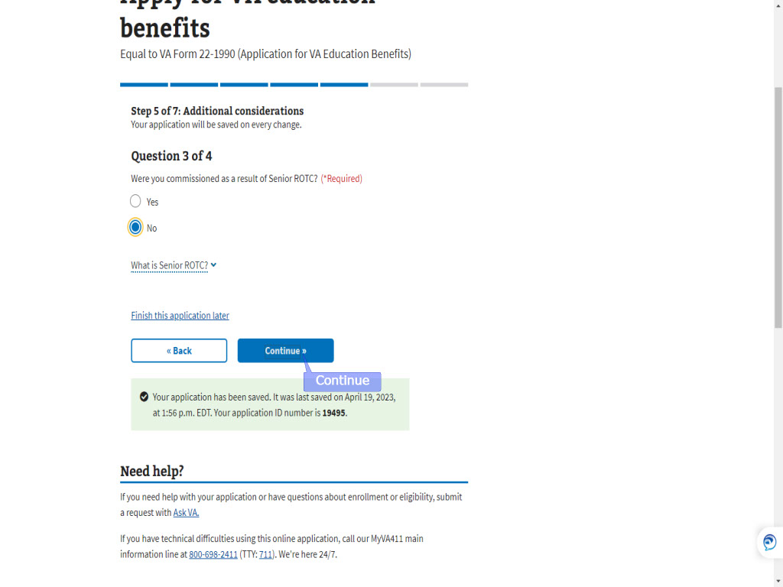
Slide notes

Slide 85 - Loan Repayment
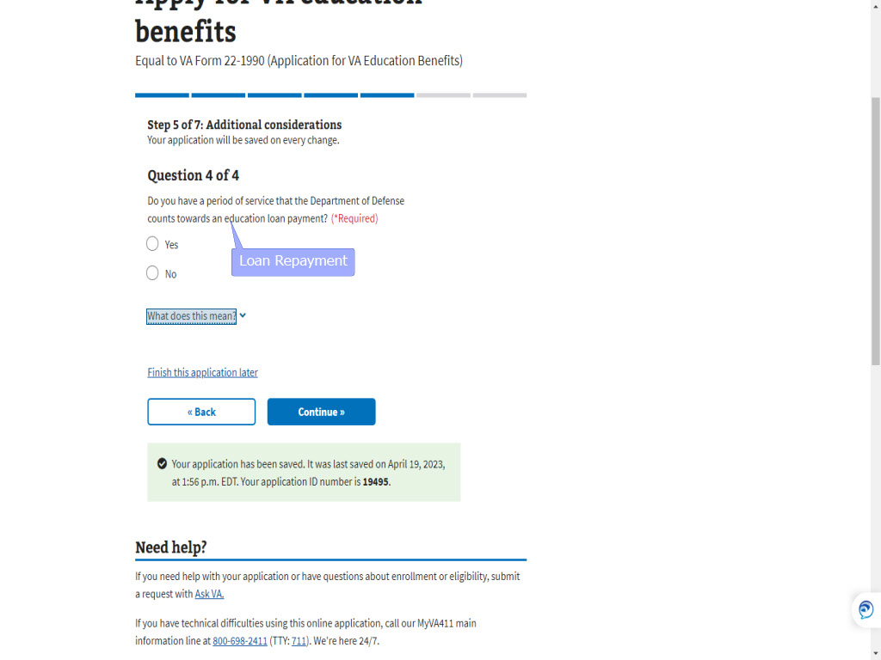
Slide notes

The final question

under “Additional Considerations”

references Education Loan Repayment

Slide 86 - What does LRP mean
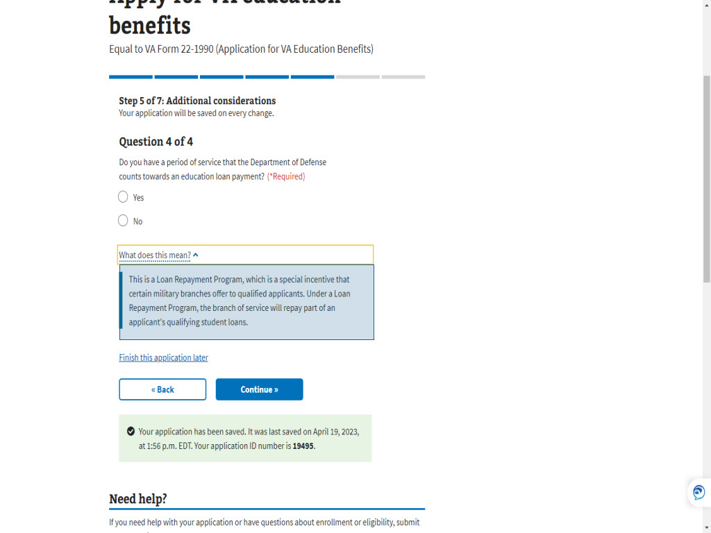
Slide notes

and explains what

loan repayment means.

Slide 87 - Continue
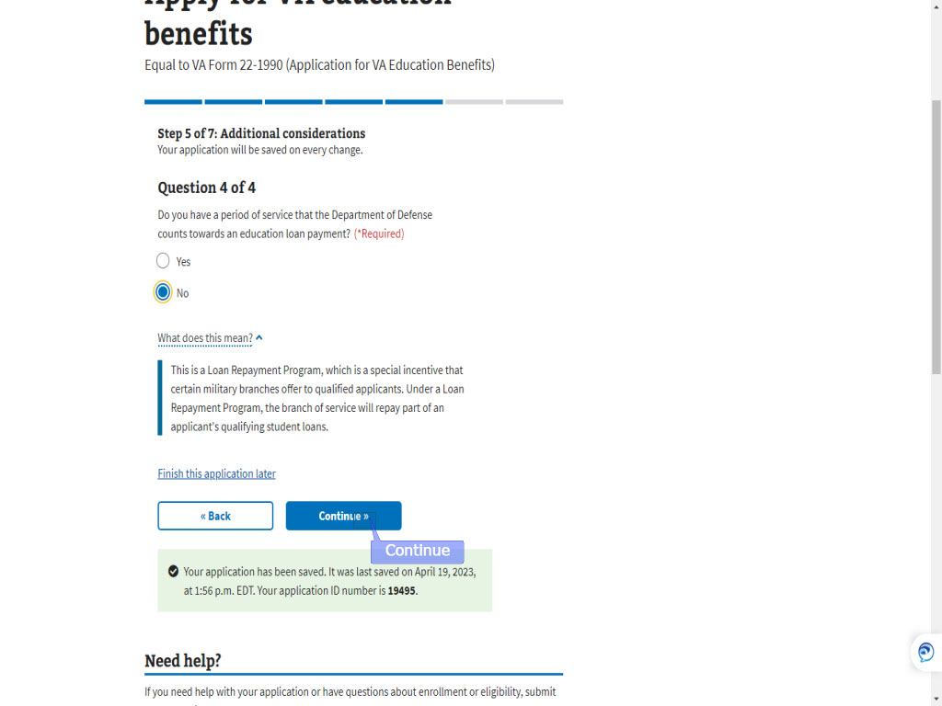
Slide notes

Slide 88 - Step 6: Direct deposit
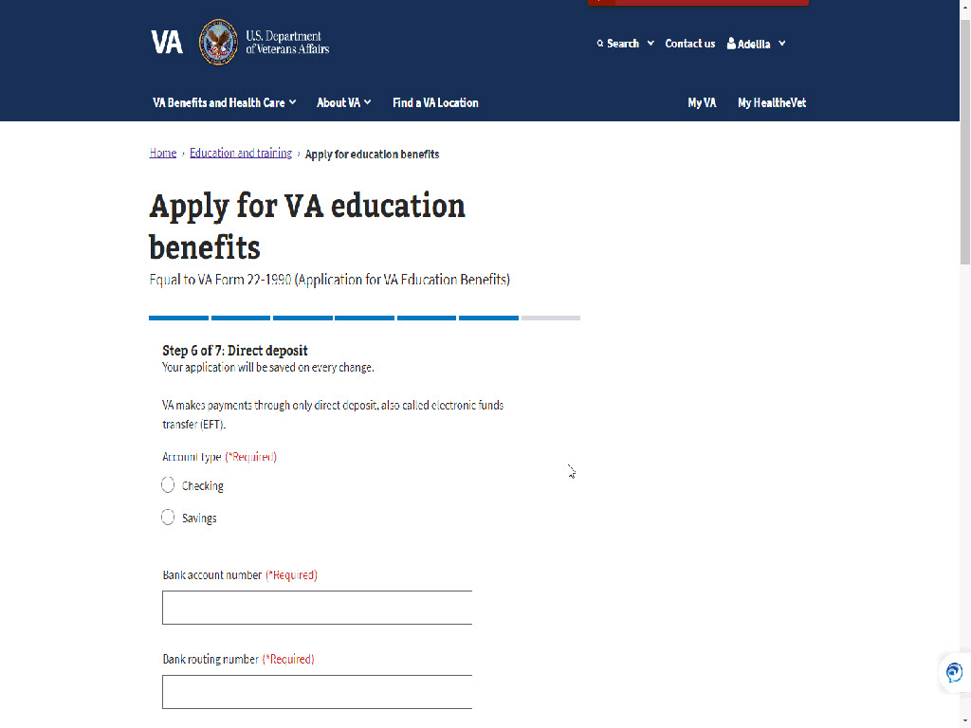
Slide notes

The application is almost complete.

Only two more steps to go.

Slide 89 - Slide 89

Slide notes

Step 6 is entering Direct Deposit information
which is required.
This should not be an issue for the applicant
as even services like Venmo and Cashapp
offer account and routing numbers for Direct Deposit.
If the applicant is unable to provide
direct deposit information,
They will not be able to advance
in the MEB application.
The applicant would need to
apply by submitting a paper application.
All online education benefit applications
require authentication and direct deposit.

Slide 90 - Bank account
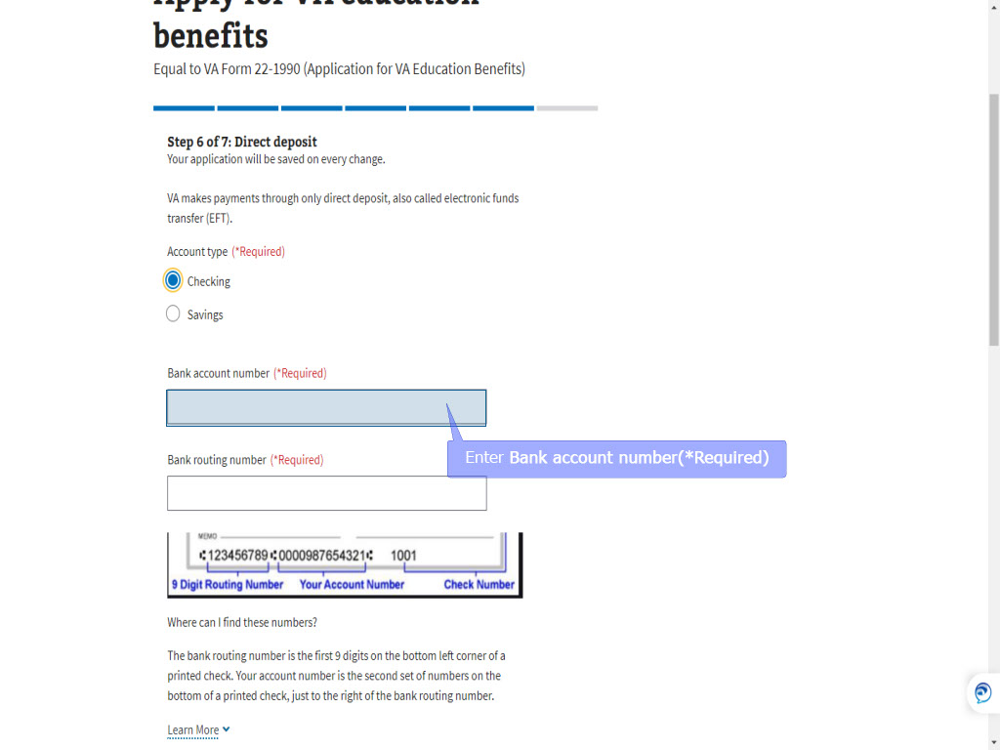
Slide notes

The applicant will enter

their account type,

bank account,

Slide 91 - Slide 91
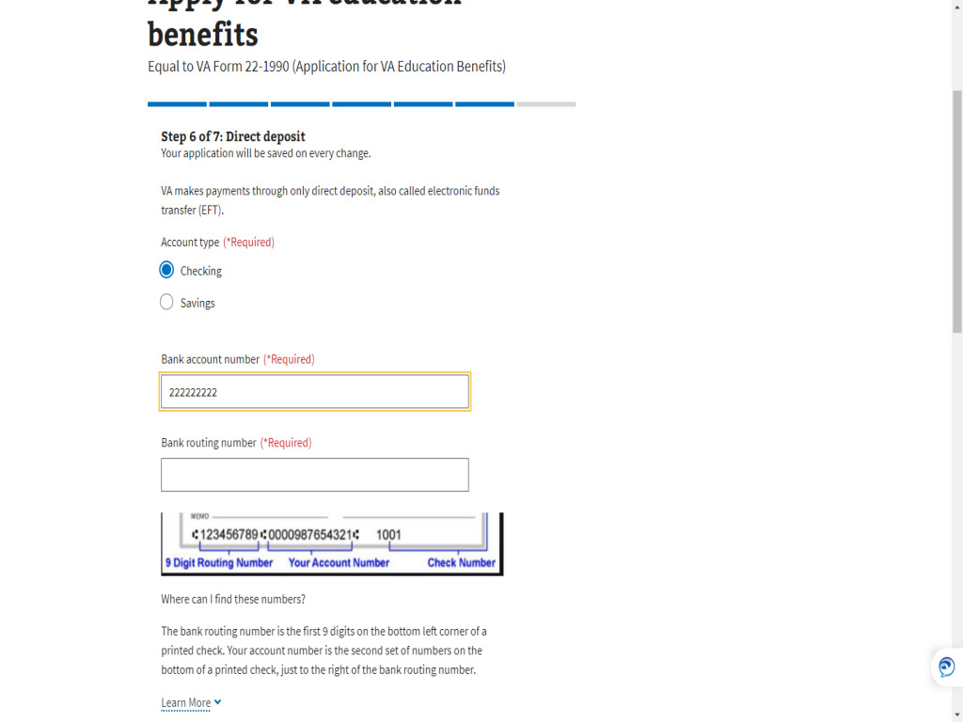
Slide notes

Slide 92 - Bank Routing
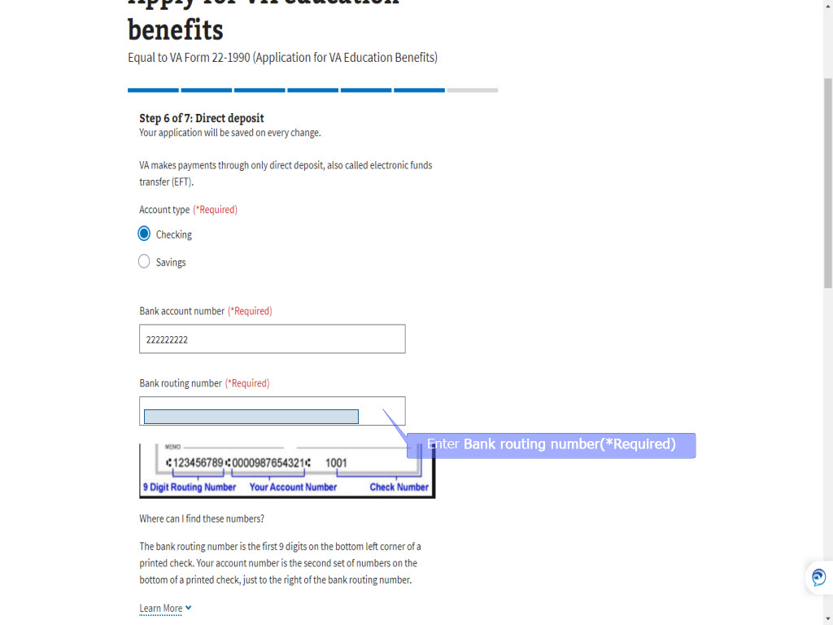
Slide notes

and routing number,

then click, “Continue”.

Slide 93 - Slide 93
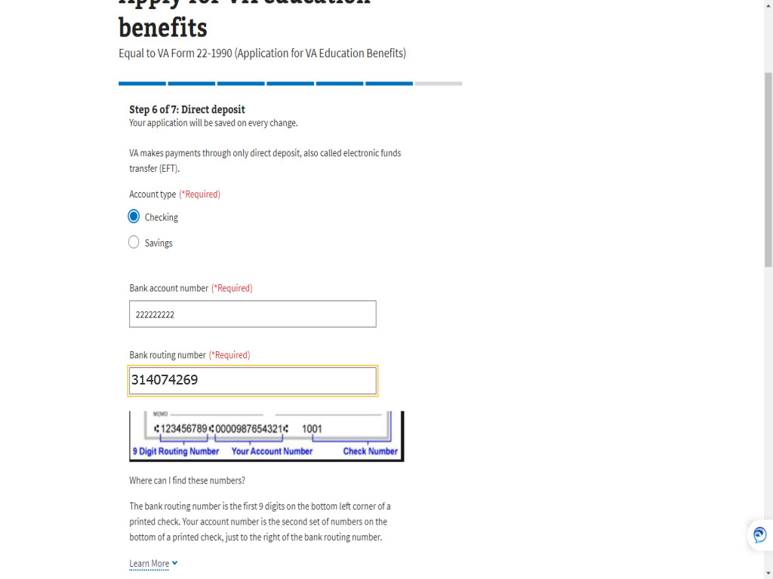
Slide notes

Slide 94 - Slide 94
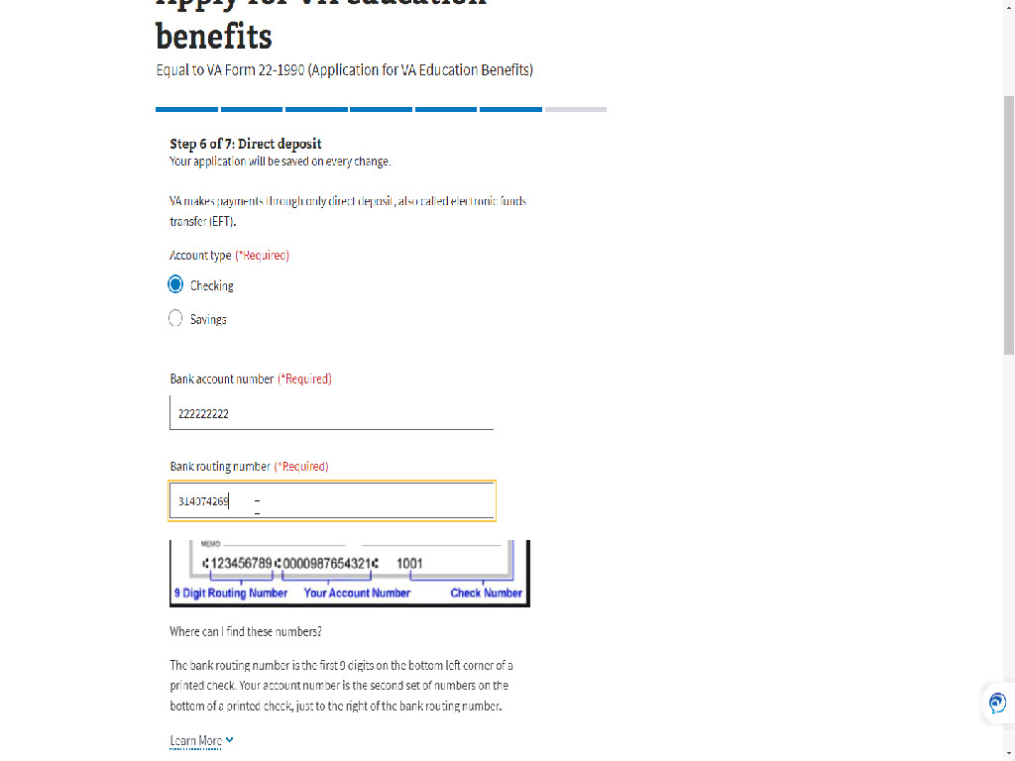
Slide notes

Slide 95 - Continue
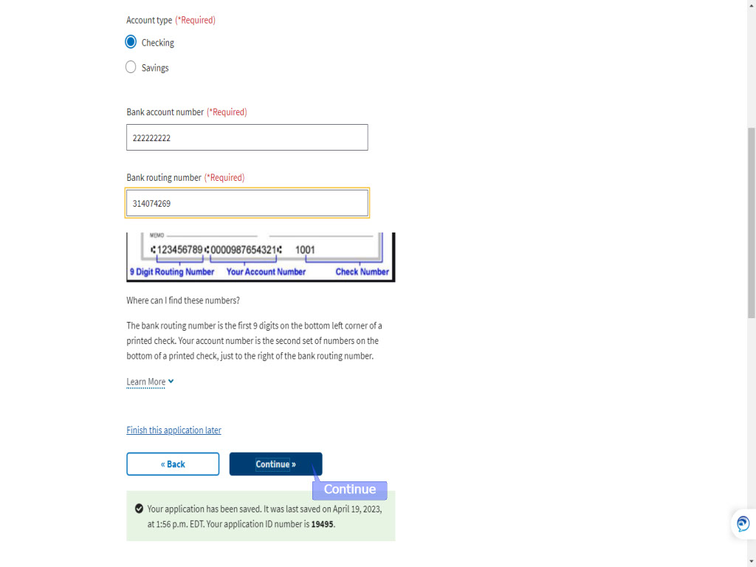
Slide notes

Slide 96 - Step7: Review Application
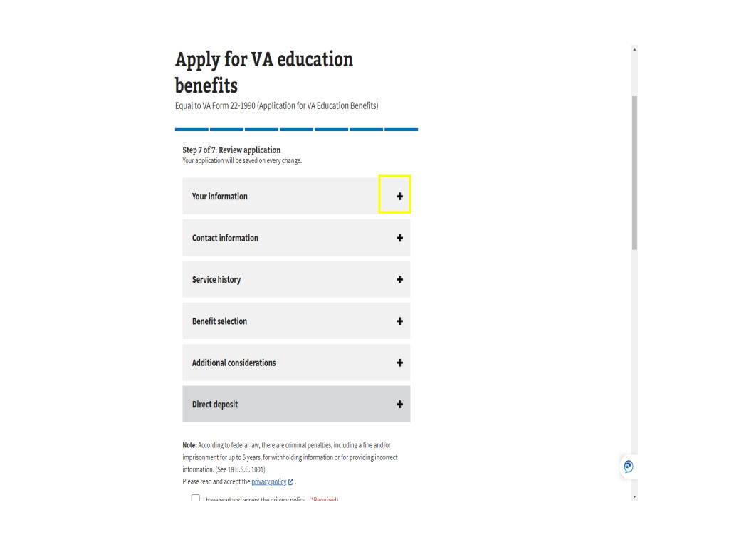
Slide notes

Step 7: “Review application”

is the final step

before submitting the application.

The applicant is given a screenshot

of all they have answered

in steps 1-6.

Clicking the plus sign

Slide 97 - Your information
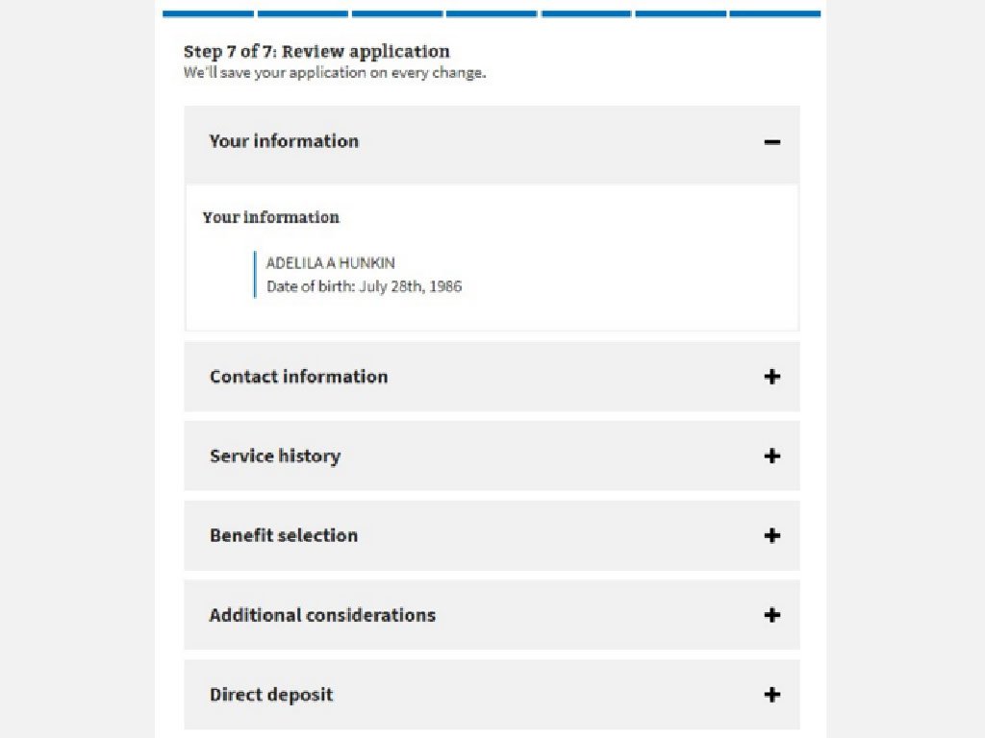
Slide notes

allows each section to expand.

Slide 98 - Contact information
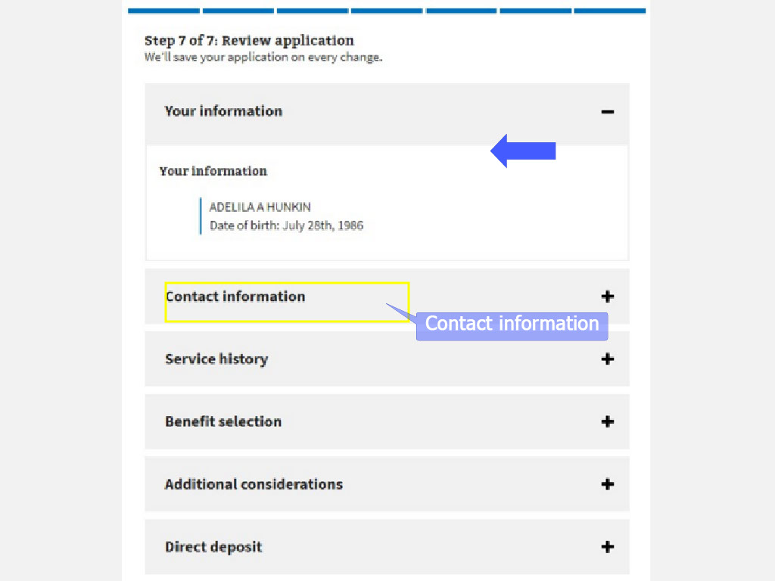
Slide notes

The applicant can review

“Your information” as just shown,

“Contact information” as seen here,

Contact information

Slide 99 - Slide 99
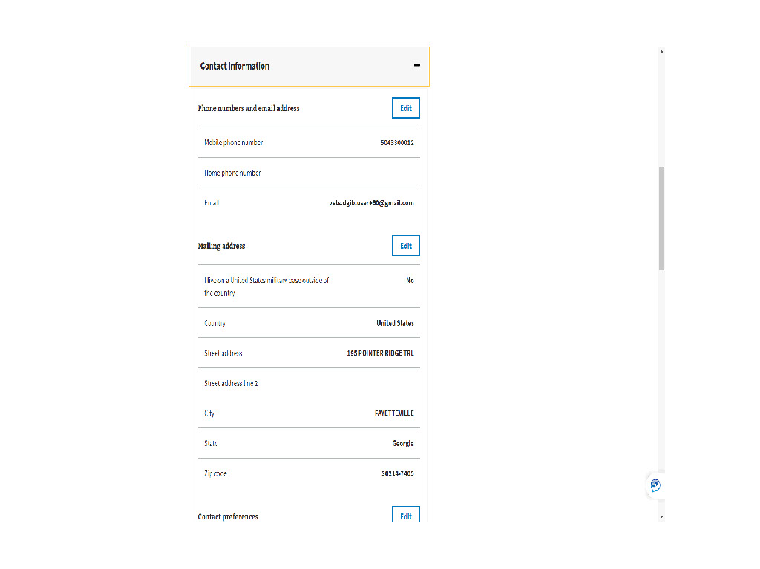
Slide notes

Slide 100 - Contact preferences
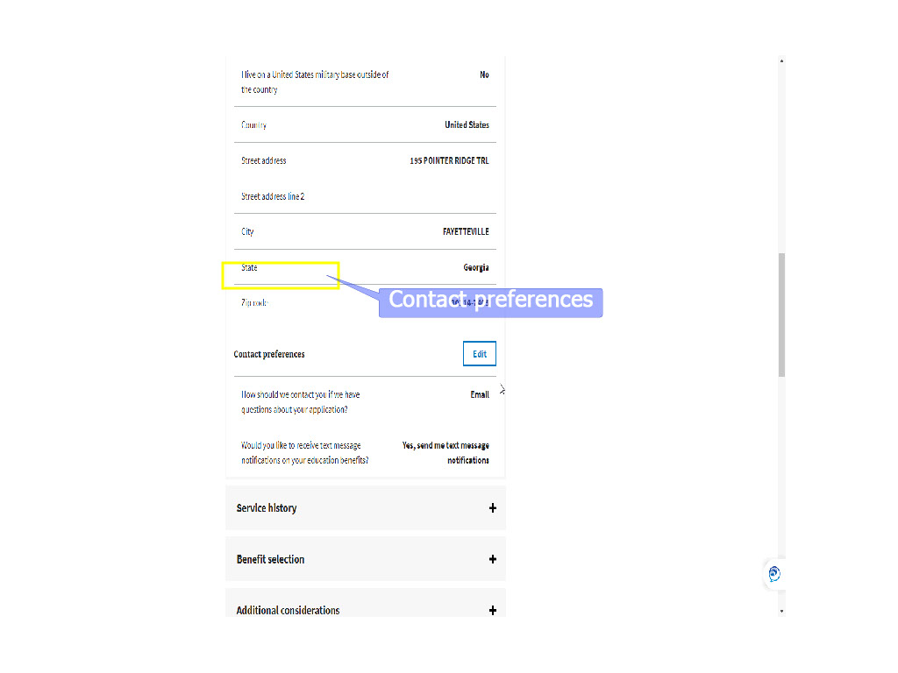
Slide notes

Contact preferences

Slide 101 - Service history
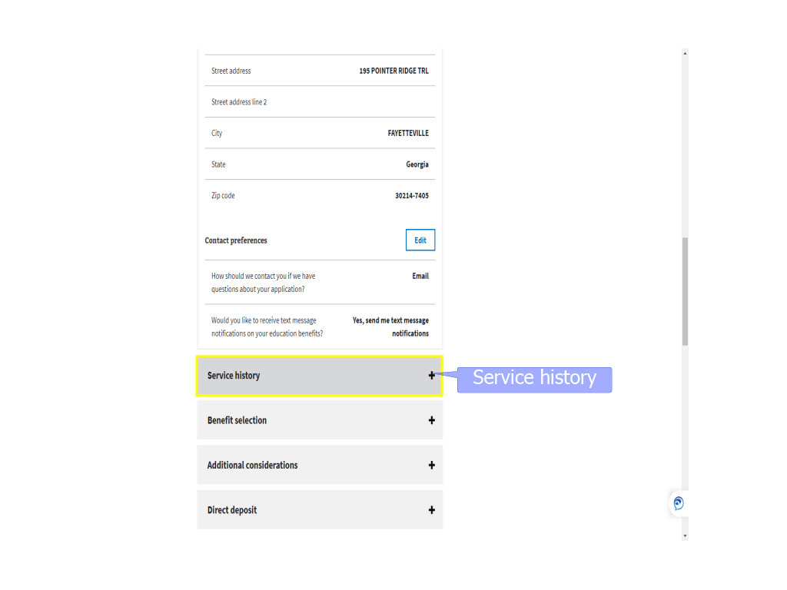
Slide notes

Service history

Slide 102 - Slide 102
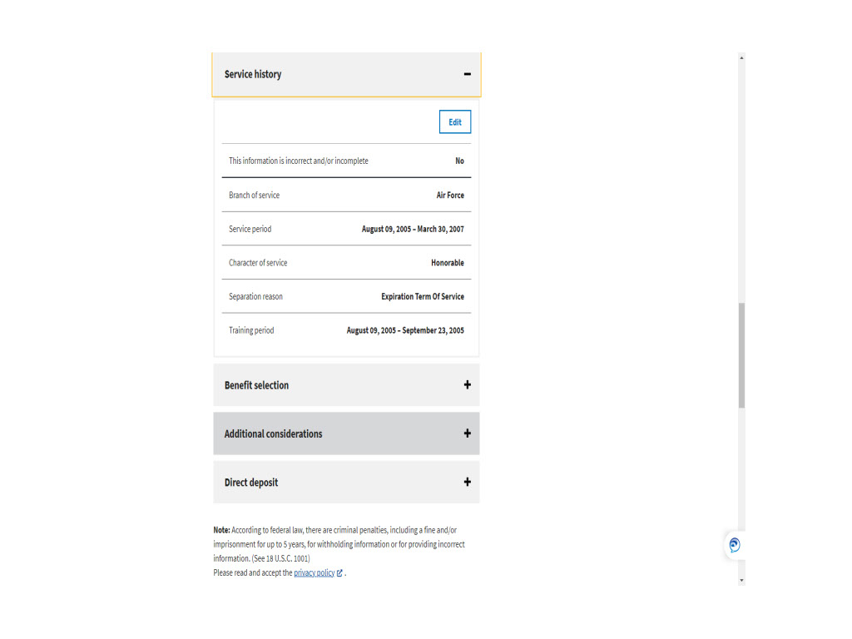
Slide notes

Slide 103 - Benefit selection
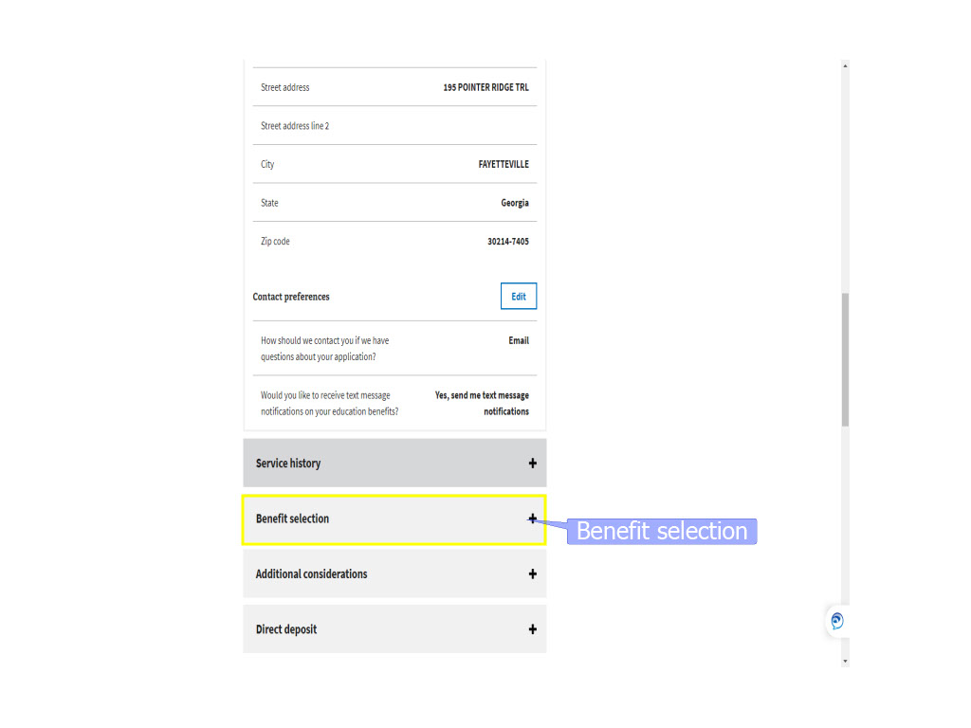
Slide notes

Benefit selection

Slide 104 - Additional considerations
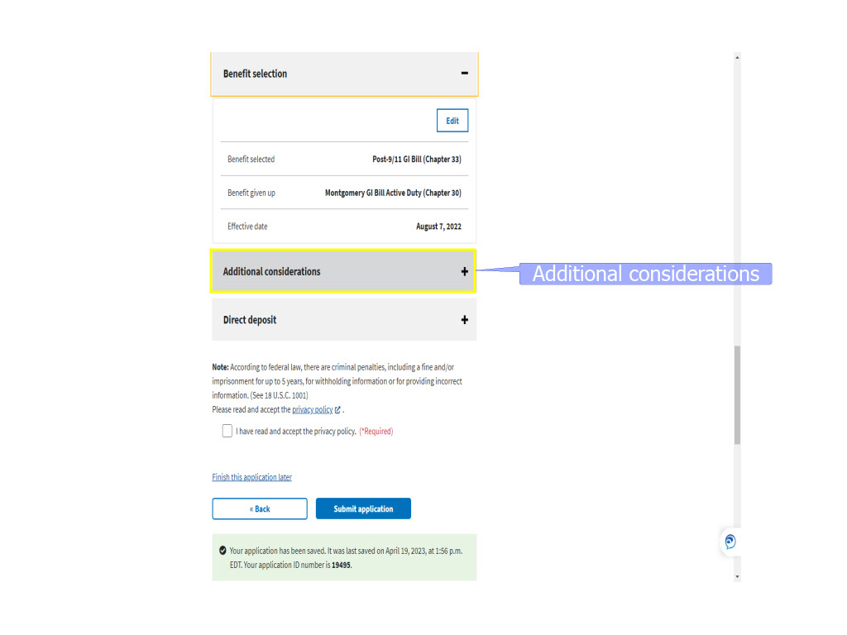
Slide notes

Additional considerations

Slide 105 - Slide 105
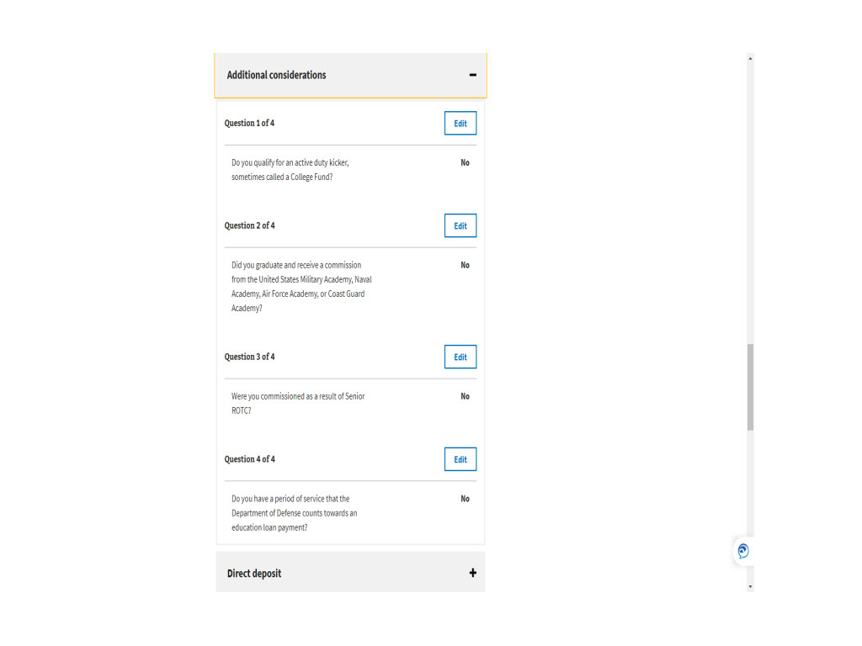
Slide notes

Slide 106 - Direct deposit
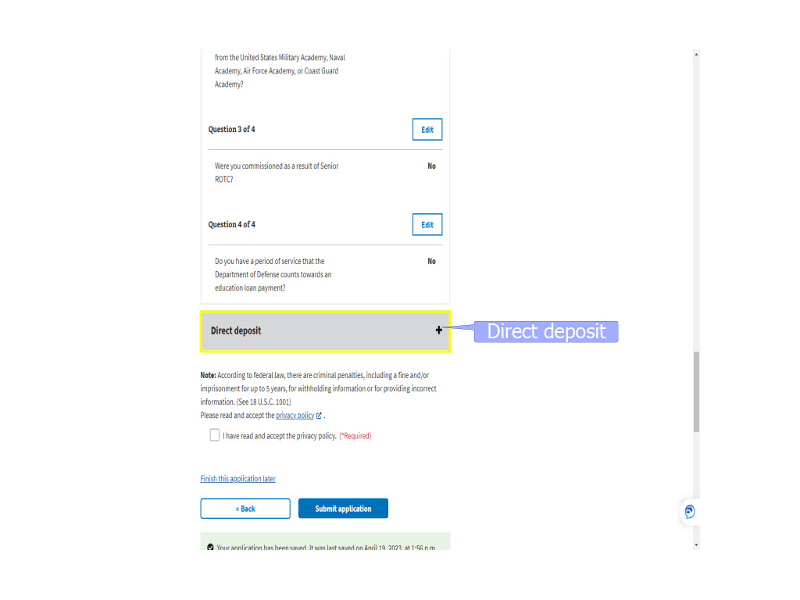
Slide notes

and Direct deposit.

Slide 107 - Slide 107
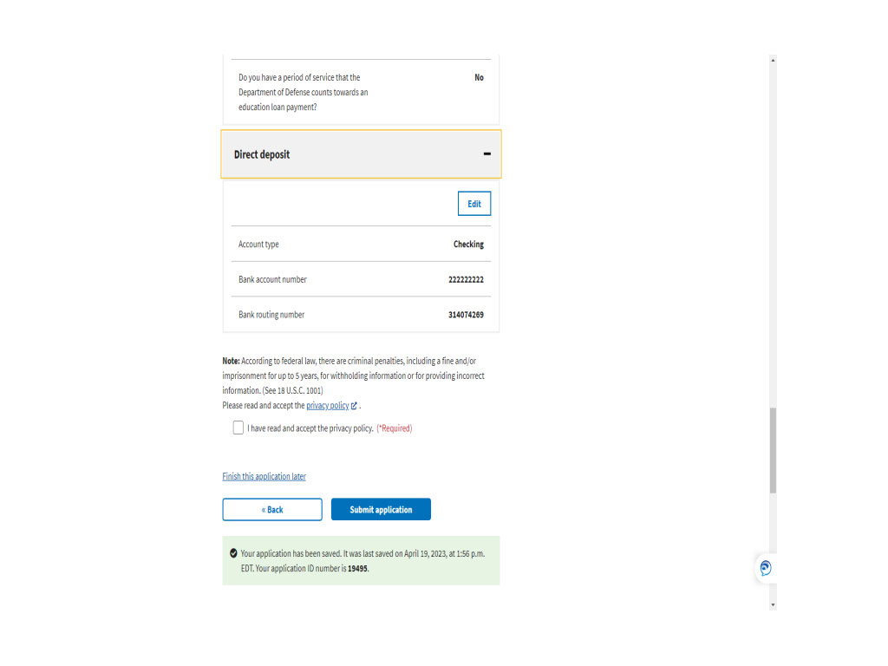
Slide notes

Slide 108 - Edit
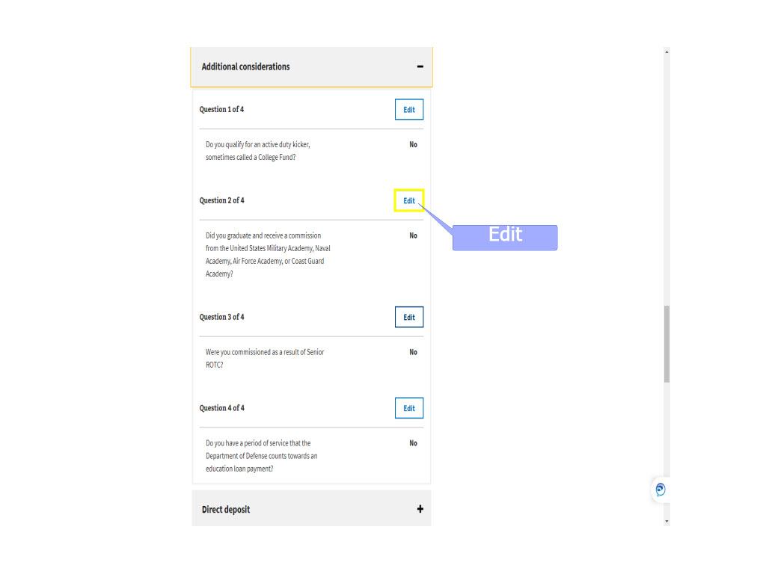
Slide notes

While reviewing what has been entered

and/or selected during the application process,

the applicant can select the “Edit” button

and adjust their choice.

Slide 109 - Update page
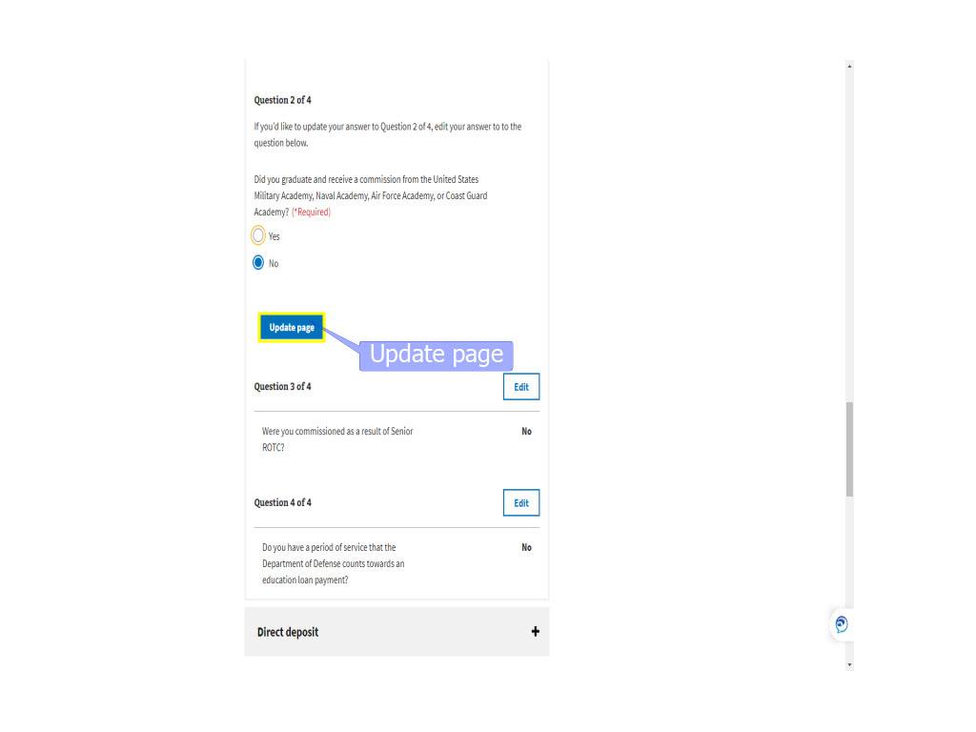
Slide notes

Once the edit has been completed,

they will select

“Update page”

to save the change.

Slide 110 - Privacy Policy
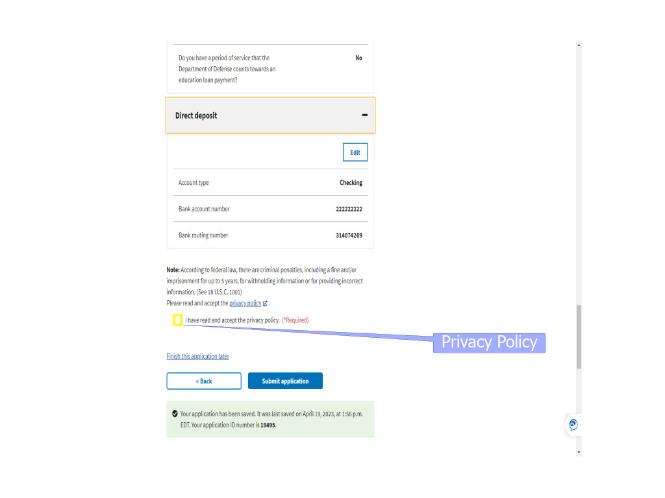
Slide notes

Prior to submitting the application

the Privacy Policy must be read,

accepted, and the checkbox checked.

The Privacy Policy

will open in a separate window

for viewing.

Slide 111 - Slide 111
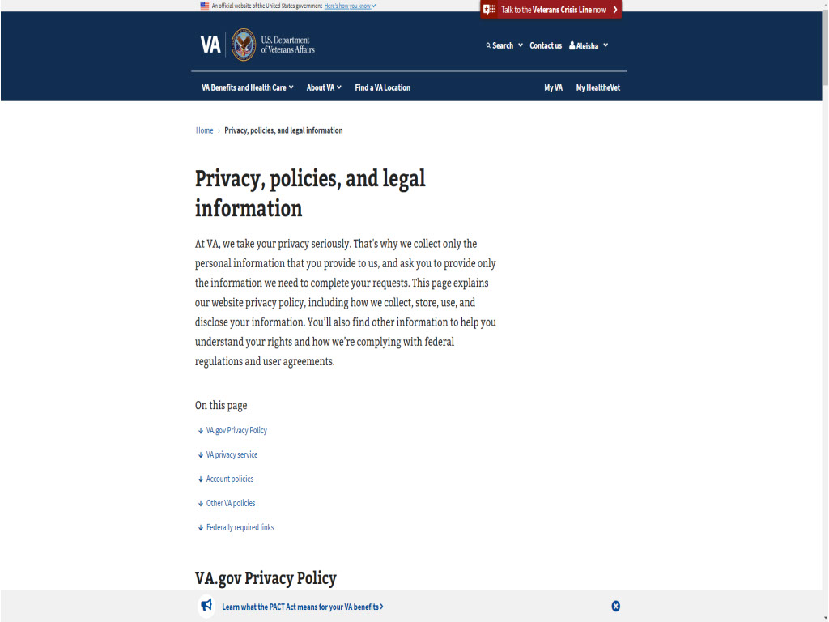
Slide notes

Slide 112 - Submit application
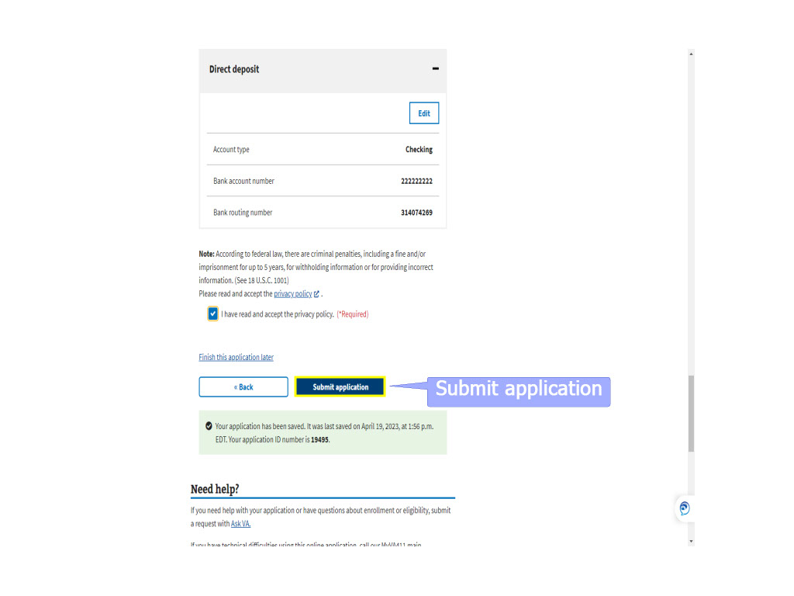
Slide notes

Finally,

the applicant will

“Submit application”

It may take a few minutes

for the application to process.

Slide 113 - Application submitted
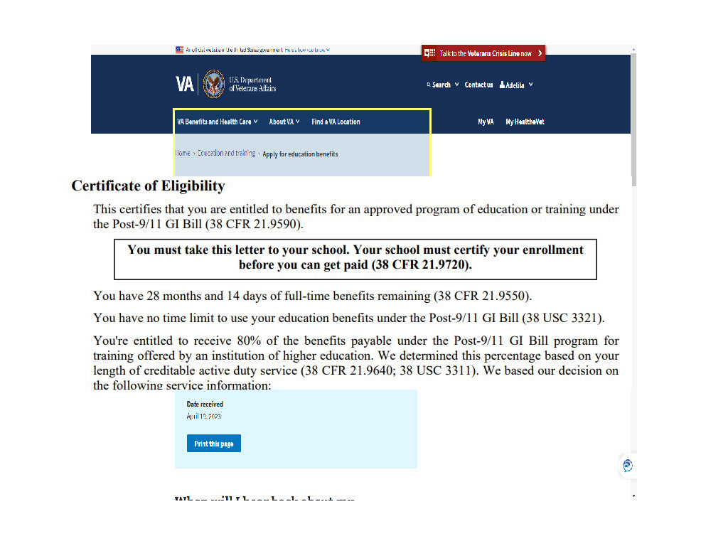
Slide notes

If an immediate decision

can be given,

the applicant will receive

a Certificate of Eligibility (COE)

or a Denial letter.

In our example,

the application was sent to the RPO

for further processing.

Slide 114 - Print this page
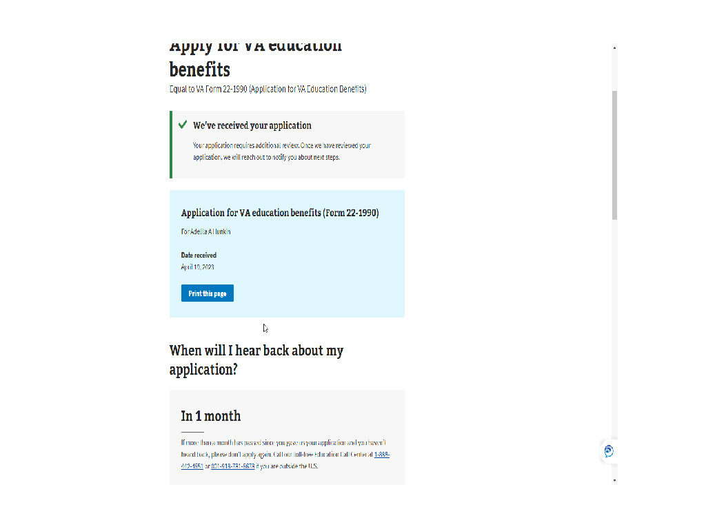
Slide notes

The applicant can print the page

for their records

and are informed they should hear back

from us within 1 month.

They are instructed

“If more than a month has passed

since you gave us your application

and you haven’t heard back,

please don’t apply again.

Call our toll-free Education Call Center at...”

and it provides the number.

Slide 115 - What happens next
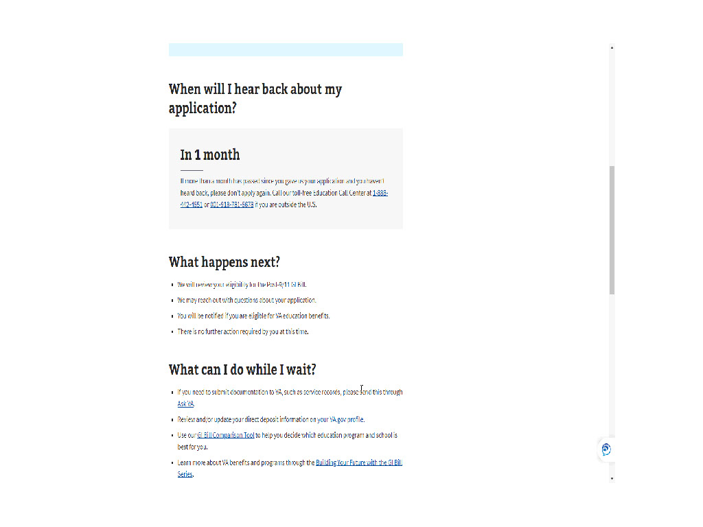
Slide notes

Lastly,

the applicant is provided information on

“What happens next”

and “What can I do while I wait”.

Slide 116 - The End

Slide notes

This completes the application process

in MEB

for a Veteran requesting

the Post-9/11 GI Bill.

I hope this demonstration provides insight

on why you see, what you see in DGI

or on the application in TIMS.

Slide 117 - TMS
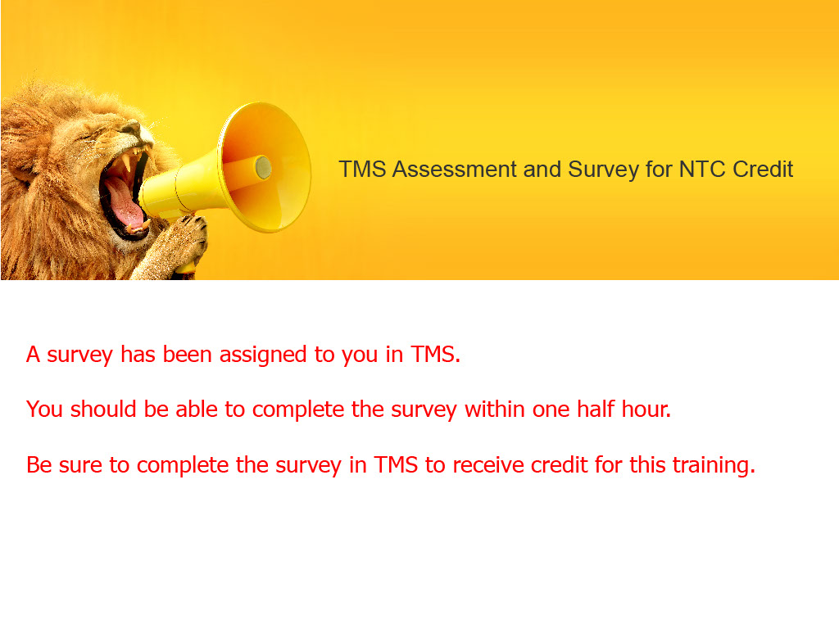
Slide notes

The survey has been assigned to you in TMS.

You should be able to complete the survey

within one half hour.

Be sure to complete the survey in TMS

to receive credit for this training.

Slide 118 - Thank You

Slide notes

Thank you for your time and attention.

This concludes the presentation.

You may exit

by clicking the balloons on your screen,

hitting enter,

or the right arrow on your keyboard.

Enjoy the rest of your day!

