Under Section 113 of the Colmery Act, Monthly Housing Allowance (MHA) must be paid for each day an individual is not serving on active duty during his or her enrollment period. These are 3 scenarios which could potentially occur and are applicable to Section 113. Though these instructions do not cover every situation, it should help Veteran Claims Examiners (VCEs) identify when to manually calculate the actual MHA payment due to an individual who enters and/or is released from active duty (AD) during an enrollment period.

**Long Term Solution (LTS) and VCE Processing Procedures – Section 113**

The LTS will off-ramp enrollment certifications when a change in service information is detected. VCEs will enter the service information in the work-product (WP), allow LTS to make the incorrect end of the month calculation, then calculate the correct MHA payment due the claimant all in the same WP.

**Scenario 1 – Released from Active Duty During the Enrollment Period**

The service period starts before the enrollment period begin date and ends before the enrollment end date.

Service Period: 08/26/2018 – 10/13/2018

Enrollment Period: 09/04/2018 – 12/21/2018



MHA is due beginning on October 14, 2018.

The LTS will underpay, because current programming will not start MHA until the first of the month following a release from active duty during an enrollment period.

**VCEs Should Follow these procedures:**

1. **Enter service and enrollment information as normal.**
2. **Review the Lifetime Awards Recurring Payments Section** for the period the LTS will pay MHA during the enrollment period.

**NOTE**: There may be no MHA due when the claimant comes off duty during the final month of an enrollment period.

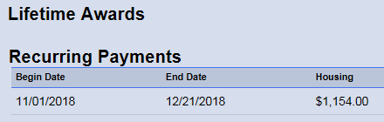

MHA is due beginning on October 14, 2018. A “Manual Award” payment will be issued for the period LTS is not paying, October 14, 2018 through October 31, 2018.

1. **Determine Manual Award and MHA Calculation Rules – No Audit Required:**
2. MHA is paid when an individual is not on AD and the Rate of Pursuit (RoP) is greater than .5 or 50%.
3. Payable days are calculated using 30-day months for every month.
   1. In this case with MHA to begin on the 14th the calculation is 30 – 13 = **17** payable days. **CAUTION**: Do not subtract the first payable day.
4. Daily rate is calculated by dividing the MHA rate by 30.
   1. In this case the monthly MHA rate is $1,154.00 and the calculation is

1154 / 30 = **38.46666** per day

1. MHA due is calculated by multiplying the daily rate times the number of payable days.
   1. In this case the amount due is $38.46666 * 17 = **$653.93**

**NOTE**: Only round during a multiple step calculation on the last step. Rounding during the calculation process may result in a payment error.

1. **Enter the Manual Award**:

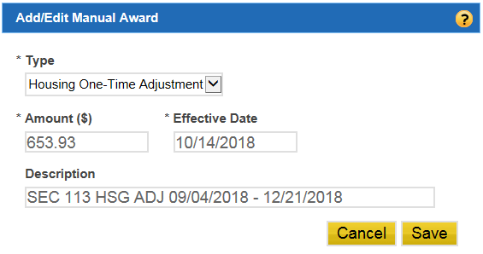

**NOTE**: Changes to service/eligibility or use of Manual Awards requires a minimum of two signatures for authorization.

1. **Modify the LTS Award Letter and Route to Authorization.** Add the following sentence after, “You will receive a prorated amount for any partial months training.”

*“Because you were released from active duty on (Month, Date, Year), you will receive a prorated MHA payment for the month of (Month).”*

*\*Note: Section 113 of the Forever GI Bill, and Public Law 115-62, requires VA to prorate the monthly housing allowance under the Post-9/11 GI Bill for everyone who enters or is released from Active Duty (AD) during an enrollment period beginning on or after August 1, 2018.”*

*Capture the modified LTS Award Letter into TIMS.

1. **Check the “Stop Automation” box** to prevent LTS from making incorrect calculations to potential future amendments to the enrollment period.

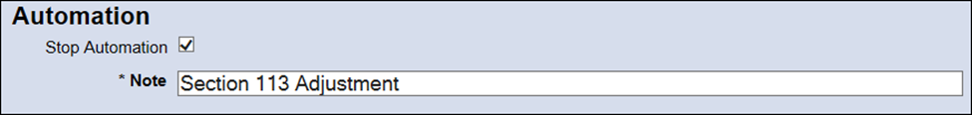

1. Follow local RPO procedures when processing manual awards and debts in LTS.

**Scenario 2 – Enters Active Duty and Released from Active Duty After the Enrollment Period**

The service period starts after the enrollment begin date and ends on or after the enrollment end date.

Service Period: 10/21/2018 – 1/12/2019

Enrollment Period: 09/04/2018 – 12/21/2018



MHA is due at the beginning of the term, September 4, 2018 and should no longer be paid when claimant reentered duty beginning on October 21, 2018.

The LTS will overpay, because current programming will not stop MHA until the first of the month following entry on active duty during an enrollment period.

**VCEs Should Follow These Procedures:**

1. Enter service and enrollment information as normal then:
2. **Review the Lifetime Awards Recurring Payments Section** for the period the LTS will pay Housing during the term.

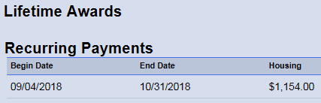

MHA should not be paid after October 20, 2018. We will need to issue a Manual Award payment with a negative amount to offset the period the LTS is paying in error, October 21, 2018 through October 31, 2018.

1. **Determine Manual Award and MHA Calculation Rules – No Audit Required**:
2. MHA is paid when not on Active Duty and RoP is greater than .5 or 50%.
3. Payable days are calculated using 30-day months for every month.
   1. In this case MHA is paid through the 20th and payable for **20** days for October, we do not need to calculate this value.
4. Daily rate is calculated by dividing the monthly housing rate by 30.
   1. In this case the monthly rate is $1,154.00 and the calculation is

1154 / 30 = **38.46666** per day

1. MHA due is calculated by multiplying the daily rate times the number of payable days.
   1. In this case the amount due is $38.46666 * 20 = **$769.33**
2. Since the LTS is paying the entire month, to determine the amount we need to offset, subtract the monthly MHA rate from the amount payable.
   1. In this case, the amount for our Manual Award will be a negative value ($769.33333 - $1,154.00 = **- 384.67)**.
   2. ‘-384.67’ is the amount we will enter in the Manual Award.

**NOTE**: Only round during a multiple step calculation on the last step. Rounding during the calculation process may result in a payment error.

1. **Enter the Manual Award:**

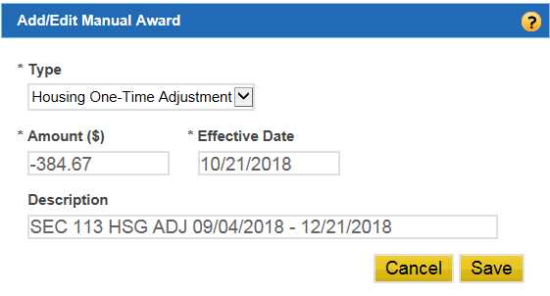

**IMPORTANT FOR RETROACTIVE PAYMENTS**: Whenever issuing a payment for a retroactive term simultanious with adding a manual award to offset proceeds, update the Collection Code Indicator in the LTS to ‘3’ and press Submit. This will ensure MHA payments are offset and avoid a payment error It would be an administrative error, if improper payments were to be released upon authorization. Additionally an adverse action letter should not be released. **DO NOT** change the colecttion code when establishing a debt to adjust for changes to service information, when service information was not provided to VA at the time housing payments were intially released. In such instances, these are valid overpayments and are alloted due process.

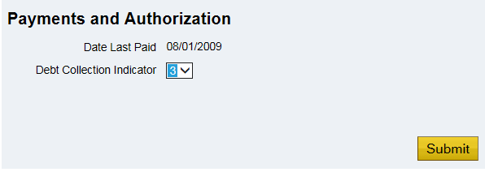

**NOTE**: Changes to service/eligibility or use of Manual Awards requires a minimum of two signatures for authorization.

1. **Modify the LTS Adverse Action Letter and Route to Authorization.** Ensure the Adverse Action letter produced by LTS reflects the correct values and reason for the adjustment.

**“How Much Do You Owe”**

Your total overpayment of **$384.67** for Housing/Kickers is determined as follows:

• **Monthly Housing Allowance:** We paid you a monthly housing allowance through October 31, 2018; however, due to recent changes, your monthly housing allowance overpayment is $384.67. *

*\*Note: Section 113 of the Forever GI Bill, and Public Law 115-62, requires VA to prorate the monthly housing allowance under the Post-9/11 GI Bill for everyone who enters or is released from Active Duty (AD) during an enrollment period beginning on or after August 1, 2018.”*

*Capture the modified LTS Award Letter into TIMS.

1. **Check the “Stop Automation box** to prevent LTS from making incorrect calculations to potential future amendments to the enrollment period.



1. Follow local RPO procedures when processing Manual Awards and debts in LTS.

**Scenario 3 – Enters and Released from Active Duty During the Enrollment Period**

The service period starts after the enrollment begin date and ends prior to the enrollment end date.

Service Period: 09/05/2018 – 10/13/2018

Enrollment Period: 09/04/2018 – 12/21/2018



During this term MHA is not due for those days while on active duty.

The LTS will not stop MHA until the first of the month following entry on active duty and will not resume MHA until the first of the month after being release. Since the LTS is both overpaying at the beginning and underpaying at the end, an audit of what is being paid and what is due is the most efficient and organized way to determine how to adjust MHA payments.

**VCEs Should Follow These Procedures:**

* + - 1. **Enter service and enrollment information as normal.**
      2. **Review the Lifetime Awards Recurring Payment Section** for the period the LTS will pay Housing during the term.

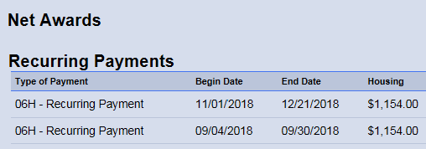

MHA should not be paid after September 4, 2018 and should resume on October 14, 2018. An audit will determine the amount for the Manual Award.

* + - 1. **Audit Accounting Principles:**

1. Enter the entire period for the enrollment period on both the paid and due sections.
2. A separate line item entry is required when the MHA payment changes.
3. Include each period where there is no payment by entering $0.00
4. With the Amount Paid and Amount Due sections properly completed, the result of our audit will have one of three possible outcomes;
   1. Total Paid **is equal to** Total Due; indicating no Manual Award is required.
   2. An Overpayment amount, indicating we will need to create a Manual Award for this amount as a negative number. (e.g.-450.00 for an **overpayment** of $450.00)

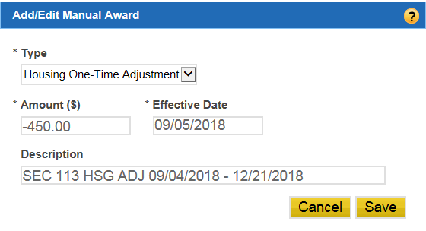

* 1. If the result is an Amount Due, we owe additional funds, that amount should be used for our Manual Award. (e.g. 450.00 for an **underpayment** of $450.00)

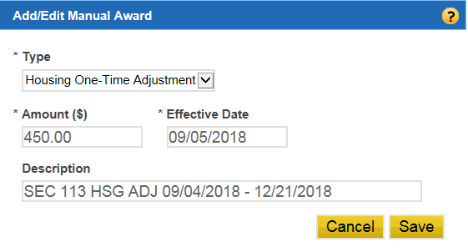

**NOTE**: An audit worksheet can also be used for any scenario.

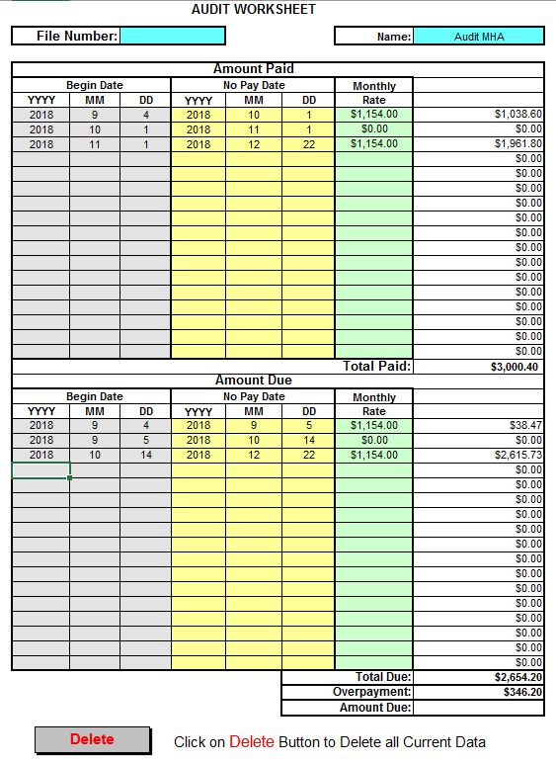

**Audit Worksheet Scenario 3**

Once the audit or calculations are completed and captured into the file for record, the remaining steps are always the same, beginning with

* + - 1. **Enter the Manual Award**:

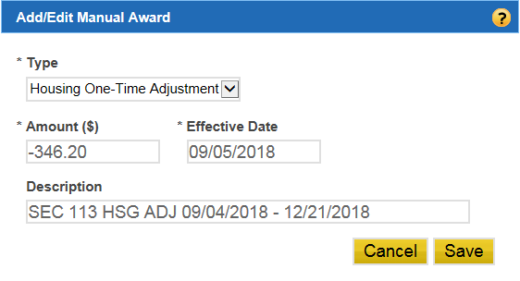

**IMPORTANT FOR RETROACTIVE PAYMENTS**: Whenever issuing a payment for a retroactive term simultanious with adding a manual award to offset proceeds, update the Collection Code Indicator in the LTS to ‘3’ and press Submit. This will ensure MHA payments are offset and avoid a payment error. It would be an administrative error, if improper payments were to be released upon authorization. Additionally an adverse action letter should not be released. **DO NOT** change the colection code when establishing a debt to adjust for changes to service information, when service information was not provided to VA at the time housing payments were intially released. In such instances, these are valid overpayments and are alloted due process.



**NOTE**: Changes to service/eligibility or use of Manual Awards requires a minimum of two signatures for authorization.

* + - 1. **Properly edit the LTS generated letter and route for authorization.**

*Capture the modified LTS Award Letter into TIMS.

* + - 1. **Check the “Stop Automation box** to prevent LTS from making incorrect calculations to potential future amendments to the enrollment period.



* + - 1. Follow local RPO procedures when processing Manual Awards and debts in LTS.

**NOTE**: When the service period overlaps the **entire** enrollment period then neither a manual MHA calculation nor audit worksheet is warranted since MHA is not payable to an individual while serving on active duty.

For example:

Service Period: 09/04/2018 – 12/21/2018

Enrollment Period: 09/04/2018 – 12/21/2018

