**Classifications of Crimes** (Slide 3)

**Infractions (Tickets and Fines)** arethe least serious offenses. These often result in fines and/or penalties.

**Misdemeanors** are more serious than infractions. They are punishable by substantial fines and sometimes jail time, usually less than a year.

**Felonies** are the most serious types of crimes. They are usually punishable by prison sentences of greater than one year.

**Lesson Objectives** (Slide 4)

At the end of this lesson, you will be able to:

* + Determine when a claimant should receive no or reduced benefits due to being incarcerated
  + Determine what costs are payable
  + Determine proper processing procedures for claims involving incarcerated claimants

**Provisions of Law** (Slide 5)

VA can authorize ***only*** the costs of **tuition, fees, necessary books, equipment,** and **supplies** to a claimant incarcerated for a***felony conviction***.

VA cannot make payments for tuition, fees, books, equipment, or supplies if another federal, state, or local program pays these costs in full.

If another government program pays only a part of the cost of tuition, fees, books, equipment, or supplies, VA can authorize the incarcerated claimant payment for the remaining part of the costs.

**NOTE:** A claimant incarceration for a misdemeanor, in a halfway house or on a work release program may receive full benefit payments entitled and would not be considered “incarcerated” for the purposes of issuing Education benefits.

**Limits to Amounts Payable** (Slide 6)

Chapter 30, category II Veterans the monthly rate may not exceed the rate prescribed by law for a Veteran with *no* dependents.

Chapter 30, Chapter 1607 and Chapter 35 claimants *pursuing training at less than half time* and Chapter 30 or 1607 members on active duty training at any rate may not receive reimbursement for books, equipment and supplies while incarcerated.

For all other incarcerated claimants, the monthly rate or benefits payable may not exceed the rate prescribed by law for a person who is not incarcerated.

**Allowable Costs** (Slide 7)

All claimed expenses or “charges” (tuition, fees, books, equipment, or supplies) must be certified by the School Certifying Official (SCO).

* Charges cannot exceed the rates charged to similarly circumstanced non-Veterans
* Charges must be required for all students in the course, including non-Veterans
* Books, equipment, or supplies which have been paid previously for one enrollment period cannot again be paid for any subsequent period
  + Exception: Consumable supplies such as pens, pencils, notebooks, and paper

**Comprehension Checks** (Slide 8)

1. What type of offense must a claimant be convicted of and serving a jail sentence for to be considered “incarcerated” for the purposes of paying Education benefits?
2. How are benefit payments limited for an incarcerated claimant?

***Review the Claim***

**Flash the TIMS Folder** (Slide 10)

When a claimant is identified as incarcerated, a “**Flash**” must be entered and maintained into The Image Management System (TIMS) which states at a minimum:

“*Incarcerated Claimant*”

**NOTE:** TIMS must be clearly and completely documented with manual calculations performed.

**Review the Folder, Development May Be Required** (Slide 11)

When notified that a claimant is incarcerated with a running awardor pending claim, request the following information, if not already of record:

* + The date the incarceration began, and
  + is incarcerated for a felony conviction

**NOTE:** If this information is not on record, development should be made to the claimant and the penal institution to submit a completed VA Form 21-4193.

**The VA Form 21- 4193** (Slide 12)

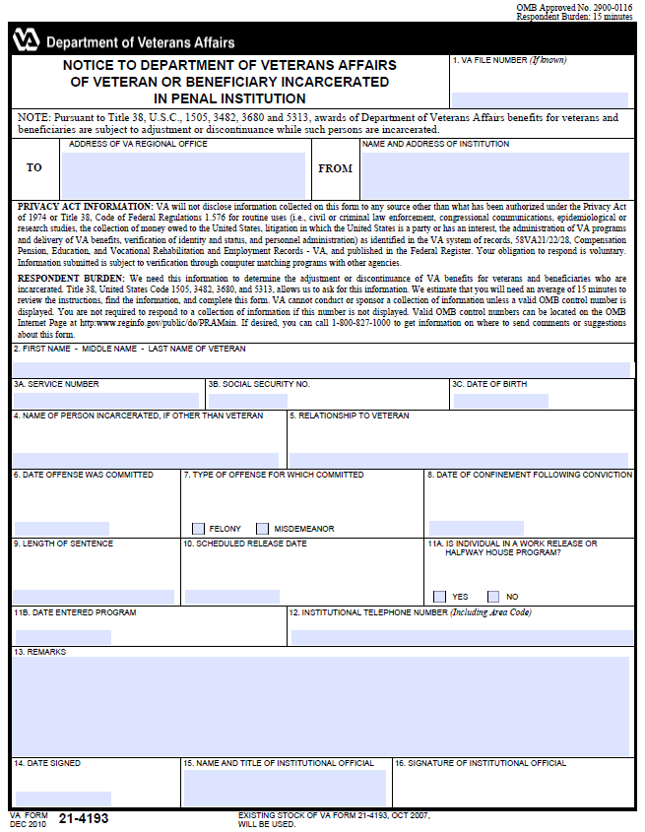

**Completed VA Form 21-4193** (Slide 13)

Prison officials will use VA Form 21-4193, Notice to Department of Veterans Affairs of Veteran or Beneficiary Incarcerated in Penal Institution, to notify stations of incarcerated education claimants in prison for a felony conviction.

A completed VA Form 21-4193 or a document containing all of the needed information must be signed by an institution official prior to issuing payments to an incarcerated claimant.

**NOTE:** A Certificate of Eligibility (COE) may be issued but payments cannot be released until this information has been received.

**Development to Verify Continued Eligibility** (Slide 14)

Develop to:

* Verify continued eligibility for incarcerated claimants using Chapter 1606 or Chapter 1607, (*if not eligible, check eligibility under other benefits*) and
* Check for lost time, not on duty time, or excess leave periods under other benefits where “active duty” is a factor

When developing, provide the service department with any information known about the incarcerated claimant’s detainment in the request.

**Enrollment Certification - Reporting of Tuition and Fees** (Slide 15)

In the **designated area** for Tuition and Fees on a VA Form 22-1999 or VA Form 22-1999b, the SCO will provide the claimant’s charges for Tuition and Fees.

* Only “net charges” will be reported under the “Tuition and Fees” for Chapter 33 enrollments.
* Additional reporting information required will be found in the “remarks” section.
* Develop with the SCO for clarification whenever reporting is unclear or if unsure.

**Enrollment Certification - Other Reporting** (Slide 16)

In the “**Remarks**” section of a VA Form 22-1999 or VA Form 22-1999b the SCO will:

* + - Annotate the claimant as “incarcerated”
  + Report if the federal, state, or local government is paying all or part of the cost for tuition, fees, books, equipment, or supplies (*Presumed to be $0.00 unless noted.*)
    - Provide the amount paid by the government
    - List books, equipment, and supplies individually showing the cost of each item
    - Consumable supplies such as pens, pencils, notebooks, and paper which total under $10 does not need to be itemized

**NOTE:** Develop with the SCO for an itemized list when not provided or for clarification whenever reporting is unclear or if unsure prior to issuing payments.

**Comprehension Check** (Slide 17)

Identify at least 3 reasons development may be necessary prior to issuing benefit payments for an incarcerated claimant?

***Chapter 33 - Long Term Solution (LTS) - Payment Processing Steps***

**Long Term Solution (LTS) - Payment Processing** (Slide 19)

The Long Term Solution (LTS) does not contain a data element for indicating a claimant is incarcerated and does not contain the rules for calculating all benefit payments for incarcerated claimants.

Therefore, manual work arounds are required to ensure that Chapter 33 incarceration claims are paid correctly.

**Review and Update Claimant’s Information** (Slide 20)

Normal claims processing and documentation rules apply.

* Check and update name, address, and EFT in BDN
* Check and update the LTS Biography page
  + Update “Stop Automation” section appropriately:

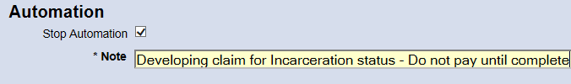

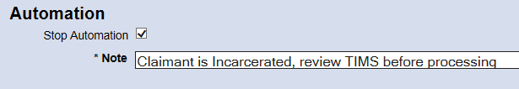

**Create a Work Product** (Slide 21)

Add Work Product, Press: Add Eork Product button

Select Entitlement Source: 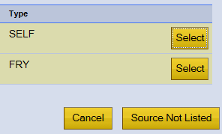

Create Work Product, Enter Date Received, Enter Description, Create a New Work Product
Enter Date Received - 04/20/2017
Enter Description - Incarcerated Claim


Press: Create Work Product button

Review the Service Data page…(next slide)

**Review and Update - Service Data Page** (Slide 22)

Review the claimant’s eligibility established and benefit level.

Check and update the items below, develop if necessary:

* + Initial entry and skill level training identified, when appropriate
  + Excluded periods identified, when appropriate
    - * Additional excluded periods: “Lost time” or “not on duty time” identified appropriately (i.e. AWOL, period of confinement, excess or appellate leave periods)

**Review and Update - Entitlement and Kickers Page** (Slide 23)

Review the Entitlement and Kickers page for accuracy and update if necessary. Kickers **are not payable** while incarcerated, if entitled:

* + Enter an End Date that corresponds with the date incarceration began or the election date, whichever is later

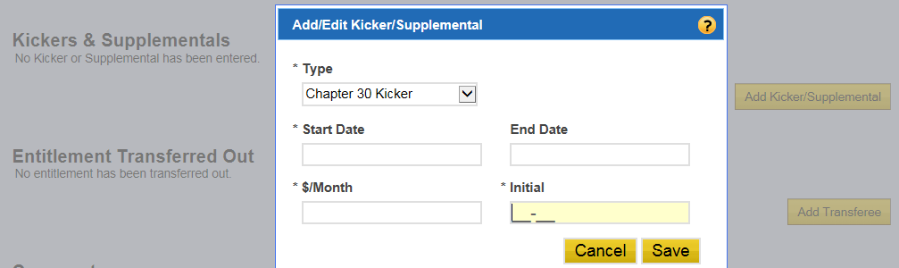

* + Add another Kicker and enter a new Start Date upon release from prison to resume kicker payments

**Review and Update - Enrollment Page - Add New Periods** (Slide 24)

Review for any enrollment periods already entered and paid that overlap period of incarceration:

* If there are no enrollment periods previously paid ***or***
* No enrollment periods overlapping period of Incarceration, add enrollments as normal

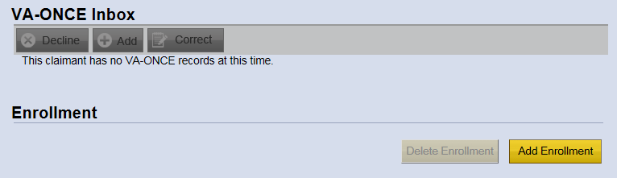

**Review and Update - Enrollment Page - Paid Periods** (Slide 25)

A review may indicate enrollment periods already entered and paid that overlap period of incarceration, when discovered recheck the following:

* Service or eligibility information was entered accurately
* Payments released on previously paid enrollment periods

When payment errors are found do the following:

* Determine appropriate corrective actions (Slide 26)
* Keep errors isolated
* Use a separate Work Product to input additional terms that have not already been paid

**Appropriate Corrective Actions for Payment Errors** (Slide 26)

1. When the claimant reported or was identified as incarcerated prior to processing.
2. Generally, this would be an administrative error. Handle as such.
3. Exception: When prison officials determine these funds as inappropriate and attempt to return payments back to VA. This would not be an admin error due to those regulations that prevent prison officials from depositing certain funds. The claim should be carefully reviewed and reworked to determine if an overpayment occurred. If an overpaid exists, the debt will be established through the LTS using a negative amount on a Books & Supplies (or other payment type) “manual award” and authorized to create those debts. Then refer to Finance to apply the returned funds against the debt(s) and reissue any balance as appropriate. Any running recurring payment processed in error should be manually stopped.
4. Where there was no indication that the claimant was incarcerated.

This would not be an administrative error due to an omission on the part of the claimant. Correct the claim and debts should be established if an overpayment had occurred. (Potential school liability may exist. When deemed appropriate, the RPO should consult with the CELO having jurisdiction for consideration and direction.)

**Review and Update - Enrollment Page - Add Enrollment** (Slide 27)

Add enrollments as normal, from the VA-Once Inbox or by using the “Add Enrollment” button.

**NOTE:** Enter remarks from the enrollment certification in the LTS Comments section and save. (See example on next slide.)

**Review Letter Information Page** (Slide 28)

The Award 3 Letter should generate.

Letter Information Page - LTS
Award 3 Letter and Comments section displayed

**NOTE:** The letter will need to be edited unless all payments issued are correct.

**Remaining Chapter 33 Processing Steps** (Slide 29)

The process will be the same up to this point. However, payments generated by the LTS, in the Net Awards section will determine how to authorize and what manual processing will be necessary.

1. Tuition & Fees and B&S payments only (no MHA), the SVCE will authorize and pay automatically by following the steps on the next several slides, including using a manual award, as necessary.
2. LTS generating MHA payments, the SVCE will authorize and pay manually (e.g. fiscal payment processing); should not require using manual awards in LTS unless if only Books, Supplies and Equipment are payable.

**Remember:** Only tuition, fees and reimbursed costs for books, supplies and equipment are payable up to the limits established under the benefit.

**Review Work Product Summary - Net Awards Section** (Slide 30)

Net Awards with Tuition & Fees and B&S payments only example.

Net Awards section - LTS
Books and Supplies payment, and Tuition and Fees payment indicated  

* Books & Supplies = $332.00
* Tuition & Fees = $2,000.00
* No other system generated payments

**Benefits Payable** (Slide 31)

Books and Supplies Rule: Pay the lesser of the amount certified or the LTS generated amount. Use Job Aid.

Tuition and Fees Rule: Properly reported tuition and fees “net charges” will be calculated correctly in the LTS. Enter amount as certified.

Other Payment Rule: No other payments are authorized except, Yellow Ribbon payments. Yellow Ribbon payments are technically, payments to cover **tuition or fees** and are allowable.

**Books & Supplies (B&S) Annual Cap** (Slide 32)

Reminder:

* IHL B&S Annual Cap = $1000.00 times benefit level
* NCD B&S Annual Cap = $996.00 times benefit level

|  |  |  |
| --- | --- | --- |
| **Benefit Level** | **IHL B&S Cap** | **NCD B&S Cap** |
| 100% | $1000.00 | $996.00 |
| 90% | $900.00 | $896.40 |
| 80% | $800.00 | $796.80 |
| 70% | $700.00 | $697.20 |
| 60% | $600.00 | $597.60 |
| 50% | $500.00 | $498.00 |
| 40% | $400.00 | $398.40 |

**Books & Supplies (B&S) Caps** (Slide 33)

LTS attempts to manage the IHL (Degree or NCD) B&S cap.

* If a manual award is used or manual fiscal payment processing (FIST/FAUT) of B&S payments for a lesser amount, then the difference not paid may be paid during the same academic year after “LTS B&S cap” has been reached

NCD (facility) maximum B&S payable for the period is determined by the LTS.

* Prior B&S payments issued will not need to be tracked when the claimant is attending training at an NCD facility

**NOTE:** Use the Job Aid.

**Offsetting Books and Supply Payments Using a Manual Award** (Slide 34)

Books and Supply payment adjustments to pay a lesser amount can be properly managed in the LTS using a manual award.

Using the first example case, determine the amount for the manual award:

* Amount Certified: $50.00 + $60.00 = $110.00
* LTS generated Books & Supplies = $332.00

**Calculation: 110– 332 = -222**

**Create a Manual Award** (Slide 35)

1. Select Books and Supplies as the type of award.
2. Enter a negative number to create a “71B” B&S debt.
3. Use the begin date for the period for the effective date.
4. Enter a brief description and press the Save button.

**Manual Award pop-up - LTS
Type: Books and Supplies
Amount: -222.00
Effective Date: 01/16/2017
Description: Offset LTS generated amount**

**Review Net Awards for Manual Award Amount** (Slide 36)

1. Verify amount generated for the Manual Award in Net Awards.
2. Change the “Debt Collection Indicator to ‘3’ and Submit.

**Update the Comments Section** (Slide 37)

Ensure the remarks reported on the enrollment certification are entered in the LTS Comments section associated with the current Work Product.

Also include Books & Supply payment calculations and any other justifications or pre-authorization statements, such as “LTS letter edited and captured in TIMS.”

**Review and Edit the LTS Generated Letter** (Slide 38)

LTS generated letter (before):

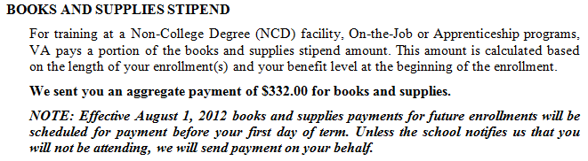

Edited Books and Supplies section (after):

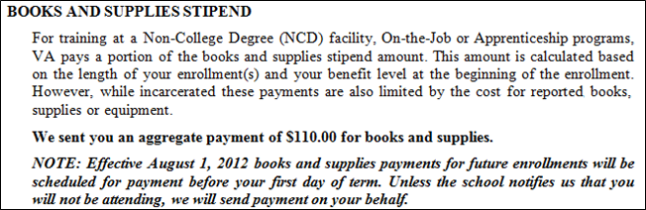

**Review and Update - Work Product Comments** (Slide 39)

Review and update the Comments section:

Bottom of Work Product Summary page - LTS
System generated letter is available & suppressed
Comments section is updated with enrollment certification "remarks" - Manual calculations - Information about the letter being edited and captured into TIMS

Route for authorization, “Authorize and Pay Automatically”

**Books and Supplies Only Job Aid** (Slide 40)

When the LTS generates MHA payments and only due payments for Books, Supplies, or Equipment, **DELETE THE TERM FROM THE LTS**. The award must be processed out of system. Use the Books and Supplies Only Job Aid to determine the amount payable and the entitlement charge to be processed as a manual awards in the LTS.

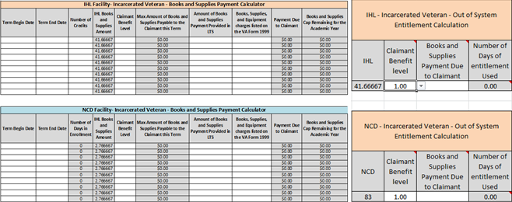

***Chapter 33 Example***

**Review LTS Generated Payments in New Awards** (Slide 42)

Note: LTS is generating a housing payment. This claim will need to be paid manually.

Net Awards section - LTS
In addtion to B&S and T&F payments generated, a recurring housing (MHA) payment is indicated  
**Determine Benefits Payable** (Slide 43)

What is payable? (*Same image as used on slide 42*)

**Only Tuition & Fees and Books & Supplies are Payable** (Slide 44)

(*Same image as used on slide 42*)

MHA is not payable.

T&F is payable.

B&S must be reviewed.

**Determine Books & Supplies Payable** (Slide 45)

B&S Rule: Pay the lesser.

* LTS generated **$200.00** B&S payment.
* Amount certified for B&S:

76.00 + 56.00 + 5.00 = **$137.00**

**NOTE:** Capture and document this and all calculations in TIMS using *NOTES* or the Job Aid.

FIST/FAUT **$137.00 (06O)** along with the tuition and fee payment amount the LTS generated.

**Review LTS Generated Letter** (Slide 46)

LTS generated letter sections to review (before):

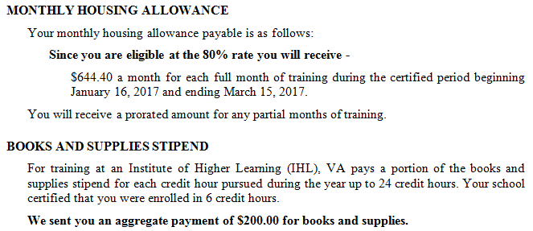

**Edit LTS Generated Letter** (Slide 47)

LTS generated letter sections edited (after):

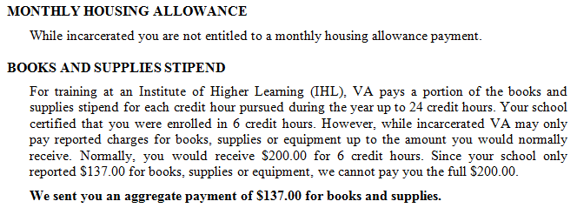

**Update Comments and Route for Authorization** (Slide 48)

Update LTS Comments section:

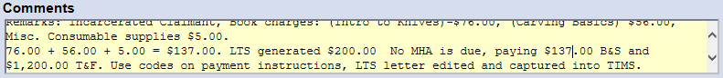

Route for authorization and payment processing assistance.

**Comprehension Check** (Slide 49)

A Veteran claimant is found to be eligible for Chapter 33 with a benefit level of 50%. The claimant is incarcerated for a felony.

* The claimant is attending 12 credit hours online from 9/1/16 through 12/15/16 for an approved IHL program.
* This is the claimant’s first term using educational benefits, so Books and Supplies have not been utilized previously.

LTS states that the Books and Supplies payment for this student is $250.00. The Books, Supplies, and Equipment charges itemized on VA Form 22-1999 totals $450.00.

1. How much can VA pay toward books and supplies?
2. What other payments would we expect the LTS to generate?
3. Can we authorize this claim with automatic payments?

**Comprehension Check Answers** (Slide 50)

1. How much can VA pay toward books and supplies?

VA must pay the lesser amount. Since the LTS generated amount is less ($250.00), we would pay $250.00 and not cover all related expenses.

1. What other payments would we expect the LTS to generate?

In addition to a B&S payment, the LTS should generate a T&F payment of $500.00 and housing payments would be generated at 50% of the standard distance learning rate.

1. Can we authorize this claim with automatic payments?

Since the LTS determined MHA payments due, we cannot authorize with automatic payments. Those payments are prohibited while incarcerated.

***Non-Chapter 33 - Benefits Delivery Network (BDN) Payment Processing***

**Steps to Process Non-33 Claims** (Slide 52)

Follow guidance in the training slides 5 –16 and,

* Review and update TIMS and BDN appropriately
  + Flash
  + Notes
  + Messages (Stop or File Pull “B”)
* Verify Incarceration (develop when necessary)
* Review for proper certification (develop when necessary)
* Determine appropriate payments (benefit specific)
* Process payments in BDN or out-of-system as appropriate
* Specific guidance on next few slides is also contained in the M22-4, Part IV, Chapter 13

**Non-33, Rate Based on Tuition and Fees** (Slide 53)

For cases in which the rate for non-incarcerated persons would be based on the amount of tuition and fees, use the same BDN award processing that would be used for non-incarcerated cases.  Enter the tuition and fees in CHARGES in the normal manner and BDN will generate the correct rate.

Cases where the rate is based on tuition and fees include the following:

1. Chapter 30 servicepersons
2. Chapter 30 or 1607 veterans training at less than 1/2 time, and
3. Chapter 35 eligible persons training at less than 1/2 time

**Non-33, Rate Not Based on Tuition and Fees** (Slide 54)

Special procedures are required to pay incarcerated claimants who would receive statutory rates (i.e., rates defined by statute as opposed to rates based on tuition and fees) if they were not incarcerated.

1. For Chapter 30 or 1607, compute the monthly rate manually and enter "J"  in the OR (override) indicator on the award screen to override the BDN generated rate.
2. For Chapter 32/903, prepare out-of-system awards per part IV, chapter 12.  (This procedure applies to all chapter 32 incarcerated cases.)
3. For Chapter 1606, prepare an out-of-system award.  (See [part IV, chapter 12](http://vbaw.vba.va.gov/bl/22/ref/m22-4/Part%20IV/ch12.htm).  This procedure applies to all Chapter 1606 incarcerated cases.)

**Non-33, Rate Not Based on Tuition and Fees (continued 1)** (Slide 55)

1. Chapter 35 cases not requiring monthly verification of enrollment, enter awards on the 412 General Education Award screen using the "I" override indicator.

Enter the total amount payable for the enrollment period in CHARGES.  The system will accept the award as an independent study award and will generate the correct monthly rate.

**Non-33, Rate Not Based on Tuition and Fees (continued 2)** (Slide 56)

Chapter 35 cases requiring monthly certification of training or verification of enrollment, apply the following:

1. Prepare the award normally except for entering the reduced monthly rate.
2. Enter "D" in the OR (override) field.  This override will generate an erroneous legend, BALANCED BUDGET ACT ADJUSTMENT -FY 86, in the Remarks block on VA Form 22-8945.  Line through the legend and write "Incarcerated Claimant" in the block.  This indicator will not affect the generated award letter.

**Awards That Pay for Books, Equipment, and Supplies**

When another federal, state, or local government program partially pays a claimant's tuition and fees, process awards as follows:

1. Calculate the total cost of the course.  Include tuition, fees, books, equipment, and supplies.
2. Subtract the amount paid by the other government program from the total cost of the course.
3. Calculate the institutional amount payable for the entire award period based on the claimant's training time.  For Chapter 30 category II claimants, this is the rate without any dependents.  Multiply the number of months of attendance by the monthly rate.
4. Enter the lesser of the institutional amount from subparagraph 3 above or the result of subparagraph 2 above as the "Total Charges" on the award.

**NOTE:***Do not include the costs of books, equipment, and supplies if the claimant is in service under Chapter 30 or is under Chapter 30, 1607 or 35 and is training less than half time.*

**Lesson References**

Manual Reference:

* [M22-4, Part IV, Chapter 13, Subchapter 4](http://vbaw.vba.va.gov/bl/22/ref/m22-4/Part%20IV/ch13.htm)

Regulations (CFR):

* [21.7139](http://www.benefits.va.gov/warms/docs/regs/38cfr/bookg/part21/s21_7139.doc) and [21.7135](http://www.benefits.va.gov/warms/docs/regs/38cfr/bookg/part21/s21_7135.doc) Chapter 30
* [21.5139](http://www.benefits.va.gov/warms/docs/regs/38cfr/bookg/part21/s21_5139.doc) and [21.4135](http://www.benefits.va.gov/warms/docs/regs/38cfr/bookg/part21/s21_4135.doc) Chapter 32
* [21.9675](http://www.benefits.va.gov/warms/docs/regs/38cfr/bookg/part21/s21_9675.doc) and [21.9635](http://www.benefits.va.gov/warms/docs/regs/38cfr/bookg/part21/s21_9635.doc) Chapter 33
* [21.3132](http://www.benefits.va.gov/warms/docs/regs/38cfr/bookg/part21/s21_3132.doc) and [21.4135](http://www.benefits.va.gov/warms/docs/regs/38cfr/bookg/part21/s21_4135.doc) Chapter 35
* 21.7639 and [21.7635](http://www.benefits.va.gov/warms/docs/regs/38cfr/bookg/part21/s21_7635.doc) Chapter 1606

Title 38 United States Code (USC):

* [38 USC 3482 (g)](http://uscode.house.gov/view.xhtml;jsessionid=0303541A185F3CBF1B5F491083C10713?path=&req=granuleid:USC-prelim-title38-section3482&f=&fq=&num=0&hl=false&edition=prelim)