|  |  |
| --- | --- |
| Department of Veterans Affairs official seal |  |

**September 30, 2022**

**TO:** Approvals, Compliance & Liaison (AC&L), Regional Office, Field Staff

**SUBJECT:** AC&L Fiscal Year (FY) 2023 National Training Curriculum (NTC) Requirements

**PURPOSE:** The purpose of this letter is to provide and explain the FY23 National Training Curriculum (NTC) requirements for Approval, Compliance & Liaison (AC&L) field employees.

**Training Requirements and Procedures**

Education Service (EDU), under the Veterans Benefits Administration (VBA) is responsible for developing a National Training Curriculum (NTC) that is designed for technical positions and for ensuring full participation by AC&L field employees in the Central, Southern, Eastern, and Western regions. This letter and accompanying standard operating procedure (SOP) are intended to provide guidance and facilitate the understanding, implementation and recording of the AC&L FY23 NTC.

The NTC provides developmental training to address skill enhancement for all technical employees. Topics identified consist of issues of high interest and/or quality concerns. Required training assigned under the AC&L NTC helps to ensure accurate and consistent information is delivered appropriately by position type. The AC&L NTC also supports the overall development of employees.

The annual VA mandatory training, which includes but is not limited to Privacy, HIPAA,

Ethics, VBA Continuity of Operations and Prevention of Harassment/No Fear Training,

will be monitored by the Office of Human Capital Service (HSC) and assigned

accordingly. This training must be completed in addition to any training required under

the NTC.

To assist in recording the completion of employee training in TMS, Education Service

has created TMS cohort ID and curriculum ID numbers for the mandatory training

courses for all categories of personnel identified in this NTC SOP. All completed training

must be documented in TMS through the completion of TMS training surveys.

Education Service will develop additional training courses throughout the year to

address new legislation and identified needs and to improve quality.

In addition, the SOP defines training per Title 5, United States Code, Chapter 41, and

outlines the elements of training which must be met for training credit to be granted. All

mandatory training must be delivered in accordance with the intent of the lesson.

The Chief Education Liaison Officers (CELOs) and Supervisors are required to support the fulfillment of this VBA requirement. The expected completion date for all AC&L NTC training is **Friday, September 29, 2023.**

**Training Audience**

The National Training Team – Compliance (NTT-C) is responsible for planning, developing, and executing the NTC for AC&L employees. The following AC&L technical positions are required to adhere to the NTC**:**

**Approval, Compliance, and Liaison (AC&L) Field Staff:**

* Chief Education Liaison Officers (CELO)
* Quality Training Specialists (QTS)
* AC&L Supervisors
* Education Liaison Representatives (ELR)
* Education Compliance Survey Specialists (ECSS)
* Management Analysts (MA)
* Program Support Assistants (PSA)

**Core Technical Training Requirements (CTTR)**

Employees identified under the AC&L NTC must complete a minimum of 24 hours of training to comply with VBA and EDU requirements. The 24-hour training requirement may consist of a combination of both mandated and VACO/REGION determined training. The NTT-C is responsible for providing mandated training. The CELOs and Supervisors are responsible for providing VACO/REGION determined training.

*This training is in addition to VA’s annual mandatory training requirements.

**AC&L TMS Administrators**

The AC&L TMS Administrators will be expected to run reports on a quarterly basis to track employees’ progress on completion of the AC&L NTC. The FY23 AC&L TMS Administrators are:

* VBA, Education Service – Laura Ross, AC&L, NTC Lead
* VBA, Education Service – Willie Bradford, AC&L, NTC Backup
* Central Region – Gerald Frederick, AC&L Learning Manager
* Eastern Region – Jerome Golombek, AC&L Learning Manager
* Southern Region – Corwlyn Payne, AC&L Learning Manager
* Western Region – James Becker, AC&L Learning Manager

**Responsibilities**

The AC&L and Education Service are responsible for ensuring the procedures outlined in the enclosed SOP are implemented, upon receipt of this letter.

Questions regarding the NTC training requirements may be directed to the National Training Team – Compliance at [EDUTRAINING.VBACO@va.gov](mailto:EDUTRAINING.VBACO@va.gov).

National Training Team – Compliance

Education Service

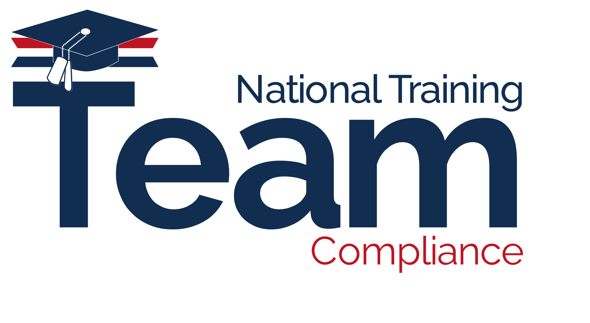

**DEPARTMENT OF VETERANS AFFAIRS**

UPDATE – 11/03/2020

**Veterans Benefits Administration**

**National Training Team-Compliance**

**FY23 National Training Curriculum**

**Standard Operating Procedure (SOP)**

**Table of Contents**

Purpose 6

Background 6

Introduction 7

Target Audience 7

1. Approval, Compliance& Liaison Org Chart 8
2. Target Audience Analysis 9

Core Technical Training Requirements (CTTR) 9

1. Mandated Training 9

Responsibilities 11

1. AC&L Field Employees 11
2. Make-Up Training 11
3. AC&L Management 11
4. TMS Administrators 11
5. National Training Team - Compliance 11

NTC Coordination Process 12

Training Development 12

Training Packages 12

Lesson Plans 13

Lesson Materials 13

Lesson Assessment 14

Training Credit Awarded to Instructors 15

Instructors – Continuing Education Credits 16

Assigning Training in TMS 16

Training Completion Status 17

VBA Learning Catalog 17

AC&L Field Staff – NTC Requirements 17

Error Trend Analysis Training (ETAT) 18

Appendix A 19

1. Approval, Compliance & Liaison Position Descriptions 19
2. Training Definitions 20

Appendix B……………………………………………………………………………………………….22

1. Section 508 Compliance……………………………………………………………………………22
2. AC&L Field TMS Station Determined Codes……………………………………………….……23

**Purpose**

The purpose of this document is to provide the requirements of the FY23 National Training Curriculum (NTC) for Approval, Compliance & Liaison (AC&L) field employees. Training assigned under the AC&L NTC ensures that accurate and consistent learning is delivered appropriately to employees based on position type.

The National Training Team – Compliance (NTT-C) is responsible for establishing the NTC for AC&L technical positions in the field and ensuring annual participation of all eligible employees. Chief Education Liaison Officers (CELOs) and Supervisors are required to support the fulfillment of this Veterans Benefits Administration (VBA) requirement. The completion date for all training is **Friday, September 29, 2023,** unless otherwise determined by VBA’s Education Service leadership.

**Background**

The NTC is a VBA mandate that requires training to address skill enhancement for all technical employees. NTC topics identified consist of issues of high interest and/or quality concerns. Courses in the NTC are required to be completed *in addition to* VA’s annual mandatory training requirements.

Previous NTC guidance included technical positions across Education Service (Processing, Approval & Compliance, and VACO). The 2023 NTC focuses on target audiences. The intent is to simplify the NTC process for Education staff and streamline annual updates and SOPs for each audience.

Education Service has three National Training Teams responsible for planning, developing, and executing learning and development strategies for Education Service employees in the field and Central Office:

**National Training Team – Compliance (NTT-C)** is responsible for the learning and development of the Approval, Compliance and Liaison (AC&L) employees in the field. The NTT-C develops and delivers national training for the AC&L field staff in support of strategic hiring initiatives; implements the national training curriculum for technical field staff; plans and supports the AC&L Learning and Development Conference; and coordinates support for national compliance conferences and training events.

**National Training Team – Processing (NTT-P)** is responsible for the learning and development of the education claims processing employees in the field. The NTT-P develops and implements the national training curriculum for claims processing of critical and technical staff in the RPOs and EDU staff in Central Office. The NTT-P is also responsible for employee development for Education Service Central Office employees.

**National Training Team – Schools (NTT-S)** is responsible for the learning and development of the School Certifying Officials (SCOs). The NTT-S develops and delivers national training for the AC&L field staff in support of strategic hiring initiatives; implements the national training curriculum for SCOs; supports the SCO Regional and National Conferences; and tracks and verifies SCO annual training compliance.

**Introduction**

This standard operating procedure (SOP) explains the process of executing the AC&L NTC, per VBA requirements and EDU guidelines. The intent of this SOP is to ensure the proper coordination and facilitation of the AC&L NTC with the Office of Human Capital Service (HCS), EDU Central Office, and AC&L field staff. This SOP is in effect upon receipt.

**Target Audience**

The target audience for this SOP is AC&L field staff. AC&L is responsible for planning, coordinating, and overseeing statutorily mandated compliance surveys, Targeted Risk Based Reviews (TRBRs), and Risk Based Surveys (RBSs) to ensure that institutions with approved programs adhere to all applicable approval, record keeping and reporting requirements.

The AC&L field staff are the backbone of the compliance effort for Education Service. Education Liaison Representatives (ELRs), Education Compliance Survey Specialists (ECSSs), Quality Training Specialists (QTSs), Supervisory Compliance and Liaison Specialists and Chief Education Liaison Officers (CELOs) are organized by region and serve as a primary point of contact for School Certifying Officials (SCOs) and State Approving Agencies (SAAs) on eligibility, approval, and compliance matters. ELRs also handle updates in VA systems as requested by schools.

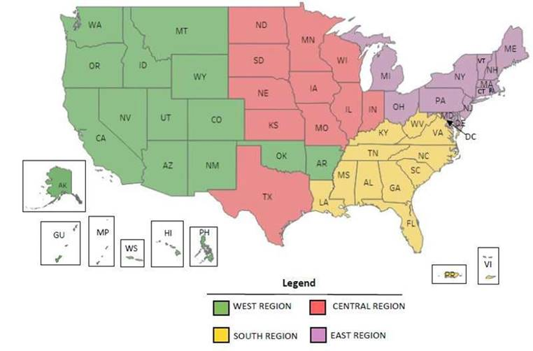

**Approval, Compliance & Liaison Org Chart**

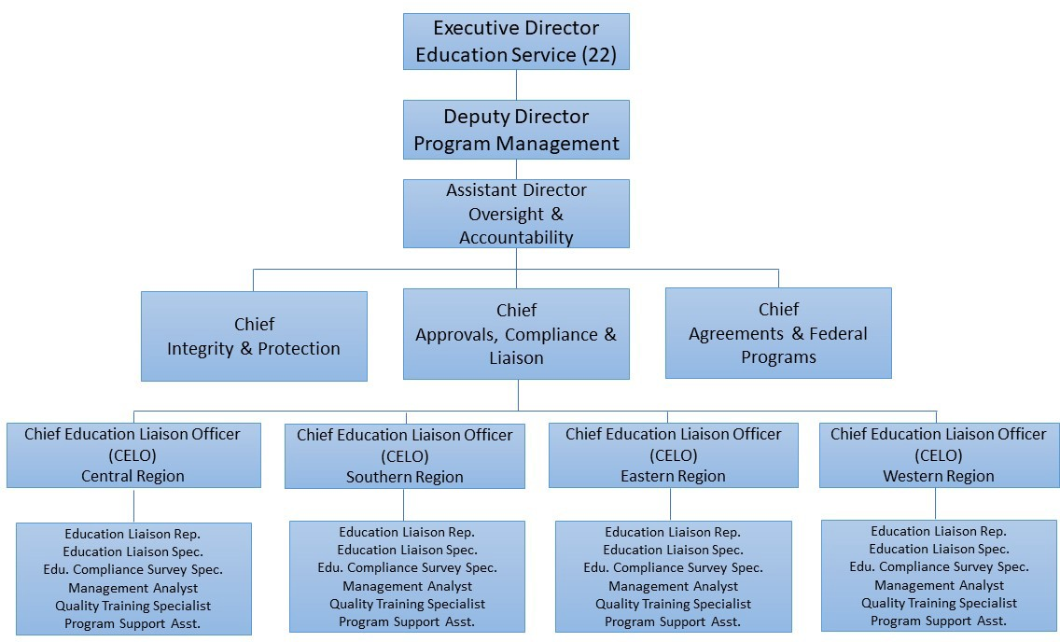

**Target Audience Analysis**

The objective of the AC&L NTC is to equip employees with the necessary technical capabilities to accomplish the VA’s mission: to enhance the delivery of quality service provided to service members, Veterans, and their dependents.

**AC&L Field Staff:**

* + Chief Education Liaison Officers (CELOs)
  + Quality Training Specialists (QTSs)
  + AC&L Supervisors
  + Education Liaison Representatives (ELRs)
  + Education Compliance Survey Specialists (ECSSs)
  + Management Analysts (MAs)
  + Program Support Assistants (PSAs)

**Core Technical Training Requirements (CTTR)**

Employees identified under the AC&L NTC must complete a minimum of 24 hours of training to comply with VBA and EDU requirements. The 24-hour training requirement may consist of a combination of both mandated and VACO/REGION determined training. The NTT-C is responsible for providing mandated training. The CELOs and Supervisors are responsible for providing VACO/REGION determined training.

Only training delivered or approved by NTT-C will be granted AC&L NTC credit in VA’s TMS system. During the fiscal year, Education Service may mandate additional training to address specific agency and department needs. All mandated training must

be completed regardless of the number of hours required annually.

**Mandated & VACO/Region Determined Training**

1. **Mandated Training** – Training on specific topics derived from emerging issues, new legislative changes, policy or procedural advisories, other training deficiencies or reminders and recurring mandated topics. The NTT-C is responsible for providing mandated training.
2. **Error Trend Analysis Training (ETAT)** – Mandated training based on identified quality error trends that merit national training. ETAT will be identified nationally based on the quality narrative reports produced by the National Quality Assurance – Compliance team in Central Office.

1. **Station-Determined Training** - Training on topics derived from emerging issues in specific regions (Central, Southern, Eastern, Western), new legislative changes, policy or procedural advisories, other training deficiencies or reminders and recurring local topics. The CELOs and Supervisors are responsible for providing VACO/REGION determined training.

|  |  |
| --- | --- |
| **Education Approvals, Compliance & Liaison Positions** | **Annual Hour Requirements** |
| **Mandated Hours** | |
| Chief Education Liaison Officer (CELO) & Managers | 19 |
| Quality Training Specialist (QTS) | 19 |
| Education Liaison Representative (ELR) | 19 |
| Education Compliance Survey Specialist (ECSS) | 19 |
| Management Analyst (MA) | 19 |
| Program Support Assistant (PSA) | 19 |
| **Error Trend Analysis Training** | |
| Chief Education Liaison Officer & Managers | 4 |
| Quality Training Specialist | 4 |
| Education Liaison Representative | 4 |
| Education Compliance Survey Specialist | 4 |
| Management Analyst | 4 |
| Program Support Assistant | 4 |
| **Station-Determined Training** | |
| Chief Education Liaison Officer & Managers | 1 |
| Quality Training Specialist | 1 |
| Education Liaison Representative | 1 |
| Education Compliance Survey Specialist | 1 |
| Management Analyst | 1 |
| Program Support Assistant | 1 |

**Responsibilities**

**AC&L Field Employees**

NTT-C strategically identifies and develops centralized training for all AC&L employees. The training will consist of lessons and exercises specific to AC&L employees (i.e., New Employee Training, Quarterly Refresher Training, Advisories) or training related to SAAs & SCOs (i.e., Monthly Office Hours). AC&L employees are required to take a minimum of 24 hours of training annually and to self-certify in TMS. During the fiscal year, Education Service may mandate additional training to address specific agency and department needs. All mandated training must be completed regardless of the number of hours required annually.

**Make-Up Training**

Employees are required to complete a minimum of 24 hours of annual training as prescribed by the AC&L NTC. Employees who miss virtual-led training, can take the training and quiz in TMS as a make-up session.

AC&L specific training must be recorded in TMS and include proof of trainee attendance, such as a level 1 survey or a self-certification object.

**AC&L TMS Administrators**

AC&L TMS Administrators should adhere to the AC&L NTC coordination process for assigning and tracking the AC&L NTC using TMS. The designated NTT-C or AC&L TMS Administrator identifies employees by their job positions and adds each employee to the TMS cohort designated by job position. The Core Technical Training Requirements (CTTR) for each position will automatically populate on employees’ TMS “My Learning Lists” as training is released throughout the fiscal year.

**NTT-C**

The NTT-C is responsible for the development, implementation, and coordination of the national training curriculum for the AC&L technical staff in the field. They partner with Human Capital Service (HCS) to update the AC&L NTC annually and they monitor training progress monthly throughout the year. In addition, they maintain all training packages on the respective SharePoint sites and/or the VBA catalog.

**NTC Coordination Process**

The AC&L NTC coordination process requires close collaboration between AC&L management, CELOs, TMS Administrators, and EDU Central Office. The coordination process requires several steps to successfully achieve the goals of the AC&L NTC.

**Training Development**

All training for the AC&L NTC is developed by Subject Matter Experts (SME), and covers topics related to error-based trends, deficiency findings, new legislative mandates, and Education Service initiatives.

The training will employ the use of a variety of media, to include but not limited to:

* [Instructor-led Training](https://intellipaat.com/blog/types-of-training-methods-and-techniques/" \l "no2)
* [On-the-job Training](https://intellipaat.com/blog/types-of-training-methods-and-techniques/#no3)
* Self-Paced Training
* [Group Discussion and Activities](https://intellipaat.com/blog/types-of-training-methods-and-techniques/#no5)
* [Lectures](https://intellipaat.com/blog/types-of-training-methods-and-techniques/#no6)
* [e-Learning](https://intellipaat.com/blog/types-of-training-methods-and-techniques/#no7)
* [Simulation Training](https://intellipaat.com/blog/types-of-training-methods-and-techniques/#no8)
* [Case Studies or Reading Materials](https://intellipaat.com/blog/types-of-training-methods-and-techniques/#no11)

Upon review and approval, the training materials should be uploaded to the respective training material folder on the SharePoint site with all supporting training package documents.

**Training Packages**

Training identified as meeting the criteria of the AC&L NTC should be tracked and assigned in TMS via a training package.

A basic training package must contain the following:

* + Lesson Plan
  + Lesson Materials (i.e., PowerPoint presentation)
  + Learning Assessment

Optional items in a training package include:

* + - Handouts
    - Job Aids
    - Scenario Exercises

A full training package includes all basic and optional items. It will be determined, on a case-by-case basis, if a full training package is required.

**Lesson Plan/Item Request Form**

The lesson plan is a detailed description of the course of instruction to be used by the facilitator to teach the content.

HCS’s [Training Center of Excellence (TCOE)](https://vba-edt.vbatraining.org/TCOE/SitePages/Home.aspx) site houses the VBA Standardized Training Lesson Plan Template, which provides a starting point for creating the lesson plan. This document is located within the [Planning, Create, Execute, and Sustain (PCES) Toolkit.](https://vba-edt.vbatraining.org/TCOE/SitePages/SystemFramework/PCESToolkit.aspx)

The lesson plan form should include:

* The estimated time it will take to complete the training
* The purpose of the lesson
* Any prerequisite training requirements
* The target audience for the lesson
* The references for the lesson
* The lesson’s objectives
* A description or list of materials and equipment needed to successfully present the lesson
* Any post-training requirements
* Instructor notes

**Note:** Education Service has a [Training Development Template](https://dvagov.sharepoint.com/:f:/r/sites/NationalTrainingCurriculum-TrainingDevelopment/Shared%20Documents/General?csf=1&web=1&e=nKjrEJ) folder for all training materials, located on the Education Service, NTT-C NTC Training Development folder in Microsoft Teams. Contact the respective Training Team for access.

**Lesson Materials**

1. The lesson materials are used to conduct the course of instruction (i.e., a PowerPoint presentation, trainee handout, job aid, and/or a scenario example).
2. All lesson materials created must meet the provisions outlined under Section 508 compliance. (See Appendix B)
3. Detailed information to develop Section 508 compliant training can be found on the [Education Service SharePoint](https://dvagov.sharepoint.com/sites/VBAEDUSvc/CLT%20TEAM%20225T/NTTC/NTC%20Library/Forms/AllItems.aspx?id=%2Fsites%2FVBAEDUSvc%2FCLT%20TEAM%20225T%2FNTTC%2FNTC%20Library%2FSection%20508%20Compliance&viewid=3b1324c1%2Dfb43%2D429d%2Dad6d%2Da0b39290e6f4) site.
4. The TCOE site houses the [VBA Standardized Training PowerPoint Template,](https://vba-edt.vbatraining.org/tcoe/SitePages/Resources/JAID_DevChkLong.pdf) which provides a starting point for creating your lesson materials. You can find it within the PCES Toolkit.
5. The TCOE sites below also provide additional guidance for developing a lesson and other instructional materials (such as job aids and reference sheets):

* [Design Training and Assessment Materials](https://vba-edt.vbatraining.org/TCOE/SitePages/SystemFramework/Create_5.aspx)
* Develop Training and Assessment Materials
* Design Performance Support Tools
* Develop Performance Support Tools

**Lesson Assessment**

1. The assessment measures the effectiveness of the course instruction through short, objective questions.
2. Assessment questions should be focused on testing the student’s knowledge and use of the information.
3. The lesson in the AC&L NTC must be taught in accordance with the approved lesson plan. For example, if the lesson plan states that the lesson is “instructor-led,” then it must be taught in an instructor-led modality. Similarly, if there is a practical exercise in the lesson plan, it must be used in the training session. Videotaped or recorded training sessions must have an instructor available to address questions either during the session or immediately afterwards, to ensure individual inquiries are addressed.
4. All training will include an assessment and a course survey to rate the training content and instructor performance. These should be completed based on the deadline given after the conclusion of training. The assessment and survey will appear on the employee’s To Do List in TMS.
5. Designated local TMS administrators will place the appropriate employees in TMS cohorts (groups of people), established specifically for each job position, and, likewise, must remove employees as they leave their position. Each cohort will be linked to the proper mandated curriculum, and the mandated item assignments will be automatic once an employee is added to the cohort. TMS administrators should move employees in and out of cohorts when they change positions (refer to the Education NTC Cohort Assignment Job Aid) on the [Training Center of Excellence (TCOE) website.](https://vba-edt.vbatraining.org/TCOE/SitePages/SystemFramework/PCESToolkit.aspx)
6. Employees assigned to a cohort (group of people) will receive training requirements on their To Do List in TMS. Additional proof of attendance for instructor-led items is required for verification of training.

* **Mandatory Training** – NTT-C will retain an electronic roster to include course title, date of training, name of employees who attended the training, and training facilitator’s name.
* **Station-Determined Training** – AC&L field staff will retain an electronic roster to include course title, date of training, name of employees who attended the training, and training facilitator’s name. Once Station-Determined Training is offered, the AC&L field staff will submit an electronic roster to the NTT-C for monitoring and tracking purposes.

1. External training events should be approved by immediate supervisors. Please submit any requests for VACO/region determined credit for external events to the NTT-C for approval.

**Credit Awarded to Instructors**

Instructors may be granted up to 6 hours of station-determined credit annually for preparation and instructional time. Training credit may be recorded under TMS item number VA 4057413 (Preparation and Instruction of Education Service Training).

**Instructions:** TMS Administrators can award this 1-hour item to instructors for time spent preparing for training and instructing employees. The item can be awarded up to 6 times during the fiscal year, for a maximum number of 6 hours, which will count toward the station-determined NTC requirement.

AC&L Quality Training Specialists should complete the HCS ELITE Instructor Certification Program that is aligned with industry standards and offers employees a unique and exciting opportunity to become a certified instructor. Not only will employees benefit from this program by receiving a certification recognized by the industry, but other employees will receive more consistent, enhanced instruction.

Human Capital Service (HCS) is administering this program using Master Instructors certified from an external Federal Agency program. Employees receiving certification will join an elite group of professionals who are highly respected and sought after to instruct. The ELITE program provides employees with the essential knowledge and skills needed to conduct training effectively.

**Instructors Continuing Education Requirement**

In accordance with HCS continuing education (CE) checklist, AC&L Quality Training Specialists who have completed HCS’s ELITE instructor training can earn the following annual CEs:

**CE Year 1**

* + Deliver a minimum of 24 instructional platform hours/year
  + Read textbook Presentation Skills: Educate, Inspire and Engage Your Audience by Michael Weiss (Skillsoft Books) or other related materials

**CE Years 2 and 3**

* + Deliver a minimum of 16 instructional platform hours/year
  + Read textbook 10 Steps to Successful Presentations by American Society for Training and Development (Skillsoft Books) or other related materials

**Assigning Training In TMS**

The NTT-C will complete the TMS Item ID Request Form for each training package created and/or received from the field and will send the request to [VBATMSHELP.VBAVACO@va.gov.](mailto:VBATMSHELP.VBAVACO@va.gov) All mandated training items will be assigned to employees by the NTTs, to ensure consistency in the field.

**Training Completion Status**

The NTT-C will monitor training quarterly based on the training reports received from AC&L field staff and notify each office of training deficiencies. AC&L field staff should conduct regular monitoring of the status of training for each region. Supervisors are encouraged to monitor training completion on a regular basis to ensure that progress is made throughout the year. Instructions on how to pull reports can be found at [EDU NTC](https://vba-media1.vbatraining.org/VBA_Learning_Catalog/EDT/Job_Aids/EDU_NTC_Progress_Report_Job_Aid.pdf) [Progress Report Job Aid.docx.](https://vba-media1.vbatraining.org/VBA_Learning_Catalog/EDT/Job_Aids/EDU_NTC_Progress_Report_Job_Aid.pdf) Due to current single user access limitations, NTC reports can be generated using one of the following links. Regions should use the link that matches their VBA district alignment.

* [Central Region](https://vba-tpi.vbatraining.org/NTCProgressReportCONT/): <https://vba-tpi.vbatraining.org/NTCProgressReportCONT/>
* [Eastern Region](https://vba-tpi.vbatraining.org/NTCProgressReportNE/): <https://vba-tpi.vbatraining.org/NTCProgressReportNE/>
* [Western Region](https://vba-tpi.vbatraining.org/NTCProgressReportPAC/): <https://vba-tpi.vbatraining.org/NTCProgressReportPAC/>
* [Southern Region](https://vba-tpi.vbatraining.org/NTCProgressReportSE/): <https://vba-tpi.vbatraining.org/NTCProgressReportSE/>

If running reports centrally, the EDU NTT should use the following link, which is also limited to one user at a time: <https://vba-tpi.vbatraining.org/ntcprogressreport>

**VBA Learning Catalog**

The [VBA Learning Catalog](https://vba-tpi.vbatraining.org/lc/(X(1)S(ufiltjrnpgbl33zqxljawt3d))/default.aspx?AspxAutoDetectCookieSupport=1) is an online training catalog that is organized specifically to support the way VBA structures and manages its training programs. The training catalog is the designated focal point to obtain Education Service training items. Search functions identify mandated items and target audiences. Items are also searchable by job position, TMS item number, curriculum, etc.

Authorized curriculum items will be listed in the VBA Learning Catalog. Other training sources identified in TMS may also be used. Some approved items, such as external events or local station training items, may not be in the VBA Learning Catalog.

**AC&L Field Staff – NTC Requirements**

The NTC applies to all the AC&L staff in the field. AC&L trainees have an On-the- Job Training (OJT) program designed as a hands-on method of teaching the skills, knowledge, and competencies needed for employees to perform a specific job within the workplace.

|  |  |  |
| --- | --- | --- |
| **Approval, Compliance & Liaison Field Staff Technical Positions** | **TMS Cohort** | **TMS Curriculum** |
| Education Service – AC&L Manager Cohort (CELOs & Supervisors) | VBA-664 | VBA-1469 |
| Education Service – AC&L QTS Cohort (NTC) | VBA-661 | VBA-1464 |
| Education Service – AC&L ELR Cohort (NTC) | VBA-395 | VBA-1465 |
| Education Service – AC&L ECSS Cohort (NTC) | VBA-393 | VBA-1466 |
| Education Service – AC&L MA Cohort (NTC) | VBA-550 | VBA-1468 |
| Education Service – AC&L PSA Cohort (NTC) | VBA-606 | VBA-1467 |
| Education Service – AC&L O&A Compliance Contractors | VBA-968 | VBA-1470 |

**\*Education Service – AC&L O&A Compliance Contractors** are assigned to TMS Cohort

VBA-968

**\*SAAs** are assigned to TMS Cohort VBA-1029. The SAAs are not required to meet the NTC training requirements. All AC&L training that is assigned to SAAs is optional.

**Error Trend Analysis Training (ETAT)**

ETAT is mandated training based on identified quality error trends. ETAT will be identified nationally based on the quality narrative reports produced by the National Quality Assurance – Compliance team in VBA Central Office. Below is a table containing 6 reusable TMS item numbers that NTT-C will use to award varying hours of credit for the ETAT conducted throughout the year. ETAT will only count toward VACO-mandated training. Any quality training conducted locally by a region should be tracked under the ETAT TMS item numbers.

|  |  |  |
| --- | --- | --- |
| **Item #** | **Title** | **Hours** |
| 4408400 | EDU Mandatory Error Trend Analysis Training | 0.5 hours |
| 4408401 | EDU Mandatory Error Trend Analysis Training | 1 hour |
| 4408402 | EDU Mandatory Error Trend Analysis Training | 1.5 hours |
| 4408403 | EDU Mandatory Error Trend Analysis Training | 2 hours |
| 4408404 | EDU Mandatory Error Trend Analysis Training | 2.5 hours |
| 4408405 | EDU Mandatory Error Trend Analysis Training | 3 hours |

**Note:** Once training is complete, the item should be recorded in the employee’s TMS Learning History by a TMS administrator. AC&L field staff will maintain sign-in sheets and a copy of all associated training materials and have them readily available for review during site visits or for any other reasons deemed necessary. Although always a good practice when there are multiple facilitators or offerings, maintaining a complete “training packet” (i.e., lesson plan) is not mandatory.

**APPENDIX A**

**Approval, Compliance & Liaison Position Descriptions**

* **Chief Education Liaison Officer (CELO):** Serves as the manager responsible for the day-to-day leadership of the approval, compliance and liaison activities in a multi-state geographical area for educational and training institutions. Serves as a consultant within Education Service on complex issues associated with the effectiveness of the compliance survey program and determinations regarding approval activities for VA educational assistance programs.
* **AC&L Supervisor:** Provides technical and administrative oversight to a team of Education Liaison Representatives (ELRs) and Education Compliance Survey Specialists (ECSSs).Plans work to be accomplished by subordinates in different geographical locations, sets and adjusts short term priorities, prepares schedules for completion of work and assigns work to subordinates based on priorities. Evaluates work performance of subordinates while overseeing the quality assurance of SAA approval packages and compliance surveys at educational and training institutions.
* **Education Liaison Representative (ELR):** Serves as a VA representative to an assigned state(s) in matters requiring liaison between educational institutions, training facilities, AC&L and SAAs. Receives, reviews, and adjudicates approval packages (official documents, data, records) from SAAs regarding educational institutions and training facilities approval, revision, suspension or withdrawal actions. Ensures a consistent application of governing laws, regulations and other criteria are applied to the adjudication of all approval packages.
* **Quality Training Specialist (QTS):** Performs quality reviews that ELR and ECSS have completed approval and compliance survey products in accordance with an established monthly schedule.Responsible for assisting and advising on unusually complex approvals or compliance surveys. Tracks and analyzes approval and compliance quality and training comprehension errors for individuals, to include errors determined by Central Office.
* **Education Compliance Survey Specialist (ECSS):** Conducts compliance surveys to verify that payments made to eligible students are in keeping with VA requirements for approval. Examines education files of students selected for sampling and ascertains enrollment data and award actions. Makes other preparations necessary to gain a thorough knowledge of the schools’ procedures and items to be reviewed during the survey.
* **Management Analyst (MA):** Provides administrative and analytical support for AC&L to make efficient decisions regarding operations. Tracks progress with respect to the region’s approvals, compliance and liaison performance measures and facilitates work or program reviews to improve efficiency.
* **Program Support Assistant (PSA):** Performs administrative and technical tasks that require a working knowledge of external and internal policies and procedures regarding AC&L activities.

**Training Definitions**

1. **Cohort:** Generally, a group of employees in the same job position or with a specific duty or assignment
2. **Talent Management System (TMS):** The official system of record for all VA training accounts.
3. **Curriculum:** The associated planned sequence of instruction (i.e., a group of items, requirements, or sub curricula). Curricula organize items into a group so that the items can be assigned to users and tracked more easily.
4. **TMS Item**: A container for a unit of learning that can be assigned to a user to track its completion. It can be a book, video, course, document, or anything else that can be assigned to a user for learning purposes.
5. [**Instructor-led Training**](https://intellipaat.com/blog/types-of-training-methods-and-techniques/#no2): Occurs in a training room with one or more instructors presenting the lecture and demonstration.
6. **Level I Survey:** Measures learning. (Feedback/Opinion)

* The NTT– C will collect anonymous feedback on Survey Monkey to measure participants’ initial experience in the training, in addition to being collected in TMS surveys.

1. **Level 2 Assessment:** Measures Learning (Exam)
2. **National Training Curriculum (NTC) Requirement:** 24 hours of required training required by Education Service to include 19 hours of mandated training, 1 hour of stationed determined training and 4 hours of ETAT. Agency-required training for all VBA employees (e.g., VA Privacy and Information Security, Prevention of Workplace Harassment/No Fear, Inside Ethics) must be completed in addition to the NTC requirements outlined in this SOP.
3. [**On-the-job Training**](https://intellipaat.com/blog/types-of-training-methods-and-techniques/#no3) - An experiential kind of training that is tailored to address the individual requirements of employees.
4. **Self-Paced Training**: Individualized training in which the trainee controls the pace at which learning takes place.
5. [**Group Discussion and Activities**](https://intellipaat.com/blog/types-of-training-methods-and-techniques/#no5)**:** Training multiple employees at once, especially if they are in the same department or team.
6. [**Lectures**](https://intellipaat.com/blog/types-of-training-methods-and-techniques/#no6): An oral presentation intended to present information or teach people about a particular subject audience.
7. [**e-Learning**](https://intellipaat.com/blog/types-of-training-methods-and-techniques/#no7): As a training method, e-learning utilizes online courses, videos, and tests. It is an easy training method where employees can do their training on any device, such as a phone or an office computer system.
8. [**Simulation Training**](https://intellipaat.com/blog/types-of-training-methods-and-techniques/#no8): Opportunity for hands-on deliberate practice, development of decision-making skills, and improved communication and teamwork.
9. [**Case Studies or Reading Materials**](https://intellipaat.com/blog/types-of-training-methods-and-techniques/#no11): Reading materials are readily available on some employee training topics.
10. **Training:** Section 4101 of Title 5, United States Code, defines “training” as “the process of providing for and making available to an employee, and placing or enrolling the employee in, a planned, prepared, and coordinated program, course, curriculum, subject, system, or routine of instruction or education, in scientific, professional, technical, mechanical, trade, clerical, fiscal, administrative, or other fields which will improve individual and organizational performance and assist in achieving the agency’s mission and performance goals.”
11. **Trainee Status (New):** The status of an employee in his or her first 12 months in the position. The trainee status starts on the date training is assigned and ends on the last day of the 12th month, or after entry-level training is completed. New employees become eligible for the NTC training requirement after the entry-level training is completed.
12. **Web-Based Learning:** Online training which provides self-directed and/or self- paced training. It may be accessed in or out of the work environment.
13. **Videos/Satellite Broadcasts:** Recorded broadcast training videos provided through Talent Management System (TMS) and other platforms.

**APPENDIX B**

**Section 508 Compliance**

Section 508 of the Rehabilitation Act Amendments of 1998 requires that when Federal agencies develop, procure, maintain or use electronic and information technology, they shall ensure that the electronic and information technology allows Federal employees with disabilities to have access to and use of information and data that is comparable to the access to and use of information and data by Federal employees who are not individuals with disabilities, unless an undue burden would be imposed on the agency.

Section 508 also requires that individuals with disabilities, who are members of the public, seeking information or services from a Federal agency, have access to and use of information and data that is comparable to that provided to the public who are not individuals with disabilities, unless an undue burden would be imposed on the agency.

The 508 standards require such things as text labels for graphics on web pages and desktop software that is compatible with assistive technology. All training material created under the NTC must meet all standards required by Section 508 of the Rehabilitation Act Amendments of 1998.

**Station-Determined TMS Code**

**Central Region**

|  |  |  |
| --- | --- | --- |
| **Item Number** | **Title** | **Hours** |
| 4621541 | EDU – Central Huddle Training .25 Hours | .25 Hours |
| 4621543 | EDU – Central Huddle Training .50 Hours | .50 Hours |
| 4621549 | EDU – Central Huddle Training .75 Hours | .75 Hours |
| 4491286 | EDU – Central Huddle Training 1 Hour | 1 Hour |
| 4621566 | EDU – Central Huddle Training 1.25 Hours | 1.25 Hours |
| 4621567 | EDU – Central Huddle Training 1.5 Hours | 1.50 Hours |
| 4621574 | EDU – Central Huddle Training 1.75 Hours | 1.75 Hours |
| 4621576 | EDU – Central Huddle Training 2.0 Hours | 2 Hours |
| 4621577 | EDU – Central Huddle Training 2.25Hours | 2.25 Hours |
| 4621578 | EDU – Central Huddle Training 2.5 Hours | 2.50 Hours |
| 4621580 | EDU – Central Huddle Training 2.75Hours | 2.75 Hours |
| 4621581 | EDU – Central Huddle Training 3 Hours | 3 Hours |

**Eastern Region**

|  |  |  |
| --- | --- | --- |
| **Item Number** | **Title** | **Hours** |
| 4621654 | EDU – Eastern Area Station Determined Training .25 Hours | .25 Hours |
| 4621655 | EDU – Eastern Area Station Determined Training .50 Hours | .50 Hours |
| 4621657 | EDU – Eastern Area Station Determined Training .75 Hours | .75 Hours |
| 4621658 | EDU – Eastern Area Station Determined Training 1 Hour | 1 Hour |
| 4621569 | EDU – Eastern Area Station Determined Training 1.25 Hours | 1.25 Hours |
| 4621660 | EDU – Eastern Area Station Determined Training 1.5 Hours | 1.50 Hours |
| 4621662 | EDU – Eastern Area Station Determined Training 1.75 Hours | 1.75 Hours |
| 4621663 | EDU – Eastern Area Station Determined Training 2 Hours | 2 Hours |
| 4621664 | EDU – Eastern Area Station Determined Training 2.25 Hours | 2.25 Hours |
| 4621666 | EDU – Eastern Area Station Determined Training 2.5 Hours | 2.50 Hours |
| 4621667 | EDU – Eastern Area Station Determined Training 2.75 Hours | 2.75 Hours |
| 4621668 | EDU – Eastern Area Station Determined Training 3 Hours | 3 Hours |

**Western Region**

|  |  |  |
| --- | --- | --- |
| **Item Number** | **Title** | **Hours** |
| 4621589 | EDU – Western Area Station Determined Training .25 Hours | .25 Hours |
| 4621591 | EDU – Western Area Station Determined Training .50 Hours | .50 Hours |
| 4621592 | EDU – Western Area Station Determined Training .75 Hours | .75 Hours |
| 4621593 | EDU – Western Area Station Determined Training 1 Hour | 1 Hour |
| 4621597 | EDU – Western Area Station Determined Training 1.25 Hours | 1.25 Hours |
| 4621598 | EDU – Western Area Station Determined Training 1.5 Hours | 1.50 Hours |
| 4621599 | EDU – Western Area Station Determined Training 1.75 Hours | 1.75 Hours |
| 4621600 | EDU – Western Area Station Determined Training 2 Hours | 2 Hours |
| 4621601 | EDU – Western Area Station Determined Training 2.25 Hours | 2.25 Hours |
| 4621603 | EDU – Western Area Station Determined Training 2.5 Hours | 2.50 Hours |
| 4621604 | EDU – Western Area Station Determined Training 2.75 Hours | 2.75 Hours |
| 4621607 | EDU – Western Area Station Determined Training 3 Hours | 3 Hours |

**Southern Region**

|  |  |  |
| --- | --- | --- |
| **Item Number** | **Title** | **Hours** |
| 4621620 | EDU – Southern Area Station Determined Training .25 Hours | .25 Hours |
| 4621622 | EDU – Southern Area Station Determined Training .50 Hours | .50 Hours |
| 4621623 | EDU – Southern Area Station Determined Training .75 Hours | .75 Hours |
| 4621624 | EDU – Southern Area Station Determined Training 1 Hour | 1 Hour |
| 4621625 | EDU – Southern Area Station Determined Training 1.25 Hours | 1.25 Hours |
| 4621626 | EDU – Southern Area Station Determined Training 1.5 Hours | 1.50 Hours |
| 4621627 | EDU – Southern Area Station Determined Training 1.75 Hours | 1.75 Hours |
| 4621628 | EDU – Southern Area Station Determined Training 2 Hours | 2 Hours |
| 4621629 | EDU – Southern Area Station Determined Training 2.25 Hours | 2.25 Hours |
| 4621630 | EDU – Southern Area Station Determined Training 2.5 Hours | 2.50 Hours |
| 4621631 | EDU – Southern Area Station Determined Training 2.75 Hours | 2.75 Hours |
| 4621632 | EDU – Southern Area Station Determined Training 3 Hours | 3 Hours |