DGI 4.0 Release 5 Script

 | Music playing
 | DGI 4.0 Release 5  Welcome to DGI 4.0 Release 5 training which will cover enhancements and changes made to the Digital GI Bill (DGI) Claims Processing System.  Click the START button to begin the training.
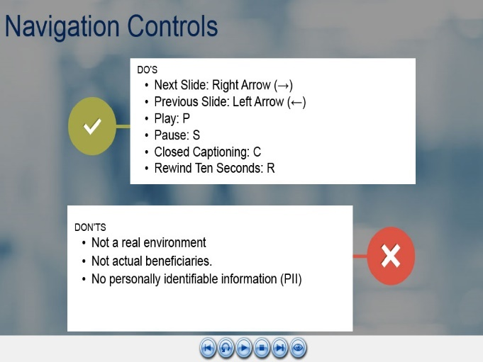 | You can use the navigation buttons at the bottom of the screen to move forward and backward throughout this module.  Also, you may use the keyboard shortcuts shown on-screen.  Please note, the examples you will see during this training were processed in a test system. All names and claim numbers you see are fictitious and do not belong to actual beneficiaries. No personally identifiable information (PII) is contained in this training.
 | Today’s Training  In today’s training you will be introduced to new search functionality, improvements to the Entitlement banner and universal language updates to chapter 33 letters.  Note: DGI is also known as Chapter 33 Processing System, formerly LTS (Long Term Solution)
 | Learning Objectives  At the end of this training, you will be able to:  - Identify the updated functionality in DGI  - Reproduce the steps to create the enhanced system processing, and  - Recognize updated chapter 33 letters verbiage
 | Let’s jump right in and begin with enhancements made to DGI.
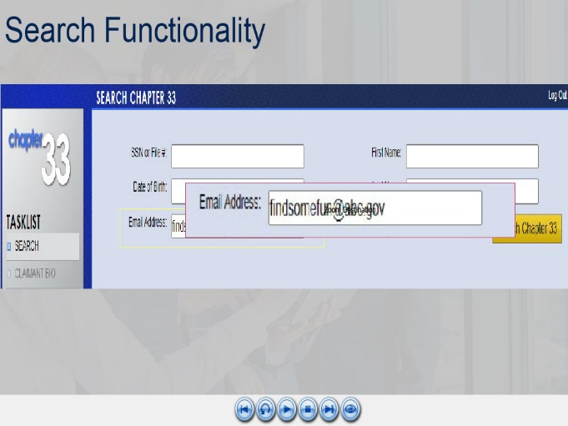 | The first update is the ability to search for a beneficiary, also known as a claimant, by their email address.  I know, I'm excited too.  A fifth box was added to enter an email address. This addition is perfect for the scenario of when a beneficiary may email an inquiry but fail to provide their claim number. If you have their name, you can enter an email address and voila! Search away by- SSN, Date of Birth, First Name, Last Name or Email address.
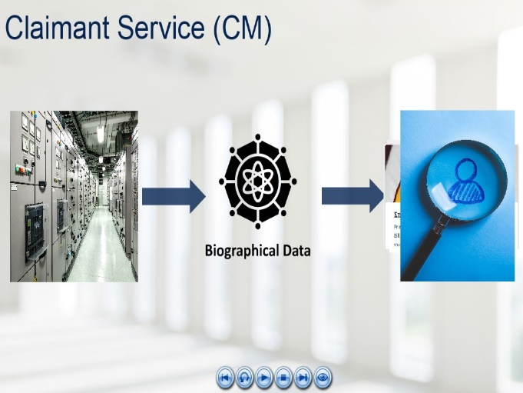 | Related to the search function is a new member to the Managed Service, the Claimant Service (CM). CM shares biographical (bio) data across the different Managed Service systems to include My Education Benefits (MEB), Benefits Manager (BM), and Enrollment Manager (EM) to name a few.  When DGI searches for a claimant, it uses the Claimant Service which garners its information from the VA Master Person Index (MPI), as well as DGI and EM.  CM happens in the background, pulling and pushing data.
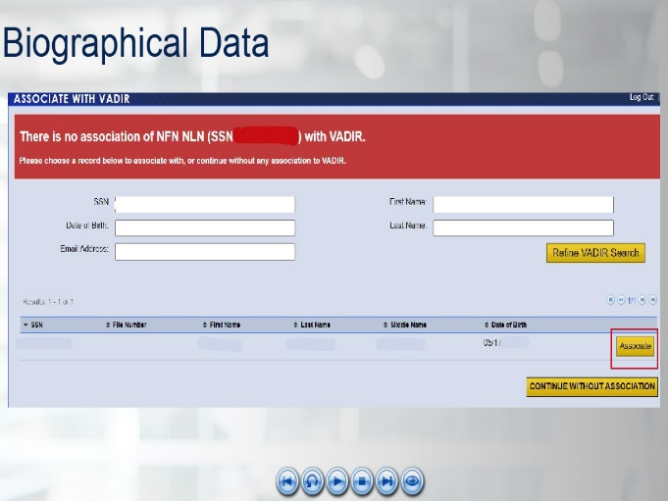 | While utilizing the bio data from CM, there may be times when you, the VCE, will need to assist the system with pulling in all the correct information. This means You will need to “Associate” with VADIR.
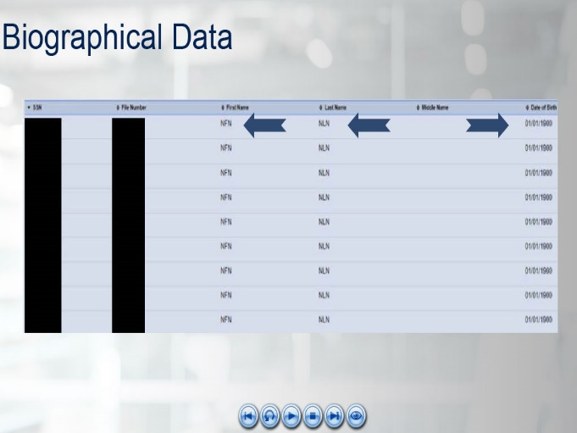 | “Continue Without Association” has been the normal pathway due to VADIR discrepancies.  Unless previously instructed by a Procedural Advisory or an M22-4 reference, you should select “Associate” in instances where “NFN” is displayed under First Name, “NLN” is displayed under Last Name or “01/01/1900” is displayed under Date of Birth.
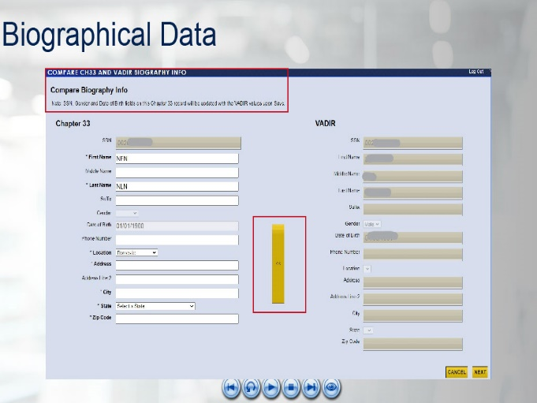 | Once Associate has been selected, a “Compare Biography Info” screen will appear.  The VCE will need to click the yellow arrows shown in the middle of the screen to move the existing VADIR data to Chapter 33.
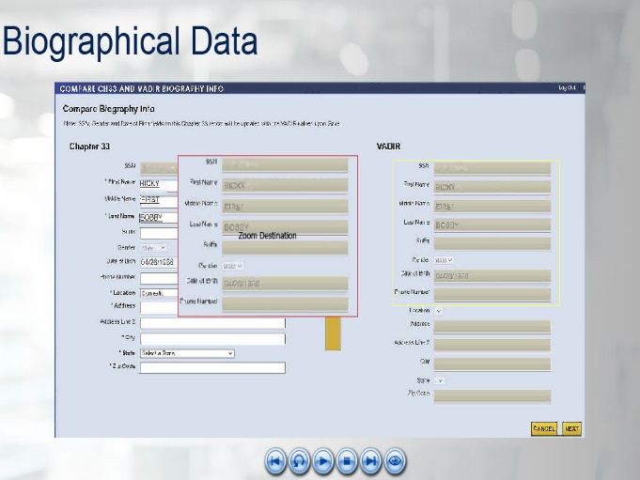 | Next, Compare the data in VIS and update any missing information to include the First and Last Name, Address, City, State or Zip Code, then select “Next”.
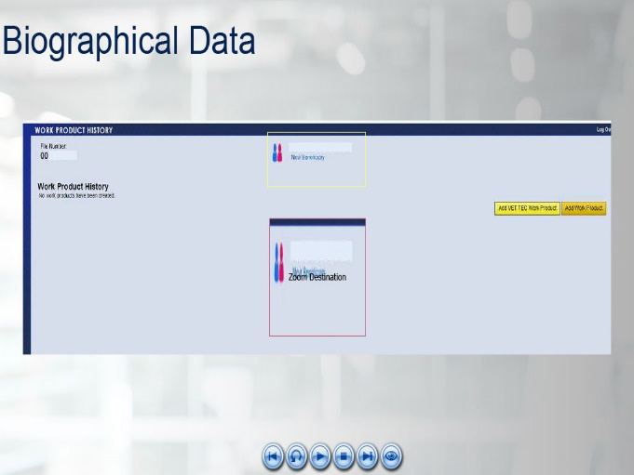 | A new chapter 33 record should now be established displaying the name of the New Beneficiary, along with a new icon on the Work History page.  The “New Beneficiary” icon will be displayed when a ‘New Beneficiary’ is created in DGI through the process outlined above, partial MEB automation or full automation.  The icon is only a system indicator and does not require VCE attention.
 | While processing, once search is complete and you have updated bio data; you may be moving on to entitlement and processing a relinquishment.
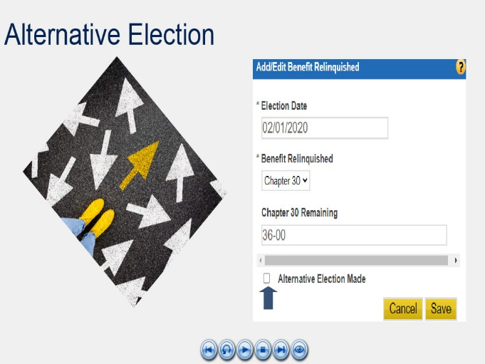 | There has been an update to benefit relinquishment and alternative election. When presented with the "Add/Edit Benefit Relinquished" pop-up window, an "Alternative Election Made" checkbox has been added.
 | The addition was designed to assist with automated applications received through MEB, though it can also be used during manual processing.  “The Alternative Election Made” checkbox serves as an indicator to those processing and updates the Award 1 letter language to include new verbiage for an alternative election.
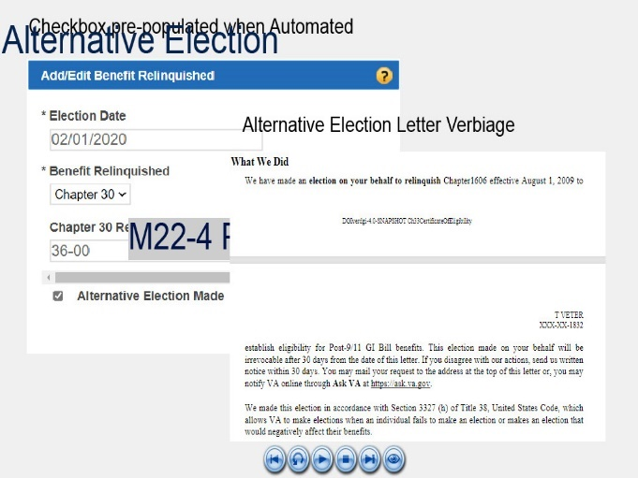 | The checkbox should be prepopulated with a check for a 1990A, 1990G or 1990EG application processed through MEB and an alternative election was made.  If manually processing an alternative election based on the guidance in M22-4 Part 3: Chapter 3.10e , ensure the checkbox has a check and the Award letter has been updated to include the Alternative language under the "What We Did" section.  We will dive deeper into letters later in this training.
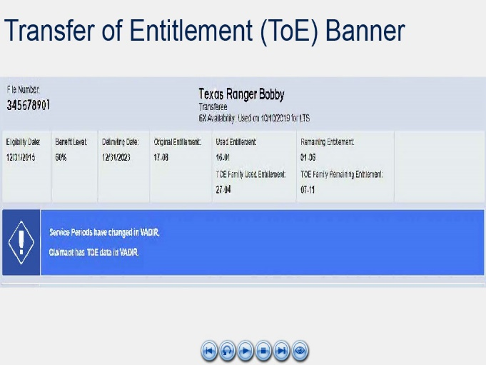 | There are times when an alternative election is made for Transfer of Entitlement (TOE) claims.  When processing a TOE claim, you will see a new entitlement banner in DGI. It now allows you, the VCE, to see the Used and Remaining for the whole TOE Family to include the transferor and each transferee.
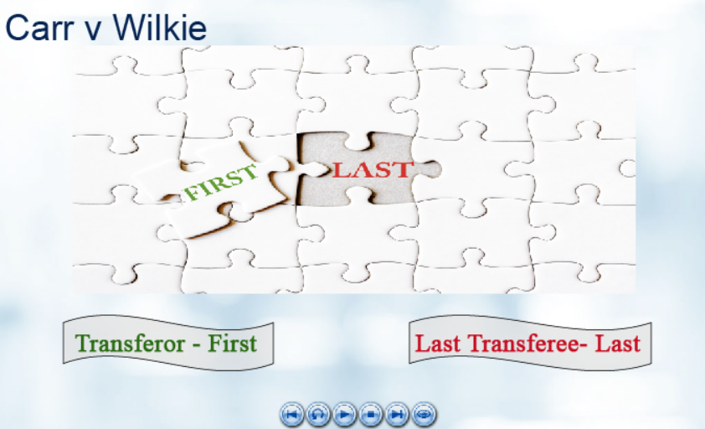 | The entitlement banner update was a result of Carr v Wilkie implementations in DGI.  Carr v Wilkie allows a one-time extension of entitlement, if an enrolled term ends beyond the wall of the 48/81-Month Rule.  With this update, DGI will work its magic behind the scenes and grant a Carr v Wilkie end-of-term entitlement extension to the last person in the family to exhaust their entitlement.  There are no required processing actions to be taken by a VCE.
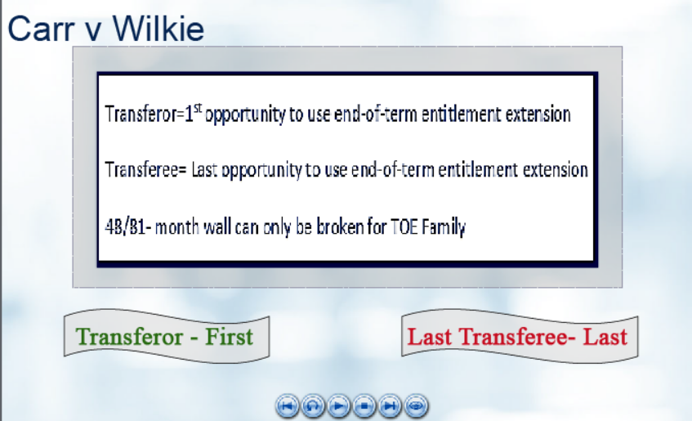 | The key takeaway is the Transferor can use the entitlement extension first. Once it has been used, then none of the transferees are eligible for the extension.  If the transferor has already exhausted entitlement, then the last transferee to exhaust entitlement is eligible to use entitlement extension for the end of a term.  Think of it like this- we can only break the 48/81- Month Rule wall once whether it is the Transferor or the Transferee, therefore it must be the final wall.
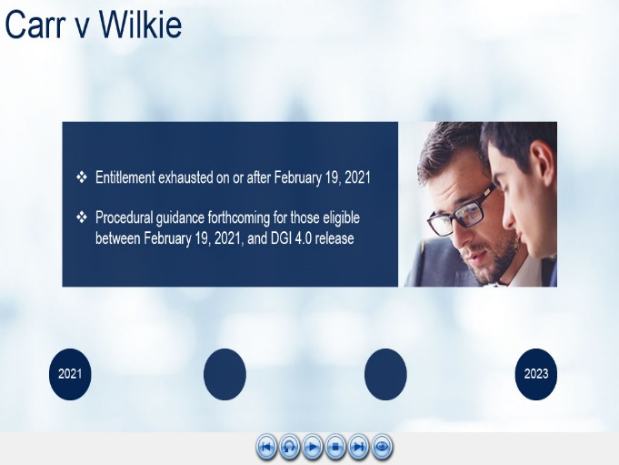 | This Carr v Wilkie update applies to those who have exhausted entitlement on or after February 19, 2021. Procedural guidance is forthcoming for those eligible for an extension between February 19, 2021, and DGI 4.0 Release 5.
 | One last TOE related item. TOE applicants have been added among those who can apply for Education benefits through the My Education Benefits (MEB) portal.  As of the 4.0 release, TOE claims will still need to be manually processed by a VCE. The MEB application will appear in TIMS as a 1990EG.
 | Whew, that was a lot. Let’s take a mini break and do some knowledge checks.
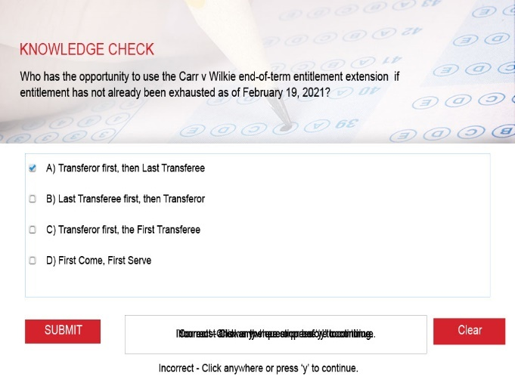 | Sample
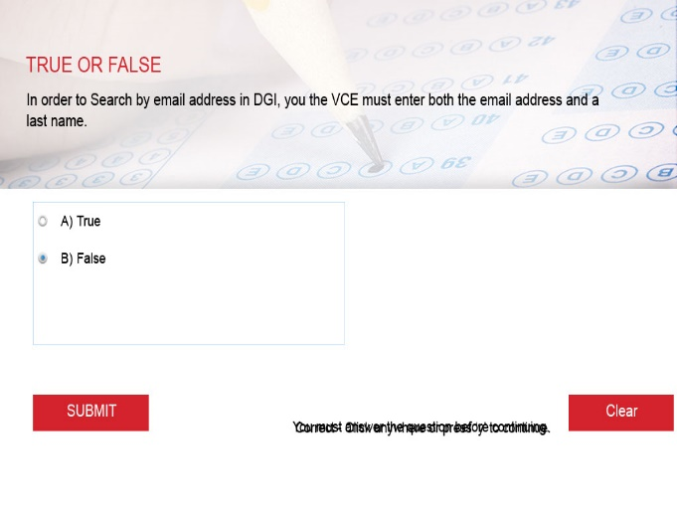
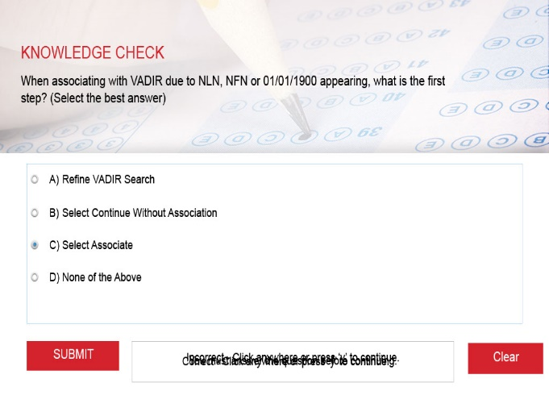
 | Ok, back to business. Let's chat about the addition of Enrollment Manager and what it means to you, the VCE.
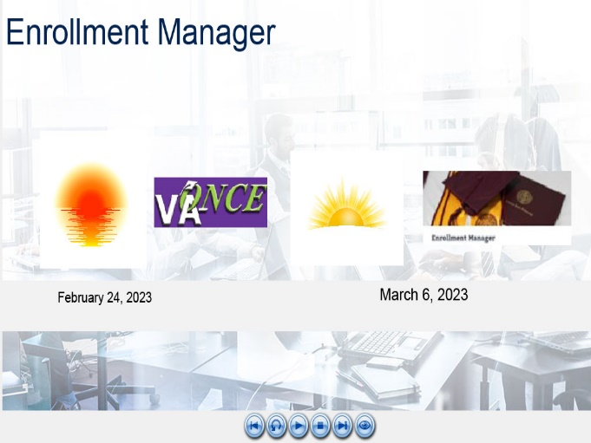 | Enrollment Manager (EM) is the replacement for VA- ONCE in the Managed Service.  As a VCE, there should be no change to how you view the enrollment certification, the information should look and feel very similar. EM is just a new way for the SCO to enter the information.  VA-ONCE sunset date is scheduled for February 24, 2023.  Enrollment Manager’s start or sunrise date is scheduled for March 6, 2023.
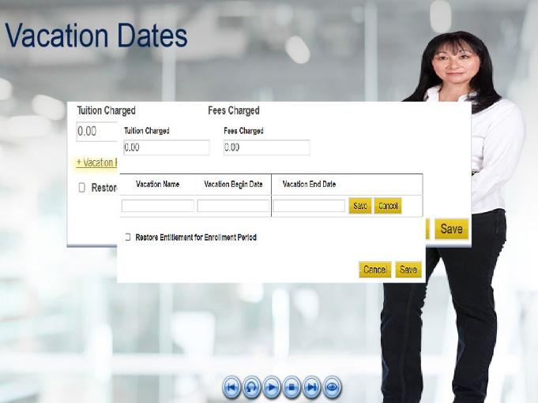 | As a result of the EM implementation, there is a new vacation section in DGI.  It has been added to the Enrollment pop-up window and is displayed on the Enrollment Summary page.  The Vacation Begin and End dates window is accessed by selecting the +Vacation Period button on the Enrollment pop-up window.
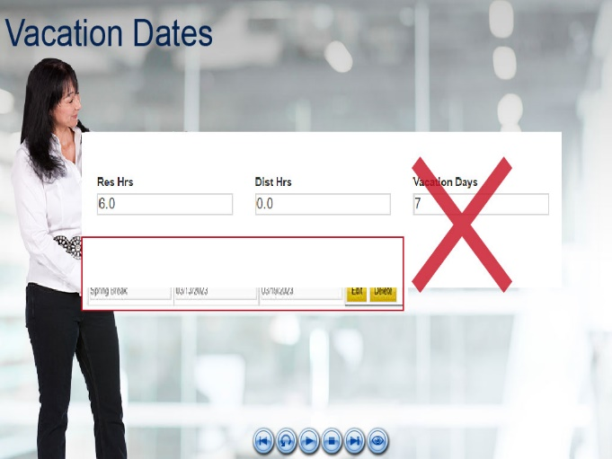 | Though DGI will allow you to enter a number in the Vacation Days box, as you have done in the past, it will not save.  The vacation period must be entered as a begin date, end date and it must be 7 or more days.
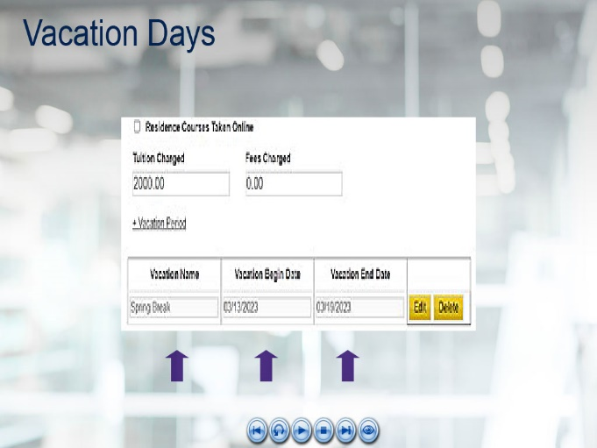 | Once the Vacation boxes appear, enter a Vacation Name (which is optional), Vacation Begin Date and Vacation End Date then click Save.  There is an option to Edit or Delete if you make an error or need to edit or delete this information in the future.
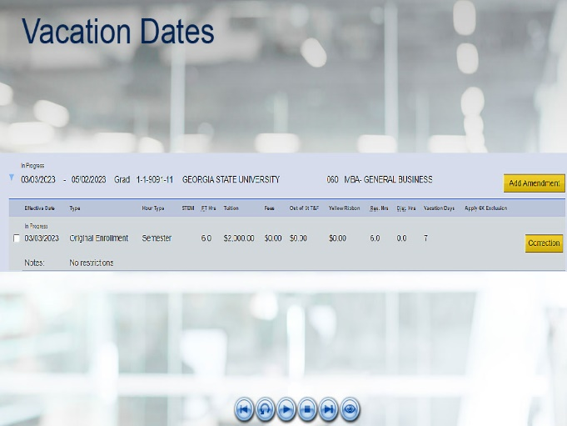 | Once entered, it will appear on the Enrollment Summary page as a number of days without the date range.
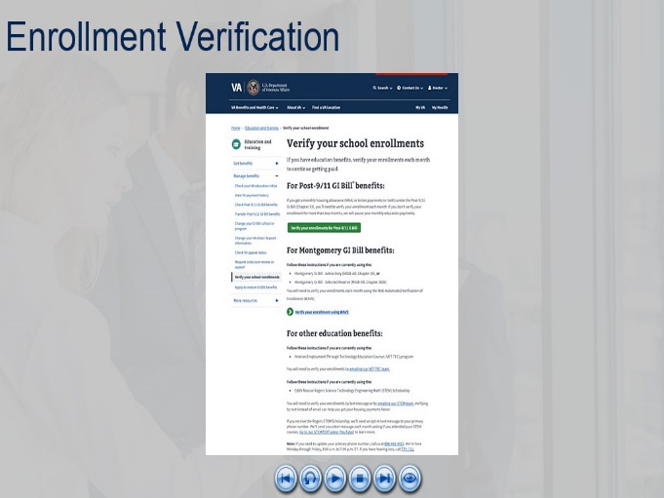 | Enrollment Certification leads to Enrollment Verification.  Certain beneficiaries can now verify their enrollment online. This brings their options up to a total of four - online, text, email, or by calling the Education Call Center (ECC).
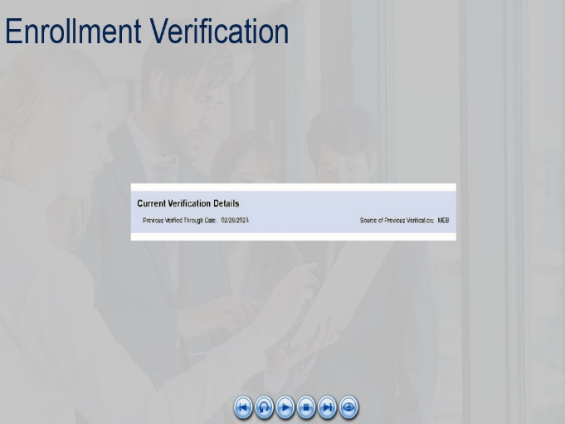 | As a VCE, you will see "MEB" as the Source of Previous Verification on the Verification of Enrollment screen in DGI when the online method has been used.
 | Now a few noteworthy fixes.  Previously, on the Claimant BIO screen the Home Phone number was listed above the Mobile Phone, resulting in instances when the home and mobile phone number were transposed.  With this release, the fields have been swapped on the DGI Bio screen.  This placement swap removes this issue and creates an alignment with MEB along with future implementations of other Managed Service applications, like Benefits Manager.
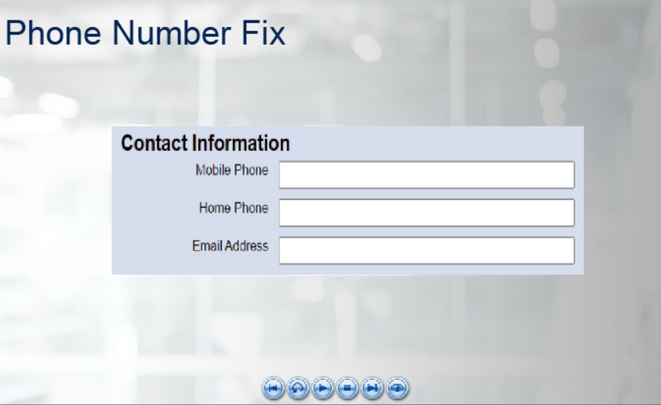
 | With the prior release, issues arose when attempting to edit the Word version of the COE/AWD 1Letter.  With DGI 4.0, VCEs are able to manually edit the Word version of the COE/AWD 1. The formatting issues has been resolved.
 | Speaking of letters…  There have been many updates to Chapter 33 letters. Almost all, if not all, have been updated in some manner. We mentioned the alternative election verbiage earlier.
 | Since there are many changes to chapter 33 letters, it may be best to delete any templates saved to your desktop or personal drive and start from scratch. Keep in mind, some may no longer be needed as they are produced in DGI.
 | Let's start with the universal changes:  Any letter which contains the "If You Have Questions or Need Assistance" table has been updated. Formerly, it displayed a 1-800 number. It has been updated to the new number "988".
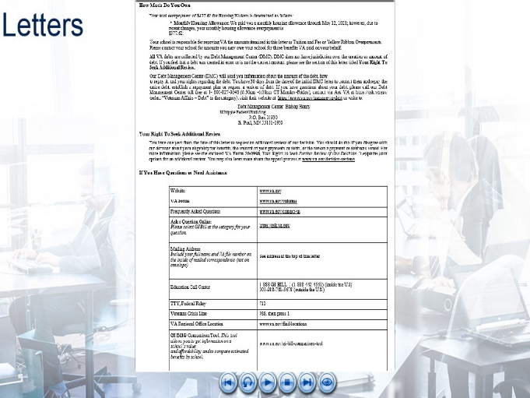 | The COE, AWD3, Adverse Action, Dis-17 and MITC letters (1,2,4 and 3 if an overpayment) are now displaying the new heading title "YOUR RIGHT TO SEEK ADDITIONAL REVIEW" with a modified appeal rights paragraph. The AVA URL has also been updated to https://ask.va.gov.
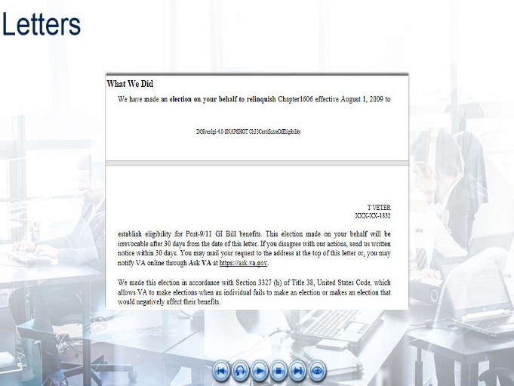 | As mentioned previously, if manually processing an alternative election, the checkbox can be checked to add the alternative election language to the letter for you. Be sure to review the Award letter has been updated to include the Alternative language seen on screen under the "What We Did" section.
 | The AWD1/COE letter for a Transferor who has transferred out any entitlement has been updated to include language stating the claimant has elected to transfer some or all of their entitlement to their dependents, which has reduced their own remaining entitlement.  It also provides the web address they can visit to make changes to the transfer.
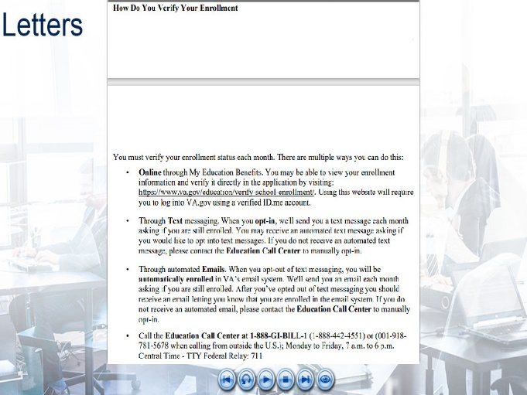 | Lastly, the “How Do You Verify Your Enrollment” section has been updated to include Online Verification information.
 | This brings us to the end of today’s training. Additional knowledge checks will come in the form of a TMS assessment.  As a result of this training, you should have acquired the ability to:  - Identify the updated functionality in DGI  - Reproduce the steps to create the enhanced system processing, and  - Recognize updated chapter 33 letters verbiage
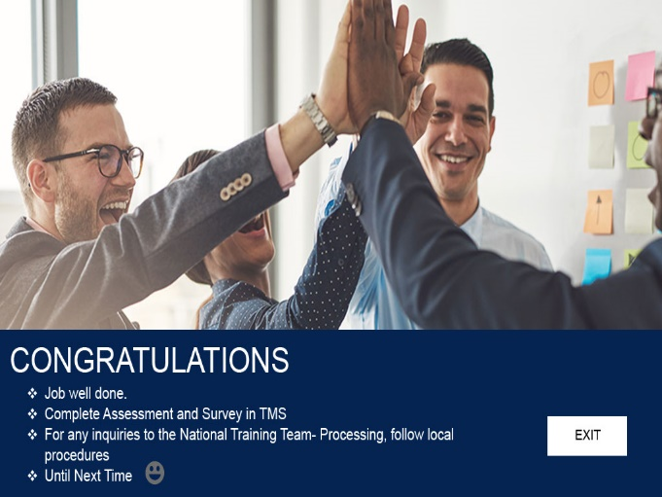 | The assessment and survey have been assigned to you in TMS. The assessment is comprised of scenario-based questions based on the information you learned today.  You should be able to complete the assessment, the survey, and the training within 90 minutes. Be sure to complete both the assessment and the survey in TMS to receive credit for this training.  If there are any additional questions requiring further guidance, follow local procedures for submitting an inquiry to the National Training Team. Until next time.

