Slides | Instructor Script
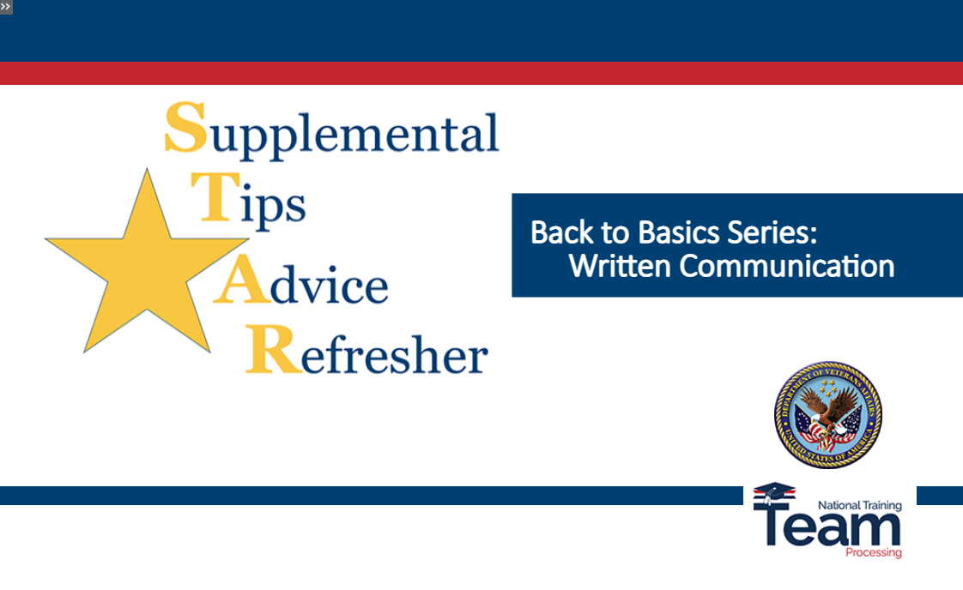 | Welcome to Supplemental Tips, Advice and Refresher Training, or STAR Training.  This lesson is part of a series focused on topics related to your daily work tasks, called Back to Basics. In this lesson we will discuss professional and efficient written correspondence.
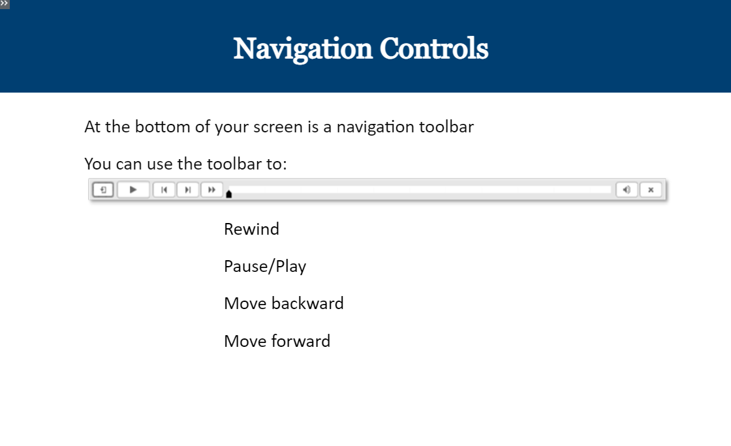 | At the bottom of your screen is a navigation toolbar. This toolbar allows you to rewind, pause, or move backward or forward.  Please select the forward button to continue
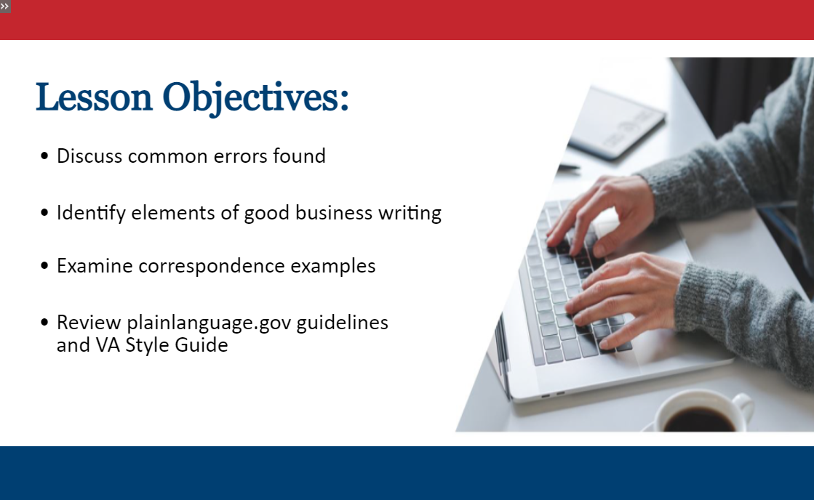 | As mentioned, this lesson will focus on written communication. The goal is to provide instruction on how to compose your written correspondence to best serve our Veterans and Stakeholders. We will discuss common errors and fundamentals of good business writing. We will also look at examples of written correspondence and review the guidelines provided by plainlanguage.gov.  Please select the forward button to continue
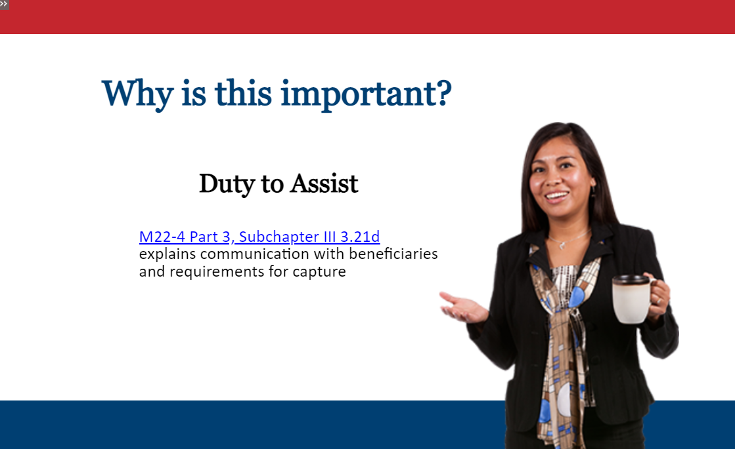 | You may be wondering how this lesson applies to you. Most letters are automated and there are specific scripts available to obtain or explain additional information.  Keep in mind we have a Duty to Assist and there may be times when we need to keep beneficiaries informed of any excessive delay in the processing of their claims. For more information, click the hyperlink on the screen which will open a separate page for the M22-4 Part 3 where this information can be found.  Whether our communication is through a letter or email, a copy of the correspondence must be placed in the TIMS folder. Please select the forward button to continue.
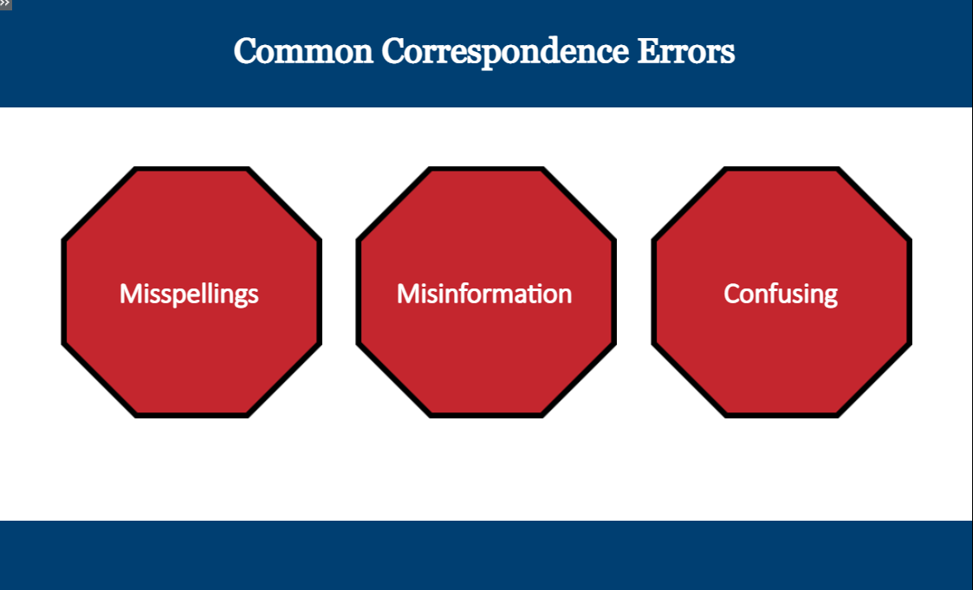 | Clear and concise communication is key to great customer service. But have you ever received a letter or perhaps an email with spelling errors, misinformation, or simply did not make sense to you as the reader? Now, think about our Veterans and how they would feel if they received a letter like this.
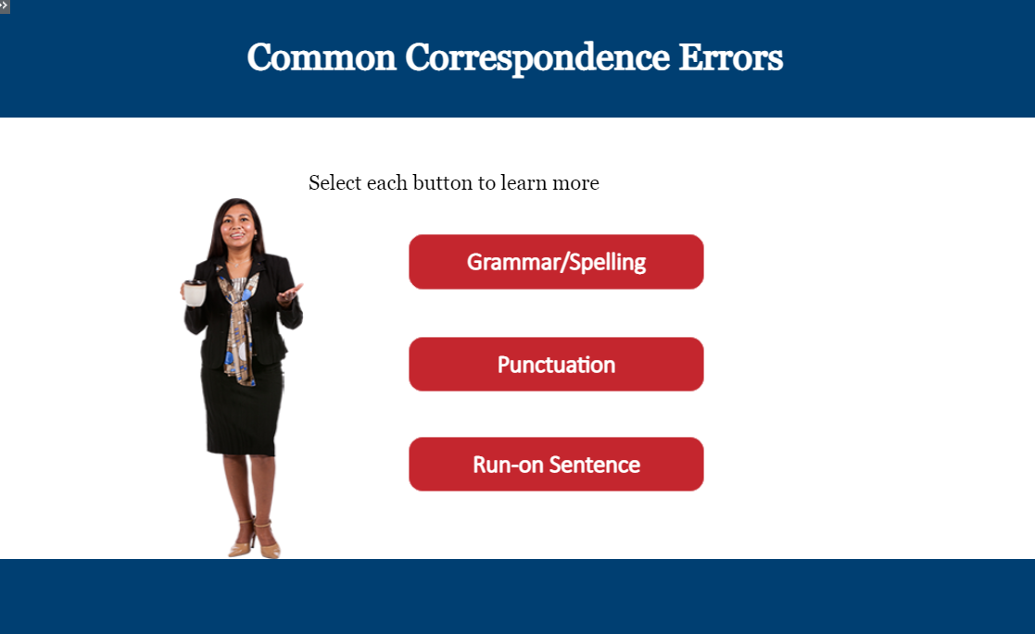 | On this screen you will note some common correspondence errors. You must select all three topics in order to advance the presentation.
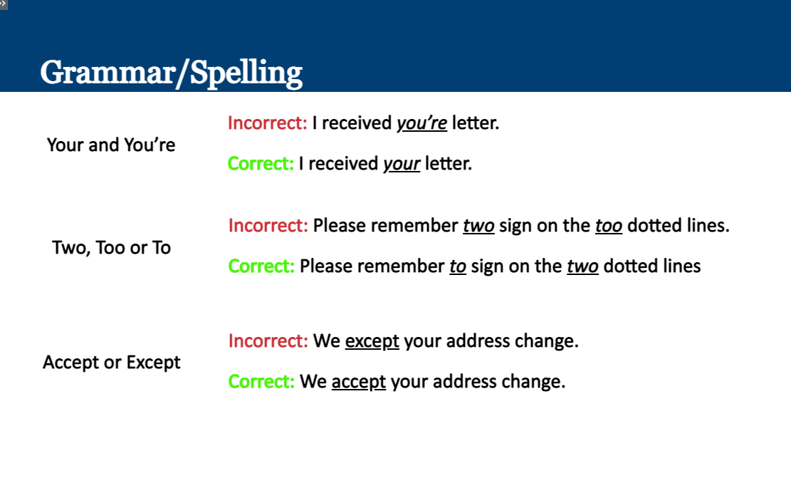 | There are many words with the same sound but have different meanings, in fact this topic could be a lesson all of its own! Let’s discuss a few examples.  Take a look at the difference between Y-O-U-R and YOU-apostrophe-RE. In the second sentence, the correct use of the word indicates a possession, ‘I received YOUR letter’, whereas in the first sentence, YOU-apostrophe-RE is actually short for the words “You are” which does not work in this sentence.  How about the word “to” … as you can see there are three options with a similar pronunciation. T-W-O is a number, T-O-O is the word to imply “also” and “To” is a preposition, meaning a word in relation to another, used before a noun to show direction, time, place etc.  Knowing when to use words like accept or except can be tricky as well. Even though their pronunciation is similar, these two words have entirely different meanings. Except with an E is most often used as a preposition or conjunction for an exclusion or to say not including, while accept with an A is a verb indicating agreement or receiving something. In this case, the proper sentence is “We accept (spelled a-c-c-e-p-t) your address change” meaning “We agree to your address change.”
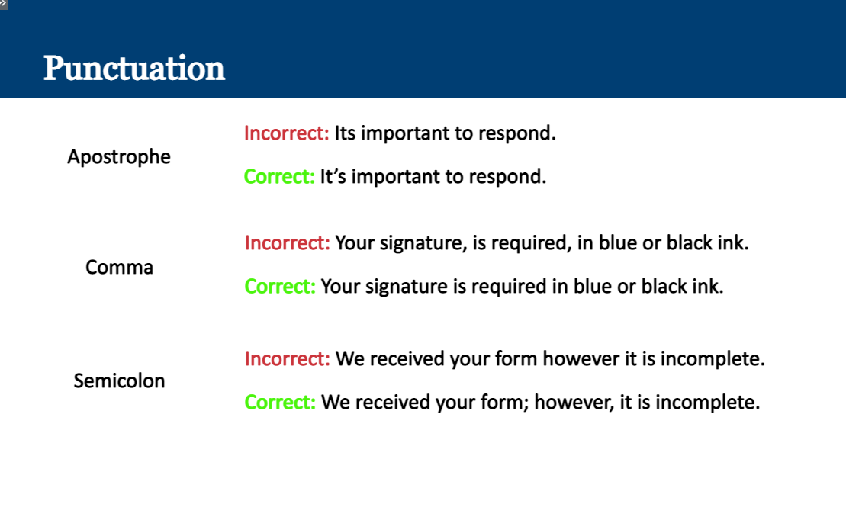 | Recognizing when and how to use punctuation is an important factor in good business writing.  Take a look at the sentence corresponding with the category titled apostrophe “It’s important to respond” and notice the correct use of It’s includes an apostrophe after the word It, which makes it mean “It is.” The incorrect sentence in our example is the one using its without an apostrophe, which implies ownership of the following word, and is the possessive form of the pronoun it.  Likewise, the use of the comma and semicolon have specific grammar rules.  You should use a comma to separate two or more related thoughts which are not independent sentences by themselves. Also use a comma between items in a series and after an introductory phrase.  A semicolon is used to connect and separate two related or similar sentences.
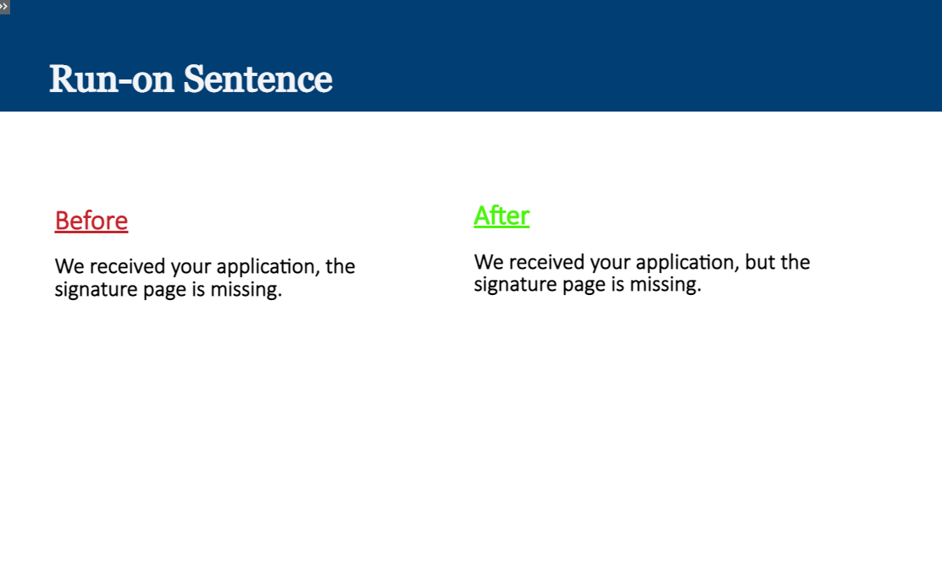 | A run-on sentence occurs when two or more complete sentences, also known as independent clauses, are not connected properly.  You can connect these using a semicolon or by using a comma and a coordinating conjunction such as but, and, nor, or yet.  In the example on screen the run-on sentence “We received your application, the signature page is missing” is corrected by adding a comma and coordinating conjunction “but” after the word application.
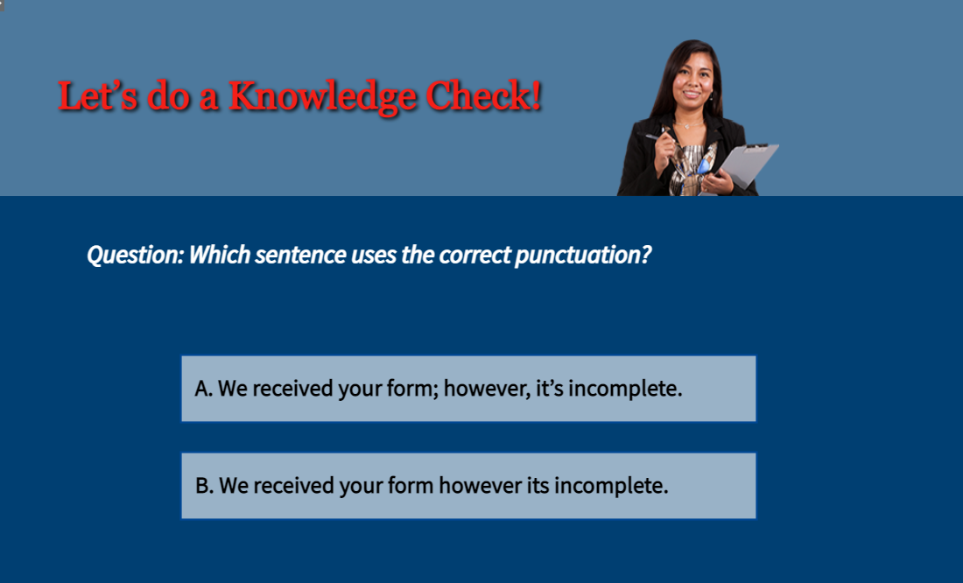 | Let’s do a Knowledge Check! Which sentence uses the correct punctuation? Please review the two answers and select the answer with the correct punctuation.  (Correct Answer is A)
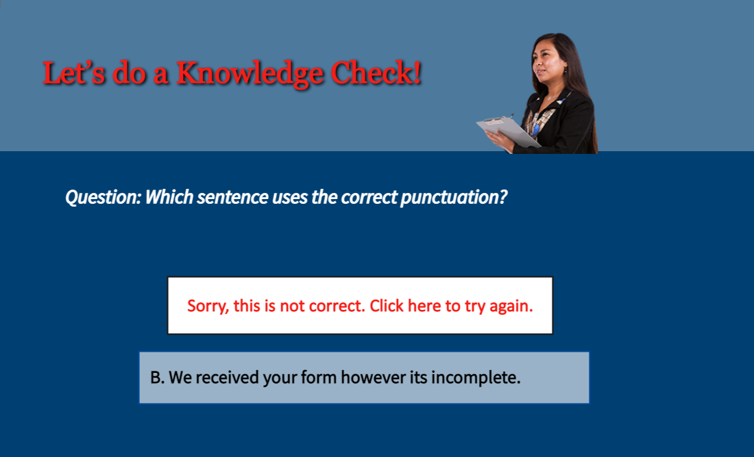 | (Select answer B) Sorry, this is not correct.
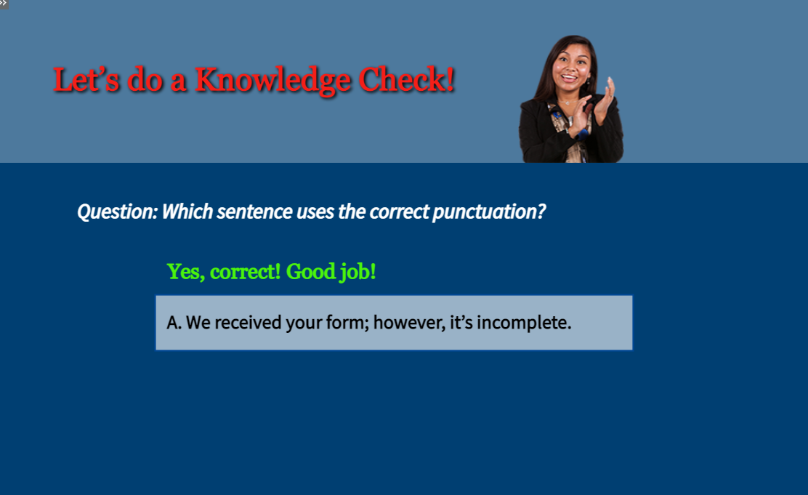 | (Select answer A) Good job! This is correct! Please select the forward button to continue.
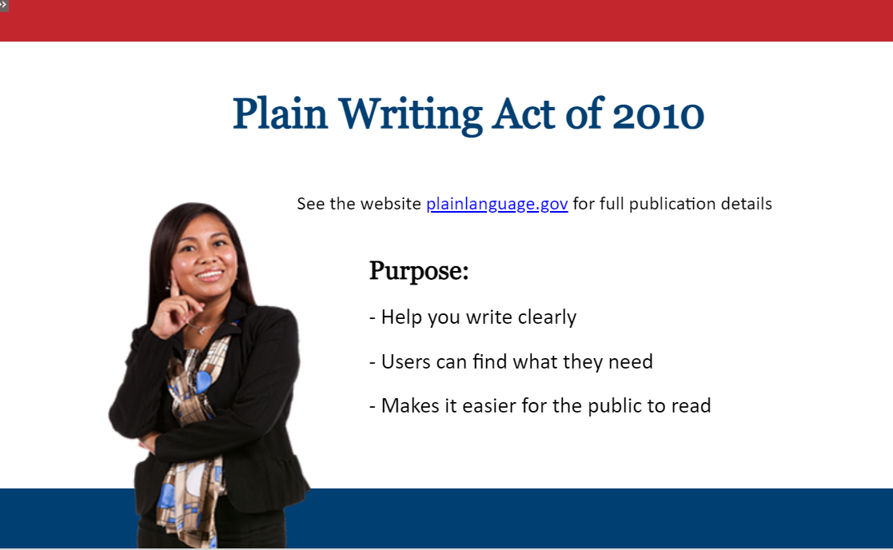 | We’ve discussed some common errors found in written correspondence, but did you know there are guidelines which were created specifically for government communications?  These guidelines are called Plain Language and they are the official guidelines for the Plain Writing Act of 2010. Federal plain language guidelines can be found on the website plainlanguage.gov and were created with the purpose to help users write in a way which makes it easier for the public to read, understand, and use government communications.  Clicking the hyperlink on screen will open a separate page to allow you to save this reference for future use. Please select the forward button to continue.
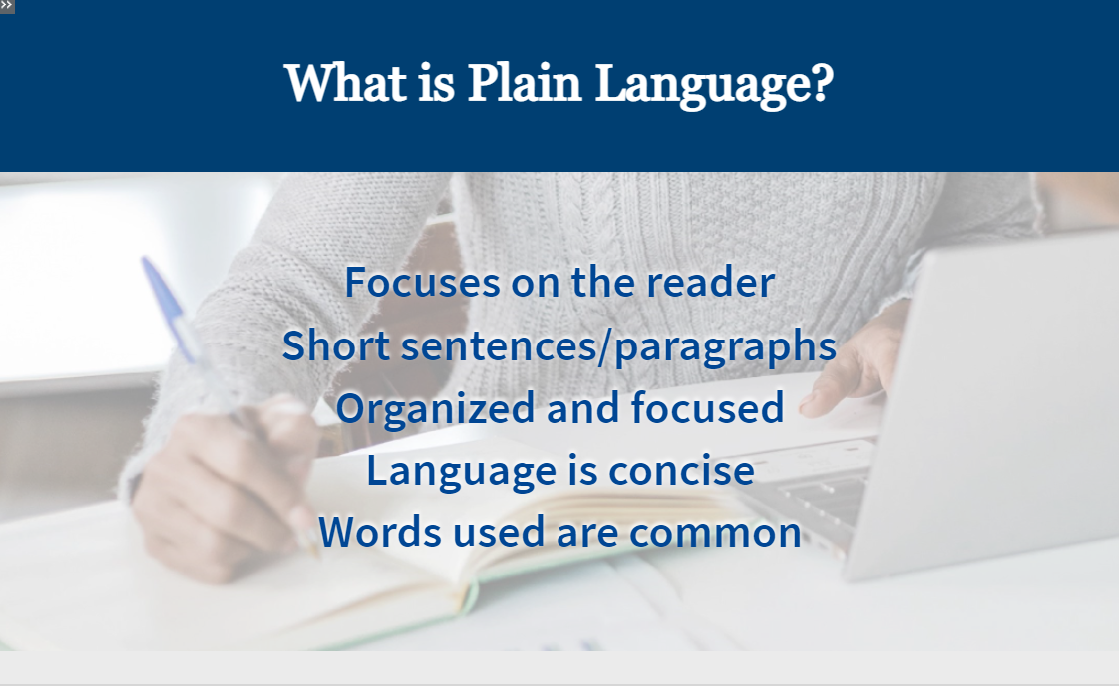 | So, what is Plain Language and why is it important?  As previously mentioned, plainlanguage.gov provides guidelines for the agency to write clearly so readers can find and understand what they read. The focus is on the reader and is delivered using short sentences and paragraphs. It is communication which is written so the audience can understand the first time they read it.  When writing for your audience, it is important to keep the information organized, focused, and concise. Also, we should always choose our words carefully and use common words. Please select the forward button to continue.
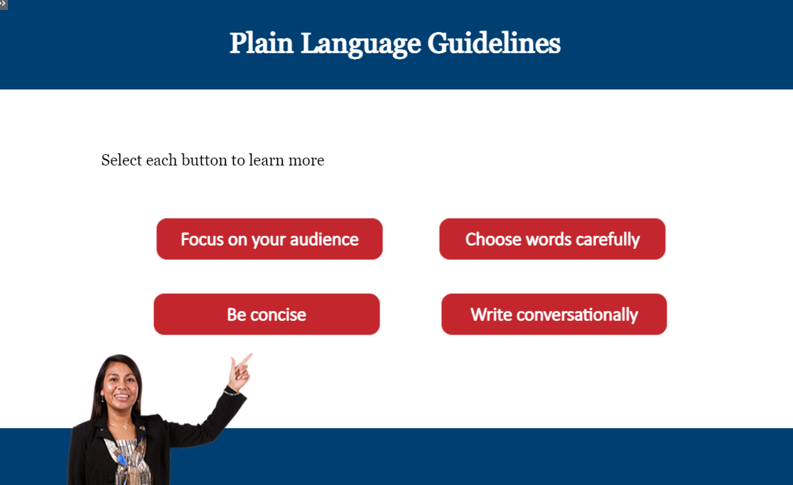 | Let’s take a few minutes to learn about some of the plain language guidelines! You must select all four topics in order to advance the presentation.
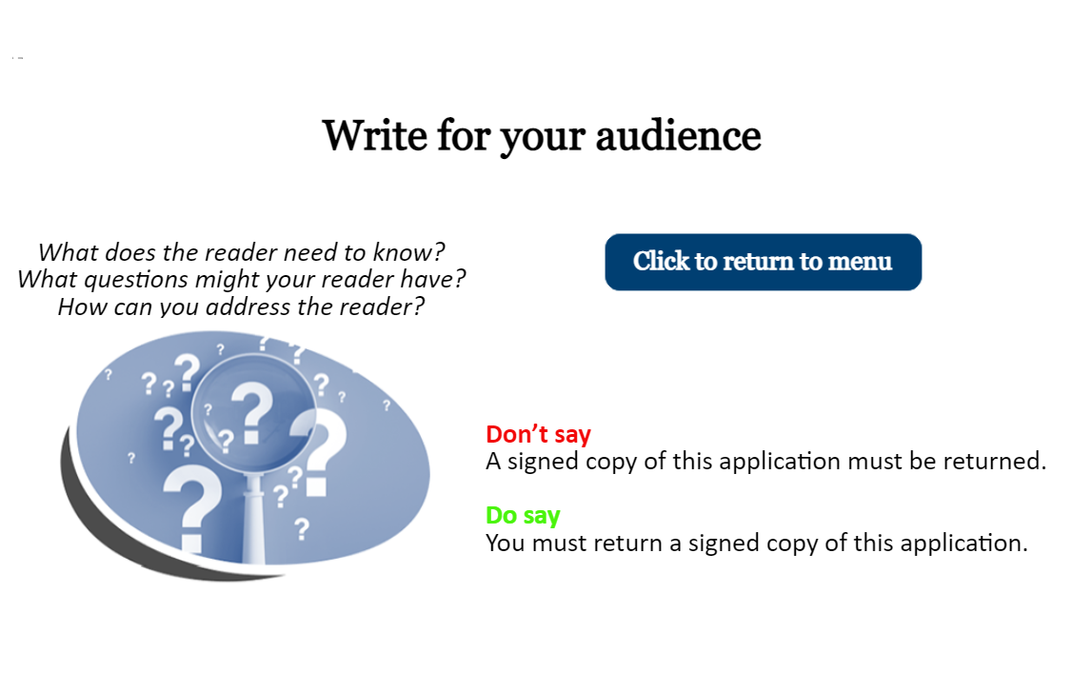 | When composing written correspondence, keep your audience in mind and write at their level of understanding. Consider what you need the reader to know and make sure to explain how it applies to them. Ask yourself what the reader may already know and consider any questions the reader may have. While a situation or issue may apply to multiple people, address the reader directly in your writing. You can do this by using pronouns such as you. On this screen is an example of how to speak directly to the reader using the pronoun “you”
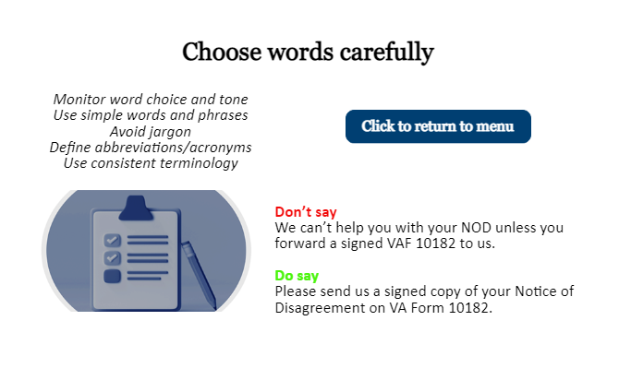 | Word choice and tone is important in your writing. Using simple words and phrases improves readability. It’s good practice to avoid jargon and undefined abbreviations and acronyms, as doing so can cause confusion for the reader. Also, using the same terms consistently for the same concept or object helps keep your writing on track.  As an example, review the two sentences on this screen. The first sentence has a negative tone with the words “we can’t help you.” Additionally, it includes acronyms which might require further research by the reader if they don’t understand the meanings. You will notice in the second sentence the acronyms are spelled out and the language used has a neutral tone.
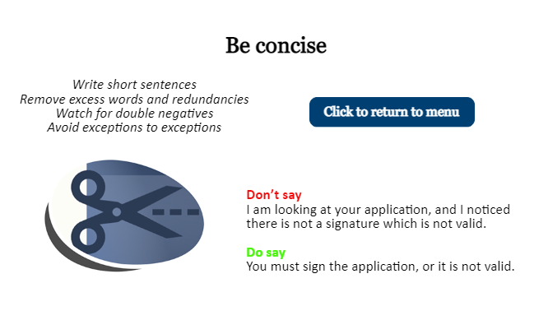 | Long, complex wordy sentences can be confusing for the audience. In order to send a clear message to your reader, critique your own writing, considering whether you need every word. Look for ways to cut out excess words and redundant language. Compose short sentences and paragraphs. Watch for words which could negate the meaning, such as double negatives and also avoid exceptions to exceptions.  The following sentence “I am looking at your application, and I noticed there is not a signature which is not valid” is dense, using more words than are needed to send the message, and contains double use of “not”- thereby negating the meaning.  Instead, saying “You must sign the application, or it is not valid.” is a concise way of saying we need a signed application.
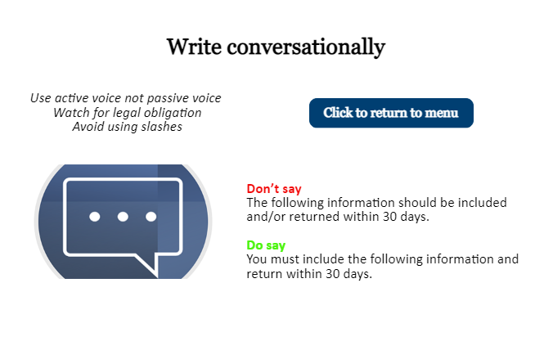 | You need to tell your audience what to do and what is needed. You can do this through the use of verbs and active voice. When using active voice, the person is the subject of the sentence and performs the action. Whereas in the passive voice, the object is the subject, is being acted upon, and it does not identify who is performing the action.  Watch for legal obligation as there are words which might convey the reader has to do something. For instance, “must” is for an obligation and “should” is for a recommendation.  Finally, avoid using slashes, such as “and/or” because even though a writer’s implied meaning is either one, it is ambiguous and puts the interpretation at the reader’s discretion.
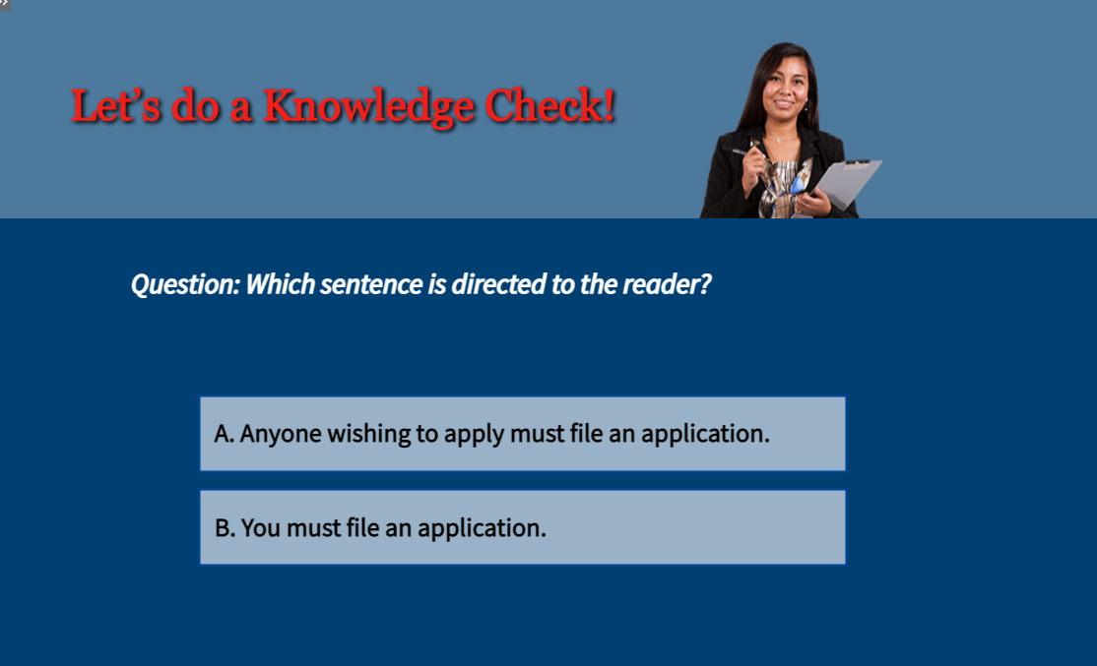 | It’s time for another knowledge Check! Which sentence is directed to the reader? Please review the two answers and select the correct answer.  (Correct Answer B)
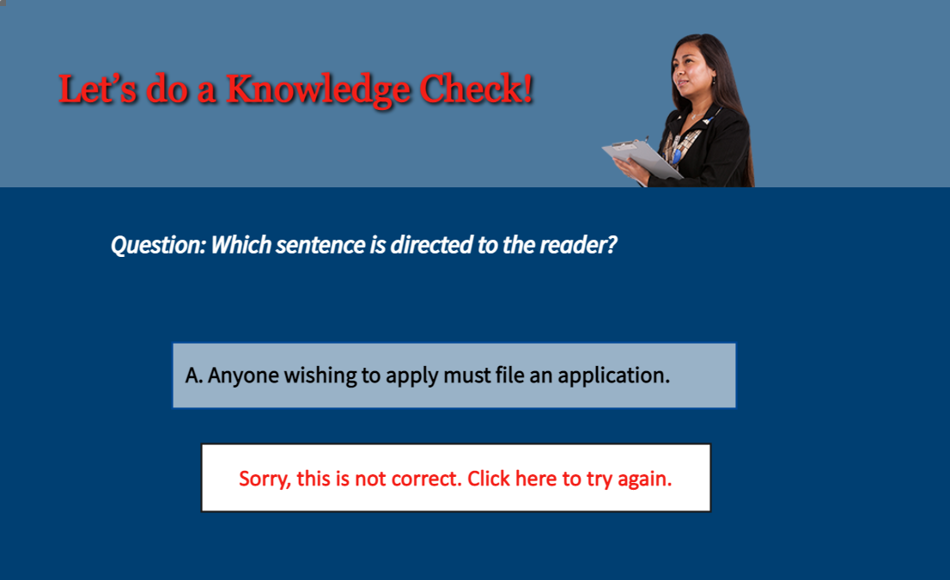 | (Select Answer A) Sorry, this is not correct.
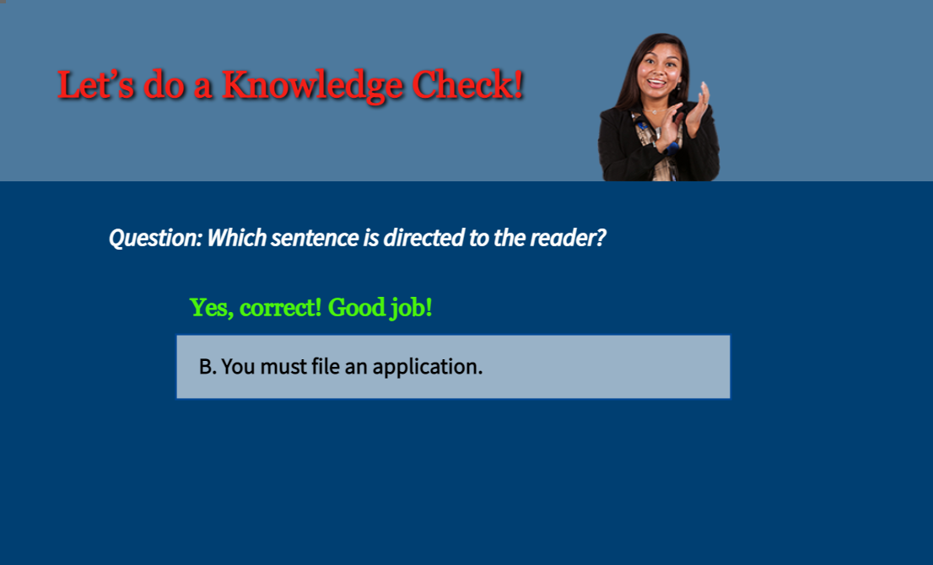 | (Select Answer B) Good job! This is correct! Please select the forward button to continue.
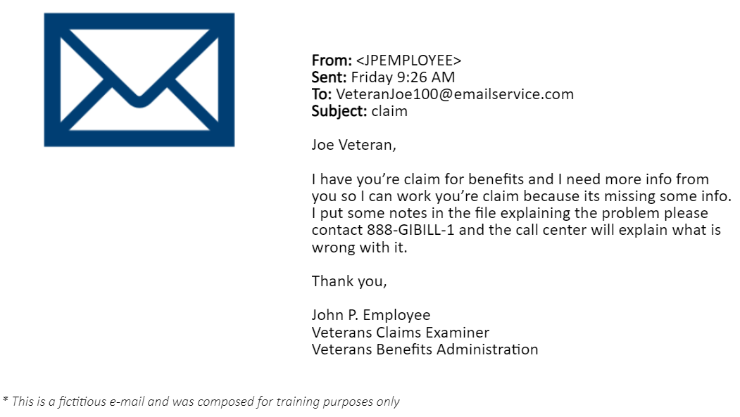 | On this slide is a copy of a mock email which was composed for training purposes. Let’s take a look at this fictitious email and evaluate the content. At first glance you may think this email is fine. There is a subject, greeting, short paragraph and it is signed by the sender. But as you take a closer look you will notice there are some issues with the tone and composition.  First, “I have you’re claim for benefits” has the incorrect spelling of your. The subject line of the email is vague and could be construed as junk email by the receiver. Also notice the negative tone conveyed by the words “problem” and “wrong with it.” Additionally, the sentences are wordy and could be revised to be more concise.  Please select the forward button to continue.
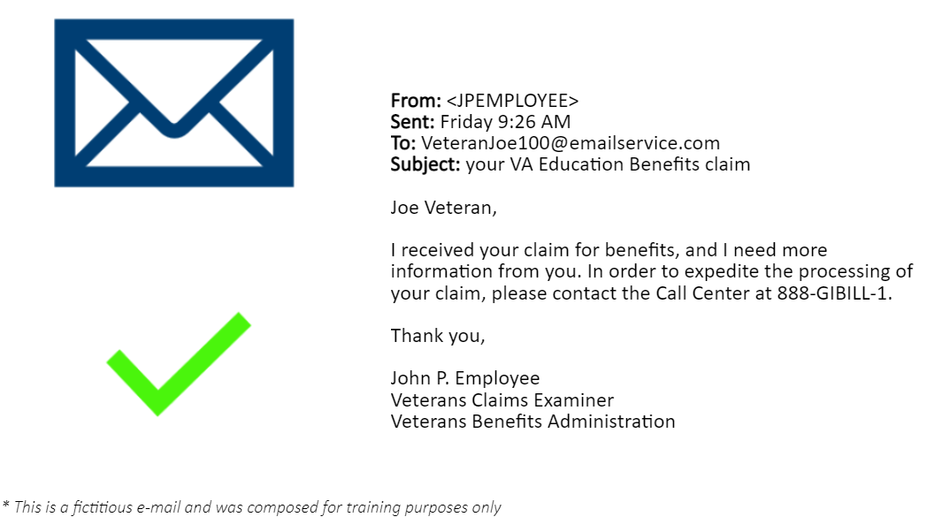 | We identified the issues in the previous email message, so let’s take a look at good business writing in an edited version.  First, you will notice the subject is more specific while still maintaining privacy. Next, the spelling is correct with the use of your and info has been spelled out to be more formal, using the proper word “information.” Also notice the independent sentences are connected with a comma and coordinating word “and”  The redundant language and words which carried a negative tone are removed and this email is now more concise and easier to understand. The receiver of this message knows the action they need to take next. Clear and focused, this message helps the reader find and understand the most important information, which is the goal of plain language. Please select the forward button to continue.
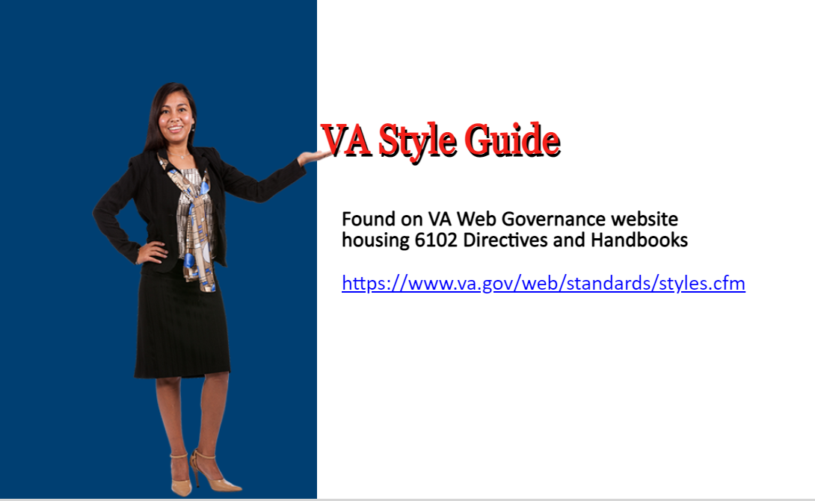 | Ok, we’ve discussed good business practices for written correspondence and the plain language guidelines. Our final topic is the VA Style guide and where you can find this resource. The hyperlink on your screen will take you directly to the website. Once you click this hyperlink, please select the forward button to continue.
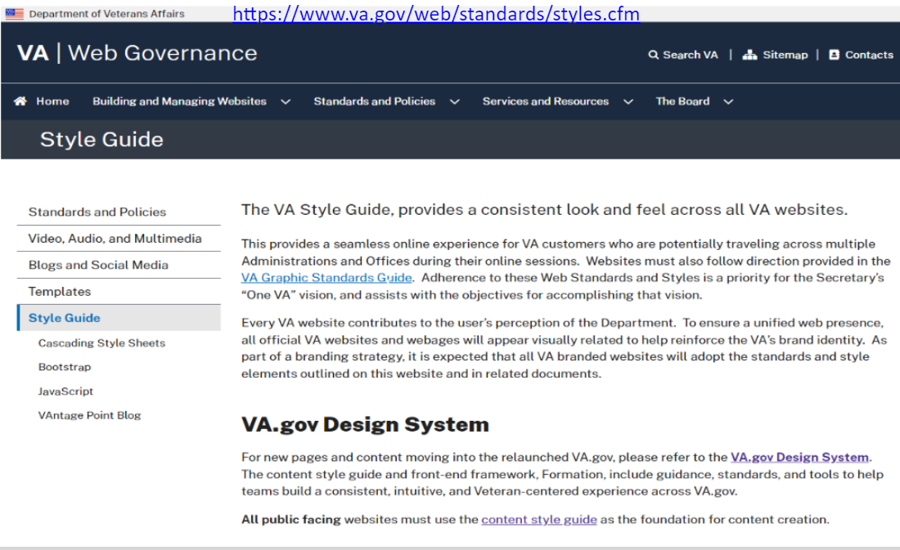 | The VA Web Governance website provides information and resources. This website address is shown at the top of this screen in case you didn’t select the hyperlink on the previous slide.  When you click the link “VA Graphics Standards Guide,” which is embedded in the paragraph text on this page, you will be able to open or save the Tier 1 Graphic Standards where you can find information on proper use of VA brand identity as well as graphics standards including general design information such as approved color, typography and font families.  Also located on this page is a link to VA.gov Design System which provides content on the use of abbreviations, capitalization, and punctuation, to name a few. It also provides a word list for terms used by VA.  Please select the forward button to continue
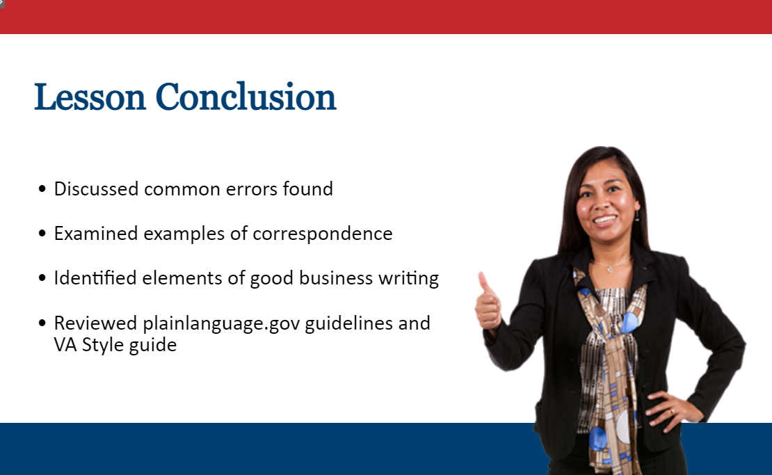 | Today’s lesson was designed to give you the tools to compose and improve your written correspondence. We discussed common errors and looked at examples of written correspondence. We also reviewed Plain Language guidelines, which are found on the website plainlanguage.gov and are the official guidelines for the Plain Writing Act of 2010. We also learned where to locate the VA Style guide.
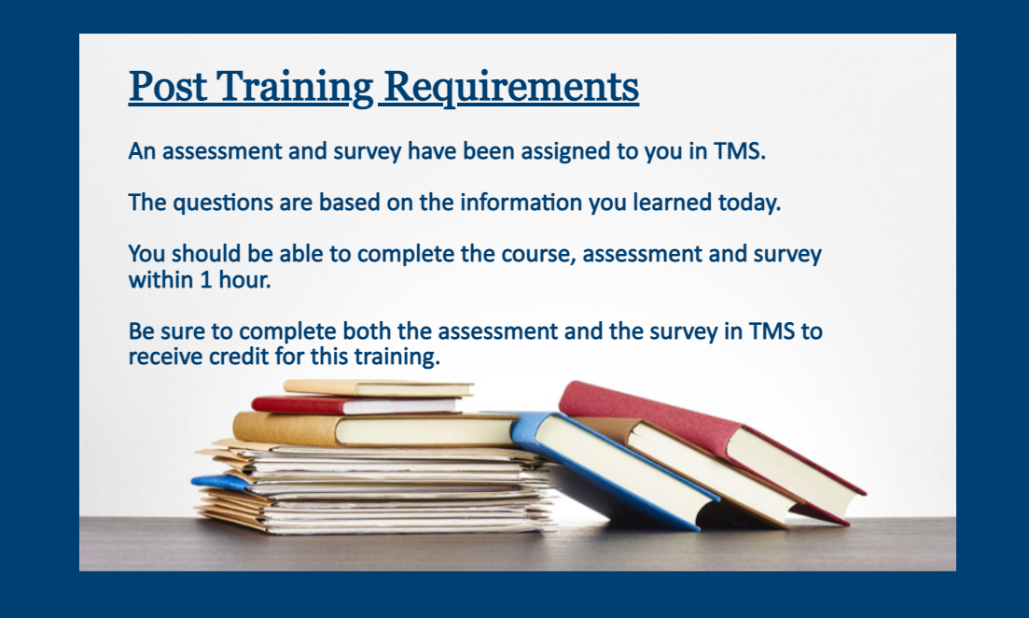 | An assessment and survey have been assigned to you. Once you complete this training, please complete the assessment and survey as soon as possible to receive credit for this training. You should be able to complete the training, assessment, and survey within 1 hour.
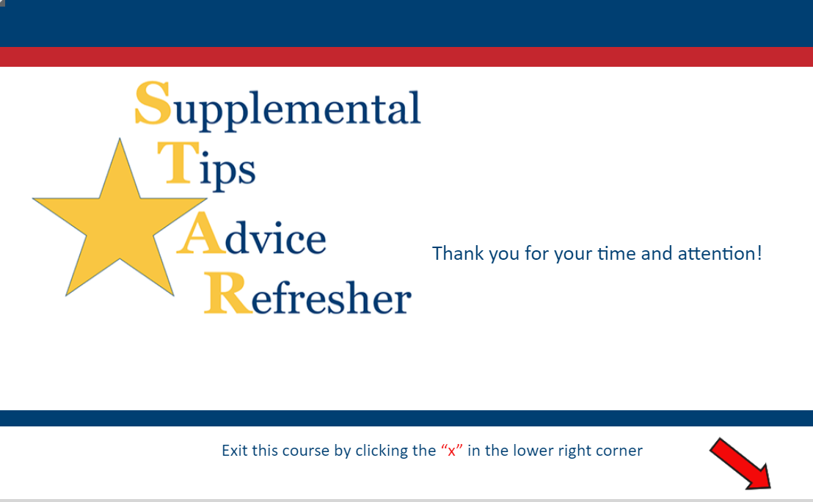 | Thank you for your time and attention, you may exit this module by clicking the “x” in the lower right corner. Remember to complete both the assessment and survey. Have a good day!

