Slides | Instructor Script
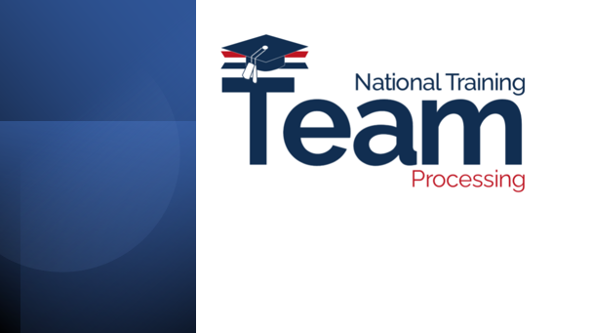 | The National Training Team-Processing is excited to bring you continued updates as we proceed through the Digital GI Bill modernization journey. Modernizing our services means integrating our data into a single platform designed to streamline and improve access.
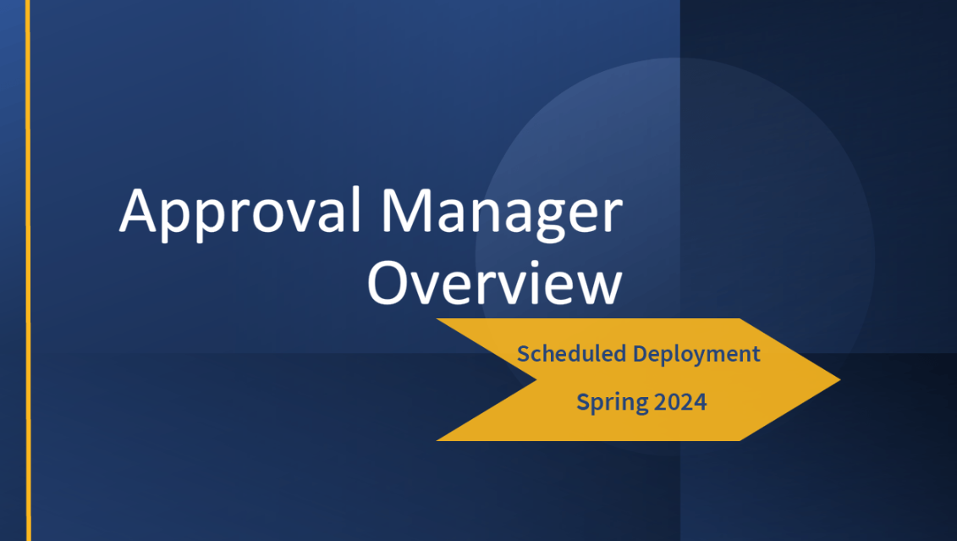 | Today we will be providing you with a high-level overview of Approval Manager, which is a DGIB managed service program set to deploy in Spring 2024.
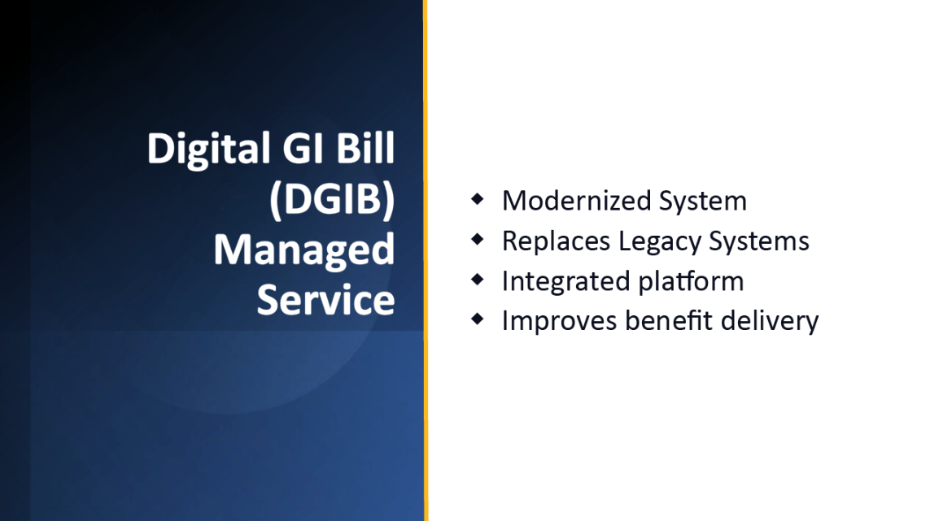 | As mentioned in our previous training called Special Edition DGIB Team Line-up, the Digital GI Bill (DGIB) Managed Service is the network of new processing and payment systems being built as part of the modernization effort aimed at replacing our legacy systems and improving benefit delivery.
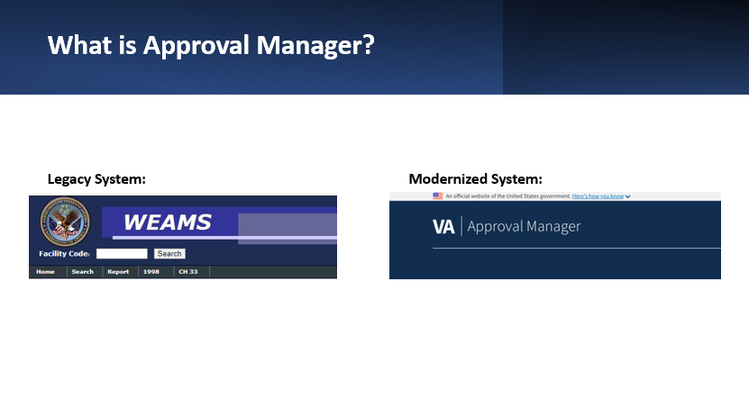 | Approval Manager will be replacing Web Enabled Approval Management System, also known as WEAMS, as the platform for school approval information.
 | Like our current system WEAMS, Approval Manager will be used by State Approving Agencies (SAAs) and Education Liaison Representatives (ELRs) to approve new programs for education benefits.
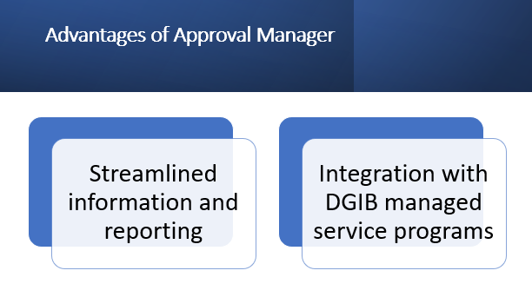 | The implementation of this system will streamline information and reporting, allowing Approval Manager to integrate with the other DGIB managed service programs.
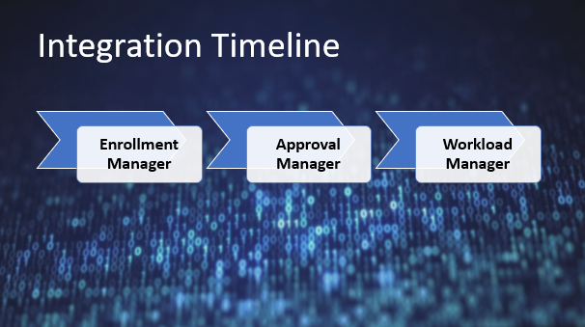 | The Approval Manager will integrate with the following DGI systems: Enrollment Manager and Workload Manager. Enrollment Manager is set to deploy in March 2023 and Workload Manager is still in development.  When Approval Manager (AM) replaces WEAMS and is fully integrated into the managed service platform, AM will improve the way approvals and enrollments are handled in our systems.
 | As a Veterans Claims Examiner, you will notice a new appearance to how the information for schools is displayed. While it looks and feels different, you will find it is both user-friendly and provides familiarity to the current system WEAMS. Approval Manager is still being developed at this time, but we are excited to share some initial design information with you.
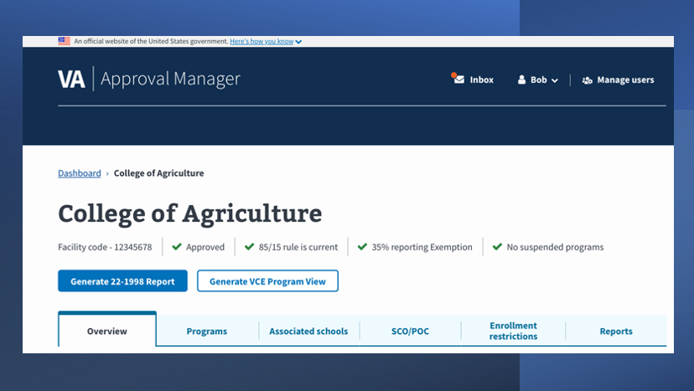 | The image shown on screen is an example of a landing page after a school search has been performed. Keep in mind, this design may change during system testing, but the overall layout should be similar when the system is deployed next year.
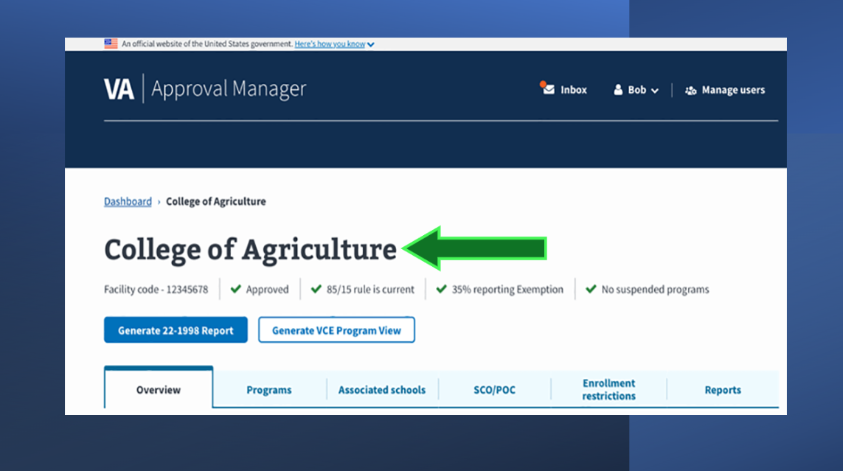 | When you first arrive on the landing page you will see the name of the institution, the corresponding facility code, and associated statuses such as approval status, 85/15 rule, 35% exemption and if there any suspended programs.
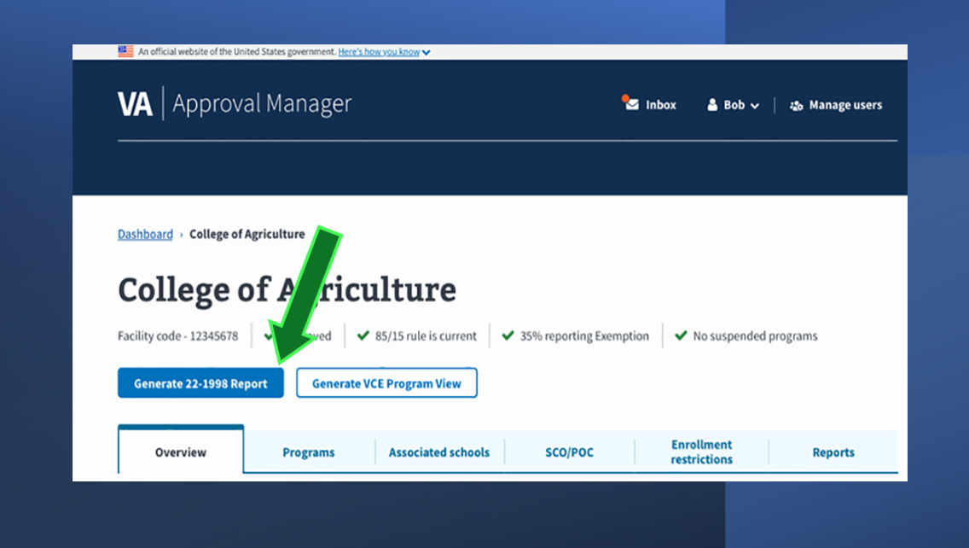 | Next you will notice a button called “Generate 22-1998 Report” which will generate and display the report and can be captured, similar to our current WEAMS capture. You will also notice a second button is available called “Generate VCE Program View” and the functionality for this is currently being built.
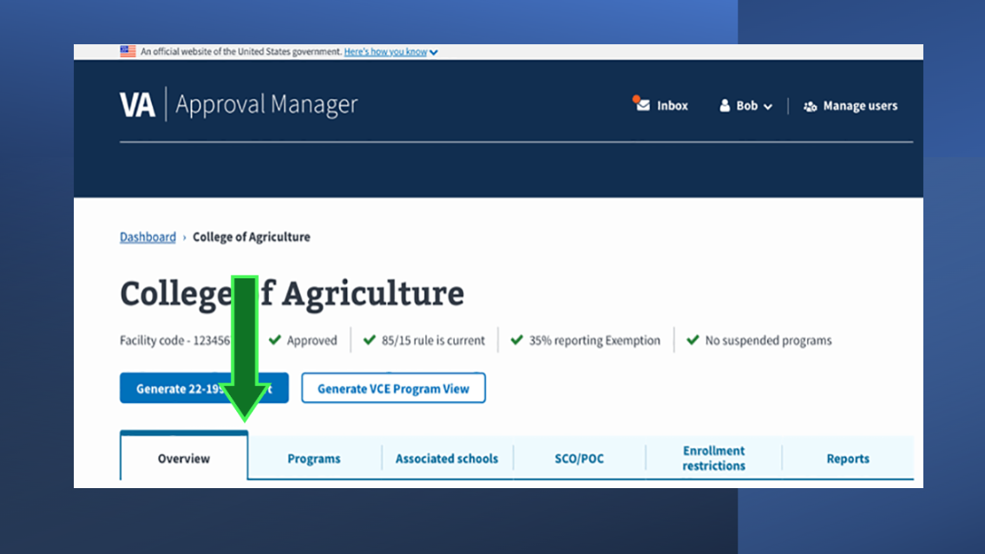 | There is also tabbed information. We will not go into detail at this time, but rest assured there will be useful information available to you within the Overview and Programs tabs including MHA rates, national exams, Yellow Ribbon Status, and VET TEC, just to name a few.  Additionally, the school search function will be similar to WEAMS, allowing a search by name or facility code and an advanced search feature for instances when this basic information is not known.
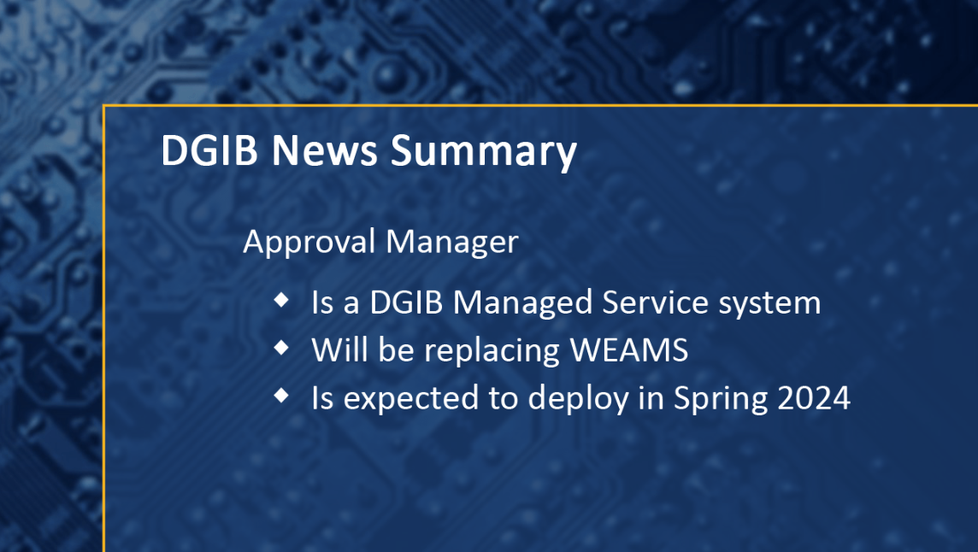 | We’ve reached the end of our DGIB news update. We hope this overview of Approval Manager has been informative for you. As we continue to work towards upgrading and replacing legacy processing systems, we look forward to sharing more details with you as they become available.
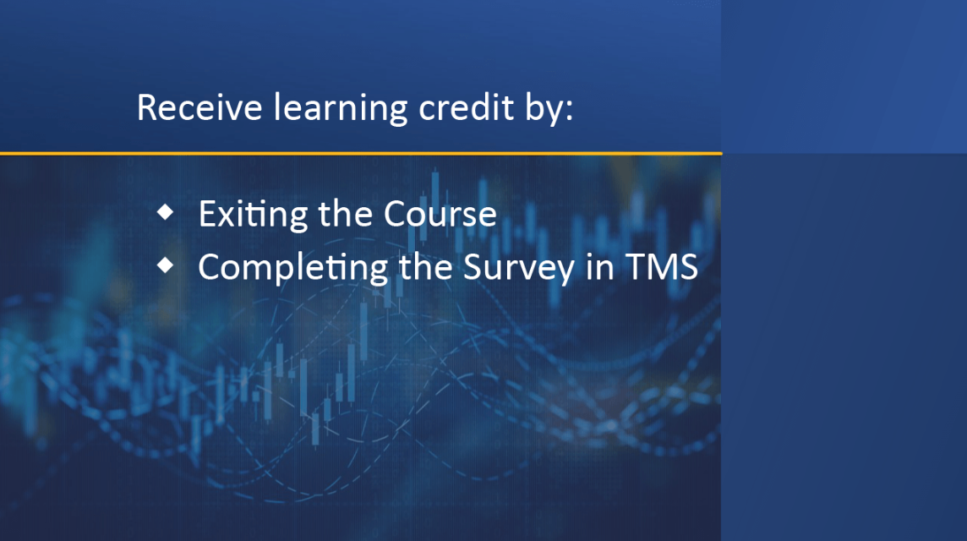 | Once you exit this course, please complete the survey in TMS to receive learning credit for completion of this training.
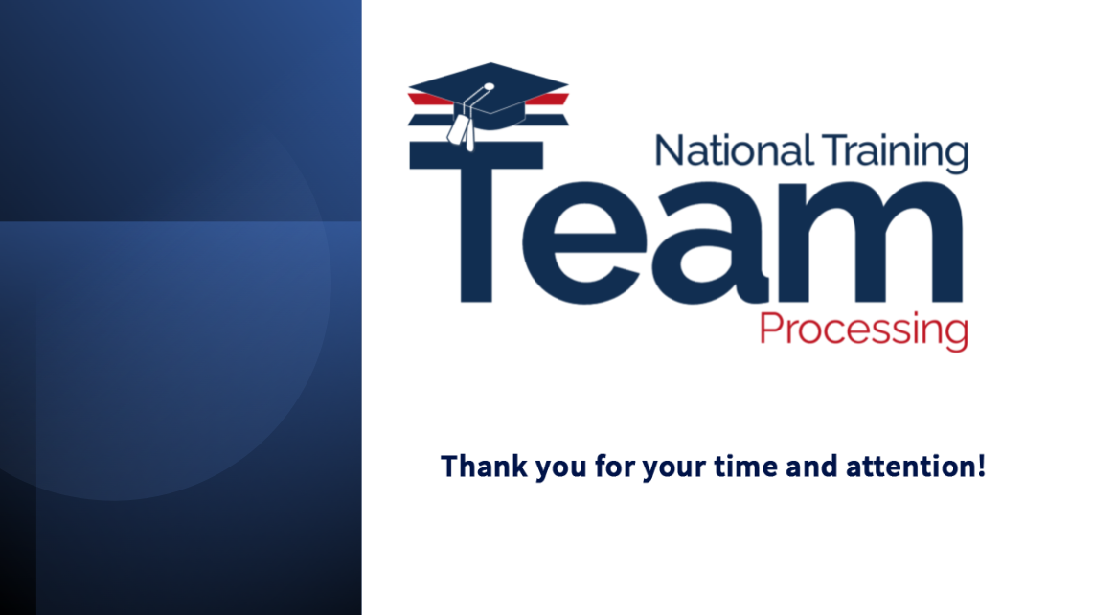 | Thanks for listening, until next time!

