DRAFT Guard and Reserve Service (GRAS) in DGI 3.1 Script

 | GRAS in DGI 3.1  Welcome to today’s training on the data ingestion of Guard and Reserve Service (GRAS) into the Digital GI Bill (DGI) Claims Processing System.  The August 2022 DGI release introduces the ingestion of qualifying GRAS periods from VADIR; previously, these periods were manually entered.  Click the START button to begin the training.
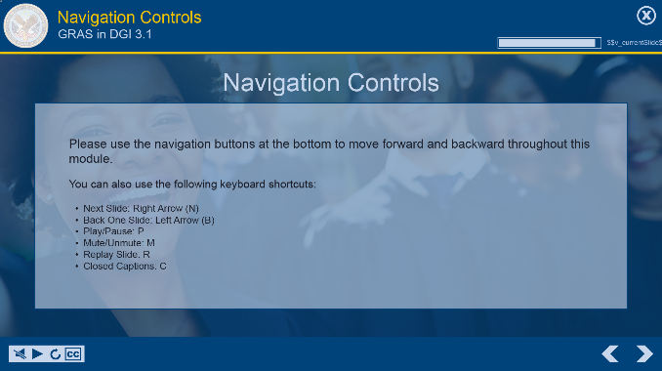 | You can use the navigation buttons at the bottom of the screen to move forward and backward throughout this module.  Also, you may use the keyboard shortcuts shown on-screen.  Please note, the examples you will see during this training were processed in a test system. All names and claim numbers you see are fictitious and do not belong to actual beneficiaries. No personally identifiable information (PII) is contained in this training.
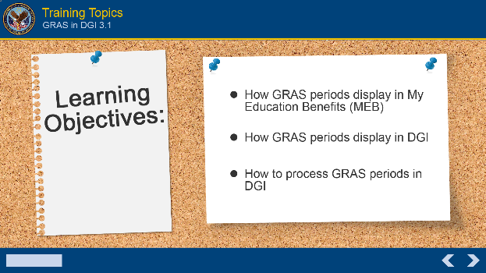 | Learning Objectives  The topics covered in this training will be:  - How GRAS periods display in My Education Benefits (MEB),  - How GRAS periods display in DGI, and  - How to process GRAS periods in DGI
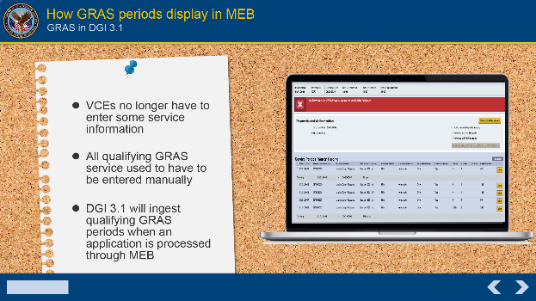 | How GRAS periods display in MEB  With the Release of DGI 3.1, Veterans Claims Examiners (VCES) are no longer required to enter some service information. As mentioned in the introduction, in LTS and earlier DGI versions, the VCE had to enter all qualifying GRAS service manually. Some beneficiaries had tens of, dare I say hundreds, of periods of GRAS service. It was a very tedious and time-consuming task. DGI 3.1, will ingest qualifying GRAS periods when an application is processed through MEB.
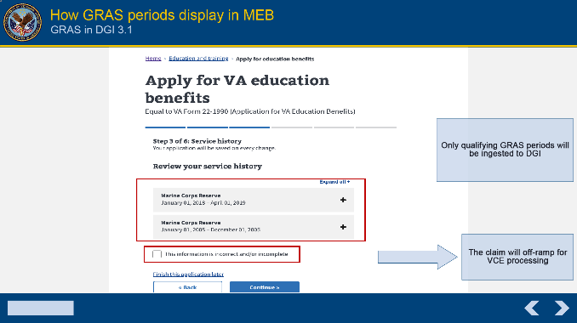 | When the applicant is working through the application process, they will see all GRAS periods, regardless of whether they are qualifying. This is due to MEB detecting all service in VADIR. The applicant is given the option to dispute the service reflected. If they do so, the claim will be off-ramped for VCE processing.  Though MEB displays all service to the applicant, it does not transfer all service to the DGI Service History page. Only qualifying GRAS will be ingested to DGI.  Now let’s look at how GRAS periods are displayed on the Service History page.
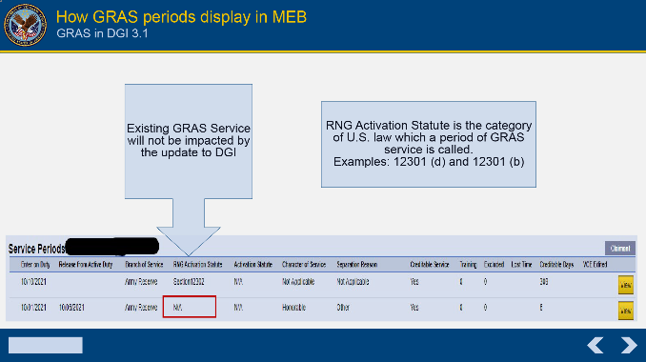 | How GRAS periods display in DGI  The update to DGI will not alter any GRAS service already existing on the Service History page. These service periods will remain as originally entered with N/A displayed under the “RNG Activation Statute” column.  An RNG Activation Statute or statute code, is the category of U.S. law under Title 10 or 32, with which a period of GRAS service is called or given orders. Examples are 12301 (d) or 12301 (b).
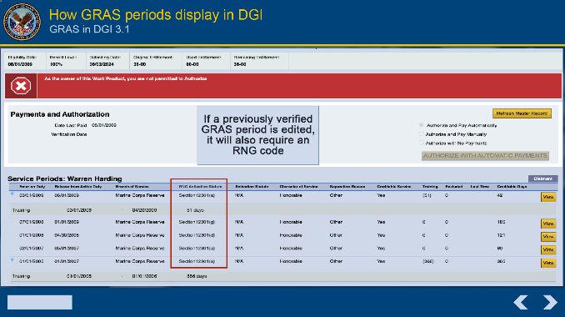 | Any new GRAS periods, found and added from VADIR, will now require a Reserve/National Guard (RNG) statute code.  If a previously verified GRAS period, the one mentioned a few minutes ago with the N/A, is edited by a VCE in a new work product, it will also require an RNG statute code be entered.
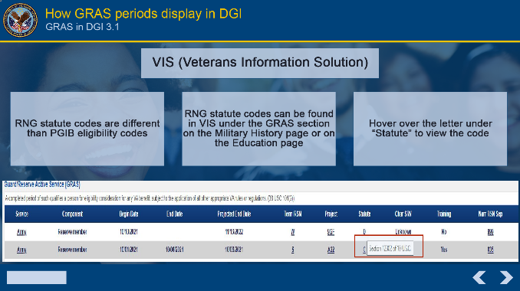 | An RNG statute code is different than the Post 9/11 GI Bill (PGIB) eligibility code, which you be familiar with viewing and verifying in VIS (Veterans Information Solution).  RNG statute codes can be found in VIS on the Military History page under “Guard/Reserve Active Service (GRAS)” section or on the Education page under “Reserve & National Guard Active-Duty Periods” section.  To view an RNG statute code, hover over the letter under “Statute” on the Military History page or under the “Service under Title 10 or Title 32 502(f)” to view on the Education page.
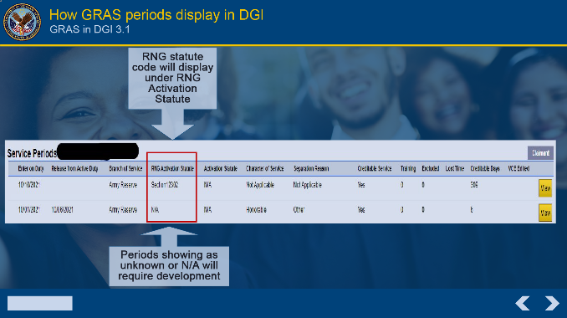 | An RNG statute code should be displayed under “RNG Activation Statute” on the Service History page in DGI. However, some statute codes are “Unknown” or “Null” in VADIR and will display as Unknown or N/A in DGI. These periods will require development.  Effective immediately, “C” Codes no longer need development.
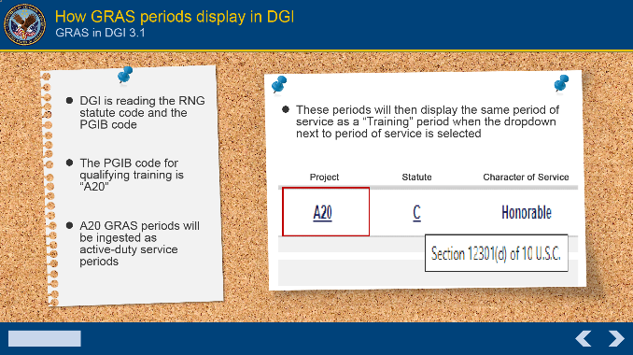 | We mentioned PGIB codes earlier. When the GRAS service is processed from MEB to DGI and determined as qualifying, DGI is reading the RNG Statute Code and the PGIB code. Though the focus of this training is the RNG Statute code, there has been an update to how you will see training periods displayed in DGI.  The PGIB code for qualifying training is A20. All “A20” GRAS periods will be ingested into the DGI as active-duty service periods. These periods will then display the same period of service as a “Training” period when the dropdown next to the period of service is selected.
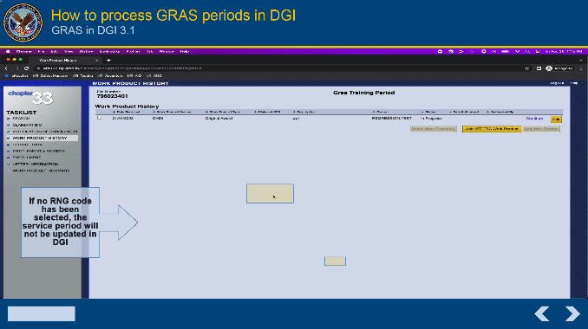 | How to process GRAS periods in DGI  After opening a pending work product or adding a new work product, access the Service History page. Verify all qualifying service listed in VIS is displayed. If adding new GRAS service or editing currently listed service, be sure to select an RNG statute code from the RNG Activation Statute dropdown when completing the “Add/Edit Service Period” window. When the “Save” button is selected the “Override DoD Service Data” warning will appear. This is to ensure the service has been verified.  If an RNG statute code has NOT been selected, a new message will appear titled “RNG Activation Statute Warning”. The message states “You have not added an RNG activation statute for this service period, this period will not be added when you press the Save button. Are you sure you want to Save?”.  If the VCE proceeds without entering an RNG statute code, the period entered will not save, qualifying service will not be updated in DGI, and the VCE will be prompted to begin the process again. Once an RNG activation statute (or RNG statute code, as referenced throughout this training) is entered in DGI, the period can be saved, and qualifying service will update.
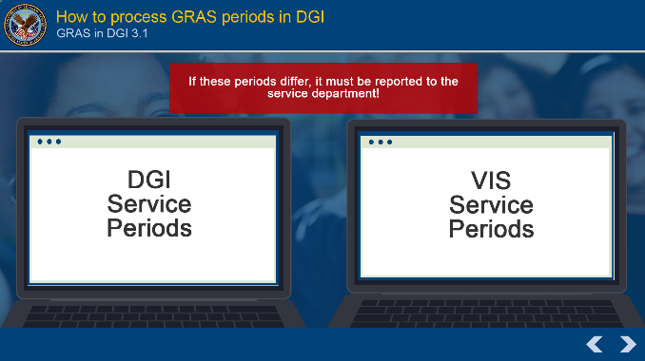 | If the VADIR service retrieved from MEB and displayed in DGI differs from the service shown in VIS, the discrepancy must be reported to the service department by your local DOD Point of Contact (POC) following local procedures.
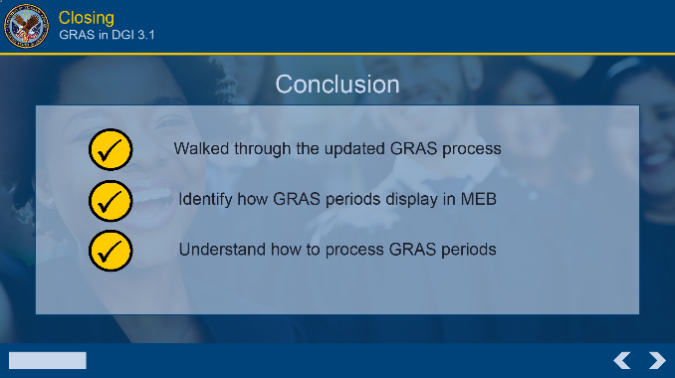 | This concludes today’s training. Thank you for joining as we walked through the updated GRAS process. You should now be able to not only identify how GRAS periods display in MEB and DGI, but also understand how to process them.
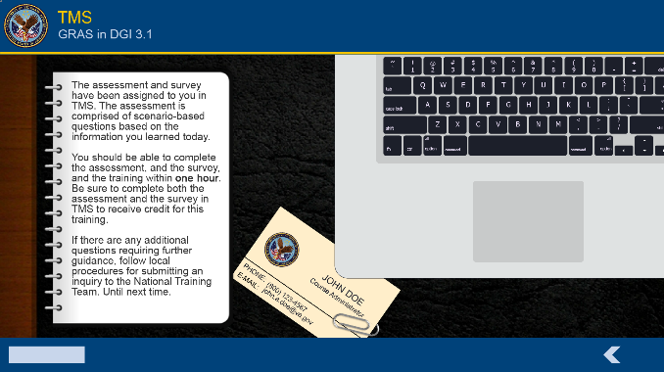 | Wrap Up  The assessment and survey have been assigned to you in TMS. The assessment is comprised of scenario-based questions based on the information you learned today.  You should be able to complete the assessment, the survey, and the training within one hour. Be sure to complete both the assessment and the survey in TMS to receive credit for this training.  If there are any additional questions requiring further guidance, follow local procedures for submitting an inquiry to the National Training Team. Until next time.

