DRAFT Training Module Script – Section 1009

Potential Video Ideas: | Intro to Section 1009  Welcome to the training module for section 1009 of Public Law (PL) 116-315, the Johnny Isakson and David P. Roe, M.D. Veterans Health Care and Benefits Improvement Act of 2020.  Please note, the examples you will see during this training were processed in a test system. All names and claim numbers you see are fictitious and do not belong to actual beneficiaries. No personally identifiable information (PII) is contained in this training  For best viewing results, please ensure you are viewing this presentation using the Microsoft Edge or Google Chrome web browser.
Section 1009 changes the way monthly housing is paid for Post-9/11 GI Bill beneficiaries while they are on active duty. Effective August 1st, 2022, beneficiaries on active duty for more than 30 continuous days will no longer be eligible to receive monthly housing (MHA) payments.

MHA payments are not impacted by active duty periods of less than 30 days.

Note: Throughout this training the Chapter 33 Processing System and DGI will be used interchangeably.
Learning Objectives

The Learning Objectives for today’s training are: Understanding the CH33 Processing System updates based on section 1009 , and
understanding when MHA should be paid by VA during different active duty scenarios.
 | The Chapter 33 Processing System has been updated, effective August 1, 2022, to accurately determine monthly housing allowance due to a beneficiary based upon the entrance, or lack of, a Release from Active Duty (RAD) date.
Active Duty and RAD

The release from active duty date (RAD) is essential to determining the proper MHA payments a beneficiary should receive.

Only qualifying periods of active duty should be entered into DGI.

When reviewing “Active Duty Service Periods” in VIS (Veterans Information Solution), only enter the date listed under “RAD”. Dates listed under “Projected End Date” should not be entered.

If a service period is entered without a RAD, it will be considered “greater than 30 days” and MHA will not be paid.

MHA will stop the day prior to the active duty “Begin Date”.

Periods of Service

Section 1009 is effective for MHA awarded August 1st, 2022, or later.

Any active duty period which begins prior to August 1st, 2022, will be considered when calculating the 30 continuous days.

Two consecutive periods of active duty service [as shown on the calendar] are considered to be a continuous period, as long as there is no break in between.
- Quiz, test or homework graphic | Use Cases  This exercise will test your practical knowledge of Section 1009. For each scenario, based on the enrollment period and service periods, let’s determine when MHA will or will not be paid.
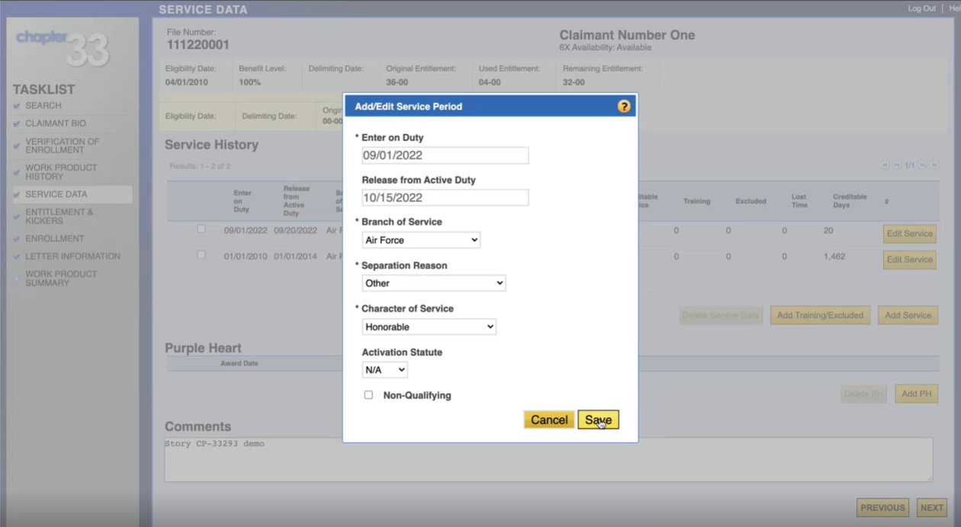 | Practice Scenario #1  #1. The Enrollment Period is from August 1st through November 30th, 2022.  The Service Period is from September 1st through October 15th, or 45 days.
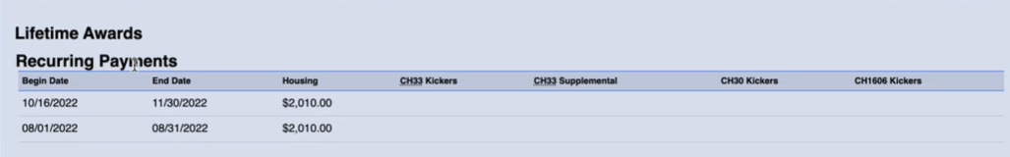 | #1 Answer  In this scenario, the active duty period is greater than 30 continuous days, therefore, MHA is not payable during this service period.  MHA is payable however, for the month of August, and from October 16th to the end of the enrollment period.
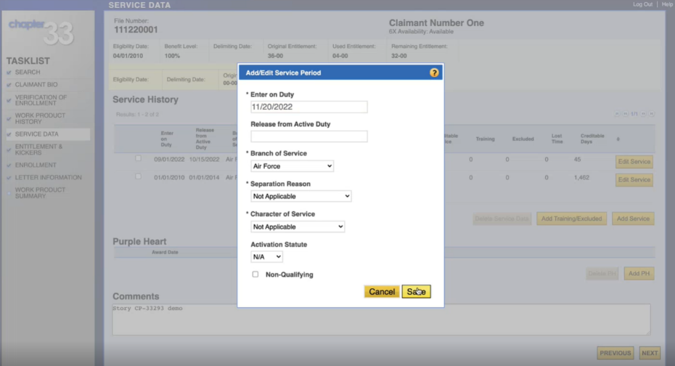 | Practice Scenario #2  #2. The Enrollment Period is from August 1st through November 30th, 2022.  The Service Period begins November 20th, 2022 and has no end date.
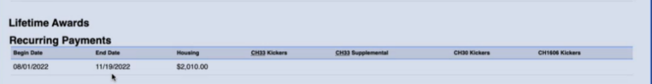 | #2 Answer  In this scenario, MHA is paid from August 1st through November 19th. Since there is no release from active duty date entered, DGI assumes the service period will be longer than 30 days.
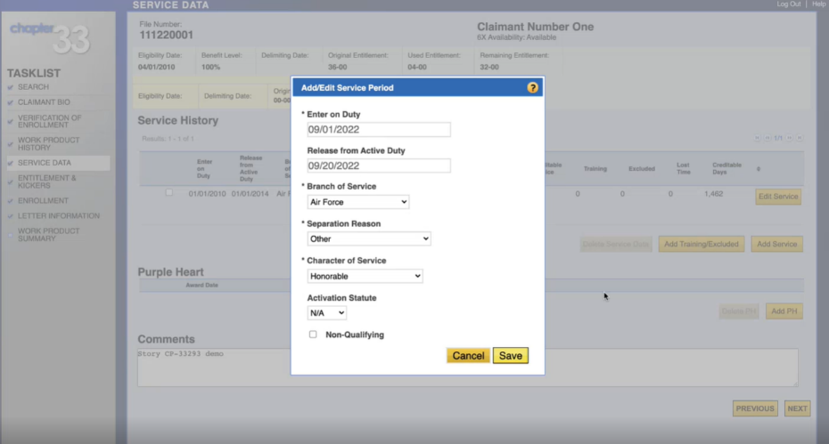 | Practice Scenario #3  #3. The Enrollment Period is from August 1st through November 30th, 2022.  The Service Period is from September 1st through September 20th or 20 days.
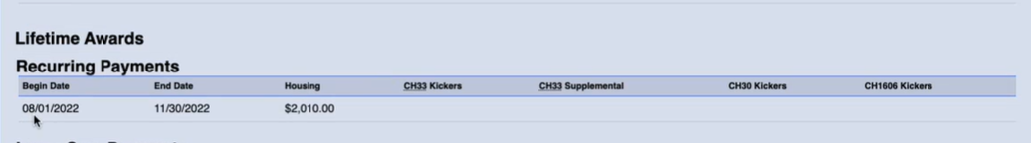 | #3 Answer  MHA is paid from August 1st through November 30th without interruptions, since the active duty period is less than 30 continuous days.  As stated earlier, had there been two consecutive periods-such as September 1st through September 20th for 20 days, and) September 21st through October 2nd for 12 additional days, then housing would not have been payable as the total continuous days is 32.
- Letter opening with new verbiage written | Letters  Now let’s talk about letters. The Monthly Housing Allowance section of the AWD3 letter has been revised to include verbiage related to section 1009.  The updated portion of the paragraph reads: “Housing is not payable when you are on active duty. Housing will be prorated for everyone who enters or is released from active duty during an enrollment period. Effective August 1st, 2022, we can pay housing for active duty periods that are 30 days or less.”
- Bulleted checklist | Summary  In today’s training we discussed:  - The purpose of Section 1009  - How the Chapter 33 processing system handles Section 1009 affected claims  - MHA payment scenarios  - AWD3 Letters verbiage changes
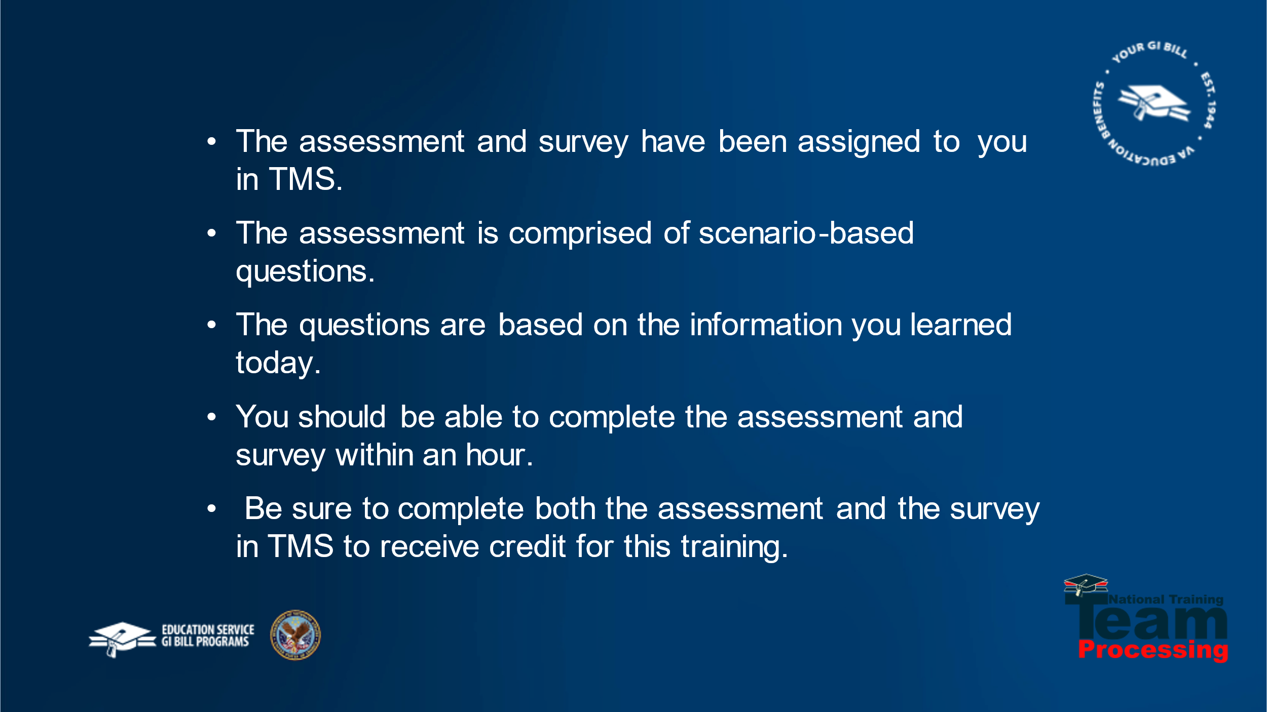 | Post Training Requirements  This concludes our training on Public Law 116-315, Section 1009. This training will be followed by an assessment and survey in TMS.  The assessment will be based on the information you were provided today.  You should be able to complete the assessment, and the survey within one hour.  Be sure to complete the assessment and survey in TMS to receive credit for this training.
-  | Wrap-up  If there are any additional questions requiring further guidance, follow local procedures for submitting an inquiry to the National Training Team. Thank you for participating in today’s training!

