Training Module Script
DGI Claims Processing Training Volume 1
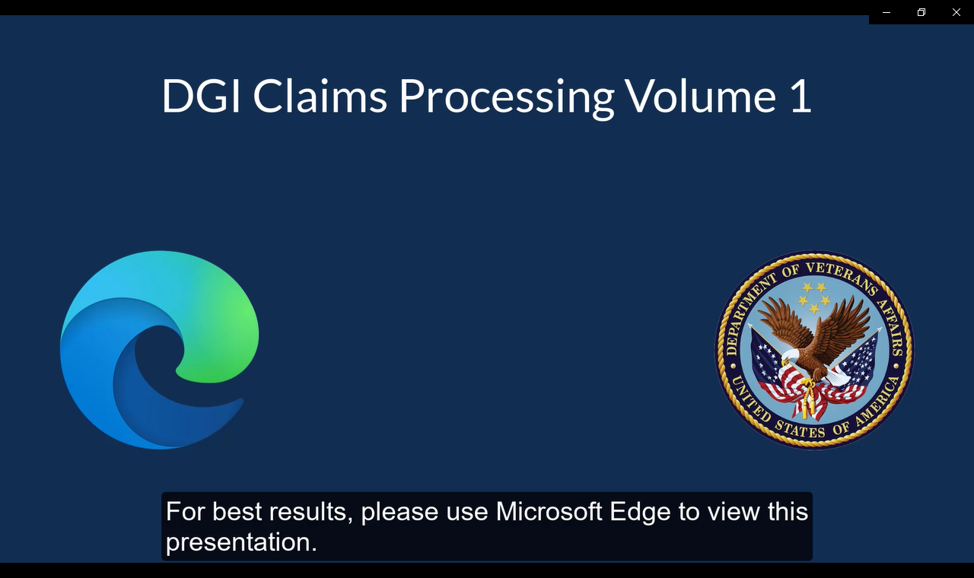 | DGI Claims Processing Training- Volume 1  Welcome to this segment of the Digital GI Bill (DGI) Claims Processing System training series. For best results, please use Microsoft Edge to view this presentation.
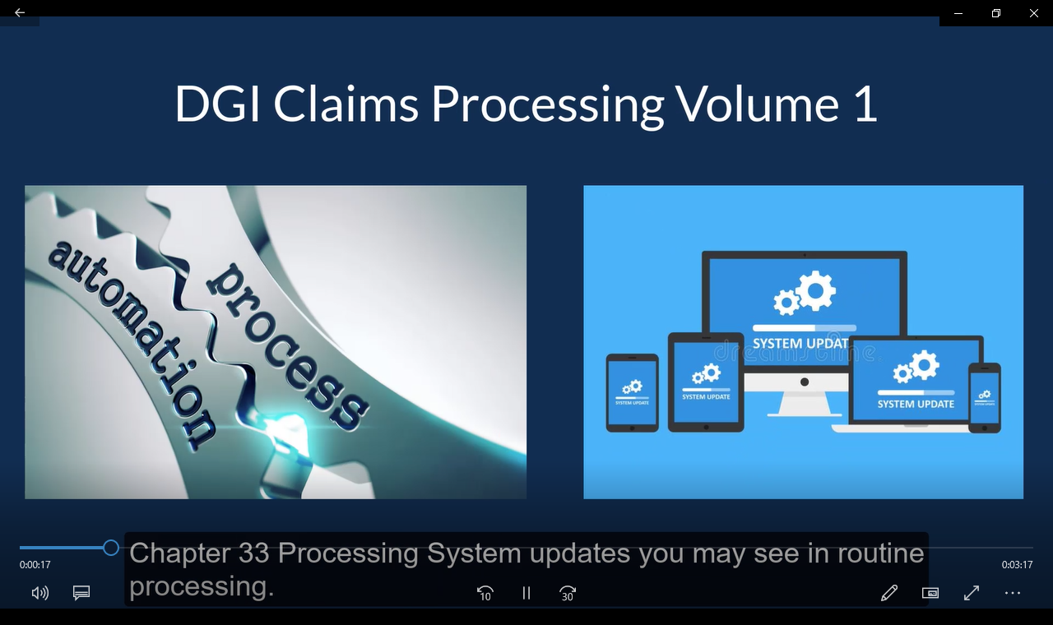 | Agenda  Today we will discuss additional supplemental claims automation efforts and Chapter 33 Processing System updates you may see in routine processing.
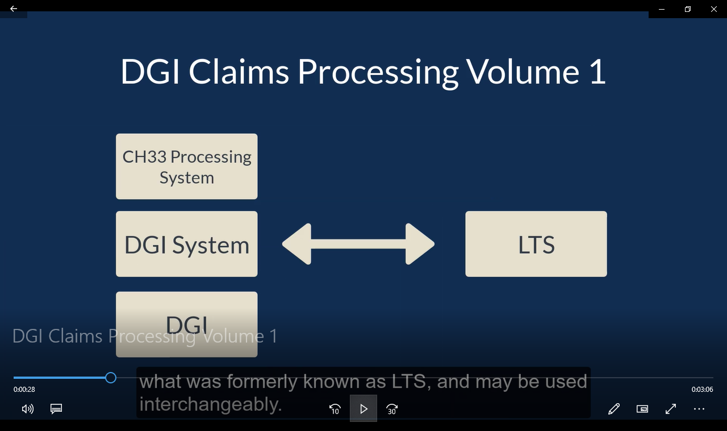 | LTS to DGI  Chapter 33 Processing System, DGI System and DGI all reference, what was formerly known as LTS, and may be used interchangeably.
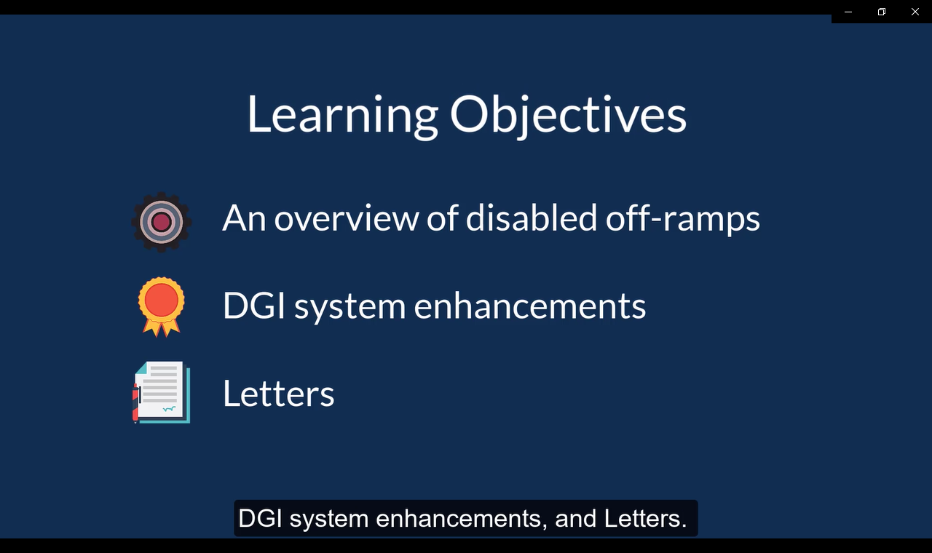 |  | Learning Objectives  The topics covered in today’s training will be:  - An overview of disabled off-ramps  - DGI system enhancements  - Letters
 | DGI System Enhancements  We will discuss a few enhancements made to improve automation of supplemental claims and highlight some new functionality you’ll see within DGI.
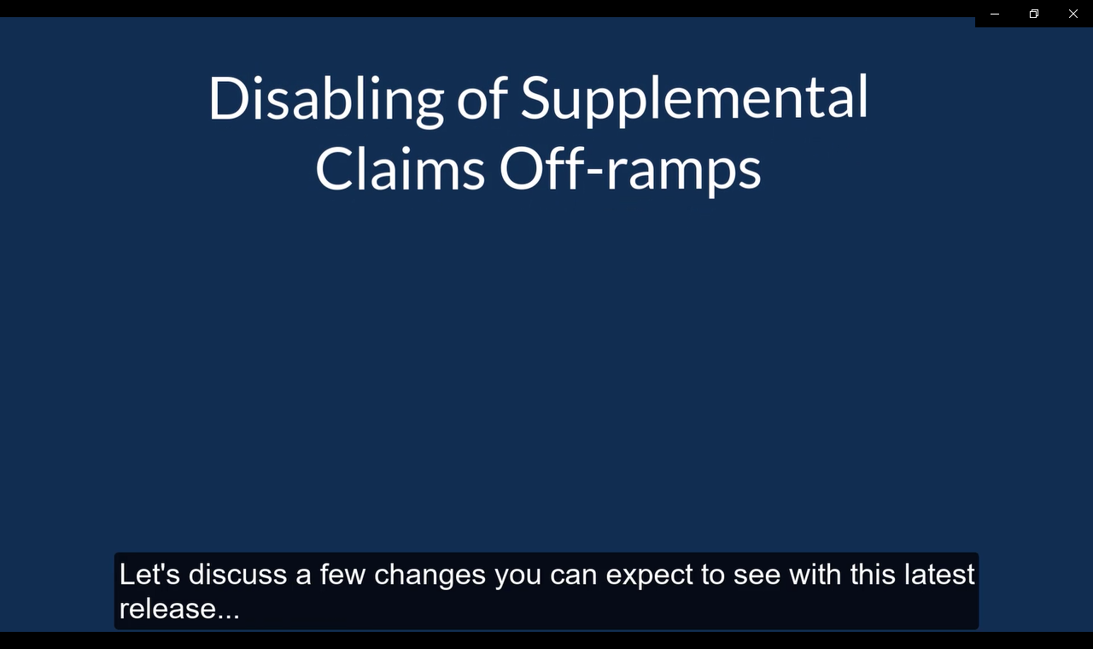 | Disabling of Supplemental Claims Off-ramps  Many off-ramps have been disabled to streamline supplemental claims processing.  Let’s discuss a few changes you can expect to see with this latest release…
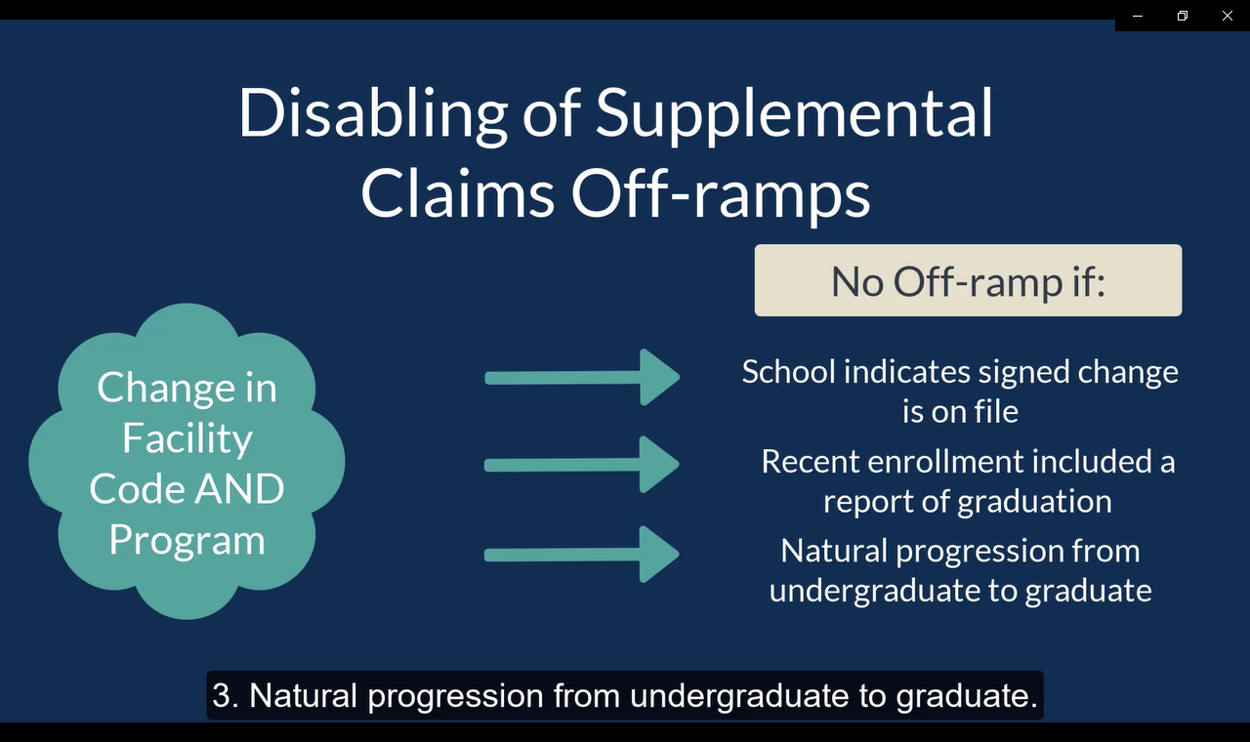 | Disabling of Supplemental Claims Off-ramps  DGI will automate a “Change in Facility Code AND Program” if any of the following exist:  1. A school remark on an enrollment certification indicates a signed Change of Program or Place of Training request is on file,  2. The beneficiary’s most recent enrollment included a graduation, or  3. Natural progression from undergraduate to graduate.  The claim will be off-ramped for VCE review if the conditions mentioned are not met.
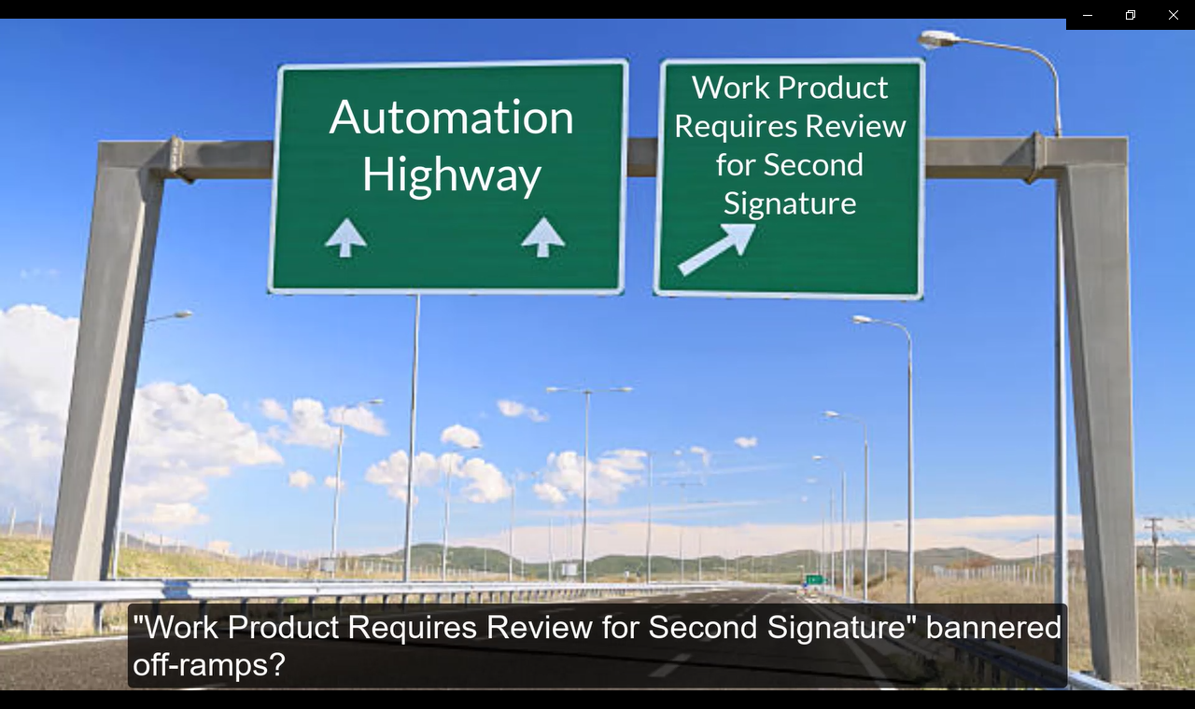 | Disabling of Supplemental Claims Off-ramps  Have you recently thought to yourself, hmmm I haven’t seen many “Work Product Requires Review for Second Signature” bannered off-ramps? This off-ramp was disabled to ALLOW the system to automate an original claim. If the claim can be fully automated, no additional signatures or VCE action will be required. If a claim is off-ramped and requires further review, DGI will act as the first review and the VCE will provide the second signature when processing an original claim.
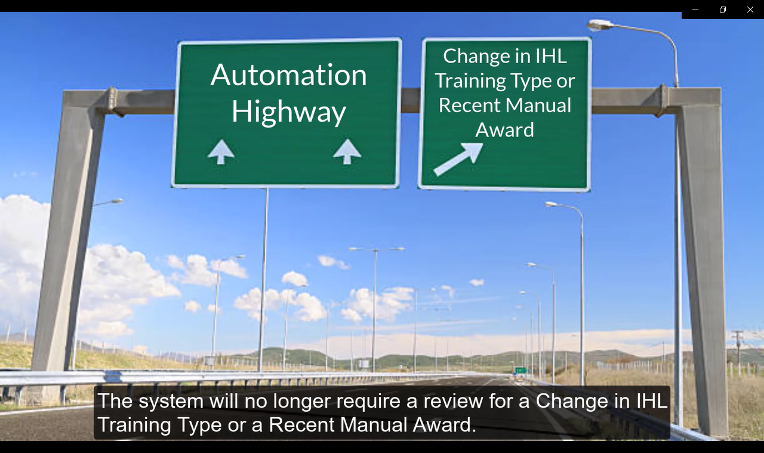 | Disabling of Supplemental Claims Off-ramps  The system will no longer require a review for a Change in IHL Training Type or a Recent Manual Award.
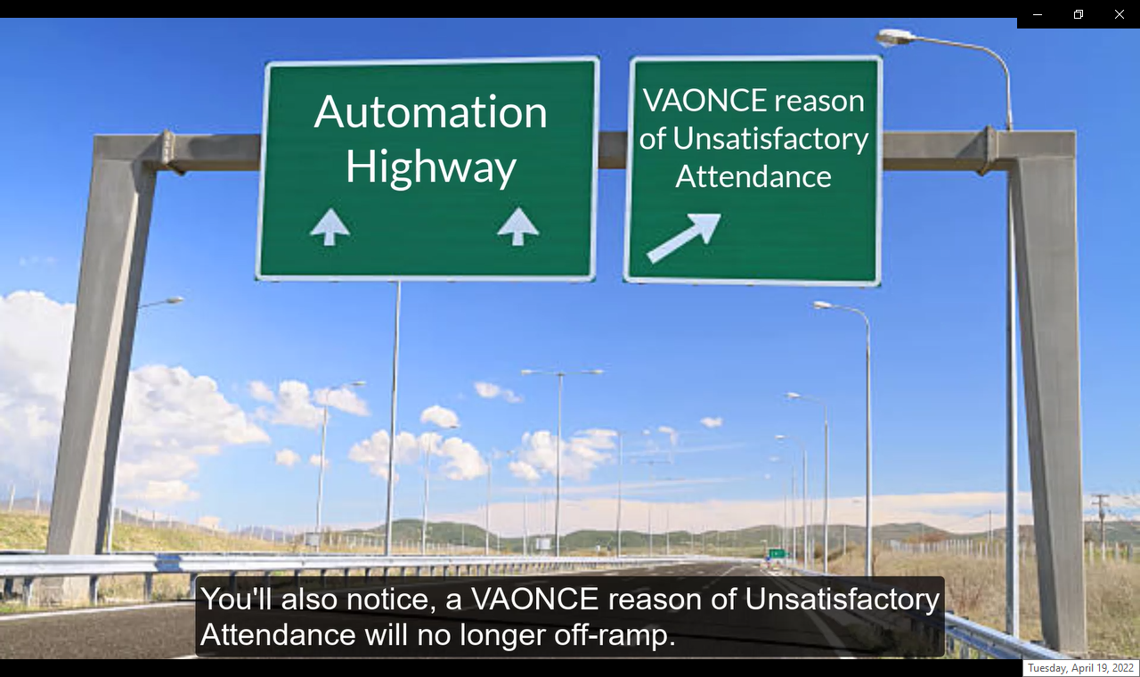 | Disabling of Supplemental Claims Off-ramps  You’ll also notice, a VAONCE reason of Unsatisfactory Attendance will no longer off-ramp. These will now automate without VCE review or intervention if no other off-ramp reason or change exists.
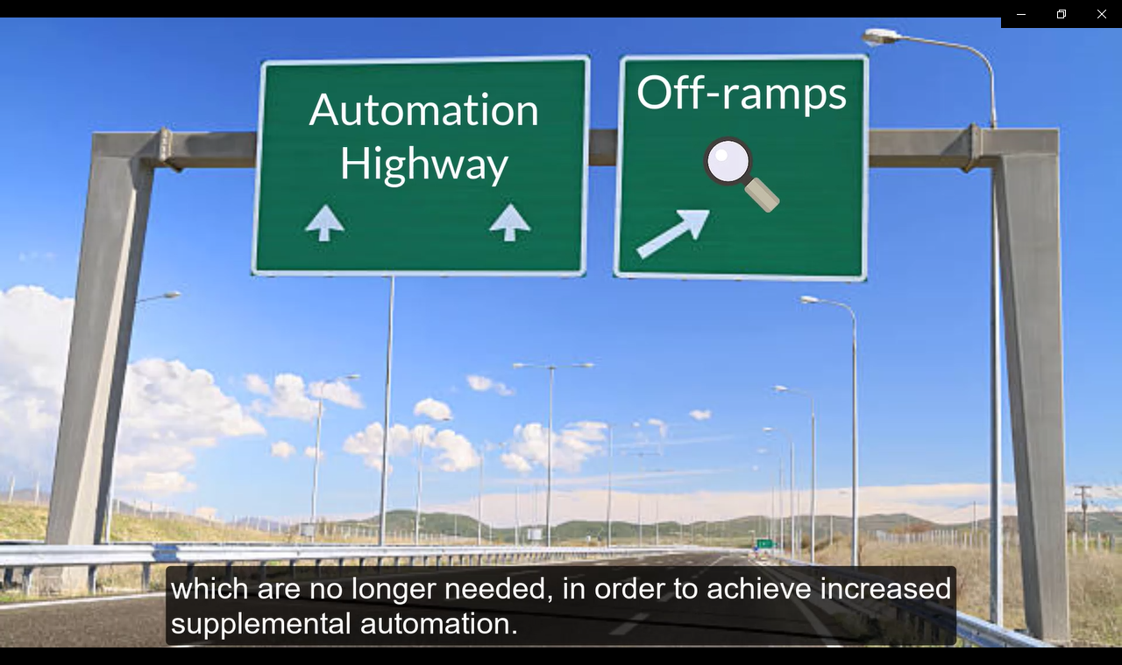 | Efforts continue to identify and disable various off-ramp reasons, which are no longer needed, in order to achieve increased supplemental automation.
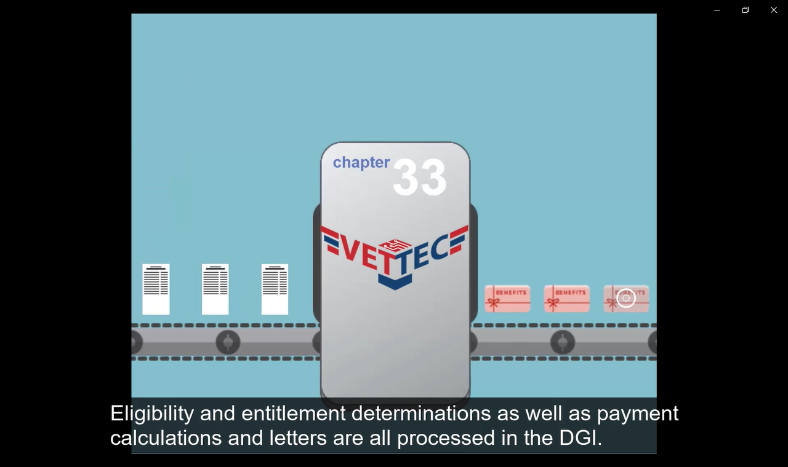 | VET TEC  Next, let’s highlight new functionality you’ll see within DGI…  This release includes the ability to process VET TEC participants within the DGI system. Eligibility and entitlement determinations as well as payment calculations and letters are all processed in the DGI.
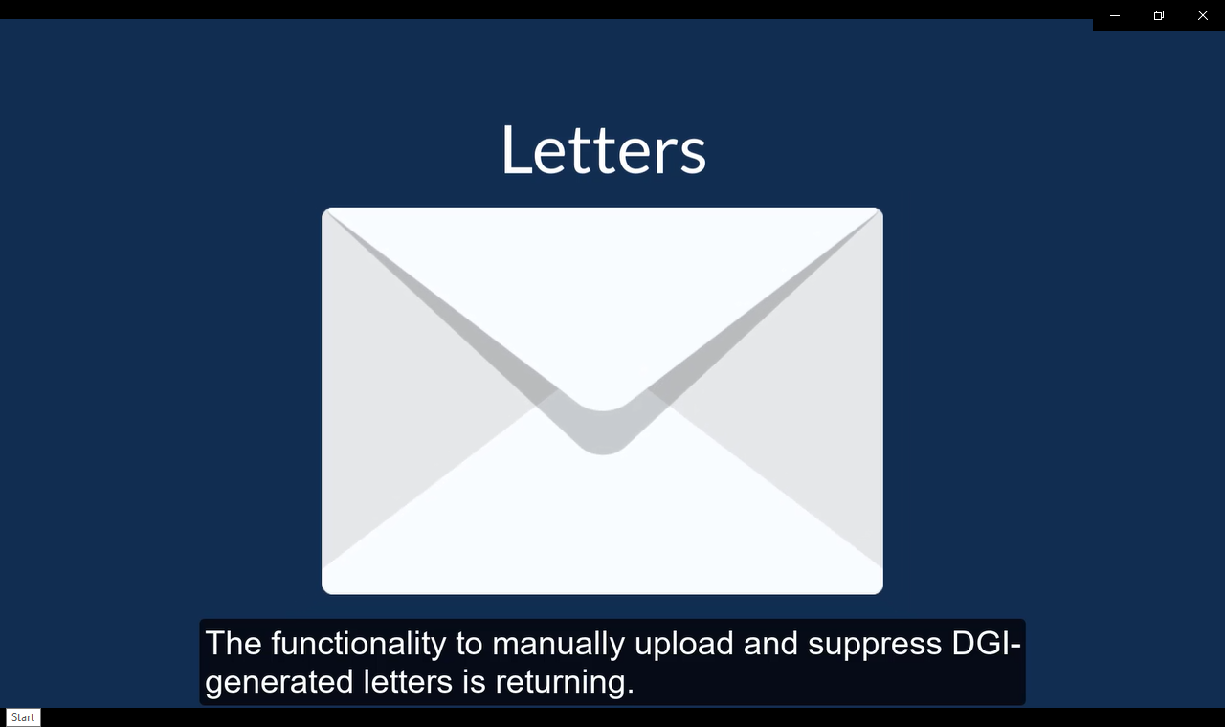 | Letters  And before closing, we must mention…  The functionality to manually upload and suppress DGI-generated letters is returning. This functionality is only available for VET TEC letters.
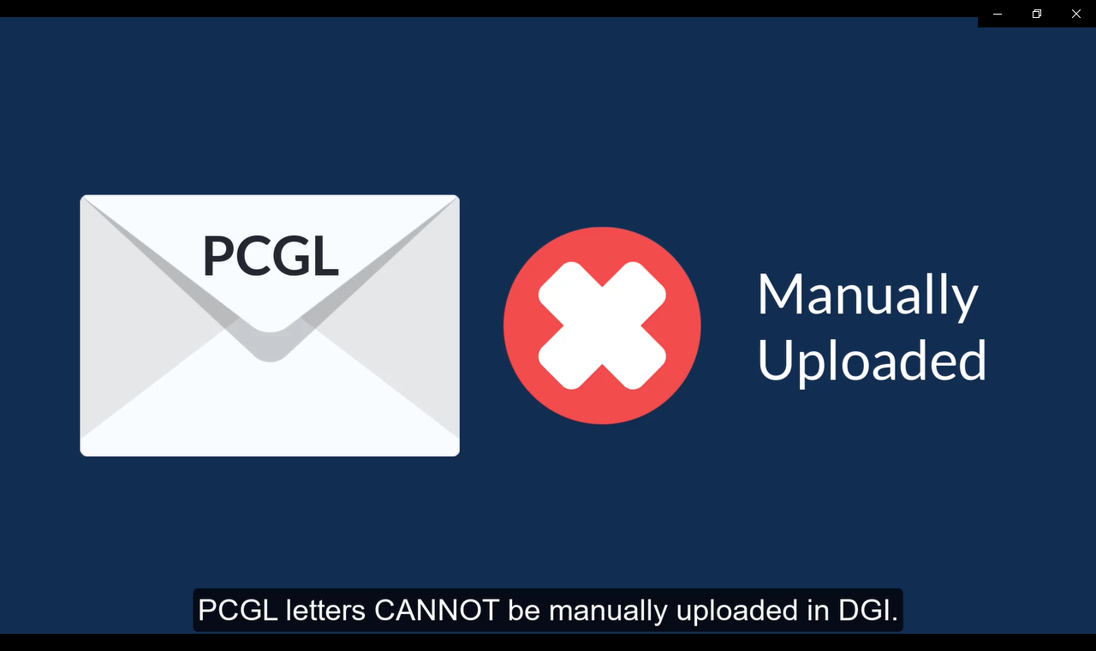 | PCGL Letters  PCGL letters CANNOT be manually uploaded in DGI.
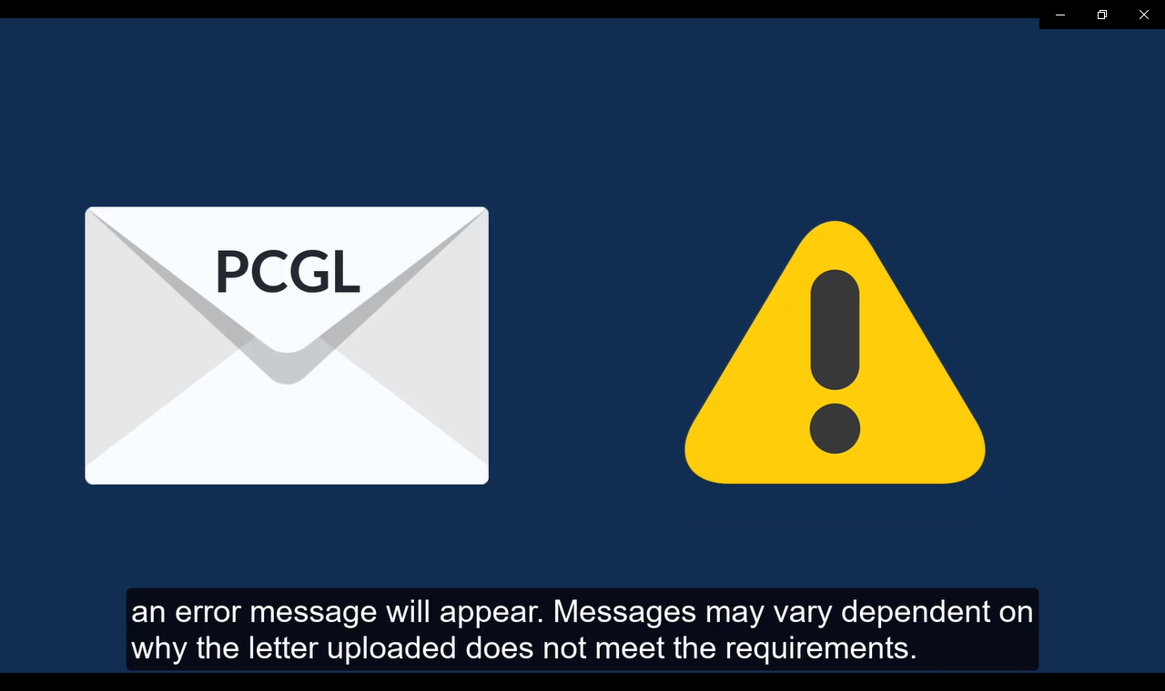 | PCGL Letters  If a VCE ignores the instruction and attempts to upload a PCGL letter, an error message will appear. Messages may vary dependent on why the letter uploaded does not meet the requirements.
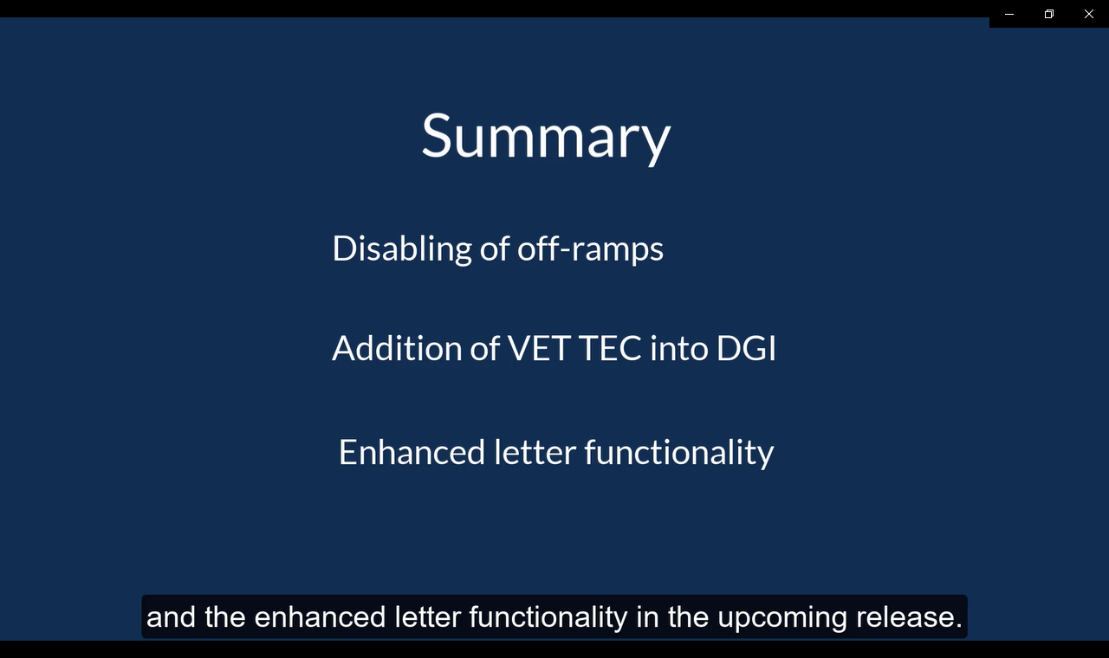 | Summary  This concludes today’s training. Thank you for joining as we walked through the disabling of several off-ramps, the addition of VET TEC into DGI, and the enhanced letter functionality in the upcoming release.
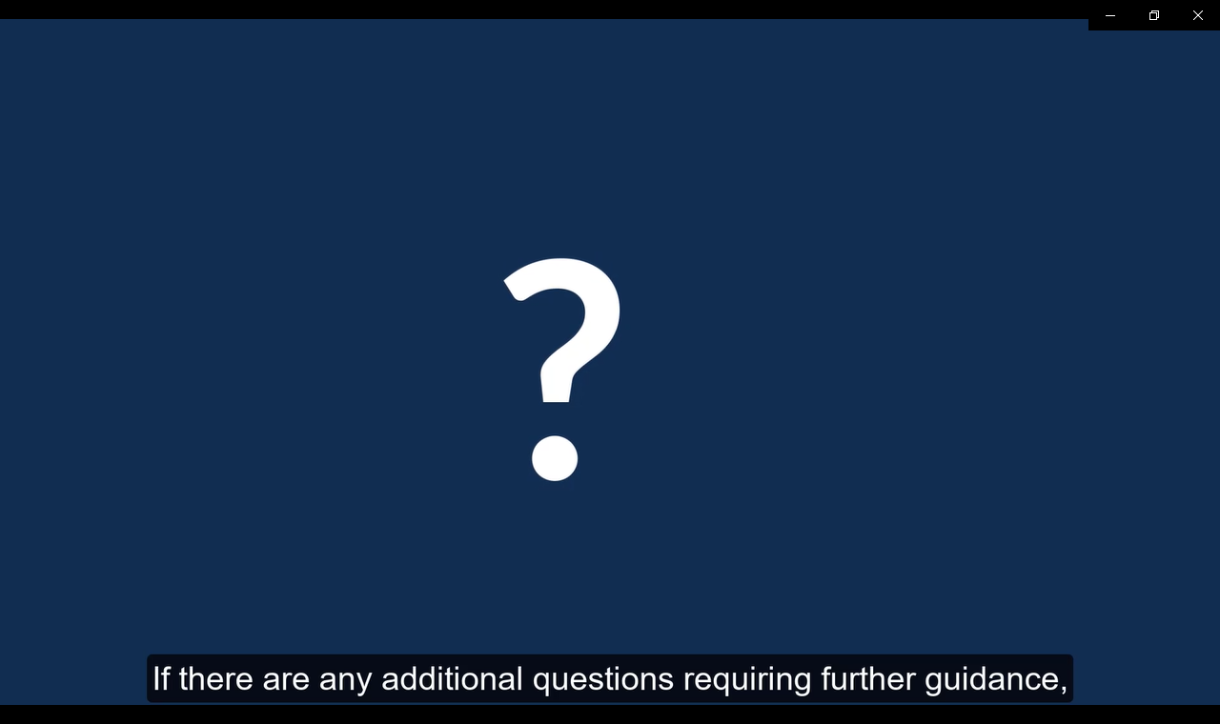 | Questions  If there are any additional questions requiring further guidance, follow local procedures for submitting an inquiry to the National Training Team.
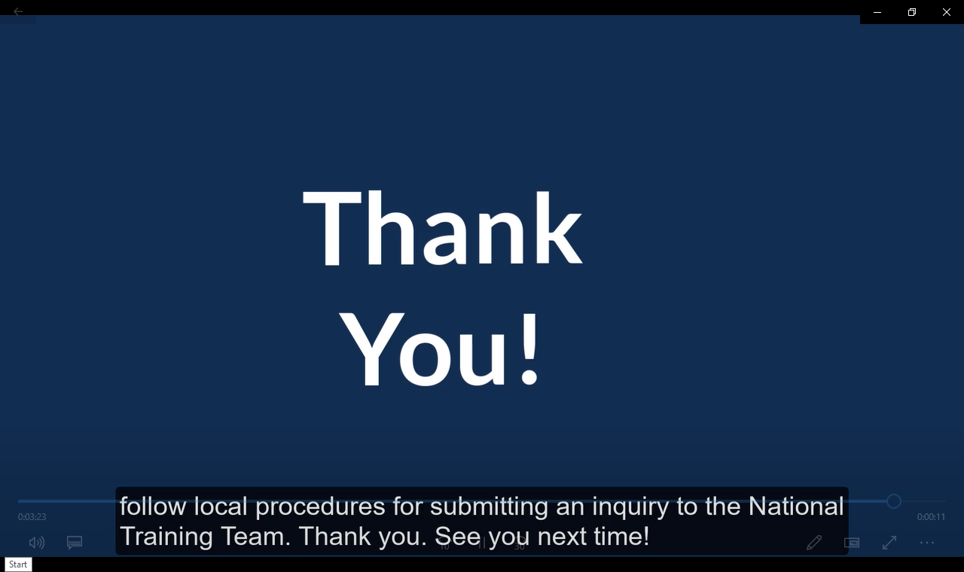 | Thank you. See you next time!

