Training Module Script – VCE Scenarios
Isakson & Roe: Section 1010 Held Payments for Future Enrollment Scenario
Storyboard | Script
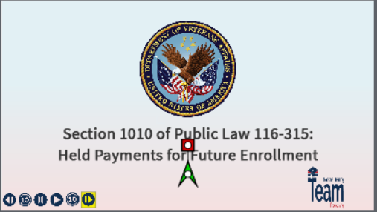 | Retro Payment Scenario Training Section 1010: VCEs  Welcome to the training module for section 1010 of Public Law (PL) 116-315, the Johnny Isakson and David P. Roe, M.D. Veterans Health Care and Benefits Improvement Act of 2020.  In today’s training, you will see an example of how a submitted enrollment term is processed in the DGI or Chapter 33 Processing system, for a period which supersedes a previous term, and the beneficiary did not verify their enrollment for two consecutive months; therefore, their payments were put on hold.  Please advance to the next slide.
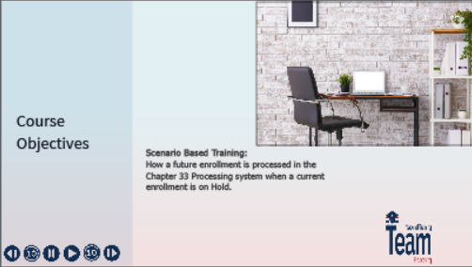 | Navigation Controls  You can use the navigation buttons at the bottom to move forward and backward throughout this module.  You can also use the following keyboard shortcuts listed on the screen.
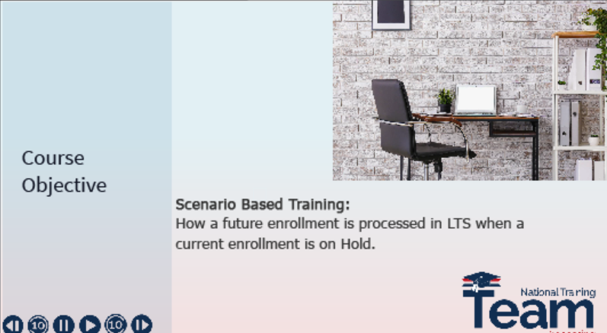 | Learning Objectives  At the end of this lesson, you will be able to understand how processing a future enrollment will impact a beneficiary’s payment status when it is currently on hold due to the nonverification of a previous or current enrollment period.  Please note, the example you will see during this training was processed in a test system. All names and claim numbers you see are fictitious and do not belong to actual beneficiaries. No personally identifiable information (PII) is contained in this training.
 | Transition to Scenario  Now, let’s get started on the training! Please select the button on your screen to view the scenario.
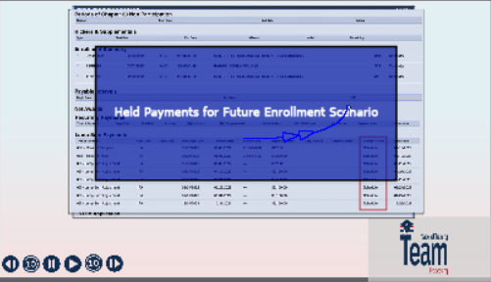 | Scenario:  This is a fictious scenario which takes place in the Chapter 33 Processing system when a future enrollment is processed while the beneficiary’s housing and/or kicker payments are currently on hold for nonverification.  After entering the new enrollment and updating all appropriate screens, advance to the Work Product Summary page. Note that the payment status for current and future terms will appear as “Scheduled.”  Now, please authorize the payments on the screen.
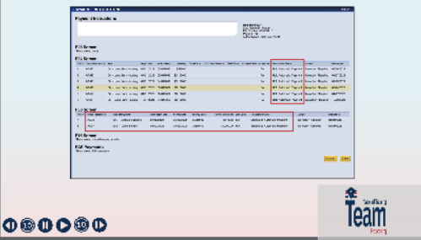 | Demo: Part 2  Once the payments are authorized, the system will automatically navigate to the Payment Instruction screen. You will see that all future housing payments now have a Transaction Status of “Hold Automatic Payment.”  As a reminder, the Transaction Status for Books and Supplies, and Tuition and Fees are not impacted by the enrollment verification requirement and will display as “Scheduled” or “Send to BDN”.
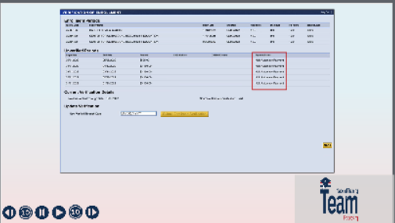 | Demo: Part 3  Next, navigate to the Verification of Enrollment screen. Like before, you will see that the Payment Status reads “Hold Automatic Payment.”
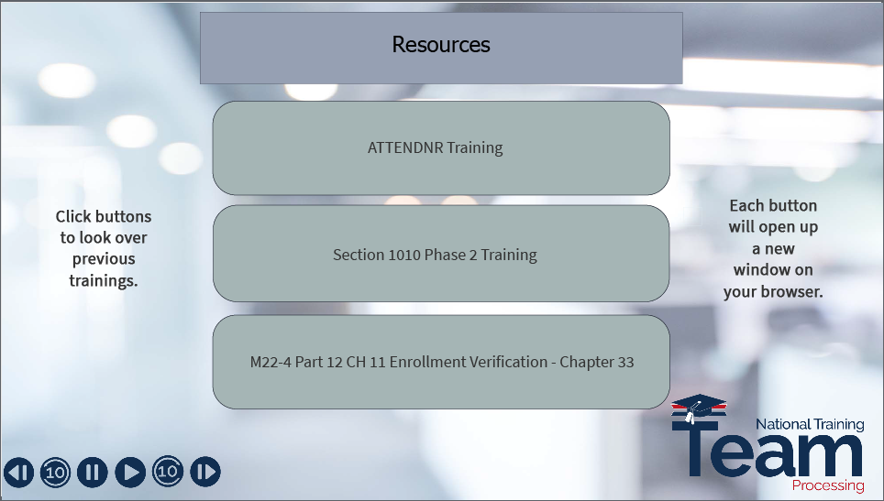 | Resources  For additional information on section 1010 of Public Law 116-315, please select a topic to review the previous training material.
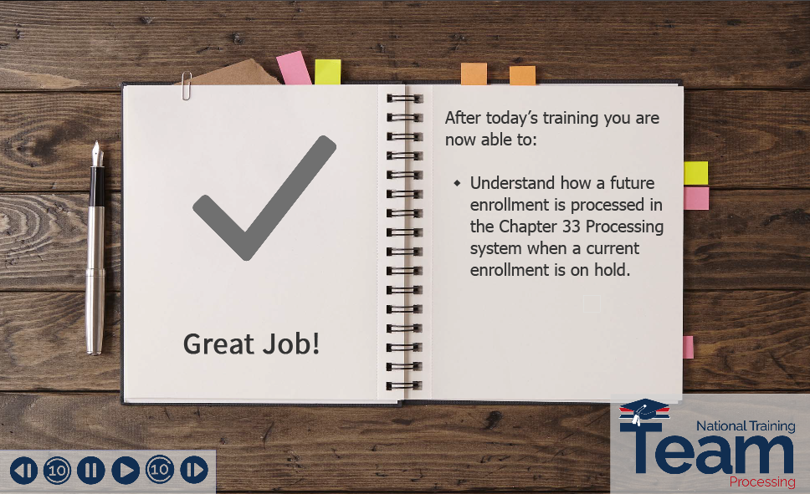 | Summary  After completing today's lesson, you are now able to understand how a future enrollment is processed in the Chapter 33 Processing system when a current enrollment is on hold.
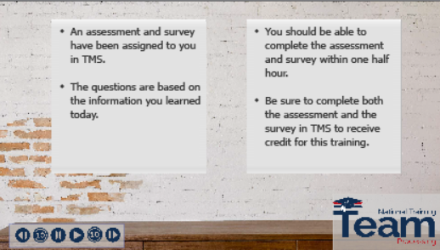 | Post Training Requirements  This concludes our training on Public Law 116-315, Section 1010 Held Payments for Future Enrollment. This training will be followed by an assessment and survey in TMS.  The assessment will be based on the information you were provided today.  You should be able to complete the assessment, and the survey within one half hour.  Be sure to complete the assessment and survey in TMS to receive credit for this training.
 | Wrap Up  If there are any additional questions or scenarios requiring further guidance, follow local procedures for submitting an inquiry to the National Training Team- Processing.  Please click the logo to exit the training.

