Story Board | Script
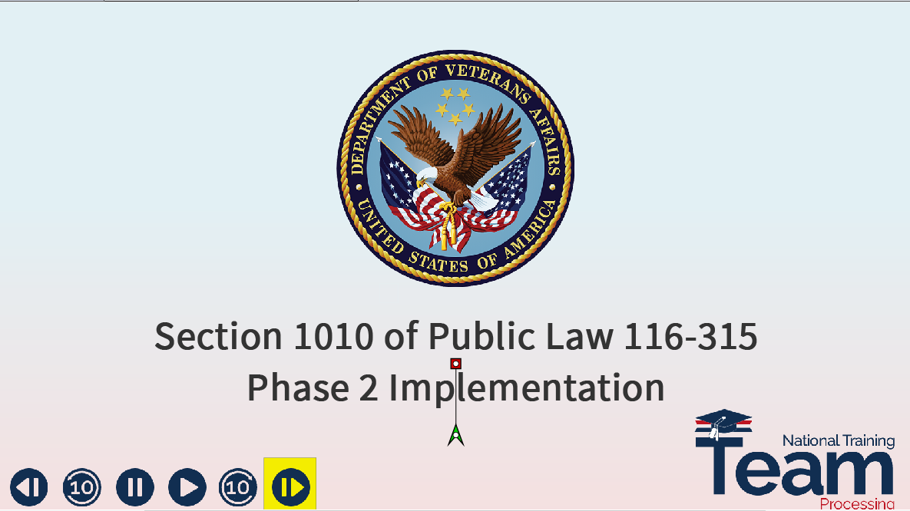 | Intro  Welcome to the training module for section 1010 of Public Law 116-315, the Johnny Isakson and David P. Roe, M.D. Veterans Health Care and Benefits Improvement Act of 2020.  In today’s training, you will learn about the second phase in the implementation of enrollment verification which adds those individuals enrolled at an Institution of Higher Learning or (IHL).  Please click the next slide key to continue.
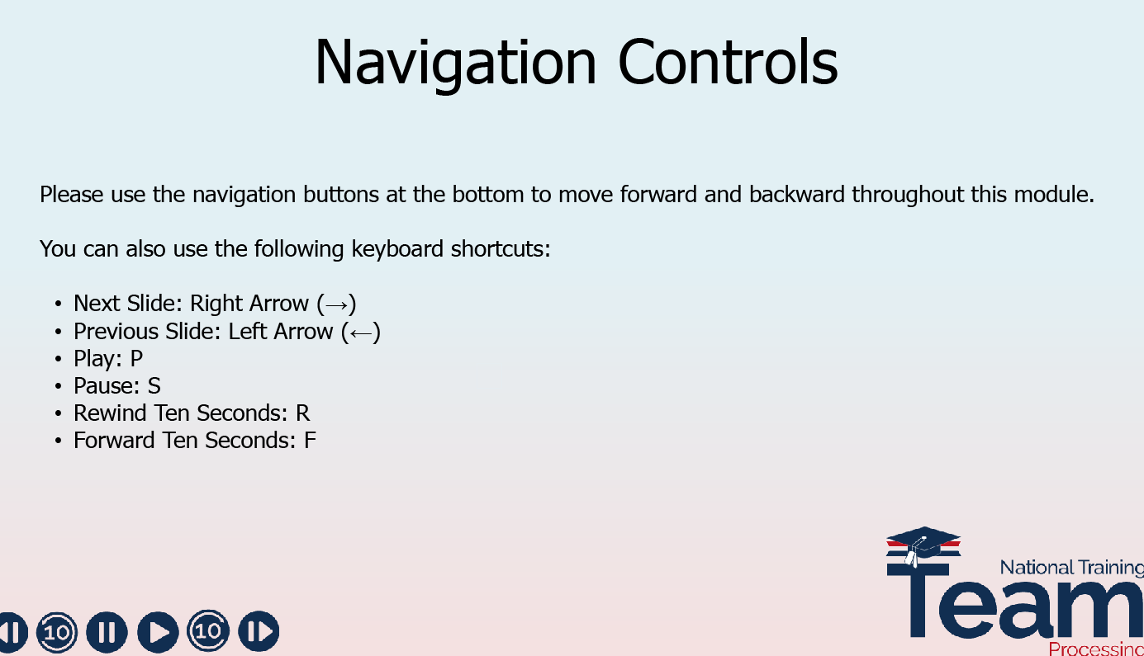 | Please use the navigation buttons at the bottom to move forward and backward throughout this module.  You can also use the following keyboard shortcuts below.
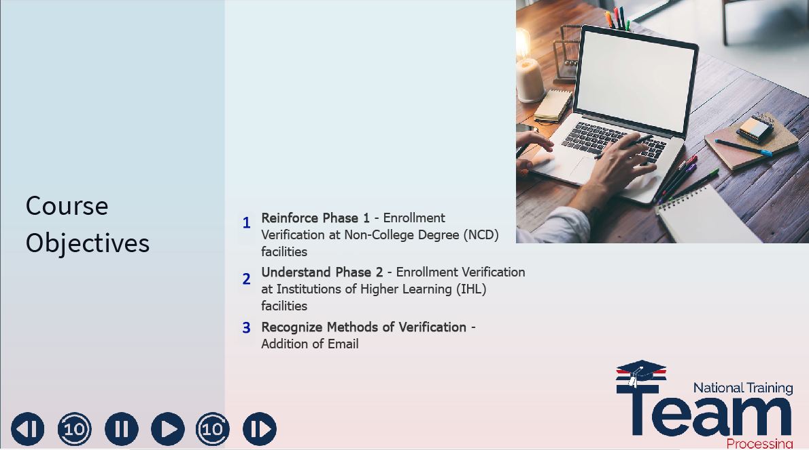 | Lesson Objectives  The objectives for today’s lesson include reinforcing your understanding of the phase 1 implementation of enrollment verification at Non-College Degree or (NCD) facilities and introducing the implementation of phase 2, requiring verification of enrollment at IHL facilities. You will also be familiarized with each verification method, which now includes email.
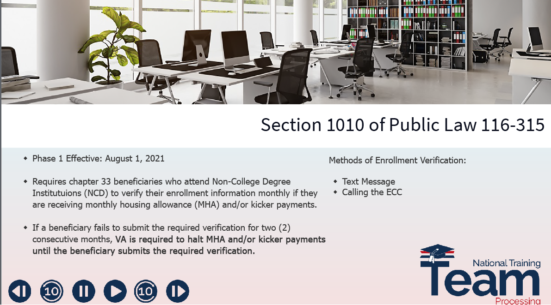 | NCD/1010 Recap  Section 1010 of P.L. 116-315 requires chapter 33 beneficiaries to verify their enrollment information monthly if they are receiving a monthly housing allowance or kicker payment.  The first phase in the implementation of section 1010 included only those beneficiaries enrolled at an NCD facility beginning on or after August 1, 2021.  If a beneficiary fails to submit the required verification for two consecutive months,  VA is required to hold monthly housing and/or kicker payments until the beneficiary submits the required verification. Prior to the implementation of additional functionality, beneficiaries could only verify via text message or by contacting the Education Call Center.  Today’s training will focus on the inclusion of the IHL beneficiaries in the enrollment verification process, and the addition of an email alternative to verify their enrollment.
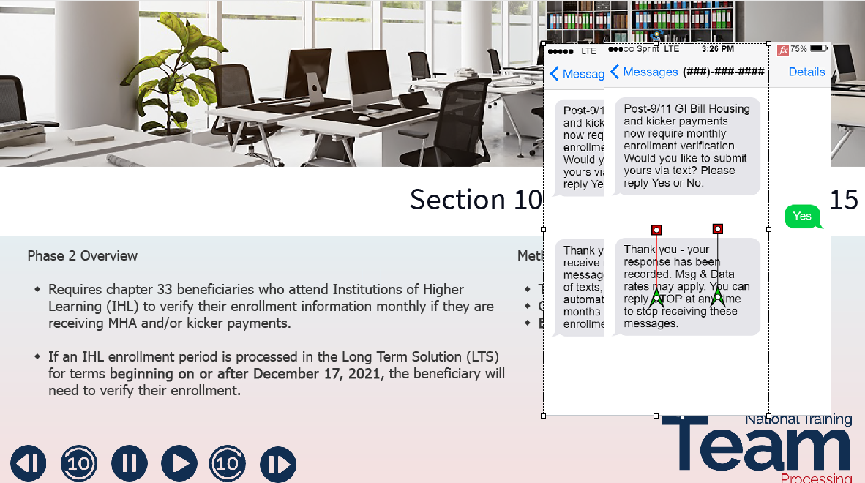 | Phase 2: IHL and Email Rollout  Beginning with Phase 2, beneficiaries attending an IHL facility are required to verify their enrollment at the end of each month.  Beneficiaries attending NCD and IHL facilities can now complete their monthly enrollment verifications via text, email or by contacting the Education Call Center.  When an IHL enrollment period is processed in the Long Term Solution or (LTS) for terms  beginning on or after December 17, 2021, a  text message will be released to the Mobile Phone number located on the beneficiary’s LTS Claimant Bio Screen.  If the beneficiary replies “Yes”, they will be opted into monthly text messages to verify their enrollment.  If the beneficiary replies “No” and there is a valid email address located under the contact information on the beneficiary’s LTS Claimant Bio screen they will receive the following text message: “Thank you – you will receive no further text messages. By opting out of texts, you will receive automatic emails each month to verify your enrollment.”  If the beneficiary responds “No” and there is no valid email address on their Claimant Bio screen, an active TXTERROR document will be sent to the beneficiary’s TIMS file for VCE review.
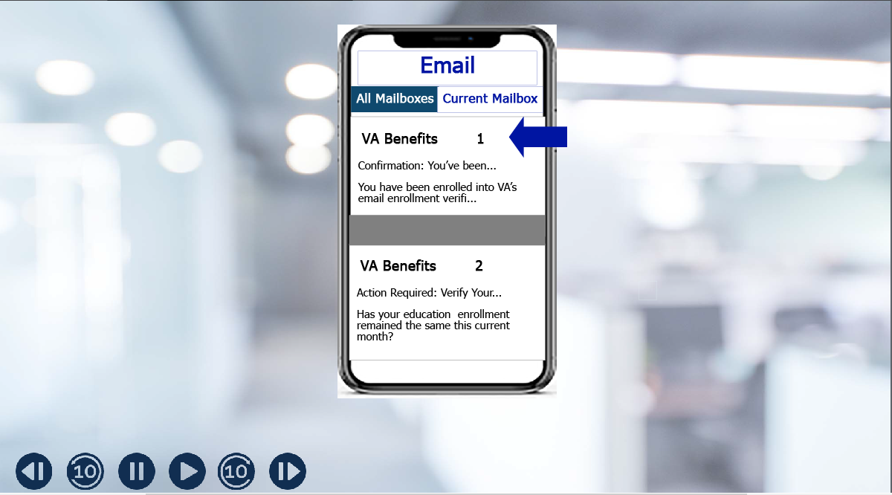 | Email Language  Once a beneficiary is enrolled in email verification, they will receive a confirmation email.  Please select the first email icon (1) to review this email message.
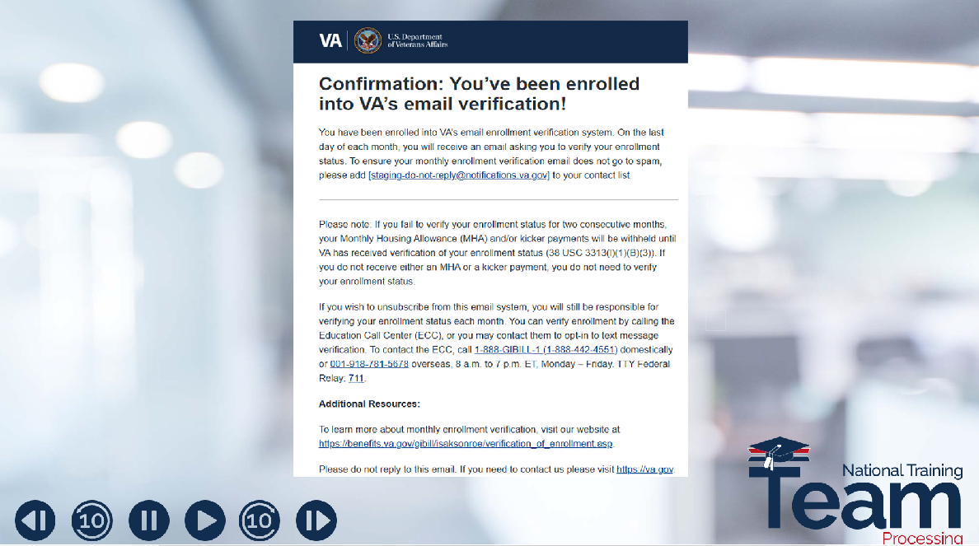 | Email Language  Here is the confirmation email message a beneficiary will receive once they are enrolled in email verification.
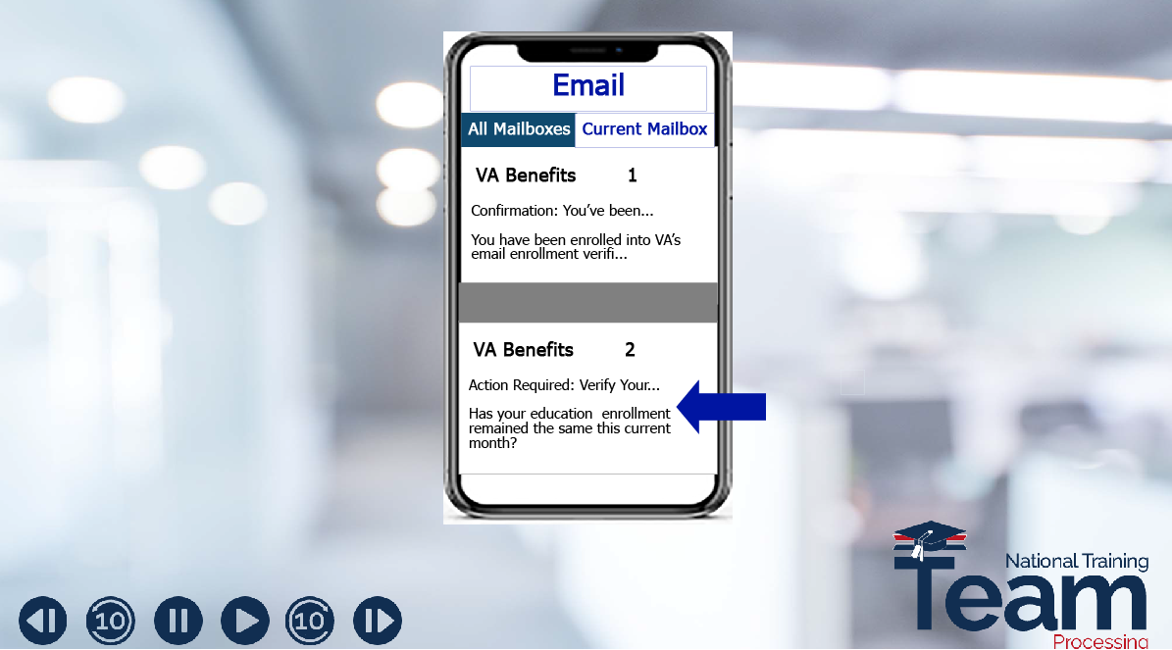 | Email Language  When using the email verification method, enrollments are verified in the same way as the text message verification method. Let’s take a closer look at the email the beneficiary will receive at the end of each month requesting them to verify their enrollment status.  Please select the second email icon (2) to review this email message.
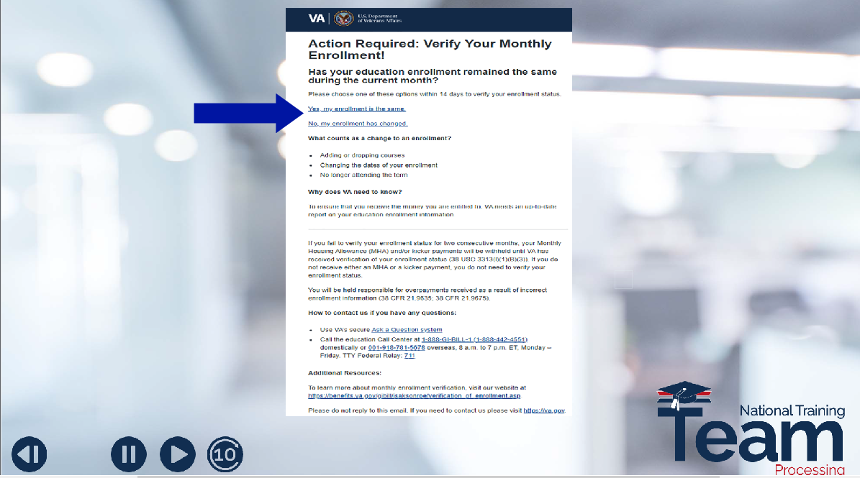 | Email Language  To verify their enrollment, the beneficiary will select one of the following links, “Yes, my enrollment is the same” or “No, my enrollment has changed”.  After clicking the correct link to verify their enrollment status, they will receive an email acknowledging their response.
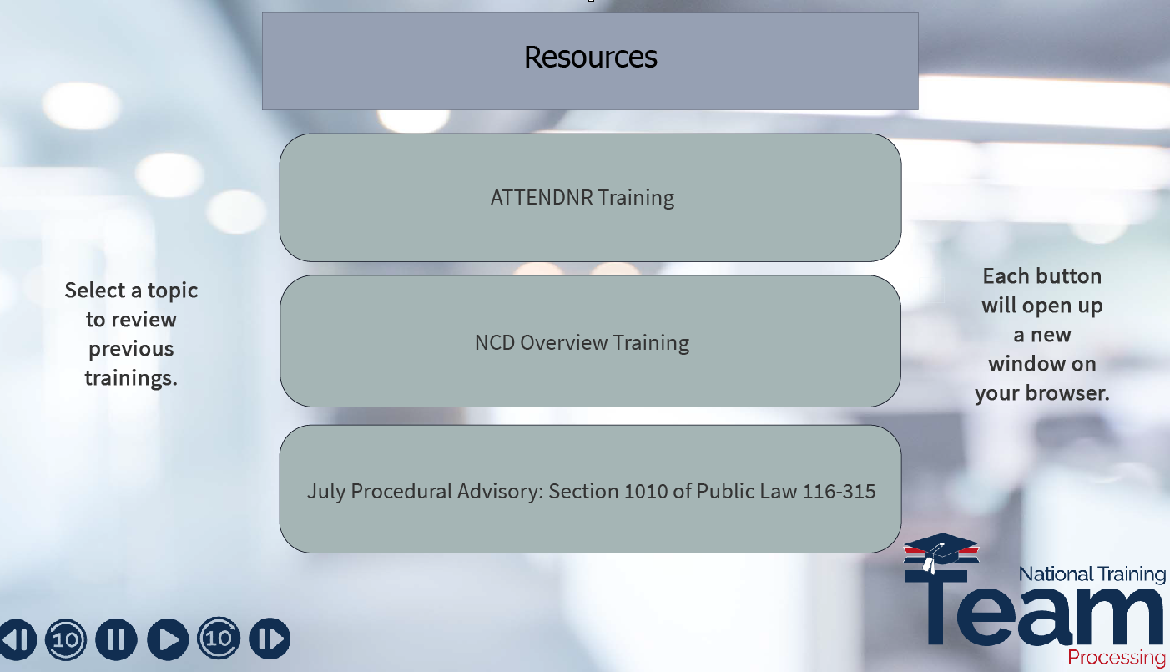 | Resources  For additional information on section 1010 of Public Law 116-315, you may select a topic to review the previous training material or advance to the next slide.
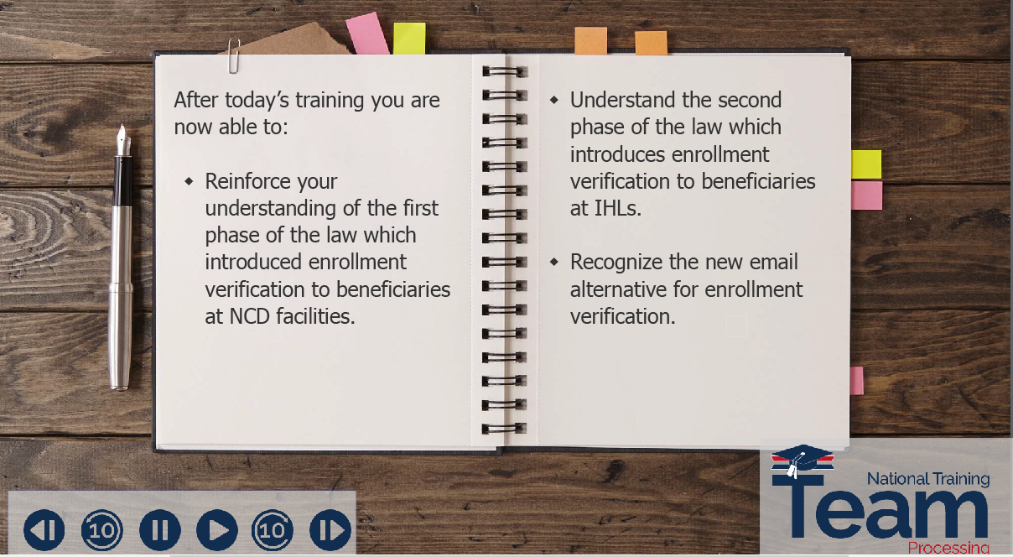 | Training Recap  After completing today’s lesson, you are now able to: Reinforce your understanding of the phase 1 implementation of enrollment verification at NCD facilities. Understand the implementation of phase 2, requiring verification of enrollment at IHL facilities, and recognize each verification method, which now includes email.
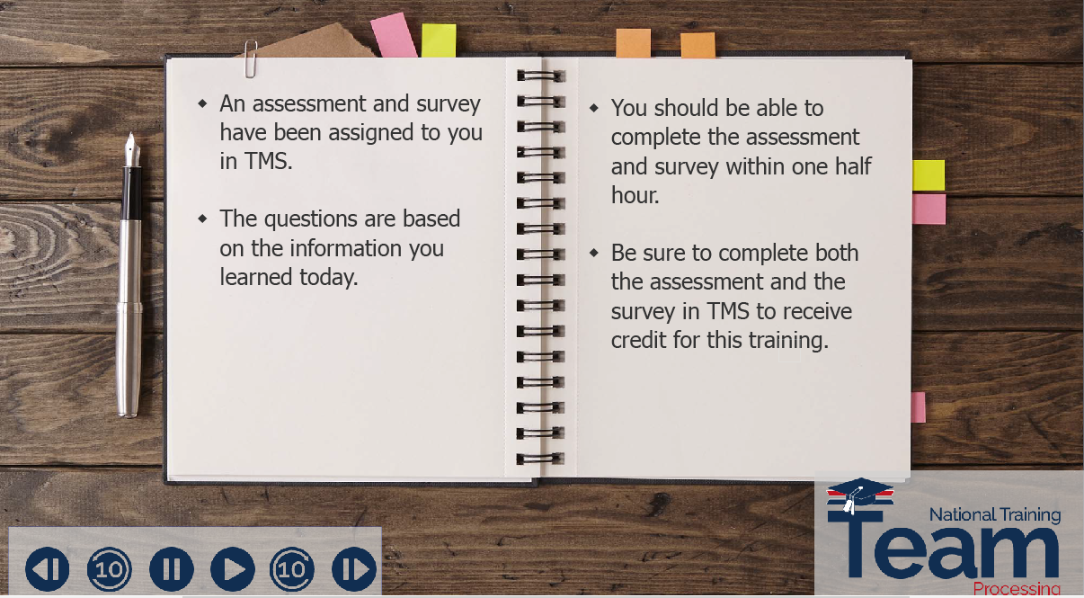 | TMS Assessment and Survey  This concludes our overview of Public Law 116-315, Section 1010. This training will be followed by an assessment and survey in TMS.  The assessment will be based on the information you were provided today.  You should be able to complete this training, the assessment, and the survey within one half hour.  Be sure to complete the assessment and survey in TMS to receive credit for this training.
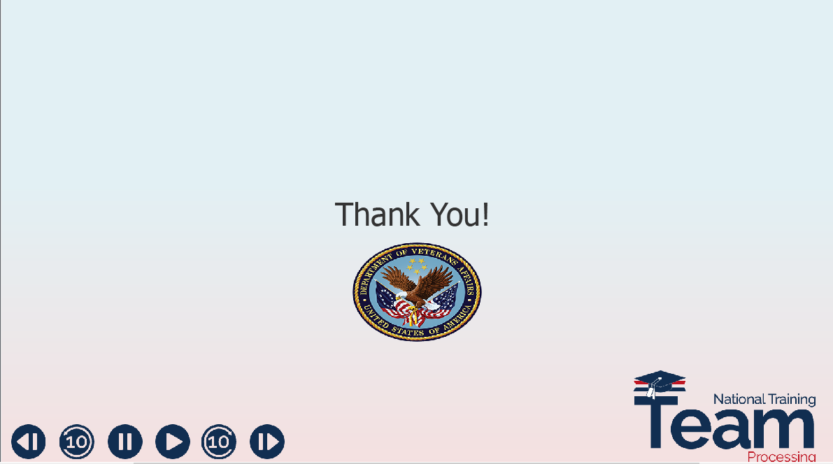 | End  Thank you!  Please click the logo to exit the training.

