Training Module Script – VCE Scenarios
Isakson & Roe: Section 1010 Retro Payment Training
Storyboard | Script
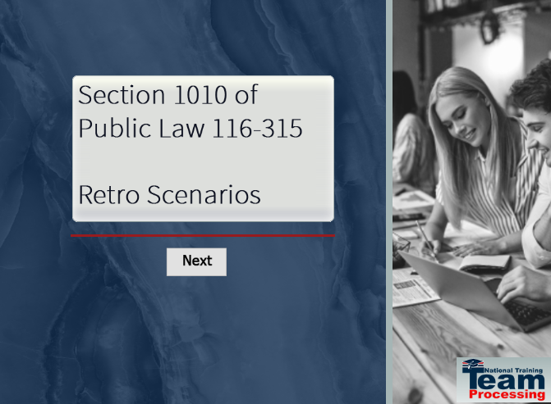 | Retro Payment Scenario Training Section 1010: VCEs  Welcome to the training module for section 1010 of Public Law (PL) 116-315, the Johnny Isakson and David P. Roe, M.D. Veterans Health Care and Benefits Improvement Act of 2020.  In today’s training, you will see two examples of how newly submitted terms, for a period prior to a current enrollment (retro), are processed in the Long Term Solution (LTS).  Please note, the examples you will see during this training were processed in a test system. All names and claim numbers you see are fictitious and do not belong to actual beneficiaries. No personally identifiable information (PII) is contained in this training.  Click Next to continue.
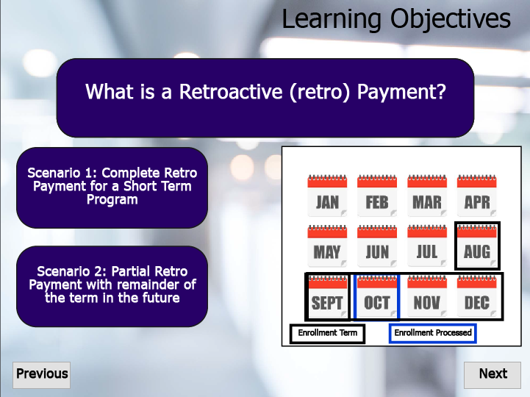 | Learning Objectives  Before we dive in, what is a retro payment?  Retroactive payments generally occur when an enrollment certification is processed after the enrollment period is completed. Please note rules regarding one-year time limits are applicable.  When the beneficiary is due housing/kicker payments, a lump sum payment will be issued as an 06I and displayed on the work product summary page.  At the end of this lesson, you will understand how a section 1010 retro payment is processed in LTS. This training will take a deep dive into two retro payment scenarios.  The first scenario describes what will take place in LTS when an enrollment certification is received for a term which occurred entirely in the past.  The second scenario describes what will take place in LTS when an enrollment certification is processed, and a portion of the term is in the past.  Click Next to continue.
 | Transition to Scenario 1  Now, let’s get started on the training! Please select Scenario 1 to view the demonstration in LTS.
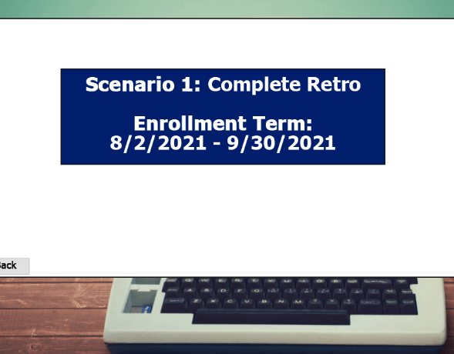 | Scenario #1:  The first scenario will demonstrate how LTS will process a section 1010 enrollment entered currently for a term solely in the past.  The beneficiary’s term date will be from August 2nd, 2021, to September 30th, 2021.  Scenario:  Since the complete term was prior to processing in LTS, the Work Product Summary page will display an 06I payment for all Housing and Kicker benefits due for the term. Verification will not be required.  Entering a retroactive enrollment will result in the LTS automatically processing the enrollment verification.  When viewing the Verification of Enrollment page, you will see the Previous Verified Through Date under the Current Verification Details remains blank and the Update Verification grayed out. Because the term was in the past, LTS automatically verifies the beneficiary’s enrollment, therefore, there is no Source of Previous Verification.  Click Next, to navigate back to the original screen and move on to scenario two.
 | Transition to Scenario 2  Now, let’s move on to the next scenario! Please select Scenario 2 to view the demonstration in LTS.
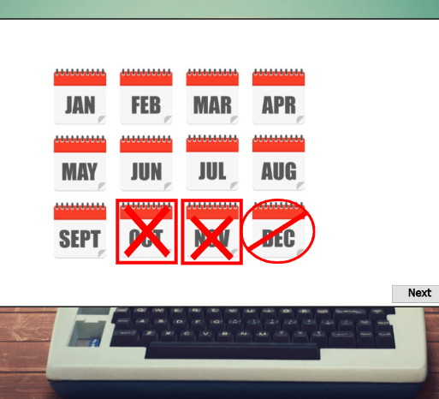 | Scenario #2:  The second scenario will demonstrate processing an enrollment certification received for a term with 2 months of the term in the past.  The beneficiary’s term will be from August 1^{st,} 2021, to December 15th, 2021.  Scenario:  In this scenario, because the term spans the date the enrollment was processed in LTS, housing and kickers will be processed in two different and distinct ways. For the period prior to the processing date (August and September), an 06I Lump Sum Payment will be created and released to the beneficiary without requiring verification.  For the current and future months, lump sum payments will be scheduled to be released at the end of the month, if the beneficiary properly verifies their enrollment.  In LTS, under Lump Sum Payments we can see the 06I payments Send to BDN and the future schedule payments in the Work Product Summary page.  The Verification of Enrollment screen will display the current and remaining months as Scheduled Automatic Payments under Unverified Periods.  The Previous Verified Through Date under the Current Verification Details remains blank and the Update Verification grayed out. Because the term was in the past, LTS automatically verifies the beneficiary’s enrollment, therefore there is no Source of Previous Verification.  If the beneficiary fails to verify their enrollment for two consecutive months, then their housing and/or kickers will be put on hold.  Click Next to continue.
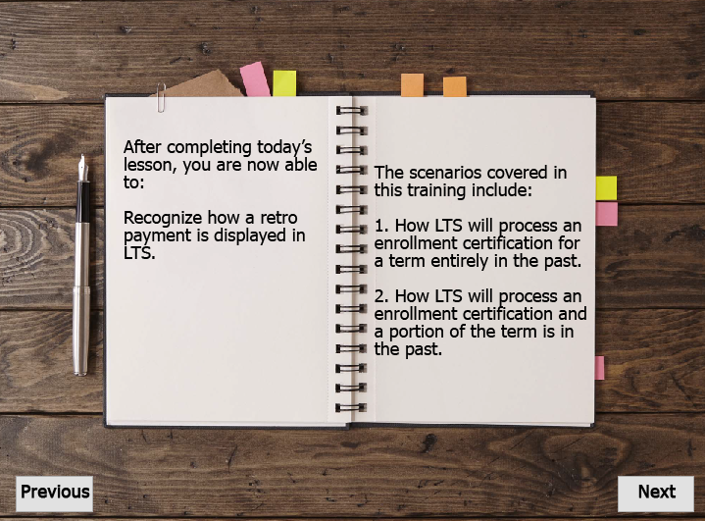 | Summary  After completing today's lesson, you are now able to understand how a retro payment term is processed in LTS.  The scenarios covered in this training include:  How LTS will process an enrollment certification for a term entirely in the past.  And  How LTS will process an enrollment certification and a portion of the term is in the past.  Click Next to continue.
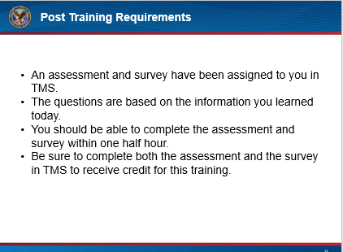 | Post Training Requirements  This concludes our training on Public Law 116-315, Section 1010 Retro Payments. This training will be followed by an assessment and survey in TMS.  The assessment will be based on the information you were provided today.  You should be able to complete the assessment, and the survey within one half hour.  Be sure to complete the assessment and survey in TMS to receive credit for this training.  Click Next to continue.
 | Wrap Up  If there are any additional questions or scenarios requiring further guidance, follow local procedures for submitting an inquiry to the National Training Team- Processing.  Click Exit, to complete this training.

