PowerPoint Slides | Instructor Activities
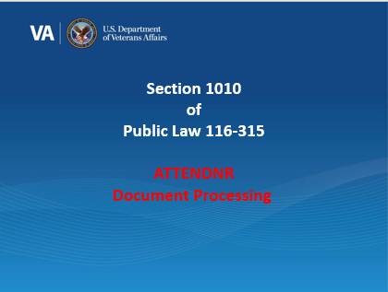 | Welcome to the training module for section 1010 of Public Law (PL) 116-315, the Johnny Isakson and David P. Roe, M.D. Veterans Health Care and Benefits Improvement Act of 2020.  In today’s training, you will learn how to handle the processing of the New TIMS “ATTENDNR” document.  Click Next to continue.
 | At the end of this lesson, you will be able to accurately process ATTENDNR TIMS documents, recognize the accompanying Payment Status in LTS, and generate the “We Need You to Verify Your Enrollment Letter” to be sent to the beneficiary.  Click Next to continue.
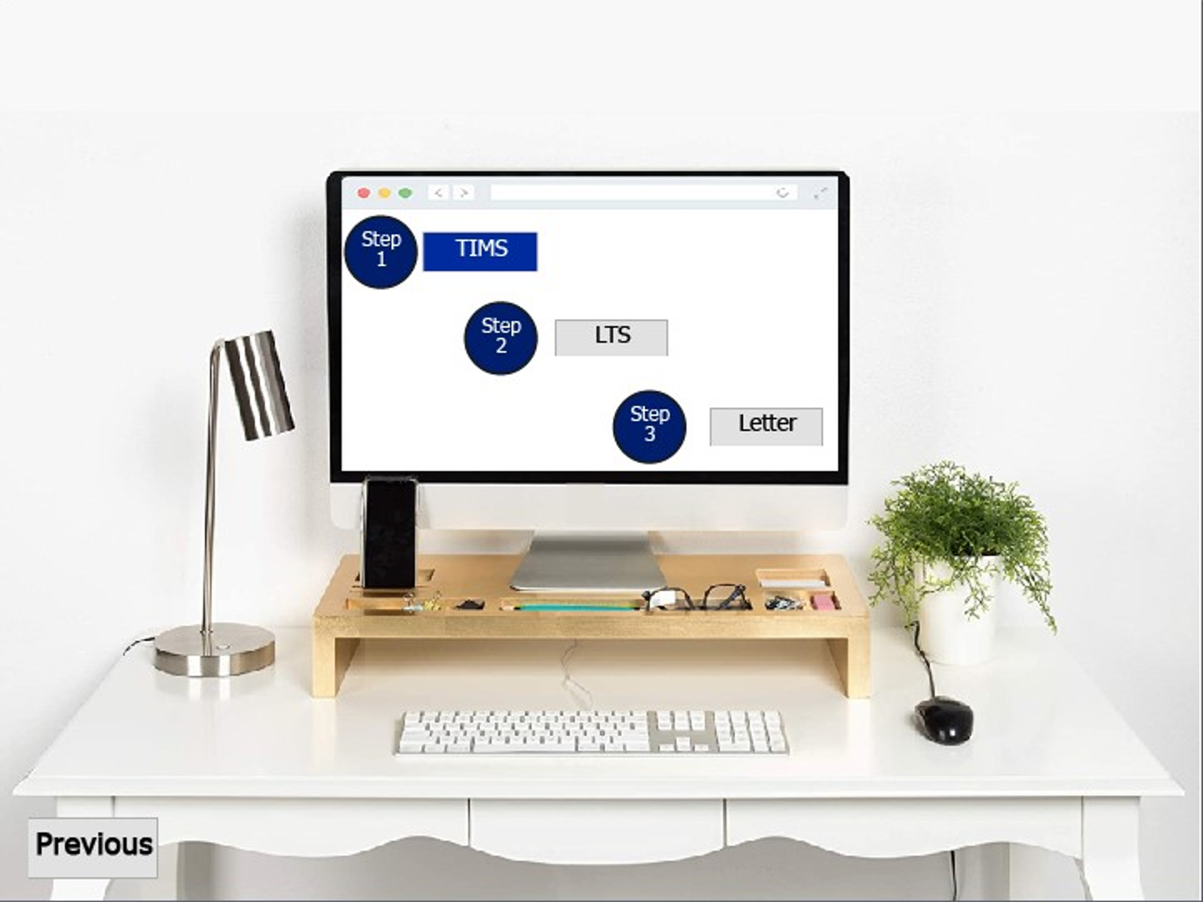 | Before we get started on how to process these documents, let’s discuss what the ATTENDNR Document Type is and when you will see it in a beneficiary’s TIMS file.  Select Step 1 to view the new document type.
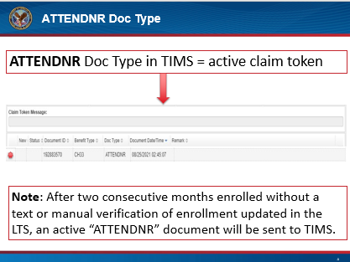  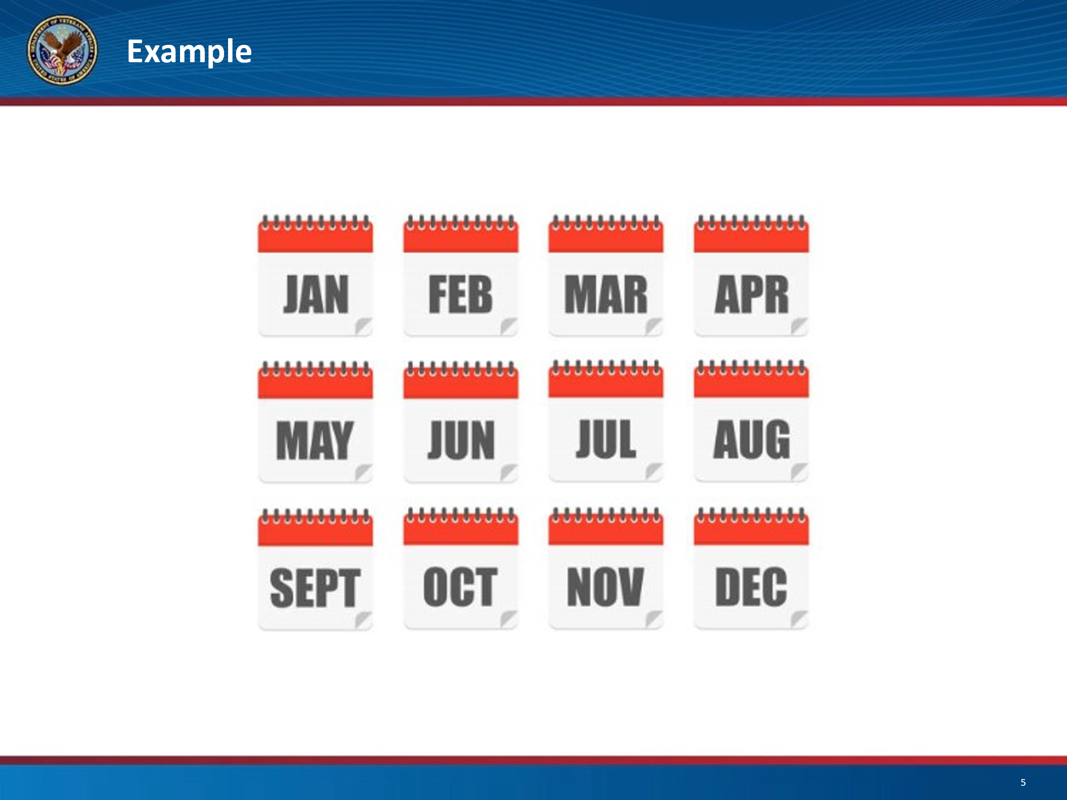  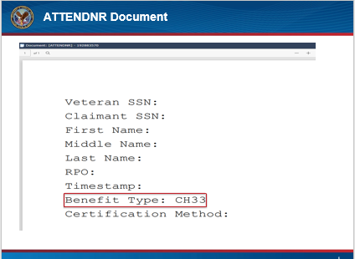 | The ATTENDNR document type is a document sent to a beneficiary’s TIMS file, creating an active claim token when a beneficiary is currently enrolled in a term eligible for housing and/or kicker payments but the beneficiary fails to verify their enrollment for two consecutive months.  For example, if a beneficiary is enrolled in a term which began in August of 2021, and they failed to verify their enrollment for August and September, an ATTENDNR document would be sent to the TIMS file in October, the month following the second consecutive failed verification of enrollment. In addition to the ATTENDNR document being sent, any monthly housing allowance and/or kicker payments due for the month of October and beyond would be put on hold pending verification of enrollment by the beneficiary.  Now, let’s take a closer look at the ATTENDNR document.  Once the ATTENDNR TIMS document has been opened, refer to the benefit type and confirm the pending enrollment verification is for a chapter 33 claim. If the benefit type is for STEM, please route it to the STEM BUFFALO queue.  Click next, to navigate back to the original screen and move on to Step 2.
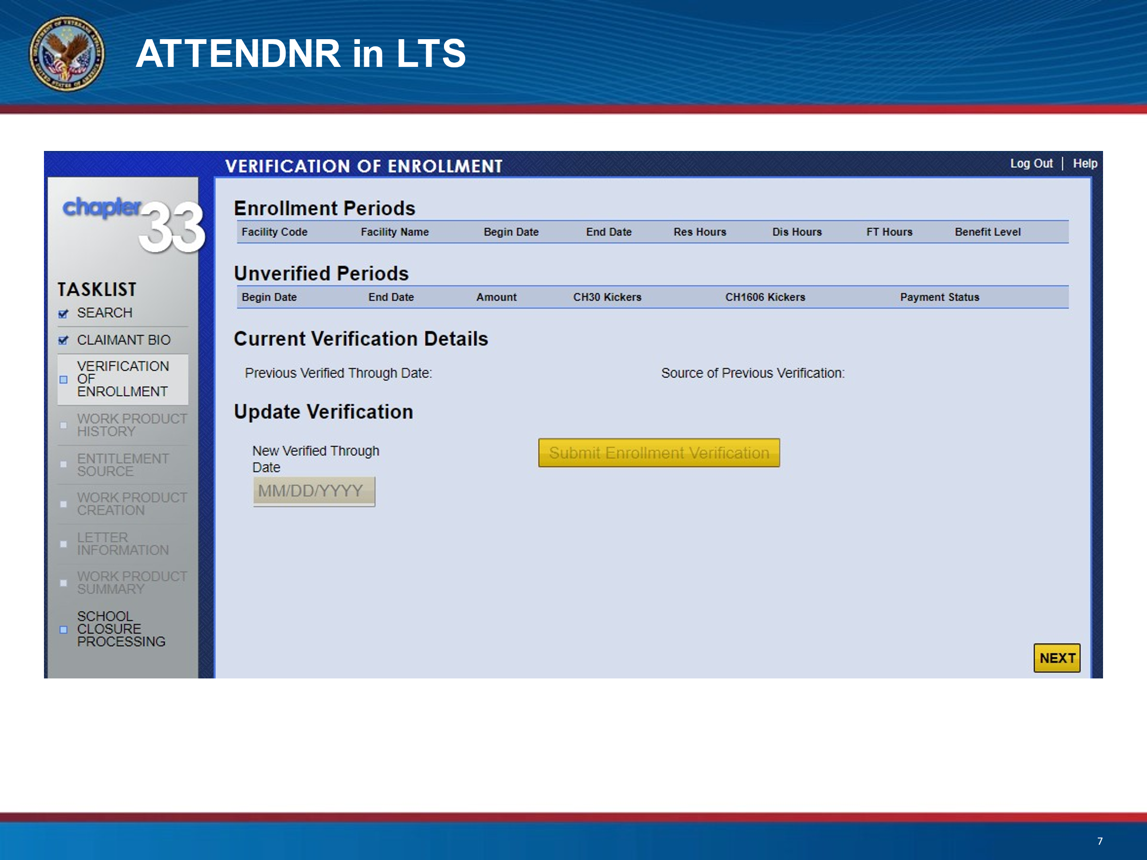  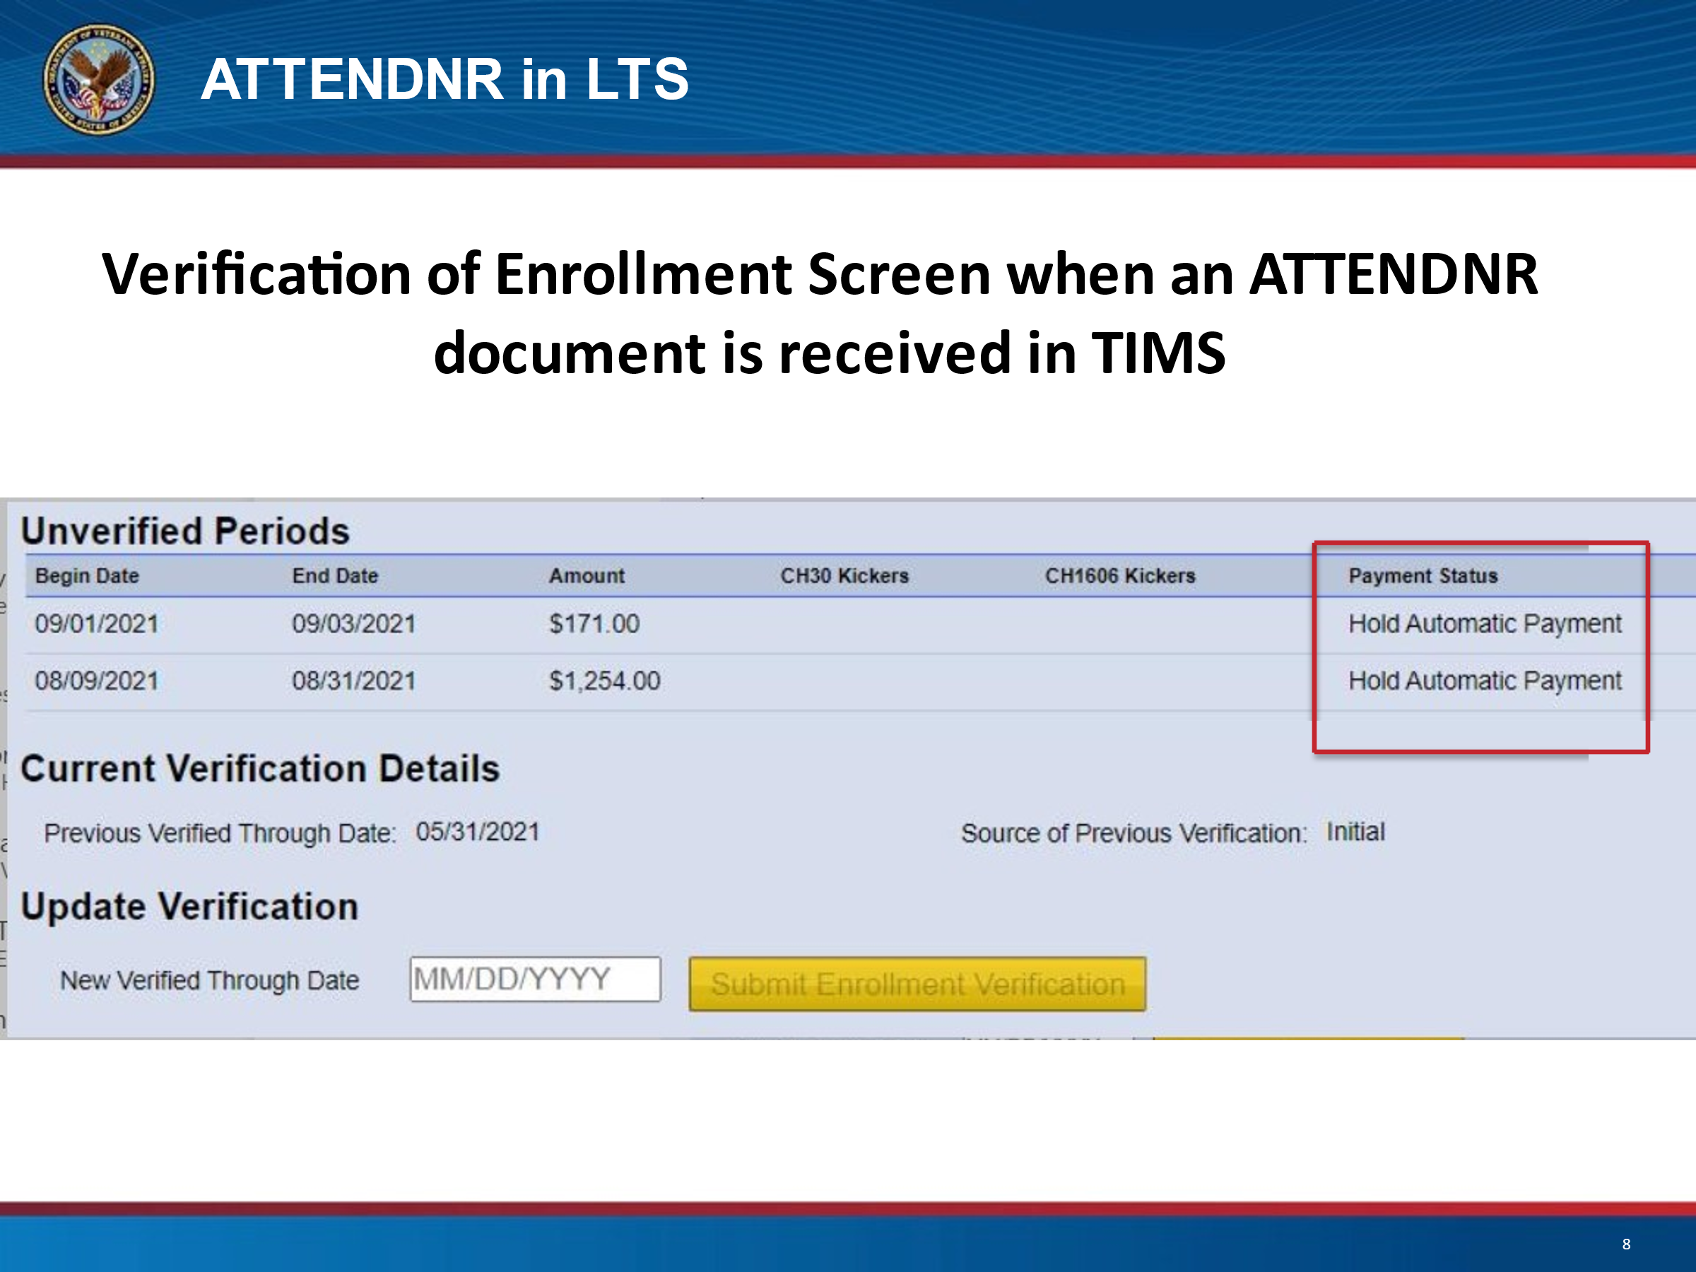 | When an ATTENDNR document is received, it will update the payment status on the Verification of Enrollment screen in LTS. Payments listed under “Unverified Periods” will display a payment status of “Hold Automatic Payment”.  As stated earlier, payments are held pending verification of enrollment.  To view accompanying payment status in LTS, you must navigate to the Verification of Enrollment screen from the Task list, as it is independent of a work product.  Click next, to navigate back to the original screen and move on to Step 3.
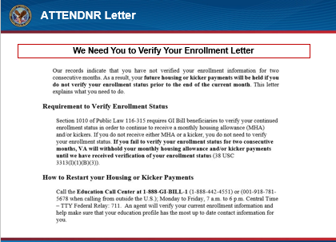 | After verifying the ATTENDNR document is for chapter 33 benefits, create and send the “We Need You to Verify Your Enrollment Letter” found in the attachment section of the procedural advisory located in the hyperlink box on the right side of the screen.  Capture the letter into TIMS and finish the claim token. VCEs may be granted excluded time at their supervisor’s discretion for processing ATTENDNR documents when no other end product credit can be claimed. VCEs should coordinate with their immediate supervisor to request excluded time. Supervisors should consider and approve in accordance with local guidelines.  Please note: ATTENDNR documents require no processing actions in LTS.  Click Next to continue.
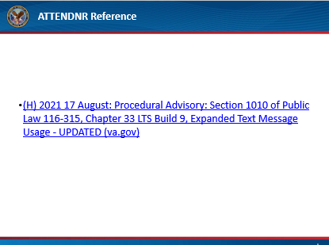 | Here are the references used in today’s presentation.  Click Next to continue.
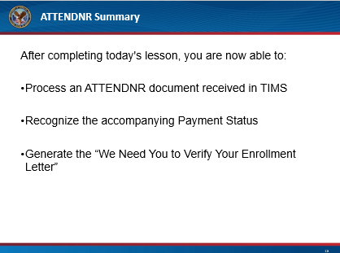 | After completing today's lesson, you are now able to accurately process ATTENDNR TIMS documents, recognize the accompanying Payment Status in LTS, and generate the “We Need You to Verify Your Enrollment Letter” to be sent to the beneficiary.  Click Next to continue
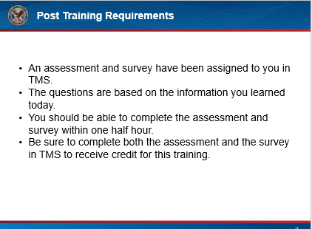 | This concludes our training on Public Law 116-315, Section 1010 ATTENDNR document processing. This training will be followed by an assessment and survey in TMS.  The assessment will be based on the information you were provided today.  You should be able to complete the assessment, and the survey within one half hour.  Be sure to complete the assessment and survey in TMS to receive credit for this training.  Click Next to continue.
 | If there are any additional questions or scenarios requiring further guidance, follow local procedures for submitting an inquiry to the National Training Team- Processing.  Click Exit, to complete this training.

