Education Service
Section 1010 of Public Law 116-315 Monthly Enrollment Verification (NCD)
July 2021
Version 1.0

Lesson Overview
Topic | Description
Time Estimate: | 1 hour
Purpose of the Lesson: | The purpose of this lesson is to give a high-level overview regarding P.L. 116-315, section 1010.
Prerequisite Training Requirements: | N/A
Target Audience: | VCEs, Senior VCEs, Lead, EQTS, ECCT & ECM
Lesson References: | - H.R.7105 - Johnny Isakson and David P. Roe, M.D. Veterans Health Care and Benefits Improvement Act of 2020  - Section 3313 of title 38 -Educational assistance: amount; payment  - (D) 2021 15 April: Policy Advisory:The Post-9/11 GI Bill and Section 1010 of Public Law (P.L.) 116-315, Johnny Isakson and David P. Roe, M. D., Veterans Health Care and Benefits Improvement Act of 2020.
Lesson Objectives: | - Understand the provisions of section 1010 of P.L. 116-315 and the potential impact it will have on a beneficiary's monthly benefit payment.  - Explain how a beneficiary can verify their monthly enrollment.  - Identify the changes made to the LTS system to support the implementation of section 1010.
What You Need: | N/A
Post Training Requirements: | Upon completion of this training, participants are required to complete an online lesson assessment and survey in Talent Management System (TMS).  To demonstrate successful completion of the lesson participants must pass the assessment with a score of at least 80%.  Participants must also complete the online survey to earn credit for completion of the lesson.

PowerPoint Slides | Instructor Activities
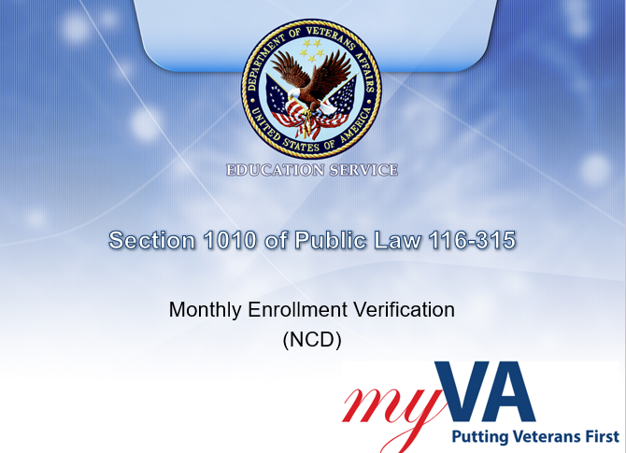 | DISPLAY slide  Welcome to the training module for section 1010 of Public Law 116-315, the Johnny Isakson and David P. Roe, M.D. Veterans Health Care and Benefits Improvement Act of 2020. This law will be implemented in phases. The first phase is for beneficiaries enrolled at Non-College Degree (NCD) facilities who are enrolled in terms or programs beginning August 1, 2021, or later. Additional phases will include those enrolled in training at an Institutions of Higher Learning (IHL).  In today’s training, you will learn how the implementation of section 1010 will impact beneficiaries and the new process for verifying monthly enrollments.  Click next to continue
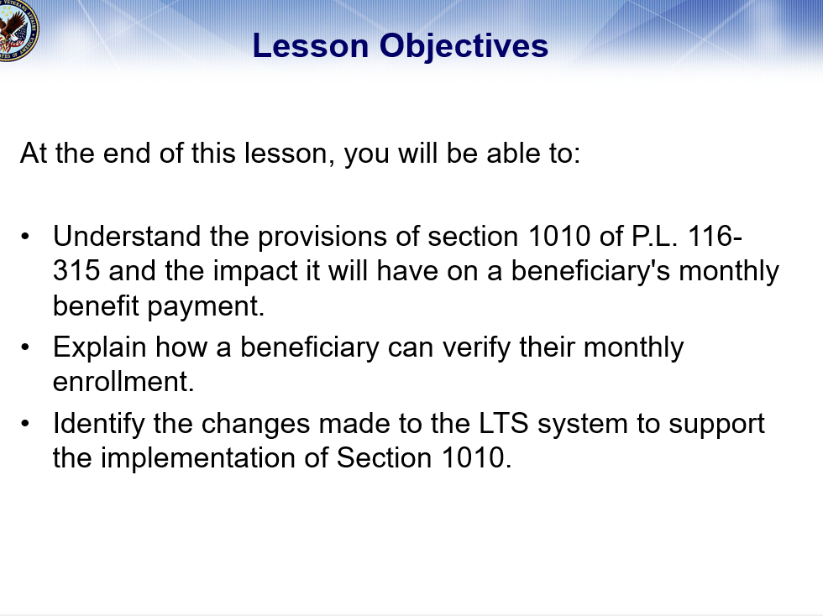 | DISPLAY slide  At the end of this lesson, you will be able to understand the provisions set forth by section 1010 of P.L. 116-315 and the impact it will have on a beneficiary's monthly benefit payment when attending a NCD (non-college degree) facility. You will be able to explain how a beneficiary can verify their monthly enrollment to avoid interruption of their monthly housing/kicker payments and you will be able to identify the changes made to the LTS (Long Term Solution) to support the implementation of Section 1010.  Click next to continue
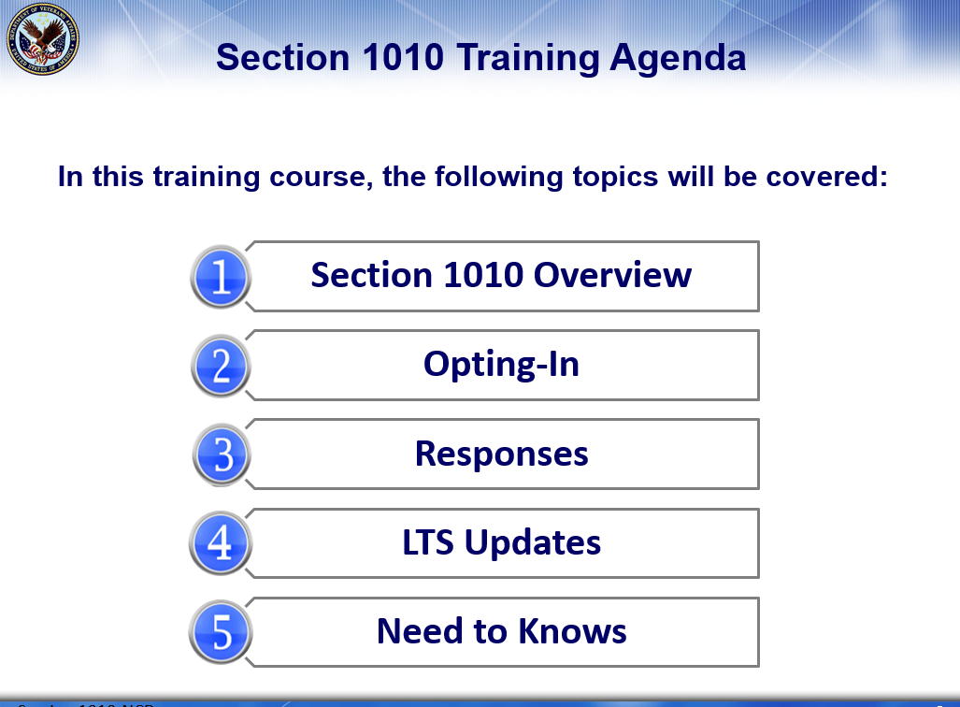 | DISPLAY slide  In this training course, we will cover: An overview of section 1010, how beneficiaries can opt-in to text messages, what procedures you will need to follow once a response is received or not received, the updates made to the LTS system, and some additional changes.  Click next to continue
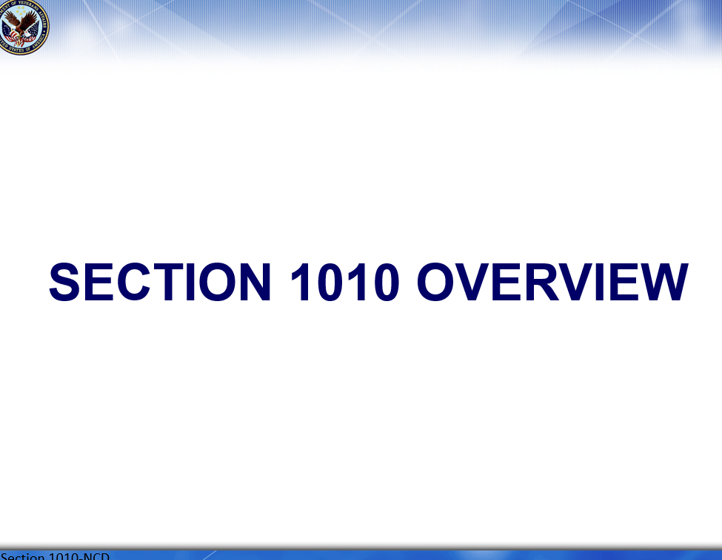 | DISPLAY slide  The first topic is an overview of Section 1010 of P.L. 116-315.  Click next to continue
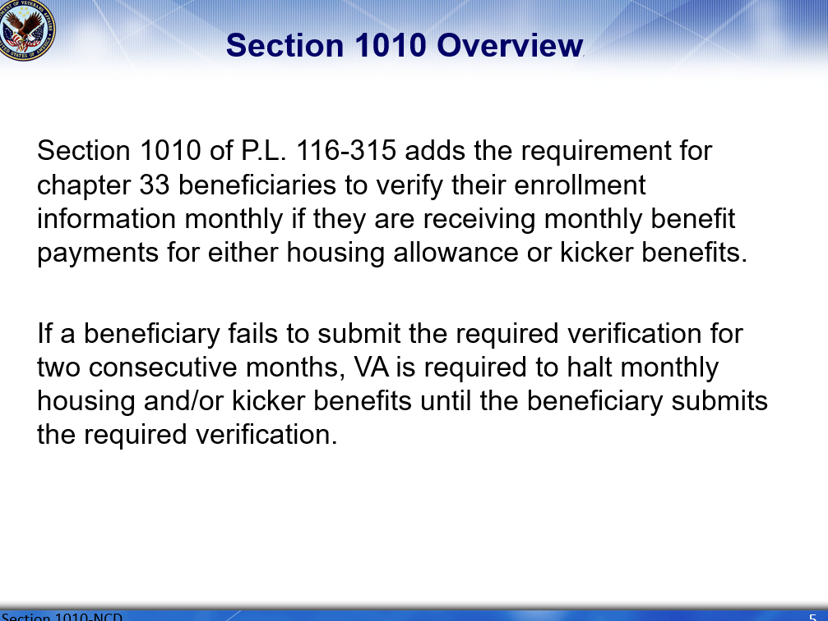 | DISPLAY slide  Section 1010 of P.L. 116-315 adds the requirement for chapter 33 beneficiaries to monthly verify their enrollment information if they are receiving monthly housing allowance or kicker payments.  If a beneficiary fails to submit the required verification for two consecutive months, VA is required to hold monthly housing and/or kicker payments until the beneficiary submits the required verification.  Click next to continue
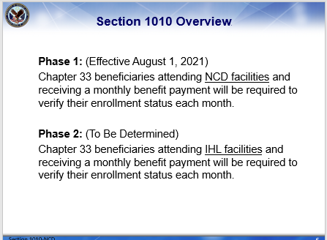 | DISPLAY slide  Previously, chapter 33 beneficiaries did not have to verify their enrollment monthly in order to receive their monthly housing and/or kicker payment. In order to comply with the new legislation defined under section 1010, effective August 1, 2021, chapter 33 beneficiaries attending NCD facilities and receiving a monthly benefit payment will be required to verify their enrollment status each month. Subsequently, for Phase 2, chapter 33 beneficiaries attending IHL facilities and receiving a monthly benefit payment will be required to verify their enrollment status each month.  Click next to continue
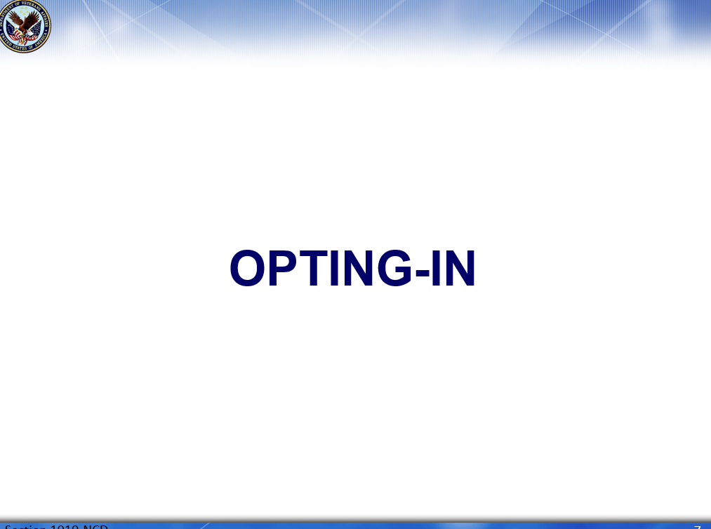 | DISPLAY slide 7.  Let’s discuss how opting-in to receive text messages regarding monthly enrollment verifications will help beneficiaries to stay on track with receiving their benefit payments.  Click next to continue
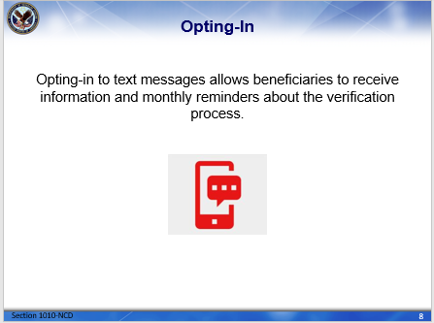 | DISPLAY slide 8.  Beneficiaries now have the opportunity to choose to opt-in to text messages. Text messaging will allow the beneficiaries to receive information regarding their chapter 33 benefits and reminders for the monthly verification process.  Click next to continue
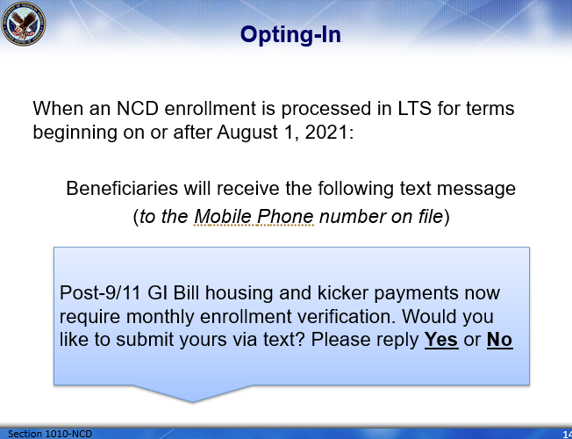 | DISPLAY slide 9.  When an NCD enrollment period is processed in the LTS for terms beginning on or after August 1, 2021, a text message will be released to the Mobile Phone number on the LTS Claimant BIO Screen. This message says:  “Post-9/11 GI Bill housing and kicker payments now require monthly enrollment verification. Would you like to submit yours via text? Please reply Yes or No.”  (Please note this functionality will not be available for terms which begin prior to or span August 1, 2021.)  Click next to continue
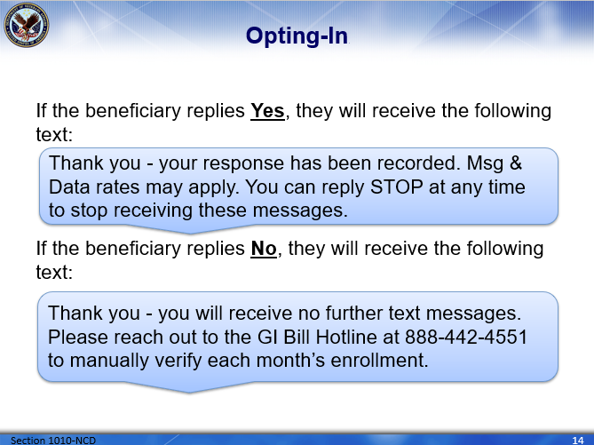 | DISPLAY slide 10.  If the beneficiary replies Yes, they will receive the following text: “Thank you - your response has been recorded. Msg & Data rates may apply. You can reply STOP at any time to stop receiving these messages.”  If the beneficiary replies No, they will receive the following text: “Thank you - you will receive no further text messages. Please reach out to the GI Bill Hotline at 888-442-4551 to manually verify each month’s enrollment.”  Click next to continue
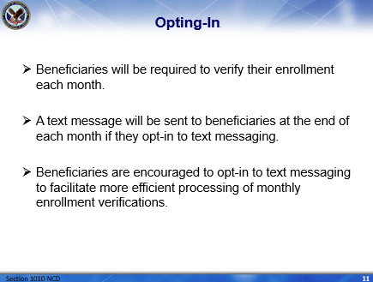 | DISPLAY slide 11.  So, what can beneficiaries expect after opting-in to text messages? At the end of each month, a text message will be sent reminding the beneficiaries they must verify their enrollment status. Beneficiaries are encouraged to opt-in to text messaging to facilitate more efficient processing of monthly enrollment verifications.  Click next to continue
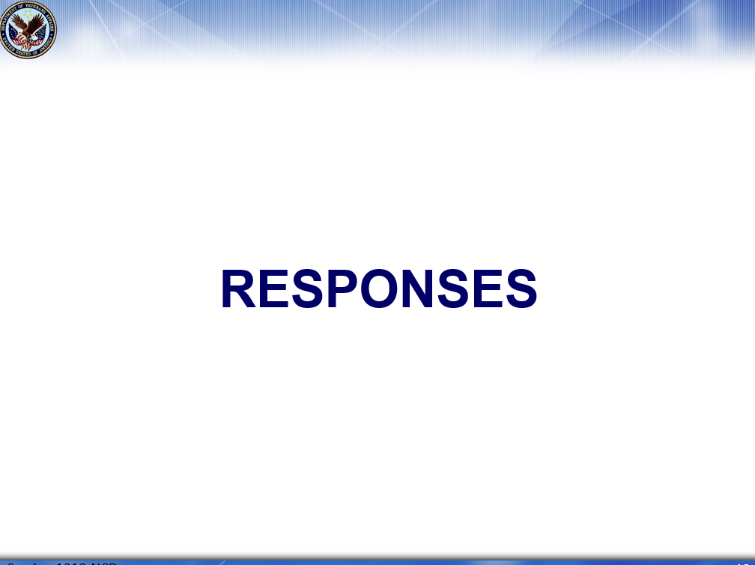 | DISPLAY slide 12.  Now that we understand the opt-in process, let’s discuss the procedures needed for each specific response. In some situations, a failure to respond also requires action.  Click next to continue
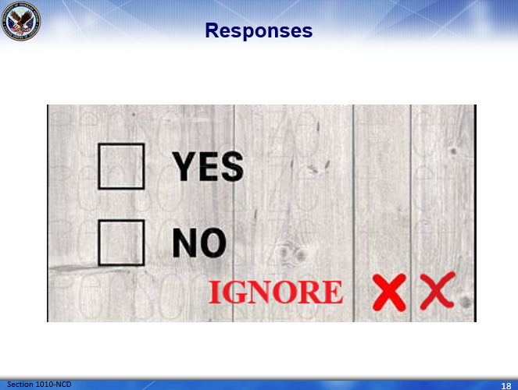 | DISPLAY slide 13.  Different actions are required depending how and whether the beneficiary responds to the text message.  Some responses will result in full automation while others will require VCE intervention. Next, we will take a deeper dive into the process and procedures of each.  Click next to continue
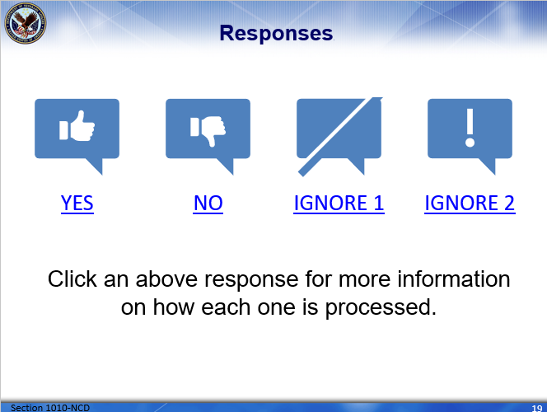 | DISPLAY slide 14.  On this slide, you will see the four (4) possible responses which may be received from the beneficiary when verifying their enrollment status. It should be noted, a response of “No” is considered a response and specific action is required for this scenario.  Click each of the responses for more information.
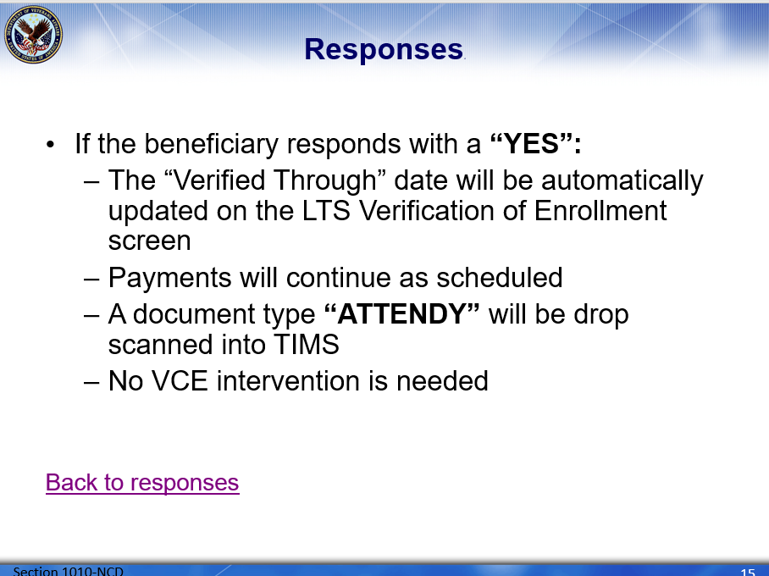 | DISPLAY slide 15.  If the beneficiary responds to the enrollment verification text message with a “YES”  - The “Verified Through” date will be automatically updated on the LTS Verification of Enrollment screen  - Payments will continue as scheduled  - A document type “ATTENDY” will be drop scanned into TIMS  - No VCE intervention is needed  Click back to responses to review the next possible response.
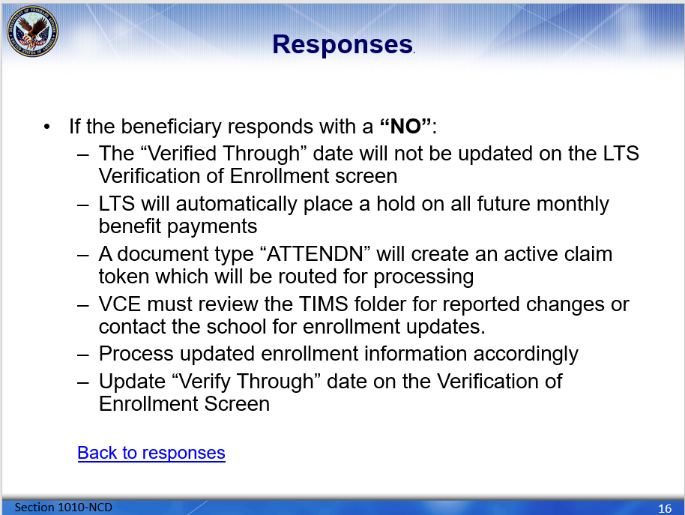 | DISPLAY slide 16.  If the beneficiary responds to the enrollment verification text message with a “NO”  - The “Verified Through” date will not be updated on the LTS Verification of Enrollment screen  - LTS will automatically place a hold on all future monthly benefit payments  - A document type “ATTENDN” will create an active claim token which will be routed to the chapter 33 supplemental queue(s) for processing.  - The VCE must review the TIMS folder for reported changes in enrollment.  - If changes are found, process and authorize accordingly. Navigate to the Verification of Enrollment screen and update the “Verify Through” date which will release the payments from the hold status.  - If changes are not found, the VCE will need to contact the school to request the updated enrollment information. Once the updated information is obtained, process and authorize accordingly Navigate to the Verification of Enrollment screen and update the “Verify Through” date which will release the payments from the hold status.  Remember, the “NO” response is considered an enrollment verification and upon clarifying the change, can be used to verify the enrollment status.  Click back to responses to review the next possible response.
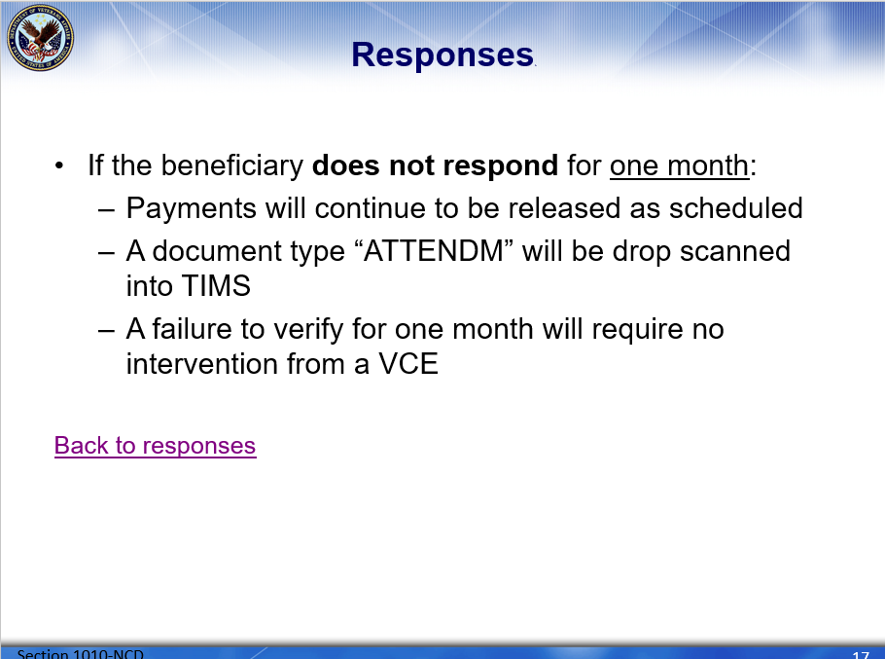 | DISPLAY slide 17.  If the beneficiary fails to verify for one month, payments will continue to be released as scheduled.  A document type “ATTENDM” will be drop scanned into TIMS  A failure to verify for one month will require no intervention from a VCE.  Click back to responses to review the next possible response.
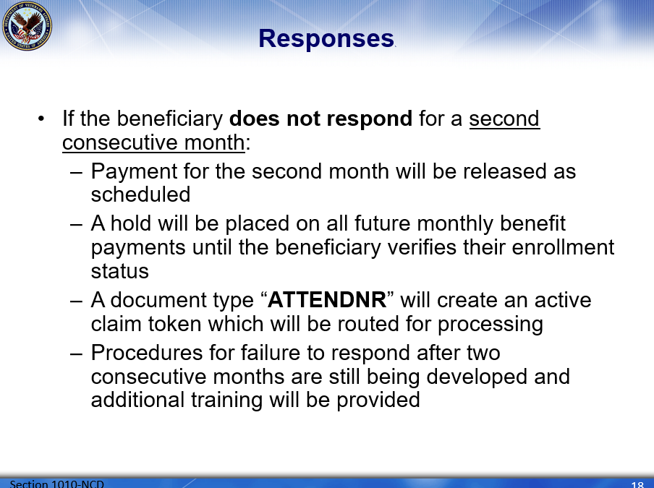 | DISPLAY slide 18.  If the beneficiary fails to verify for a second consecutive month, payment for the second month will be released as scheduled. However, a hold will be placed on all future monthly benefit payments until the beneficiary verifies their enrollment status.  A document type “ATTENDNR” will create an active claim token which will be routed to the chapter 33 supplemental queue(s) for processing.  Procedures for failure to respond after two consecutive months are still being developed and additional training will be provided.  Click next to continue
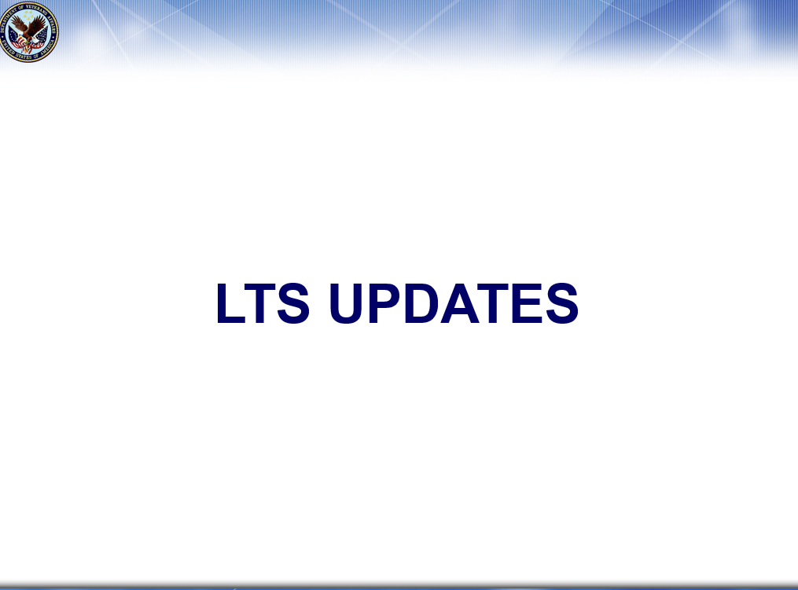 | DISPLAY slide 19.  In order to comply with P.L. 116-315, section 1010, LTS required a few additional updates. Now we will review the updates made to LTS specifically for section 1010.  Click next to continue
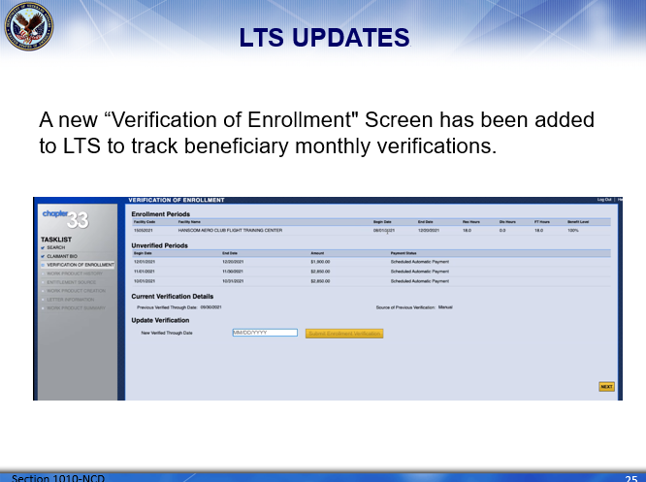 | DISPLAY slide 20.  Up first, a new “Verification of Enrollment" Screen has been added to LTS to track beneficiary monthly verifications. This screen is intended to be a one-stop-shop of information when reviewing the beneficiary’s monthly verification of enrollments.  Click next to continue
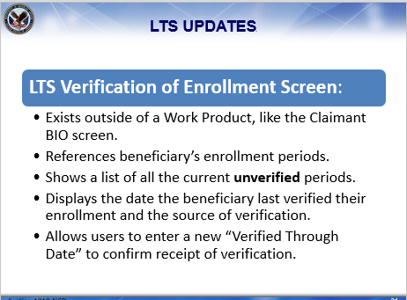 | DISPLAY slide 21.  The new LTS “Verification of Enrollment” screen exists outside of a Work Product, just like the Claimant BIO screen. It references the beneficiary’s enrollment periods which have been processed in LTS. This screen displays a list of all the current unverified periods and the payment status of each. It is important to understand if a period is listed under the “unverified period” section of this screen, it will need to be verified regardless of the payment status in order to prevent holds from being placed on future payments. This new screen also shows the date the beneficiary last verified their enrollment status as well as, specifies the source of the verification. The source of verification will be text if the beneficiary responded to the monthly verification text or it will be manual if it was updated through manual processing in LTS.  To update the verification of enrollment screen manually, authorized users are able to enter a new “Verified Through Date” to update unverified periods and confirm receipt of the beneficiary’s enrollment verification.  Click next to continue
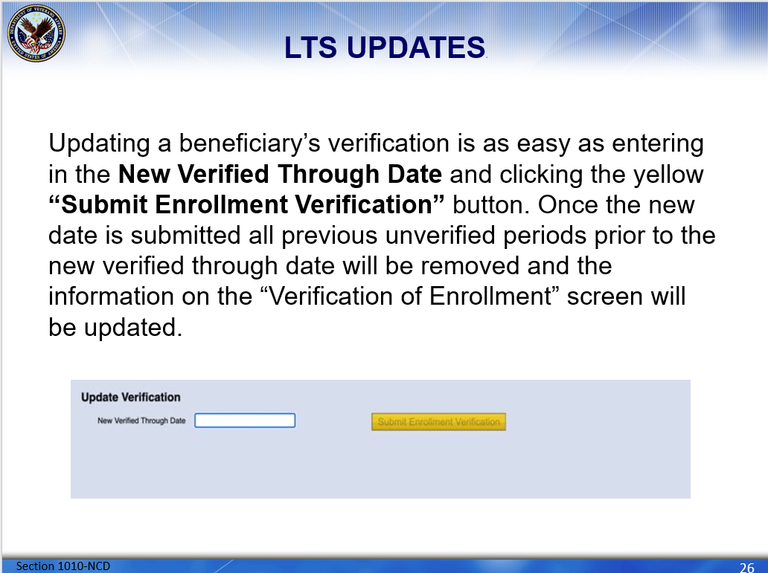 | DISPLAY slide 22.  Updating a beneficiary’s verification is as easy as entering in the New Verified Through Date and clicking the yellow “Submit Enrollment Verification” button. Once the new date is submitted, all previous unverified periods prior to the new verified through date will be removed and the information on the “Verification of Enrollment” screen will be updated.  Click next to continue
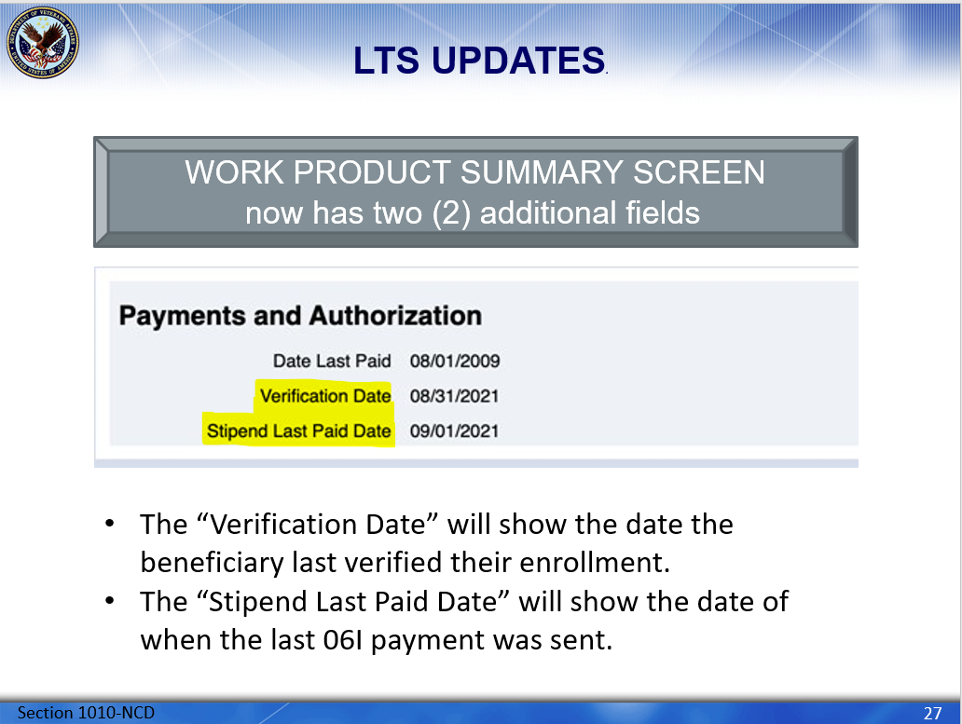 | DISPLAY slide 23.  The final LTS update we will cover in this training can be found on the LTS Work Product Summary screen. This screen has been updated to include two additional fields under the “Payments and Authorization” section. In addition to the “Date Last Paid” you will now see “Verification Date” and “Stipend Last Paid Date”. The “Verification Date” references the date the beneficiary last verified their enrollment and the “Stipend Last Paid Date” references the date of when the last 06I payment was sent.  Click next to continue
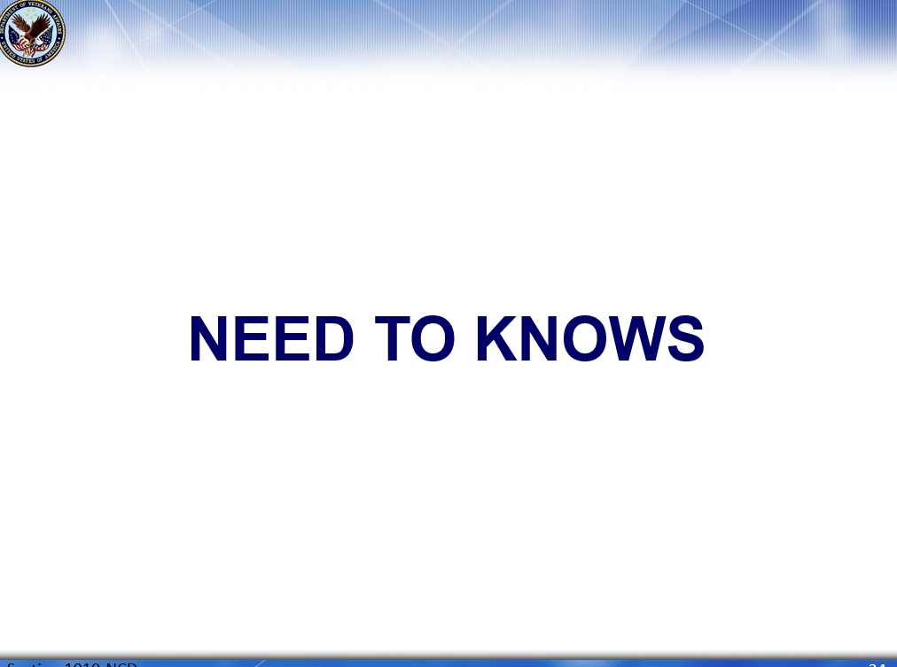 | DISPLAY slide 24.  Before we conclude today’s training, there are a few more very important rules and guidelines you will need to know when it comes to section 1010.  Click next to continue
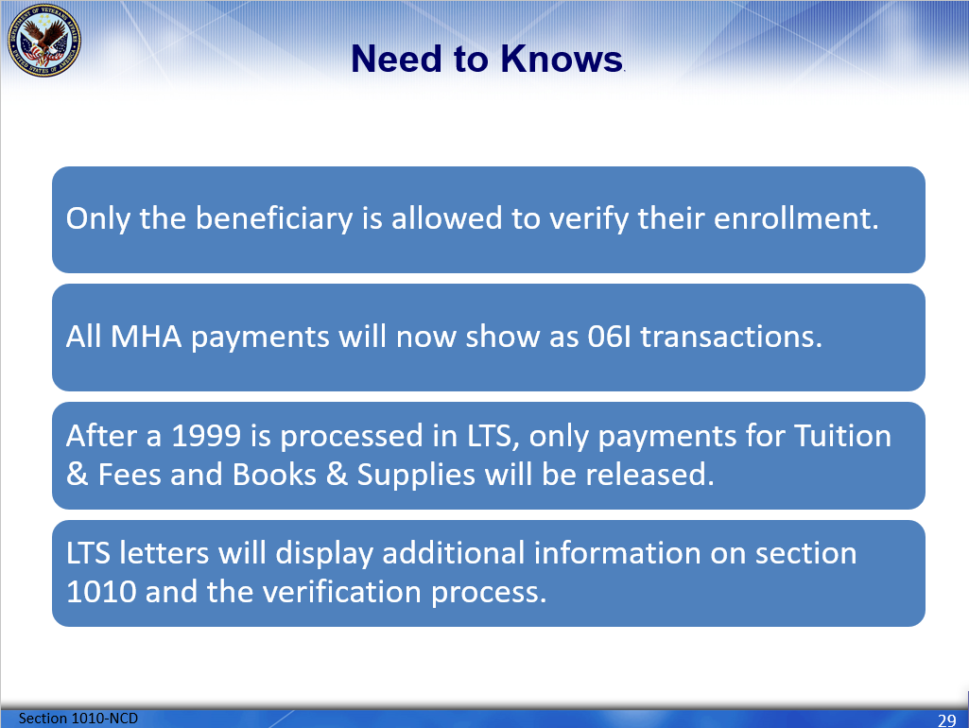 | DISPLAY slide 25.  - It is imperative to know that only the beneficiary is allowed to verify their enrollment. We cannot accept verification from an SCO or a third party.  - MHA payments will no longer show as 06H, all verified monthly enrollment housing payments will now show as 06I transactions.  - After an enrollment certification is processed in LTS, only the payments for Tuition & Fees and Books & Supplies will be released upon authorization, housing and kickers will have to be verified on the “Verification of Enrollment” screen.  - As of August 1, 2021, LTS letters will be updated with additional information on section 1010 and how the beneficiary can verify their enrollment.  Click next to continue
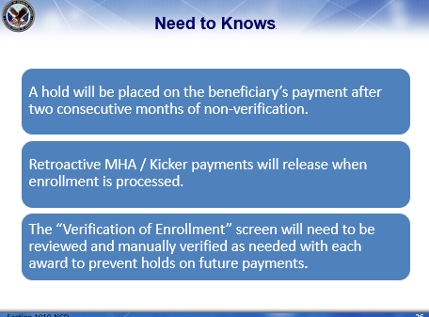 | DISPLAY slide 26.  - It is important to understand a hold will be placed on the beneficiary’s future monthly benefit payments after 2 consecutive months of non-verification.  - Retroactive housing/kicker payments will release once the enrollment is processed in LTS.  - Even though the retroactive payments were released when the enrollment was processed in LTS, the “Verification of Enrollment” screen will still need to be reviewed and manually verified as needed to prevent holds from being erroneously placed on future payments.  Click next to continue
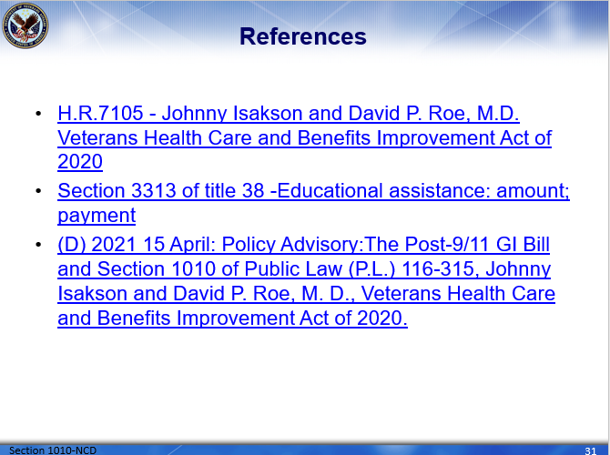 | DISPLAY slide 27.  Here are the references used in today’s presentation.  Click next to continue
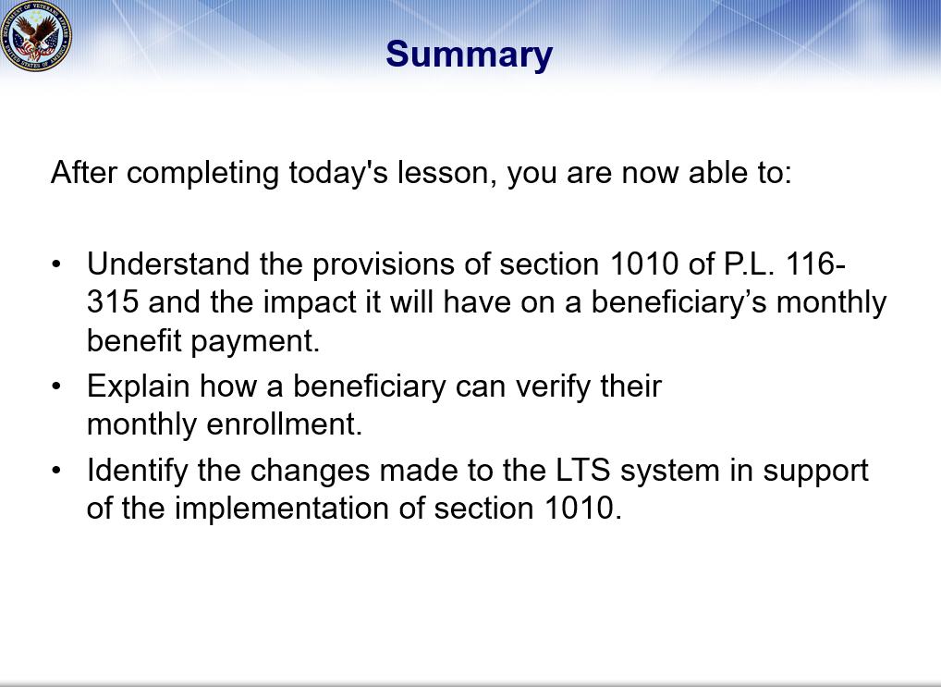 | DISPLAY slide 28.  After completing today's lesson, you are now able to: Understand the provisions of section 1010 of P.L. 116-315 and the impact it will have on a beneficiary’s monthly benefit payment. Explain how a beneficiary can verify their monthly enrollment and identify the changes made to the LTS system in support of the implementation of section 1010.  Click next to continue
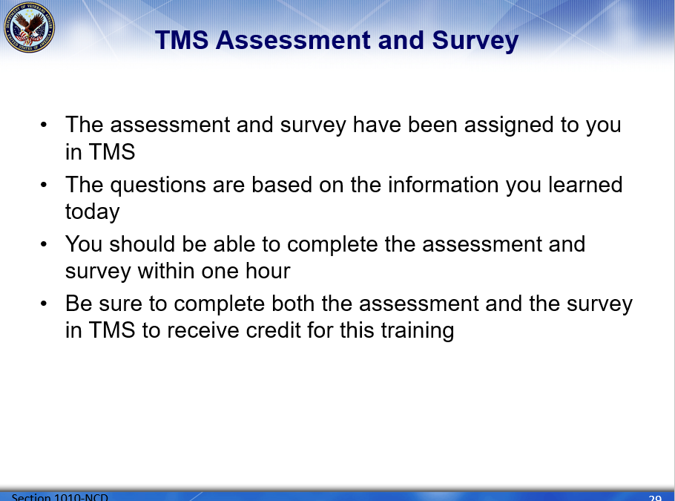 | DISPLAY slide 29.  This concludes our review of PL 116-315, Section 1010. This training will be followed by an assessment and survey in TMS.  The assessment will be based on the information you were provided today.  You should be able to complete this training, the assessment, and the survey within one hour.  Be sure to complete the assessment and survey in TMS to receive credit for this training.  Click next to continue
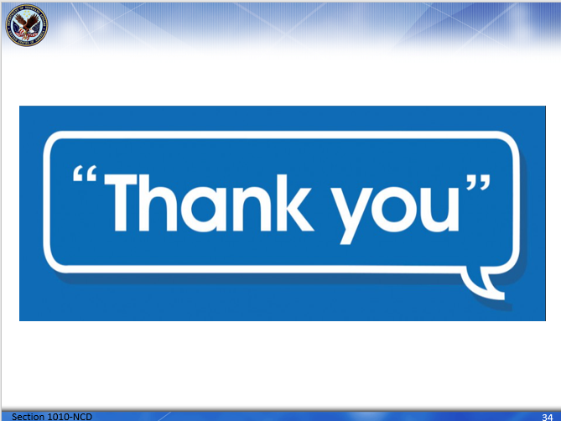 | DISPLAY slide 30.  Thank you!

