Education Service
Section 1010 of Public Law 116-315

Monthly Enrollment Verification (Opt-in/Opt-out Demo)

PowerPoint Slides | Instructor Activities
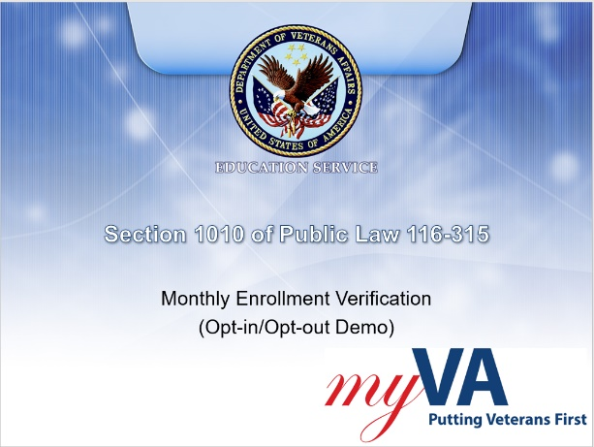 | DISPLAY slide  Welcome to the training module covering the LTS (Long Term Solution) enhancements made to assist with implementing section 1010 of Public Law 116-315 of the Johnny Isakson and David P. Roe, M.D. Veterans Health Care and Benefits Improvement Act of 2020. In today’s training, you will learn how to manually process requests for beneficiaries to opt in or opt out of text messaging for enrollment verification in LTS.  Please note the examples you will see during this training were processed in a test system. All names and claim numbers you see are fictitious and do not belong to actual beneficiaries. No personally identifiable information (PII) is contained in this training.
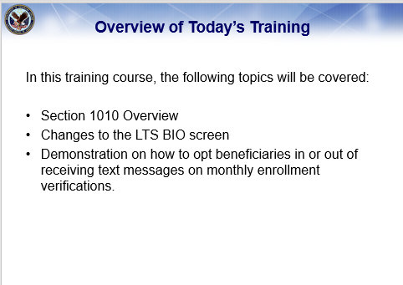 | DISPLAY slide  In this training course, the following topics will be covered:  An Overview of P.L. 116-315, section 1010. The changes made to the LTS BIO screen to help implement this law, and a step-by-step demonstration on how to opt beneficiaries in or out of receiving text messages on monthly enrollment verifications.
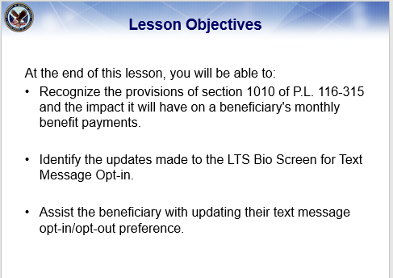 | DISPLAY slide  At the end of this lesson, you will be able to:  Recognize the provisions of section 1010 of P.L. 116-315 and the impact it will have on a beneficiary's monthly benefit payments.  Identify the updates made to the LTS Bio Screen for Text Message Opt-in,  and assist the beneficiary with updating their text message opt-in/opt-out preference.
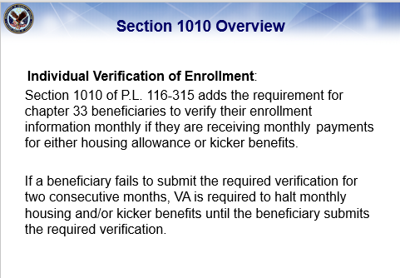 | DISPLAY slide  Section 1010 of P.L. 116-315 adds the requirement for chapter 33 beneficiaries to verify their enrollment information monthly, if they are receiving monthly payments for either housing allowance or kicker benefits.  If a beneficiary fails to submit the required verification for two consecutive months, VA is required to halt monthly housing and/or kicker benefits until the beneficiary submits the required verification.  Effective August 1, 2021, beneficiaries can opt-in to receive text messages and verify their enrollment each month via text.
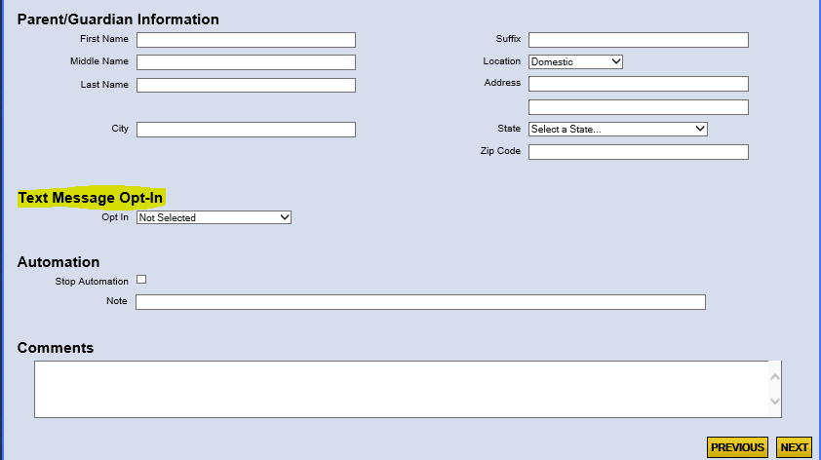 | DISPLAY slide  Previously, a Text Message Opt-in field was added to the LTS to support enrollment verification for STEM beneficiaries. This field is now available for all chapter 33 beneficiaries. The Text Message Opt-in field works in tandem with Twilio programming to allow automated text messages to be sent to beneficiaries.
DEMO | DISPLAY slide  - In this demo, we will review a scenario in which a beneficiary calls requesting to opt-in or out of text messaging for enrollment verification.  - Once you have completed the proper ID protocol, navigate to the “BIO” screen in LTS.”  - First, verify the contact information of the beneficiary.  - Are there any updates to the beneficiary’s mobile phone number, email address, or home address?  - Confirm the mobile phone number provided can receive text messages.  - Next, review the “Text Message Opt-In” field.  - Education Call Center Technicians (ECCTs) will only be able to choose the option “Yes” or “No” from the dropdown. Any additional options you see in the dropdown box are system-generated by Twilio.  - If the beneficiary requests to opt in to receive monthly text message updates on their enrollment verification, select “Yes” from the dropdown. Advise the beneficiary, enrollment verification will be deployed in phases. Beneficiaries enrolled in an NCD program at an NCD facility beginning on or after August 1, 2021, will begin receiving text messages once their enrollment has been processed. All other beneficiaries will begin receiving text messages as additional phases are implemented.  - Inform the beneficiary they will receive a text message on the final day of each month they are enrolled asking, “Did you remain enrolled in your courses for the corresponding month and year as certified?”  To save the updated contact information and text message preferences, click “Next” at the bottom of the bio screen.  - If the beneficiary wants to opt out of receiving text message updates for their monthly enrollment verifications, navigate to the Claimant Bio screen and select “No” from the dropdown. Advise the claimant since they are opting out of text messaging, currently the only other option for monthly enrollment verification is to contact the call center on or after the last day of each month to verify their enrollment. Further advise the claimant, the option to submit monthly enrollment verification through email will be available in the coming months.  - Click “Next” to save their updated text message preference.  - If a beneficiary calls in to update their text message preference and it has already been set to the correct option, no further action is necessary.
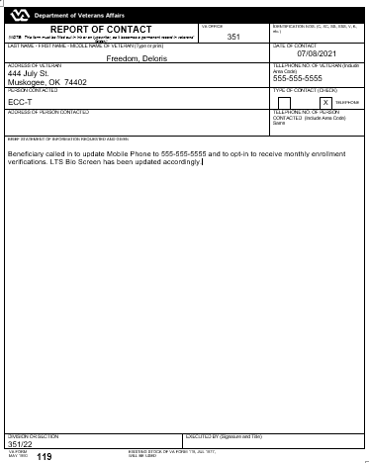 | Once you have updated the beneficiary’s contact information and text message preference, you will need to complete a Report of Contact Form (VA Form 119) to document the information received from the beneficiary during this call. Capture this document to TIMS using the Doc Type TXTREPLY.
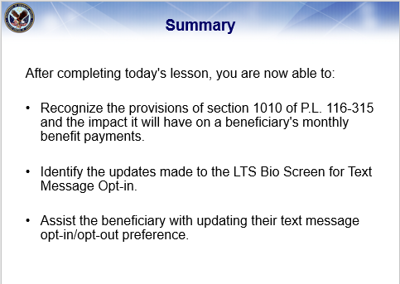 | DISPLAY slide  After completing today's lesson, you are now able to:  Recognize the provisions of section 1010 of PL 116-315 and the impact it will have on a beneficiary's monthly benefit payments.  Identify the updates made to the LTS Bio Screen for Text Message Opt-in,  and assist the beneficiary with updating their text message opt-in/opt-out preference.
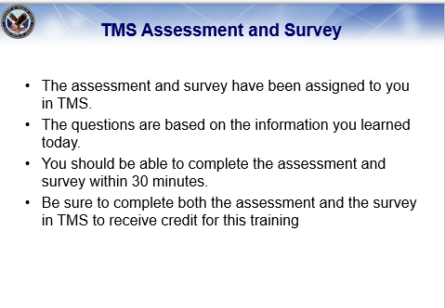 | DISPLAY slide  This concludes today’s training. To receive credit for completion of today’s training, you will need to complete the TMS assessment and survey.  The assessment and survey have been assigned to you in TMS.  The questions are based on the information you learned today.  You should be able to complete the assessment and survey within 30 minutes.  Be sure to complete both the assessment and the survey in TMS to receive credit for this training.
 | Thank you for joining us today!

