Adobe Captivate Training Scripts
COVID-19 Temporary School Closure Training Module
Visual | Script
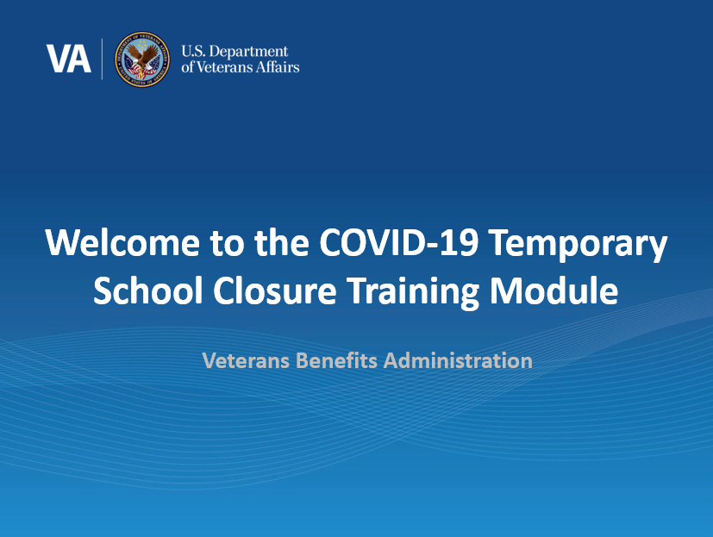 | Welcome to the Long-Term Solution (LTS) Release 7.3, COVID-19 Temporary School Closure Training. In today’s training, you will learn about the recent updates made to the LTS to enable VA to accurately process claims impacted by COVID-19 in accordance with the COVID-19 Emergency Situation legislation.  Please note the examples you will see during this training were processed in a test system so all names and social security numbers are fictitious and do not belong to actual beneficiaries. No personally identifiable information (PII) is contained in this training.  Please click ‘Next’ in the bottom right-hand corner when you are ready to move on to the next page.
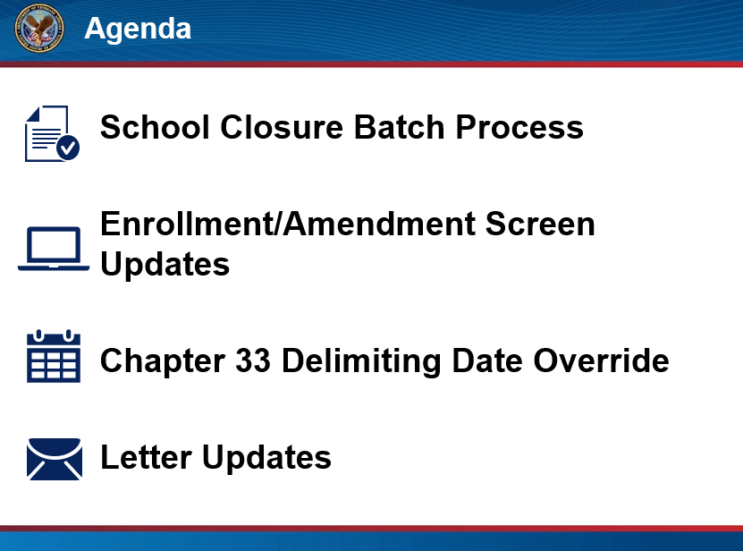 | In this training, we will begin by providing an overview of the updates made in the LTS, including the school closure batch process, updates to the enrollment and amendment screens, and a new “Chapter 33 Delimiting Date Override” Field. We will then provide a demonstration on how to process temporary school closure amendments within LTS when the school has closed due to COVID-19. Lastly, we will discuss the letters associated with the temporary school closures and the chapter 33 delimiting date override processes.  Click next to proceed.
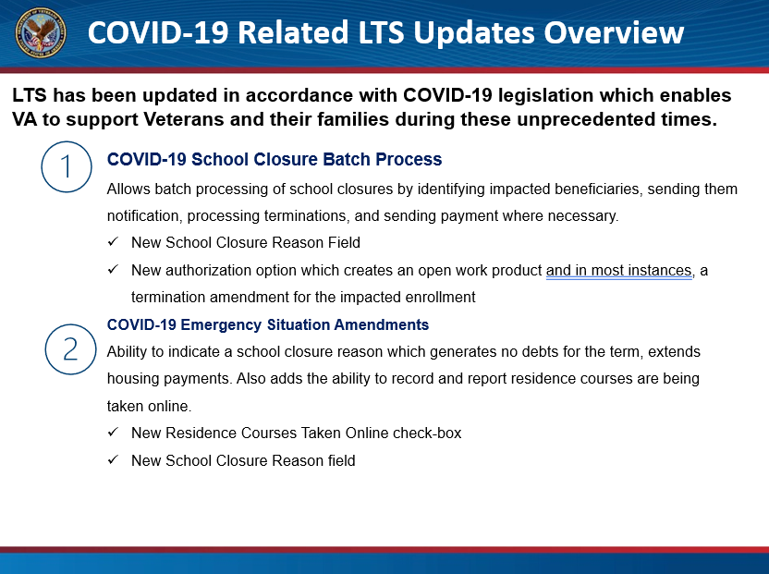 | Before we demonstrate the temporary school closure process, let’s discuss each of the COVID-19 related enhancements made to the LTS in this release. Remember, these enhancements were made to process claims in accordance with the COVID-19 legislation, including Public Law 116-140 “Student Veteran Coronavirus Response Act of 2020” and 116-159 “Continuing Appropriations Act, 2021 and Other Extensions Act”.  The first update is the school closure processing screen. Locally selected “Authorized Users” can now select “COVID-19” as the school closure reason and authorize the batch process with terminations.  Once the school batch process is authorized, a work product, and in most instances a termination amendment will be created for all beneficiaries impacted by a school closure. On the amendment screen, there is a new “School Closure Reason” field and a “Residence Courses Taken Online” checkbox. Note: Both may be auto-populated based on the batch process and VA-ONCE respectively.  For OJT/Apprenticeship certifications, a termination amendment will not be created, only the work product. The termination will need to be authorized and payments sent if applicable.  Click next to continue.
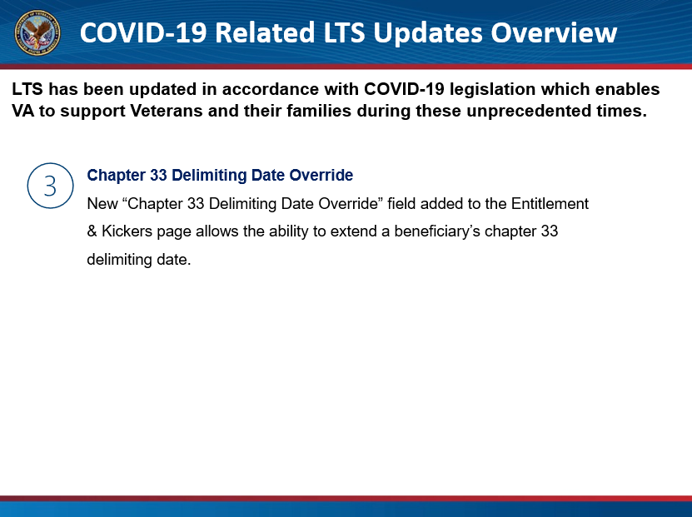 | Lastly, a new “Chapter 33 Delimiting Date Override” field has been added to the Entitlement and Kickers page which allows VCEs to extend a beneficiary’s chapter 33 delimiting date when the law allows.  We will now discuss each of these new enhancements in more detail.  Click next to continue.
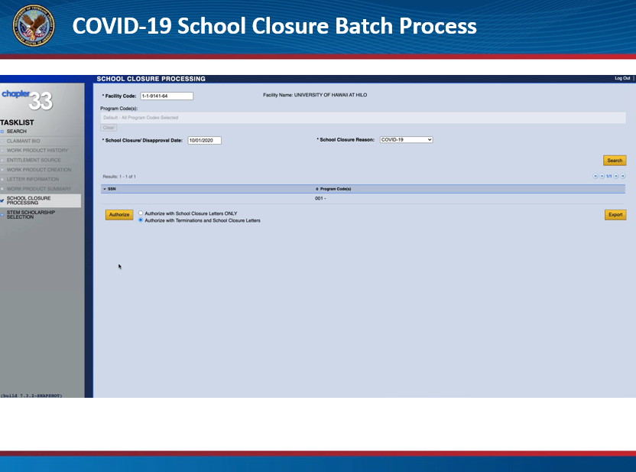 | To begin the COVID-19 Temporary School Closure process, locally selected authorized users will access the School Closure Processing page and run the school closure batch process to select beneficiaries impacted by a school closure due to any reason, including COVID-19. Once the school batch process is authorized, a work product and in most instances a termination amendment will be created for all beneficiaries impacted by a school closure. The user who authorizes the batch process will also export the list of impacted beneficiaries which then will be distributed for VCE action.  For most, the process will begin here. VCEs will use the list of impacted beneficiaries to review and authorize each school closure amendment.  Note: The School Closure Processing option will appear for all Senior VCEs. This option and all functionality should NOT be accessed by anyone other than the locally selected Authorized Users.Click next to review the amendment demonstration.
[video demonstration]  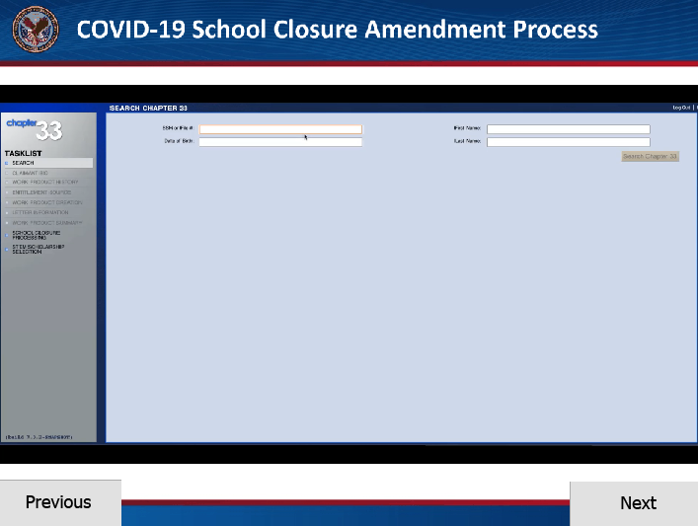 | From the list of impacted beneficiaries, VCEs will begin by searching for the beneficiary. Notice, there is an “Auto” created work product with the school closure termination description. In the event the beneficiary had an open work product when the batch process was run, the batch process will not create a new school closure work product or amendment.  In this case, the VCE will need to review TIMS to determine proper adjudication of the open work product prior to processing the temporary school closure termination. Then, VCEs may need to manually create a work product for the termination amendment.  Open the school closure termination work product that has been created and proceed to the enrollment page to review the enrollments and amendments. Open the new amendment created by the batch process. Review and verify the effective date is populated with the correct school closure date, the “School Closure/Program Disapproval” check-box is auto-selected, and “COVID-19” is auto-populated in the new “School Closure Reason” field. The “Continue Monthly Housing Allowance” and the “Do Not Apply 6x” checkboxes will also be selected. After reviewing the amendment information, proceed to the Work Product Summary page.  On the Work Product Summary page, review the housing payments. Remember, when COVID-19 is selected as the school closure reason, monthly housing allowance payments will continue for 28 days after the school closure date or at the end of the term, whichever comes first. Whereas when “Colmery: Section 109” is selected as the school closure reason, monthly housing allowance continues for 120 days after the school closure date or at the end of the term, whichever comes first. Note, if tuition and fees debts are generated, they will appear as no action and they will not be processed.  When the VCE verifies the information is correct, authorize the work product. Keep in mind, the school closure amendment is a termination, and current functionality does not allow any amendments to the enrollment after the school closure date. Enrollments terminated in error or certifications received out-of-order require additional instruction to be provided in an advisory.  Click next to continue.
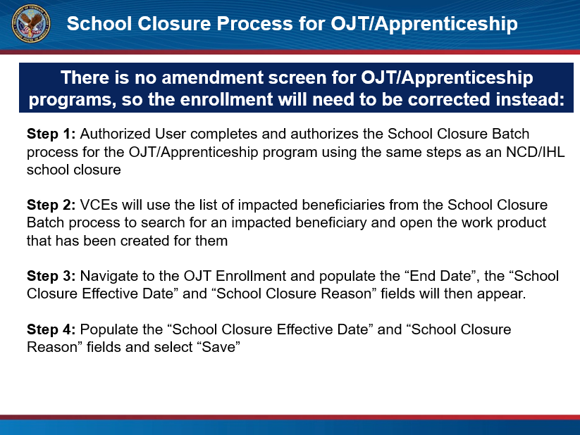 | It is also important to note for OJT and Apprenticeships when a program closes, the enrollment must be corrected as opposed to processing a termination amendment, as with the NCDs and IHLs.  To review this process, the first step will be for the locally selected authorized users to run the school closure batch process for the OJT or Apprenticeship program. Then, VCEs will use the list of impacted beneficiaries exported from the school closure batch process to search for an impacted beneficiary and open the newly created work product. Next, instead of reviewing a school closure amendment, navigate to the existing OJT Enrollment and “correct” the enrollment to reflect the closure. On the enrollment screen, select the dropdown for the affected enrollment then click “Correction” to advance to the enrollment pop-up. There are two new fields, “School Closure Effective Date” and “School Closure Reason” which appear when an end date exists. These fields will need to be populated in accordance with the closure information and then select “Save”. Update the CERTS hours as applicable, then proceed to authorize the work product.  Note: To avoid certifying enrollments in a closed facility, LTS will restrict VCEs from adding any certifications in the month following the school closure date. If an attempt to add a new certification after the school closure date is executed, an error message stating, “Enrollment has certification that is later than school closure/program disapproval date, please correct before saving.” will appear.  Click next to proceed.
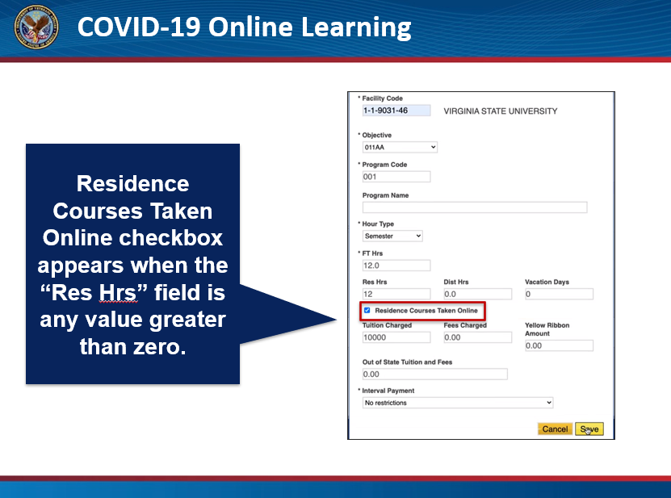 | In addition to the enhancements made to the amendment screen for COVID-19 school closures processing, there is also a new “Residence Courses Taken Online” checkbox which appears on both the enrollment and amendment screen. When the residence hours field is greater than zero, the new field allows VCEs to indicate when an enrollment has converted from a residence course to online due to COVID-19. This field is for reporting purposes and should be pre-selected if the standard remark is indicated on the enrollment in VA-ONCE. However, if not, VCEs can also select the checkbox on either the enrollment or amendment screen.  Click next to continue to the activity.
[Activity]  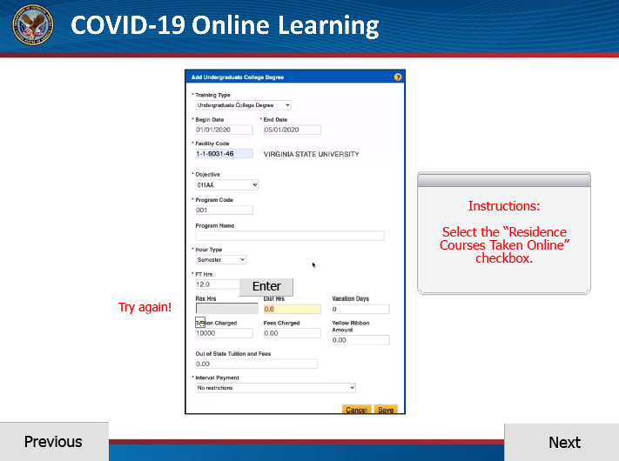 | Let’s try it out. On the screen, enter “12” into the “Res Hrs” field on the enrollment and select “enter”. Notice, the “Residence Courses Taken Online” checkbox is now available. Select the checkbox and click save.  Great job! Click next to proceed.
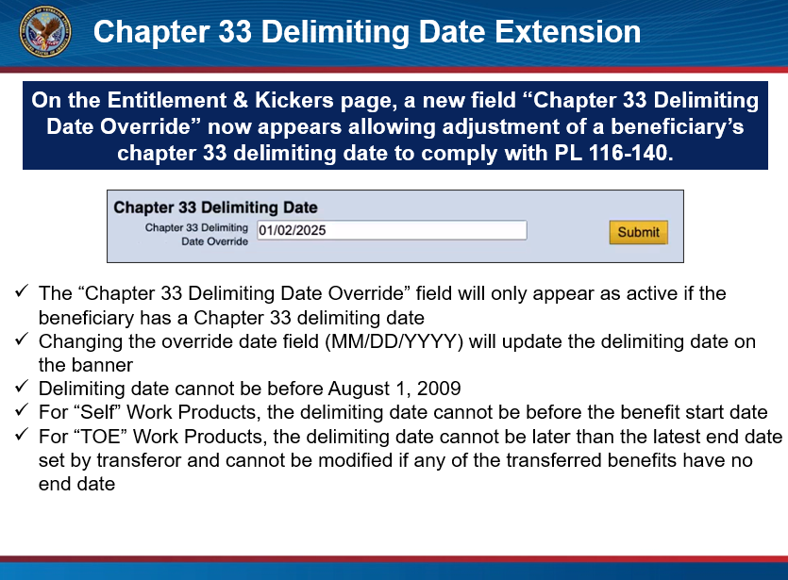 | Now, let’s go over the new “Chapter 33 Delimiting Date Override” field. This field was added to the Entitlement & Kickers page to allow the “Extension of Time Limitations for Use of Entitlement” per Section 6 of Public Law 116-140. The “Chapter 33 Delimiting Date Override” field should only be used for COVID-19 School Closure extensions and will only appear if the beneficiary has a chapter 33 delimiting date. Follow current procedures for all Non-COVID delimiting date extension. The “Chapter 33 Delimiting Date Override” field will only appear as active if the beneficiary has a chapter 33 delimiting date. Changing the date, using the format, month-day-year, will update the delimiting date on the banner.  Please keep in mind, when extending a delimiting date due to a temporary school closure, there are some restrictions. The delimiting date cannot be before August 1, 2009, and the overriding delimiting date cannot be before the benefit start date for “Self” Work Products. For “TOE” Work Products, the overriding delimiting date cannot be later than the latest end date set by the transferor, and the “Chapter 33 Delimiting Date Override” field cannot be modified if any of the transferred benefits have no end date.  Click next to proceed.
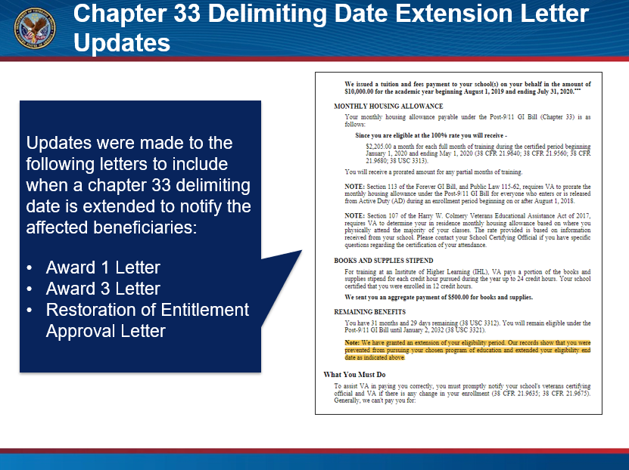 | Before concluding this training module, let’s review the chapter 33 delimiting date letter updates.  Updates have been made to the Award 1, Award 3, and Restoration of Entitlement Approval Letters to include notification to the impacted beneficiary when a Chapter 33 delimiting date is extended.  Click next to proceed.
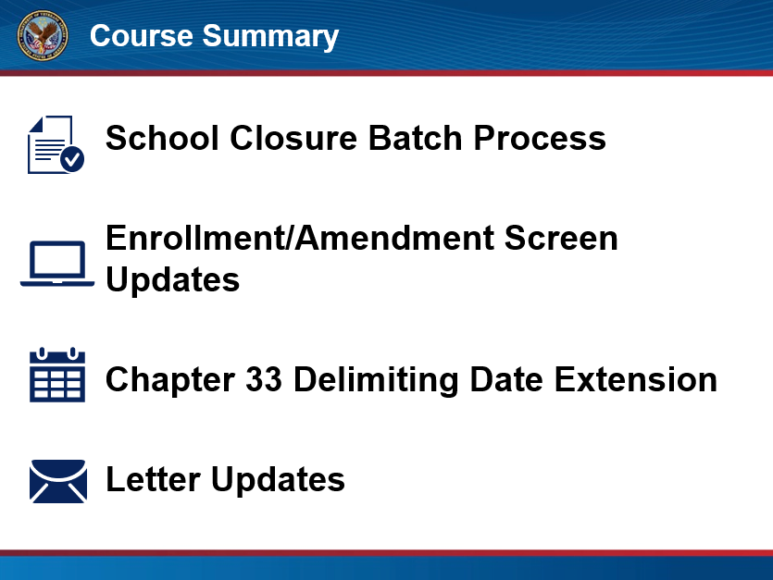 | This concludes the LTS Release 7.3, COVID-19 Temporary School Closure Training. Let’s review what was discussed.  First, an overview of the updates made in the LTS was provided, including the school closure batch process, updates to the enrollment and amendment screens, and the new “Chapter 33 Delimiting Date Override” field.  The training then demonstrated how to process temporary school closures within LTS when the school has closed due to COVID-19 and discussed the letters associated with the school closure. Instructions for converting residence to online learning using the new field on the enrollment and amendment screen were given, and lastly, the new chapter 33 delimiting date override process was introduced.  Click next to proceed.
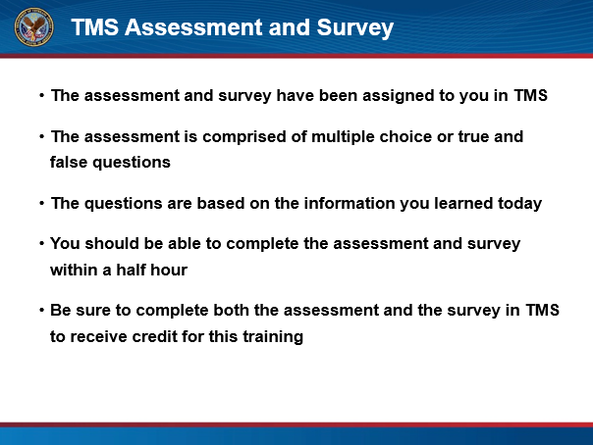 | TMS Assessment and Survey:  The assessment and survey have been assigned to you in TMS.  The assessment is comprised of multiple choice or true and false questions.  The questions are based on the information you learned today.  You should be able to complete the assessment and survey within a half hour.  Be sure to complete both the assessment and the survey in TMS to receive credit for this training.  Click Exit to leave this training.

