Adobe Captivate Training Scripts
Section 109 Restoration of Entitlement Training Module
Visual | Script
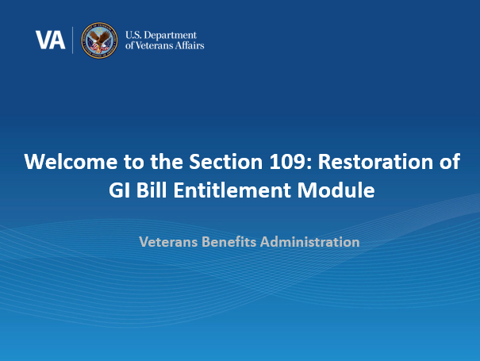 | Welcome to the Harry W. Colmery Act Section 109 Training. In today’s training, you will learn about Section 109 of the Harry W. Colmery Act, which authorizes restoration of GI Bill entitlement due to school closures and/or program disapprovals, and recent updates which have been made to the Long-Term Solution (LTS). This training module is self-paced.  Please note the examples were processed in a test system so all names and SSNs you see are fictitious. They do not belong to actual beneficiaries. No personally identifiable information (PII) is contained in this training.  Please click ‘Next’ in the bottom right-hand corner when you are ready to move on to the next page.
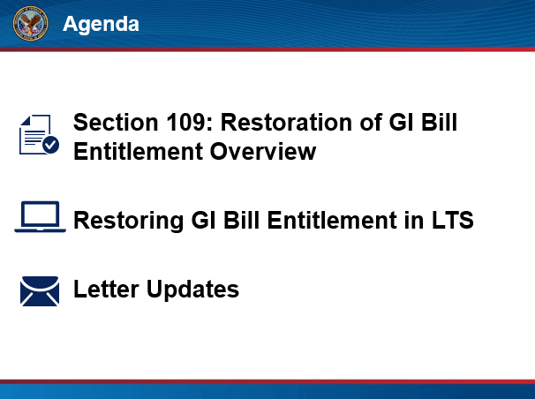 | In this training, we will begin by providing an overview of the Section 109 of the Colmery Act, then we will demonstrate the updates in LTS which allow VCEs to properly restore GI Bill Entitlement, and lastly, we will share the updates made to letters to inform beneficiaries of their restored entitlement.  Click next to proceed.
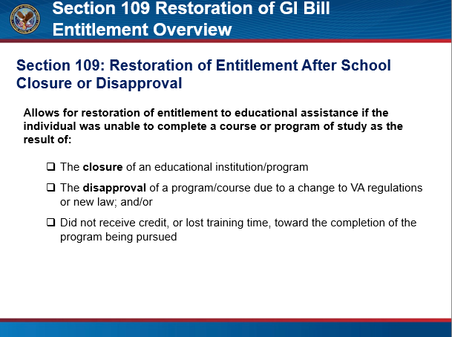 | Section 109 of the Colmery Act allows for restoration of entitlement to educational assistance if the beneficiary was unable to complete a course or program of study due to:  - the closure of an educational institution or program  or  - the disapproval of a program or course due to a change to VA regulations or new law  and  - did not receive credit or lost training time, toward the completion of the program being pursued.  Click next to proceed.
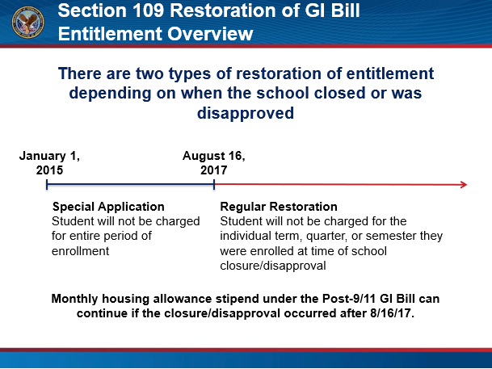 | There are two types of restoration of entitlement depending on when the school closed or was disapproved: special application and regular restoration.  Special Application applies to school closures which occurred between January 1, 2015 and August 15, 2017. Beneficiaries eligible for restoration of entitlement for enrollments during the special application timeframe will not be charged for the entire period of enrollment if last attending the school within 120 days of the school’s closure and not enrolled in a comparable program prior to August 16, 2017; or were enrolled in a comparable program, but did not transfer any credits from the closed school.  Regular Restoration applies to school closures or disapprovals which occurred on or after August 16, 2017. Beneficiaries eligible for regular restoration of entitlement will not be charged for the individual term, quarter or semester in which enrolled, if they did not receive credit or lost training time. Correspondence and Vocational Flight school closures do not qualify for Restoration of Entitlement.  Monthly housing allowance under the Post-9/11 GI Bill can continue to the end of the current term, quarter, or semester or for the next 120 days, whichever is less.  Click next to proceed.
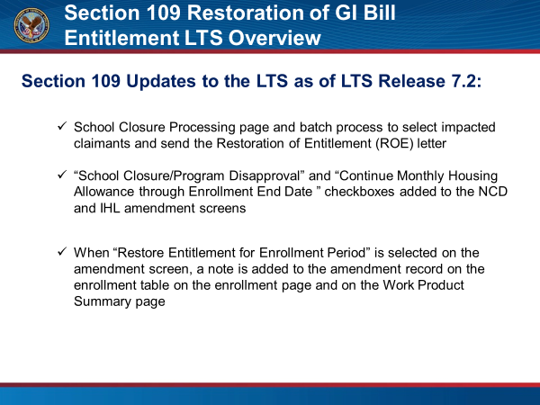 | Now that we have reviewed the Restoration of Entitlement provision, we will go over the updates made to the LTS to inform beneficiaries of a school closure or program disapproval, and to appropriately restore GI Bill Beneficiaries’ entitlement.  As of LTS release 7.2, there is a new School Closure Processing page and a batch process available for Superusers to select beneficiaries potentially impacted by a school closure or disapproval. This process will send the beneficiaries the Restoration of Entitlement 5-day letter. Additionally, there are two new checkboxes on both the IHL and NCD amendment screens, a “School Closure/Program Disapproval” checkbox and a “Continue Monthly Housing Allowance through Enrollment End Date” checkbox. Lastly, when a beneficiary’s entitlement has been restored, a note is added when viewing the amended enrollment on the enrollment and Work Product Summary pages.  Now, let’s take a look in LTS to review the restoration of entitlement process.  Click next to proceed.
[Video Demo]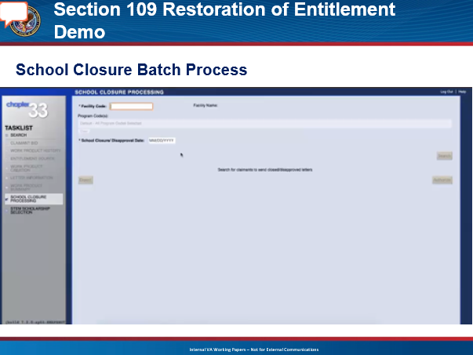 | First, we will demonstrate the new School Closure Processing page and the school closure batch process. It is important to note, only the Superusers will have access to the School Closure Processing page.  When a school closes or a program is disapproved, the RPO will be notified. The impacted facility codes, program code(s), if applicable, and date of school closure or disapproval will be referred to a Superuser who will generate the list of beneficiaries who have an enrollment period that spans the date of the school closure or program disapproval, or who have a future enrollment at the facility using the School Closure Batch process.  Once in LTS, navigate to the School Closure Processing page by selecting the tab in the Tasklist to run the batch process. On the School Closure Processing page, you will need to enter the facility code of the affected school, add any specific program codes from the Program Code(s) drop down if necessary, or default to all program codes, and enter the school closure or disapproval date. Once the fields are complete, click “search”. LTS will then list all beneficiaries who have an enrollment period that spans the school closure date or who have a future enrollment in the results section of the page.  Once the list is generated, select the “Export” button and save the spreadsheet. Then, select the Authorize button which will queue the 5-day letters to be sent to all impacted beneficiaries.  The 5-day letter will instruct the beneficiaries to submit a VA Form 22-0989, Department of Veterans Affairs Education Benefit Entitlement Restoration Request Due to School Closure or Withdrawal, to VA to review for eligibility for restoration of entitlement. The form will be provided along with the letter the beneficiary receives.  Note, because the batch process does not create work products, the letters are not stored on the beneficiary’s LTS record or in TIMS. Please follow Procedural Advisory: Colmery Section 109 Restoration of Entitlement, LTS update for capturing a copy of the letter in TIMS.  Click next to proceed.
[Video Demo]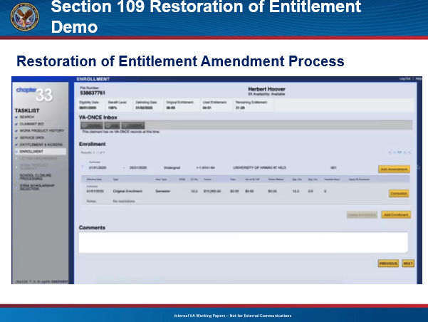 | In addition to the batch process for Superusers, LTS has also been updated to allow all VCEs on the Restoration of Entitlement team to indicate the school closure or program disapproval and to continue MHA payments through the enrollment period on an amendment for impacted beneficiaries. Upon completion of the batch process, VCEs will review the exported batch process list to determine the appropriate action.  First, select a beneficiary from the exported batch list and open a new work product. Once on a new work product, navigate to the Enrollment page and select “Add Amendment” for the enrollment that spans the closure date to open the amendment screen. On the Amendment screen, you will notice there are two new checkboxes on the right-hand side to select if a beneficiary has been impacted by a school closure or disapproval. The checkboxes are titled “School Closure/Program Disapproval”, and “Continue Monthly Housing Allowance through Enrollment End Date”.  A school closure amendment is in effect a termination due to closure or disapproval, which does not fall under the usual amendment reasons. Therefore, you will need to Enter the closure date as the “Effective Date” and select “Other” from the dropdown reason. Ensure all remaining fields are zero. Make sure the “School Closure/Program Disapproval”, “Continue MHA through Enrollment End Date”, and the “Do Not Apply 6x” checkboxes are selected. Click “Save”.  If there are additional impacted terms beginning on or after the school closure date, select “Add Amendment” and enter the first day of term as the effective date. Select “Other” from the dropdown reason, check “Student Did Not Attend Class” and click “Save”. Do this for all impacted future terms.  Proceed to authorize the work product to send the School Debt Letter and any other applicable letters.  Click next to proceed.
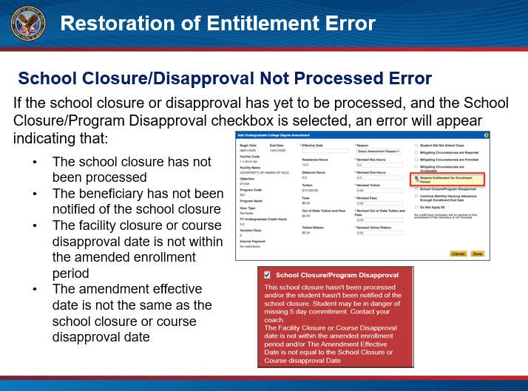 | It is important to note, if the batch process has not been authorized by the Superuser, and the School Closure/Program Disapproval checkbox is selected, an error will appear indicating:  - The school closure has not been processed  - The beneficiary has not been notified of the school closure  - The facility closure or course disapproval date is not within the amended enrollment period  - The amendment effective date is not the same as the school closure or course disapproval date  If you receive this error, verify that the beneficiary information was entered correctly. If so, please contact your coach for further instruction.  Click next to proceed.
[Video Demo]  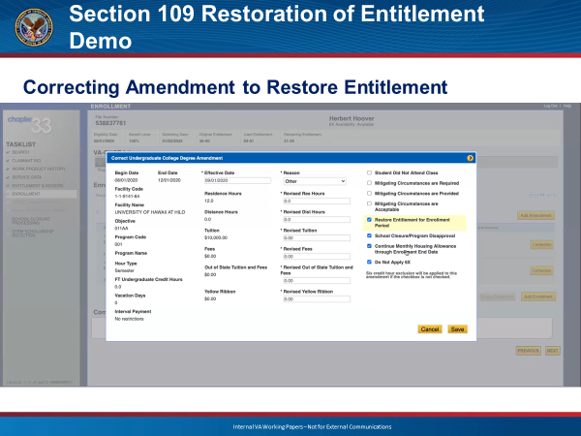 | The next step to restore a beneficiary’s entitlement will occur after the beneficiary has submitted their VA Form 22-0989. If the beneficiary is ineligible for restoration of entitlement, send the appropriate disallowance letter following standard procedures. If they are eligible for restoration, restore their entitlement by correcting the school closure/program disapproval amendment.  To restore the beneficiary’s entitlement, open up a new work product and navigate to the enrollment page. Once on the enrollment page, expand the enrollment history to view the amendments and select “Correction” on the school closure/program disapproval amendment. This will open the amendment screen. Select the “Restore Entitlement for Enrollment Period” checkbox and save the amendment.  Click next to proceed.
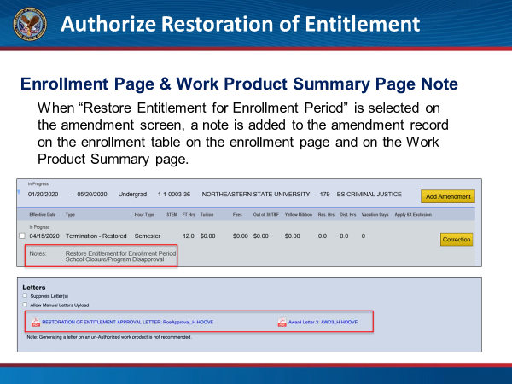 | Once the amendment is saved with the “Restore Entitlement for Enrollment Period” checkbox selected, a note is added to the amendment table and the work product summary screen indicating that entitlement has been restored, and the Restoration of Entitlement Approval Letter and Award 3 letter will be sent upon work product authorization.  Click next to proceed.
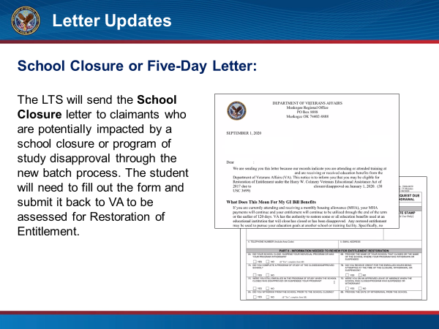 | Now that we have reviewed the process in LTS to send school closure letters and to restore Post 9/11 GI Bill entitlement, let’s review the related letters.  The School Closure Letter is a new LTS letter which will be sent to beneficiaries who are identified from the school closure batch process as having been enrolled in a school that closed or had their program of study disapproved. The impacted beneficiaries will be sent a letter informing them they may be eligible for restoration of entitlement and will need to submit the enclosed VA Form in order to be considered for entitlement restoration.  Click next to proceed.
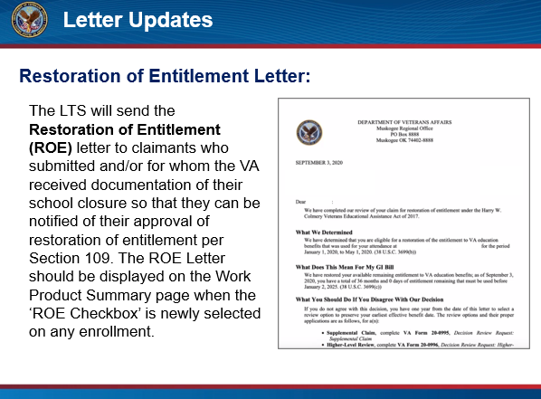 | The Restoration of Entitlement (ROE) approval letter is sent to beneficiaries who submitted the Restoration of Entitlement request form and were eligible for restoration as notification of their approval of restoration of entitlement per Section 109. The ROE Letter is displayed on the Work Product Summary page when the ‘ROE Checkbox’ is selected on any enrollment.  Click next to proceed.
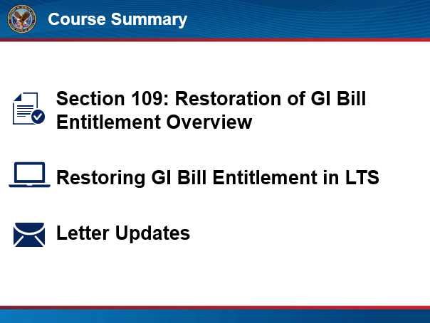 | Course Summary:  You have reached the end of this training module. In this training, you learned about Section 109: Restoration of GI Bill Entitlement, the updates made in LTS and the related letters. Thank you for completing this training.  Click next to proceed.
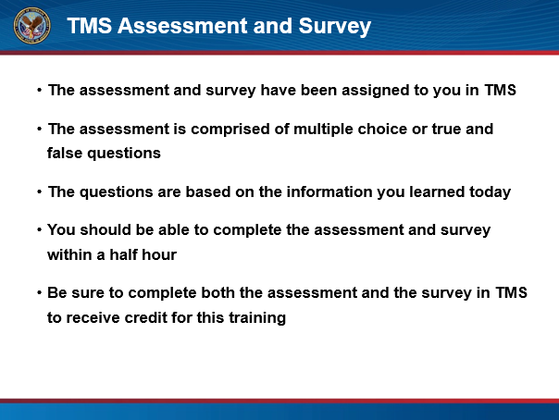 | TMS Assessment and Survey:  The assessment and survey have been assigned to you in TMS.  The assessment is comprised of multiple choice or true and false questions.  The questions are based on the information you learned today.  You should be able to complete the assessment and survey within a half hour.  Be sure to complete both the assessment and the survey in TMS to receive credit for this training.  Click Exit to leave this training.

