Adobe Captivate Training Scripts
Section 110 TOE Training Module
Visual | Script
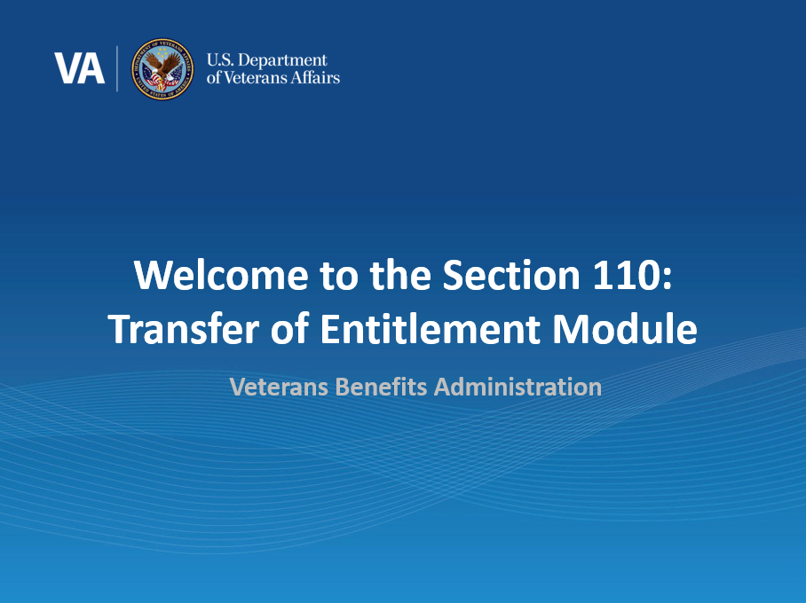 | Welcome to the Section 110: Transfer of Entitlement (ToE)Training Module. In today’s training, you will learn of updates made to the Transfer of Entitlement process due to section 110 of the Harry W. Colmery Act and updates made to the Long Term Solution (LTS). This training module is self-paced.  Please note the examples were processed in a test system so all names and SSNs you see are fictitious. They do not belong to actual beneficiaries. No personally identifiable information (PII) is contained in this training.  Please click ‘Next’ in the bottom right-hand corner when you are ready to move on to the next page.
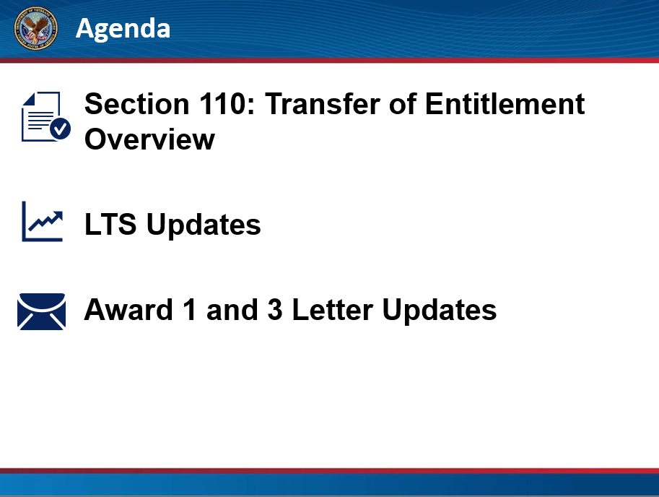 | In this training, we will begin by providing an overview of Section 110: Transfer of Entitlement, and the LTS updates made to allow for the new transfer of entitlement rules. Lastly, we will discuss the Award 1 and Award 3 letter updates.  Click next to proceed.
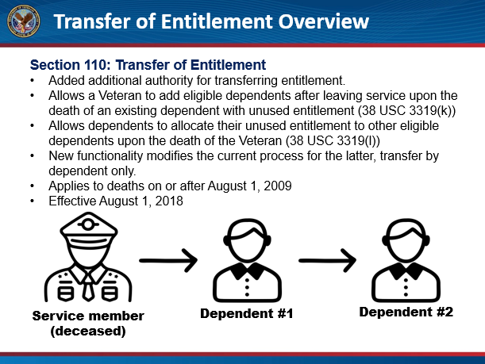 | Section 110: Transfer of Entitlement  Effective August 1, 2018, Section 110 of the Harry W. Colmery Act added additional authority for transferring entitlement. It allows a Veteran to add eligible dependents after leaving service upon the death of an existing dependent with unused entitlement (38 USC 3319(k)) and it allows dependents to allocate their unused entitlement to other eligible dependents upon the death of the Veteran (38 USC 3319(l)) if the death occurred on or after August 1, 2009. New functionality modifies the current process for the latter, transfer by dependent only.  Click next to proceed.
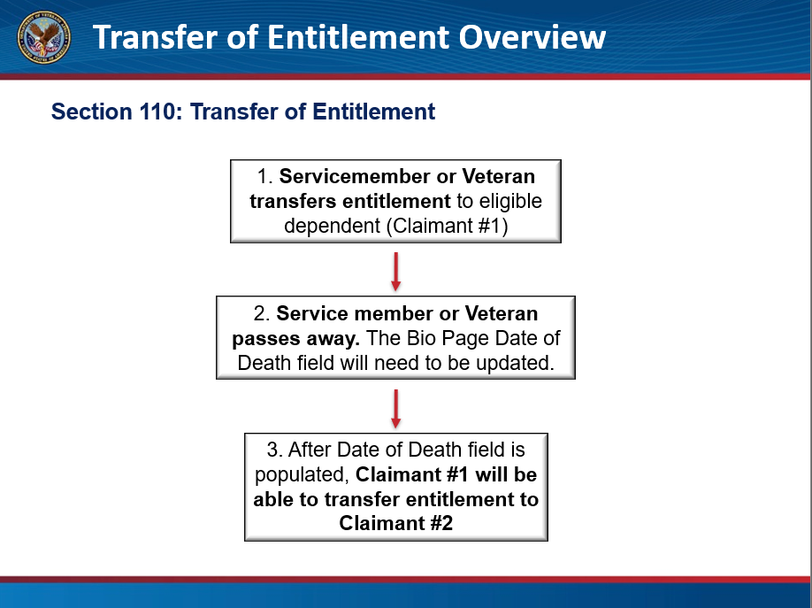 | There are three key steps in the transfer of entitlement process. First, the Service member or Veteran makes a valid transfer of entitlement to one or more eligible dependents. Second, the Service member or Veteran subsequently passes away. The third step involves a dependent with unused transferred entitlement making a request to transfer their remaining entitlement to another eligible dependent. RPO Service Representatives will verify dependency and complete this process.  Note: Dependents which were not previously allocated benefits while the member was in-service may now be eligible. Eligible dependent is in this case being the surviving spouse and all of the Veteran’s children.  Click next to proceed.
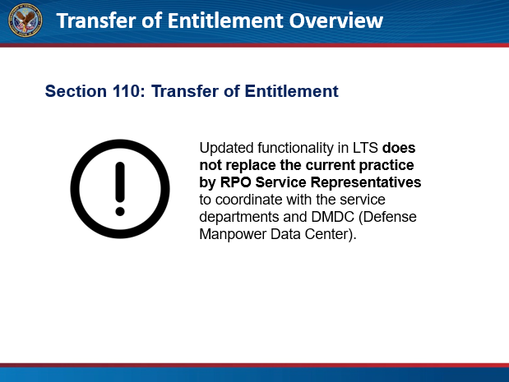 | Updated functionality in LTS does not replace the current practice by RPO Service Representatives to coordinate with the service departments and DMDC (Defense Manpower Data Center). Verification, approval and system updates, such as updating VIS (Veterans Information Solution) through BEAST are required before processing in LTS.  All requests and/or modifications will be reflected in the VIS. VCEs will process TOE claims based upon TOE data reflected in VIS. All requests by dependents received by a VCE or the ECC must be forwarded to the RPO Service Representative.  Click next to proceed.
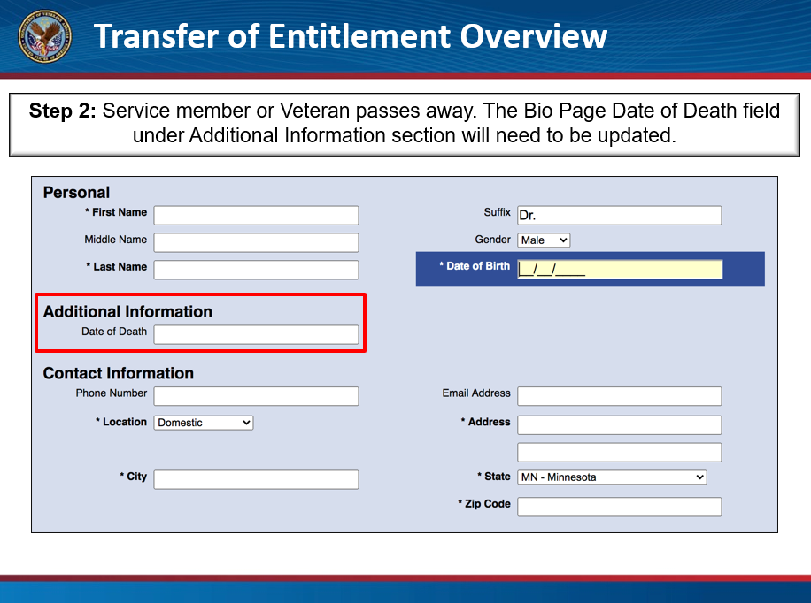 | The first step once the service member or Veteran has passed away is to enter in the date of death (new field) on the Veteran’s Bio Page. The date of death cannot be before the Veteran’s date of birth nor August 1, 2009. Once this field is populated, the system will allow transfer of entitlement from an eligible dependent to another eligible dependent.  It is important to note, only RPO Service Representatives should alter the date of death field. This field is for 110 claims processing only and should not be utilized for general processing.  Click next to proceed.
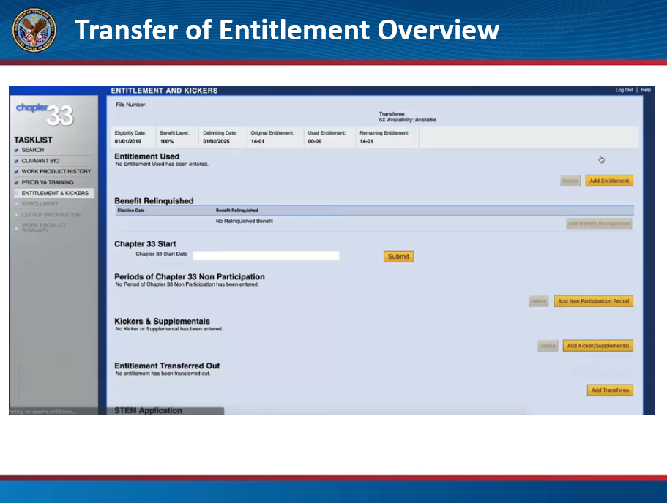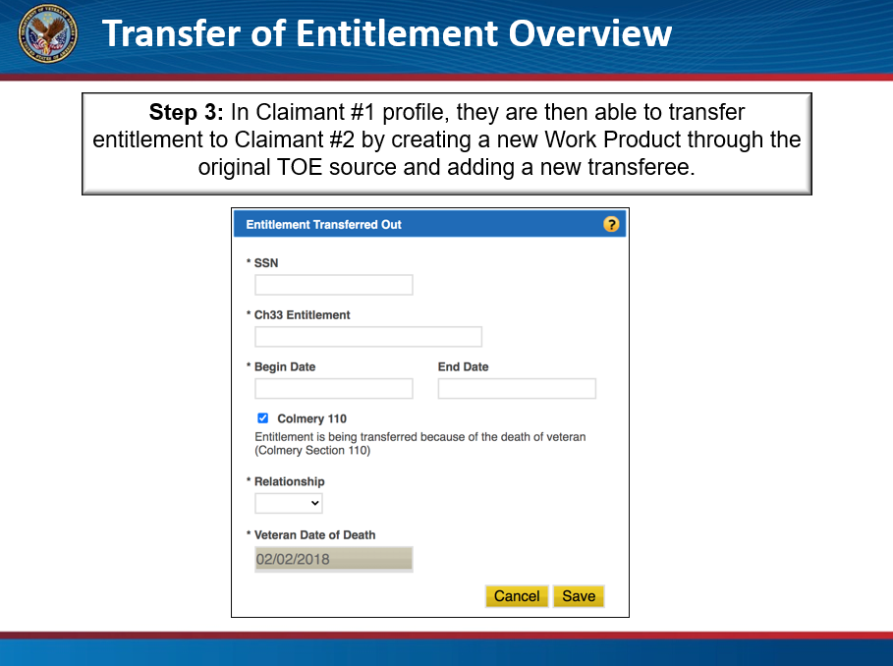 | A new work product must be created for the ToE dependent (Transferee) requesting to transfer out entitlement. On the entitlement and kickers page, you will click on the “Add Transferee” button under the Entitlement Transferred Out section.  Once the button is clicked, an Entitlement Transferred Out pop up window will appear.  (entitlement transferred out image appears)  There are two fields displayed in the pop up which cannot be edited, a Colmery 110 checkbox and a Veteran date of death. The first will be checked and cannot be unchecked, the other is grayed out and is copied from the Veteran’s record.  This new window requires you to enter the SSN of the receiving dependent, the amount of chapter 33 entitlement to be transferred, the date when the transfer is to begin (on or after August 1, 2018 and on or after the Veteran’s death), the receiving dependent’s relationship to the transferee and click Save.  (entitled transferred out details on page appears)  The new Section 110 Entitlement Transferred Out portion of the Entitlement & Kickers page will now display all information entered.  After authorization of this work product, when entering a new ToE work Product under the original Veteran SSN Source, the entitlement transferred will be added to the Original Entitlement displayed in the receiving transferee’s Eligibility and Entitlement banner. Normal ToE processing can occur.  Click next to proceed.
[Video Demo] | In this example, we will be demonstrating how to transfer entitlement from one qualifying dependent to another after the Veteran has passed and the date of death has already been entered on the bio page. Create a ToE work product under the transferring dependent’s record, and navigate to the entitlement and kicker page. Select the Add Transferee button under the Entitlement Transferred Out section. A pop-up window will appear. Notice the Veteran Date of Death field information is pulled from the Veteran’s bio page and the Colmery 110 checkbox is automatically marked. Fill in the required fields marked by an asterisk which are the SSN, Ch33 Entitlement amount, Begin Date and Relationship. Once you have completed this, click save.  You see the information you just entered is now displayed under the Entitlement Transferred Out section. If we advance to the Work Product Summary page, you will see the same information is listed. For the receiving dependent, the entitlement transferred would appear under Entitlement Transferred In.  Click next to proceed.
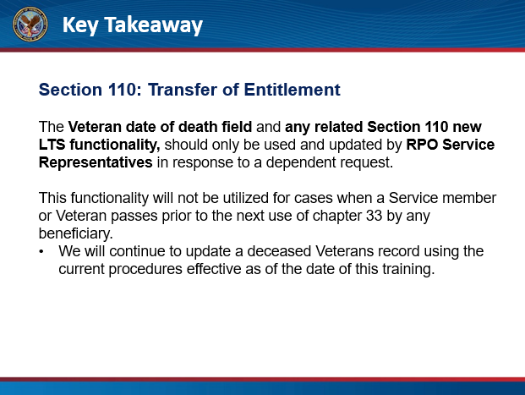 | It is important to stress, the Veteran date of death field and any related Section 110 new LTS functionality should only be used and updated by RPO Service Representatives in response to a dependent request.  This particular functionality will not be utilized for cases when a Service member or Veteran passes prior to the next use of chapter 33 by any beneficiary. We will continue to update a deceased Veteran’s record using the current procedures effective as of the date of this training.  Click next to proceed.
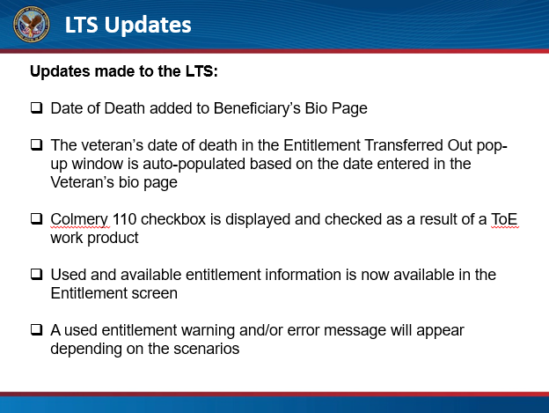 | Now let’s revisit some of updates to LTS shown during the demonstration and cover a few safeguards built into the system.  - The Date of Death field has been added to the bio page.  - The date of death information is auto-populated in the entitlement transfer pop-up window based on the date entered on the bio page when transferring entitlement in accordance with Section 110.  - In the entitlement transfer pop up window, a Colmery 110 checkbox is displayed and checked as a result of a ToE work product being created when the Veterans date of death is listed on the Veterans LTS record.  - Used and available entitlement information is now available in the Entitlement screen.  - A used entitlement warning and/or error message will appear depending on the scenarios.  Click next to proceed.
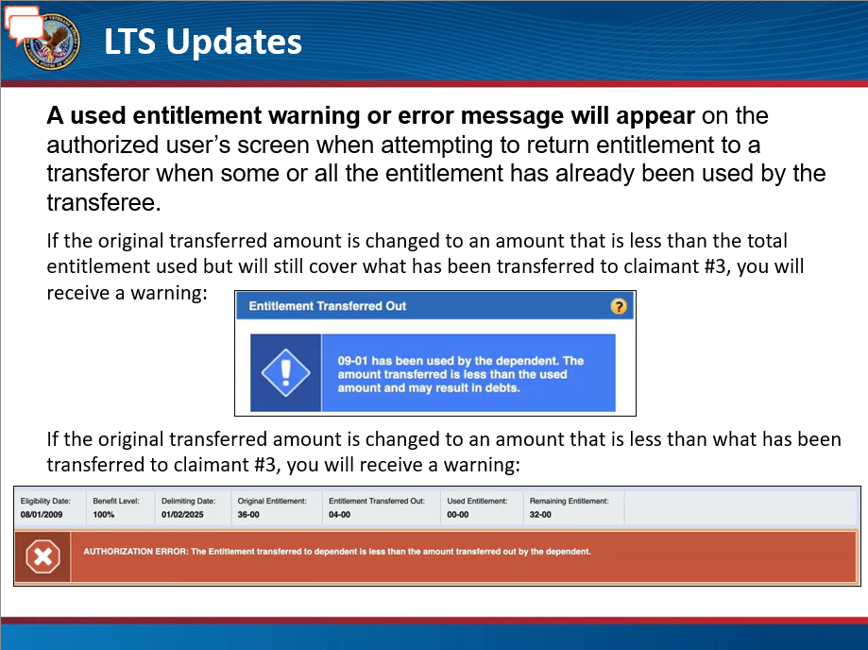 | New functionality introduces warning and error messages when a VCE attempts to transfer out more entitlement than available.  The safeguards were added to protect entitlement transferred from one dependent to another. If a VCE attempts to rescind or reallocate entitlement previously transferred, a warning will appear in both the entitlement transfer pop-up window and the work product summary if entitlement has been used by the other dependent.  If in the rare instance, the transferring dependent tries to reallocate entitlement after using entitlement themselves and the dependent using entitlement, then an error message will appear in addition the warnings and the VCE will not be able to authorize any actions until the allocation is corrected.
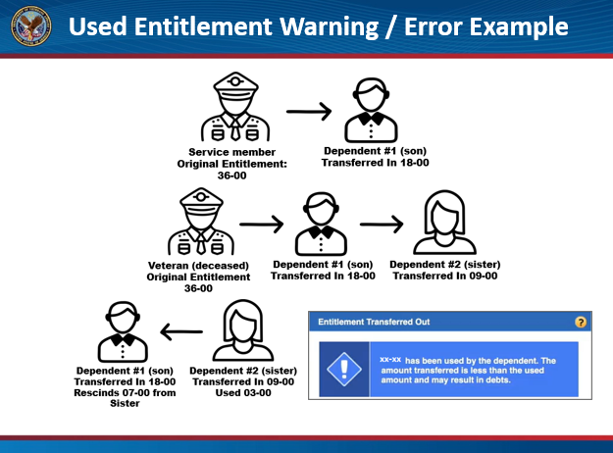 | For example, the Veteran’s original entitlement was 36 months. The male dependent (Son) was transferred 18 months of entitlement. The Veteran passes and now the Son transfers 9 months to his eligible Sister.  If Sister has used 3 months of her entitlement and Son tries to rescind 7 months resulting in a transfer of 2 months, a warning message will appear to the VCE- “03-00 has been used by the dependent. The amount transferred is less than the used amount and may result in debts”. LTS will not stop this action, just a warning.  If a correction is processed on the Veteran’s record or an adjustment is made in error, to alter the months transferred to Son from 18 months to say 8 because the 1 was fat-fingered and based on the original scenario, he had already transferred 9 months to Sister, an Authorization Error will appear on the Work Product Summary page- “The Entitlement transferred to dependent is less than the amount transferred out by the dependent”. LTS will not allow the work product to be authorized until the error is corrected.  Click next to proceed.
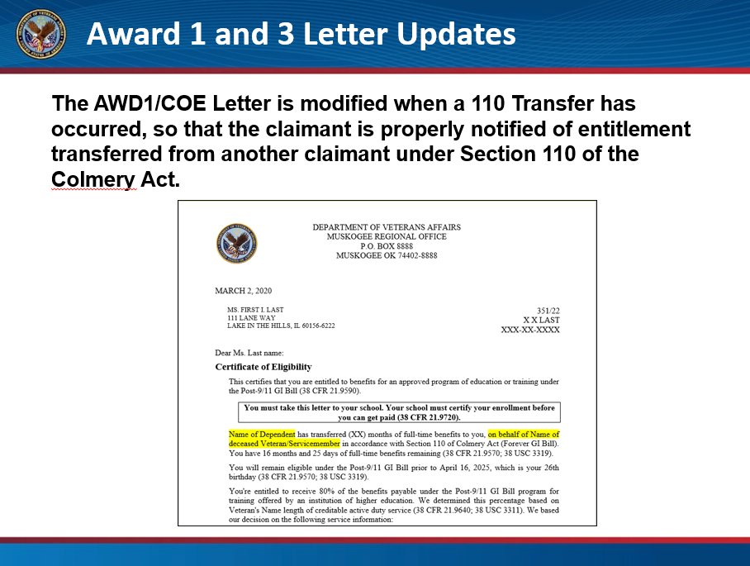 | The Award 1 letter was modified to include language when a Section 110 Transfer of Entitlement has occurred to notify the beneficiary of entitlement transferred from another beneficiary.  Click next to proceed.
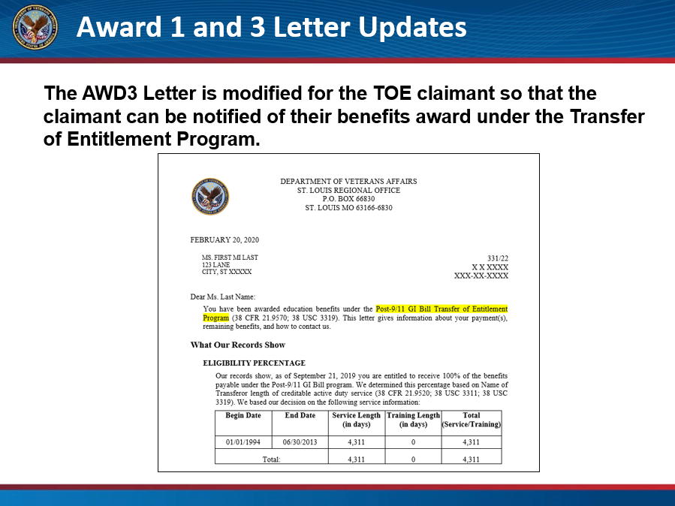 | The Award 3 Letter has been modified for the ToE beneficiary so that the beneficiary can be notified of their benefits award under the Transfer of Entitlement Program.  Click next to proceed.
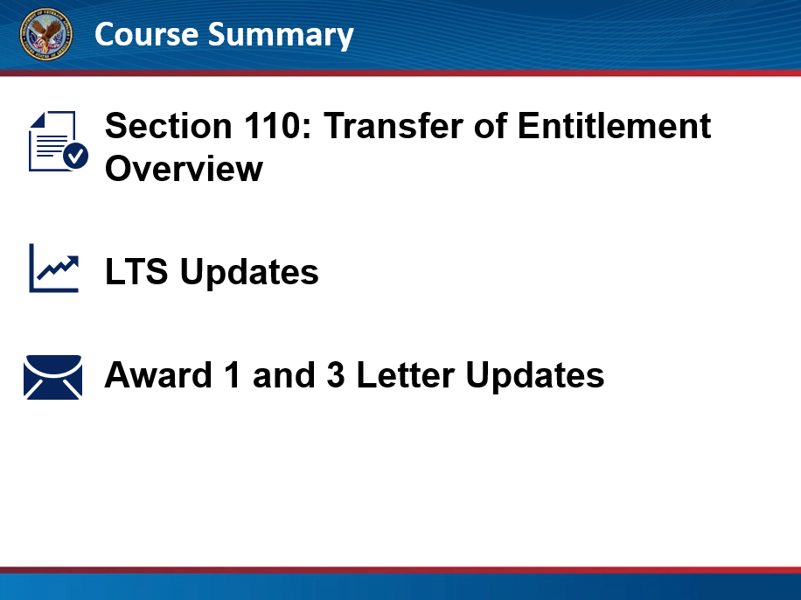 | Course Summary:  You have reached the end of this training module. In this training, you learned about Section 110: Transfer of Entitlement, the updates to the LTS, and Award 1 and 3 Letter Updates. Thank you for completing this training.  Click next to proceed.
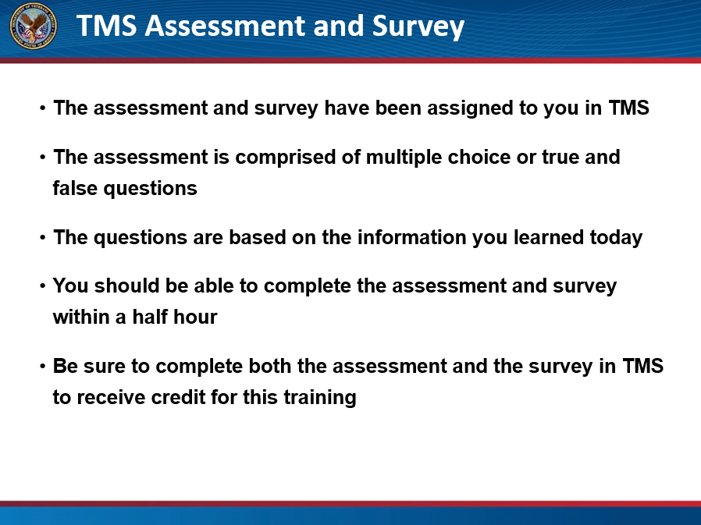 | TMS Assessment and Survey:  The assessment and survey have been assigned to you in TMS.  The assessment is comprised of multiple choice or true and false questions.  The questions are based on the information you learned today.  You should be able to complete the assessment and survey within a half hour.  Be sure to complete both the assessment and the survey in TMS to receive credit for this training.  Click Exit to leave this training.

