Adobe Captivate Training Scripts
STEM Eligibility Training Module
Visual | Script
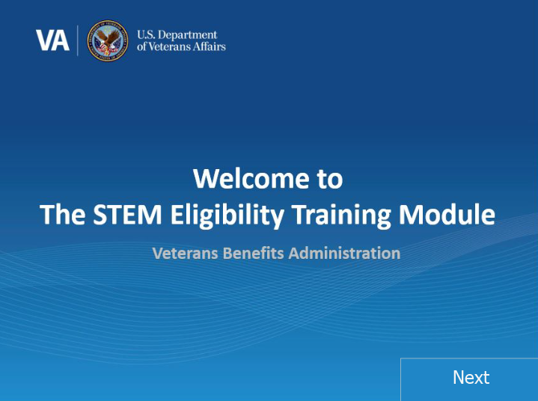 | Intro:  Welcome to the Edith Nourse Rogers STEM Eligibility Training Module. In today’s training, you will learn about the STEM Scholarship process, and updates made to the Long-Term Solution (LTS). This training module is self-paced.  Please note that this is a test system so all names and SSNs you see are fake. They do not belong to real people and the SSNs are not valid.  Please click ‘Next’ in the bottom right-hand corner when you are ready to move on to the next page.
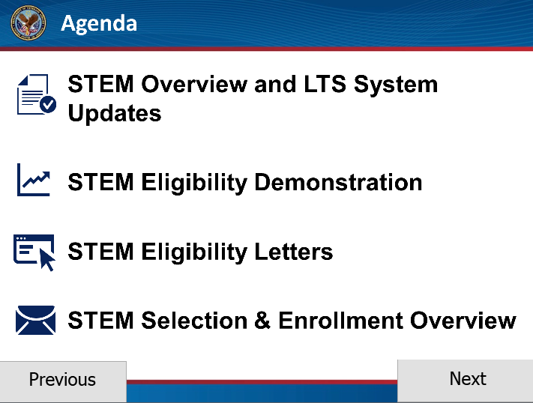 | Agenda:  In this training, we will discuss the STEM scholarship and how the eligibility process will be conducted in LTS. We will begin by providing an overview of STEM and the STEM process. Then, we will demonstrate how eligibility is determined in LTS, and finally review the STEM Eligibility Letters. Lastly, we will briefly discuss what comes next in the STEM process by providing a STEM Selection and Enrollment Overview.  Click next to proceed.
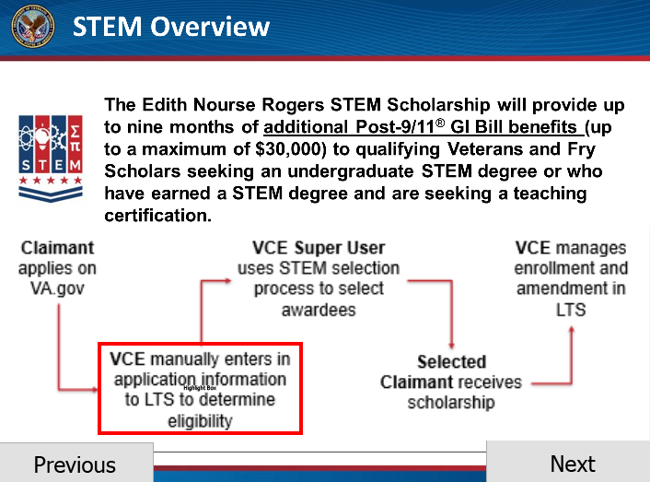 | STEM Overview  On August 1, 2019, a provision of the Harry W. Colmery Act went into effect known as “The Edith Nourse Rogers STEM Scholarship”. This scholarship program provides an additional nine months of Post-9/11 GI Bill benefits, up to a maximum of $30,000 dollars, to qualifying Veterans and Fry Scholars seeking an undergraduate degree in a STEM program, or those who have earned a STEM degree and are seeking a qualifying teaching certification.  Since the STEM scholarship program went into effect, STEM enrollments have been processed out of the Buffalo Regional Processing Office manually outside of LTS. As of August 2020, the STEM process will transition into the LTS.  The STEM scholarship approval or denial process has several steps: Application, Eligibility Verification, Selection, Enrollment Processing, and finally, payment. Completing these steps will require a VCE, a Senior VCE, and a LTS “Super User”.  Application information will be entered into the LTS, and applicants that are found eligible for the STEM scholarship will then be entered into the LTS selection process, in which the LTS Super User will select students to be awarded the scholarship.  Once a claimant is selected, enrollments can be entered and awards processed and authorized by the Senior VCE in LTS.  In this training, we will be demonstrating the steps you will take to complete the eligibility process.  Click next to proceed.
[Screenshot: STEM Eligibility pop-up window]  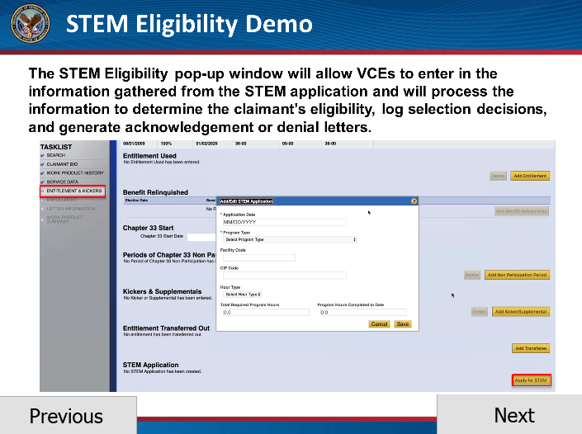 | STEM Eligibility Demo:  Before demonstrating the process in LTS, Let’s start by previewing the steps you will take.  Once the application information is received via TIMS, you will review the application details. Please refer to the eligibility processing guides to check for common denial reasons. Based on initial assessment, if the applicant is ineligible for the STEM scholarship, you will need to complete the eligibility process to send the denial letter. To do so, you will create a work product and navigate to the Entitlement & Kickers page and select the “Apply for STEM” button. Once you select the button, the Eligibility pop-up window will appear. In the pop-up window, you will enter in all of the required fields, and LTS will determine eligibility and generate the denial letter.  If the applicant seems to be eligible based on their application, you will need to confirm that you have all the information necessary to complete the required eligibility fields in LTS prior to creating a new work product. If there are any missing pieces of information, you will need to develop with the school.  Once you have all the required information, you will create a new work product to enter in the data and process the claim.  Now that we have provided an introduction to the eligibility process, let’s see how it works in LTS.  Click next to proceed.
[Video demo: No Qualifying Program]  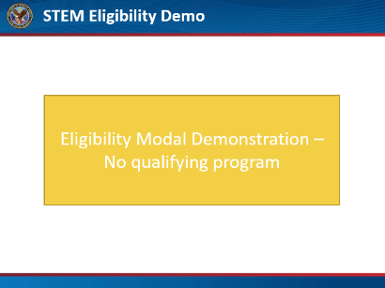  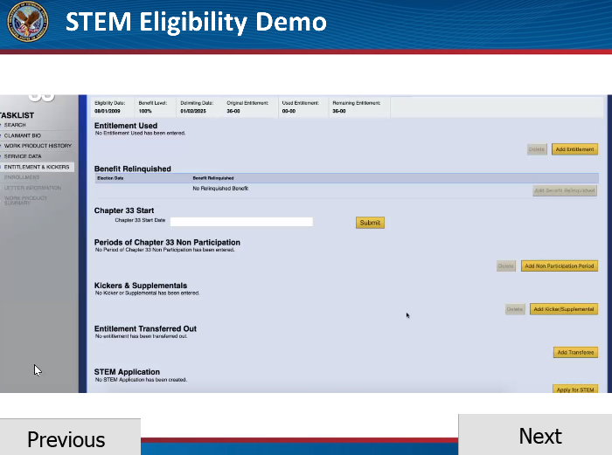 | STEM Eligibility Demo:  You will begin by searching for the STEM applicant and creating a new Work Product. Review and update necessary screens before advancing to the Entitlement & Kickers page to select the “Apply for STEM” button to open the eligibility pop-up window.  Within the pop-up window, you will complete the fields based on the information provided on the application. You will notice if you select the Program Type: Program of Study, Not STEM Eligible or Program of Study, Not Approved or Teaching Certificate, Not Earned a Prior STEM Undergraduate Degree, only the application date and program type fields will be required, since this applicant would be ineligible.  Click next to proceed.
[Video demo: Other Program Types]  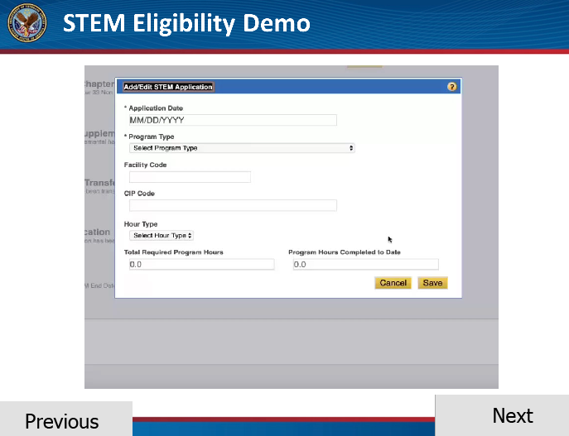 | STEM Eligibility Demo:  For Chapter 33 eligible applicants who are enrolled in a qualifying undergraduate program or qualifying teaching certification program, all visible fields are required, if not already populated.  The pop-up window includes the following fields, some fields may be auto-populated if the information is available:  - Application Date  - Program Type  - Facility Code  - If Undergraduate: Program of Study  - If Teaching: STEM-Related Post-Secondary Degree  - Program Name  - CIP Code  - Total Required Program Hours  - Hour Type  - Program Hours Completed to Date  Remember, if the CIP code or other information is missing, you will need to contact the school. Once you have completed the fields, you will select Save.  Click next to proceed.
Interactive Video: STEM Eligibility Activity  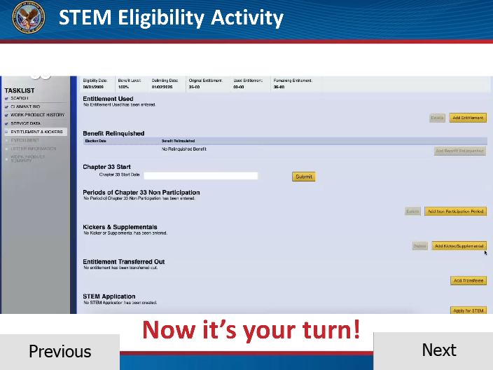 | STEM Eligibility Activity:  Now that we have demonstrated how to enter the STEM applicant’s information into the eligibility window, it is your turn to practice!  Select the “Apply for STEM” button on the Entitlement and Kickers page to bring up the STEM Eligibility window.  Click next to proceed with the activity.
Interactive Video: STEM Eligibility Activity  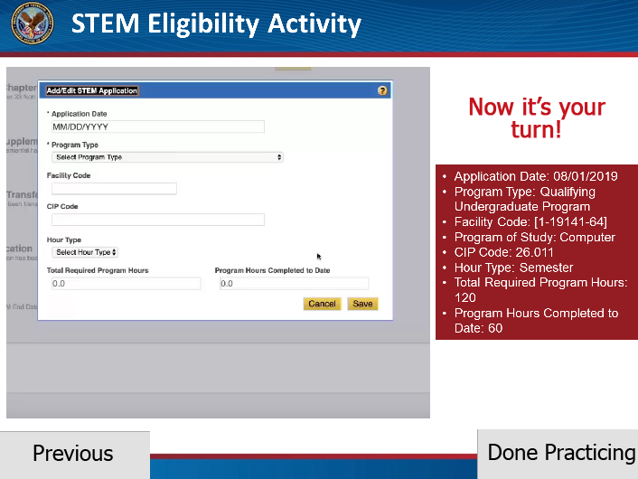 | STEM Eligibility Activity:  Now, we will have you practice entering in some applicant data in the Eligibility window. The information is provided to you on the right side of your screen.  Select the Qualifying Undergraduate Program as your Program Type.  Enter in 26.011 in the CIP code field and press enter.  Great job! Let’s continue with the demonstration.  Click Done Practicing to Proceed.
[Video demo: STEM Eligibility Results]  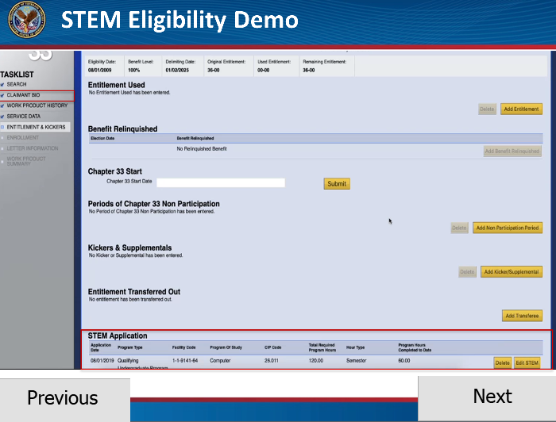 | STEM Eligibility Results:  After the claimant data is entered, LTS will make the eligibility decision for the claimant based on the information submitted.  If the applicant is ineligible, no STEM icon or banner will appear.  Before advancing to the Letter Information page, please remember to update the Bio page as needed.  Then you can advance to the Letter Information page to select the denial reasons.  Click Next to proceed.
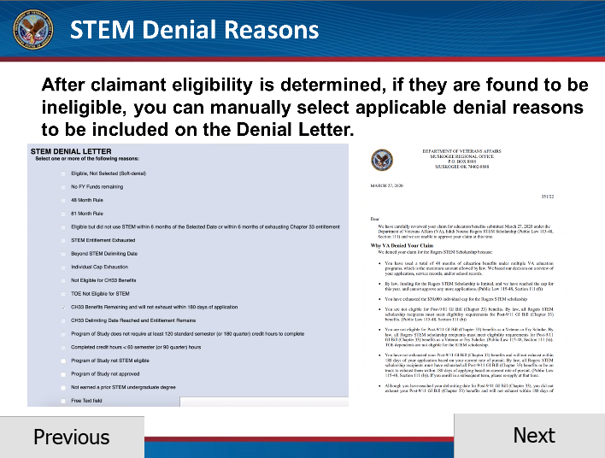 | STEM Denial Reasons:  For ineligible applicants, you must select all applicable denial reason(s) to ensure the denial letter is complete. A free text option is available if necessary. No manual edits should be needed for the Denial Letters.  The reasons include: 48 Month Rule; 81 Month Rule; Not eligible for CH33 Benefits or STEM; TOE Recipient Not Eligible for STEM; CH33 Benefits Remaining and will not exhaust within 180 days of STEM scholarship application; STEM program of study does not require at least 120 standard semester (or 180 quarter) credit hours to complete; and/or Completed STEM credit hours is less than 50% of total hours.  There may be some reasons automatically selected, and you can select other reasons that may apply. Once you’ve finished selecting any additional reasons, click “Submit”.  Click Next to proceed.
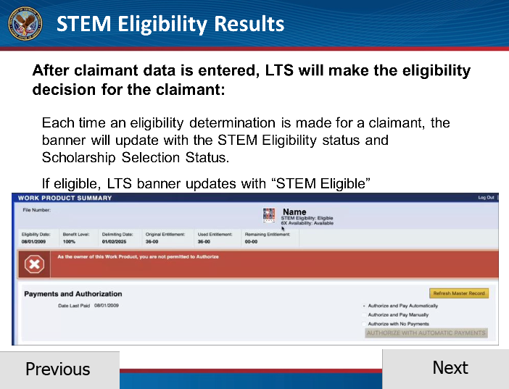 | STEM Eligibility Results  If the applicant is eligible, a STEM icon will appear in the banner with the status “STEM Eligible”. Each time a selection determination is made for the claimant, the banner will update with the STEM Eligibility status or Scholarship Selection Status.  Next, you will proceed to the Letter Information page to review the acknowledgement letter that will be sent to the STEM applicants.  Click next to proceed.
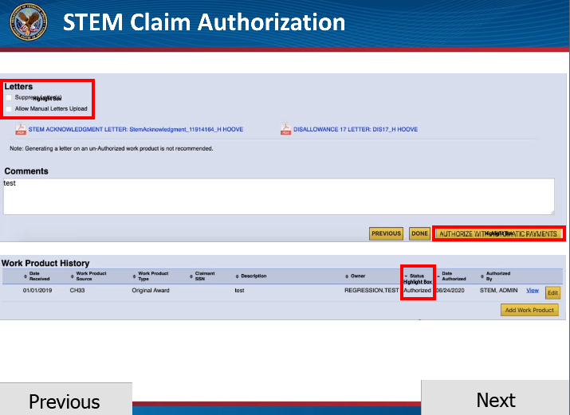 | Once you are ready to submit the claim, route it to the senior VCE for authorization.  The senior VCE will need to open the work product and navigate to the Entitlement & Kickers page to review the eligibility information. Once the senior VCE is ready to authorize, they will need to navigate to the bottom of the Work Product Summary page to authorize and ensure status of letter suppression.  Click next to proceed.
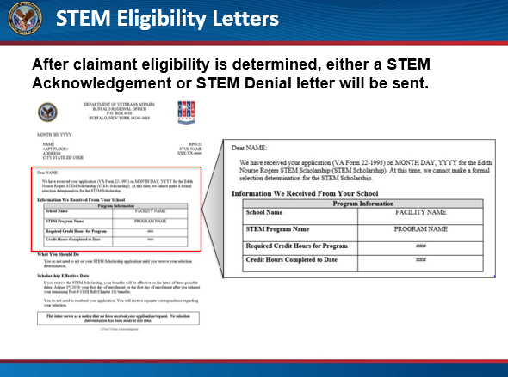 | STEM Eligibility Letters:  After the claim is authorized by the senior VCE, the Acknowledgement or STEM Denial letter will be sent based on the applicant’s eligibility.  If the applicant is STEM eligible, they will be sent the Acknowledgement letter letting them know that they are eligible, but a formal selection for the STEM Scholarship has not been made yet.  Click Next to proceed.
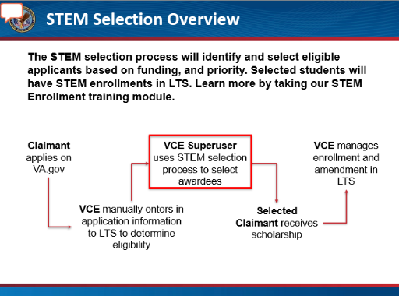 | STEM Selection Overview:  After the applicant’s eligibility is determined and the acknowledgement or denial letters are sent, the eligibility process has concluded. Next, the eligible applicants will be entered into the Selection Process.  During the three selection windows, designated LTS Superusers will utilize the STEM scholarship selection process to identify and select eligible applicants that will be awarded the scholarship based on funding and priority. Students who are selected will receive the award letter and then will have their STEM enrollment entered into LTS for processing. Students who are not selected the first time will be entered into the selection process for the remaining selection windows in the fiscal year before needing to apply again.  Please take the STEM Enrollment Training Module to learn more about processing STEM enrollments and amendments.  Click next to proceed.
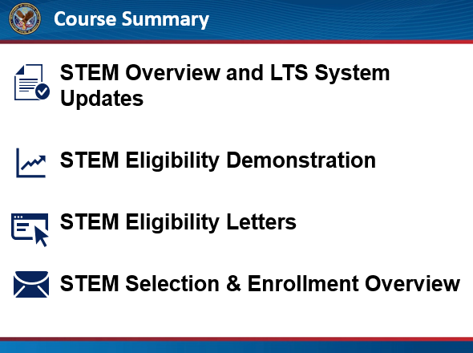 | Course Summary:  You have reached the end of this training module. In this training, you learned about the STEM application process, eligibility letters and the STEM selection and enrollment overview. Thank you for completing this training.  Click next to proceed.
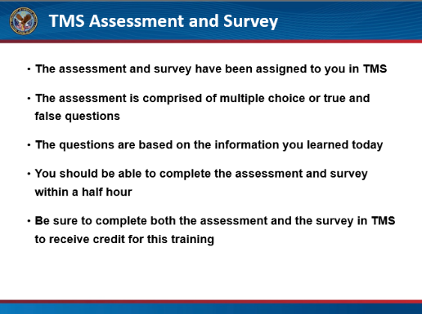 | TMS Assessment and Survey:  The assessment and survey have been assigned to you in TMS.  The assessment is comprised of multiple choice or true and false questions.  The questions are based on the information you learned today.  You should be able to complete the assessment and survey within a half hour.  Be sure to complete both the assessment and the survey in TMS to receive credit for this training.  Click Exit to leave this training.

