Adobe Captivate Training Script
  - Section 105 Consolidation of Benefit Level Training

1. Section 105
Visual | Script
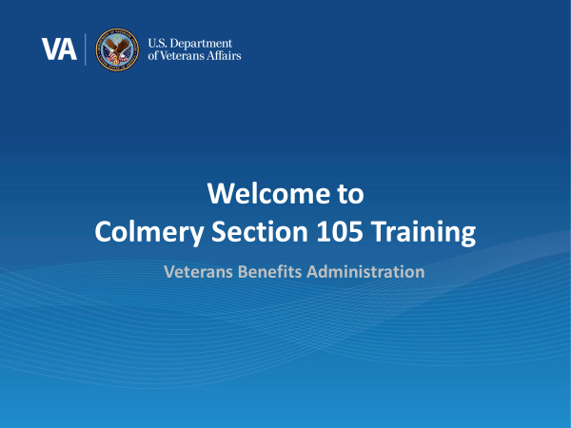 | Intro: Welcome! In today’s training, you will learn about Section 105 of the Harry W. Colmery Veterans Educational Assistance Act and the updates to the Long-Term Solution (LTS) based on this provision. This training module is self-paced. Please click ‘next’ in the bottom right-hand corner of the page when you are ready to move on to the next page.
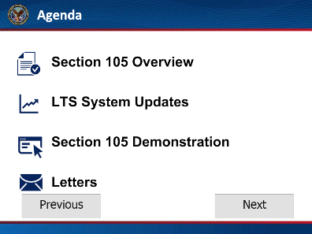 | Agenda: In this training, we will discuss Section 105 of the Colmery Act and provide an overview and demonstration of the update in LTS to accurately calculate the benefit level for those members of the Armed Forces affected by the consolidation of the eligibility tiers under the Post-9/11 GI Bill. Then, we will review a beneficiary letter and the updates required by Section 105.  Click next to proceed to the next page.
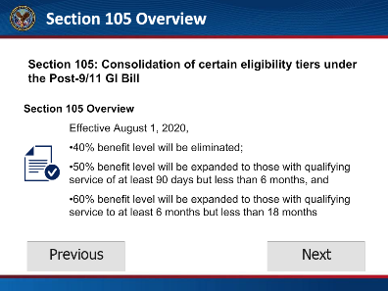 | Section 105 Overview: Section 105 of the Colmery Act consolidates the eligibility tiers under the Post-9/11 GI Bill and eliminates the 40% benefit level. Effective August 1, 2020, a beneficiary with qualifying service of at least 90 days but less than 6 months will now be eligible at the 50% benefit level. Those with qualifying service of at least 6 months but less than 18 months will be eligible at the 60% benefit level.  Click next to proceed to the next page.
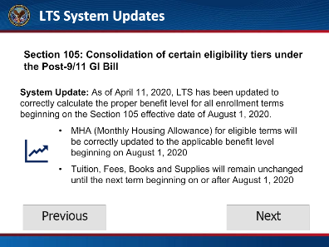 | LTS System Updates: As of April 11, 2020, LTS was updated to correctly calculate the proper benefit level for all enrollments beginning on or after August 1, 2020.  The Monthly Housing Allowance will be updated to reflect the correct benefit tier for terms beginning on or after August 1, 2020.  Tuition, Fees, Books and Supplies will remain unchanged until the next term beginning on or after August 1, 2020.  Let’s watch a short demonstration on how the new tiers will appear in LTS.  Click next to proceed to the next page.
[Demo: Service Data]  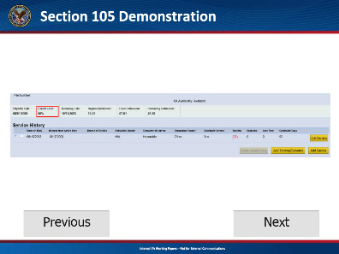 | Demo  To begin, create a new Work Product. Notice the benefit level on the Service Data page. The claimant is at the 40% benefit level. Review and update necessary screens before advancing to the enrollment tab. Enter the enrollment(s) captured in TIMS or from the VA-ONCE Inbox.  Click next to proceed to the next page.
[Eligibility Banner]  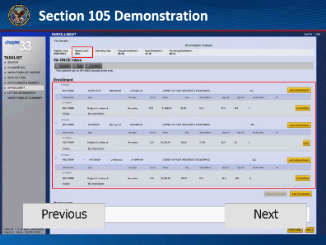 | Notice the Benefit Level in the Eligibility Banner remains at 40%. The banner updates with the benefit level in effect at the date of processing. Since Section 105 does not go into effect until August 1, 2020 all banners will show the current benefit level until that date.  Note: Existing qualifying service rules remain in effect. For Active Duty members and their dependents, benefit level increases are effective when the service tier minimums are reached.  Click next to proceed to the next page.
[Recurring Payment]  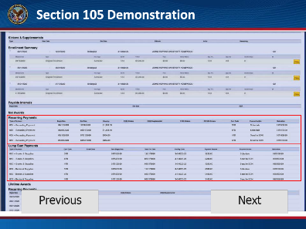 | After completing all required actions and advancing to the Work Product Summary page, scroll down to “Recurring Payments”. Notice for terms spanning or beginning on or after August 1, 2020, the cost code changes and housing has increased to the next benefit level.  In this demonstration, for terms prior to August 1, 2020, housing is paid at the 40% benefit level. On August 1, it increases to 50%. When you view Lump Sum Payments, they remain unchanged until the next term beginning on or after August 1st.  Click next to proceed to the next page.
[Screenshot of Letter]  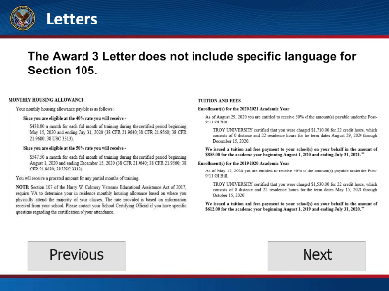 | The Award 3 letter does not include specific language for Section 105. However, it does reference both benefit levels under Monthly Housing Allowance and, if applicable, Tuition and Fees.  Communication of the Section 105 changes has been shared with Veterans, Service Members and their dependents. Information can also be found on the Education and Training page of the GI Bill website.  Click next to proceed to the next page.
[Course Summary Slide]  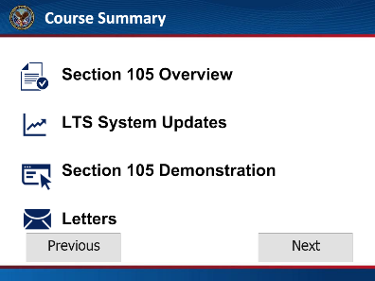 | You have reached the end of this training module. In this training you learned about the system updates for the consolidation of the eligibility tiers under the Post-9/11 GI Bill. Thank you for completing this training.  Click next to proceed to the next page.
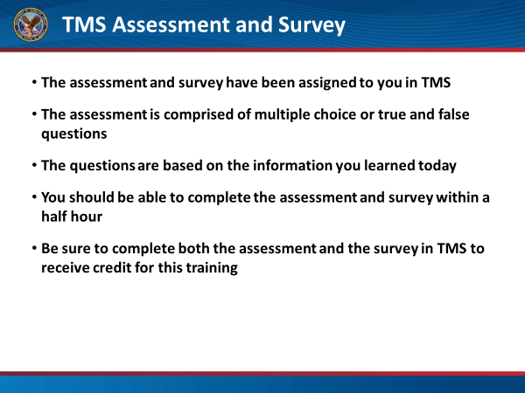 | The assessment and survey have been assigned to you in TMS.  The assessment is comprised of multiple choice or true and false questions.  The questions are based on the information you learned today.  You should be able to complete the assessment and survey within a half hour.  Be sure to complete both the assessment and the survey in TMS, to receive credit for this training.

