Adobe Captivate Training Scripts
  - Section 102 (Purple Heart) & Section 103 (Yellow Ribbon) Training

Section 102
Visual | Script
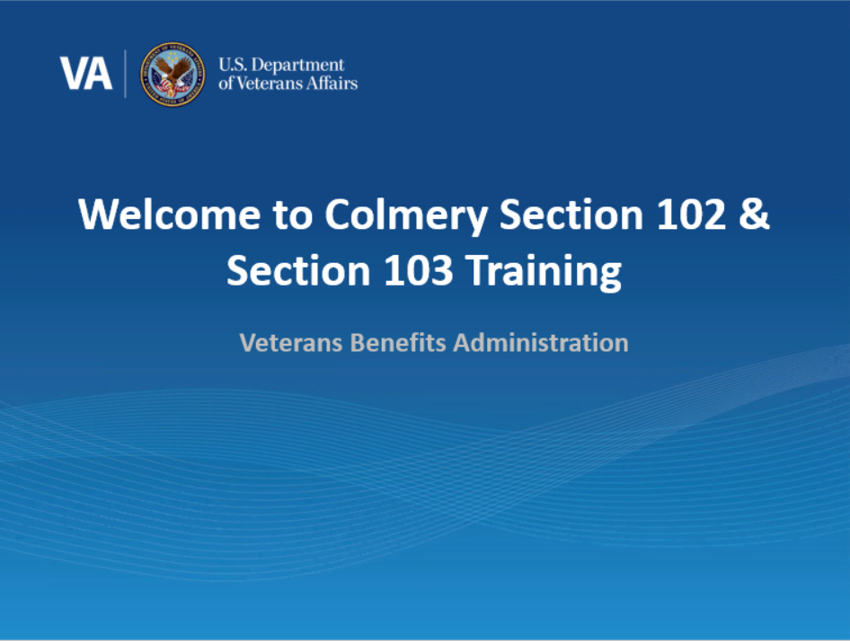 | Intro: Welcome! In today’s training, you will learn about Sections 102 and 103 of the Harry W. Colmery Veterans Educational Assistance Act and the updates to the Long-Term Solution (LTS) based on these provisions. This training module is self-paced. Please click ‘next’ in the bottom right-hand corner of the page when you are ready to move on to the next page.
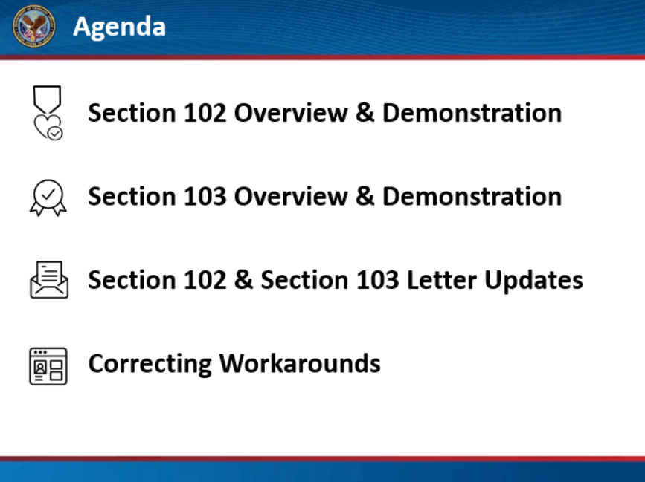 | Agenda: In this training, we will discuss Section 102 of the Colmery Act and provide an overview of updates in LTS to accurately calculate the benefit level for those members of the Armed Forces who received a Purple Heart for service on or after September 11, 2001. Then, we will discuss Section 103 of the Colmery Act and describe how LTS has been updated to allow Yellow Ribbon for Fry Scholarship and Purple Heart Recipients. Next, we will review updates to beneficiary letters to include Sections 102 and 103 updates. Finally, we will also provide guidance on previous workarounds.  Click next to proceed to the next page.
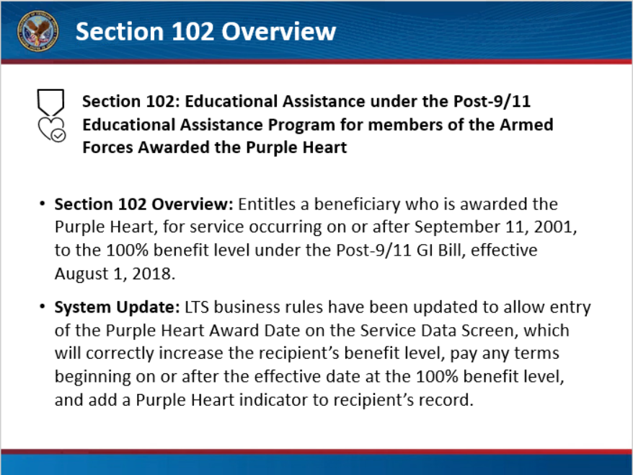 | Section 102 Overview: Section 102 of the Colmery Act entitles a beneficiary who is awarded the Purple Heart, for service occurring on or after September 11, 2001, to the 100% benefit level under the Post-9/11 GI Bill. This provision was effective August 1, 2018 and required a manual workaround. LTS business rules have been updated to allow entry of the Purple Heart Award Date on the Service Data screen, which will correctly increase the recipient’s benefit level, pay any terms beginning on or after the effective date at the 100% benefit level, and add a Purple Heart indicator to the recipient’s record. Manual workarounds will no longer be required.  Let’s watch a short demonstration on how to enter a Purple Heart Award Date in LTS.  Click next to proceed to the next page.
[Video demo 1: PH modal] | Demo  To begin, create a new Work Product, then navigate to the Service Data Screen and update the ‘Service History’ as needed. Notice there is now a ‘Purple Heart’ section directly below.  In this demonstration, the individual has a benefit level of 60 percent.  Select ‘Edit PH’ to edit the Purple Heart Award date to May 1, 2005 and select “Army” ‘Branch of Service’ from the drop-down menu. Both fields are required before clicking ‘Save’.  The Purple Heart Award date is now added, and the benefit level has increased to 100%. A Purple Heart Award date only impacts the benefit level if it is on or after September 11, 2001, and there is at least one service period with an ‘Honorable’ separation reason. It is important to ensure all service information has been accurately entered into the system.  If you enter an award date prior to September 11, 2001, the Purple Heart information will be accepted, but the benefit level will not be adjusted. If a future award date is entered, an error message stating ‘Award date entered cannot be a future date’ will appear.  Click next to proceed to the next page.
[Video: Service Data page with 100% benefit level and PH icon] | Once a Purple Heart Award date is added for service occurring on or after September 11, 2001, the benefit level accurately increases to 100% and the Purple Heart indicator will be displayed next to their name. The Purple Heart indicator is now visible on every page within the beneficiary’s LTS profile.  Click next to proceed to the next page.
[Video demo of multiple PH awards] | If a beneficiary’s profile has multiple Purple Heart awards documented, the earliest award on or after September 11, 2001, will be the award date listed in the Entitlement Summary. As you can see, when we enter a Purple Heart award date before the existing award, but still on or after September 11, 2001, the earlier award is listed under ‘Entitlement Summary’ on the Work Product Summary tab.  Now it’s time for you to practice!
[Adobe Captivate Interactive – Trainee’s turn] | Interactive/Trainee’s Turn: In this part of the training, you will have the opportunity to practice the steps we just demonstrated. Click next when you’re ready to start.  As we saw in the demonstration, you will need to create a new Work Product to edit the Service Data Screen. Now that you are in an open Work Product, navigate to the Service Data page (service has already been entered, no need to update) and find the Purple Heart section.  Select ‘Add PH’ to add the Purple Heart Award Date. Enter in an Award date on or after September 11, 2001, choose a ‘Branch of Service’ and select ‘Save’.  Great job! As you can see, the beneficiary’s benefit level now reads 100% and the Purple Heart icon appears next to their name.
[Video of editing/deleting Purple Heart] | If a Purple Heart date is entered incorrectly, you can select ‘Edit PH’ or ‘Delete PH’ to change the information. If deleted, the benefit level will revert to its previous level and the Purple Heart icon will disappear.  This concludes the Section 102 instruction: click ‘next’ to proceed to the Section 103 portion of today’s training.

Section 103
Visual | Script
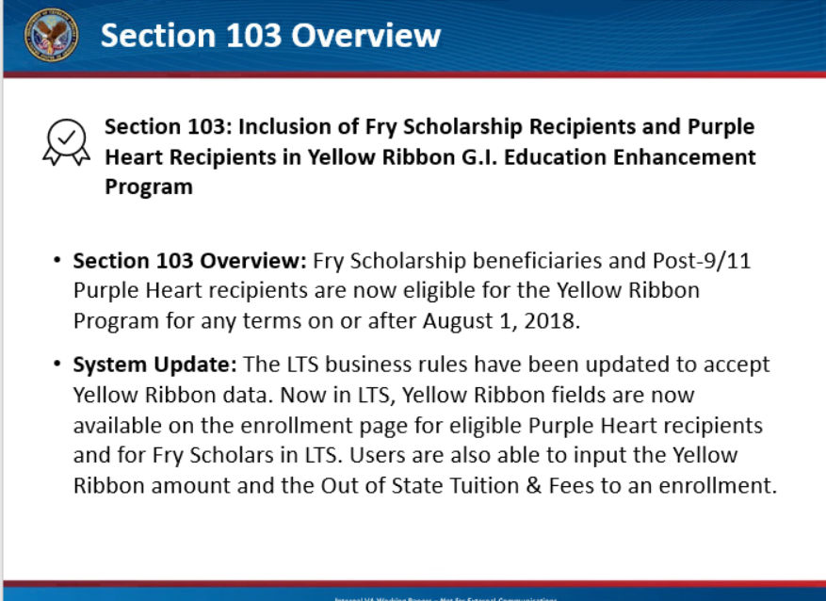 | Section 103 Overview: Under Section 103 of the Colmery Act, Fry Scholarship beneficiaries and Post-9/11 Purple Heart recipients are eligible for the Yellow Ribbon Program. This provision was effective August 1, 2018 and required a manual workaround. The LTS business rules have been updated to accept Yellow Ribbon data. Manual workarounds will no longer be required.  To support these changes, the necessary Yellow Ribbon fields are now available in the LTS on the enrollment page for eligible Fry Scholarship beneficiaries and Purple Heart recipients. You can now select either ‘Spouse’ or ‘Parent’ for Fry Scholars to indicate their relationship to the Service Member, have access to a new field for ‘Remarriage Date’ for Fry Spouses who have remarried, and have the ability to enter data into the Yellow Ribbon and Out of State Tuition and Fees field. Next, we will take a look at a demonstration of these updates in the LTS.  Click next to proceed to the next page.
[screenshot Fry Scholar in Work Product tab] | Demo: First we will demonstrate Yellow Ribbon for a Fry Scholarship spouse. Add a new Work Product and select Fry as an entitlement source, which will navigate you to the Work Product creation page. Select ‘Spouse’ from the Relationship dropdown. Note when ‘Spouse’ is selected, a new field, ‘Remarriage Date’ became available. Leave this date blank unless the spouse has remarried. Remember the ‘Veteran’s Date of Death’ field is mandatory. In this demonstration, we have filled in the information with test data in the Description, Veteran First and Last Name, Branch of Service, and Veteran Date of Death. Click on “Create Work Product.”
[Video of entering enrollment modal] | Click on “Add enrollment” and enter information from the enrollment certification. In this demonstration, we will select undergraduate college degree as the training type, with a start date of January 1, 2020 and end date May 1, 2020.  As you can see, the ‘Yellow Ribbon Amount’ field is now available on the enrollment screen. The Out of State Tuition and Fees field also appears if the facility is out of state. These fields will only accept information when the enrollment start date is on or after August 1, 2018. If the enrollment start date is prior to August 1, 2018 and information is entered into these fields, you will receive an error. We continue to enter in test data into this enrollment, including $10,000 in Tuition charged; $1,000 in Yellow Ribbon amount and $10,000 in out of state Tuition & Fees.
[Screenshot: Amendment modal]  [Screenshot Enrollment section] | Similar to the enrollment screen, the amendment screen includes a Revised Yellow Ribbon Amount field and a Revised Out of State Tuition & Fees field, if applicable. In this demonstration, we can include a revision out of state Tuition & Fees of $8,000 and a revised Yellow Ribbon amount of $800. Click save.
[Screenshot: Work summary page] | On the Work Product Summary Page, you can now see the Yellow Ribbon payment by scrolling down to ‘Lump Sum Payment’.  Click next to proceed to the next page.
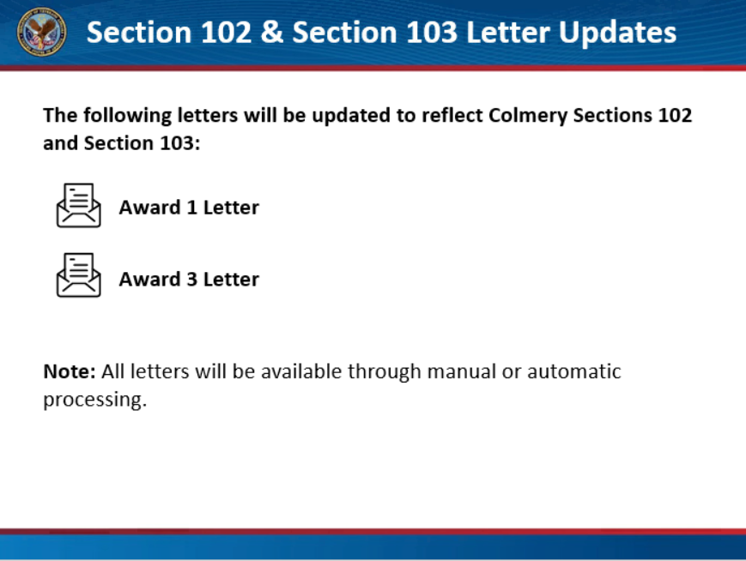 | Now that we have reviewed the system changes related to Colmery Section 102 and Colmery Section 103, let’s see how these updates will also be reflected in letters sent to beneficiaries. Updated letters will include the Award 1 Certificate of Eligibility (COE) and Award 3 letters, where appropriate.
[Screenshot: Award 1 Letter] | The Award 1 COE letter has been updated to include a paragraph for beneficiaries who qualify at the 100% benefit level based on receipt of a Purple Heart on or after September 11, 2001.  The Award 1 COE Letter will also be populated with the standard Yellow Ribbon paragraph, so beneficiaries are aware of their Yellow Ribbon eligibility.
[Screenshot: Award 3 letter] | The Award 3 Letter generated for a Fry Scholarship beneficiary eligible for Yellow Ribbon will populate existing verbiage for Yellow Ribbon payments. For Purple Heart letters, the Award 3 Letter update reflects when a beneficiary qualifies at the 100% benefit level due to Section 102, based on receipt of a Purple Heart on or after September 11, 2001.
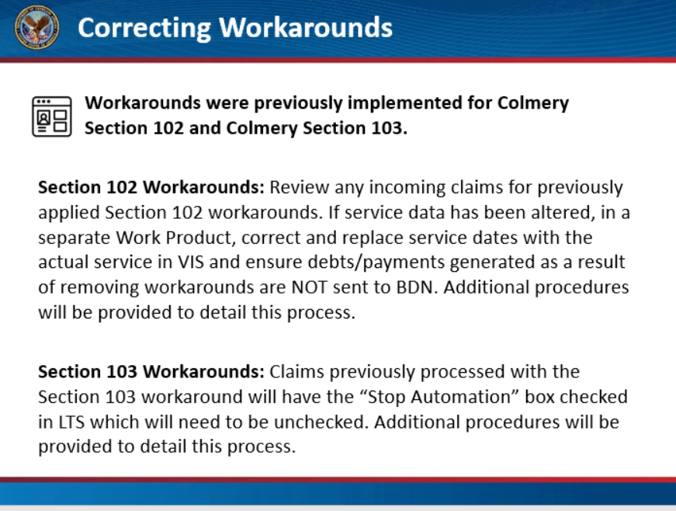 | Section 102 Workarounds: Due to previous manual workarounds, you will need to review any incoming claims for previously applied Section 102 workarounds. If service data has been altered, in a separate Work Product, correct and replace service dates with the actual service in VIS or the Veteran Information Solution. Ensure debts or payments generated as a result of removing workarounds are NOT sent to BDN. Claims with both service and enrollments beginning prior to August 1, 2018, should be carefully reviewed. Additional procedures will be provided to detail this process.  Section 103 Workarounds: A workaround was implemented for Section 103 for claims received prior to this LTS system update. Claims previously processed with the Section 103 workaround will have the “Stop Automation” box checked in LTS which will need to be unchecked. Additional procedures will be provided to detail this process.
[Course Summary Slide] | You have reached the end of this training module. In this training you learned about the system updates to LTS for Purple Heart Award recipients, Fry Scholars and adding the Yellow Ribbon Program to both beneficiary groups. Thank you for completing this training.
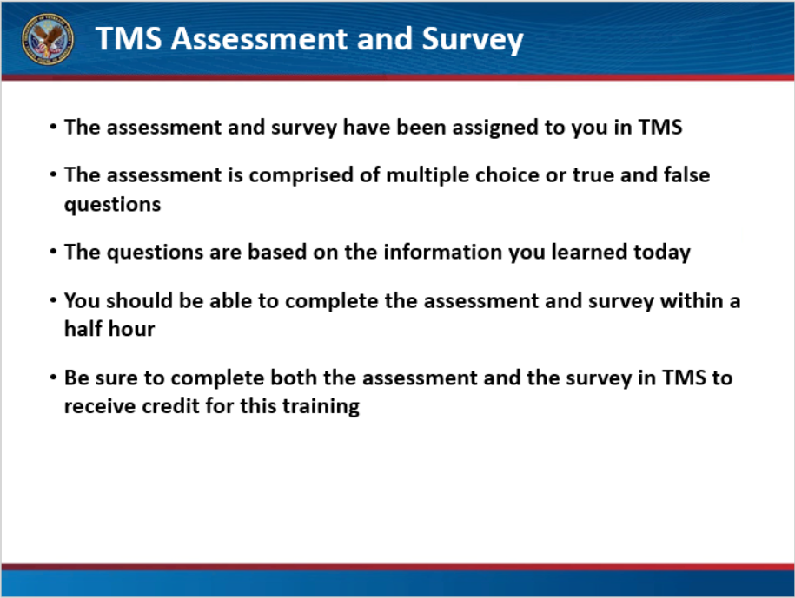 | The assessment and survey have been assigned to you in TMS.  The assessment is comprised of multiple choice or true and false questions.  The questions are based on the information you learned today.  You should be able to complete the assessment and survey within a half hour.  Be sure to complete both the assessment and the survey in TMS to receive credit for this training.

