Adobe Captivate Training Scripts
  - Section 108 (National Exam Reimbursement) & Section 113 (Active Duty Housing Proration)

Section 108
Visual | Script
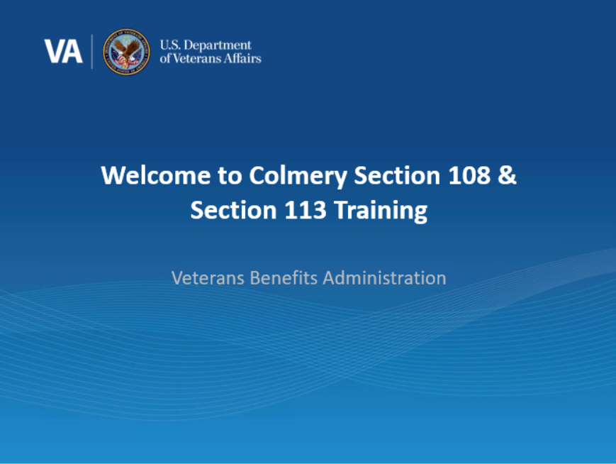 | Intro: Welcome! In today’s training, you will learn about Sections 108 and 113 of the Harry W. Colmery Veterans Educational Assistance Act and the impact of these provisions to the Long-Term Solution (LTS). This training module is self-paced, please click ‘next’ in the bottom right-hand corner of the page when you are ready to move on to the next page.
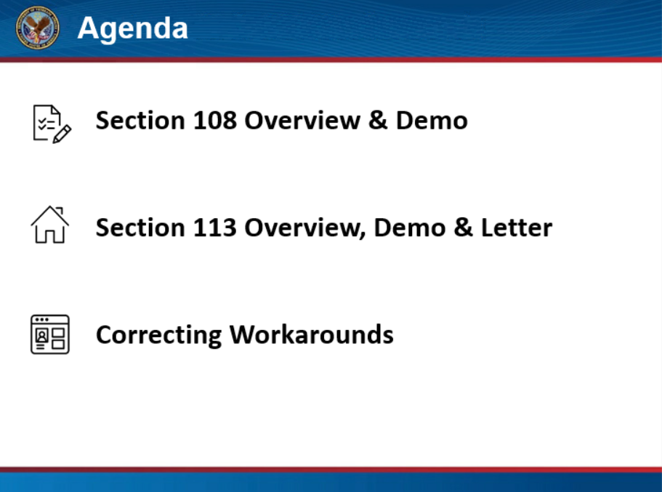 | Agenda: In this training, we will discuss Section 108 of the Colmery Act and provide an overview of updates to LTS to accurately prorate and calculate the entitlement charge for licensing & certification and national tests, eliminating the need for a manual work-around. Then, we will go over Section 113 of the Colmery Act and discuss how LTS has been updated to prorate the Monthly Housing Allowance or MHA rate the beneficiary will receive from VA based on the days of the month the service member is not on active duty. In this training, we will also instruct how to correct previous workarounds. Click next to proceed to the next page.
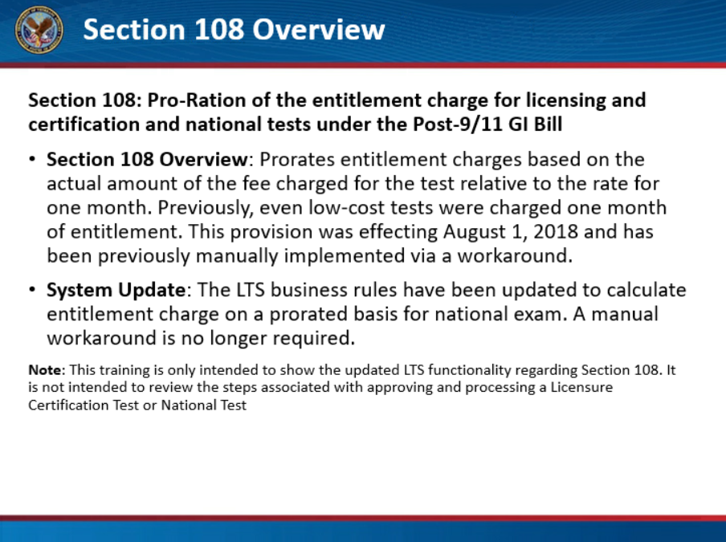 | Section 108 Overview: Section 108 of the Colmery Act prorates entitlement charges for licensing & certification and national tests under the Post-9/11 GI Bill. Previously, one month of entitlement was charged for each test, regardless of cost. This provision was effective August 1, 2018 and required a manual workaround. The LTS business rules have been updated to correctly calculate entitlement charge on a prorated basis for licensing and certification and national tests. Manual workarounds will no longer be required.  Let’s watch a short demonstration on how to prorate entitlement charges for licensing and certification and national tests.  Click next to proceed to the next page.
[Video Demo 1: Proration based on exam cost] | Demo: This demo will show how LTS will calculate the correct entitlement charge for a national test.  Create a new Work Product and advance to the Work Product Summary (WPS) screen. On the banner of the WPS screen, notice the amount of used and remaining entitlement. Under Miscellaneous Benefit, select “Add Benefit” and choose the appropriate Licensing and Certification or National Exam option from the dropdown.  In this example, the beneficiary took a National Exam, on January 1, 2020, at a cost of $1,000 (in this scenario we will use “test” as a name of the National Exam). Enter the amount claimed for the test, the date and the name of the test in the appropriate field, then select “Save”.  Once the information is saved, notice the used and remaining entitlement have been updated. The system has correctly prorated the amount of entitlement used, rather than charging a full month of entitlement. Review the Lump Sum Payments and note the test amount has been added as a payment.  Click next to proceed to the next page.

Section 113
Visual | Script
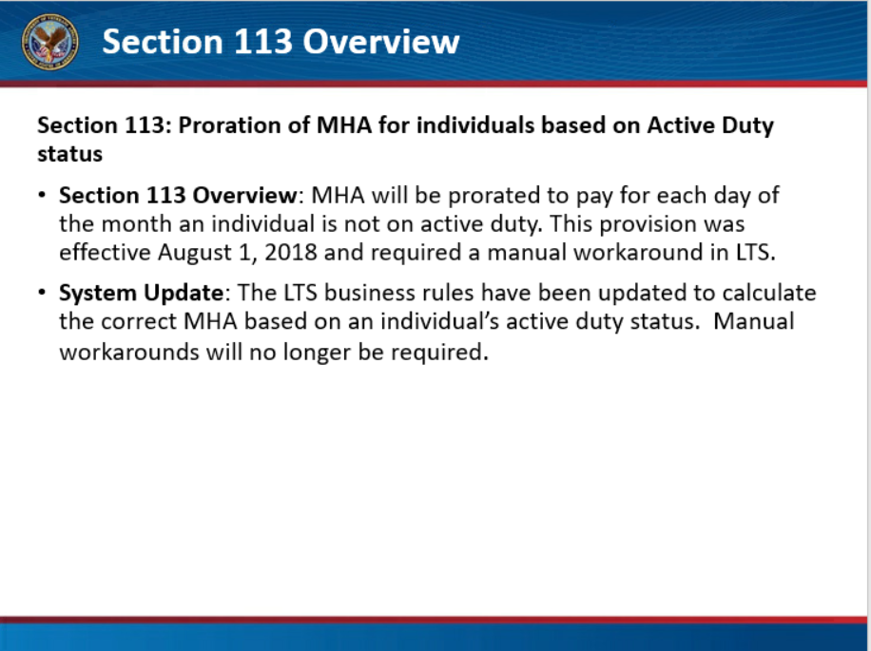 | Section 113 Overview: Next we will discuss how to prorate the Monthly Housing Allowance (MHA) based on a change in active duty status during an enrollment period. Section 113 of the Colmery Act allows for the proration of MHA for individuals entering and being released from active duty. The MHA will be prorated to pay for each day of the month an individual is not on active duty. This provision was effective August 1, 2018 and required a manual workaround. The LTS business rules have been updated to calculate the correct MHA based on an individual’s active duty status. Manual workarounds will no longer be required.  Let’s watch a short demonstration on how MHA will be adjusted in LTS to issue the correct payment based on an individual’s active duty status during an enrollment period,  Click next to proceed to the next page.
[Video Demo] | Demo:  In this example, the service member was on active duty from February 1, 2020, to March 1, 2020, which is during the enrollment period of January 15, 2020 to May12, 2020  To demonstrate how LTS will prorate MHA based on active duty status, start by creating a new Work Product. On the Service Data screen enter any additional service periods, enter “Service Verified” in the comments box, and select “Next” to navigate through the additional screens, updating as necessary until you reach the WPS screen.  On the WPS page under “Recurring Payments”, you will notice the system has correctly calculated and displayed the recurring MHA payment schedule. The housing is paid before the Veteran began active duty service, January 15, 2020, through January 31, 2020, and after the service member was released from active duty, March 2, 2020, through the end of the enrollment period.  Now that we have demonstrated how the system will correctly calculate the MHA, let’s review the changes to the letters.  Click next to proceed to the next page.
[Letter Screenshot] | The Award 3 Letter has also been updated to include an explanation of changes introduced by Section 113, so claimants are fully aware of how their MHA was generated. When MHA is awarded for enrollment periods beginning on or after August 1, 2018, LTS will now add language at the end of the Monthly Housing Allowance section. Click next to proceed to the next page.
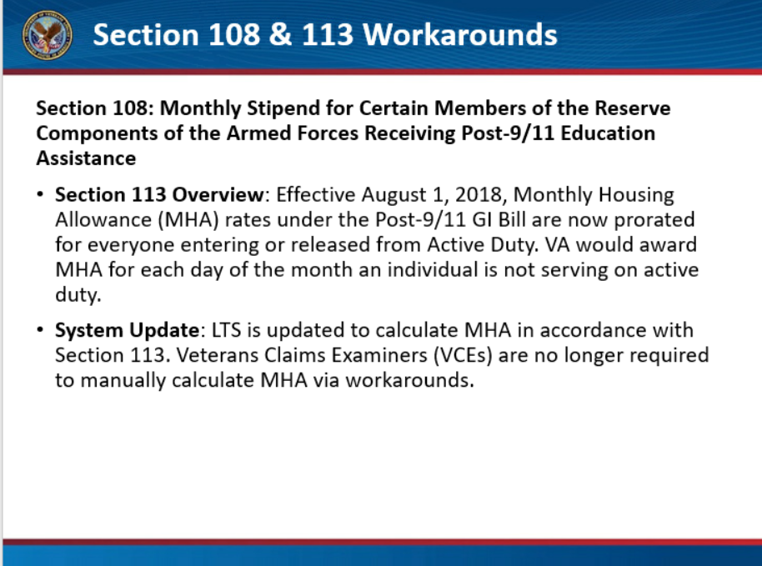 | Section 108 Workarounds: If upon review of the WPS there is a manual award to “Add entitlement - titled Colmery Section 108 with the name of the exam”, an action to “Charge entitlement” for the same exam and the same amount of entitlement should be processed to avoid granting too much entitlement to the beneficiary. Additional procedures will be provided to detail this process.  Section 113 Workarounds: When a new work product is generated in LTS for which a beneficiary had a prior workaround applied for Section 113, the claim will be off-ramped. Additional procedures will be provided to detail this process.  Click next to proceed to the next page.
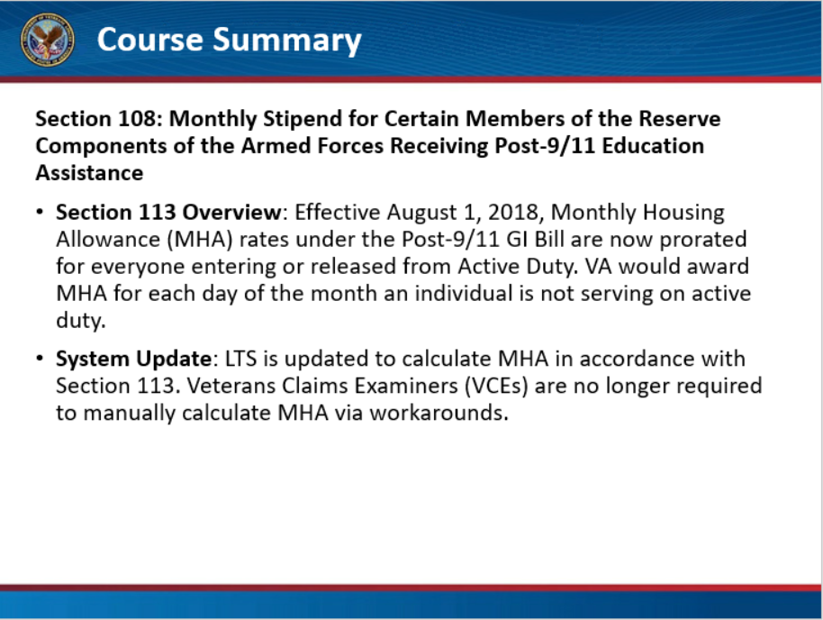 | Course Summary: You have reached the end of this training module. In this training you learned how to correctly charge entitlement for licensing and certification and national tests in the LTS without manual workarounds. You also learned how to correctly pay MHA when a beneficiary’s active duty status changes during an enrollment period.  Click next to proceed to the next page.
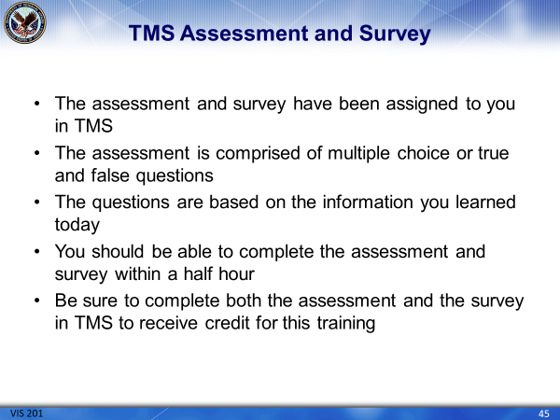 | The assessment and survey have been assigned to you in TMS.  The assessment is comprised of multiple choice or true and false questions.  The questions are based on the information you learned today.  You should be able to complete the assessment and survey within a half hour.  Be sure to complete both the assessment and the survey in TMS to receive credit for this training.

